Fernando Salazar

Assignment 4

Assignment 4 (Arbitrary list operations)

Completion requirements

Create a linked-list that allows:

an add function that takes a value and inserts it into a given position into the list

(example: myList.add(someValue, somePosition) )

a remove function that takes a position and removes the value stored at that position of the list and returns it

(example: myList.remove(somePosition) )

a get function that takes a position and returns that value without removing it

(example: myList.get(somePosition) )

Be sure to include at least one test function for each piece of functionality that should verify that your code is working!  This should be at least one test per behavior, likely more.  You can make these tests in a source file with a main where your tests are either directly in the main or inside their own standalone functions (please do not neglect the importance of testing!)

Once you have implemented and tested your code, add to the README file what line(s) of code or inputs and outputs show your work meeting each of the above requirements (or better, include a small screen snip of where it meets the requirement!).

(Note: we will cover the analysis of some of this in class next week, then we will have you analyze the next ones!)

Attempt to analyze the complexity of your implementation with line-by-line analysis,

Note: This assignment is to get you to think about the trade-offs that we may have to weigh before using one structure over another

// Design

an add function that takes a value and inserts it into a given position into the list

a remove function that takes a position and removes the value stored at that position of the list and returns it

a get function that takes a position and returns that value without removing it

test functions for each function

//requirements

//add function

//remove function

// get function

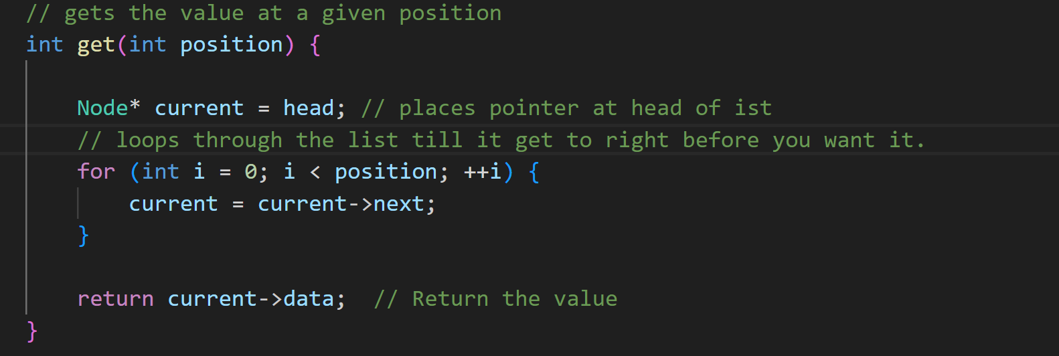

// test functions

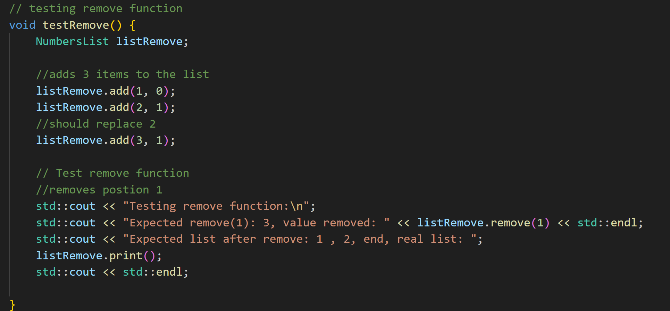

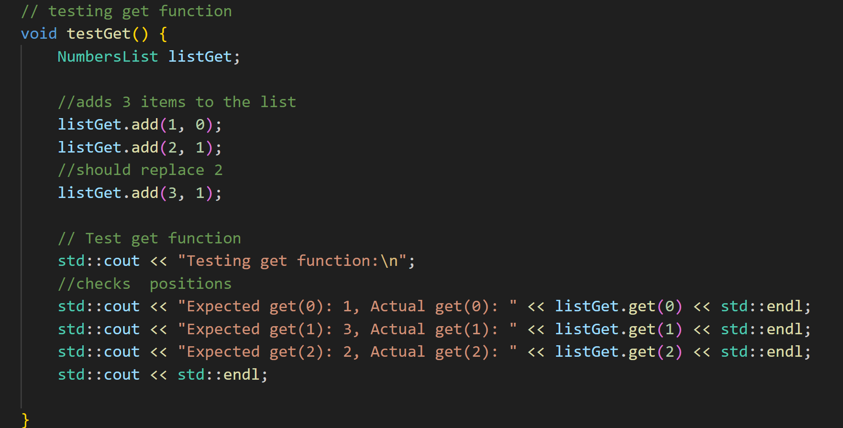

// results from test functions

// line analysis

/ line-by-line analysis of the three main functions

// not sure if I did it right but the bulk of my code is going to be  o(1) in the complexity because it only does the one thing,

olny when it as to loop through in 3 parts does it get higher  o(n)

 // Add function that lets you pick location in list

    void add(int value, int position) {  // needs data and location

 * o(1)      if (position < 0) { // checks if the position is in range //less then zero

            throw std::out_of_range("position out of range");

        }

 * o(1)       if (position > count) { // checks if the position is in range // greater than count

            throw std::out_of_range("position out of range");

        }

* o(1)        Node* newNode = new Node();  //  new node

* o(1)       newNode->data = value;       // Sets the dat in node.

        // sets postion at front of list

 * o(1)       if (position == 0) {

            newNode->next = head;    //  points to current head

            head = newNode; // becomes new head

 * o(n)       } else {

            Node* current = head;

            // loops through the list to the point to just before you want it

            for (int i = 0; i < position - 1; ++i) {

                // this makes the  node poin to the next in the list

                current = current->next;

            }

* o(1)            newNode->next = current->next;

* o(1)           current->next = newNode;  // points to new newnode

        }

* o(1)        count++;  // adds one to the count

    }

    // Function to remove an element at any postion

    // very similar to add function

    int remove(int position) {

* o(1)        if (position < 0) { // checks if the position is in range //less then zero

            throw std::out_of_range("position out of range");

        }

* o(1)        if (position > count) { // checks if the position is in range // greater than count

            throw std::out_of_range("position out of range");

        }

* o(1)        Node* temp; // pointer for node to be deleted

* o(1)        int value; // for data in node to be deleted

* o(1)        if (position == 0) {

            temp = head; // saves

            value = head->data; // saves data

            head = head->next; // updates head pointer to  next node

* o(n)        } else {

            Node* current = head;

            // loops through the list to the point to just before you want it

            for (int i = 0; i < position - 1; ++i) {

                current = current->next;

            }

* o(1)            temp = current->next;  // saves the node data etc

* o(1)            value = temp->data;

* o(1)            current->next = temp->next;

        }

* o(1)        delete temp;  // Deletes the node

* o(1)       count--;      // lowers count

* o(1)        return value; // Returns the removed node value

    }

    // gets the value at a given position

    int get(int position) {

* o(1)        if (position < 0) { // checks if the position is in range //less then zero

            throw std::out_of_range("position out of range");

        }

* o(1)        if (position > count) { // checks if the position is in range // greater than count

            throw std::out_of_range("position out of range");

        }

        Node* current = head; // places pointer at head of ist

        // loops through the list till it get to right before you want it.

* o(n)        for (int i = 0; i < position; ++i) {

            current = current->next;

        }

* o(1)        return current->data;  // Return the value

    }