Project Proposal

Prepared for: Applied Technology Project 2019,Worthy Smile

Prepared by: Fernando Santos Tenorio, N. 2016198

10 December 2019

Table of Contents

Overview 3

The Problem 4

What are the benefits of Volunteering? 4

5

Physical and Mental Health 5

Depression 5

Anxiety 6

Social Isolation 6

Students doing Volunteer Work 7

Worthy Smile 8

Expected Tools for Deployment 9

React-Native 9

Firebase 10

Node.js 10

References 11

# Overview

Last year project has shown how Volunteer work can be hard, especially when you are a full time student and still have to work to pay bills, but still many students want to participate on community activities, help on taking care of people with special needs but they are not able to commit to institutions that provide open vacancies/roles to people willing to help, it because time management and applications policies make it hard for people(specially students to commit themselves to a bureaucratic work).

After working on this project, I was able to analyze the main problem and developed an Android app that would work as a Blog where people would be able to share their activities related to volunteer commute. Institutions were able to post upcoming events and interested to apply would fill a form and an email with the form will be sent to the institution with the applicant information. Unfortunately, the app was not completed. Also, we had the policies when applying to a volunteer work, where applicants must have Gard Vetting - which may take while to acquire - to be able to do any type of work in any institution.

So, seeing these barriers, I decided to create a Social media, where the idea is to get users to interact and show their activities, so that others interested in the same idea will be able to check other opportunities for similar events or activities and participate. Institution will be able to post their upcoming events, but now instead of people click to apply to these events and having to fill out a form, they will only see when and where the events will occur, so they may be able to apply to participate if the event is free, or payed.

The applicants are mainly students who do not have much free time to practice others activities, and end up giving up on the volunteer and commute activities. The idea is to bring them to get involved with the community, and be aware of contents that might be helpful for their health and self-esteem.

On the other side, the organizations will be able to promote any type of events and activities on a dedicated section, where they can share with others users how they can do to participate, providing information such as cost, type of event, location, how other users can help, and more, so that interested to it will choose the event that most match to their personality.

# The Problem

People now-a-days are more likely to suffer from depression, social isolation, anxiety and others cause by mental disorders.

As most of us tend to live busy lives being occupied whether at work, university of in our personal lives, the idea of volunteering seems to be a very hard idea to be committed at, it because for us, allowing a new activities that would take more of our time seems not suitable for our life style, especially when not getting monetary reward from it. But why would I volunteer myself for a new job without financial reward? What benefits can I take from it, other than exhaust myself, and getting nothing in return?

Those are some questions that you may get when mentioning the world “Volunteer” to someone for the first time. But then answer to those questions can be very simple, and straight forward. Moreover, it can be shown with actions. Volunteering is more than just giving you time for a cause and commit yourself to something, it is helping people, worthwhile causes, the community and help on your self-confidence, open doors to new cultures, help on your loneliness or simply for the willing to help.

## What are the benefits of Volunteering?

Early this year, 2019, the [Time Well Spent](https://www.ncvo.org.uk/images/documents/policy_and_research/volunteering/Volunteer-experience_Full-Report.pdf) survey conducted by the authors Amy McGarvey, Véronique Jochum, John Davies, Joy Dobbs and Lisa Hornung shows a promising results on how the volunteer is affecting everyone involved into it. In Britain alone, two in five adults have taken volunteering work, in which according to [Time Well Spent](https://www.ncvo.org.uk/images/documents/policy_and_research/volunteering/Volunteer-experience_Full-Report.pdf) 96% were happy with the results and their experience.

Researches have proven that participating on community activities and being part of volunteer commute brings benefits from spiritual enrichment to reducing anxiety and stress, such as:

Opportunities to learn from others;

Greater welfare;

Get you away from boredom;

Improve networking;

Improve sensitivity and empathy;

The figure Bellow describes the Volunteer Activities of recent and frequent volunteer, and recent and occasional volunteers.

## Figure 1. Represents

## 

## 

Figure Volunteering Activities. - Source (McGarvey, n.d.)

### 

## 

## Physical and Mental Health

### Depression

Depression is a common mental disorder and one of the leading causes of disability worldwide. Globally, according to (Roser, 2017) survey it is estimated that 300 million people are affected by this condition. More women suffer from depression than men. Depression is characterized by sadness, loss of interest or pleasure, feelings of guilt or low self-esteem, altered sleep and appetite, tiredness and lack of concentration. Patients with this condition may also have multiple physical complaints with no apparent cause. Depression can be long-term or recurrent, substantially impairing people's ability to be functional at work or school, as well as their ability to cope with daily life. In its most severe state, depression can lead to suicide.

### Anxiety

Anxiety is the body's natural reaction to stress. It is an emotional state characterized by feelings of tension, worry and bad thoughts. Importantly, anxiety is not always a disease. Anxiety in its normal state is healthy for the individual as it drives them to undertake projects, prosper and plan for the future. What becomes alarming is the excess of this feeling.

According to (Mental Health Ireland, n.d.) there are some physical problems that can be caused by anxiety such as:

* Fast breathing;
* Sweating;
* Dizziness;
* Weakened;

Furthermore, related to the (Roser, 2017) , the number of people worldwide that suffer from anxiety is approximately 280 million, which represents 3.8% from the total of people with Mental Issues.

### Social Isolation

According to the (No Isolation, 2018) article, social isolation occurs when a group or an individual, whether involuntarily or voluntarily, withdraws, avoids contact or interaction, or is deprived by others of having contact or maintaining relationships with that group, being excluded from the common environment. The motivations for this phenomenon are diverse and should be seen on a case-by-case basis, but there are factors that may be determining and which are generally fully visible.

It may be related to the economic situation of individuals, where they are eventually deprived of their full belonging to the socioeconomic sphere to which they belong, with stigmatized diseases such as AIDS, old age, the simple fact of being different, or numerous other factors that, either for one reason or another, they become sufficient for an individual to be socially isolated or isolated from ordinary contact.

## Students doing Volunteer Work

A recent study made by [The National Youth Agency](https://dera.ioe.ac.uk/6643/1/RW103.pdf), shows that young people are getting more into to practice volunteer activities. It proves how volunteering can be beneficial for their mental and physical health, but not only, it makes them to believe that they are doing some good for their community, and having a “sense of purpose”.

Although students nowadays are very busy, when it comes to work, and study at all the same time, it feels hard for them to be committed to and extra activity that might take some time to complete. Well, that’s true…

Volunteering has proven over the years, that its practice has helped students to find themselves into a new world. But how?

It simply helps them to feel confident, it because many students now are sometime getting frustrated with their job search, many projects to complete, and moreover, living their life style. Which sometimes can get students into a really hard time, and leading them to develop problems such as depression, anxiety, social isolation and more.

It has also proved that volunteering helps to stand up into your career. It because many companies are always looking for someone able to help other members of the team, and with students it is not different. Volunteering helps students to practice skills needed into the work environment, and it can be very beneficial for both companies and applicants.

Basically, it is possible to understand how we deal with more complicated situations, what our attitude looks like, and why it goes - especially when we are young and have little experience. So never underestimate the importance that volunteer work can have on your personal growth and development.

# Worthy Smile

What Worthy Smile?

Worthy Smile is a Hybrid application, that will be used as a tool to bring new ideas to the volunteer world. It main idea is to create connectivity between Organizations that provide these activities, such as - Nursing Home, Care House and other Institutions that provide Volunteer Abroad Programs - and applicants - people who are willing to participate of these programs/activities - and with that, share their experiences in a blog feed app, all into one single app.

But how will it work?

Organizations and Institutions will be able to post upcoming events, and make it visible for users the read more about, and participate, if interested. Also, with it, there will be a section where all users will be able to post their recent participated events on a Blog Feed, allowing others to visualize, comment and like it, just like most social media nowadays. This will create new connections between all of our users, and engage them into a new life style.

The idea of having this app, is to get those who are looking for new challenges, and help others to see that volunteering is a fun activity in most cases, and it can be shared in a app created to promote these events and show others that it do not take a huge a commitment to participate of community activities and get involved with what is happening around.

## Expected Tools for Deployment

To create the app, I have taken a course on Udemy which I learned how to use React-Native, which is a platform where I can develop a Hybrid App able to run in both Android and iPhone Devices. This library uses JavaScript code, to store the user data and to perform real-time responses, I will be using Firebase, and to perform the backend I have chosen Node.js.

After I have decided the purpose of my project, the next steps were the planning part, it because among with the Final Project, we have been facing other challenges, and getting more and more assignments, so planning my time is being crucial part of this project “even though in the begging I got bit lost”. So after setting down my schedule with the help of my Supervisor Amilcar, I have being studying other technologies such as IONIC, which I read some articles and created a project, react-native (The one I chose for my project), which I have taken a course on Udemy to get a better idea of how it work, and surprisingly I enjoyed it more than what I thought I would, it because uses JavaScript Language, so I can get hands-on developing on a tool I was not comfortable at.

### React-Native

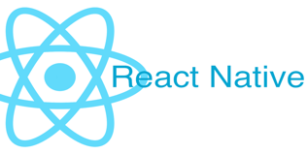React-Native is a Framework developed by Facebook based on React, which enables the developer to develop Hybrid Application, in other words, for both Android and IOS Devices using only JavaScript. It does not seem to be surprisingly innovative, since there are already many frameworks that package web applications in a kind of a browser, such as Cordova or Manifold.js, but React-Native is different, it because all the developed code is converted to the native language of the operating system, providing advantages such as:

* Fluid user experience;
* Faster Loading;
* Better integration between phone and functions such as camera gyro, etc.;
* Security;
* Best Overall Performance;

With the language I was going to work with and the library to use chosen, I had to decide where to store all the data produced by the application, such as pictures taken, user information, security and perform real-time data transmission. To do that, a powerful Cloud based data based is necessary, and for this project I have decided to go with Firebase.

### Firebase

Firebase is a Google platform that contains a bunch of tools and provides great infrastructure to help on the web and mobile development to build high quality and high-performance applications. Firebase contains four service segments: Analytics, Develop, Grow and Earn, as shown on the figure bellow:

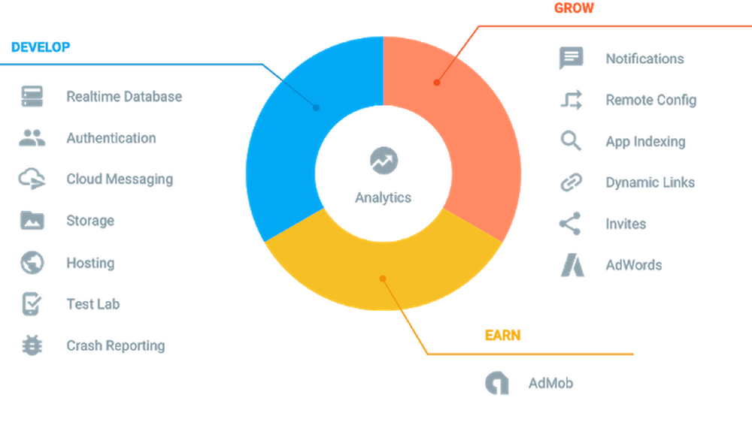

Figure Firebase Services Segments – Source. (Fan, 2016)

Develop is the segment we are going to use for this project, it because the app will perform real-time data transfer, the user will be able to choose in signing up with their Facebook account, and probably Google account, store all pictures taken or selected by the users and provide secure authentication.

To perform the overall implementation of the application rules, I have decided to develop the Worthy Smile app using Node.js as the backend, it will be one responsible for creating connection between Firebase and the user interaction.

### Node.js

Node.js is a async drive-event platform created to help on building high performance scalable web and mobile applications using JavaScript developed by [Ryan Dahl](https://en.wikipedia.org/wiki/Node.js). It enables users to set up HTTP and HTTPS Servers, as well as DNS, TCP, and so on. Because of its way to be implemented, Node.js is great for undertaking many types of projects, such as:

* APIs;
* Real-time Transfer such as chat server, or collaborate apps between multiple users;
* Multiple game players;
* Applications that demand high scalability;
* Data Streaming Servers;

# References

Ncvo.org.uk. (2019). [online] Available at: https://www.ncvo.org.uk/images/documents/policy_and_research/volunteering/Volunteer-experience_Full-Report.pdf [Accessed 9 Dec. 2019].

Dera.ioe.ac.uk. (2019). The National Youth Agency. [online] Available at: https://dera.ioe.ac.uk/6643/1/RW103.pdf [Accessed 10 Dec. 2019].

No Isolation. (2017). What is social isolation? [online] Available at: https://www.noisolation.com/global/research/what-is-social-isolation/ [Accessed 10 Dec. 2019].

ncvo. (2019). Volunteering. [online] Available at: https://data.ncvo.org.uk/volunteering/ [Accessed 10 Dec. 2019].

Ritchie, H. and Roser, M. (2019). *Mental Health*. [online] Our World in Data. Available at: https://ourworldindata.org/mental-health [Accessed 11 Dec. 2019].

Mental Health Ireland. (2019). [online] Available at: https://www.mentalhealthireland.ie/a-to-z/anxiety/ [Accessed 11 Dec. 2019].

O’Reilly | Safari. (2019). *Learning React Native*. [online] Available at: https://www.oreilly.com/library/view/learning-react-native/9781491929049/ch01.html [Accessed 11 Dec. 2019].

Google. (2019). *How Using Firebase Can Help You Earn More*. [online] Available at: https://www.blog.google/products/admob/how-using-firebase-can-help-you-earn-more [Accessed 12 Dec. 2019].

Firebase. (2019). *Firebase*. [online] Available at: https://firebase.google.com [Accessed 12 Dec. 2019].

Foundation, N. (2019). *About | Node.js*. [online] Node.js. Available at: https://nodejs.org/en/about/ [Accessed 12 Dec. 2019].