Setup:

initial_state = # has to be defined

final_state = # has to be defined

--

self.Agent_Start = (0,0) # but not always 0,0

-------------- P A R T O N E --------------

Pizza deliverer delivers pizza by bike.

- Pizza deliverer delivers pizza from base.

- Pizza deliverer goes back to base from deliver place.

Considerations:

- Only one restaurant.

- Only one client.

- Two orders at most.

- Maximum load capacity of the bike is two (pizzas I suppose)

- Deliverer can only ride through 'restaurant' or 'delivery

location' tiles.

- All actions have a unit-cost.

-- The total cost of the solution is the total number of

actions performed by the delivery person

- Movements between tiles.

- Loading pizza.

- Unloading pizza.

>>>>>>>>>>>>>>>>>>>>>>>>>>>>>>>>>>>>>>>>>>>>>>

- We have to modify:

- map.txt | defines the configuration of the problem

- config.py | defining initial settings of the problem

- gameProblem.py | contains the functions required by the

search module of SIMPLE-AI that must be implemented. They are 8:

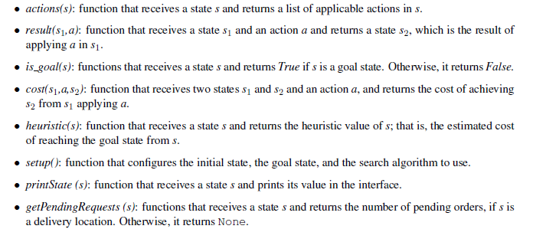

To complete the advanced part, we have to implement:

