GROUP 4 · SEN 106 / SEN 216
Online Library Management System
Front end — how the work is split, and how to start
Hezekiah Oluwasanmi Library, Obafemi Awolowo University
github.com/Ferousco-dev/HOLibrary_frontend

Read this first
We are building the front end for a library system that already exists. The back end is written, tested and deployed: 223 titles, 892 physical copies, and a live API you can call from your browser right now. You are not building a prototype against invented data. Everything you put on screen will be real.
Three of you have three screens each. There are nine screens left, and one is already finished as an example to copy from.

What the system is
A catalogue and circulation desk for a physical library. Students search for a book, see whether a copy can be borrowed, and reserve it if every copy is out. Librarians issue and receive copies at a counter.
It is not an e-library. It never stores or shows the contents of a book. It tells you where a physical copy is and who is holding it. If you find yourself designing a Read Online button, stop and re-read this paragraph.

The one idea everything depends on
A book is a title. A copy is an object on a shelf.
A book has a name, an author, an ISBN and a call number such as LIB 001, shared by all its copies. It is a description, and it is never on a shelf.
A copy has its own accession number, unique across the whole library, and a state: available, on loan, reserved, lost or withdrawn.
You do not borrow a book. You borrow one numbered copy of it. Every screen has to respect this. Search results are titles; anything about location, availability or borrowing is copies.

Last-copy retention
The final available copy of a title never leaves the building, so that somebody can always come and consult it. This produces three states your screens must tell apart:
The library has | Borrowable | What the reader is told
5 copies, 3 on the shelf | 2 | You can borrow this today
2 copies, 1 on the shelf | 0 | You can read it here, but not take it home
1 copy, 1 on the shelf | 0 | The library's only copy, so it stays
Confusing “on the shelf” with “can be borrowed” is the single most likely mistake on this project. They are different numbers.

Getting started

1. Get the code
git clone https://github.com/Ferousco-dev/HOLibrary_frontend.git
cd HOLibrary_frontend
git checkout <your branch, from the table below>

2. Run it
python3 scripts/serve.py
Then open http://localhost:8899 in your browser.
Do not double-click the HTML files. A page opened straight from your file system has an origin of “null”, and the API refuses it. You will get errors that have nothing to do with your code and waste an evening on them. The script also stops your browser serving you a stylesheet you edited ten minutes ago, which wastes the other evening.

3. Read the API documentation
https://api.library.appmd.dev/docs
Every endpoint, every field it returns and every error it can give you is on that page, and you can call the real API from it. Open it before you write your first line.
If a brief and the documentation disagree, the documentation is right. Do not invent a field. If you need data no endpoint returns, say so and we will discuss it, but do not fake it.
One trap: the API returns PascalCase names for stored fields (Title, ISBN13, CallNumber) and snake_case for derived ones (wing, borrowable). That is inconsistent, but it is what the contract says. Match it rather than guessing — guessing cost us an afternoon of entirely blank search results.

How it should look
The catalogue page is finished and is the reference. When you are unsure how anything should be written or styled, open index.html and copy the pattern.
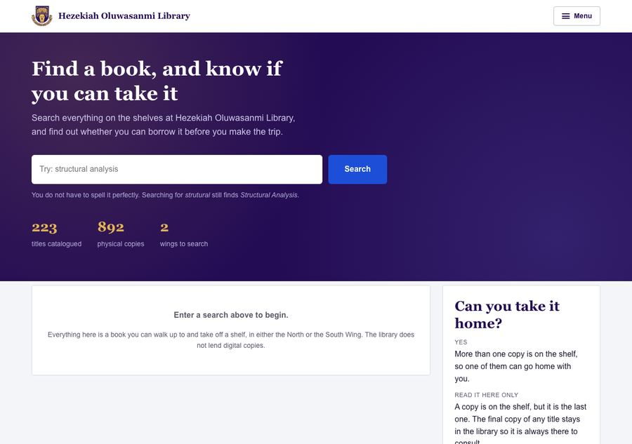
index.html — the finished catalogue page. This is the standard.
Note what it does: one quiet header with the crest, the library name and a single Menu button. Flat bordered panels, no drop shadows and no coloured stripes down the edge of a card. Serif headings, sans body. Book covers where they exist, and a call-number placeholder where they do not.

The rules that are checked automatically
Run this before you push. It is the same script that runs on your pull request, so a green result here means a green tick there.
python3 scripts/check.py
- Copy pages/_template.html to start a screen. Never build one from scratch, and never edit the template itself — the header and footer must be identical on all eleven screens.
- Never write fetch(). Use api.get, api.post, api.patch, api.del from js/api.js. They handle the token, the refresh and the error shape.
- Never write a colour or a pixel gap. Use var(--indigo), var(--space-4) and the rest from css/tokens.css. A raw hex code anywhere but that file fails the build.
- Never put API data into innerHTML. A book title can contain a < and a member's name comes from a form. Use textContent.
- Never remove a focus outline. It is how a keyboard user knows where they are.
- Every <img> needs alt. Use alt="" if it is decorative — that is a decision; a missing attribute is not.

Accessibility is graded
It is on the course marking sheet and it is genuinely half the work in HTML. Real labels tied to inputs with for and id. Real tables with a caption and scope on every header. Headings in order. Every control reachable by keyboard. Colour is never the only signal — if something is overdue, the word overdue appears, not just the colour red.
Run Lighthouse in Chrome DevTools (Lighthouse tab, tick Accessibility, Analyze) and put the score in your pull request. Below 95 needs a sentence explaining what is left.

How we work together
Nobody pushes to main. Not for a small fix, not once. main is what gets deployed, and if it breaks there is nothing to show at the defence. GitHub is configured to reject a direct push, so this is enforced by the server rather than by trust.
Work reaches main one way: you push your branch, you open a pull request, it is reviewed, and it is merged.

Your loop, every time
git checkout <your branch>
git pull
# ... work ...
git add -A
git commit -m "Add the copies table to the book page"
git push
Then open the pull request on GitHub. Fill in the template: it asks for a desktop screenshot, a phone screenshot, your Lighthouse score and your Ìlànà entries. All four are checked.
Do not merge your own pull request. The button is disabled for you. If changes are asked for, push another commit to the same branch and the pull request updates itself. Do not close it and open a new one.

Commit messages
Say why, not what. The diff already shows what changed.
Good: Show the accession number on each loan, not just the title
A member can hold two copies of one book. Without it the
two rows are indistinguishable.
Bad: update
fixed stuff
final version FINAL

Never commit
- An API key, a password or a token. If you do it by accident, say so immediately — deleting it in the next commit does not remove it from the history.
- node_modules, .DS_Store, editor settings.
- A file you did not mean to touch. Read git status before you commit.

The split
Three screens each, balanced by difficulty rather than by count. A and C each carry one hard screen; B carries three medium ones.
Who | Branch | Screens
A | feature/a-catalogue-and-access | Book detail · Sign in · Change password
B | feature/b-member-records | My loans · Reservations · Dashboard
C | feature/c-circulation-desk | Issue a copy · Receive a return · Members
Your full brief is in the repository at docs/tasks/developer-a.md (or -b, or -c). It lists every field each screen must show and which endpoint supplies it. What follows here is the summary — read the file before you start.

About the pictures below
They show layout and content only. They were drawn before the design system existed, so their styling is out of date: an older header, coloured stripes down the side of cards, their own spacing. Read them for what belongs on the page and roughly where.
For how it should look, the authority is index.html and the css/ folder. Where a picture and the design system disagree, the design system wins.

Developer A — the catalogue and getting in
Branch: feature/a-catalogue-and-access
Start with the book page. It is the hardest of your three and the other two make more sense afterwards.

Book detail — pages/03-book.html
The reader arrives from a search result, so the id is in the URL: 03-book.html?id=<uuid>. Fetch GET /books/{id}.
- The title: name, authors, publisher, year, ISBN, call number, wing, and the cover via coverElement(book, "detail").
- The availability sentence from availabilityLine(book). Do not write your own wording and do not work out the borrowable count yourself — the server sends it.
- A table of the physical copies: accession number, status, shelf location. This is the heart of the page and the reason it exists.
- A reserve button. Signed out, it is visible but disabled with a reason. Signed in with copies free, reserving makes no sense so say so. Signed in with everything out, it posts to POST /reservations and reports the queue position.
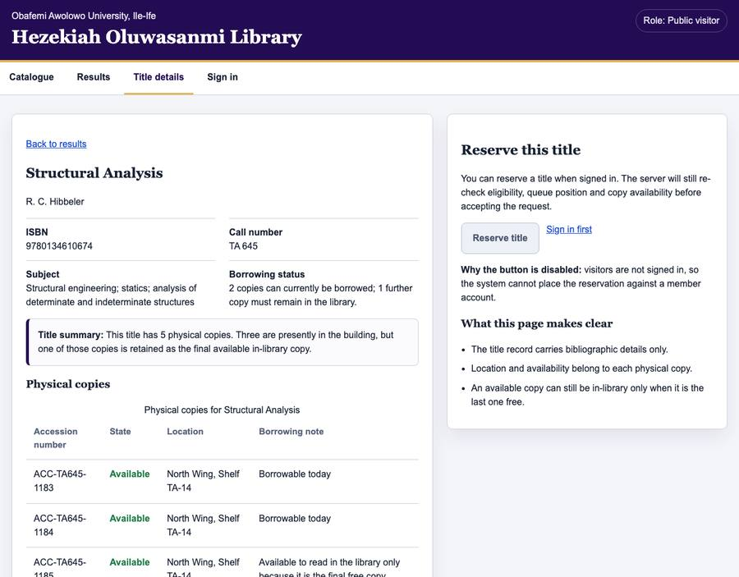
Book detail — layout reference only

Sign in — pages/04-signin.html
- Two fields: matric or staff number (not an email — members are known by SWE/2025/001) and password.
- Submit with api.login(identifier, password). Do not touch sessionStorage yourself.
- If the response says must_change_password, send them to the change-password page and nowhere else. The server refuses every other route until it is changed.
- There is no Create account link. Members are registered at the desk after showing an ID card. Adding one would describe a library we do not have.
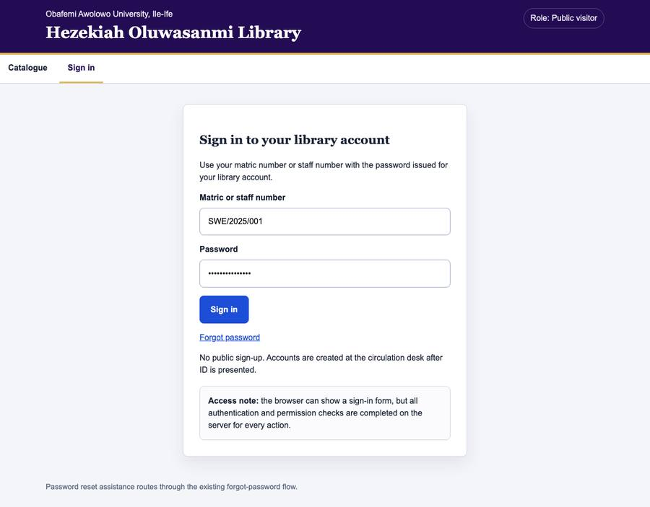
Sign in — layout reference only

Change password — pages/07-change-password.html
- Say at the top that this blocks everything else until it is done.
- Current password, new password, confirm. Check the two match before posting.
- Afterwards every session issued before the change is void, including this one. Say so, and send them back to sign in.
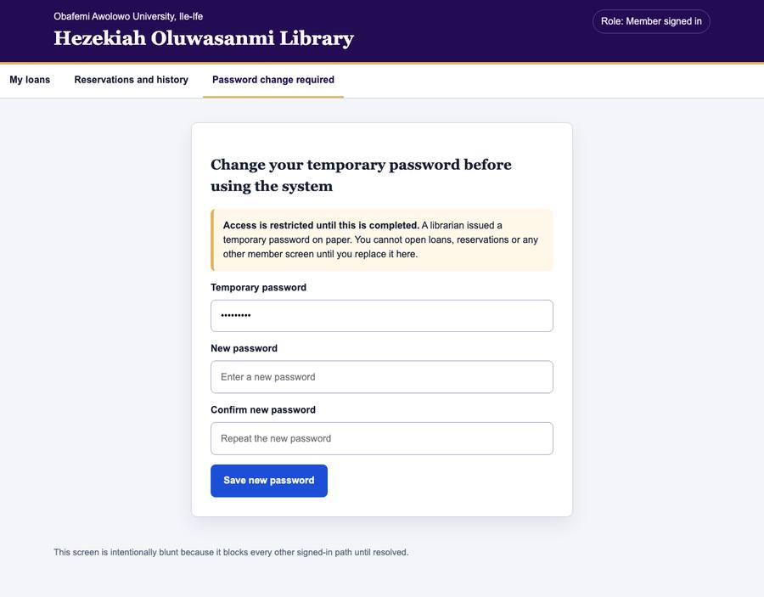
Change password — layout reference only

Developer B — a member's own records
Branch: feature/b-member-records
All three need a signed-in session. If api.isSignedIn() is false, show a short panel inviting them to sign in rather than an empty table or a wall of errors.

My loans — pages/05-my-loans.html
- The title, linked to the book page.
- The accession number of the copy actually held. This matters: a member can hold two copies of one book, and without it the rows are identical.
- The due date through formatDateTime(). Never print a raw timestamp — a reader should never see the letter T or a Z.
- How long is left, from dueState(dueAt). It returns the words and the colour together so they can never disagree.
- There is no overdue field in the API and there must not be one here. Overdue is worked out from the clock every time the page draws, which is why it can never be stale.
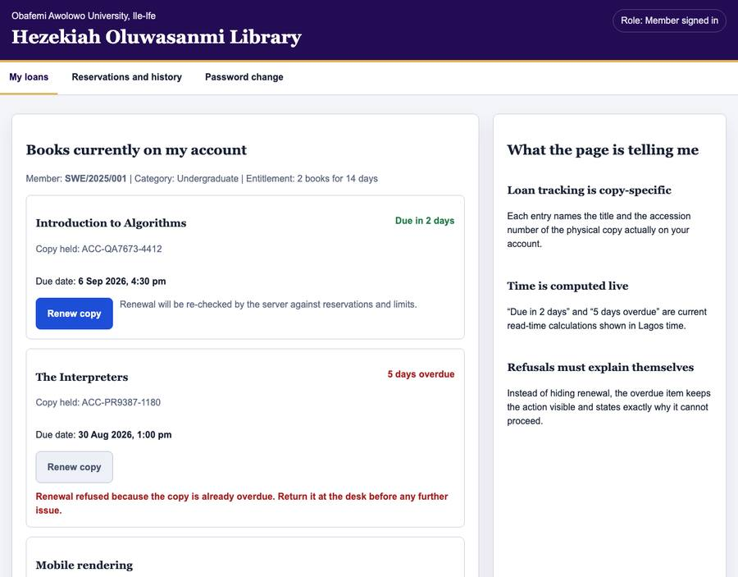
My loans — layout reference only

Reservations — pages/06-reservations.html
- Your position in the queue, in words: “You are 2nd in the queue”, not a bare number in a box.
- If a copy is ready for collection, that is the most important thing on the row and should read like it.
- A cancel button. It cannot be undone, so confirm first, then remove the row and call announce().
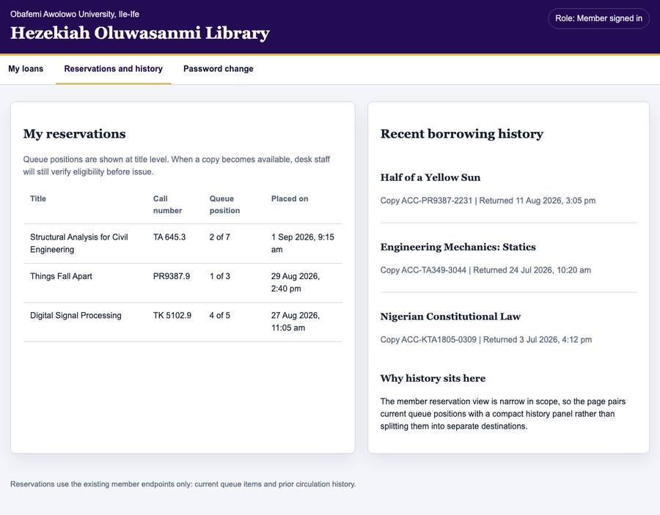
Reservations — layout reference only

Dashboard — pages/11-dashboard.html
- Counts from GET /admin/dashboard: titles, copies, members, open loans, overdue.
- Recent activity from GET /admin/audit, as a table. It must read as English: “Ada Okafor issued HOL/2019/00412 to SWE/2025/001”, not “loan.create”.
- If the reader is not an administrator the server answers 403. Say clearly that the page is for administrators; do not show an empty dashboard.
- Do not invent a statistic the endpoint does not return.
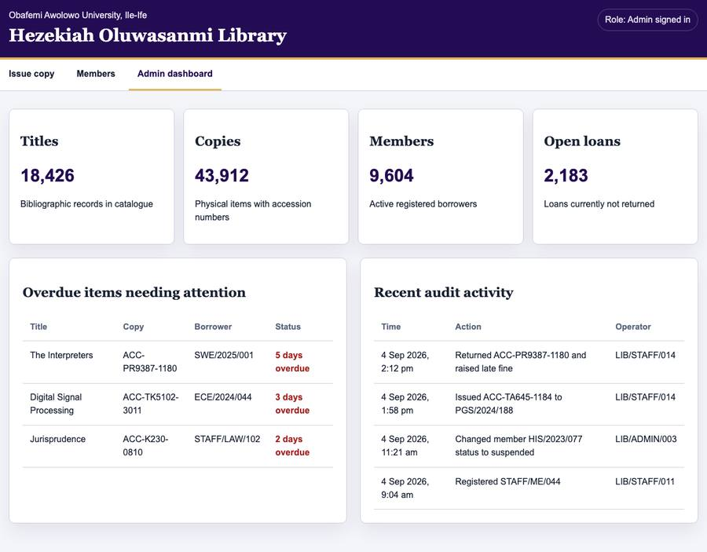
Dashboard — layout reference only

Developer C — the circulation desk
Branch: feature/c-circulation-desk
These are used by staff standing at a counter with somebody waiting. That changes the design: information over decoration, the main action reachable without hunting, nothing that needs a second look.
These are also the screens where the library's rules become visible. When the server refuses something, the refusal is the most useful thing on the page and must explain itself in the server's own words. Never reduce it to “Error”.

Issue a copy — pages/08-desk-issue.html
- Two fields in the order things happen at a desk: accession number of the copy in hand, then the member's matric or staff number.
- Put focus in the accession field on load. A librarian doing this fifty times an hour should never have to click first.
- On success: who now has what, and when it is due. The member is standing there reading it.
- On refusal, show why: at their loan limit, copy already out or reserved, account suspended, or it is the last copy and cannot leave the building.
- Keep the entitlements on screen as a small table — undergraduate 2 books for 14 days, postgraduate 4 for 21, staff 6 for 28 — so a refusal makes sense at a glance.
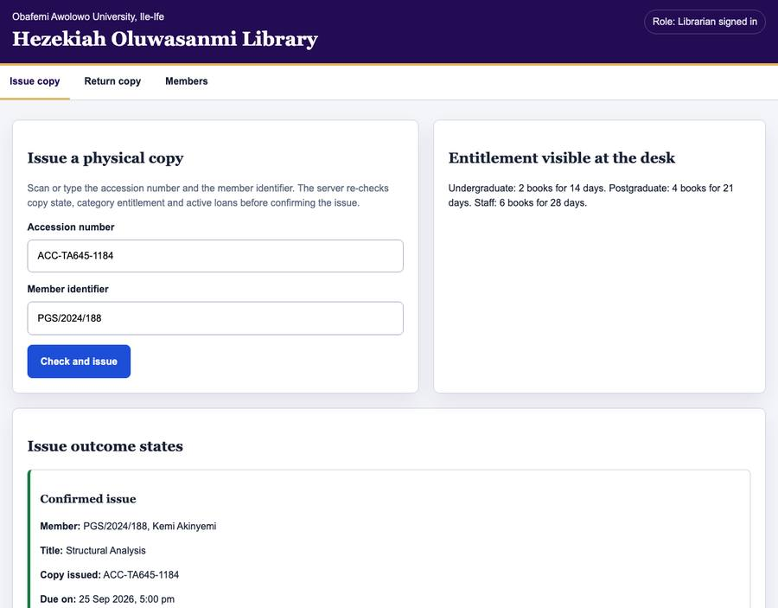
Issue a copy — layout reference only

Receive a return — pages/09-desk-return.html
One field, one button, and a result that answers four questions:
- Which loan closed — the title, and who had it.
- Was it late, and by how long.
- Is there a fine, and how much.
- Is somebody waiting. If a reservation exists the copy goes behind the desk, not back on the shelf, and the librarian has about two seconds to notice. Design that one carefully.
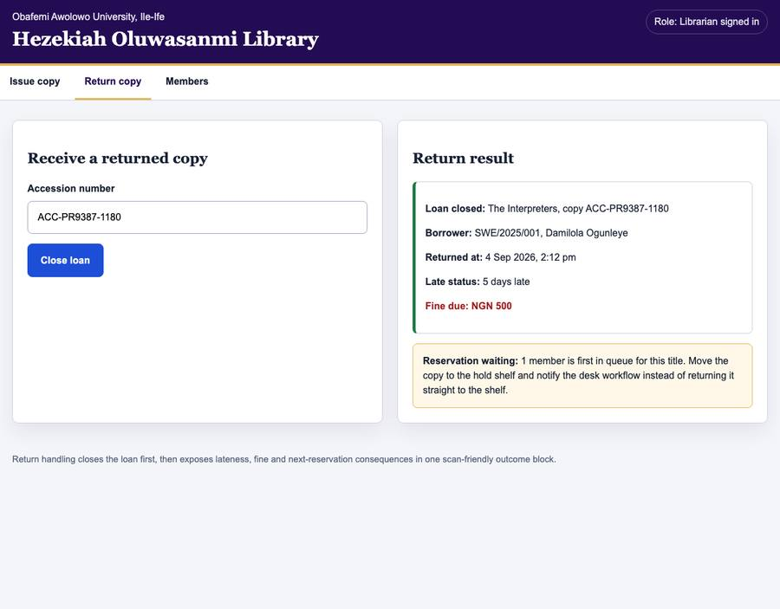
Receive a return — layout reference only

Members — pages/10-members.html
- A list with pagination — copy the pager from index.html, do not write a second one — plus search by name or identifier.
- Columns: name, identifier, category, status, books currently out. A real table with a caption and scope on every header.
- Suspend and restore, via PATCH. Confirm it, and say what it does: the person can no longer sign in or borrow.
- Registration happens at the desk after an ID card is shown. There is no public sign-up anywhere in this system and you must not add one.
- Category is required for members and forbidden for staff. A librarian may create members only; staff accounts need an administrator.
- On success the server issues a temporary password. Show it once, clearly, and say it will not be shown again.
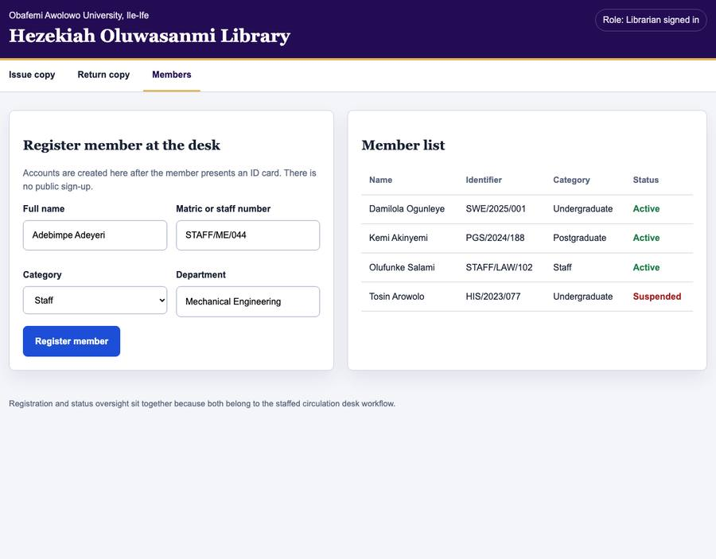
Members — layout reference only

Writing it down
Every decision and every defect goes in .ilana/. This is not ceremony. The report we submit is largely assembled from these files, and at the defence you will be asked why something is the way it is. An answer you wrote at the time is worth more than one you reconstruct in the exam hall.

A decision (DEC)
Whenever you chose between two reasonable options. Not every line of code is a decision; a decision is a fork where a sensible person could have gone the other way.
### DEC-A01 — Copies shown as a table, not as cards
Chose: a <table>, one row per physical copy.
Rejected: a grid of cards.
Why: copies differ only by accession number, status and
shelf. That is tabular data, and a screen reader can
navigate a table by column.
“I did not make any decisions” is never true. It means you have not noticed them yet. Two or three per screen is normal.

A defect (DEF)
Anything that was wrong and is now fixed, including something you found in your own work before anybody else saw it. Those are the most valuable entries in the file, because nobody else could have written them.
### DEF-B03 — Due dates were an hour early
Found: comparing a due date on screen with Swagger.
Cause: toLocaleString() with no timeZone, so it used the
laptop's clock, which was on UTC.
Fix: formatDateTime(), which passes Africa/Lagos.
Severity: Medium — every date was wrong, and wrong quietly.
Number your entries with your own letter — DEC-A01, DEF-B03, DEC-C02 — so three people can write at once without colliding.

Why we bother
The back end recorded 29 defects. No single technique found more than half: twelve came from adversarial review, seven from a checklist, three from the first run against a real database, two from measuring queries, two from a concurrency test, one from a unit test, one from a parse that had never been run, and one from somebody simply looking at a dashboard.
The bug you ship is the one your chosen technique cannot see. So write down how you found each one, not only what it was. That finding is worth more marks than any single screen.

Before you open a pull request
- python3 scripts/check.py passes.
- You copied pages/_template.html and did not change the header or footer.
- aria-current="page" is on your page's menu link and no other.
- Every input has a <label for> matching its id.
- Every <img> has alt text, or alt="" if decorative.
- You tabbed through the whole page and reached every control, with a visible focus ring.
- Nothing is announced by colour alone.
- Data from the API goes in with textContent, not innerHTML.
- Lighthouse accessibility is 95 or better.
- Your DEC and DEF entries are written.
- Desktop and phone screenshots are attached.

Ask early rather than guessing. A question costs five minutes; a screen built on a wrong assumption costs an evening, and we do not have many left.

