**Thermodynamic and transport properties**

# Annex 1: Thermodynamic and transport properties (liquids and gases)

# Annex 2: Thermodynamic and transport properties of gases (JANAF)

**ANNEX 1. Thermodynamic and transport properties[1]**

**Some gases and liquids fuels**[2]**:**

* **Isobutene**, , *, ,*
* **n-Octane**, , , ,
* **n-Decane** (similar characteristics of kerosene), , *,* ,
* **Propane**, , , range: ; .

**Table 1. Thermochemical properties of selected substances at and**

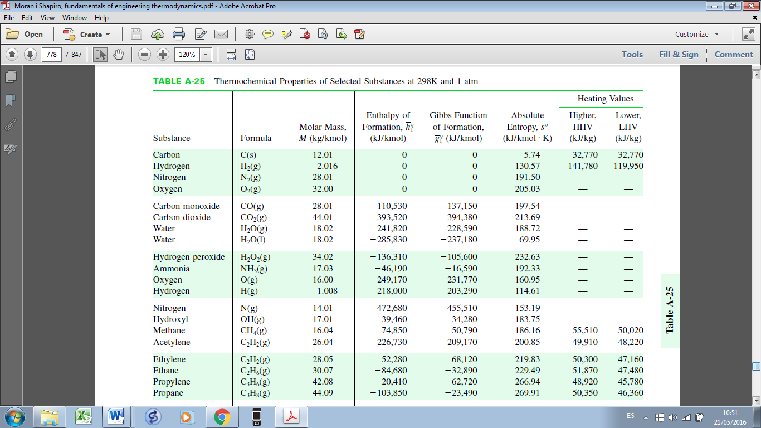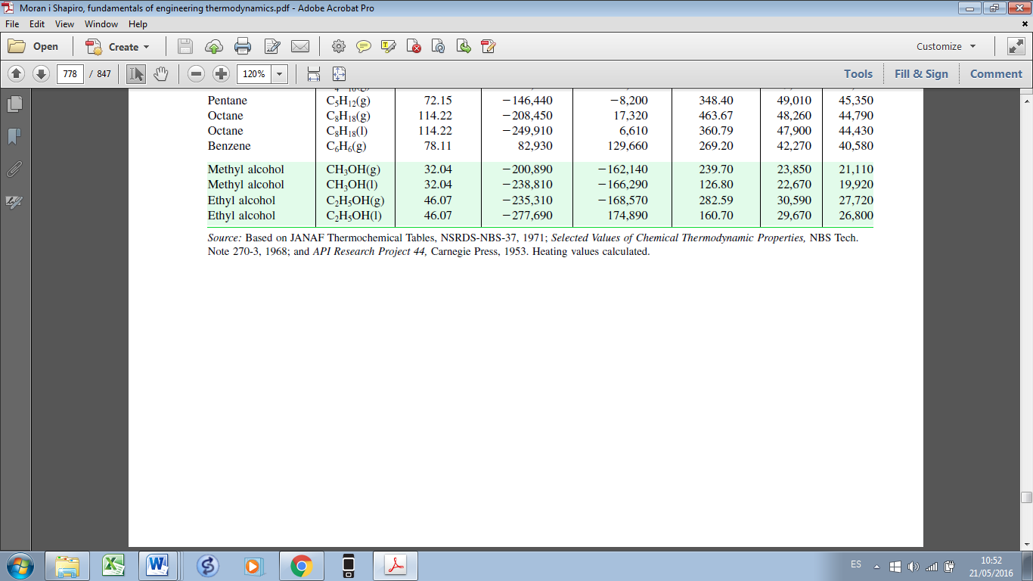

Absolute entropy, (kJ/kmol K)

Gibbs function of formation, (kJ/kmol)

Enthalpy of formation, (kJ/kmol)

Molar mass, (kg/kmol)

**Table 2. Specific heat for selected ideal gases** ( in ; range: )

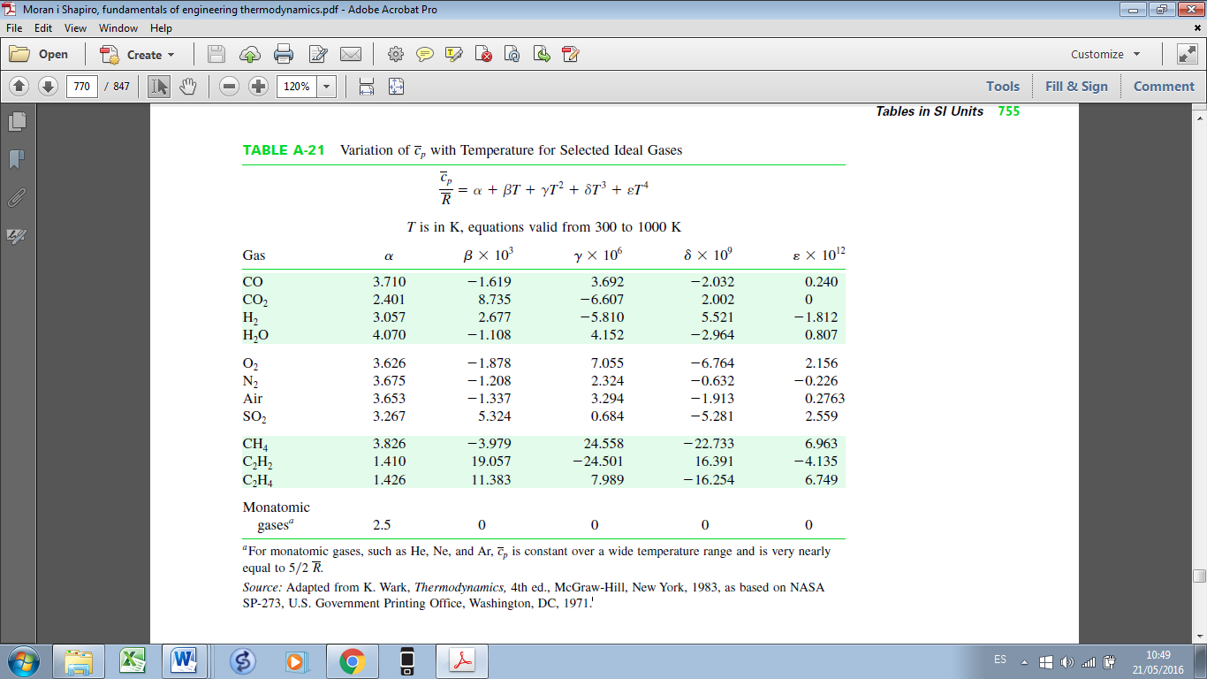

**Table 3. Flammability limits and ignition temperatures of common fuels in fuel/air mixtures**

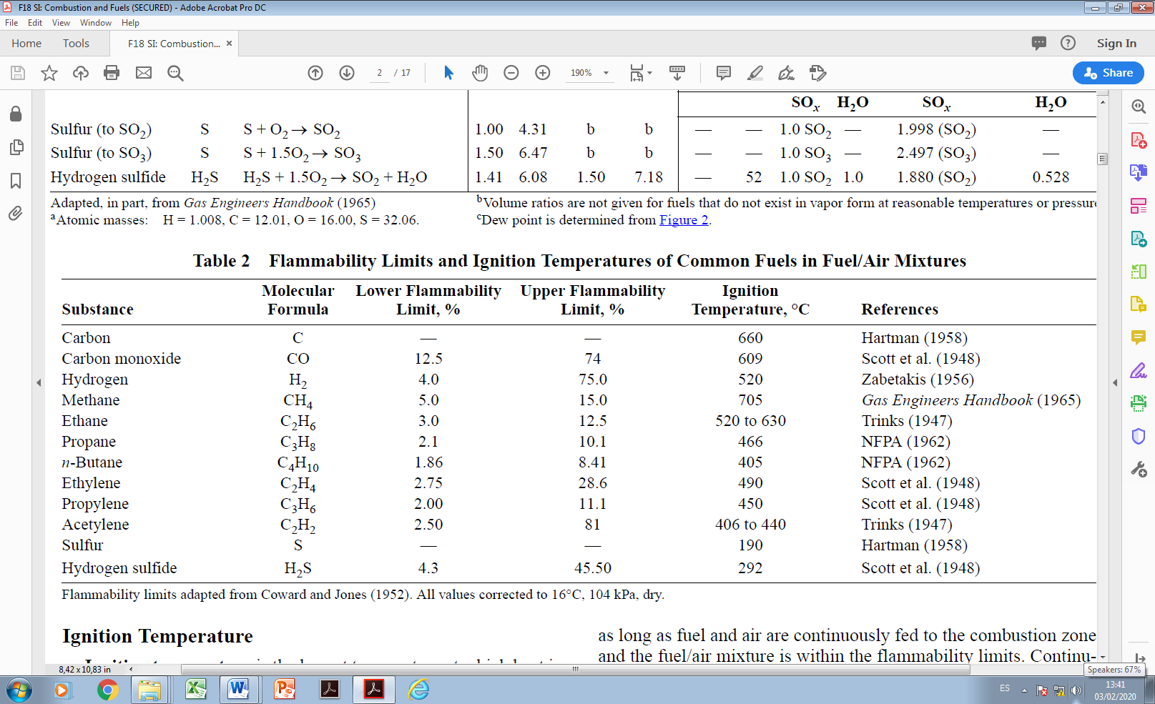

(% by volume of air)

ASHRAE Fundamentals

**Table 4. Equilibrium constant**

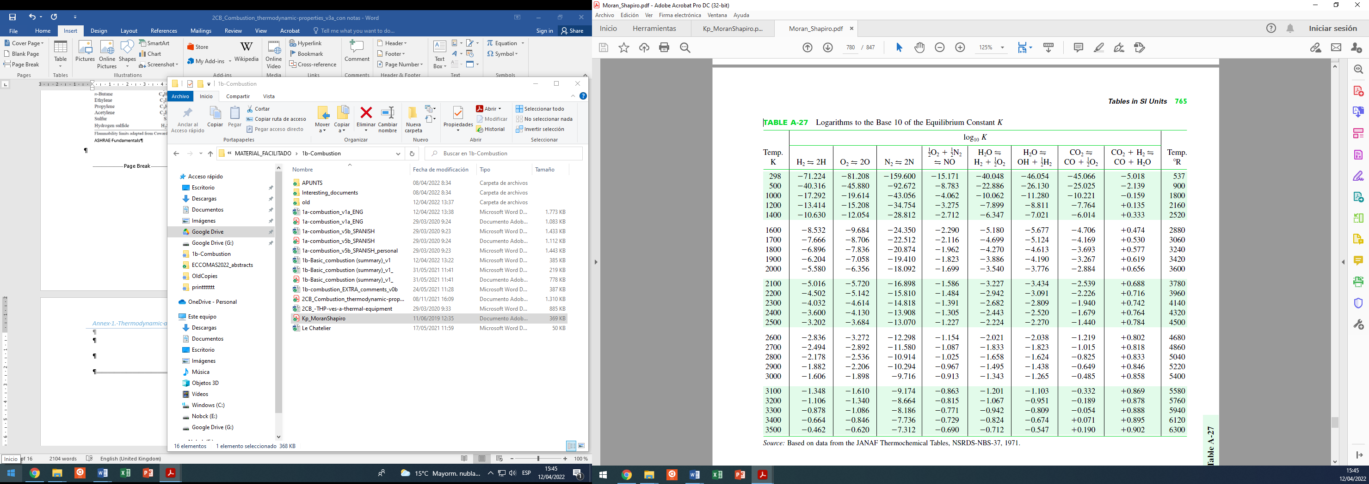

(Table from M.J.Moran and H.N.Shapiro, Fundamentals of Engineering Thermodynamics, John Wiley & Sons, Inc, 5th ed., 2006)

**Annex 2. Thermodynamic and transport properties of gases**

Thermodynamic and transport properties of different gases are given below. Specifically: Argon (Ar), Carbon (C), Methane (CH4), Carbon monoxide (CO), Carbon dioxide (CO2), Hydrogen atom (H), Hydrogen (H2), Water (H2O), Peroxide (H2O2), Hydroperoxyl (HO2), Nitrogen atom (N), Nitrogen (N2), Nitrous oxide (N2O), Nitrogen monoxide (NO), Nitrogen dioxide (NO2), Oxygen atom (O), Oxygen (O2), Hydroxyl (OH), Acetylene (C2H2), n-decane (C10H22).

General equations are given in terms of different coefficients. In all these equations, temperature is given in K. The universal gas constant () and the gas constant () are used in the thermodynamic properties.

**Specific heat at constant pressure:**

**Absolute enthalpy (formation enthalpy is included) at :**

**Absolute entropy at :**

**Dynamic viscosity and thermal conductivity:**

.

**Coefficients for different gases of the polynomial expressions given below for. The coefficients corresponding to the thermodynamic properties (, and ) have been obtained from JANAF**[3]**. Transport properties ( and ) from CHEMKIN**[4]**.**

**List of gases considered:** Argon (Ar), Carbon (C), Methane (CH4), Carbon monoxide (CO), Carbon dioxide (CO2), Hydrogen atom (H), Hydrogen (H2), Water (H2O), Peroxide (H2O2), Hydroperoxyl (HO2), Nitrogen atom (N), Nitrogen (N2), Nitrous oxide (N2O), Nitrogen monoxide (NO), Nitrogen dioxide (NO2), Oxygen atom (O), Oxygen (O2), Hydroxyl (OH), Acetylene (C2H2), n-decane (C10H22).

**AR Argon**

JANAF-CHEMKIN

MW 0.3994800186e+02 (**molecular mass in kg/kmol**)

2

200.0 1000.0 (**temperature range from 200 to 1000** K)

RO GASIDEAL

MU EPOLI3 -0.2133949627e+02 0.3467381630e+01 -0.3746257298e+00 0.1658331947e-01

LAMBDA EPOLI3 -0.1467956128e+02 0.3467381630e+01 -0.3746257298e+00 0.1658331947e-01

CP JANAF_CP 0.2500000000e+01 0.0000000000e+00 0.0000000000e+00 0.0000000000e+00 0.0000000000e+00

H JANAF_H 0.2500000000e+01 0.0000000000e+00 0.0000000000e+00 0.0000000000e+00 0.0000000000e+00 -0.7453750000e+03

S JANAF_S 0.2500000000e+01 0.0000000000e+00 0.0000000000e+00 0.0000000000e+00 0.0000000000e+00 0.4366000000e+01

1000.0 5000.0 (**temperature range from 1000 to 5000 K**)

RO GASIDEAL

MU EPOLI3 -0.2133949627e+02 0.3467381630e+01 -0.3746257298e+00 0.1658331947e-01

LAMBDA EPOLI3 -0.1467956128e+02 0.3467381630e+01 -0.3746257298e+00 0.1658331947e-01

CP JANAF_CP 0.2500000000e+01 0.0000000000e+00 0.0000000000e+00 0.0000000000e+00 0.0000000000e+00

H JANAF_H 0.2500000000e+01 0.0000000000e+00 0.0000000000e+00 0.0000000000e+00 0.0000000000e+00 -0.7453750000e+03

S JANAF_S 0.2500000000e+01 0.0000000000e+00 0.0000000000e+00 0.0000000000e+00 0.0000000000e+00 0.4366000000e+01

#--------------------

**C Carbon**

JANAF-CHEMKIN

MW 0.1201115036e+02

2

200.0 1000.0

RO GASIDEAL

MU EPOLI3 -0.1733304620e+02 0.1706343689e+01 -0.1443632622e+00 0.6539115412e-02

LAMBDA EPOLI3 -0.9471367964e+01 0.1706343689e+01 -0.1443632622e+00 0.6539115412e-02

CP JANAF_CP 0.2554239550e+01 -0.3215377240e-03 0.7337922450e-06 -0.7322348890e-09 0.2665214460e-12

H JANAF_H 0.2554239550e+01 -0.3215377240e-03 0.7337922450e-06 -0.7322348890e-09 0.2665214460e-12 0.8544388320e+05

S JANAF_S 0.2554239550e+01 -0.3215377240e-03 0.7337922450e-06 -0.7322348890e-09 0.2665214460e-12 0.4531308480e+01

1000.0 5000.0

RO GASIDEAL

MU EPOLI3 -0.1733304620e+02 0.1706343689e+01 -0.1443632622e+00 0.6539115412e-02

LAMBDA EPOLI3 -0.9471367964e+01 0.1706343689e+01 -0.1443632622e+00 0.6539115412e-02

CP JANAF_CP 0.2492668880e+01 0.4798892840e-04 -0.7243350200e-07 0.3742910290e-10 -0.4872778930e-14

H JANAF_H 0.2492668880e+01 0.4798892840e-04 -0.7243350200e-07 0.3742910290e-10 -0.4872778930e-14 0.8545129530e+05

S JANAF_S 0.2492668880e+01 0.4798892840e-04 -0.7243350200e-07 0.3742910290e-10 -0.4872778930e-14 0.4801503730e+01

#--------------------

**CH4 Methane**

JANAF-CHEMKIN

MW 0.1604303026e+02

2

200.0 1000.0

RO GASIDEAL

MU EPOLI3 -0.2230715913e+02 0.3569542093e+01 -0.3874920393e+00 0.1712461411e-01

LAMBDA EPOLI3 0.1793259165e+01 -0.4960294457e+01 0.1032808843e+01 -0.5633567903e-01

CP JANAF_CP 0.5149876130e+01 -0.1367097880e-01 0.4918005990e-04 -0.4847430260e-07 0.1666939560e-10

H JANAF_H 0.5149876130e+01 -0.1367097880e-01 0.4918005990e-04 -0.4847430260e-07 0.1666939560e-10 -0.1024664760e+05

S JANAF_S 0.5149876130e+01 -0.1367097880e-01 0.4918005990e-04 -0.4847430260e-07 0.1666939560e-10 -0.4641303760e+01

1000.0 5000.0

RO GASIDEAL

MU EPOLI3 -0.2230715913e+02 0.3569542093e+01 -0.3874920393e+00 0.1712461411e-01

LAMBDA EPOLI3 0.1793259165e+01 -0.4960294457e+01 0.1032808843e+01 -0.5633567903e-01

CP JANAF_CP 0.7485149500e-01 0.1339094670e-01 -0.5732858090e-05 0.1222925350e-08 -0.1018152300e-12

H JANAF_H 0.7485149500e-01 0.1339094670e-01 -0.5732858090e-05 0.1222925350e-08 -0.1018152300e-12 -0.9468344590e+04

S JANAF_S 0.7485149500e-01 0.1339094670e-01 -0.5732858090e-05 0.1222925350e-08 -0.1018152300e-12 0.1843731800e+02

#--------------------

**CO Carbon monoxide**

JANAF-CHEMKIN

MW 0.2801055050e+02

2

200.0 1000.0

RO GASIDEAL

MU EPOLI3 -0.1891819775e+02 0.2400975158e+01 -0.2357717790e+00 0.1054820948e-01

LAMBDA EPOLI3 0.3641755785e+00 -0.3154801253e+01 0.6020483455e+00 -0.3032714733e-01

CP JANAF_CP 0.3579533470e+01 -0.6103536800e-03 0.1016814330e-05 0.9070058840e-09 -0.9044244990e-12

H JANAF_H 0.3579533470e+01 -0.6103536800e-03 0.1016814330e-05 0.9070058840e-09 -0.9044244990e-12 -0.1434408600e+05

S JANAF_S 0.3579533470e+01 -0.6103536800e-03 0.1016814330e-05 0.9070058840e-09 -0.9044244990e-12 0.3508409280e+01

1000.0 5000.0

RO GASIDEAL

MU EPOLI3 -0.1891819775e+02 0.2400975158e+01 -0.2357717790e+00 0.1054820948e-01

LAMBDA EPOLI3 0.3641755785e+00 -0.3154801253e+01 0.6020483455e+00 -0.3032714733e-01

CP JANAF_CP 0.2715185610e+01 0.2062527430e-02 -0.9988257710e-06 0.2300530080e-09 -0.2036477160e-13

H JANAF_H 0.2715185610e+01 0.2062527430e-02 -0.9988257710e-06 0.2300530080e-09 -0.2036477160e-13 -0.1415187240e+05

S JANAF_S 0.2715185610e+01 0.2062527430e-02 -0.9988257710e-06 0.2300530080e-09 -0.2036477160e-13 0.7818687720e+01

#--------------------

**CO2 Carbon dioxide**

JANAF-CHEMKIN

MW 0.4400995064e+02

2

200.0 1000.0

RO GASIDEAL

MU EPOLI3 -0.2627315808e+02 0.5130426196e+01 -0.5724284704e+00 0.2440888722e-01

LAMBDA EPOLI3 -0.2286363338e+02 0.5875667874e+01 -0.5677982250e+00 0.2031670239e-01

CP JANAF_CP 0.2356773520e+01 0.8984596770e-02 -0.7123562690e-05 0.2459190220e-08 -0.1436995480e-12

H JANAF_H 0.2356773520e+01 0.8984596770e-02 -0.7123562690e-05 0.2459190220e-08 -0.1436995480e-12 -0.4837196970e+05

S JANAF_S 0.2356773520e+01 0.8984596770e-02 -0.7123562690e-05 0.2459190220e-08 -0.1436995480e-12 0.9901052220e+01

1000.0 5000.0

RO GASIDEAL

MU EPOLI3 -0.2627315808e+02 0.5130426196e+01 -0.5724284704e+00 0.2440888722e-01

LAMBDA EPOLI3 -0.2286363338e+02 0.5875667874e+01 -0.5677982250e+00 0.2031670239e-01

CP JANAF_CP 0.3857460290e+01 0.4414370260e-02 -0.2214814040e-05 0.5234901880e-09 -0.4720841640e-13

H JANAF_H 0.3857460290e+01 0.4414370260e-02 -0.2214814040e-05 0.5234901880e-09 -0.4720841640e-13 -0.4875916600e+05

S JANAF_S 0.3857460290e+01 0.4414370260e-02 -0.2214814040e-05 0.5234901880e-09 -0.4720841640e-13 0.2271638060e+01

#--------------------

**H Hydrogen atom**

JANAF-CHEMKIN

MW 0.1007969975e+01

2

200.0 1000.0

RO GASIDEAL

MU EPOLI3 -0.2270792854e+02 0.3652691486e+01 -0.3980303021e+00 0.1757072886e-01

LAMBDA EPOLI3 -0.1236835327e+02 0.3652691486e+01 -0.3980303021e+00 0.1757072886e-01

CP JANAF_CP 0.2500000000e+01 0.7053328190e-12 -0.1995919640e-14 0.2300816320e-17 -0.9277323320e-21

H JANAF_H 0.2500000000e+01 0.7053328190e-12 -0.1995919640e-14 0.2300816320e-17 -0.9277323320e-21 0.2547365990e+05

S JANAF_S 0.2500000000e+01 0.7053328190e-12 -0.1995919640e-14 0.2300816320e-17 -0.9277323320e-21 -0.4466828530e+00

1000.0 5000.0

RO GASIDEAL

MU EPOLI3 -0.2270792854e+02 0.3652691486e+01 -0.3980303021e+00 0.1757072886e-01

LAMBDA EPOLI3 -0.1236835327e+02 0.3652691486e+01 -0.3980303021e+00 0.1757072886e-01

CP JANAF_CP 0.2500000010e+01 -0.2308429730e-10 0.1615619480e-13 -0.4735152350e-17 0.4981973570e-21

H JANAF_H 0.2500000010e+01 -0.2308429730e-10 0.1615619480e-13 -0.4735152350e-17 0.4981973570e-21 0.2547365990e+05

S JANAF_S 0.2500000010e+01 -0.2308429730e-10 0.1615619480e-13 -0.4735152350e-17 0.4981973570e-21 -0.4466829140e+00

#--------------------

**H2 Hydrogen**

JANAF-CHEMKIN

MW 0.2015939951e+01

2

200.0 1000.0

RO GASIDEAL

MU EPOLI3 -0.1614293964e+02 0.1003491326e+01 -0.5016044555e-01 0.2330995224e-02

LAMBDA EPOLI3 -0.2277096638e+01 -0.4674267764e+00 0.1156734789e+00 -0.2596025563e-02

CP JANAF_CP 0.2344331120e+01 0.7980520750e-02 -0.1947815100e-04 0.2015720940e-07 -0.7376117610e-11

H JANAF_H 0.2344331120e+01 0.7980520750e-02 -0.1947815100e-04 0.2015720940e-07 -0.7376117610e-11 -0.9179351730e+03

S JANAF_S 0.2344331120e+01 0.7980520750e-02 -0.1947815100e-04 0.2015720940e-07 -0.7376117610e-11 0.6830102380e+00

1000.0 5000.0

RO GASIDEAL

MU EPOLI3 -0.1614293964e+02 0.1003491326e+01 -0.5016044555e-01 0.2330995224e-02

LAMBDA EPOLI3 -0.2277096638e+01 -0.4674267764e+00 0.1156734789e+00 -0.2596025563e-02

CP JANAF_CP 0.3337279200e+01 -0.4940247310e-04 0.4994567780e-06 -0.1795663940e-09 0.2002553760e-13

H JANAF_H 0.3337279200e+01 -0.4940247310e-04 0.4994567780e-06 -0.1795663940e-09 0.2002553760e-13 -0.9501589220e+03

S JANAF_S 0.3337279200e+01 -0.4940247310e-04 0.4994567780e-06 -0.1795663940e-09 0.2002553760e-13 -0.3205023310e+01

#--------------------

**H2O Water**

JANAF-CHEMKIN

MW 0.1801534009e+02

2

200.0 1000.0

RO GASIDEAL

MU EPOLI3 -0.1286013492e+02 -0.1377850379e+01 0.4213981638e+00 -0.2414423056e-01

LAMBDA EPOLI3 0.1185254026e+02 -0.8965822807e+01 0.1528828068e+01 -0.7590175979e-01

CP JANAF_CP 0.4198640560e+01 -0.2036434100e-02 0.6520402110e-05 -0.5487970620e-08 0.1771978170e-11

H JANAF_H 0.4198640560e+01 -0.2036434100e-02 0.6520402110e-05 -0.5487970620e-08 0.1771978170e-11 -0.3029372670e+05

S JANAF_S 0.4198640560e+01 -0.2036434100e-02 0.6520402110e-05 -0.5487970620e-08 0.1771978170e-11 -0.8490322080e+00

1000.0 5000.0

RO GASIDEAL

MU EPOLI3 -0.1286013492e+02 -0.1377850379e+01 0.4213981638e+00 -0.2414423056e-01

LAMBDA EPOLI3 0.1185254026e+02 -0.8965822807e+01 0.1528828068e+01 -0.7590175979e-01

CP JANAF_CP 0.3033992490e+01 0.2176918040e-02 -0.1640725180e-06 -0.9704198700e-10 0.1682009920e-13

H JANAF_H 0.3033992490e+01 0.2176918040e-02 -0.1640725180e-06 -0.9704198700e-10 0.1682009920e-13 -0.3000429710e+05

S JANAF_S 0.3033992490e+01 0.2176918040e-02 -0.1640725180e-06 -0.9704198700e-10 0.1682009920e-13 0.4966770100e+01

#--------------------

**H2O2 Peroxide**

JANAF-CHEMKIN

MW 0.3401474023e+02

2

200.0 1000.0

RO GASIDEAL

MU EPOLI3 -0.1943012788e+02 0.2678088349e+01 -0.2721592408e+00 0.1214173233e-01

LAMBDA EPOLI3 -0.1063014819e+02 0.1315528335e+01 0.1916184484e-01 -0.4416817199e-02

CP JANAF_CP 0.4276112690e+01 -0.5428224170e-03 0.1673357010e-04 -0.2157708130e-07 0.8624543630e-11

H JANAF_H 0.4276112690e+01 -0.5428224170e-03 0.1673357010e-04 -0.2157708130e-07 0.8624543630e-11 -0.1770258210e+05

S JANAF_S 0.4276112690e+01 -0.5428224170e-03 0.1673357010e-04 -0.2157708130e-07 0.8624543630e-11 0.3435050740e+01

1000.0 5000.0

RO GASIDEAL

MU EPOLI3 -0.1943012788e+02 0.2678088349e+01 -0.2721592408e+00 0.1214173233e-01

LAMBDA EPOLI3 -0.1063014819e+02 0.1315528335e+01 0.1916184484e-01 -0.4416817199e-02

CP JANAF_CP 0.4165002850e+01 0.4908316940e-02 -0.1901392250e-05 0.3711859860e-09 -0.2879083050e-13

H JANAF_H 0.4165002850e+01 0.4908316940e-02 -0.1901392250e-05 0.3711859860e-09 -0.2879083050e-13 -0.1786178770e+05

S JANAF_S 0.4165002850e+01 0.4908316940e-02 -0.1901392250e-05 0.3711859860e-09 -0.2879083050e-13 0.2916156620e+01

#--------------------

**HO2 Hydroperoxyl**

JANAF-CHEMKIN

MW 0.3300677025e+02

2

200.0 1000.0

RO GASIDEAL

MU EPOLI3 -0.1944516852e+02 0.2678088349e+01 -0.2721592408e+00 0.1214173233e-01

LAMBDA EPOLI3 -0.1264302144e+02 0.2340066563e+01 -0.1632055933e+00 0.5799980518e-02

CP JANAF_CP 0.4301798010e+01 -0.4749120510e-02 0.2115828910e-04 -0.2427638940e-07 0.9292251240e-11

H JANAF_H 0.4301798010e+01 -0.4749120510e-02 0.2115828910e-04 -0.2427638940e-07 0.9292251240e-11 0.2948080400e+03

S JANAF_S 0.4301798010e+01 -0.4749120510e-02 0.2115828910e-04 -0.2427638940e-07 0.9292251240e-11 0.3716662450e+01

1000.0 5000.0

RO GASIDEAL

MU EPOLI3 -0.1944516852e+02 0.2678088349e+01 -0.2721592408e+00 0.1214173233e-01

LAMBDA EPOLI3 -0.1264302144e+02 0.2340066563e+01 -0.1632055933e+00 0.5799980518e-02

CP JANAF_CP 0.4017210900e+01 0.2239820130e-02 -0.6336581500e-06 0.1142463700e-09 -0.1079085350e-13

H JANAF_H 0.4017210900e+01 0.2239820130e-02 -0.6336581500e-06 0.1142463700e-09 -0.1079085350e-13 0.1118567130e+03

S JANAF_S 0.4017210900e+01 0.2239820130e-02 -0.6336581500e-06 0.1142463700e-09 -0.1079085350e-13 0.3785102150e+01

#--------------------

**N Nitrogen atom**

JANAF-CHEMKIN

MW 0.1400669956e+02

2

200.0 1000.0

RO GASIDEAL

MU EPOLI3 -0.1725619603e+02 0.1706343689e+01 -0.1443632622e+00 0.6539115412e-02

LAMBDA EPOLI3 -0.9548218134e+01 0.1706343689e+01 -0.1443632622e+00 0.6539115412e-02

CP JANAF_CP 0.2500000000e+01 0.0000000000e+00 0.0000000000e+00 0.0000000000e+00 0.0000000000e+00

H JANAF_H 0.2500000000e+01 0.0000000000e+00 0.0000000000e+00 0.0000000000e+00 0.0000000000e+00 0.5610463700e+05

S JANAF_S 0.2500000000e+01 0.0000000000e+00 0.0000000000e+00 0.0000000000e+00 0.0000000000e+00 0.4193908700e+01

1000.0 5000.0

RO GASIDEAL

MU EPOLI3 -0.1725619603e+02 0.1706343689e+01 -0.1443632622e+00 0.6539115412e-02

LAMBDA EPOLI3 -0.9548218134e+01 0.1706343689e+01 -0.1443632622e+00 0.6539115412e-02

CP JANAF_CP 0.2415942900e+01 0.1748906500e-03 -0.1190236900e-06 0.3022624500e-10 -0.2036098200e-14

H JANAF_H 0.2415942900e+01 0.1748906500e-03 -0.1190236900e-06 0.3022624500e-10 -0.2036098200e-14 0.5613377300e+05

S JANAF_S 0.2415942900e+01 0.1748906500e-03 -0.1190236900e-06 0.3022624500e-10 -0.2036098200e-14 0.4649609600e+01

#--------------------

**N2 Nitrogen**

JANAF-CHEMKIN

MW 0.2801339912e+02

2

200.0 1000.0

RO GASIDEAL

MU EPOLI3 -0.1886822179e+02 0.2388167036e+01 -0.2341208183e+00 0.1047727173e-01

LAMBDA EPOLI3 0.1417117599e+01 -0.3528374680e+01 0.6455829015e+00 -0.3194413600e-01

CP JANAF_CP 0.3298677000e+01 0.1408240400e-02 -0.3963222000e-05 0.5641515000e-08 -0.2444854000e-11

H JANAF_H 0.3298677000e+01 0.1408240400e-02 -0.3963222000e-05 0.5641515000e-08 -0.2444854000e-11 -0.1020899900e+04

S JANAF_S 0.3298677000e+01 0.1408240400e-02 -0.3963222000e-05 0.5641515000e-08 -0.2444854000e-11 0.3950372000e+01

1000.0 5000.0

RO GASIDEAL

MU EPOLI3 -0.1886822179e+02 0.2388167036e+01 -0.2341208183e+00 0.1047727173e-01

LAMBDA EPOLI3 0.1417117599e+01 -0.3528374680e+01 0.6455829015e+00 -0.3194413600e-01

CP JANAF_CP 0.2926640000e+01 0.1487976800e-02 -0.5684760000e-06 0.1009703800e-09 -0.6753351000e-14

H JANAF_H 0.2926640000e+01 0.1487976800e-02 -0.5684760000e-06 0.1009703800e-09 -0.6753351000e-14 -0.9227977000e+03

S JANAF_S 0.2926640000e+01 0.1487976800e-02 -0.5684760000e-06 0.1009703800e-09 -0.6753351000e-14 0.5980528000e+01

#--------------------

**N2O ---**

JANAF-CHEMKIN

MW 0.4401279926e+02

2

200.0 1000.0

RO GASIDEAL

MU EPOLI3 -0.2607150910e+02 0.5067455296e+01 -0.5674645603e+00 0.2432611681e-01

LAMBDA EPOLI3 -0.2297207455e+02 0.6034436002e+01 -0.6061276742e+00 0.2281390045e-01

CP JANAF_CP 0.2257150200e+01 0.1130472800e-01 -0.1367131900e-04 0.9681980600e-08 -0.2930718200e-11

H JANAF_H 0.2257150200e+01 0.1130472800e-01 -0.1367131900e-04 0.9681980600e-08 -0.2930718200e-11 0.8741774400e+04

S JANAF_S 0.2257150200e+01 0.1130472800e-01 -0.1367131900e-04 0.9681980600e-08 -0.2930718200e-11 0.1075799200e+02

1000.0 5000.0

RO GASIDEAL

MU EPOLI3 -0.2607150910e+02 0.5067455296e+01 -0.5674645603e+00 0.2432611681e-01

LAMBDA EPOLI3 -0.2297207455e+02 0.6034436002e+01 -0.6061276742e+00 0.2281390045e-01

CP JANAF_CP 0.4823072900e+01 0.2627025100e-02 -0.9585087400e-06 0.1600071200e-09 -0.9775230300e-14

H JANAF_H 0.4823072900e+01 0.2627025100e-02 -0.9585087400e-06 0.1600071200e-09 -0.9775230300e-14 0.8073404800e+04

S JANAF_S 0.4823072900e+01 0.2627025100e-02 -0.9585087400e-06 0.1600071200e-09 -0.9775230300e-14 -0.2201720700e+01

#--------------------

**NO Nitrogen monoxide**

JANAF-CHEMKIN

MW 0.3000609970e+02

2

200.0 1000.0

RO GASIDEAL

MU EPOLI3 -0.1883386291e+02 0.2388167036e+01 -0.2341208183e+00 0.1047727173e-01

LAMBDA EPOLI3 -0.1947028576e+01 -0.2131168801e+01 0.4544282044e+00 -0.2335117715e-01

CP JANAF_CP 0.4218476300e+01 -0.4638976000e-02 0.1104102200e-04 -0.9336135400e-08 0.2803577000e-11

H JANAF_H 0.4218476300e+01 -0.4638976000e-02 0.1104102200e-04 -0.9336135400e-08 0.2803577000e-11 0.9844623000e+04

S JANAF_S 0.4218476300e+01 -0.4638976000e-02 0.1104102200e-04 -0.9336135400e-08 0.2803577000e-11 0.2280846400e+01

1000.0 5000.0

RO GASIDEAL

MU EPOLI3 -0.1883386291e+02 0.2388167036e+01 -0.2341208183e+00 0.1047727173e-01

LAMBDA EPOLI3 -0.1947028576e+01 -0.2131168801e+01 0.4544282044e+00 -0.2335117715e-01

CP JANAF_CP 0.3260605600e+01 0.1191104300e-02 -0.4291704800e-06 0.6945766900e-10 -0.4033609900e-14

H JANAF_H 0.3260605600e+01 0.1191104300e-02 -0.4291704800e-06 0.6945766900e-10 -0.4033609900e-14 0.9920974600e+04

S JANAF_S 0.3260605600e+01 0.1191104300e-02 -0.4291704800e-06 0.6945766900e-10 -0.4033609900e-14 0.6369302700e+01

#--------------------

**NO2 Nitrogen dioxide**

JANAF-CHEMKIN

MW 0.4600549984e+02

2

200.0 1000.0

RO GASIDEAL

MU EPOLI3 -0.2468321217e+02 0.4668511699e+01 -0.5223152219e+00 0.2264144496e-01

LAMBDA EPOLI3 -0.2541446897e+02 0.7263546623e+01 -0.7968863012e+00 0.3249189251e-01

CP JANAF_CP 0.3944031200e+01 -0.1585429000e-02 0.1665781200e-04 -0.2047542600e-07 0.7835056400e-11

H JANAF_H 0.3944031200e+01 -0.1585429000e-02 0.1665781200e-04 -0.2047542600e-07 0.7835056400e-11 0.2896617900e+04

S JANAF_S 0.3944031200e+01 -0.1585429000e-02 0.1665781200e-04 -0.2047542600e-07 0.7835056400e-11 0.6311991700e+01

1000.0 5000.0

RO GASIDEAL

MU EPOLI3 -0.2468321217e+02 0.4668511699e+01 -0.5223152219e+00 0.2264144496e-01

LAMBDA EPOLI3 -0.2541446897e+02 0.7263546623e+01 -0.7968863012e+00 0.3249189251e-01

CP JANAF_CP 0.4884754200e+01 0.2172395600e-02 -0.8280690600e-06 0.1574751000e-09 -0.1051089500e-13

H JANAF_H 0.4884754200e+01 0.2172395600e-02 -0.8280690600e-06 0.1574751000e-09 -0.1051089500e-13 0.2316498300e+04

S JANAF_S 0.4884754200e+01 0.2172395600e-02 -0.8280690600e-06 0.1574751000e-09 -0.1051089500e-13 -0.1174169500e+00

#--------------------

**O Oxygen atom**

JANAF-CHEMKIN

MW 0.1599940014e+02

2

200.0 1000.0

RO GASIDEAL

MU EPOLI3 -0.1740286218e+02 0.1929024678e+01 -0.1738657445e+00 0.7841476915e-02

LAMBDA EPOLI3 -0.9827899765e+01 0.1929024678e+01 -0.1738657445e+00 0.7841476915e-02

CP JANAF_CP 0.3168267100e+01 -0.3279318840e-02 0.6643063960e-05 -0.6128066240e-08 0.2112659710e-11

H JANAF_H 0.3168267100e+01 -0.3279318840e-02 0.6643063960e-05 -0.6128066240e-08 0.2112659710e-11 0.2912225920e+05

S JANAF_S 0.3168267100e+01 -0.3279318840e-02 0.6643063960e-05 -0.6128066240e-08 0.2112659710e-11 0.2051933460e+01

1000.0 5000.0

RO GASIDEAL

MU EPOLI3 -0.1740286218e+02 0.1929024678e+01 -0.1738657445e+00 0.7841476915e-02

LAMBDA EPOLI3 -0.9827899765e+01 0.1929024678e+01 -0.1738657445e+00 0.7841476915e-02

CP JANAF_CP 0.2569420780e+01 -0.8597411370e-04 0.4194845890e-07 -0.1001777990e-10 0.1228336910e-14

H JANAF_H 0.2569420780e+01 -0.8597411370e-04 0.4194845890e-07 -0.1001777990e-10 0.1228336910e-14 0.2921757910e+05

S JANAF_S 0.2569420780e+01 -0.8597411370e-04 0.4194845890e-07 -0.1001777990e-10 0.1228336910e-14 0.4784338640e+01

#--------------------

**O2 Oxygen**

JANAF-CHEMKIN

MW 0.3199880028e+02

2

200.0 1000.0

RO GASIDEAL

MU EPOLI3 -0.1946067566e+02 0.2678088349e+01 -0.2721592408e+00 0.1214173233e-01

LAMBDA EPOLI3 -0.1344962361e+02 0.2890477542e+01 -0.2709591162e+00 0.1152570281e-01

CP JANAF_CP 0.3782456360e+01 -0.2996734160e-02 0.9847302010e-05 -0.9681295090e-08 0.3243728370e-11

H JANAF_H 0.3782456360e+01 -0.2996734160e-02 0.9847302010e-05 -0.9681295090e-08 0.3243728370e-11 -0.1063943560e+04

S JANAF_S 0.3782456360e+01 -0.2996734160e-02 0.9847302010e-05 -0.9681295090e-08 0.3243728370e-11 0.3657675730e+01

1000.0 5000.0

RO GASIDEAL

MU EPOLI3 -0.1946067566e+02 0.2678088349e+01 -0.2721592408e+00 0.1214173233e-01

LAMBDA EPOLI3 -0.1344962361e+02 0.2890477542e+01 -0.2709591162e+00 0.1152570281e-01

CP JANAF_CP 0.3282537840e+01 0.1483087540e-02 -0.7579666690e-06 0.2094705550e-09 -0.2167177940e-13

H JANAF_H 0.3282537840e+01 0.1483087540e-02 -0.7579666690e-06 0.2094705550e-09 -0.2167177940e-13 -0.1088457720e+04

S JANAF_S 0.3282537840e+01 0.1483087540e-02 -0.7579666690e-06 0.2094705550e-09 -0.2167177940e-13 0.5453231290e+01

#--------------------

**OH Hydroxil**

JANAF-CHEMKIN

MW 0.1700737011e+02

2

200.0 1000.0

RO GASIDEAL

MU EPOLI3 -0.1737231441e+02 0.1929024678e+01 -0.1738657445e+00 0.7841476915e-02

LAMBDA EPOLI3 0.2649305782e+01 -0.3244626711e+01 0.5336588173e+00 -0.2328116832e-01

CP JANAF_CP 0.3992015430e+01 -0.2401317520e-02 0.4617938410e-05 -0.3881133330e-08 0.1364114700e-11

H JANAF_H 0.3992015430e+01 -0.2401317520e-02 0.4617938410e-05 -0.3881133330e-08 0.1364114700e-11 0.3615080560e+04

S JANAF_S 0.3992015430e+01 -0.2401317520e-02 0.4617938410e-05 -0.3881133330e-08 0.1364114700e-11 -0.1039254580e+00

1000.0 5000.0

RO GASIDEAL

MU EPOLI3 -0.1737231441e+02 0.1929024678e+01 -0.1738657445e+00 0.7841476915e-02

LAMBDA EPOLI3 0.2649305782e+01 -0.3244626711e+01 0.5336588173e+00 -0.2328116832e-01

CP JANAF_CP 0.3092887670e+01 0.5484297160e-03 0.1265052280e-06 -0.8794615560e-10 0.1174123760e-13

H JANAF_H 0.3092887670e+01 0.5484297160e-03 0.1265052280e-06 -0.8794615560e-10 0.1174123760e-13 0.3858657000e+04

S JANAF_S 0.3092887670e+01 0.5484297160e-03 0.1265052280e-06 -0.8794615560e-10 0.1174123760e-13 0.4476696100e+01

#--------------------

**C2H2 Acetylene**

JANAF-CHEMKIN

MW 0.2603824067e+02

2

200.0 1000.0

RO GASIDEAL

MU EPOLI3 -0.2563911990e+02 0.4790351552e+01 -0.5364560276e+00 0.2318560947e-01

LAMBDA EPOLI3 -0.1920397367e+02 0.4564166690e+01 -0.4040787948e+00 0.1405248078e-01

CP JANAF_CP 0.8086810940e+00 0.2336156290e-01 -0.3551718150e-04 0.2801524370e-07 -0.8500729740e-11

H JANAF_H 0.8086810940e+00 0.2336156290e-01 -0.3551718150e-04 0.2801524370e-07 -0.8500729740e-11 0.2642898070e+05

S JANAF_S 0.8086810940e+00 0.2336156290e-01 -0.3551718150e-04 0.2801524370e-07 -0.8500729740e-11 0.1393970510e+02

1000.0 5000.0

RO GASIDEAL

MU EPOLI3 -0.2563911990e+02 0.4790351552e+01 -0.5364560276e+00 0.2318560947e-01

LAMBDA EPOLI3 -0.1920397367e+02 0.4564166690e+01 -0.4040787948e+00 0.1405248078e-01

CP JANAF_CP 0.4147569640e+01 0.5961666640e-02 -0.2372948520e-05 0.4674121710e-09 -0.3612352130e-13

H JANAF_H 0.4147569640e+01 0.5961666640e-02 -0.2372948520e-05 0.4674121710e-09 -0.3612352130e-13 0.2593599920e+05

S JANAF_S 0.4147569640e+01 0.5961666640e-02 -0.2372948520e-05 0.4674121710e-09 -0.3612352130e-13 -0.1230281210e+01

#--------------------

**C10H22 (n-decane) (gas) (ref.** <http://webbook.nist.gov/chemistry/>**)**

|  |  |  |  |  |  |  |  |  |  |  |  |  |  |  |  |  |
| --- | --- | --- | --- | --- | --- | --- | --- | --- | --- | --- | --- | --- | --- | --- | --- | --- |
| Temperature (K) | 200 | 273.15 | 298.15 | 300 | 400 | 500 | 600 | 700 | 800 | 900 | 1000 | 1100 | 1200 | 1300 | 1400 | 1500 |
| cp,gas (J/mol*K) | 179.08 | 217.9 | 233.1 | 234.18 | 297.98 | 356.43 | 405.85 | 446.43 | 479.9 | 508.36 | 531.79 | 551.87 | 569.44 | 585.76 | 598.31 | 610.86 |

1. Note: Tables A25 and A-21 from M.J.Moran and H.N.Shapiro, Fundamentals of Engineering Thermodynamics, John Wiley & Sons, Inc.
2. R.D.Flack, Fundamentals of jet propulsion with applications, Cambridge Aerospace Series, 2005.
3. See website: <http://www.sandia.gov/HiTempThermo/chemkin.html>. Note, similar correlations (but not the same) can be seen on the NIST website: <http://webbook.nist.gov/chemistry/>
4. See the same website:<http://www.sandia.gov/HiTempThermo/chemkin.html>.