TERRORISM IN

THE UNITED STATES
Data Mining

Agulló López, Ferran
Alarcón Julián, Samuel
Esquina Muñoz, Daniel
González López, Rubén
Tormos Llorente, Adrián
Volkova Volkova, Alejandra

Fall Semester 2019-2020

Index
Tocará hacerlo a mano porque habrá merge de pdf's

Introduction
In this project, we will be studying a curated sample of a dataset that collects information about the known terrorist incidents that have taken place in the USA in the last ~50 years, with detailed information and variables for each one. All these incidents meet different criteria to be considered as terrorism, with some of them labeled as unclear, but since we didn’t see a lot of discrepancy we deemed unnecessary to look further into it and simply considered all the incidents as terrorism, without differences in the criteria that considers them as such.
The reason we chose this topic for the project was that, between all the different datasets we found, this was one of the more complete we had, with enough information, cases and variables to study, and also was interesting enough to extract some conclusions unlike other topics that were more bland or simple, or included concepts we didn’t understand and therefore we would have probably ended up finding it too difficult to develop meaningful conclusions with our analysis’ results. For each recorded incident we have variables like the type of weapon used, the number of injured people and deaths it caused, and so on; which allows us to see which weapons are the most used, which cities have the most amount of lethal incidents…
Furthermore, the fact that our data consists of incidents that happen in a specific place allows us to create maps that represent it with different goals in mind, giving us an interesting alternative to graphs to show our data in different ways.
Before reading all the material that we’ve attached to the delivery, it’s important to note that the best explanations are found in this report: for example, we’ve included R scripts and markdown files that explain in detail all the preprocessing we’ve done for each variable, but all these explanations can also be found in this report, and here’s where we’ve refined and improved them, while in the original files the contents haven’t been updated. The code and results are the same, but our explanations alongside them are not.

Data Source Presentation

About the dataset
The chosen dataset is named Global Terrorism Database, uploaded by the START (Study of Terrorism and Responses to Terrorism) Consortium. The set can be accessed in the following webpage: https://www.kaggle.com/START-UMD/gtd.
We downloaded the dataset from the webpage Kaggle on 16th September, 2019. The only prerequisite we met was creating a Kaggle account: there are different options available, and we chose signing up with Google.
Despite having information of incidents in a worldwide scale, since the amount of data was too much to handle, we have limited the scope to the United States, removing all the entries outside the region. We have chosen to limit the scope to this specific region because the dataset includes attributes about US citizen casualties and injuries, apart from overall attributes, so we figured that we would extract more information if we made use of this parameters, which wouldn’t be too relevant for other countries or regions.
We have also removed the duplicated columns that give the same information, since there were a lot of categorical attributes that were represented twice: once with a numerical code, and another time with the actual word of the category. We’ve chosen to keep the textual ones, since the numerical ids meant the same but required looking at an external table to understand what they meant.
This dataset collects information of more than 180,000 terrorist attacks from all around the world, with dates ranging from 1970 to 2017, and it is maintained by researchers of the START Consortium (lastly updated on July 2018). The dataset includes information such as the date and location of the incident, the weapons used and the number of fatal or injured victims.

Analysis of the data matrix
We use the following table to resume the information about basic structure of data matrix.
Amount of rows: | 2836
Amount of variables: | 107
Amount of numerical variables: | 19
Amount of binary variables: | 24
Amount of categorical variables: | 32
Amount of missing values and percentage for each variable: | See the table "Missing values by column" in the appendix to the report for details
Proportion of total missing values (0-1): | 0.32362433862433865

Data structure & Metadata Description
Initially, our dataset had 135 variables. It was an excessive amount of information for the scope of this project, so we decided to filter out a lot of them, and in the end even decided to include two additional ones of our own, with external data, in order to be able to study further topics we considered interesting. In this section we explain a few of the motivations that brought us to choose the variables we did, we give a complete description of all the ones that were kept in the end, and an explanation of which ones were deleted and why.
As a summary, the dataset has 28 columns of which 12 are numerical, 10 categorical, 5 binary and the final one is a date.

Selection of variables based on our objectives
We don’t know what specific conclusions we’ll extract or what we’ll discover from our analysis, but we have a few notions of things we want to study and take a look at their results. For example, we want to search if there’s any relation between the president's party and the conflicts that take place during the government’s ruling, search for relations between the medium used by the criminals and other variables of the incident or if it’s irrelevant, study the proportion of injured and dead US citizens compared to people from other nationalities… With those objectives in mind, we have a handful of variables that we believe will give us the exact information we need.
On the other hand, we also want to make a map of the USA to visually represent all the incidents that we have in our data, looking in which zones there’s more of them, which zones are more lethal, and so on. To do this, we’ll use the Latitude and Longitude variables.

Description of each variable
In the following table, for each one of our variables we’ve compiled their modalities, type, measuring unit, missing code, measuring procedure, and range. If any of these values doesn’t apply (for example, the Range for the city variable), we’ve instead written a symbol “-”. Additionally, we’ve briefly explained the meaning of each of the variables.
Variable | Modalities | Meaning | Type | Measuring unit | Missing code | Measuring procedure | Range
id | Identifier | Identifier, unique for each row | Num. | - | - | - | [0, 2835]
date | - | Date of the attack | Date | month-day-  year | - | - | [1/1/1970, 12/31/2017]
provstate | Every U.S. state (including Puerto Rico, U.S. Virgin Islands) | State where the terrorist attacks were perpetrated | Cat. | - | Unknown , “” | - | -
city | - | City where the terrorist attacks were perpetrated | Cat. | - | Unknown | - | -
latitude | - | Coordinates of the attack | Num. | degrees | “” | - | [17.97, 64.84]
longitude | - | Coordinates of the attack | Num. | degrees | “” | - | [-157.86, 105.27]
doubterr | - | It indicates whether there is doubt or not about the attack being a terrorist one | Bin. | - | -9 | - | -
success | - | It indicates whether the terrorist attack was a success or not | Bin. | - | - | - | -
attacktype1_txt | Assassination, Hijacking, Kidnapping, Barricade Incident , Bombing / Explosion , Armed Assault, Unarmed Assault, Facility / Infrastructure Attack | This field captures the general method of attack and often reflects the broad class of tactics used. | Cat. | - | Unknown | - | -
targtype1_txt | Abortion Related, Airports & Aircraft, Business, Educational Institution, Food or Water Supply, Government (Diplomatic), Government (General), Journalists & Media, Maritime, Military, NGO, Police, Private Citizens & Property, Religious Figures / Institutions, Terrorists/Non-State Militia, Tourists, Transportation, Utilities, Violent Political Party | It captures the general type of target | Cat. | - | Unknown | - | -
natlty1_txt | Every country in the world | This is the nationality of the target that was attacked, and is not necessarily the same as the country in which the incident occurred | Cat. | - | “” | - | -
gname | Attacker group name | Group that carried out the attack | Cat. | - | “”, Unknown | - | -
nperps | - | Total amount of terrorists participating in the incident | Num. | Number of people | “”, -99, NA | Reports from credible sources | [1, 24]
nperpcap | - | Total amount of captured perpetrators | Num. | Number of people | “”, -99, NA | - | [0, 11]
claimed | Yes/1, No/0 | Whether a group or person claimed responsibility for the attack | Bin. | - | “”, -9, NA | - | -
claimedmode_txt | Letter, Call (post-incident), Call (pre-incident), E-mail, Note left at scene, Video,  “Posted to website, blog, social media”, Personal claim, Other, Unknown | Mode used by the claimant to claim responsibility | Cat. | - | “”, Unknown | - | -
weaptype1_txt | Biological, Chemical, Radiological, Nuclear, Firearms, Explosives, Fake Weapons, Incendiary, Melee, Vehicle, Sabotage Equipment, Other, Unknown | Type of the (main) weapon used in the attack | Cat. | - | “”, Unknown | - | -
nkill | - | Total confirmed fatalities of the attack | Num. | Number of people | “”, NA | - | [0, 190]
nkillus | - | Total confirmed U.S. citizen fatalities of the attack | Num. | Number of people | “”, NA | - | [0, 1360]
nkillter | - | Total confirmed perpetrator fatalities of the attack | Num. | Number of people | “”, NA | - | [0, 5]
nwound | - | Total confirmed non-fatal injuries the attack | Num. | Number of people | “”, NA | - | [0, 851]
nwoundus | - | Total confirmed U.S. citizen non-fatal injuries of the attack | Num. | Number of people | “”, NA | - | [0, 151]
nwoundte | - | Total confirmed perpetrator non-fatal injuries of the attack | Num. | Number of people | “”, NA | - | [0, 36]
propvalue | - | U.S. dollar amount of total damages | Num. | USD (not normalized) | “”, -99 | - | [0, 652000000]
INT_IDEO | 0 / 1 | It indicates whether a perpetrator group attacked a target of a different nationality | Bin. | - | -9, “” | - | -
INT_MISC | 0 / 1 | It indicates if the attack was miscellaneous international | Bin. | - | -9, “” | Comparison between the location of the attack and the nationality of the target(s) / victim(s) | -
president_party | Republican, Democratic | Governing party of the U.S. at the moment of the attack | Cat. | - | Nan | - | -
state_governor_party | Republican, Democrat, Popular Democratic Party, Domecratic - Farmer - Labor, New Progressive Party | Governing party of the attacked state at the moment it happened | Cat. | - | Nan | - | -

Justification of deleted variables
While taking a look at the chosen dataset, we noticed that some columns either had very little meaning for our research or their occurrence rate was minimal. We have decided to remove all these columns from the dataset in order to make it clearer and also focus it on the matters we are studying. In this section, we’ve grouped different deleted variables that were removed following the same reasoning, and explained which one it was.
Variables:
- eventid
- iyear
- imonth
- iday
- approxdate
Reasoning:
They were event date related and we exchanged them for a single, fused date column, that gives the same information and is cleaner.
Variables:
- extended
- resolution
Reasoning:
Both this columns referenced acts of terrorism that took more than a day to resolve but there were not enough cases in order to contemplate this issue, so it wasn’t worth enough to keep.
Variables:
- country_txt
- region_txt
Reasoning:
In our sample these variables had the same value for every row and therefore it didn’t give any additional information. The reason they existed at all in the original dataset was because it contemplated terrorism incidents in the whole world, but since our sample was smaller, the value in this variables became useless.
Variables:
- specificity
- vicinity
- multiple
Reasoning:
These variables were too specific for our project and there were not enough cases in any of them.
Variables:
- location
- summary
- alternative_txt
- motive
- weapdetail
- addnotes
Reasoning:
These were text variables that served no purpose in our study even though they carried additional information about the crime, since we could not develop statistical analysis with them.
Variables:
- crit1
- crit2
- crit3
Reasoning:
We decided that all records of terrorism were going to be conceived as such independently of the criteria because we have at our disposal the column doubtterr, which indicates whether there is doubt or not about the attack being a terrorist one.
Variables:
- suicide
- individual
Reasoning:
There were not enough records to take these variables into account, even though they could have provided interesting information otherwise.
Variables:
- corp1
- target1
Reasoning:
These textual variables did not serve a purpose in our study because they were too specific.
Variables:
- gsubname
- targsubtype1_txt
- weapsubtype1_txt
Reasoning:
These categorical variables were too specific and they had too many values, we considered that the columns gname, targtype1_txt and weaptype1_txt would provide us more than enough information.
Variables:
- guncertain1
Reasoning:
We will assume that in the case that there is a perpetrator group name specified in gname, there is no doubt that they were in fact the perpetrators.
Variables:
- attacktype2_txt
- attacktype3_txt
- targettype2_txt
- targetsubtype2_txt
- corp2
- target2
- natlty2_txt
- targettype3_txt
- targetsubtype3_txt
- corp3
- target3
- natlty3_txt
- gname2
- gsubname2
- gname3
- gsubname3
- guncertain2
- guncertain3
- claim2
- claimmode2_txt
- claim3
- claimmode3_txt
- weaptype2_txt
- weapsubtype2_txt
- weaptype3_txt
- weapsubtype3_txt
- weaptype4_txt
- weapsubtype4_txt
Reasoning:
All these variables, as we can see, are part of a longer series (they all have a “2” or “3”) and existed originally in case extra information was collected, but after further inspection and analysis we deemed them unnecessary, so we will only take into account the main variables (the first one of each series).
Variables:
- compclaim
Reasoning:
This column made no sense in most of the cases as there being more than one claim of an act is a really strange occurrence.
Variables:
- property
- propextent_txt
- propcomment
Reasoning:
These textual and categorical variables referenced the amount of economic damage inflicted in the acts of violence, giving additional insight into it. We have decided to remove them because we already have the column propvalue which properly quantifies it.
Variables:
- ishostkid
- nhostkid
- nhostkidus
- nhours
- ndays
- divert
- kidhijcountry
- ransom
- ransomamt
- ransomamtus
- ransompaid
- ransompaidus
- ransomenote
- hostkidoutcome_txt
- nreleased
Reasoning:
All these variables make reference to different values and attributes of a hostage situation, and although we acknowledge that studying data with a hostage situation would be very interesting, there are not enough records in the dataset in order to take them into account in our study.
Variables:
- scite1
- scite2
- scite3
- dbsource
Reasoning:
These columns carried information about the source of the crime record so it was not focused in our case of study.
Variables:
- INT_LOG
- INT_ANY
Reasoning:
We removed these columns because they carried very similar information to INT_IDEO and INT_MISC.

Complete Data Mining process
The first step in the process was choosing a dataset. We considered some options, and kept the one we believed to be the most interesting and to have the most potential. After the decision came the preprocessing, step that needed a disproportionate amount of work, as the dataset contained several irrelevant or unusable columns, and misplaced and missing values. The process was performed in both R and Python. We also decided to add two columns, giving additional political insight.
Once the preprocessing ended, we worked in parallel in a geographical representation of the terrorist attacks across time and the basic statistical analysis of the different variables. This analysis was still performed in time for the first delivery, although some of the graphs had to be corrected afterwards.
After it, while still working in the geographical representation, we started working on the Principal Component Analysis of the data, which suffered a big delay following a misunderstanding between members of the team. All the while, the members of the team filled the corresponding sections of the written report when possible.
With the PCA finished, it was time to perform hierarchical clustering on the data, using Ward’s method and Gower’s distance, and the following profiling of the resulting clusters. It was at this point that the geographical visualization of the data was finally complete and bug-free.
Once every one of these processes ended, it only remained to finish the report, filling sections such as the Conclusions or this one, and to prepare the oral presentation (which due to the general strikes became the creation of a video presentation).

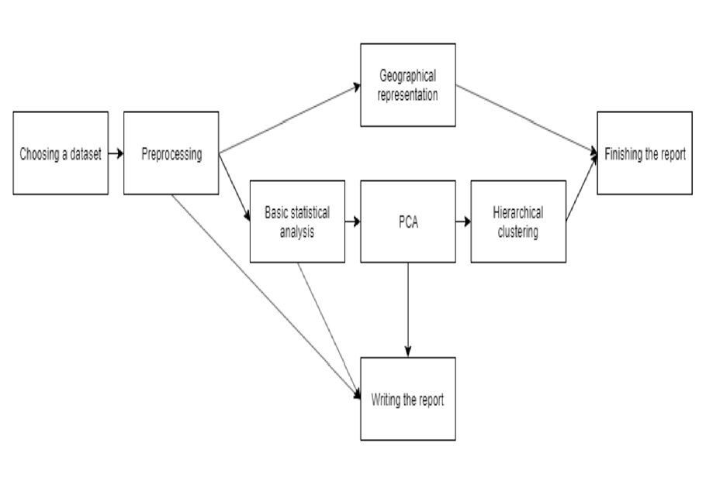

Preprocessing
For this project, we’ve needed to do a good amount of preprocessing work since there were too many variables, rows, that were irrelevant or didn’t have enough instances that used them, misplaced numbers, and so on. A small part of this work was made before importing all the data with R, working directly on a csv file, but the majority of the process has been performed in R, which is reflected in the scripts attached to the delivery, alongside this report.

Enumeration and description of steps
In this section, we explain which steps of the Preprocessing process we’ve gone through and which ones we haven’t, briefly explaining what we did in the first case and why we didn’t go through it in the second case.
- Data fusion & merging
  - We briefly went through this step in our data preparation phase, before starting the preprocessing itself, because we got all the data from a single dataset which has enough information, but we decided to add two additional columns that contain information about the political status of the state at the moment of each incident. Specifically, which political party was ruling over the USA and which one was ruling over the specific state where the incident happened.
- Variables declaration in pre-processing tool
  - We also briefly went through this step, deleting redundant categorical variables that were represented in two different formats.
- Visualization and basic descriptive statistics
  - We introduced our data into R to look at the most basic statistics, in order to understand a little more about what we’re gonna work with. We’ve spent a lot of time in this step, and all the results can be found in the attached files.
- Filtering
  - We looked at all the attributes of our data, column by column, and chose which ones to delete (reasoning why). We also deleted all the information about incidents outside the United States of America, therefore bounding our data and reducing the object of study.
- Expert-based variable selection
  - We skipped this step, since we didn’t ask for any expert’s help because we had more than enough information to begin with.
- Outlier detection and correction
  - We introduced all our data in R and searched there for outliers, using boxplots and summaries to detect them. All the outliers were then deleted, cleaning our data, leaving it inside its most usual interval. As stated earlier in the report, all these results, analysis and reasonings can be found in the attached files.
- Error detection and correction
  - We noticed two different mistakes in our dataset: firstly, since we imported the data in a textual format into excel, part of some rows were displaced after the format transformation (one attribute is missing, and then all the posterior attributes are moved one column to the left). Since we deleted some columns, erasing the attributes we chose not to include in our project, we accidentally deleted the wrong information for those rows, and when we realized it we had to go back to an older version of the dataset to get back the lost data. The second error we detected was that, after manipulating the data, at some point the decimal comma in the values of the Latitude column disappeared for all its rows, so we had to check an older version again in order to get the right numbers back.
- Missing data treatment
  - When introducing our data into R, using its tools we quickly found the different missing values in each column. To decide how to handle each one we reasoned in a case by case basis. All of the reasoning and treatments are shown and explained in the attached files.
- Compositional and multivalued variables
  - We didn’t go through this step, because our data already had the compositional variables we needed and therefore we didn’t have to create our own.
- Instance selection and Feature selection/dimensionality reduction
  - As we explained earlier, in the Filtering step we reduced our data to the United States instead of the entire planet. We didn’t perform any additional tasks in these steps.
- Transformations
  - We’ve only made a transformation of fusing some variables into a single one: there were some groups of variables consisting of a day, month and year, and we transformed them into a single date type variable. Apart from this, we didn’t transform any other variables.
- Creation of new variables
  - We didn’t go through this step, since we didn’t create any additional variable from previous ones.

Description of the preprocessing made in each variable
In this section we will briefly explain the steps we’ve followed during the preprocessing of each variable, but we have created a self-explanatory script of R markdown, which is included and improved in this report in the Appendix: all the comments regarding the preprocessing performed to each variable can be found in the "Preprocess of each variable". There’s also other sections related to the preprocessing like “Deleting rows with lots of null values”, “Assigning the right type to each variable” and “Saving the preprocessed dataset”.
For each one of the variables, the first thing we do is always a summary command to see how the data in each column really is: this is the best way to be able to easily detect the anomalies in the data, like null values (misses), outliers or errors.
Once detected, we look at them with more detail and decide if it’s obvious what’s happening and how to fix it (for example, if there’s a typo). If it’s not obvious, then we consider all the different methods we have to deal with the situation, and discuss which one is the most adequate for the situation. When dealing with outliers, we’ve studied why the numbers were off and decided if we should keep or delete them: for example, the infamous incident of the 9/11 had an abnormally amount of deaths compared to other terrorist attacks, and we decided not to consider that incident and instead focus our study into the incidents that happen more commonly. When dealing with null values, for example, we decided if we should use KNN, the mode, the median, the mean… in the majority of cases, we’ve used the mode for categorical variables and the median for the numericals, but in some of them we’ve used a different method, as we can see in the Appendix.
When this analysis is done, we finish by making another summary command in order to verify that everything is correct.

Basic statistical descriptive analysis

Univariate
In this section we will study each preprocessed variable in a univariate way. In the R script, which we can comfortably see in the appendix’s section called “Descriptive statistics of variables after preprocessing”, we can see step by step all the commands we’ve done to study the variables and the results of their summaries. For some variables, we’ve also included a graph choosing the most suitable type between two different ones: boxplot or histogram for the numerical ones, and bar or pie chart for the categorical ones. Some variables have been left as textual since they had too many different values to be reasonably considered categorical, so we’ve described them with some summarized statistics.
The statistics of the numerical variables contain the following information:
- Mean
- Variance and Standard Deviation
- 25% and 75% percentile
- Median
- Skewness
- Kurtosis
The statistics of the categorical variables, on the other hand, contain the following information:
- Count
- Mode

Bivariate
A detailed explanation of this analysis can be found in the section “Bivariate statistical analysis of relevant variables”, in the appendix of this document.
The analysis we have applied to each pair of variables follows the same steps every time: first we analyze if they are related, usually with a chi-square test, and then we manipulate the data to be able to extract conclusions and show the graphs.
Each analysis applies to a pair of variables that we‘ve chosen to group together because we think that, if they have any type of relation, they can give us interesting information about our data set. Some of these pairs are chosen with the same goal in our mind: for example, there‘s a few of them that study if a given variable is related to the success or failure of the attack, with the objective of giving us a better understanting of which attack_type, weapon_type or similar are the most efficient and trying to discover why, or which target_type is the most commonly attacked and with which probability of success.
The other interesting point to analyze is if there‘s any specific claim mode that increases the chances of capturing the perpetrator of an attack, and we‘ve discovered that that‘s indeed the case: the result, which can be found in our appendix, shows that the incidents where the claim mode was a Personal claim have a bigger tendency to end with the perpetrator of the attack getting caught, followed by a Letter, and then a Note.
We have also studied the damage caused by the different types of weapons, looking at the number of deaths and injuries for each one.
We also saw which distribution follows the attacks of our dataset, according to the years and months they take place in.
We also made some top 3 charts to analyze information we have about different terrorist groups.
And finally we analyze our added on variables, president_party and state_governor_party, mainly with the objective of studying which president party has the biggest amount of successful attacks taking place during their ruling.

Conclusions
After doing all this elaborate preprocessing, we’ve realized that the dataset was too messy and unfinished, with a lot of variables that lacked values, and mistakes that ranged from very easy to solve (but still annoying, and in sum ended up giving additional work) to quite hard and difficult to decide how to handle. There even were some variables that didn’t make much sense, or they should in theory but its values in the whole column didn’t.
However our dataset has these disadvantages, and especially the numerical variables, after further study, have ended up being too homogeneous and poor, with big amounts of zeros, missing values, binary results, and not many distinct values in general. But our categorical variables give us quite interesting information as we have seen in the bivariate analysis. So we try will to apply them and in later analyzes to improve the results.

Visualization of terrorist attacks on a USA map
Since our project analyzes different terrorist attacks that happen all across USA, we considered that it would be interesting to create maps that represented all those attacks in different ways. Using the folium module for Python, we’ve developed 4 scripts that read our dataset and create 4 different HTML files in which we can interact with a map of the world to see this mentioned data. We’ve attached to the delivery each one of these maps, alongside the Python code we’ve made to generate them. The name of each map (.html) is the same as the script that created it (.py).

map_points

This map is the most straightforward: each incident is represented as a dot in the exact point it took place in, regardless of when it happened. There’s four different filters that we can apply (ignoring “openstreetmap” and “stamenterrain”, which only change the colors of the background map): “All attacks” shows all the incidents as green dots, without any distinctions, as we can see in the image above. “President party” toggles the option to show the points distinguishing between which was the president party of the USA when the incident happened (blue for the republican, red for the democratic), and the last two, “___Republican” and “___Democratic”, hide or show the dots that correspond to that party.

map_time
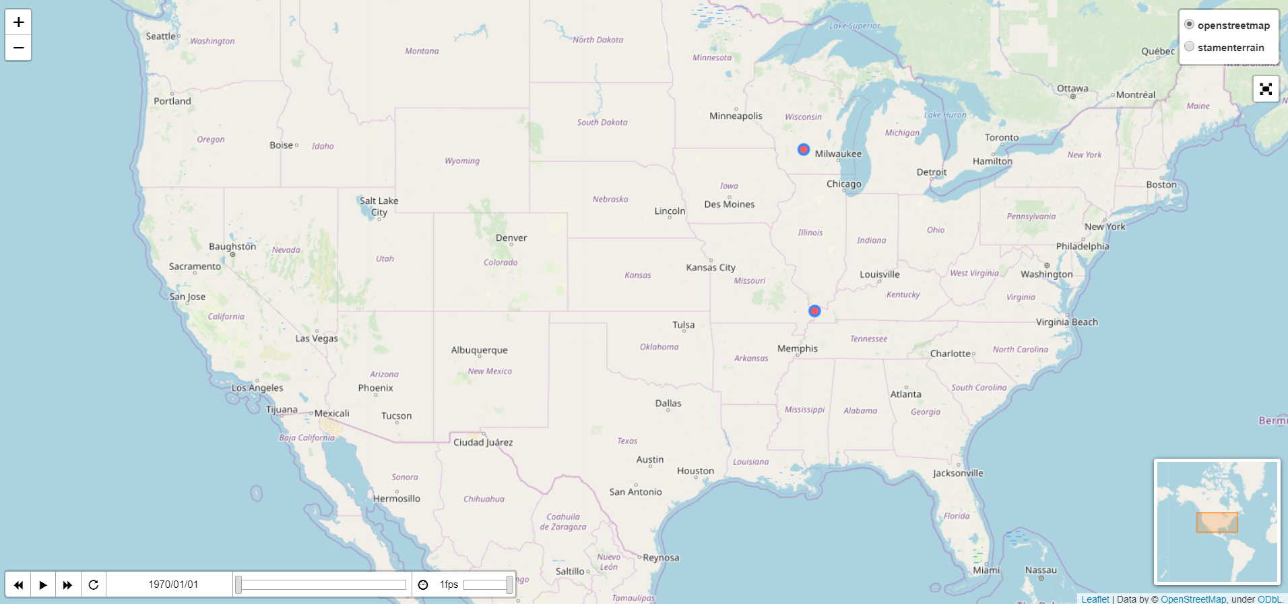
This map shows us, using a play/pause button and a time slider, the incidents that took place all over USA in each month since 1970 (because that’s the earliest incident we have in our dataset), month by month. This gives us insight of how long each region is in conflict, how it expands to nearby zones, and so on, and how all of this changes with the pass of time. Since the map only shows the data on a month by month basis, if we wanna have the exact date of an incident we can click on the red point that represents it.

map_states

This map shows us the amounts of incidents in each one of the states, with a range of color values from white to green: the darker the tone, the bigger amount of terrorist attacks in that state. The scale is linear: each color has an interval of values of size 58 (0 to 58, 59 to 116…) except the last one, which has a bigger interval. We chose this size because there are a lot of incidents in a few selected states, but not so much in the others, so we tinkered with the interval size until we got at least a little of diversity.

map_provs

This map is similar to the previous one, but uses the fips code of the location the incident took place in instead of the state. Since the original dataset didn’t have this code, we programmed a script in Python that read a different dataset we found, with the fips code of each city and state, and for each row of our dataset it searched its fips code and added its value into a new column. However, the result doesn’t match with our dataset (for example, there’s a lot of incidents in Los Angeles but here it seems like the opposite), so it’s possible that the fips codes are wrong, or the Python module folium uses some different codes and we’re misunderstanding how it works, but nevertheless the map that the script generates doesn’t correspond to the incidents in our dataset, and nevertheless it’s meaningless.

PCA analysis for numerical variables
To perform Principal Component Analysis over our data, we chose the numerical variables without a too significant amount of missing values. The chosen ones were nkill, nkillus, nkillter, nwound, nwoundus and nwoundter. As you can probably deduce, the PCA served as a sort of analysis of the deadliness of the attacks, as the six variables are related to the number of casualties of them.
The PCA returned six variables, the inertia of which are represented in the following scree plot:
As stated in the report, from a numerical standpoint, the three main variables of the PCA amount to more than the 92% of the total inertia. Wanting to keep around 80%-90% of it, it was enough with those three.

This is the factorial map of the six original variables over the two main variables of the PCA.

Coefficients and variable names
After the factorial map, here are the coefficients for the six resulting variables of the PCA:
 | PCA1 | PCA2 | PCA3 | PCA4 | PCA5 | PCA6
nkill | 0,57 | -0,2 | 0,19 | -0,31 | 0,02 | 0,71
nkillus | 0,57 | -0,2 | 0,17 | -0,31 | -0,13 | -0,7
nkillter | 0,47 | -0,18 | -0,28 | 0,82 | 0,03 | 0
nwound | 0,27 | 0,65 | 0,04 | -0,02 | -0,7 | 0,07
nwoundus | 0,21 | 0,68 | -0,03 | 0,04 | -0,7 | 0,07
nwoundte | 0,09 | -0,02 | -0,92 | -0,37 | 0,03 | 0,01

The first one is mainly related to the number of casualties of the incident, more than the number of injured. One could think it's referring to how much of a bloodbath it was, so that is how we've named it: the "bloodbath-ness" of the incident.
The second component is strongly related to the amount of wounded people at the incident, but only those that were not terrorists. We've thought that it could be pointing at how many relevant people (so terrorists don't matter) were saved, so that is its name: the "saved-ness" of the incident.
The third almost entirely relates to the amount of wounded terrorists, but the lower the value, the more wounded terrorists the attack had. So, it can be called just that, "wounded terrorists", one only has to remember to interpret it the right way.

Projections over the PCA variables
Now we present the projection of the data over the three main components of the PCA, and a brief analysis of them.
On “bloodbath-ness” against “saved-ness”, we can see one big group of attacks that follows an almost horizontal line, ranging from almost no "bloodbath-ness" to a notorious amount, and another group that has consistently more "saved-ness" than "bloodbath-ness", meaning that they weren't very lethal.
On "bloodbath-ness" against "wounded terrorists", there are two clearly separated lines of attacks, one that starts with no wounded terrorists and another that starts at one. It's curious to observe that the second one starts approximately at the value at which the first line ends. From that and the "outliers" from the second graph, we can extract that the more deadly an attack is, the more likely it is that one or more perpetrators end up injured. The exception are a group of attacks that have several wounded terrorists, but have very low "bloodbath-ness". These are probably failed attacks.
On “saved-ness” against “wounded terrorists”, we see that there's a big cluster around (0,0), indicating there were neither wounded terrorists nor injured victims in a big amount of attacks. There's also a cluster of attacks with wounded terrorists and negative "saved-ness", indicating a bigger amount of fatal casualties than injured people. Lastly, there's also a group of attacks with no woudned terrorists and a varying degree of "saved-ness"; these might be clean attacks, with no casualties.

Projection of qualitative variables over the PCA variables
We have also projected the categorical variables over the two PCA variables that can provide the best explanation of the categories, if at all.

In the "doubterr" variable, that represents if there was any doubt about whether an attack was in fact terrorism or not, the biggest, deadliest attacks are all confirmed terrorist attacks, but we can see a group of incidents (some of them even happening to be quite bloody) that spawn some doubt. If we consult the data, we’ll see that the deadliest two of these are a bombing and a kidnapping, and it's reasonable to have doubts about them because it's easier to pass them off as an accident or an incident without an ulterior motive, respectively.

Regarding the success of the attack, the vast majority of them are considered successes. It's noticeable that there are two failures on the Y axis, representing two attacks with a great amount of injured terrorists while few to none injured civilians. It makes sense to call them failures when terrorists are almost the only ones affected by the attacks. The rest of failures are scattered around the origin of coordinates (even if some of the failures have actual casualties), meaning they were smaller attacks. The attacks with a big value for "saved-ness" are all still considered successes even if they weren't lethal, likely because they still affected a great amount of people.

On the type of the attack, we notice some clear outliers.
There are two hijackings corresponding, more than likely, to the two 9/11 attacks previously mentioned.
There's also an unarmed assault that affected a vast amount of civilians but wasn't as deadly. If we check the graph below showing the type of weapon used, we'll see that this attack was performed with a biological weapon. It's very likely that this attack corresponds to the 1984 Rajneeshee attack in The Dalles, Oregon: a biological attack carried out by the members of an indian movement for political reasons in which they poisoned 751 people with Salmonella by contaminating the food of then restaurants of the area.
We can also see a clear tendency in armed assaults, ranging in the amount of fatal casualties, but all having in common the fact that they were very lethal, resulting in no injuries. On the other hand, bombings and explosions often leave a bigger amount of injured than killed people.

On the type of weapon of the attack, we clearly see that the armed attacks clearly correspond with the ones that used firearms. Also as we said before, that unarmed assault was carried out with a biological weapon (Salmonella) and the two hijackings correspond to attacks performed with vehicles (planes).

On the type of the target, there are too much different possibilities and there isn't any apparent pattern to extract any meaningful conclusions. The same happens regarding whether the attack was claimed or not, although the deadliest attacks were still all claimed. On the type of claim, there exist to many NA's for this graph to be of any value.
On the governing party at the time of the attack, it's noticeable that the deadliest attacks that the dataset registers (thus definitely being part of the deadliest attacks the US has suffered) all happened under the Republican party. Those very likely correspond to the 9/11 attacks, which happened under the George W. Bush administration. Regarding the governing party at the state at the time of the attack, the same conclusions can be taken as before.

Conclusions
The first conclusion that we can extract from the Principal Component Analysis is that the data can be explained mostly by the deadliness of the attack, the amount of wounded civilians and the amount of wounded terrorists. We can also conclude that there is almost no difference between the variables that relate to US citizens and the corresponding ones relating to all citizens.
Another conclusion we can extract is that the armed assaults are very deadly, and resulting in almost no injuries, only deaths. Still, the deadliest registered attacks are the 9/11 hijackings. On the other hand, bombings and explosions often leave a bigger amount of injured than killed people.
In addition, the armed attacks are generally carried out with firearms and the hijackings, with vehicles. Both facts make a lot of sense.
Another conclusion to extract is that although the United States have suffered a big amount of terrorist attacks under both Republican and Democratic administrations, the largest, deadliest ones happened under Republican administrations (9/11 attacks and the Rajneeshee attack).

Hierarchical Clustering

In this section we are summarizing the clustering process. The full report can be seen in the script called clusters_script.Rmd.

Description of the data used
We have selected all the variables of the preprocessed dataset except for the following:
- id: gives no information
- provstate: there are too many values and we have studied this variable a lot in the prior sections
- city: there are too many values
- latitude: we have studied this variable a lot in the prior sections
- longitude: we have studied this variable a lot in the prior sections
- gname: there are too many values
- date: we didn’t want to divide our dataset according to the date
We have deleted one row that was a clear outlier and appeared alone in a cluster in all the cluster partitions we have tested.

Clustering method used
We have opted for using the Gower dissimilarity coefficient considering the amount of categorical variables in our dataset. However, we have also tested using only the numerical variables (nkillus, nkillter, nwound, nwoundus, nwoundte) and the clusters achieved were very easy to classify. They split the different terrorist attacks on four different levels of severity (the amount of wounds and deaths).
The resulting dendogram appears in the next page as required:

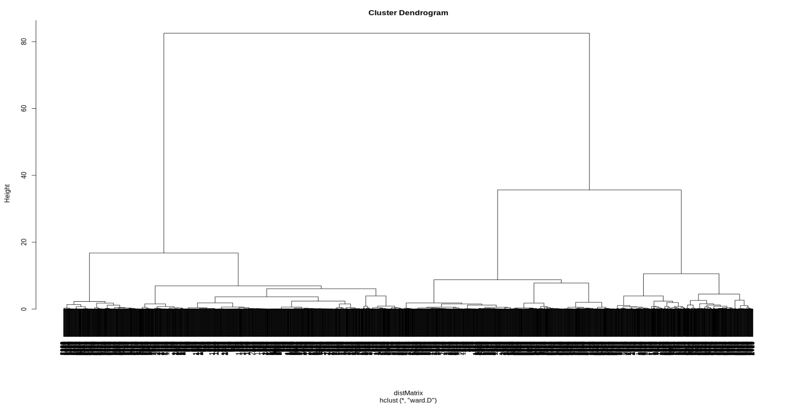

After a brief discussion in our team, we have decided to split the dataset in four clusters. We think that adding another cluster doesn't give much better modeling of the data and that four clusters already explain the majority of the variance and make easier the later study. This option is also supported by the results we obtained with the k-means analysis. We compute the y the within cluster sum of squares depending of the selected k. The following image shows the results.
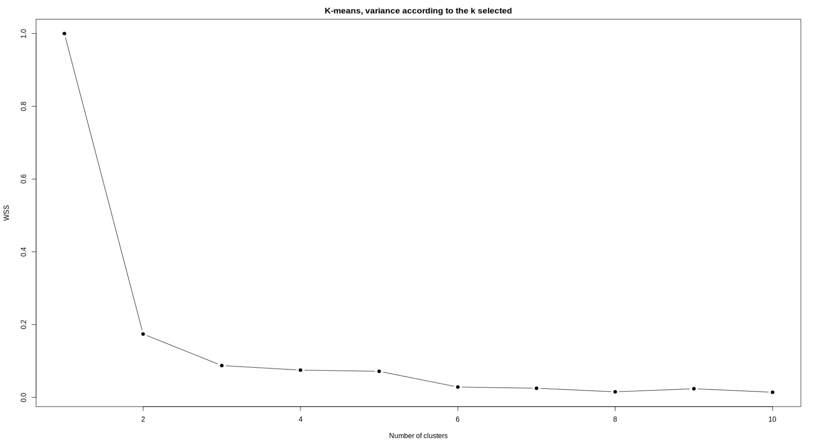

Clusters partition description
The next table shows the distribution of the terrorist attacks in the different clusters. We can see that any cluster has less than the 10 % of the observations.

Cluster id | Number of observations | Percentage of observations
1 | 543 | 19.8
2 | 1040 | 38.2
3 | 845 | 30.8
4 | 309 | 11.2

Profiling of clusters
In this section, we are going apply cluster profiling in our dataset and show the results with the most significative variables.

attacktype1_txt
We can clearly see that cluster 2 and 4 are practically all Bombing/Explosion, cluster 3 are Facility/Infrastructure Attack and cluster 1 is a mix of the other attack types. To narrow this a bit more we will focus on the weapon used in the attack rather than the assigned type.

weaptype1_txt
If we take a look into the weapon type used in the attack, we can see that the clusters 2 and 4 are mostly Explosions, the cluster 3 is Incendiary and the cluster number 1 has a variety of weapons although the most common one are Firearms acts.

targettype1_txt
In this image we can observe how in cluster 1 the most frequent target was private property, closely followed by business and police. In the second cluster the clear majority of attacks were made to businesses and government facilities. The third cluster, as the second one, has most of its attacks focused on businesses and also focused on abortions. Finally the last cluster is very similar to the second.
In the previous two plots we see that the difference between clusters in the rate of success and claimed are not significant enough to extract any conclusions.

president_party
It does not look like we can take any information out of clusters 1 and 3 but we can see that cluster 2 is practically only Republican, while cluster 4 is only Democratic. Taking into account the both of them were Explosion attacks we can now see the biggest difference between them is the president's party at that time.

Nkill

The cluster number 1 has a much bigger kill average in comparison with the other clusters. If we analyse nkillus, nwound, nwoundus the results are very similar. That is probably due to the fact that this cluster has a lot of Firearms attacks, which normally target people’s lives.

Summary
Cluster 1: As we have seen this cluster is a mix of attack types, although the most used weapon are firearms and the most frequent target are police related, which consequently increases the wound and kill rate.
Cluster 2: This second cluster are explosion attacks, mostly targeted at businesses and government facilities while the president’s party was republican.
Cluster 3: The third cluster are facility or infrastructure attacks where some kind of incendiary weapon was used.
Cluster 4: This fourth cluster are also explosion attacks, they are also targeted at businesses and governement facilities, just like cluster 2, but these acts were commited while the president’s party was democratic.

Conclusions
In this section we are going to summarize all the conclusions we have made in the different prior chapters. We’ll start by showing the useful conclusions for every variable and then we are going to write down the relations between the pairs.

Weapon types and their success rate
As we have seen, the type of weapon used in acts of terrorism is a determinant factor of whether the attack succeeds or not. The methods that have the most total amount of successful acts are Explosives, Incendiary and Firearms, although we have seen that Vehicle, Melee and Sabotage Equipment attacks have a better success rate. This is due to the fact that, while the first three are more common and therefore have more cases registered (which also increases the amount of successes), the later three types of weapon have a far higher amount of wounded or killed citizens, creating a larger social impact, which is the pursued objective in most cases and therefore classifying the incident as a success.

Amount of incidents through the years
We can clearly see an increasing tendency of acts of terrorism in the United States in the last years (2009-2017). The highest density of attacks were in the 70’s and lowest in the 00's: the situation was improving as time passed (with the exception, of course, of the incident of the 9/11/2001), but in the last decade it started growing again. That could be related, for example, to the financial crisis of 2007-2008, which could have introduced tense social and political situations leading to the incidents.

Successful incidents depending on the president party
The incidents that took place while the ruling president party was the republican have a total of additional 3.34% successes compared to the democratic. If this number was higher, we could have investigated to try to guess why there’s a big difference (it could be because the republican party introduces laws that are less secure, because there’s more people against what they do or the opposite party is more aggressive, or some other explanation). However, since the difference isn’t very big, it’s very probable that there isn’t any special reason to it.

Attack type depending on the president party
After performing the cluster profiling, we’ve realized that the attack type doesn’t depend on the governing party at the moment of the incident. This is expected, since otherwise it would be very strange that a certain party provokes a specific type of attack to happen.

Abort related attacks
The majority of abort related attacks are incendiary ones which target facilities and infrastructures, so we guessed that the majority of those incidents were attacks directed by anti-abortion radicals against the abortion clinics. After some research we found some information to back up this claim, so we can conclude that this is, in fact, the cause of this relation.
(https://www.ncbi.nlm.nih.gov/pubmed/1957842)

Small observations
There’s a few small observations that are simple or quite obvious, but are interesting to note nevertheless. We’ve noticed that firearms are the the deadliest weapons, even higher than explosives, even though explosives are more common. The reason this happens could be that explosives are used to provoke social impact and to cause structural damage, while bringing a gun tends to mean you have the intention of killing other human beings. We also noticed that companies and corporations are the most common target of an attack, which interestingly means that there are more people aggressively going against private companies instead of the state itself or the government; in other words, the reason they’re making a terrorist attack isn’t related to the political state of the USA.

Working plan

Initial working plan
We’ve made an initial working plan taking a look at the guidelines and steps for the project. A lot of concepts are unknown to us since they will be introduced in future lessons, so we’ve tried our best to balance the time span for each one of them in our Gantt chart, and also made sure not to assign a task’s initial date before the day on which the according lesson is expected to happen. It’s very likely that the real dates won’t match with this initial working plan, taking into account what’s already mentioned and additional factors that may mess up our progress, like projects from other subjects, as we explain later in the Risk contingency plan section of this report.

Project development timeline with Gantt
To make the Gantt chart we used the free program ProjectLibre, which allowed us to create tasks, assign an initial and final date to them, organize them with subtasks, and set dependencies.
The images of Initial and Final Gantt can be seen in the next pages:

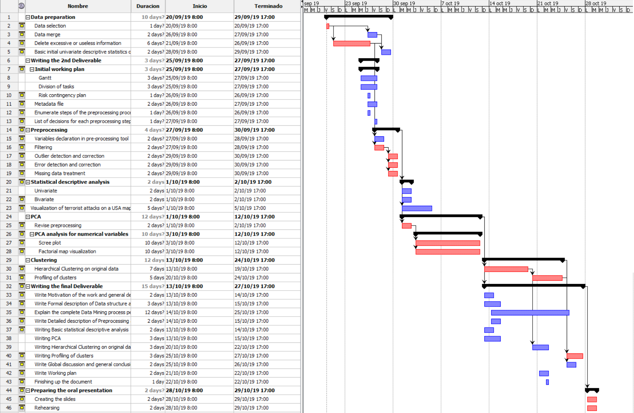
Initial Gantt
Final Gantt
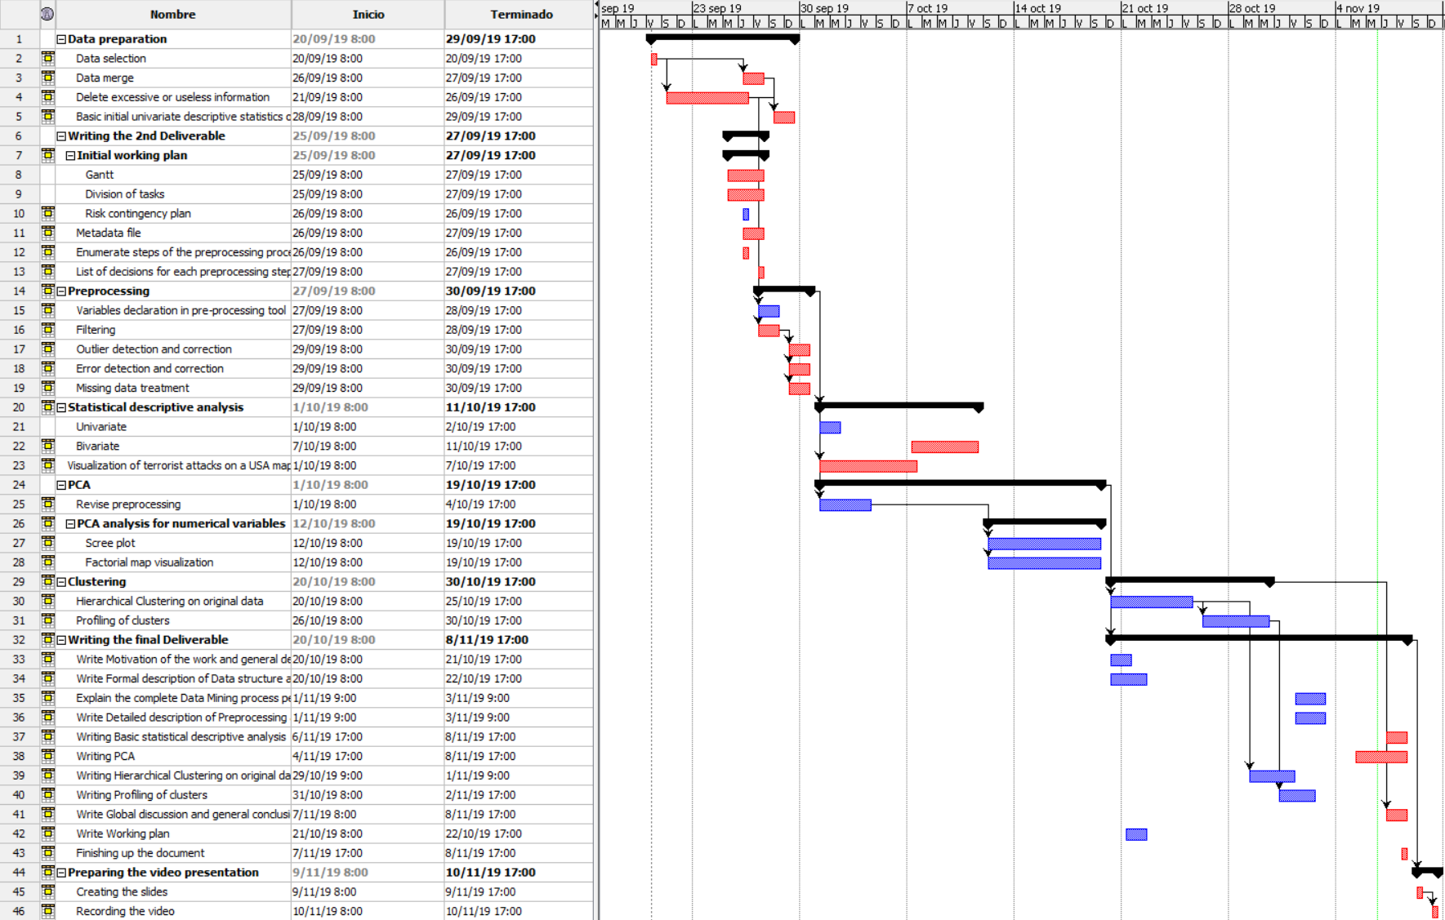

Assignment of tasks
As the guidelines propose, each one of the tasks has at least to team members working on it. Additionally, each task has a coordinator or supervisor, which is represented in the following tables by an uppercase and bold X.
- Data preparation
Task | Ferran | Samuel | Daniel | Rubén | Adrián | Alejandra
Data selection | x | x | x | x | X | x
Data merge | X |  |  |  | x
Delete excessive or useless information | x |  | X | x
Basic initial univariate descriptive statistics of raw variables | x |  |  | x | X | x
- Writing the 2nd Deliverable
Task | Ferran | Samuel | Daniel | Rubén | Adrián | Alejandra
Gantt | x | X |  |  | x | x
Division of tasks | x | x | x | x | x | X
Risk contingency plan |  | X |  |  | x | x
Metadata file |  |  | x | X | x
Enumerate steps of the preprocessing process that we use |  | x |  |  |  | X
List of decisions for each preprocessing step |  | x | X | x |  | x
- Preprocessing
Task | Ferran | Samuel | Daniel | Rubén | Adrián | Alejandra
Variables declaration in pre-processing tool | X |  | x | x
Filtering | X |  | x | x
Outlier detection and correction | X |  | x | x | x | x
Error detection and correction | X |  | x | x | x | x
Missing data treatment | X |  | x | x | x
- Statistical descriptive analysis
Task | Ferran | Samuel | Daniel | Rubén | Adrián | Alejandra
Univariate |  |  | x | X | x
Bivariate |  |  | X |  |  | x
- Visualization of terrorist attacks on a USA map
Task | Ferran | Samuel | Daniel | Rubén | Adrián | Alejandra
Visualization of terrorist attacks on a USA map | x | X
- PCA
Task | Ferran | Samuel | Daniel | Rubén | Adrián | Alejandra
Revise preprocessing |  | x |  | X
Scree plot |  | x |  |  | X
Factorial map visualization |  |  |  | X | x
- Clustering
Task | Ferran | Samuel | Daniel | Rubén | Adrián | Alejandra
Hierarchical Clustering on original data |  | x |  |  | X | x
Profiling of clusters |  |  | X | x
- Writing the final Deliverable
Task | Ferran | Samuel | Daniel | Rubén | Adrián | Alejandra
Write Motivation of the work and general description of the problem to be analyzed |  | X | x
Write Formal description of Data structure and metadata |  | x |  | X
Explain the complete Data Mining process performed |  | x |  |  | x | X
Write Detailed description of Preprocessing and data preparation. | x | X
Writing Basic statistical descriptive analysis |  |  | x | X | x
Writing PCA |  | x |  |  | X
Writing Hierarchical Clustering on original data | X | x
Writing Profiling of clusters |  |  | x | X
Write Global discussion and general conclusions of the whole work |  | X | x |  |  | x
Write Working plan |  | X |  |  | x
Finishing up the document |  | x |  |  |  | X
- Preparing the video presentation
Task | Ferran | Samuel | Daniel | Rubén | Adrián | Alejandra
Creating the slides | x | X | x | x | x | x
Recording the video | x | x | x | x | x | X

Risk contingency plan
We’ve thought about the different risks and expected problems that could arise during the development of this project, in order to think in advance about how to prevent them, and also how to manage them if they end up happening anyway.

Risk 1: Bad decisions in preprocessing
- Description: As it’s expected, we will delete data that we consider unnecessary, but this could give us additional work if we mistakenly delete an attribute that ends up being very important. In that case, we might have to undo a lot of work and redo everything we’ve done that’s affected by those changes. The opposite situation may also happen: we could end up not deleting enough information, and dedicating time and work to study data that’s not useful, losing our time in the process.
- How to prevent: All the team members must have a clear idea of the scope of the project: which tasks we’re gonna perform and what is and isn’t necessary. Before making important decisions or taking actions that affect the whole project, a team member must talk about it with all its teammates. If in doubt, consult with the professor what decision should be taken.
- How to manage: When facing a problem, decide how to solve taking into account the project goals and the remaining time, consulting the professor if it’s necessary. If the outcome is critical to other parts of the project, then dedicate more resources to solve the issue.

Risk 2: Conflicts inside the team
- Description: It’s possible that bad relationships between team members end up creating conflicts that affect our performance, making the meetings longer and with mixed feelings about how to perform some task, resulting in hard disagreements. Also, any unexpected problem could give additional work and trouble, for instance a team member being apathetic and not finishing their work on time, or an accident leaving them unable to work for a certain period of time.
- How to prevent: It’s important to keep in mind that we’re all human, and have different abilities and opinions. We must be reasonable and respect each other, avoiding unnecessary conflicts. If we realize that a task won’t be finished in time, we can ask that task’s coordinator in advance, before it’s too late, in order to reorganize our resources and prevent future conflicts.
- How to manage: Trying to solve the situation through a meeting where all the points of the conflict will be discussed to try to find some middle-ground agreement so that every member is satisfied and can work comfortably.

Risk 3: Wrong task difficulty evaluations
- Description: As it’s expected for any software project, it’s difficult to evaluate how long everything will take, especially since we don’t have a lot of experience taking part in this kind of projects, and it’s our first experience in data mining.
- How to prevent: If there’s any doubt, it’s always better to be cautious and spend more time and resources with tasks that seem more difficult or unknown to us. If we overestimate the amount of work it will require, we will just end ahead of planned, but if we underestimate it we’ll get into schedule problems.
- How to manage: If a task’s progress doesn’t meet the expectations, find out why it’s slower than expected, avoiding stagnation, even changing the team members in charge of it or asking for help if necessary.

Risk 4: Scheduling problems
- Description: It’s easier to plan what to do each week in advance than actually applying it, since we don’t know what will happen in the following weeks. A weekend that we might have destined to develop a certain task could end up very busy due to other subject’s work or personal problems, or maybe it was underestimated how long it would take to finish it. This means that it’s very likely that some tasks are finished later than scheduled, giving us extra work to reorganize, and stress out.
- How to prevent: Take into account the other subjects that other members of the group have, respecting their schedules and other assignments when choosing dates for meetings and tasks, and trying to avoid leaving everything for the last day possible.
- How to manage: Trying to always make some progress, bit by bit in a continuous way, and when in doubt always assuming that a task will take more time than expected. If a team member finds themselves in a situation in which they think they won’t finish a task before the deadline because of sudden new work from other subjects, they must ask their teammates for help.

Final scheduling deviances Discussion
As we expected at the beginning, the schedule we ended up having doesn’t perfectly match our preparation and expectations. While we were following our planning at the beginning, the biggest factor that messed up our schedule was losing a theory class because of a strike, and therefore not learning in class the needed contents. The second biggest factor was, as we anticipated, that different exams and deliveries from other subjects got in our way, letting us dedicate less time to this project in key dates that we previously destined to work. However, since the date of the delivery was delayed, we had time to finish everything in the end anyways, and just moved the dates of every task as needed.
The oral presentation got changed to a video, which requires more time to create (instead of just rehearsing a presentation), so we had to make the last days before the delivery a little bit more dense, but still managed to get it in time.
So, in summary, from all the risks we anticipated the 4th one was the one that affected our project the most, alongside the unaccounted risk of losing a theory class due to a strike, while the other risks were avoided in a good enough measure, following the plan we established at the beginning.
In order to organize and maintain all this parallel work we used GitHub, which allowed us to have version control, work with the same files and merge our results, and have access to the project from any system. On the other hand, we used Discord to communicate between the members of the project, with different text and voice chats that allowed us to easily keep in touch with our progress, ask for help, work in real time while talking with microphone and sharing our screens, and so on.

R Scripts
Yo haria una lista de los scripts que vamos a entregar con un commentario de que hace (como si fuera una bibliografia)
Preprocessing.Rmd → R markdown file with the explanation alongside the code of each step we've gone through during preprocessing of our original dataset.

Appendix

Missing values by column
In the next table there is a summary about the number of missing values for each attribute and its corresponding percentage, counted by a python script that we created.
 | Proportion of missing values (0-1) | Amount of missing values
eventid | 0.00000000 | 0
iyear | 0.00000000 | 0
imonth | 0.00000000 | 0
iday | 0.00000000 | 0
approxdate | 0.98695346 | 2799
extended | 0.00000000 | 0
resolution | 0.99576869 | 2824
country_txt | 0.00000000 | 0
region_txt | 0.00000000 | 0
provstate | 0.00176305 | 5
city | 0.00528914 | 15
latitude | 0.00035261 | 1
longitude | 0.00035261 | 1
specificity | 0.00000000 | 0
vicinity | 0.00000000 | 0
location | 0.66255289 | 1879
summary | 0.37129760 | 1053
crit1 | 0.01516220 | 43
crit2 | 0.01551481 | 44
crit3 | 0.00000000 | 0
doubtterr | 0.05183357 | 147
alternative_txt | 0.84344147 | 2392
multiple | 0.00211566 | 6
success | 0.00000000 | 0
suicide | 0.01410437 | 40
attacktype1_txt | 0.01904090 | 54
attacktype2_txt | 0.97884344 | 2776
attacktype3_txt | 0.99576869 | 2824
targtype1_txt | 0.02009873 | 57
targsubtype1_txt | 0.05923836 | 168
corp1 | 0.37023977 | 1050
target1 | 0.03349788 | 95
natlty1_txt | 0.02115656 | 60
targtype2_txt | 0.96015515 | 2723
targsubtype2_txt | 0.95733427 | 2715
corp2 | 0.96579690 | 2739
target2 | 0.96332863 | 2732
natlty2_txt | 0.96086037 | 2725
targtype3_txt | 0.99541608 | 2823
targsubtype3_txt | 0.99647391 | 2826
corp3 | 0.98448519 | 2792
target3 | 0.98095910 | 2782
natlty3_txt | 0.98589563 | 2796
gname | 0.20204513 | 573
gsubname | 0.97284908 | 2759
gname2 | 0.97179126 | 2756
gsubname2 | 0.98166432 | 2784
gname3 | 0.98025388 | 2780
gsubname3 | 0.99153738 | 2812
motive | 0.54548660 | 1547
guncertain1 | 0.01622003 | 46
guncertain2 | 0.02045134 | 58
guncertain3 | 0.02115656 | 60
individual | 0.02433004 | 69
nperps | 0.35860367 | 1017
nperpcap | 0.33251058 | 943
claimed | 0.03067701 | 87
claimmode_txt | 0.84203103 | 2388
claim2 | 0.02115656 | 60
claimmode2_txt | 0.97884344 | 2776
claim3 | 0.02221439 | 63
claimmode3_txt | 0.98519041 | 2794
compclaim | 0.03878702 | 110
weaptype1_txt | 0.02256700 | 64
weapsubtype1_txt | 0.09414669 | 267
weaptype2_txt | 0.91995769 | 2609
weapsubtype2_txt | 0.93511989 | 2652
weaptype3_txt | 0.95944993 | 2721
weapsubtype3_txt | 0.96015515 | 2723
weaptype4_txt | 0.96755994 | 2744
weapsubtype4_txt | 0.97602257 | 2768
weapdetail | 0.19499295 | 553
nkill | 0.01445698 | 41
nkillus | 0.00775740 | 22
nkillter | 0.00564175 | 16
nwound | 0.00211566 | 6
nwoundus | 0.00105783 | 3
nwoundte | 0.00599436 | 17
property | 0.05289140 | 150
propextent_txt | 0.53631876 | 1521
propvalue | 0.75528914 | 2142
propcomment | 0.62023977 | 1759
ishostkid | 0.00352609 | 10
nhostkid | 0.00881523 | 25
nhostkidus | 0.00246827 | 7
nhours | 0.01763047 | 50
ndays | 0.02644570 | 75
divert | 0.97496474 | 2765
kidhijcountry | 0.97425952 | 2763
ransom | 0.01692525 | 48
ransomamt | 0.00952045 | 27
ransomamtus | 0.01622003 | 46
ransompaid | 0.01551481 | 44
ransompaidus | 0.01727786 | 49
ransomnote | 0.98624824 | 2797
hostkidoutcome_txt | 0.96967560 | 2750
nreleased | 0.01939351 | 55
addnotes | 0.57757405 | 1638
scite1 | 0.40338505 | 1144
scite2 | 0.46156559 | 1309
scite3 | 0.60260931 | 1709
dbsource | 0.03737659 | 106
INT_LOG | 0.52256700 | 1482
INT_IDEO | 0.51939351 | 1473
INT_MISC | 0.04090268 | 116
INT_ANY | 0.49083216 | 1392
related | 0.83497884 | 2368

Preprocess of each variable
In this section, we start preprocessing the null values of each variable as well as the incorrect ones and the outliers. We assign the type to the different variables at the end of the script instead of doing it earlier because the incorrect values corrupt the data when assigning the right type.

Variable provstate
Thanks to the summary command, we discover that there are 4 rows with NaN values and 1 equal to Unknown, so we start by looking if we can fix them. First, we try to deal with the NaN values by making a subset with them and looking at it.
id provstate city latitude longitude
769 768 Washington 38.90864 -77.01538
2199 2198 New York City 40.69713 -73.93135
2774 2773 Hudson Bend 30.41117 -97.93015
2780 2779 Manchester 42.99361 -71.48640
As expected, all rows have a null provstate value. However, the city variable isn’t null: this means that we can easily find the state by looking at where these cities are located, using external information if needed, so we can complete the provstate variable with the corresponding values.
mydata$provstate[which(mydata$id == 768)] <- 'District of Columbia'
mydata$provstate[which(mydata$id == 2198)] <- 'New York'
mydata$provstate[which(mydata$id == 2773)] <- 'Texas'
mydata$provstate[which(mydata$id == 2779)] <- 'New Hampshire'
Now we move onto the row with the Unknown value, and study what happened with it.
id provstate city latitude longitude
1085 1084 Unknown Unknown NA NA
This row has the city value as null, and also lacks its latitude and longitude, so we cannot figure out where this incident took place. Because of that, we decided that it wasn’t worth to keep and chose to delete it.
mydata <- mydata[!mydata$provstate == 'Unknown', ]
After this cleaning process, we shouldn’t have any more problems with the provstate variable, so we can see the result of the preprocess of this variable and check that everything’s alright.
Alabama Alaska Arizona
16 1 34
Arkansas California Colorado
5 595 45
Connecticut Delaware District of Columbia
17 3 84
Florida Georgia Hawaii
158 29 4
Idaho Illinois Indiana
14 112 22
Iowa Kansas Kentucky
24 14 4
Louisiana Maine Maryland
22 4 35
Massachusetts Michigan Minnesota
57 45 25
Mississippi Missouri Montana
11 39 6
Nebraska Nevada New Hampshire
24 18 11
New Jersey New Mexico New York
47 24 516
North Carolina North Dakota Ohio
34 6 51
Oklahoma Oregon Pennsylvania
15 67 33
Puerto Rico Rhode Island South Carolina
248 2 5
South Dakota Tennessee Texas
9 24 64
U.S. Virgin Islands Utah Vermont
3 20 5
Virginia Washington West Virginia
42 101 2
Wisconsin Wyoming
37 2
As we can see, all the problems have been correctly treated. Now we have to repeat this process for all the other remaining variables: since the steps are the same everytime, we won’t explain them thoroughly again, and instead will highlight the important differences, like the reasoning and process we follow to handle the NaN and Unknown values.

Variable city
We can see that there are 14 rows without a city, so we make a subset to study them.
id provstate city latitude longitude
904 903 Puerto Rico Unknown 18.22083 -66.59015
905 904 Puerto Rico Unknown 18.22083 -66.59015
906 905 Puerto Rico Unknown 18.22083 -66.59015
934 933 Puerto Rico Unknown 18.22083 -66.59015
935 934 Puerto Rico Unknown 18.22083 -66.59015
1117 1116 Florida Unknown 27.66483 -81.51575
1193 1192 Puerto Rico Unknown 18.22083 -66.59015
1345 1344 Puerto Rico Unknown 18.22083 -66.59015
1346 1345 Puerto Rico Unknown 18.22083 -66.59015
1709 1708 Puerto Rico Unknown 18.22083 -66.59015
1882 1881 New York Unknown 43.00684 -75.04701
2032 2031 Puerto Rico Unknown 18.22083 -66.59015
2335 2334 Pennsylvania Unknown 41.20332 -77.19452
2336 2335 Oregon Unknown 43.80413 -120.55420
These rows don‘t have the latitude and longitude variables empty, and 14 rows isn‘t a very big amount of cases, so we have decided to manually complete these values using external information like Google Maps, so we can complete the city variable with the corresponding values.
First we put this variable as character, in order to make changing Unknown values possible.
mydata$city <- as.character(mydata$city)
Now we can replace the missing values of this variable.
mydata$city[which(mydata$provstate == 'Puerto Rico' & mydata$city == 'Unknown')] <- 'Jayuya'
mydata$city[which(mydata$provstate == 'Florida' & mydata$city == 'Unknown')] <- 'Polk County'
mydata$city[which(mydata$provstate == 'New York' & mydata$city == 'Unknown')] <- 'Ilion'
mydata$city[which(mydata$provstate == 'Pennsylvania' & mydata$city == 'Unknown')] <- 'Level Corner'
mydata$city[which(mydata$provstate == 'Oregon' & mydata$city == 'Unknown')] <- 'Brothers'

Variable latitude
summary(mydata$latitude)
Min. 1st Qu. Median Mean 3rd Qu. Max.
17.97 34.10 38.91 126.77 40.70 40616.00
We see that there are incorrect values, because it impossible that Max. is 40616.00
aux <- mydata[mydata[,"latitude"] > 100,]
aux <- aux[c('id','provstate','city','latitude','longitude')]
aux
id provstate city latitude longitude
234 233 North Carolina Oxford 36312 -78.58820
239 238 North Carolina Oxford 36312 -78.58820
250 249 North Carolina Oxford 36312 -78.58820
251 250 North Carolina Oxford 36312 -78.58820
252 251 North Carolina Oxford 36312 -78.58820
1499 1498 New York Inwood 40616 -73.74661
2396 2395 Arizona Scottsdale 33494 -111.92069
We think these are miss inputs, so we correct them thanks to the city variable.
mydata$latitude[mydata$latitude == 36312] <- 36.312
mydata$latitude[mydata$latitude == 40616] <- 40.616
mydata$latitude[mydata$latitude == 33494] <- 33.494
Now we can see the result of the preprocess of this variable that corresponds to the US coordinates (including Hawaii and Puerto Rico).
Min. 1st Qu. Median Mean 3rd Qu. Max.
17.97 34.10 38.91 36.68 40.70 64.84

Variable longitude
summary(mydata$longitude)
Min. 1st Qu. Median Mean 3rd Qu. Max.
-66266.00 -117.81 -84.51 -115.17 -73.93 105.27
We see that there are incorrect values, because it impossible that Min. is -66266.00
aux <- mydata[mydata[,"longitude"] < -200,]
aux <- aux[c('id','provstate','city','latitude','longitude')]
aux
id provstate city latitude longitude
1904 1903 Puerto Rico Aibonito 18.13996 -66266
We think this is a miss input, so we correct them thanks to the city variable.
mydata$longitude[mydata$longitude == -66266] <- -66.266
Now we can see the result of the preprocess of this variable that corresponds to the US coordinates (including Hawaii and Puerto Rico).
Min. 1st Qu. Median Mean 3rd Qu. Max.
-157.86 -117.79 -84.51 -91.82 -73.93 105.27

Variable doubtterr
summary(mydata$doubtterr)
Min. 1st Qu. Median Mean 3rd Qu. Max.
-9.000 0.000 0.000 -0.321 0.000 1.000
As we can see there are null values with the value -9, so we change these values to NaN because we think that changing it to 0 or making any other suposition has no sense in this case.
mydata$doubtterr[mydata$doubtterr == -9] <- NA

Variable success
summary(mydata$success)
Min. 1st Qu. Median Mean 3rd Qu. Max.
0.000 1.000 1.000 0.824 1.000 1.000
There is nothing to change in this variable, because it has no null values and this is a binary variable, so max and min values are correct.

Variable attacktype1_txt
summary(mydata$attacktype1_txt)
0 Armed Assault
9 281
Assassination Bombing/Explosion
132 1382
Facility/Infrastructure Attack Hijacking
862 17
Hostage Taking (Barricade Incident) Hostage Taking (Kidnapping)
62 20
Unarmed Assault Unknown
59 11
We think that in this case it makes sense to use KNN to predict the null values. However, in order to be able to use the KNN method and input the missing values, there has to exist a high correlation between attacktype1_txt and the numeric variables of the dataset, so first we filter out the non-numeric variables and then compute their correlation with attacktype1_txt.
mydata.numerics <- Filter(is.numeric, mydata)
mydata.numerics$attacktype1_txt <- as.numeric(mydata$attacktype1_txt)
cor(mydata.numerics)
After analyzing the results we can see that there is no correlation between them and attacktype1_txt, so we discard the possibility of using KNN. Instead, we replace the NAs with the mode of the variable.
Mode <- function(x) {
ux <- unique(x)
ux[which.max(tabulate(match(x, ux)))]
}
moda_attack_type <- Mode(mydata$attacktype1_txt)
mydata$attacktype1_txt[which(mydata$attacktype1_txt == '0' | mydata$attacktype1_txt == 'Unknown')] <- moda_attack_type
Now we can observe the NA’s have disappeared.
Armed Assault Assassination
281 132
Bombing/Explosion Facility/Infrastructure Attack
1402 862
Hijacking Hostage Taking (Barricade Incident)
17 62
Hostage Taking (Kidnapping) Unarmed Assault
20 59

Variable targtype1_txt
There are 9 empty values and 11 unknown values, so we substitute them for the attribute mode.
moda_target_type <- Mode(mydata$targtype1_txt)
mydata$targtype1_txt[which(mydata$targtype1_txt == '' | mydata$targtype1_txt == 'Unknown')] <- moda_target_type
Now we can see the result of the preprocess of this variable.
Abortion Related Airports & Aircraft
253 53
Business Educational Institution
800 169
Food or Water Supply Government (Diplomatic)
7 148
Government (General) Journalists & Media
326 60
Maritime Military
7 187
NGO Other
28 2
Police Private Citizens & Property
170 340
Religious Figures/Institutions Telecommunication
147 10
Terrorists/Non-State Militia Tourists
8 9
Transportation Utilities
17 88
Violent Political Party
6

Variable natlty1_txt
As we can see with the results of the summary command, there are incorrect and null values, so first of all we convert all of them to NaN.
mydata$natlty1_txt[which(mydata$natlty1_txt == '')] <- NA
mydata$natlty1_txt[which(mydata$natlty1_txt == 'Tourists: Hernan Diego Mendoza, Diego Enrique Angelini, Alejandro Damian Pagnucco')] <- NA
mydata$natlty1_txt[which(mydata$natlty1_txt == 'House')] <- NA
mydata$natlty1_txt[which(mydata$natlty1_txt == 'Church')] <- NA
mydata$natlty1_txt[which(mydata$natlty1_txt == 'Journalist: Kurt Eichenwald')] <- NA
mydata$natlty1_txt[which(mydata$natlty1_txt == 'Los Angeles International Airport')] <- NA
mydata$natlty1_txt[which(mydata$natlty1_txt == 'Students')] <- NA
mydata$natlty1_txt[which(mydata$natlty1_txt == 'unidentified white man')] <- NA
mydata$natlty1_txt[which(mydata$natlty1_txt == 'William Long and Quinton I. Ezeagwula, soldiers who were outside of a military recruiting station')] <- NA
Then we also simplify some values.
mydata$natlty1_txt[which(mydata$natlty1_txt == 'Multinational')] <- 'International'
mydata$natlty1_txt[which(mydata$natlty1_txt == 'Virgin Islands (U.S.)')] <- 'United States'
mydata$natlty1_txt[which(mydata$natlty1_txt == 'West Germany (FRG)')] <- 'Germany'
mydata$natlty1_txt[which(mydata$natlty1_txt == 'Branch')] <- 'United States' # is a county in the U.S. state of Michigan
Now we can see the result of our preprocess in this variable.
Angola Argentina
1 1
Bahamas Bangladesh
2 1
Brazil Canada
1 1
Chile China
1 4
Colombia Costa Rica
2 2
Croatia Cuba
3 24
Czechoslovakia Democratic Republic of the Congo
1 1
Dominican Republic Egypt
5 9
France Germany
2 2
Great Britain Haiti
3 9
India International
6 12
Iran Iraq
11 5
Ireland Israel
1 14
Ivory Coast Japan
1 2
Jordan Lebanon
1 4
Liberia Libya
1 3
Malawi Mexico
1 13
New Zealand Nicaragua
1 2
Panama Philippines
1 1
Poland Portugal
1 4
Puerto Rico Rhodesia
71 1
Russia Saudi Arabia
2 2
South Africa South Korea
11 1
Soviet Union Spain
47 6
Switzerland Taiwan
5 1
Tunisia Turkey
1 15
United States Uruguay
2461 1
Venezuela Vietnam
8 9
West Bank and Gaza Strip Yugoslavia
5 11
NA's
17

Variable gname
As we can see there some null values called Unknown. We convert them to NaN because we think that it doesn‘t make sense to do any prediction or substitution.
mydata$gname[which(mydata$gname == 'Unknown')] <- NA
mydata$gname[which(mydata$gname == '')] <- NA
Now we can see the result of our preprocess.
Anti-Abortion extremists
196
Left-Wing Militants
169
Fuerzas Armadas de Liberacion Nacional (FALN)
120
White extremists
87
New World Liberation Front (NWLF)
86
Black Nationalists
83
Animal Liberation Front (ALF)
76
Jewish Defense League (JDL)
74
Student Radicals
71
Earth Liberation Front (ELF)
66
Omega-7
54
Weather Underground, Weathermen
45
Macheteros
37
Black Liberation Army
36
Anti-Government extremists
35
Chicano Liberation Front
31
Armed Revolutionary Independence Movement (MIRA)
30
United Freedom Front (UFF)
29
Anti-Muslim extremists
27
Jihadi-inspired extremists
27
Ku Klux Klan
26
Puerto Rican Nationalists
26
Black Panthers
24
Strikers
23
Army of God
21
Cuban Exiles
21
George Jackson Brigade
20
May 19 Communist Order
20
Independent Armed Revolutionary Commandos (CRIA)
19
Zebra killers
19
Jewish Armed Resistance
17
Aryan Republican Army
16
Organization of Volunteers for the Puerto Rican Revolution
15
Revolutionary Commandos of the People (CRP)
15
Anti-Technology extremists
14
Muslim extremists
14
The Justice Department
14
Armed Commandos of Liberation
13
Croatian Nationalists
12
Cuban Action
12
National Front for the Liberation of Cuba (FLNC)
12
Anti-Semitic extremists
10
Black September
10
Chicano Radicals
10
Neo-Nazi extremists
10
Luis Boitel Commandos
9
Coalition to Save the Preserves (CSP)
8
Jewish Extremists
8
Justice Commandos for the Armenian Genocide
8
Secret Cuban Government
8
The Order (Silent Brotherhood)
8
Up the IRS, Inc
8
Anti-Police extremists
7
Armenian Secret Army for the Liberation of Armenia
7
Guerrilla Forces for Liberation
7
Pedro Albizu Campos Revolutionary Forces
7
Symbionese Liberation Army (SLA)
7
American Indian Movement
6
Anti-Government Group
6
Anti-White extremists
6
Aryan Nation
6
Black Muslims
6
World Church of the Creator
6
Americans for a Competent Federal Judicial System
5
Croatian Freedom Fighters
5
Environmentalists
5
Evan Mecham Eco-Terrorist International Conspiracy (EMETIC)
5
Fred Hampton Unit of the People's Forces
5
International Committee Against Nazism
5
Jamaat-al-Fuqra
5
Puerto Rican Armed Resistance
5
Puerto Rican Revolutionary Movement
5
Red Guerilla Family
5
Revolutionary Force Seven
5
Al-Qaida
4
Anti-Environmentalists
4
Anti-LGBT extremists
4
Black Afro Militant Movement
4
Covenant, Sword and the Arm of the Lord (CSA)
4
Grupo Estrella
4
Latin America Anti-Communist Army (LAACA)
4
National Integration Front (FIN)
4
New Jewish Defense League
4
New Year's Gang
4
Popular Liberation Army (Puerto Rico)
4
Provisional Coordinating Committee for the Defense of Labor
4
Rajneeshees
4
Right-wing extremists
4
Sovereign Citizen
4
American Servicemen's Union (ASU)
3
Anarchists
3
Animal Rights extremists
3
Anti-Castro Group
3
Anti-Gun Control extremists
3
Armed Forces of Popular Resistance (FARP)
3
Black Revolutionary Assault Team
3
Earth First!
3
Front for the National Liberation of Puerto Rico
3
(Other)
193
NA's
580

Variable nperps
summary(as.factor(mydata$nperps))
-99 0 1 2 3 4 5 6 7 8 9 10 12 14 16
1028 10 464 133 96 65 25 8 5 5 1 4 4 1 1
18 24 200 400 NA's
1 1 1 1 981
We can see that there are some missing values like -99 and some outliers like 200 or 400. Also we think that value 0 is probably a miss input of this variable, because we can’t have a terrorist attack without perpetrators, so we also consider this values as Unknown.
We will change the null values to NA and delete the outliers.
mydata$nperps[mydata$nperps == -99] <- NA
mydata$nperps[mydata$nperps == 0 ] <- NA
mydata$nperps[mydata$nperps == 200] <- NA
mydata$nperps[mydata$nperps == 400] <- NA
Now we can see the result of the preprocess of this variable.
Min. 1st Qu. Median Mean 3rd Qu. Max. NA's
1.000 1.000 1.000 2.082 3.000 24.000 2021

Variable nperpcap
summary(as.factor(mydata$nperpcap))
-99 0 1 2 3 4 5 6 7 8 10 11 NA's
963 278 337 78 54 43 16 3 2 5 2 1 1053
We can see that there are a lot of -99 that we will need to convert to NA for consistency.
mydata$nperpcap[mydata$nperpcap == -99] <- NA
Now we can see the result of the preprocess of this variable.
Min. 1st Qu. Median Mean 3rd Qu. Max. NA's
0.000 0.000 1.000 1.233 1.000 11.000 2016

Variable claimed
summary(as.factor(mydata$claimed))
-99 -9 0 1 3 4 NA's
1 43 1221 518 2 1 1049
We can see that there are some missing values like -9 and -99. There are also strange values like 3 and 4 that make no sense. We will change all of them to NA.
mydata$claimed[mydata$claimed == -9] <- NA
mydata$claimed[mydata$claimed == -99] <- NA
mydata$claimed[mydata$claimed == 3] <- NA
mydata$claimed[mydata$claimed == 4] <- NA
Now we can see the result of the preprocess of this variable.
Min. 1st Qu. Median Mean 3rd Qu. Max. NA's
0.0000 0.0000 0.0000 0.2979 1.0000 1.0000 1096

Variable claimmode_txt
We can see that there are some values that make no sense like 0 and 1. We also have some missing values as Unknown and ‘‘. We will now change all these values to NA.
mydata$claimmode_txt[mydata$claimmode_txt == '0'] <- NA
mydata$claimmode_txt[mydata$claimmode_txt == '1'] <- NA
mydata$claimmode_txt[mydata$claimmode_txt == 'Unknown'] <- NA
mydata$claimmode_txt[mydata$claimmode_txt == ''] <- NA
Now we can see the result of the preprocess of this variable.
Call (post-incident) Call (pre-incident)
82 11
E-mail Letter
9 105
Note left at scene Other
71 52
Personal claim Posted to website, blog, etc.
105 32
Video NA's
4 2364

Variable weaptype1_txt
We can see that the value 0 makes no sense. We also have some missing values as ’’. Now we will change all these values to NA.
mydata$weaptype1_txt[mydata$weaptype1_txt == '0'] <- NA
mydata$weaptype1_txt[mydata$weaptype1_txt == ''] <- NA
mydata$weaptype1_txt[mydata$weaptype1_txt == 'Unknown'] <- NA
We also will simplify one factor.
mydata$weaptype1_txt <- as.character(mydata$weaptype1_txt)
mydata$weaptype1_txt[mydata$weaptype1_txt == 'Vehicle (not to include vehicle-borne explosives, i.e., car or truck bombs)'] <- 'Vehicle'
mydata$weaptype1_txt <- as.factor(mydata$weaptype1_txt)
Now we can see the result of the preprocess of this variable.
Biological Chemical Explosives
24 21 1402
Fake Weapons Firearms Incendiary
4 400 844
Melee Other Radiological
43 16 1
Sabotage Equipment Vehicle NA's
18 10 52

Variable nkill
After looking on the results of the summary command, we can see that there‘s some problems like outliers and miss inputs.
We start by analyzing the two major numbers: 1383 and 1384, our outliers.
id provstate city latitude longitude date
2416 2415 New York New York City 40.69713 -73.93135 9-11-2001
id provstate city latitude longitude date
2415 2414 New York New York City 40.69713 -73.93135 9-11-2001
Thanks to the date we assume that these attacks correspond to the 9/11 incident. We consider these values as outliers because we want to analyse the usual terrorist attacks, the most common ones and not a big-scale incident like that one. So we will delete these rows.
mydata <- mydata[!(mydata$nkill==1383 | mydata$nkill==1384),]
We can also see that there are a lot of wrongly introduced values, so we will change them all to NA.
mydata$nkill[mydata$nkill == ''] <- NA
mydata$nkill[mydata$nkill == 'A knife and a vehicle were used in the attack.' ] <- NA
mydata$nkill[mydata$nkill == 'A rental pickup truck and replica firearms were used in the attack.' ] <- NA
mydata$nkill[mydata$nkill == 'A strobe light GIF sent via Twitter was used in the attack.' ] <- NA
mydata$nkill[mydata$nkill == 'An SKS semi-automatic rifle' ] <- NA
mydata$nkill[mydata$nkill == 'four containers of a diesel and gasoline mixture, placed at two locations in the office, ignited via timed ignition devices.' ] <- NA
mydata$nkill[mydata$nkill == 'Gasoline was used in the attack.' ] <- NA
mydata$nkill[mydata$nkill == 'incendiaries' ] <- NA
mydata$nkill[mydata$nkill == 'knives, machetes, meat cleavers, metal cutters' ] <- NA
mydata$nkill[mydata$nkill == 'ruger .22 caliber semi-automatic pistol' ] <- NA
mydata$nkill[mydata$nkill == 'Shotgun; revolver; pipe bomb' ] <- NA
Since the number of null values is small in comparison to the total number of attacks, we will change these values with the median.
mydata$nkill <- as.character(mydata$nkill) # avoid unforeseen results
mydata$nkill <- as.numeric(mydata$nkill)
nkill_without_nulls <- subset(mydata, !is.na(nkill))
median_nkill <- median(nkill_without_nulls$nkill)
mydata$nkill[which(is.na(mydata$nkill))] <- median_nkill
Now we can see the result of the preprocess of this variable.
Min. 1st Qu. Median Mean 3rd Qu. Max.
0.0000 0.0000 0.0000 0.3491 0.0000 190.0000

Variable nkillus
summary(mydata$nkillus)
Min. 1st Qu. Median Mean 3rd Qu. Max. NA's
0.0000 0.0000 0.0000 0.4309 0.0000 182.0000 953
Like before, we substitute the NaN values with the median.
nkillus_without_nulls <- subset(mydata, !is.na(nkillus))
median_nkillus <- median(nkillus_without_nulls$nkillus)
mydata$nkillus[which(is.na(mydata$nkillus))] <- median_nkillus
Now we can see the result of the preprocess of this variable.
Min. 1st Qu. Median Mean 3rd Qu. Max.
0.0000 0.0000 0.0000 0.2859 0.0000 182.0000

Variable nkillter
summary(mydata$nkillter)
Min. 1st Qu. Median Mean 3rd Qu. Max. NA's
0.0000 0.0000 0.0000 0.0361 0.0000 5.0000 1003
There is nothing to change in this variable because the amount of null values is too huge and we don’t want to risk altering too much our results by replacing them with median value, since we already did that with the previous variable.

Variable nwound
summary(mydata$nwound)
Min. 1st Qu. Median Mean 3rd Qu. Max. NA's
0.000 0.000 0.000 1.555 0.000 851.000 93
In this variable we decided not to change the NA values, because we do not have the reliable criteria to replace this values.
However, after analyzing the summary we were able to detect some outliers, so we will delete the outliers rows.
mydata <- mydata[!(mydata$nwound==650 | mydata$nwound==751 | mydata$nwound==851),]
Now we can see the result of the preprocess of this variable.
Min. 1st Qu. Median Mean 3rd Qu. Max. NA's
0.0000 0.0000 0.0000 0.7337 0.0000 151.0000 93

Variable nwoundus
summary(mydata$nwoundus)
Min. 1st Qu. Median Mean 3rd Qu. Max. NA's
0.0000 0.0000 0.0000 0.6659 0.0000 151.0000 974
There is nothing to do with the number of null values because there‘s a lot of them, so we decided to leave this variable as it is now and treat the NA’s later if it ends up being necessary.

Variable nwoundte
summary(mydata$nwoundte)
Min. 1st Qu. Median Mean 3rd Qu. Max. NA's
0.0000 0.0000 0.0000 0.0465 0.0000 36.0000 1025
In this case it is the same as in the previous variable, so there is nothing to change in this variable because there are too many null values.

Variable propvalue
We can see with summary that there are some values that make no sense such as the different sentences. We also have some missing values like -99 and ’’. We will now change all these values to NA.
mydata$propvalue[mydata$propvalue == '-99'] <- NA
mydata$propvalue[mydata$propvalue == ''] <- NA
mydata$propvalue[mydata$propvalue == 'Minor (likely < $1 million)'] <- NA
mydata$propvalue[mydata$propvalue == 'Major (likely >= $1 million but < $1 billion)'] <- NA
Now we can see the result of the preprocess of this variable. We will not substitute the null values because there‘s a lot of them respect the total number of attacks.
1000 5000 100000 2000 10000 3000 50000
42 37 35 33 27 25 22
2500 20000 25000 75000 500000 200000 30000
19 18 18 18 17 15 15
250000 500 15000 1500 40000 0 1000000
12 12 11 9 9 8 8
300000 60000 1500000 400 4000 70000 150000
8 7 6 6 6 6 5
200 90000 100 17000 2000000 2500000 35000
5 5 4 4 4 4 4
6000 8000 300 333 333333 400000 50
4 4 3 3 3 3 3
600000 700 7000 700000 80000 9000 105000
3 3 3 3 3 3 2
11000 12000 125000 135000 150 1600 175000
2 2 2 2 2 2 2
18000 250 26000 29000 3000000 350000 450000
2 2 2 2 2 2 2
5000000 5500 65000 7500 82000 100000000 1041696
2 2 2 2 2 1 1
110000 118000 11890 1200000 1211388 122000 126000
1 1 1 1 1 1 1
1300 13000 13000000 135 13500 13800 153000
1 1 1 1 1 1 1
162500 16606 1689593 1750 1800 180000 1830000
1 1 1 1 1 1 1
187500 1900 20000000 207497 210000 21500 2200
1 1 1 1 1 1 1
(Other) NA's
65 2170

Variable INT_IDEO
We can see that there are some values that make no sense, like all the different sentences. We also have some missing values like -9. We will now change all these values to NA.
mydata$INT_IDEO[mydata$INT_IDEO == '-9'] <- NA
mydata$INT_IDEO[mydata$INT_IDEO == ' revolutionary cells says it left the device at Shaklee in Pleasanton and threatens more violence,\\" Contra Costa Times October, 1 2003."'] <- NA
mydata$INT_IDEO[mydata$INT_IDEO == 'Anti-Abortion Project 2010'] <- NA
mydata$INT_IDEO[mydata$INT_IDEO == 'Brent L. Smith and Kelly R. Damphousse, \\ Patterns of precursor behaviors in the life span of a U.S. environmental terrorist group,\\" Criminology & Public Policy, Volume 8, Issue 3, 2009."'] <- NA
mydata$INT_IDEO[mydata$INT_IDEO == 'CETIS'] <- NA
mydata$INT_IDEO[mydata$INT_IDEO == 'Eco Project 2010'] <- NA
mydata$INT_IDEO[mydata$INT_IDEO == 'FBI, \\Terrorism in the United States: 1999,\\" Counterterrosism Threat Assessment and Warning Unit, Counterterrorism Division, FBI, DOJ, 1998."'] <- NA
mydata$INT_IDEO[mydata$INT_IDEO == 'FBI, \\Terrorism in the United States: 1999,\\" Counterterrosism Threat Assessment and Warning Unit, Counterterrorism Division, FBI, DOJ, 1999."'] <- NA
mydata$INT_IDEO[mydata$INT_IDEO == 'Hewitt Project'] <- NA
mydata$INT_IDEO[mydata$INT_IDEO == 'START Primary Collection'] <- NA
mydata$INT_IDEO[mydata$INT_IDEO == 'UMD Miscellaneous'] <- NA
Now we can see the result of the preprocess of this variable.
0 1 NA's
888 433 1509

Variable INT_MISC
Again, we can see that there are some values that make no sense, like all the different sentences. We also have some missing values like -9. We will now change all these values to NA.
mydata$INT_MISC[mydata$INT_MISC == '-9'] <- NA
mydata$INT_MISC[mydata$INT_MISC == 'CETIS'] <- NA
mydata$INT_MISC[mydata$INT_MISC == 'Eco Project 2010'] <- NA
mydata$INT_MISC[mydata$INT_MISC == 'Eric Collins, \\Animal Rights Group Says It Started Fire at Oregon Meat Plant,\\" The Register Guard, June 1, 1999."'] <- NA
mydata$INT_MISC[mydata$INT_MISC == 'Legal Affairs Editors, \\Animal Liberation Front and Earth Liberation Front Members Sentenced in Oregon for Acts of Eco-Terrorism in Five Western States,\\" PR Newswire Association LLC, Public Interest Services, June 5, 2007."'] <- NA
Now we can see the result of the preprocess of this variable.
0 1 NA's
2306 320 204

Variable president_party
summary(mydata$president_party)
Democratic Republican NA's
842 1895 93
In this case this is an additional variable that we added to the dataset, so we consider that there is nothing wrong that we should fix with this variable.

Variable state_governor_party
We can see that there are some values that are typos like the Democratic instead of Democrat or Domecratic-Farmer-Labor instead of Democratic-Farmer-Labor. We also have some missing values like NaN that we will change into NA.
mydata$state_governor_party[mydata$state_governor_party == ''] <- NA
mydata$state_governor_party[mydata$state_governor_party == 'Nan'] <- NA
mydata$state_governor_party[mydata$state_governor_party == 'Democratic'] <- 'Democrat'
mydata$state_governor_party[mydata$state_governor_party == 'Domecratic-Farmer-Labor'] <- 'Democratic-Farmer-Labor'
Now we can see the result of the preprocess of this variable.
Democrat
1019
Democrat, Independent
1
Democrat, Republican
302
Democratic-Farmer-Labor
8
Minnesota Independence Party
3
New Progressive Party
147
New Progressive Party of Puerto Rico (PNP)
1
Popular Democratic Party
78
Republican
959
NA's
312

Variable date
We create a sorted subset to see more clearly if all the date values are correct or not.
dateSubset <- mydata[c('id','date')]
dateSubset[order(dateSubset$date),]
As we can observe, there are some values that have an incorrect value in the day attribute, a zero. We convert these values to 1 because we are not taking into account this characteristic in our study: we will study the year attribute, not the day of the attack.
mydata$date <- as.character(mydata$date)
mydata$date[which(mydata$date == '1-0-1981')] <- '1-1-1981'
mydata$date[which(mydata$date == '1-0-1989')] <- '1-1-1989'
mydata$date[which(mydata$date == '1-0-1994')] <- '1-1-1994'
mydata$date[which(mydata$date == '1-0-1995')] <- '1-1-1995'
mydata$date[which(mydata$date == '2-0-1978')] <- '2-1-1978'
mydata$date[which(mydata$date == '3-0-1972')] <- '3-1-1972'
mydata$date[which(mydata$date == '3-0-1974')] <- '3-1-1974'
mydata$date[which(mydata$date == '5-0-1970')] <- '5-1-1970'
mydata$date[which(mydata$date == '5-0-1980')] <- '5-1-1980'
mydata$date[which(mydata$date == '5-0-1999')] <- '5-1-1999'
mydata$date[which(mydata$date == '6-0-1998')] <- '6-1-1998'
mydata$date[which(mydata$date == '7-0-1970')] <- '7-1-1970'
mydata$date[which(mydata$date == '7-0-1971')] <- '7-1-1971'
mydata$date[which(mydata$date == '8-0-1987')] <- '8-1-1987'
mydata$date[which(mydata$date == '8-0-1999')] <- '8-1-1999'
mydata$date[which(mydata$date == '9-0-1981')] <- '9-1-1981'
mydata$date[which(mydata$date == '9-0-2005')] <- '9-1-2005'
mydata$date[which(mydata$date == '10-0-1981')] <- '10-1-1981'
mydata$date[which(mydata$date == '10-0-2010')] <- '10-1-2010'
mydata$date[which(mydata$date == '11-0-1977')] <- '11-1-1977'
mydata$date[which(mydata$date == '11-0-1990')] <- '11-1-1990'
mydata$date[which(mydata$date == '11-0-2010')] <- '11-1-2010'
mydata$date[which(mydata$date == '12-0-1981')] <- '12-1-1981'
mydata$date[which(mydata$date == '12-0-1992')] <- '12-1-1992'

Deleting rows with lots of null values
After doing all these preprocessing steps for each variable, we have decided that we might be interested in deleting the rows that have a number of nulls per columns that exceed a certain limit, established by ourselves. We did that by applying the steps we explain in this section, but after trying to establish different limits we ended up seeing that the dataset was reduced considerably, losing many more rows than we expected, therefore we have decided to neutralize this step and only delete the rows that have all their columns equal to NaN.
We have done it this way, because it is always possible to delete things later, but it would be difficult to recover them if necessary.
So first, we count the number of nulls in each row.
na_count <- apply(mydata, 1, function(x) sum(is.na(x)))
summary(na_count)
Min. 1st Qu. Median Mean 3rd Qu. Max.
0.000 3.000 5.000 6.033 8.000 28.000
We delete all rows with all the columns equal to NaN.
mydata$na_count = na_count
mydata<-mydata[!(mydata$na_count>27),]
Now we can see the result of our preprocess. The final dataset has the following rows:
[1] 2737

Assigning the right type to each variable
The last step of our preprocessing consists of change the types to the right ones, as we stated earlier.
mydata$id <- as.numeric(mydata$id)
mydata$provstate <- as.factor(mydata$provstate)
mydata$city <- as.factor(mydata$city)
mydata$latitude <- as.numeric(mydata$latitude)
mydata$longitude <- as.numeric(mydata$longitude)
mydata$doubtterr <- as.numeric(mydata$doubtterr) # avoid unforeseen results
mydata$doubtterr <- as.logical(mydata$doubtterr)
mydata$success <- as.numeric(mydata$success) # avoid unforeseen results
mydata$success <- as.logical(mydata$success)
mydata$attacktype1_txt <- as.factor(mydata$attacktype1_txt)
mydata$targtype1_txt <- as.factor(mydata$targtype1_txt)
mydata$natlty1_txt <- as.factor(mydata$natlty1_txt)
mydata$gname <- as.factor(mydata$gname)
mydata$nperps <- as.numeric(mydata$nperps)
mydata$nperpcap <- as.numeric(mydata$nperpcap)
mydata$claimed <- as.numeric(mydata$claimed) # avoid unforeseen results
mydata$claimed <- as.logical(mydata$claimed)
mydata$claimmode_txt <- as.factor(mydata$claimmode_txt)
mydata$weaptype1_txt <- as.factor(mydata$weaptype1_txt)
mydata$nkill <- as.character(mydata$nkill) # avoid unforeseen results
mydata$nkill <- as.numeric(mydata$nkill)
mydata$nkillus <- as.numeric(mydata$nkillus)
mydata$nkillter <- as.numeric(mydata$nkillter)
mydata$nwound <- as.numeric(mydata$nwound)
mydata$nwoundus <- as.numeric(mydata$nwoundus)
mydata$nwoundte <- as.numeric(mydata$nwoundte)
mydata$propvalue <- as.character(mydata$propvalue) # avoid unforeseen results
mydata$propvalue <- as.numeric(mydata$propvalue)
mydata$INT_IDEO <- as.character(mydata$INT_IDEO);mydata$INT_IDEO <- as.numeric(mydata$INT_IDEO) # avoid unforeseen results
mydata$INT_IDEO <- as.logical(mydata$INT_IDEO)
mydata$INT_MISC <- as.character(mydata$INT_MISC); mydata$INT_MISC <- as.numeric(mydata$INT_MISC) # avoid unforeseen results
mydata$INT_MISC <- as.logical(mydata$INT_MISC)
mydata$president_party <- as.factor(mydata$president_party)
mydata$state_governor_party <- as.factor(mydata$state_governor_party)
mydata$date <- as.Date(mydata$date,format("%m-%d-%Y"))
Now we can check that all variables have the right type assigned.
id provstate city
"numeric" "factor" "factor"
latitude longitude doubtterr
"numeric" "numeric" "logical"
success attacktype1_txt targtype1_txt
"logical" "factor" "factor"
natlty1_txt gname nperps
"factor" "factor" "numeric"
nperpcap claimed claimmode_txt
"numeric" "logical" "factor"
weaptype1_txt nkill nkillus
"factor" "numeric" "numeric"
nkillter nwound nwoundus
"numeric" "numeric" "numeric"
nwoundte propvalue INT_IDEO
"numeric" "numeric" "logical"
INT_MISC president_party state_governor_party
"logical" "factor" "factor"
date
"Date"

Saving the preprocessed dataset
Finally we save our preprocessed dataset in a csv.
write.csv(mydata, file = "preprocessed_dataset.csv")

Descriptive statistics of variables after preprocessing
The structure of this file is similar to the previous ones: for each variable, we have a small section showing its results with a small analysis or observation of them. Not all variables have been modified, but since we deleted some rows, all of them are affected anyways, so we decided not to exclude any variable from this analysis, even if we’re only showing the small differences in their summary.

Variable provstate
As we can see in the barplot, California and New York are the most attacked states, much more than any other state.
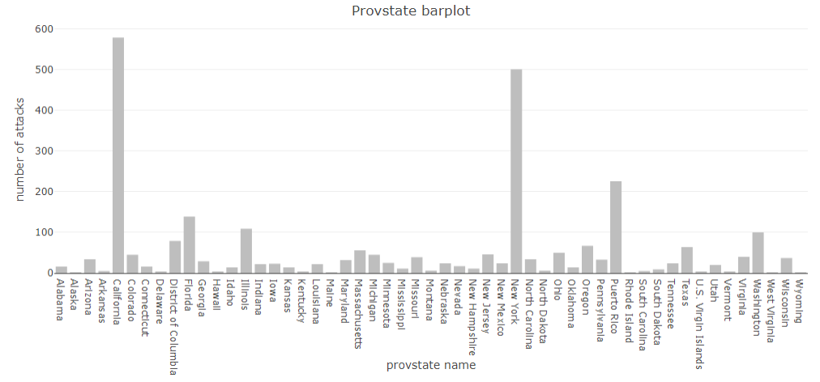

Variable city
In the following table, we can see the top 10 cities which have the biggest number of attacks recorded in the dataset. We can see that New York City has the most of all the cities by a huge margin, having more than four times the amount of incidents as San Juan, the city in second place. Moreover, taking into account the fact that the dataset records attacks of approximately the last 40 years, only the cities on the top of this table have a big amount of attacks and the rest of them only have occasional incidents: the number quickly goes down.
City name Number of attacks
439 New York City 449
566 San Juan 107
364 Los Angeles 102
562 San Francisco 97
682 Washington 80
399 Miami 69
128 Chicago 54
594 Seattle 39
61 Berkeley 32
173 Denver 23

Variable latitude
Because of the purpose of latitude in this study, it’s not really relevant to analyze and visualize it now.
summary(mydata$latitude)
Min. 1st Qu. Median Mean 3rd Qu. Max.
17.97 34.10 38.91 36.84 40.70 64.84

Variable longitude
Because of the purpose of longitude in this study, it’s not really relevant to analyze and visualize it now.
summary(mydata$longitude)
Min. 1st Qu. Median Mean 3rd Qu. Max.
-157.86 -117.87 -85.76 -92.13 -73.93 105.27

Variable doubtterr
Because of the meaning of this variable, it’s not necessary to give an analysis of it.
summary(mydata$doubtterr)
Mode FALSE TRUE NA's
logical 2207 398 133

Variable success
summary(mydata$success)
Mode FALSE TRUE
logical 496 2242
Since this is a logical variable, we will represent it with a pie chart.
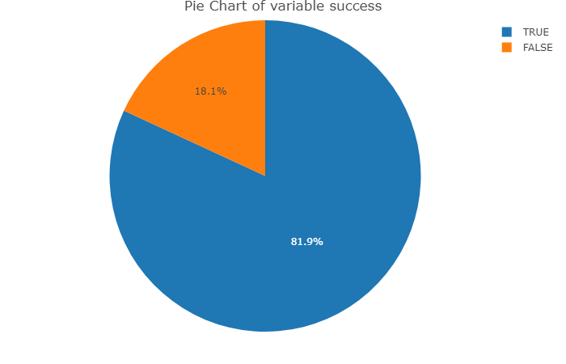
We can see that there are many more successful acts (~82%) than unsuccessful ones (~18%).

Variable attacktype1_txt
Mode(mydata$attacktype1_txt)
[1] Bombing/Explosion
8 Levels: Armed Assault Assassination ... Unarmed Assault
The most common method of attack type is “Bombing/Explosion”.
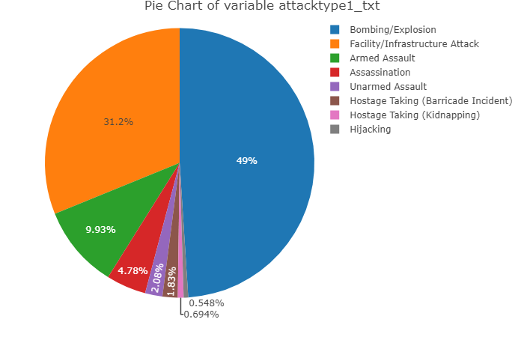
The category which has most acts is “Bombing/Explosion” which has 49% of the acts, followed by “Facility/Infrastructure Attack” with 31%.

Variable targtype1_txt
Mode(mydata$targtype1_txt)
[1] Business
21 Levels: Abortion Related Airports & Aircraft ... Violent Political Party
The most common target type is “Business”.
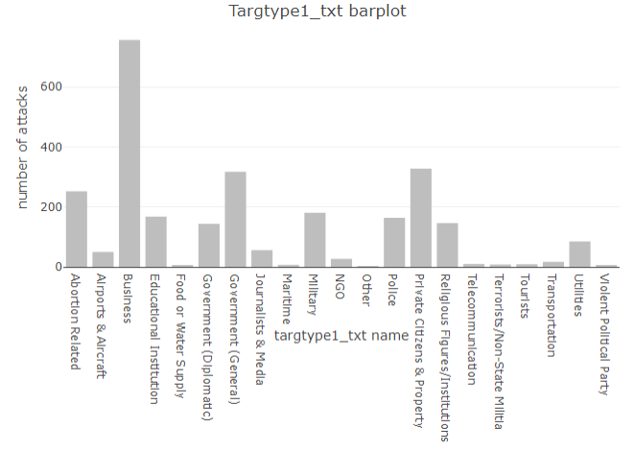
The “Business” target type has 28% of the records.

Variable natlty1_txt
Mode(mydata$natlty1_txt)
[1] United States
58 Levels: Angola Argentina Bahamas Bangladesh Brazil Canada ... Yugoslavia
Obviously the vast majority of the attacks are targeted towards the United States since that‘s the country we are studying.
We will remove the value “United States“ and take the most significative ones in order to make a proper comparison between the other values.
Nationality of victim Number of attacks
41 Puerto Rico 60
47 Soviet Union 45
12 Cuba 20
26 Israel 14
34 Mexico 13
22 International 12
52 Turkey 12
23 Iran 11
45 South Africa 11
57 Yugoslavia 10
16 Egypt 9
20 Haiti 9
55 Vietnam 9
54 Venezuela 8
21 India 6
As we see in those plots there are some nationalities that receive more acts of terrorism than others. Those are the cases of “Puerto Rico” with 60, “Soviet Union” with 45 and “Cuba” with 20.

Variable gname
Mode(mydata$gname)
[1] <NA>
229 Levels: Action Squad African-American extremists ... Zebra killers
Most of the acts of terrorism were either claimed by individuals or an unknown group.
f<-table(mydata$gname)
f1 = as.data.frame(f)
f2 = f1[order(-f1$Freq),]
f2 = subset(f2, f2$Freq > 20)
colnames(f2) = c ("Group name", "Number of attacks")
print(f2)
Group name Number of attacks
12 Anti-Abortion extremists 196
120 Left-Wing Militants 169
88 Fuerzas Armadas de Liberacion Nacional (FALN) 109
143 New World Liberation Front (NWLF) 86
222 White extremists 85
52 Black Nationalists 83
10 Animal Liberation Front (ALF) 76
197 Student Radicals 71
109 Jewish Defense League (JDL) 70
77 Earth Liberation Front (ELF) 66
146 Omega-7 50
220 Weather Underground, Weathermen 43
50 Black Liberation Army 36
126 Macheteros 36
18 Anti-Government extremists 33
57 Chicano Liberation Front 31
39 Armed Revolutionary Independence Movement (MIRA) 30
25 Anti-Muslim extremists 27
112 Jihadi-inspired extremists 27
116 Ku Klux Klan 25
53 Black Panthers 24
165 Puerto Rican Nationalists 23
196 Strikers 23
43 Army of God 21
73 Cuban Exiles 21
As we can see in this barplot there are a lot of group names. The one with more associated acts is “Anti-Abortion extremists” with 196 followed by “Left-Wing Militants” with 169.

Variable nperps
summary(mydata$nperps)
Min. 1st Qu. Median Mean 3rd Qu. Max. NA's
1.00 1.00 1.00 2.08 3.00 24.00 1941
The minimum value is 1 because it makes no sense that a crime has been commited by no perpetrators. In preprocessing we corrected those values by changing them to NA.
boxplot(mydata$nperps, main = "Boxplot of variable nperps")
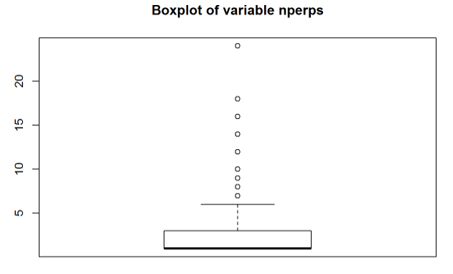
As we can see in this boxplot most of the acts of terrorism in the United States were perpetrated by individuals that worked alone.
skewness(mydata$nperps,na.rm = TRUE)
[1] 4.292201
This value tells us that this variable is asimetric, just as we have seen in the boxplot.
kurtosis(mydata$nperps,na.rm = TRUE)
[1] 32.51557
This value tells us that there is an extreme peak in the distribution where most of the values are clustered. The peak is number 1.

Variable nperpcap
summary(mydata$nperpcap)
Min. 1st Qu. Median Mean 3rd Qu. Max. NA's
0.000 0.000 1.000 1.239 1.500 11.000 1931
In this case the value 0 makes sense.
boxplot(mydata$nperpcap, main = "Boxplot of variable nperpcap")
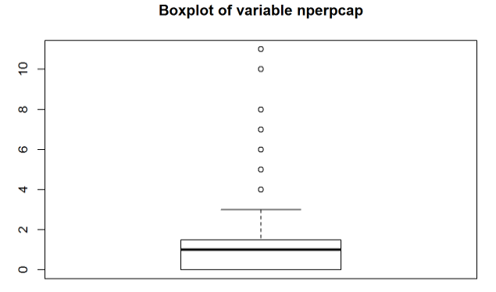
As we can see in this boxplot most of the time 0, 1 or 2 perpetrators are captured.
skewness(mydata$nperpcap,na.rm = TRUE)
[1] 2.244441
The positive value of skewness shows us that the variable value distribution is asimetric, its mode being a lower value than the median.
kurtosis(mydata$nperpcap,na.rm = TRUE)
[1] 10.33862
This value tells us that there is a peak in the distribution where most of the values are clustered. The peak values are numbers 0 and 1.

Variable claimed
summary(mydata$claimed)
Mode FALSE TRUE NA's
logical 1194 516 1028
As we can see in this pie chart ~70% of the acts were not claimed while ~30% of them were.
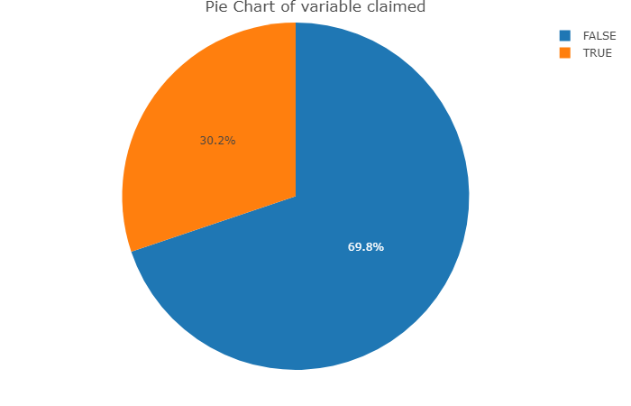

Variable claimmode_txt
summary(mydata$claimmode_txt)
Call (post-incident) Call (pre-incident)
82 11
E-mail Letter
9 105
Note left at scene Other
71 52
Personal claim Posted to website, blog, etc.
105 32
Video NA's
2 2269
As we see in the pie chart there are multiple methods of claiming an act with different occurance rates.
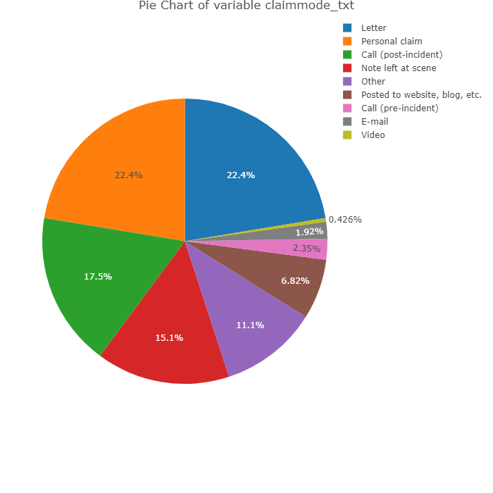

Variable weaptype1_txt
summary(mydata$weaptype1_txt)
Biological Chemical Explosives
23 20 1345
Fake Weapons Firearms Incendiary
4 390 834
Melee Other Radiological
43 16 1
Sabotage Equipment Vehicle NA's
17 8 37
f<-table(mydata$weaptype1_txt)
f1=as.data.frame(f)
plot_ly(f1, labels = ~Var1, values = ~Freq, type = 'pie', height = 750) %>%
layout(title = 'Pie Chart of variable weaptype1_txt',
xaxis = list(showgrid = FALSE, zeroline = FALSE, showticklabels = FALSE),
yaxis = list(showgrid = FALSE, zeroline = FALSE, showticklabels = FALSE))
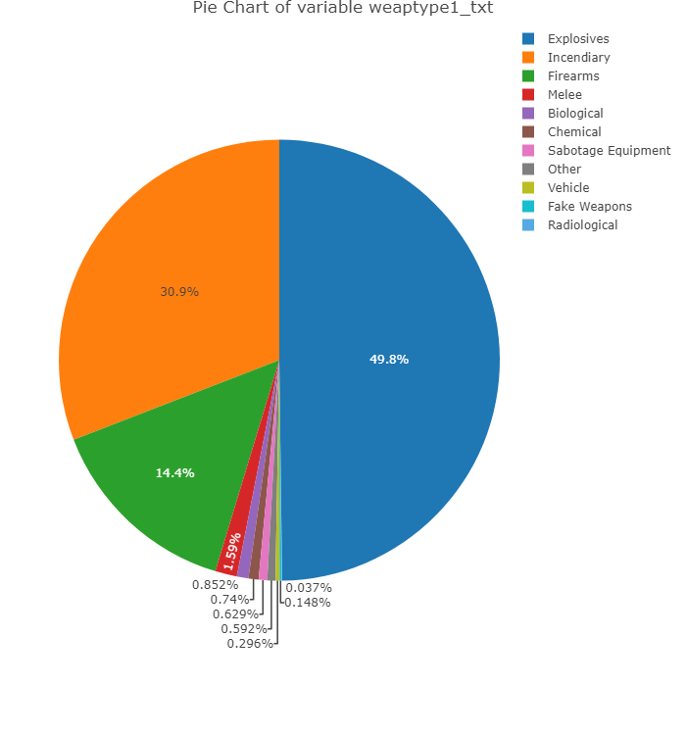
As we see in those plots, there is a big favourite weapon type used during the recorded acts of terrorism which is “Explosives” with 50%, followed by “Incendiary” with 31%.

Variable nkill
summary(mydata$nkill)
Min. 1st Qu. Median Mean 3rd Qu. Max.
0.0000 0.0000 0.0000 0.2772 0.0000 190.0000
Even though there are some extreme values like 190, the mean stays really close to 0. This gives us an idea of the amount of 0s this variable contains.
hist(mydata$nkill)
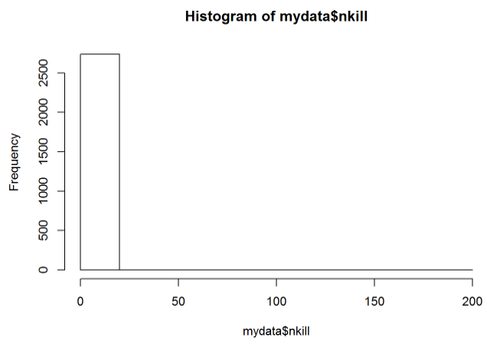
As we can see in this histogram most of the acts of terrorism do not have fatal victims.
skewness(mydata$nkill,na.rm = TRUE)
[1] 42.26456
This value tells us that this variable is widely asimetric, just as we have seen in the histogram.
kurtosis(mydata$nkill,na.rm = TRUE)
[1] 1987.84
This value tells us that there is an extreme peak in the distribution where most of the values are clustered. This peak is 0 as we have seen before.

Variable nkillus
summary(mydata$nkillus)
Min. 1st Qu. Median Mean 3rd Qu. Max.
0.0000 0.0000 0.0000 0.2341 0.0000 182.0000
This variable is very similar to nkill.
hist(mydata$nkillus)
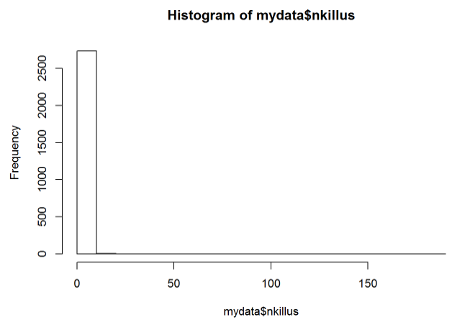
As we can see in this histogram most of the acts of terrorism do not have fatal victims of United States citizens.
skewness(mydata$nkillus,na.rm = TRUE)
[1] 43.20675
This value tells us that this variable is widely asimetric, just as we have seen in the histogram.
kurtosis(mydata$nperpcap,na.rm = TRUE)
[1] 10.33862
This value tells us that there is an extreme peak in the distribution where most of the values are clustered. This peak is 0 as we have seen before.

Variable nkillter
summary(mydata$nkillter)
Min. 1st Qu. Median Mean 3rd Qu. Max. NA's
0.000 0.000 0.000 0.036 0.000 5.000 931
This variable is very focused on 0 considering its max value is 5.
hist(mydata$nkillter)
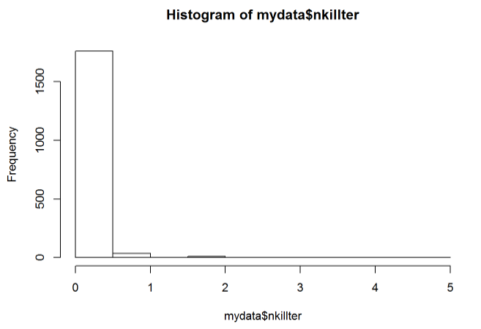
As we can see in this histogram most of the acts of terrorism do not have fatal victims terrorists.
skewness(mydata$nkillter,na.rm = TRUE)
[1] 10.19833
This positive value shows us that it is an asimetric variable.
kurtosis(mydata$nkillter,na.rm = TRUE)
[1] 140.5823
This positive value shows us that most values are clustered around a peak which is number 0 as we noticed before.

Variable nwound
summary(mydata$nwound)
Min. 1st Qu. Median Mean 3rd Qu. Max.
0.000 0.000 0.000 1.008 0.000 751.000
The maximum value of 751 is way off the mean. The 1st and 3rd quartile are 0 which tells us that most values are 0.
hist(mydata$nwound)
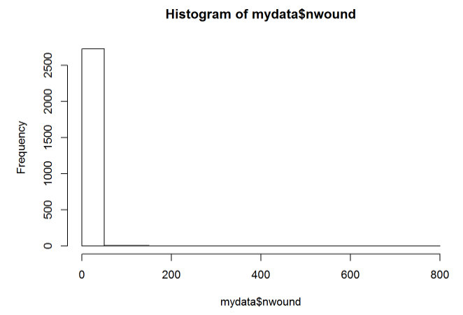
As we can see in this histogram most of the acts of terrorism do not have wounded victims.
skewness(mydata$nwound,na.rm = TRUE)
[1] 41.2821
This value tells us that this variable is very asimetric, just as we have seen in the histogram.
kurtosis(mydata$nperpcap,na.rm = TRUE)
[1] 10.33862
This value tells us that there is an extreme peak in the distribution where most of the values are clustered. This peak is 0 as we have seen before.

Variable nwoundus
summary(mydata$nwoundus)
Min. 1st Qu. Median Mean 3rd Qu. Max. NA's
0.00 0.00 0.00 1.07 0.00 751.00 881
The maximum value of 751 is way off the mean. The 1st and 3rd quartile are 0 which tells us that most values are 0.
hist(mydata$nwoundus)
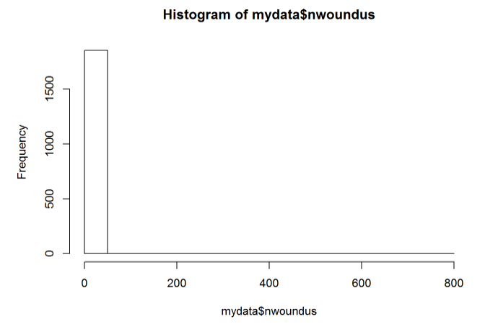
As we can see in this histogram most of the acts of terrorism do not have wounded United States citizens.
skewness(mydata$nwoundus,na.rm = TRUE)
[1] 38.63135
This positive value shows us that the variable is asimetric.
kurtosis(mydata$nperpcap,na.rm = TRUE)
[1] 10.33862
This positive value shows us that the values are clustered around a peak which is 0 in this case.

Variable nwoundte
summary(mydata$nwoundte)
Min. 1st Qu. Median Mean 3rd Qu. Max. NA's
0.0000 0.0000 0.0000 0.0465 0.0000 36.0000 932
This variable is very similar to nkillter. This is related to the fact that the number of perpetrators nperp is 1 most of the times.
hist(mydata$nwoundte)
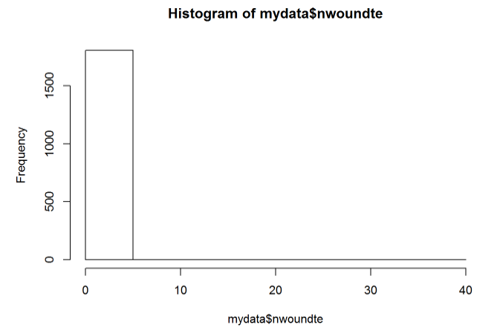
As we can see in this histogram most of the acts of terrorism do not have wounded terrorists.
skewness(mydata$nwoundte,na.rm = TRUE)
[1] 35.3397
This positive value shows us that this variable is asimetric.
kurtosis(mydata$nwoundte,na.rm = TRUE)
[1] 1364.17
This positive value shows us that there is an extreme peak where all values are clustered around.

Variable propvalue
summary(as.numeric(mydata$propvalue))
Min. 1st Qu. Median Mean 3rd Qu. Max. NA's
0 2500 20000 501607 100000 100000000 2078
mydata.propvaluelog <- sapply(as.vector(mydata$propvalue), function(x) log10(x))
boxplot(mydata$propvalue, main = "Boxplot of variable propvalue")
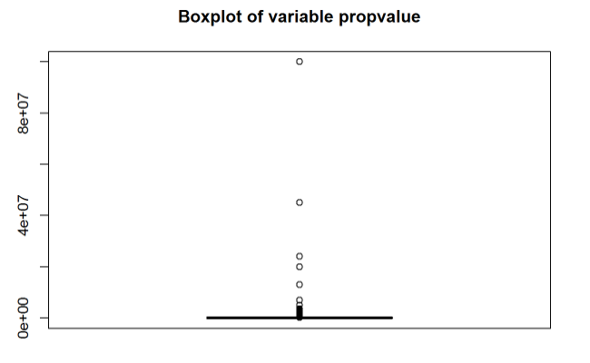
boxplot(mydata.propvaluelog, main = "Boxplot of variable propvalue", ylab = "log10(propvalue)")
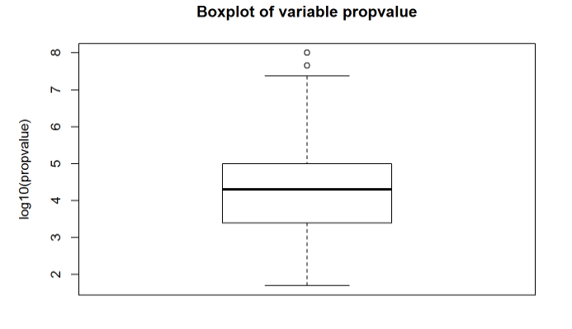
These are the boxplots for both the variable propvalue and its logarithm, because log(propvalue) is the one that appears to follow a normal distribution. We can observe that the majority of the incidents had very low valued property damage.
skewness(mydata$propvalue[!is.na(mydata$propvalue)])
[1] 18.4448
This value tells us that this variable is very asimetric, just as we have seen before.
kurtosis(mydata$propvalue[!is.na(mydata$propvalue)])
[1] 384.4994
This value shows us there is a big peak distribution which we know happens in the values close to zero.

Variable INT_IDEO
summary(mydata$INT_IDEO)
Mode FALSE TRUE NA's
logical 888 434 1416
This pie chart indicates the proportion of ideologically international registered incidents out of the total. Only one third of them, ~33%, was considered international by this criteria.
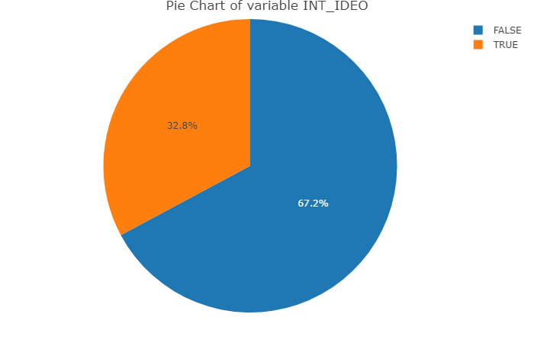

Variable INT_MISC
summary(mydata$INT_MISC)
Mode FALSE TRUE NA's
logical 2307 320 111
This pie chart indicates that only 12% of the registered incidents were international.
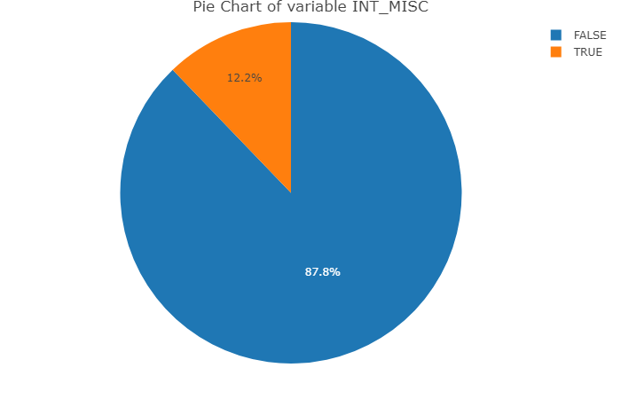

Variable president_party
summary(mydata$president_party)
Democratic Republican
842 1896
This is the distribution of the number of acts of terrorism and which was the president party at the time of the incident. We can see that the majority of the incidents (69%) happened under a Republican president.
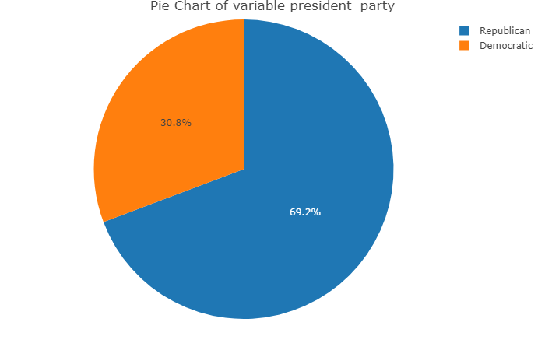

Variable state_governor_party
summary(mydata$state_governor_party)
Democrat
1019
Democrat, Independent
1
Democrat, Republican
302
Democratic-Farmer-Labor
8
Minnesota Independence Party
3
New Progressive Party
147
New Progressive Party of Puerto Rico (PNP)
1
Popular Democratic Party
78
Republican
960
NA's
219
This is the distribution of the number of acts of terrorism and which was the state governor party at the time of the incident. Under the Democrat and Republican parties, the two main ones in the country, there were a similar amount of incidents (40% and 38% respectively).
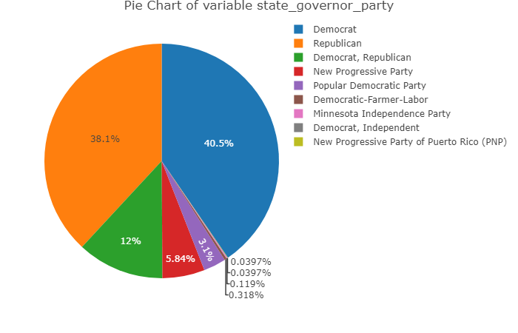

Variable date
We will not statistically analyse this variable because it makes no sense to check for any distributions or take conclusions with the data of the attacks since it is not a continuous variable.

Bivariate statistical analysis of relevant variables
For this section, we will be choosing different pairs of variables from our dataset which we think could have a relation between them and, if they do have one, it could be interesting to analyze and would let us extract some conclusions from it.
For each one of these pair of variables, we will make a step by step description of the analysis we‘ve done in R, alongside the results that the code gives us and some graphs to ilustrate the data.

Success Rate / attacktype1_txt
First we want to make an analysis and detect if there is any dependence between the variables attacktype1_txt and success. In order to do that, we create a table with the values of these two variables.
FALSE TRUE SuccessRate
Armed Assault 17 255 0.9375000
Assassination 52 79 0.6030534
Bombing/Explosion 307 1034 0.7710664
Facility/Infrastructure Attack 89 764 0.8956624
Hijacking 2 13 0.8666667
Hostage Taking (Barricade Incident) 3 47 0.9400000
Hostage Taking (Kidnapping) 0 19 1.0000000
Unarmed Assault 26 31 0.5438596
Then we do the chi-square test, in order to check if there is a dependency between these two variables or not.
Pearson's Chi-squared test
data: aux
X-squared = 159.95, df = 7, p-value < 2.2e-16
With a p-value of 2.2e-16, we can reject this test’s null hypothesis and conclude that this variables are, in fact, dependent.
Now we want to analyze the number of successful acts of each type of attack, using a grafical representation.
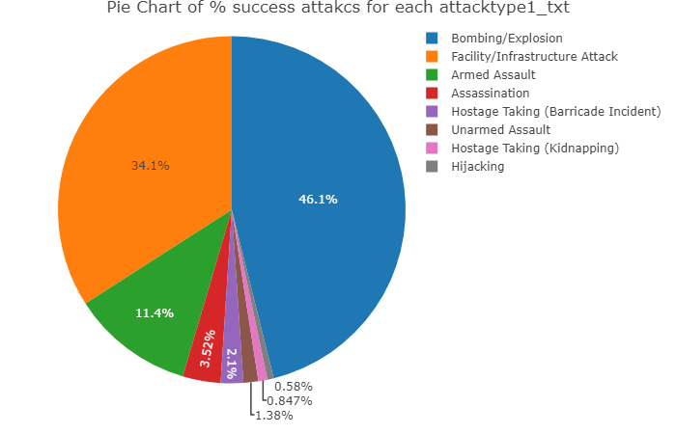

Success Rate / weaptype1_txt
First we want to analyze if there is any dependence between the variables weaptype1_txt and success. In order to do that, we create a table with the values of these two variables.
FALSE TRUE SuccessRate
Biological 11 12 0.5217391
Chemical 4 16 0.8000000
Explosives 314 1031 0.7665428
Fake Weapons 2 2 0.5000000
Firearms 45 345 0.8846154
Incendiary 94 740 0.8872902
Melee 2 41 0.9534884
Other 14 2 0.1250000
Radiological 1 0 0.0000000
Sabotage Equipment 1 16 0.9411765
Vehicle 0 8 1.0000000
Then we do the chi-square test, to check if there is a dependency between this two variables or not.
Pearson's Chi-squared test
data: aux
X-squared = 144.47, df = 10, p-value < 2.2e-16
With a p-value of 2.2e-16, we can reject this test’s null hypothesis and conclude that this variables are, in fact, dependent.
Now we want to analyze with grafical representation the number of successful acts of each weapon type.
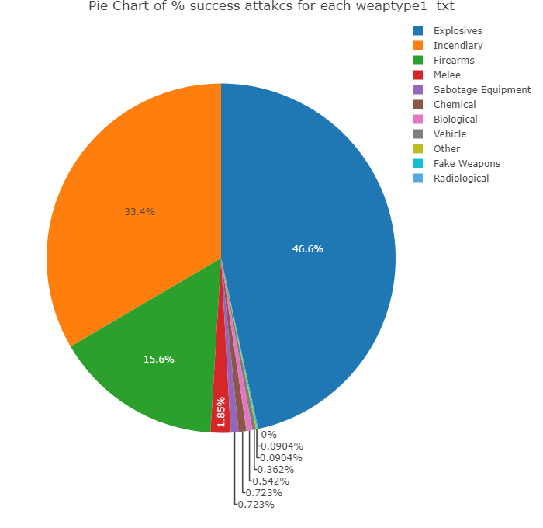

targtype1_txt / provstate
In this section we want to see if there is a relation between the different type of targets and the state where the attacks take place in.
Pearson's Chi-squared test
data: aux
X-squared = 2288.1, df = 1040, p-value < 2.2e-16
With a p-value of 2.2e-16 we can reject this test’s null hypothesis and conclude that this variables are, in fact, dependent.
Looking at the following table we can see that some big states like California, New York, Florida or Illinois and Puerto Rico have more variability in the type of targets.
aux2 = table(mydata$targtype1_txt,mydata$provstate);
aux2
Alabama Alaska Arizona Arkansas
Abortion Related 3 0 4 0
Airports & Aircraft 0 0 0 0
Business 2 0 5 3
Educational Institution 1 0 2 0
Food or Water Supply 0 0 0 0
Government (Diplomatic) 0 0 1 0
Government (General) 2 0 5 0
Journalists & Media 0 0 1 0
Maritime 0 0 0 0
Military 1 0 1 0
NGO 1 0 0 0
Other 0 0 0 0
Police 0 0 0 1
Private Citizens & Property 4 0 9 0
Religious Figures/Institutions 2 0 2 0
Telecommunication 0 0 0 0
Terrorists/Non-State Militia 0 0 0 0
Tourists 0 0 0 0
Transportation 0 0 1 0
Utilities 0 1 3 1
Violent Political Party 0 0 0 0
California Colorado Connecticut Delaware
Abortion Related 31 4 0 1
Airports & Aircraft 6 0 0 0
Business 173 4 5 0
Educational Institution 55 4 2 0
Food or Water Supply 0 0 0 0
Government (Diplomatic) 19 0 0 0
Government (General) 70 7 1 0
Journalists & Media 14 1 0 0
Maritime 0 0 0 0
Military 31 4 2 0
NGO 5 1 1 1
Other 0 0 0 0
Police 38 6 0 0
Private Citizens & Property 76 12 2 0
Religious Figures/Institutions 17 1 3 0
Telecommunication 1 0 0 0
Terrorists/Non-State Militia 0 0 0 0
Tourists 4 0 0 0
Transportation 2 1 0 1
Utilities 36 0 0 0
Violent Political Party 1 0 0 0
District of Columbia Florida Georgia
Abortion Related 3 20 5
Airports & Aircraft 1 7 1
Business 5 39 5
Educational Institution 0 10 3
Food or Water Supply 0 0 0
Government (Diplomatic) 26 4 0
Government (General) 28 11 3
Journalists & Media 2 11 0
Maritime 0 2 0
Military 4 4 3
NGO 3 1 1
Other 0 0 0
Police 0 5 2
Private Citizens & Property 5 10 5
Religious Figures/Institutions 1 10 1
Telecommunication 0 0 0
Terrorists/Non-State Militia 1 2 0
Tourists 0 0 0
Transportation 0 1 0
Utilities 0 1 0
Violent Political Party 0 1 0
Hawaii Idaho Illinois Indiana Iowa Kansas
Abortion Related 0 1 11 4 0 4
Airports & Aircraft 1 0 2 0 0 0
Business 0 6 26 3 9 2
Educational Institution 1 0 6 0 1 2
Food or Water Supply 0 0 0 0 0 0
Government (Diplomatic) 0 0 2 0 0 0
Government (General) 0 1 19 3 1 0
Journalists & Media 0 0 0 0 0 0
Maritime 0 0 0 0 0 0
Military 2 3 8 1 0 1
NGO 0 0 2 1 0 0
Other 0 0 0 0 0 0
Police 0 0 16 2 4 1
Private Citizens & Property 0 0 13 6 5 2
Religious Figures/Institutions 0 3 3 2 0 2
Telecommunication 0 0 0 0 0 0
Terrorists/Non-State Militia 0 0 0 0 0 0
Tourists 0 0 0 0 0 0
Transportation 0 0 0 0 0 0
Utilities 0 0 1 0 3 0
Violent Political Party 0 0 0 0 0 0
Kentucky Louisiana Maine Maryland
Abortion Related 0 5 0 5
Airports & Aircraft 0 2 0 0
Business 1 2 1 2
Educational Institution 0 2 0 1
Food or Water Supply 0 1 0 1
Government (Diplomatic) 0 0 0 1
Government (General) 0 1 0 7
Journalists & Media 1 0 0 1
Maritime 0 0 0 0
Military 0 0 0 2
NGO 0 0 0 0
Other 0 0 0 0
Police 0 3 0 3
Private Citizens & Property 2 4 0 7
Religious Figures/Institutions 0 1 0 0
Telecommunication 0 0 0 0
Terrorists/Non-State Militia 0 0 0 0
Tourists 0 0 0 0
Transportation 0 0 0 0
Utilities 0 1 0 2
Violent Political Party 0 0 0 0
Massachusetts Michigan Minnesota
Abortion Related 4 5 7
Airports & Aircraft 2 2 0
Business 9 8 6
Educational Institution 9 9 2
Food or Water Supply 0 0 0
Government (Diplomatic) 2 1 0
Government (General) 4 2 3
Journalists & Media 1 0 0
Maritime 0 1 0
Military 4 1 2
NGO 1 0 0
Other 0 0 0
Police 4 5 2
Private Citizens & Property 6 7 2
Religious Figures/Institutions 9 3 1
Telecommunication 0 0 0
Terrorists/Non-State Militia 0 0 0
Tourists 0 0 0
Transportation 0 1 0
Utilities 1 0 0
Violent Political Party 0 0 0
Mississippi Missouri Montana Nebraska
Abortion Related 0 8 4 2
Airports & Aircraft 0 0 0 1
Business 1 7 0 3
Educational Institution 1 1 0 0
Food or Water Supply 0 0 0 0
Government (Diplomatic) 0 0 0 0
Government (General) 1 5 0 0
Journalists & Media 4 0 0 0
Maritime 0 0 0 0
Military 0 2 0 0
NGO 0 0 0 0
Other 0 0 0 0
Police 0 2 2 1
Private Citizens & Property 3 5 0 10
Religious Figures/Institutions 1 7 0 2
Telecommunication 0 0 0 0
Terrorists/Non-State Militia 0 0 0 0
Tourists 0 0 0 0
Transportation 0 1 0 1
Utilities 0 1 0 4
Violent Political Party 0 0 0 0
Nevada New Hampshire New Jersey
Abortion Related 2 3 3
Airports & Aircraft 0 0 1
Business 3 3 20
Educational Institution 0 0 0
Food or Water Supply 0 0 0
Government (Diplomatic) 0 0 0
Government (General) 6 3 0
Journalists & Media 0 0 0
Maritime 0 0 1
Military 1 0 1
NGO 0 0 1
Other 1 0 0
Police 1 1 4
Private Citizens & Property 1 0 9
Religious Figures/Institutions 2 1 3
Telecommunication 0 0 0
Terrorists/Non-State Militia 0 0 0
Tourists 0 0 0
Transportation 0 0 1
Utilities 0 0 0
Violent Political Party 0 0 2
New Mexico New York North Carolina
Abortion Related 8 9 10
Airports & Aircraft 0 17 1
Business 4 202 6
Educational Institution 1 14 3
Food or Water Supply 0 1 0
Government (Diplomatic) 0 77 0
Government (General) 0 35 1
Journalists & Media 0 10 0
Maritime 0 0 0
Military 1 21 2
NGO 1 5 0
Other 0 1 0
Police 1 31 0
Private Citizens & Property 4 47 9
Religious Figures/Institutions 4 13 2
Telecommunication 0 1 0
Terrorists/Non-State Militia 0 5 0
Tourists 0 5 0
Transportation 0 5 0
Utilities 0 1 0
Violent Political Party 0 1 0
North Dakota Ohio Oklahoma Oregon
Abortion Related 3 19 8 13
Airports & Aircraft 0 0 0 1
Business 1 6 0 19
Educational Institution 0 0 3 7
Food or Water Supply 0 0 0 0
Government (Diplomatic) 0 0 0 0
Government (General) 0 2 1 14
Journalists & Media 0 1 0 0
Maritime 0 0 0 0
Military 0 3 0 3
NGO 0 0 0 0
Other 0 0 0 0
Police 1 3 0 2
Private Citizens & Property 1 12 1 5
Religious Figures/Institutions 0 2 1 1
Telecommunication 0 0 0 0
Terrorists/Non-State Militia 0 0 0 0
Tourists 0 0 0 0
Transportation 0 0 0 0
Utilities 0 1 0 2
Violent Political Party 0 1 0 0
Pennsylvania Puerto Rico Rhode Island
Abortion Related 1 0 0
Airports & Aircraft 0 3 0
Business 9 82 1
Educational Institution 1 7 0
Food or Water Supply 0 1 0
Government (Diplomatic) 1 9 0
Government (General) 5 36 1
Journalists & Media 0 2 0
Maritime 0 3 0
Military 1 51 0
NGO 0 0 0
Other 0 0 0
Police 6 7 0
Private Citizens & Property 6 5 0
Religious Figures/Institutions 2 0 0
Telecommunication 0 4 0
Terrorists/Non-State Militia 0 0 0
Tourists 0 0 0
Transportation 1 0 0
Utilities 0 16 0
Violent Political Party 0 0 0
South Carolina South Dakota Tennessee
Abortion Related 0 3 0
Airports & Aircraft 0 0 0
Business 0 0 2
Educational Institution 0 0 2
Food or Water Supply 0 0 0
Government (Diplomatic) 0 0 0
Government (General) 1 4 0
Journalists & Media 0 0 0
Maritime 0 0 0
Military 0 0 2
NGO 0 0 0
Other 0 0 0
Police 0 0 2
Private Citizens & Property 0 1 6
Religious Figures/Institutions 4 0 10
Telecommunication 0 0 0
Terrorists/Non-State Militia 0 0 0
Tourists 0 0 0
Transportation 0 0 0
Utilities 0 1 0
Violent Political Party 0 0 0
Texas U.S. Virgin Islands Utah Vermont
Abortion Related 13 0 0 3
Airports & Aircraft 1 0 0 0
Business 5 0 10 0
Educational Institution 3 0 3 0
Food or Water Supply 0 0 0 0
Government (Diplomatic) 1 0 0 0
Government (General) 5 1 2 0
Journalists & Media 1 0 0 0
Maritime 0 0 0 0
Military 2 2 1 0
NGO 0 0 0 0
Other 0 0 0 0
Police 6 0 0 0
Private Citizens & Property 10 0 2 0
Religious Figures/Institutions 14 0 1 0
Telecommunication 2 0 0 0
Terrorists/Non-State Militia 0 0 0 0
Tourists 0 0 0 0
Transportation 0 0 0 0
Utilities 1 0 1 1
Violent Political Party 0 0 0 0
Virginia Washington West Virginia
Abortion Related 9 11 0
Airports & Aircraft 0 1 0
Business 6 40 0
Educational Institution 0 7 1
Food or Water Supply 0 0 0
Government (Diplomatic) 0 0 0
Government (General) 7 14 1
Journalists & Media 4 1 0
Maritime 0 0 0
Military 3 4 0
NGO 2 0 0
Other 0 0 0
Police 0 0 0
Private Citizens & Property 3 10 0
Religious Figures/Institutions 5 8 0
Telecommunication 0 1 0
Terrorists/Non-State Militia 0 0 0
Tourists 0 0 0
Transportation 0 1 0
Utilities 1 2 0
Violent Political Party 0 0 0
Wisconsin Wyoming
Abortion Related 3 0
Airports & Aircraft 0 0
Business 10 1
Educational Institution 4 0
Food or Water Supply 0 0
Government (Diplomatic) 0 0
Government (General) 3 1
Journalists & Media 1 0
Maritime 0 0
Military 7 0
NGO 0 0
Other 0 0
Police 2 0
Private Citizens & Property 1 0
Religious Figures/Institutions 2 0
Telecommunication 1 0
Terrorists/Non-State Militia 0 0
Tourists 0 0
Transportation 0 0
Utilities 3 0
Violent Political Party 0 0
With this pie chart we can see that the most popular/common target types are:
Business - individuals or organizations engaged in commercial or mercantile activity as a means of livelihood.
Private Citizens & Property - includes attacks on individuals, the public in general or attacks in public areas including markets, commercial streets, busy intersections and pedestrian malls.
Government (General) - any attack on a government building; government member, former members, including members of political parties in official capacities, their convoys, or events sponsored by political parties; political movements; or a government sponsored institution where the attack is expressly carried out to harm the government.
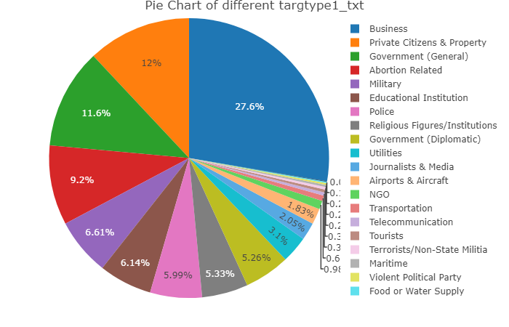

Success Rate / targtype1_txt
Here we want to study if there is a relation between targtype1_txt and success. In order to do this we execute chisq.test(), which gives us the next results:
Pearson's Chi-squared test
data: aux
X-squared = 56.208, df = 20, p-value = 2.704e-05
With a p-value of 2.704e-05 we can reject this test’s null hypothesis and conclude that this variables are, in fact, dependent.
In the following table we can see the success rate of each target types implicated in attacks.
FALSE TRUE SuccessRate
Abortion Related 38 214 0.8492063
Airports & Aircraft 11 39 0.7800000
Business 117 640 0.8454425
Educational Institution 38 130 0.7738095
Food or Water Supply 1 3 0.7500000
Government (Diplomatic) 32 112 0.7777778
Government (General) 87 230 0.7255521
Journalists & Media 11 45 0.8035714
Maritime 0 7 1.0000000
Military 39 142 0.7845304
NGO 5 22 0.8148148
Other 0 2 1.0000000
Police 29 135 0.8231707
Private Citizens & Property 52 276 0.8414634
Religious Figures/Institutions 14 132 0.9041096
Telecommunication 5 5 0.5000000
Terrorists/Non-State Militia 1 7 0.8750000
Tourists 0 9 1.0000000
Transportation 6 11 0.6470588
Utilities 10 75 0.8823529
Violent Political Party 0 6 1.0000000

nperpcap / claimmode_txt
We think it might be interesting to know whether the way in which the perpretators claimed the attack affects or helps capturing them. To determine that we use the next table, which contains the times each number of perpetrators where captured depending on that variable.
0 1 2 3 4 5 6 7 8 10 11
Call (post-incident) 0 3 2 2 0 0 0 0 0 0 0
Call (pre-incident) 2 5 0 0 0 0 0 0 0 0 0
E-mail 6 0 1 1 0 0 0 0 0 0 0
Letter 17 22 3 4 8 4 0 0 0 0 0
Note left at scene 22 15 1 3 2 0 0 0 0 0 0
Other 2 11 1 1 1 0 0 0 0 0 0
Personal claim 15 82 4 2 1 0 0 0 0 0 1
Posted to website, blog, etc. 10 5 1 1 0 1 0 0 0 0 0
Video 2 0 0 0 0 0 0 0 0 0 0
We will also represent this with a boxplot to make the visualization easier.
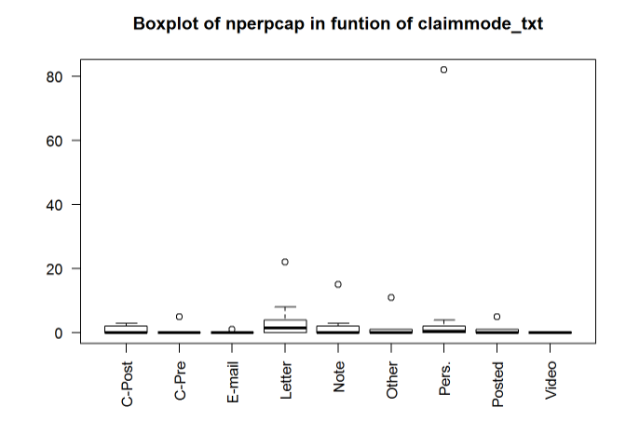
Legend: “C-Post: Call (post-incident)”, “C-Pre: Call (pre-incident)”, “E-mail: E-mail”, “Letter: Letter”, “Note: Note left at scene”, “Other: Other”, “Pers.: Personal claim”, “Posted: Posted to website, blog, etc.”, “Video: Video”
With this boxplot we can obviously see that “Personal claim” has the biggest number of perpetrators captured. We don’t consider it an outlier, but we want to see how the boxplot would change if we deleted this particular case. So in the next boxplot we decide to ignore this specific claimed mode.
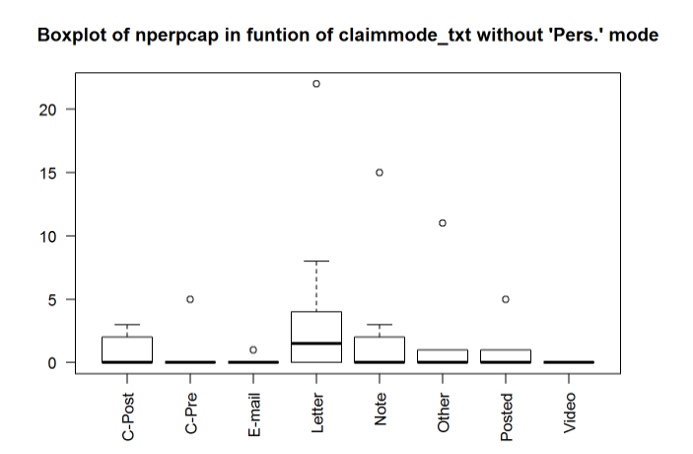

Legend: “C-Post: Call (post-incident)”, “C-Pre: Call (pre-incident)”, “E-mail: E-mail”, “Letter: Letter”, “Note: Note left at scene”, “Other: Other”, “Posted: Posted to website, blog, etc.”, “Video: Video”
Here we can see that “Letter” and “Note left at scene” are the next two claimed modes with the biggest number of captured perpetrators.

nkill / weaptype1_txt
In this section we study if there is a dependence between the weapon type and number of kills. First of all we make a table with the corresponding variables and see what our data looks like.
0 1 2 3 4 5 6 7 8 9
Biological 18 3 2 0 0 0 0 0 0 0
Chemical 20 0 0 0 0 0 0 0 0 0
Explosives 1301 35 5 1 1 0 0 0 0 0
Fake Weapons 4 0 0 0 0 0 0 0 0 0
Firearms 203 128 35 6 4 3 2 2 2 1
Incendiary 826 5 2 0 0 0 0 0 0 0
Melee 29 12 1 1 0 0 0 0 0 0
Other 16 0 0 0 0 0 0 0 0 0
Radiological 1 0 0 0 0 0 0 0 0 0
Sabotage Equipment 16 1 0 0 0 0 0 0 0 0
Vehicle 3 2 1 0 0 0 0 0 0 0
10 11 13 15 16 44 50 190
Biological 0 0 0 0 0 0 0 0
Chemical 0 0 0 0 0 0 0 0
Explosives 0 1 0 0 1 0 0 0
Fake Weapons 0 0 0 0 0 0 0 0
Firearms 1 0 1 1 0 0 1 0
Incendiary 0 0 0 1 0 0 0 0
Melee 0 0 0 0 0 0 0 0
Other 0 0 0 0 0 0 0 0
Radiological 0 0 0 0 0 0 0 0
Sabotage Equipment 0 0 0 0 0 0 0 0
Vehicle 0 0 0 0 0 1 0 1
With this table we understand that there are some columns that have no sense for the study we want to do, so we decide to remove them and prepare our data for the boxplot.

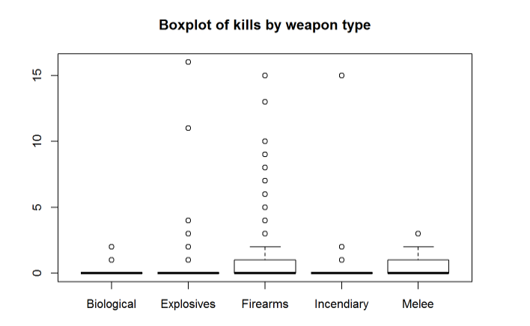

The vast majority of the cases have 0 kills so the graphical representation does not give us much information.

nwound / weaptype1_txt
For these two variables, we‘ll do the same type of study as in the “nkill / weaptype1_txt” section: we repeat the same process we followed for those two, but in this case with the pair of variables “nwound / weaptype1_txt”.
0 1 2 3 4 5 6 7 8 9
Biological 13 3 2 0 0 1 2 0 0 0
Chemical 15 1 0 2 0 0 0 0 0 0
Explosives 1205 71 23 11 9 2 1 4 2 0
Fake Weapons 4 0 0 0 0 0 0 0 0 0
Firearms 266 60 23 11 8 4 4 2 2 4
Incendiary 796 22 10 1 0 1 0 0 1 0
Melee 16 17 1 5 2 1 0 0 0 0
Other 15 1 0 0 0 0 0 0 0 0
Radiological 1 0 0 0 0 0 0 0 0 0
Sabotage Equipment 16 0 0 0 0 0 0 0 0 0
Vehicle 3 0 0 0 0 0 1 0 0 1
10 11 12 13 15 16 17 19 20 22
Biological 0 0 0 0 0 0 0 0 0 0
Chemical 1 0 0 0 0 0 0 0 0 0
Explosives 3 1 0 1 1 1 2 0 1 1
Fake Weapons 0 0 0 0 0 0 0 0 0 0
Firearms 1 0 0 1 0 0 0 0 1 0
Incendiary 0 0 1 0 0 0 0 0 0 0
Melee 1 0 0 0 0 0 0 0 0 0
Other 0 0 0 0 0 0 0 0 0 0
Radiological 0 0 0 0 0 0 0 0 0 0
Sabotage Equipment 0 0 0 0 0 0 0 0 0 0
Vehicle 0 0 0 0 1 0 0 1 0 0
24 25 27 29 32 53 74 78 106 110
Biological 0 1 0 0 0 0 0 0 0 0
Chemical 0 0 0 0 1 0 0 0 0 0
Explosives 0 0 0 1 0 1 1 0 0 1
Fake Weapons 0 0 0 0 0 0 0 0 0 0
Firearms 1 0 0 0 1 1 0 0 0 0
Incendiary 0 0 1 0 0 0 0 0 0 0
Melee 0 0 0 0 0 0 0 0 0 0
Other 0 0 0 0 0 0 0 0 0 0
Radiological 0 0 0 0 0 0 0 0 0 0
Sabotage Equipment 0 0 0 0 0 0 0 1 0 0
Vehicle 0 0 0 0 0 0 0 0 1 0
132 151 751
Biological 0 0 1
Chemical 0 0 0
Explosives 2 0 0
Fake Weapons 0 0 0
Firearms 0 0 0
Incendiary 0 1 0
Melee 0 0 0
Other 0 0 0
Radiological 0 0 0
Sabotage Equipment 0 0 0
Vehicle 0 0 0
Most of the weapon types have small quantities of kills which would distort our representation. We will remove those types for the graphical comparison just as we did before.

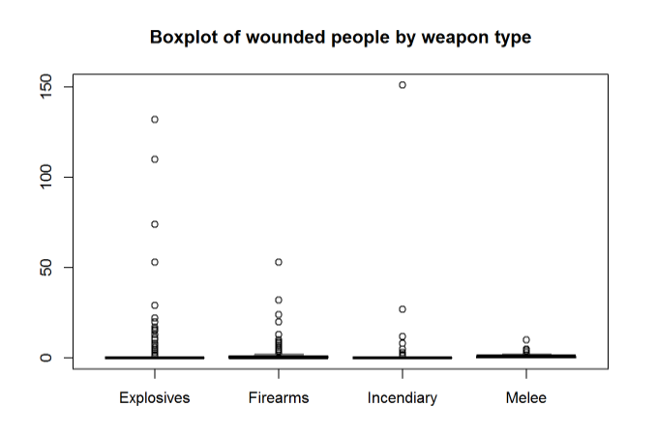

The vast majority of the cases have 0 wounded, so the graphical representation does not give us much information.

nº acts / year date
In this analysis, we want to look into the distribution of acts over the years. We will see 10 year intervals and 1970-2017 graphs in order to compare them properly.

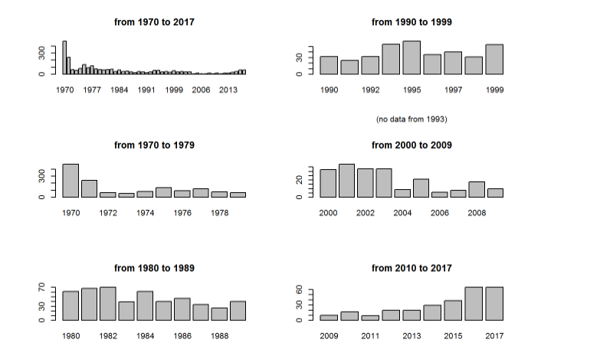
We can see that the year with the biggest amount acts of terrorism is, by far, 1970. We can clearly see, however, that in the last graph (which contains the years ranging from 2010 to 2017) there is an increasing tendency.

nº acts / month
In this analysis we want to see what is the distribution of acts of terrorism over the months in order to see if there is any anomaly.
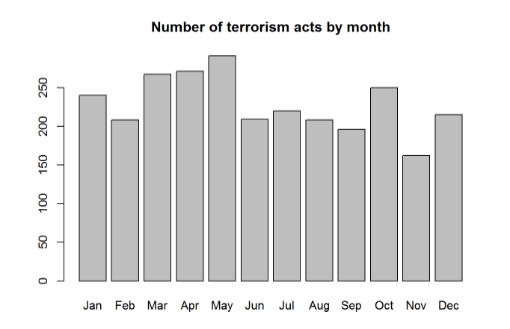

The acts are fairly uniformly distributed, with the preferred month being May and the least favorite being November.

provstate / gname
These two categorical variables seem interesting to analyze, but first we need to bee sure if there is a relation between them. As we know, in order to do this we can use the chi square test.
Pearson's Chi-squared test
data: mydata$provstate and mydata$gname
X-squared = 23839, df = 11400, p-value < 2.2e-16
With a p-value of 2.2e-16, we can reject this test’s null hypothesis and conclude this variables are, in fact, dependent.

gname / provstate (top 3 provstate)
In this analysis, we want to see the distributions of acts of terrorism by each group in the 3 most striked states.
We will remove the gname with less than 9 apperances in order to properly view the result, as we will not consider them relevant to our study.
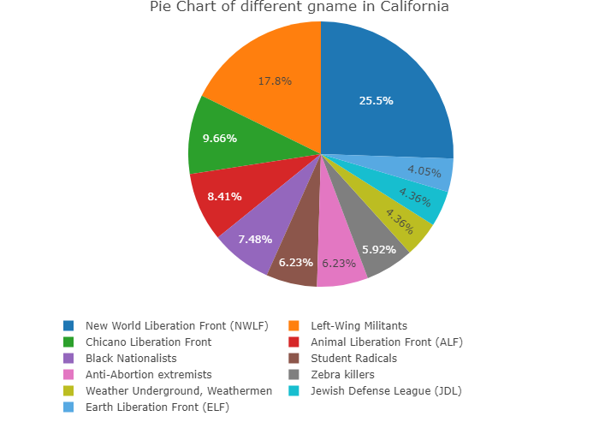
We can see that 25.5% of the acts of terrorism in California are from the same group.
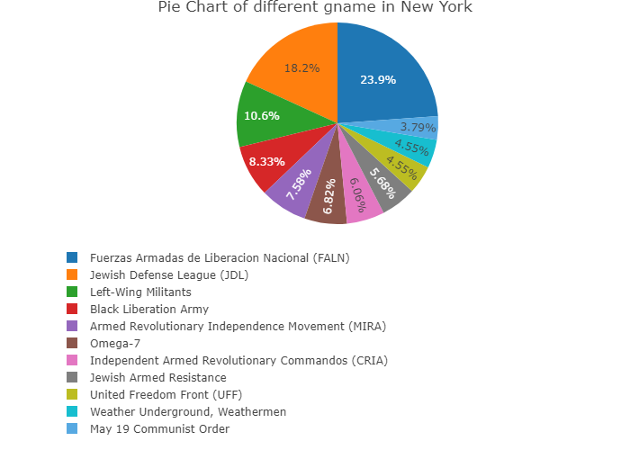
Most of the names of this pie chart do not match the ones in the California one. This confirms us that different groups focus different states.
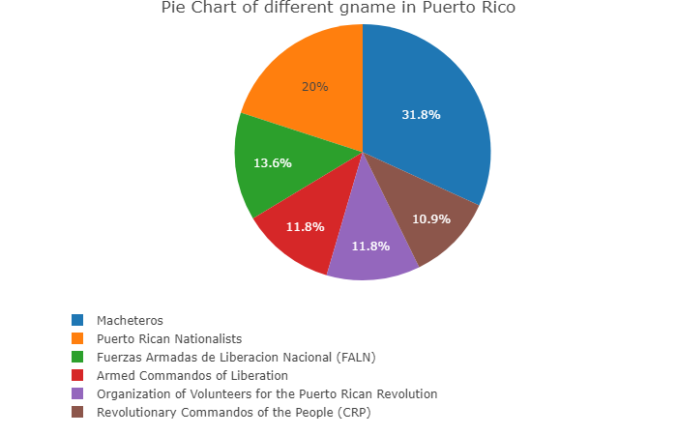
By the names of the groups and the quantity of them we can already see that Puerto Rico’s terrorist attacks are majorly internal.

provstate / gname (top 3 gname)
In this analysis we want to identify in which states a given gname has committed acts of terrorism. This will provide us insight of the group’s target population.
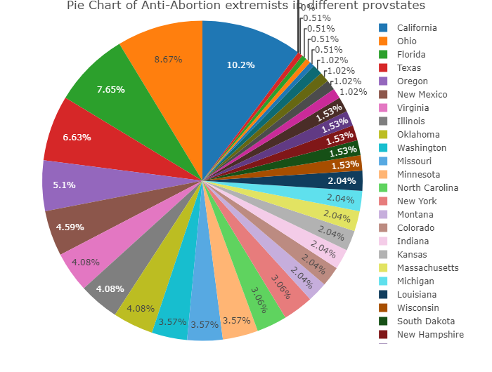
We can see that this group widely distributed their acts of terrorism over the states.
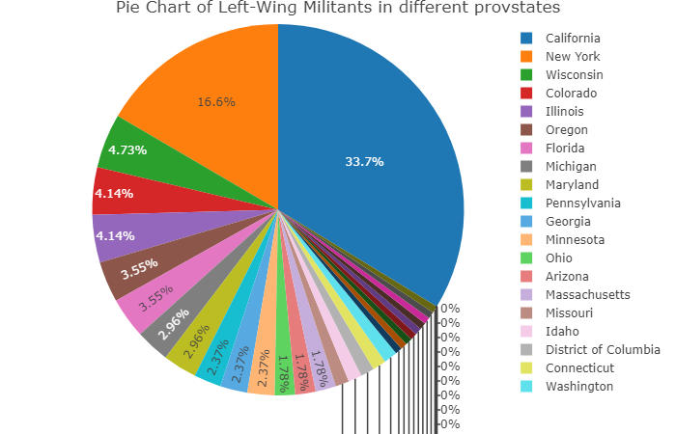
We can see that this group’s acts were fairly distributed, although half of them were targeted to the two main victim states.
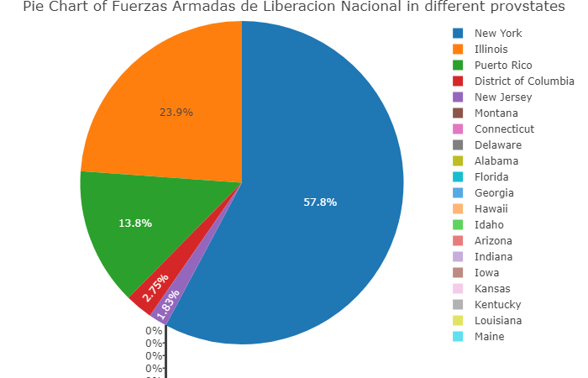
In this case we can clearly see that the acts were targeted towards the states of New York, Illinois and Puerto Rico.

Event Rate / state_governor_party (top 3 provstates)
We want to know what is the percentage of acts committed during the ruling of each state_governor_party. Only the 3 states with most recorded acts will be considered, because in some of the states the sample size would be too small.
We will remove the minor state_governor_parties with less than 9 apperances in order to properly view the result as we will not consider them relevant to our study.
First, we will check California as it is the state with the most recorded acts of terrorism (532).
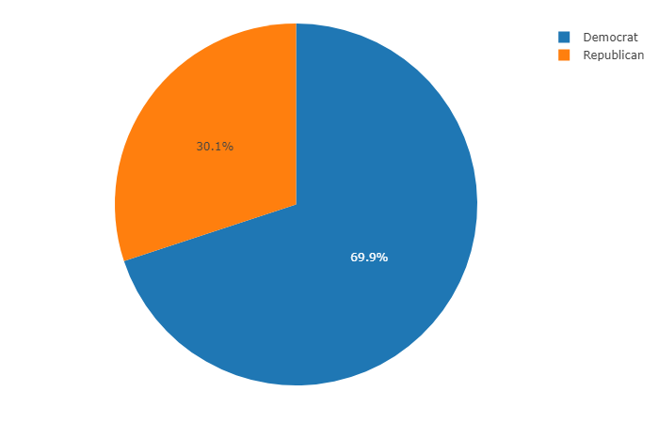
Not considering the outliers, we can see that 69.9% of the acts were committed in this state while the Democrat party was ruling.
We will do the same analysis with New York as it is the second state with most recorded acts of terrorism (473).
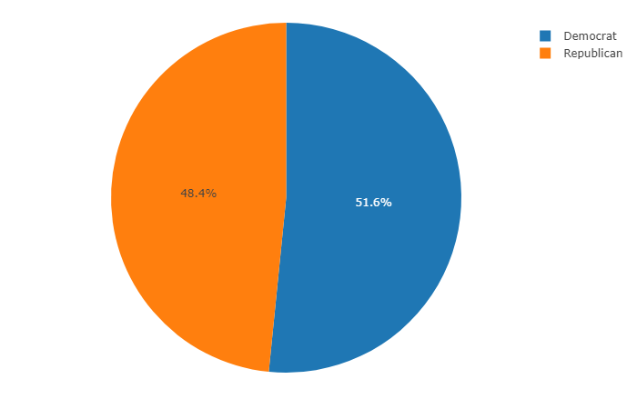
In this case the ratio is more equaly distributed, with 51.6% for the Democrats
Lastly we will do the same analysis with Puerto Rico as it is the third state with most recorded acts of terrorism (226).
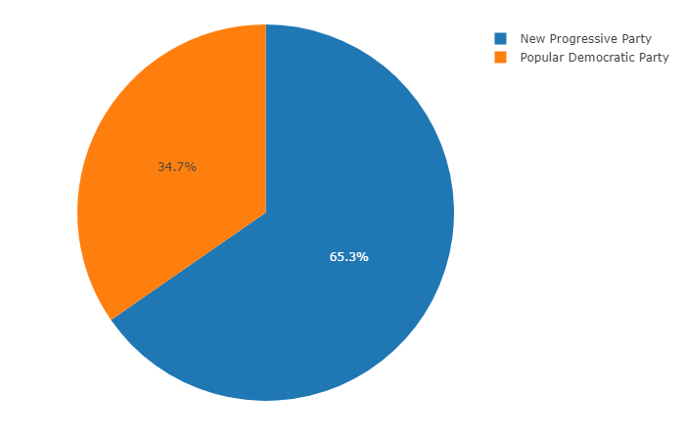
In the pie chart we can see that 65.3% of the acts were commited while the New Progressive Party was ruling.

Success Rate / president_party
In this analysis we want to check what is the ratio of success of terrorist acts while each president_party was ruling.
success = mydata$president_party[mydata$success == TRUE]
fail = mydata$president_party[mydata$success == FALSE]
success = as.data.frame(table(success))
fail = as.data.frame(table(fail))
s = success[2]+fail[2]
ts = 100*success[2]/s
tf = 100*fail[2]/s
s=c(ts[1,1],ts[2,1])
f=c(tf[1,1],tf[2,1])
t <- cbind(s,f);
colnames(t) <- c("Success", "Fail")
rownames(t) <- c("Democratic", "Republican")
print(t)

Success Fail
Democratic 79.57245 20.42755
Republican 82.91139 17.08861
As we can see, both parties have similar success rates.

