Bivariate statistical analysis of relevant variables

#### Success Rate / attacktype1_txt

First we want to make an analysis and detect if there is a dependence between the variables attacktype1_txt and success. In order to do that, we make a table with the values of these two variables.

FALSE TRUE SuccessRate  
Armed Assault 17 255 0.9375000  
Assassination 52 79 0.6030534  
Bombing/Explosion 307 1034 0.7710664  
Facility/Infrastructure Attack 89 764 0.8956624  
Hijacking 2 13 0.8666667  
Hostage Taking (Barricade Incident) 3 47 0.9400000  
Hostage Taking (Kidnapping) 0 19 1.0000000  
Unarmed Assault 26 31 0.5438596

And then we do the chi-square test, in order to check if there is a dependency between these two variables or not.

Pearson's Chi-squared test  
  
data: aux  
X-squared = 159.95, df = 7, p-value < 2.2e-16

With a p-value of 2.2e-16, we can reject this test’s null hypothesis and conclude that this variables are, in fact, dependent.

Now we want to analyze the number of successful acts of each type of attack, using a grafical representation.

#### Success Rate / weaptype1_txt

First we want to analyze if there is a dependence between the variables weaptype1_txt and success. In order to do that we make a table with the values of these two variables.

FALSE TRUE SuccessRate  
Biological 11 12 0.5217391  
Chemical 4 16 0.8000000  
Explosives 314 1031 0.7665428  
Fake Weapons 2 2 0.5000000  
Firearms 45 345 0.8846154  
Incendiary 94 740 0.8872902  
Melee 2 41 0.9534884  
Other 14 2 0.1250000  
Radiological 1 0 0.0000000  
Sabotage Equipment 1 16 0.9411765  
Vehicle 0 8 1.0000000

And then we do the chi-square test, to check if there is a dependency between this two variables or not.

Pearson's Chi-squared test  
  
data: aux  
X-squared = 144.47, df = 10, p-value < 2.2e-16

With a p-value of 2.2e-16, we can reject this test’s null hypothesis and conclude that this variables are, in fact, dependent.

Now we want to analyze with grafical representation the number of successful acts of each weapon type.

#### targtype1_txt / provstate

In this section we want to see if there is a relation between the different type of targets and the state where the attacks take place in.

Pearson's Chi-squared test  
  
data: aux  
X-squared = 2288.1, df = 1040, p-value < 2.2e-16

With a p-value of 2.2e-16 we can reject this test’s null hypothesis and conclude that this variables are, in fact, dependent.

So with the next table we can see that some big states as California, New York, Florida or Illinois and Puerto Rico have more variability in the type of targets.

aux2 = table(mydata$targtype1_txt,mydata$provstate);  
aux2

Alabama Alaska Arizona Arkansas  
 Abortion Related 3 0 4 0  
 Airports & Aircraft 0 0 0 0  
 Business 2 0 5 3  
 Educational Institution 1 0 2 0  
 Food or Water Supply 0 0 0 0  
 Government (Diplomatic) 0 0 1 0  
 Government (General) 2 0 5 0  
 Journalists & Media 0 0 1 0  
 Maritime 0 0 0 0  
 Military 1 0 1 0  
 NGO 1 0 0 0  
 Other 0 0 0 0  
 Police 0 0 0 1  
 Private Citizens & Property 4 0 9 0  
 Religious Figures/Institutions 2 0 2 0  
 Telecommunication 0 0 0 0  
 Terrorists/Non-State Militia 0 0 0 0  
 Tourists 0 0 0 0  
 Transportation 0 0 1 0  
 Utilities 0 1 3 1  
 Violent Political Party 0 0 0 0  
   
 California Colorado Connecticut Delaware  
 Abortion Related 31 4 0 1  
 Airports & Aircraft 6 0 0 0  
 Business 173 4 5 0  
 Educational Institution 55 4 2 0  
 Food or Water Supply 0 0 0 0  
 Government (Diplomatic) 19 0 0 0  
 Government (General) 70 7 1 0  
 Journalists & Media 14 1 0 0  
 Maritime 0 0 0 0  
 Military 31 4 2 0  
 NGO 5 1 1 1  
 Other 0 0 0 0  
 Police 38 6 0 0  
 Private Citizens & Property 76 12 2 0  
 Religious Figures/Institutions 17 1 3 0  
 Telecommunication 1 0 0 0  
 Terrorists/Non-State Militia 0 0 0 0  
 Tourists 4 0 0 0  
 Transportation 2 1 0 1  
 Utilities 36 0 0 0  
 Violent Political Party 1 0 0 0  
   
 District of Columbia Florida Georgia  
 Abortion Related 3 20 5  
 Airports & Aircraft 1 7 1  
 Business 5 39 5  
 Educational Institution 0 10 3  
 Food or Water Supply 0 0 0  
 Government (Diplomatic) 26 4 0  
 Government (General) 28 11 3  
 Journalists & Media 2 11 0  
 Maritime 0 2 0  
 Military 4 4 3  
 NGO 3 1 1  
 Other 0 0 0  
 Police 0 5 2  
 Private Citizens & Property 5 10 5  
 Religious Figures/Institutions 1 10 1  
 Telecommunication 0 0 0  
 Terrorists/Non-State Militia 1 2 0  
 Tourists 0 0 0  
 Transportation 0 1 0  
 Utilities 0 1 0  
 Violent Political Party 0 1 0  
   
 Hawaii Idaho Illinois Indiana Iowa Kansas  
 Abortion Related 0 1 11 4 0 4  
 Airports & Aircraft 1 0 2 0 0 0  
 Business 0 6 26 3 9 2  
 Educational Institution 1 0 6 0 1 2  
 Food or Water Supply 0 0 0 0 0 0  
 Government (Diplomatic) 0 0 2 0 0 0  
 Government (General) 0 1 19 3 1 0  
 Journalists & Media 0 0 0 0 0 0  
 Maritime 0 0 0 0 0 0  
 Military 2 3 8 1 0 1  
 NGO 0 0 2 1 0 0  
 Other 0 0 0 0 0 0  
 Police 0 0 16 2 4 1  
 Private Citizens & Property 0 0 13 6 5 2  
 Religious Figures/Institutions 0 3 3 2 0 2  
 Telecommunication 0 0 0 0 0 0  
 Terrorists/Non-State Militia 0 0 0 0 0 0  
 Tourists 0 0 0 0 0 0  
 Transportation 0 0 0 0 0 0  
 Utilities 0 0 1 0 3 0  
 Violent Political Party 0 0 0 0 0 0  
   
 Kentucky Louisiana Maine Maryland  
 Abortion Related 0 5 0 5  
 Airports & Aircraft 0 2 0 0  
 Business 1 2 1 2  
 Educational Institution 0 2 0 1  
 Food or Water Supply 0 1 0 1  
 Government (Diplomatic) 0 0 0 1  
 Government (General) 0 1 0 7  
 Journalists & Media 1 0 0 1  
 Maritime 0 0 0 0  
 Military 0 0 0 2  
 NGO 0 0 0 0  
 Other 0 0 0 0  
 Police 0 3 0 3  
 Private Citizens & Property 2 4 0 7  
 Religious Figures/Institutions 0 1 0 0  
 Telecommunication 0 0 0 0  
 Terrorists/Non-State Militia 0 0 0 0  
 Tourists 0 0 0 0  
 Transportation 0 0 0 0  
 Utilities 0 1 0 2  
 Violent Political Party 0 0 0 0  
   
 Massachusetts Michigan Minnesota  
 Abortion Related 4 5 7  
 Airports & Aircraft 2 2 0  
 Business 9 8 6  
 Educational Institution 9 9 2  
 Food or Water Supply 0 0 0  
 Government (Diplomatic) 2 1 0  
 Government (General) 4 2 3  
 Journalists & Media 1 0 0  
 Maritime 0 1 0  
 Military 4 1 2  
 NGO 1 0 0  
 Other 0 0 0  
 Police 4 5 2  
 Private Citizens & Property 6 7 2  
 Religious Figures/Institutions 9 3 1  
 Telecommunication 0 0 0  
 Terrorists/Non-State Militia 0 0 0  
 Tourists 0 0 0  
 Transportation 0 1 0  
 Utilities 1 0 0  
 Violent Political Party 0 0 0  
   
 Mississippi Missouri Montana Nebraska  
 Abortion Related 0 8 4 2  
 Airports & Aircraft 0 0 0 1  
 Business 1 7 0 3  
 Educational Institution 1 1 0 0  
 Food or Water Supply 0 0 0 0  
 Government (Diplomatic) 0 0 0 0  
 Government (General) 1 5 0 0  
 Journalists & Media 4 0 0 0  
 Maritime 0 0 0 0  
 Military 0 2 0 0  
 NGO 0 0 0 0  
 Other 0 0 0 0  
 Police 0 2 2 1  
 Private Citizens & Property 3 5 0 10  
 Religious Figures/Institutions 1 7 0 2  
 Telecommunication 0 0 0 0  
 Terrorists/Non-State Militia 0 0 0 0  
 Tourists 0 0 0 0  
 Transportation 0 1 0 1  
 Utilities 0 1 0 4  
 Violent Political Party 0 0 0 0  
   
 Nevada New Hampshire New Jersey  
 Abortion Related 2 3 3  
 Airports & Aircraft 0 0 1  
 Business 3 3 20  
 Educational Institution 0 0 0  
 Food or Water Supply 0 0 0  
 Government (Diplomatic) 0 0 0  
 Government (General) 6 3 0  
 Journalists & Media 0 0 0  
 Maritime 0 0 1  
 Military 1 0 1  
 NGO 0 0 1  
 Other 1 0 0  
 Police 1 1 4  
 Private Citizens & Property 1 0 9  
 Religious Figures/Institutions 2 1 3  
 Telecommunication 0 0 0  
 Terrorists/Non-State Militia 0 0 0  
 Tourists 0 0 0  
 Transportation 0 0 1  
 Utilities 0 0 0  
 Violent Political Party 0 0 2  
   
 New Mexico New York North Carolina  
 Abortion Related 8 9 10  
 Airports & Aircraft 0 17 1  
 Business 4 202 6  
 Educational Institution 1 14 3  
 Food or Water Supply 0 1 0  
 Government (Diplomatic) 0 77 0  
 Government (General) 0 35 1  
 Journalists & Media 0 10 0  
 Maritime 0 0 0  
 Military 1 21 2  
 NGO 1 5 0  
 Other 0 1 0  
 Police 1 31 0  
 Private Citizens & Property 4 47 9  
 Religious Figures/Institutions 4 13 2  
 Telecommunication 0 1 0  
 Terrorists/Non-State Militia 0 5 0  
 Tourists 0 5 0  
 Transportation 0 5 0  
 Utilities 0 1 0  
 Violent Political Party 0 1 0  
   
 North Dakota Ohio Oklahoma Oregon  
 Abortion Related 3 19 8 13  
 Airports & Aircraft 0 0 0 1  
 Business 1 6 0 19  
 Educational Institution 0 0 3 7  
 Food or Water Supply 0 0 0 0  
 Government (Diplomatic) 0 0 0 0  
 Government (General) 0 2 1 14  
 Journalists & Media 0 1 0 0  
 Maritime 0 0 0 0  
 Military 0 3 0 3  
 NGO 0 0 0 0  
 Other 0 0 0 0  
 Police 1 3 0 2  
 Private Citizens & Property 1 12 1 5  
 Religious Figures/Institutions 0 2 1 1  
 Telecommunication 0 0 0 0  
 Terrorists/Non-State Militia 0 0 0 0  
 Tourists 0 0 0 0  
 Transportation 0 0 0 0  
 Utilities 0 1 0 2  
 Violent Political Party 0 1 0 0  
   
 Pennsylvania Puerto Rico Rhode Island  
 Abortion Related 1 0 0  
 Airports & Aircraft 0 3 0  
 Business 9 82 1  
 Educational Institution 1 7 0  
 Food or Water Supply 0 1 0  
 Government (Diplomatic) 1 9 0  
 Government (General) 5 36 1  
 Journalists & Media 0 2 0  
 Maritime 0 3 0  
 Military 1 51 0  
 NGO 0 0 0  
 Other 0 0 0  
 Police 6 7 0  
 Private Citizens & Property 6 5 0  
 Religious Figures/Institutions 2 0 0  
 Telecommunication 0 4 0  
 Terrorists/Non-State Militia 0 0 0  
 Tourists 0 0 0  
 Transportation 1 0 0  
 Utilities 0 16 0  
 Violent Political Party 0 0 0  
   
 South Carolina South Dakota Tennessee  
 Abortion Related 0 3 0  
 Airports & Aircraft 0 0 0  
 Business 0 0 2  
 Educational Institution 0 0 2  
 Food or Water Supply 0 0 0  
 Government (Diplomatic) 0 0 0  
 Government (General) 1 4 0  
 Journalists & Media 0 0 0  
 Maritime 0 0 0  
 Military 0 0 2  
 NGO 0 0 0  
 Other 0 0 0  
 Police 0 0 2  
 Private Citizens & Property 0 1 6  
 Religious Figures/Institutions 4 0 10  
 Telecommunication 0 0 0  
 Terrorists/Non-State Militia 0 0 0  
 Tourists 0 0 0  
 Transportation 0 0 0  
 Utilities 0 1 0  
 Violent Political Party 0 0 0  
   
 Texas U.S. Virgin Islands Utah Vermont  
 Abortion Related 13 0 0 3  
 Airports & Aircraft 1 0 0 0  
 Business 5 0 10 0  
 Educational Institution 3 0 3 0  
 Food or Water Supply 0 0 0 0  
 Government (Diplomatic) 1 0 0 0  
 Government (General) 5 1 2 0  
 Journalists & Media 1 0 0 0  
 Maritime 0 0 0 0  
 Military 2 2 1 0  
 NGO 0 0 0 0  
 Other 0 0 0 0  
 Police 6 0 0 0  
 Private Citizens & Property 10 0 2 0  
 Religious Figures/Institutions 14 0 1 0  
 Telecommunication 2 0 0 0  
 Terrorists/Non-State Militia 0 0 0 0  
 Tourists 0 0 0 0  
 Transportation 0 0 0 0  
 Utilities 1 0 1 1  
 Violent Political Party 0 0 0 0  
   
 Virginia Washington West Virginia  
 Abortion Related 9 11 0  
 Airports & Aircraft 0 1 0  
 Business 6 40 0  
 Educational Institution 0 7 1  
 Food or Water Supply 0 0 0  
 Government (Diplomatic) 0 0 0  
 Government (General) 7 14 1  
 Journalists & Media 4 1 0  
 Maritime 0 0 0  
 Military 3 4 0  
 NGO 2 0 0  
 Other 0 0 0  
 Police 0 0 0  
 Private Citizens & Property 3 10 0  
 Religious Figures/Institutions 5 8 0  
 Telecommunication 0 1 0  
 Terrorists/Non-State Militia 0 0 0  
 Tourists 0 0 0  
 Transportation 0 1 0  
 Utilities 1 2 0  
 Violent Political Party 0 0 0  
   
 Wisconsin Wyoming  
 Abortion Related 3 0  
 Airports & Aircraft 0 0  
 Business 10 1  
 Educational Institution 4 0  
 Food or Water Supply 0 0  
 Government (Diplomatic) 0 0  
 Government (General) 3 1  
 Journalists & Media 1 0  
 Maritime 0 0  
 Military 7 0  
 NGO 0 0  
 Other 0 0  
 Police 2 0  
 Private Citizens & Property 1 0  
 Religious Figures/Institutions 2 0  
 Telecommunication 1 0  
 Terrorists/Non-State Militia 0 0  
 Tourists 0 0  
 Transportation 0 0  
 Utilities 3 0  
 Violent Political Party 0 0

And with this pie chart we can see that the most popular/common target types are:

Business - individuals or organizations engaged in commercial or mercantile activity as a means of livelihood.

Private Citizens & Property - includes attacks on individuals, the public in general or attacks in public areas including markets, commercial streets, busy intersections and pedestrian malls.

Government (General) - any attack on a government building; government member, former members, including members of political parties in official capacities, their convoys, or events sponsored by political parties; political movements; or a government sponsored institution where the attack is expressly carried out to harm the government.

#### Success Rate / targtype1_txt

Here we want to study if there is a relation between targtype1_txt and success. For this we make chisq.test() with the next results:

Pearson's Chi-squared test  
  
data: aux  
X-squared = 56.208, df = 20, p-value = 2.704e-05

With a p-value of 2.704e-05 we can reject this test’s null hypothesis and conclude that this variables are, in fact, dependent.

And with this table we can see the success rate of each target types implicated in attacks.

FALSE TRUE SuccessRate  
Abortion Related 38 214 0.8492063  
Airports & Aircraft 11 39 0.7800000  
Business 117 640 0.8454425  
Educational Institution 38 130 0.7738095  
Food or Water Supply 1 3 0.7500000  
Government (Diplomatic) 32 112 0.7777778  
Government (General) 87 230 0.7255521  
Journalists & Media 11 45 0.8035714  
Maritime 0 7 1.0000000  
Military 39 142 0.7845304  
NGO 5 22 0.8148148  
Other 0 2 1.0000000  
Police 29 135 0.8231707  
Private Citizens & Property 52 276 0.8414634  
Religious Figures/Institutions 14 132 0.9041096  
Telecommunication 5 5 0.5000000  
Terrorists/Non-State Militia 1 7 0.8750000  
Tourists 0 9 1.0000000  
Transportation 6 11 0.6470588  
Utilities 10 75 0.8823529  
Violent Political Party 0 6 1.0000000

#### nperpcap / claimmode_txt

We think it might be interesting to know whether the way in which the perpretators claimed the attack affects or helps capturing them. To analyse it we use the next table, which contains the times each number of perpetrators where captured depending on that variable.

0 1 2 3 4 5 6 7 8 10 11  
Call (post-incident) 0 3 2 2 0 0 0 0 0 0 0  
Call (pre-incident) 2 5 0 0 0 0 0 0 0 0 0  
E-mail 6 0 1 1 0 0 0 0 0 0 0  
Letter 17 22 3 4 8 4 0 0 0 0 0  
Note left at scene 22 15 1 3 2 0 0 0 0 0 0  
Other 2 11 1 1 1 0 0 0 0 0 0  
Personal claim 15 82 4 2 1 0 0 0 0 0 1  
Posted to website, blog, etc. 10 5 1 1 0 1 0 0 0 0 0  
Video 2 0 0 0 0 0 0 0 0 0 0

We will also represent this with a boxplot to ease the visualization. 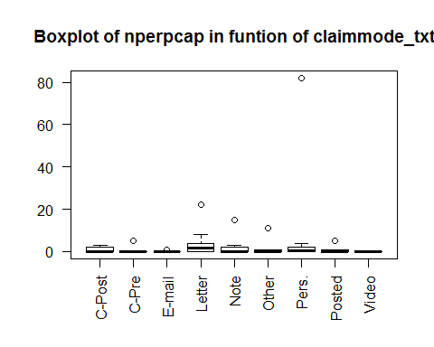

Legend: “C-Post: Call (post-incident)”, “C-Pre: Call (pre-incident)”, “E-mail: E-mail”, “Letter: Letter”, “Note: Note left at scene”, “Other: Other”, “Pers.: Personal claim”, “Posted: Posted to website, blog, etc.”, “Video: Video”

With this boxplot we can obviously see that “Personal claim” has the biggest number of perpetrators captured. We don’t consider it an outlier, but we want to see how the boxplot will change if we delete this particular case. So in the next boxplot we decide to ignore this specific claimed mode.

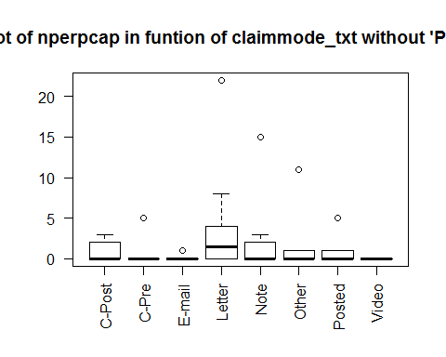

Legend: “C-Post: Call (post-incident)”, “C-Pre: Call (pre-incident)”, “E-mail: E-mail”, “Letter: Letter”, “Note: Note left at scene”, “Other: Other”, “Posted: Posted to website, blog, etc.”, “Video: Video”

And we can see that “Letter” and “Note left at scene” are the next two claimed modes with the biggest number of captured perpetrators.

#### nkill / weaptype1_txt

In this section we study if there is a dependence between the weapon type and number of kills. First of all we make a table with the corresponding variables and see what our data looks like.

0 1 2 3 4 5 6 7 8 9  
 Biological 18 3 2 0 0 0 0 0 0 0  
 Chemical 20 0 0 0 0 0 0 0 0 0  
 Explosives 1301 35 5 1 1 0 0 0 0 0  
 Fake Weapons 4 0 0 0 0 0 0 0 0 0  
 Firearms 203 128 35 6 4 3 2 2 2 1  
 Incendiary 826 5 2 0 0 0 0 0 0 0  
 Melee 29 12 1 1 0 0 0 0 0 0  
 Other 16 0 0 0 0 0 0 0 0 0  
 Radiological 1 0 0 0 0 0 0 0 0 0  
 Sabotage Equipment 16 1 0 0 0 0 0 0 0 0  
 Vehicle 3 2 1 0 0 0 0 0 0 0  
   
 10 11 13 15 16 44 50 190  
 Biological 0 0 0 0 0 0 0 0  
 Chemical 0 0 0 0 0 0 0 0  
 Explosives 0 1 0 0 1 0 0 0  
 Fake Weapons 0 0 0 0 0 0 0 0  
 Firearms 1 0 1 1 0 0 1 0  
 Incendiary 0 0 0 1 0 0 0 0  
 Melee 0 0 0 0 0 0 0 0  
 Other 0 0 0 0 0 0 0 0  
 Radiological 0 0 0 0 0 0 0 0  
 Sabotage Equipment 0 0 0 0 0 0 0 0  
 Vehicle 0 0 0 0 0 1 0 1

With this table we understand that there are some columns that have no sense for the study we want to do, so we decide remove them and prepare our data for boxplot.

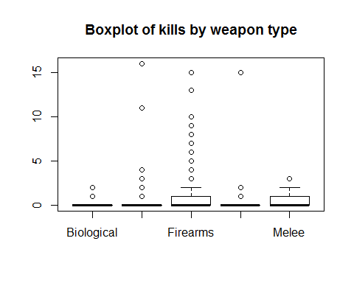

The vast majority of the cases have 0 kills so the graphical representation does not give us much information.

#### nwound / weaptype1_txt

The same type of study as in the “nkill / weaptype1_txt” section: we repeat it with “nwound / weaptype1_txt”.

0 1 2 3 4 5 6 7 8 9  
 Biological 13 3 2 0 0 1 2 0 0 0  
 Chemical 15 1 0 2 0 0 0 0 0 0  
 Explosives 1205 71 23 11 9 2 1 4 2 0  
 Fake Weapons 4 0 0 0 0 0 0 0 0 0  
 Firearms 266 60 23 11 8 4 4 2 2 4  
 Incendiary 796 22 10 1 0 1 0 0 1 0  
 Melee 16 17 1 5 2 1 0 0 0 0  
 Other 15 1 0 0 0 0 0 0 0 0  
 Radiological 1 0 0 0 0 0 0 0 0 0  
 Sabotage Equipment 16 0 0 0 0 0 0 0 0 0  
 Vehicle 3 0 0 0 0 0 1 0 0 1  
   
 10 11 12 13 15 16 17 19 20 22  
 Biological 0 0 0 0 0 0 0 0 0 0  
 Chemical 1 0 0 0 0 0 0 0 0 0  
 Explosives 3 1 0 1 1 1 2 0 1 1  
 Fake Weapons 0 0 0 0 0 0 0 0 0 0  
 Firearms 1 0 0 1 0 0 0 0 1 0  
 Incendiary 0 0 1 0 0 0 0 0 0 0  
 Melee 1 0 0 0 0 0 0 0 0 0  
 Other 0 0 0 0 0 0 0 0 0 0  
 Radiological 0 0 0 0 0 0 0 0 0 0  
 Sabotage Equipment 0 0 0 0 0 0 0 0 0 0  
 Vehicle 0 0 0 0 1 0 0 1 0 0  
   
 24 25 27 29 32 53 74 78 106 110  
 Biological 0 1 0 0 0 0 0 0 0 0  
 Chemical 0 0 0 0 1 0 0 0 0 0  
 Explosives 0 0 0 1 0 1 1 0 0 1  
 Fake Weapons 0 0 0 0 0 0 0 0 0 0  
 Firearms 1 0 0 0 1 1 0 0 0 0  
 Incendiary 0 0 1 0 0 0 0 0 0 0  
 Melee 0 0 0 0 0 0 0 0 0 0  
 Other 0 0 0 0 0 0 0 0 0 0  
 Radiological 0 0 0 0 0 0 0 0 0 0  
 Sabotage Equipment 0 0 0 0 0 0 0 1 0 0  
 Vehicle 0 0 0 0 0 0 0 0 1 0  
   
 132 151 751  
 Biological 0 0 1  
 Chemical 0 0 0  
 Explosives 2 0 0  
 Fake Weapons 0 0 0  
 Firearms 0 0 0  
 Incendiary 0 1 0  
 Melee 0 0 0  
 Other 0 0 0  
 Radiological 0 0 0  
 Sabotage Equipment 0 0 0  
 Vehicle 0 0 0

Most of the weapon types have small quantities of kills which would distort our representation. We will remove those types for the graphical comparison just as we did before.

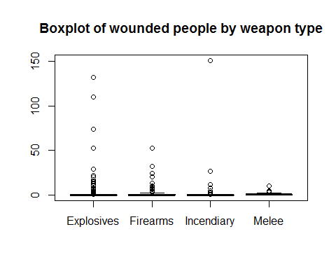

The vast majority of the cases have 0 wounded, so the graphical representation does not give us much information.

#### nº acts / year date

In this analysis, we want to look into the distribution of acts over the years. We will see 10 year intervals and 1970-2017 graphs in order to compare them properly.

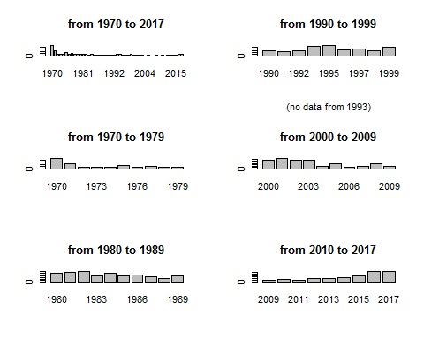

We can see that the year with most acts of terrorism is by far 1970. In the last graph 2009-2017 we can clearly see that there is an increasing tendency.

#### nº acts / month

In this analysis we want to see what is the distribution of acts of terrorism over the months in order to see if there is any anomaly.

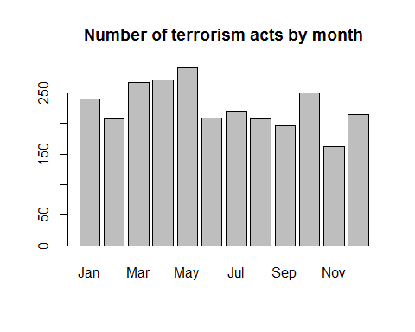

The acts are fairly uniform distributed, with the preferred month being May and the least favorite being November.

#### provstate / gname

This two categorical variable seem interesting to analyze, but first we need to bee sure if there is a relation between them. As we know, for this we can use the chi square test.

Pearson's Chi-squared test  
  
data: mydata$provstate and mydata$gname  
X-squared = 23839, df = 11400, p-value < 2.2e-16

With a p-value of 2.2e-16, we can reject this test’s null hypothesis and conclude this variables are, in fact, dependent.

#### gname / provstate (top 3 provstate)

In this analysis, we want to see the distributions of acts of terrorism by each group in the 3 most striked states.

We will remove the gname with less than 9 apperances in order to properly view the result, as we will not consider them relevant to our study.

We can see that 25.5% of the acts of terrorism in California are from the same group.

Most of the names of this pie chart do not match the ones in the California one. That confirms us that different groups focus different states.

By the names of the groups and the quantity of them we can already see that Puerto Rico’s terrorist attacks are majorly internal.

#### provstate / gname (top 3 gname)

In this analysis we want to identify in which states a given gname has committed acts of terrorism. This will provide us insight of the group’s target population.

We can see that this group widely distributed their acts of terrorism over the states.

We can see that this group’s acts were fairly distributed, although half of them were targeted to the two main victim states.

In this case we can clearly see that the acts were targeted towards the states of New York, Illinois and Puerto Rico.

#### Event Rate / state_governor_party (top 3 provstates)

We want to know what is the percentage of acts committed during the rule of each state_governor_party. Only the 3 states with most recorded acts will be considered, because in some of the states the sample size would be too small.

We will remove the minor state_governor_parties with less than 9 apperances in order to properly view the result as we will not consider them relevant to our study.

First, we will check California as it is the first state with most recorded acts of terrorism (532).

Not considering the outliers, we can see that 69.9% of the acts were committed in this state while the Democrat party was ruling.

We will do the same analysis with New York as it is the second state with most recorded acts of terrorism (473).

In this case the ratio is more equaly distributed, with 51.6% for the Democrats

Lastly we will do the same analysis with Puerto Rico as it is the third state with most recorded acts of terrorism (226).

In the pie chart we can see that 65.3% of the acts were commited while the New Progressive Party was ruling.

#### Success Rate / president_party

In this analysis we want to check what is the ratio of success of terrorism acts while each president_party was ruling.

success = mydata$president_party[mydata$success == TRUE]  
fail = mydata$president_party[mydata$success == FALSE]  
success = as.data.frame(table(success))  
fail = as.data.frame(table(fail))  
s = success[2]+fail[2]  
ts = 100*success[2]/s  
tf = 100*fail[2]/s  
  
s=c(ts[1,1],ts[2,1])  
f=c(tf[1,1],tf[2,1])  
t <- cbind(s,f);  
colnames(t) <- c("Success", "Fail")  
rownames(t) <- c("Democratic", "Republican")  
  
print(t)

Success Fail  
Democratic 79.57245 20.42755  
Republican 82.91139 17.08861

As we can see, both parties have similar success rates.