## GIT installation ir config

On this link you can find a brief manual how to install everything, together with dowload link:

<https://help.github.com/articles/set-up-git/>

Afterwards, create a folder called in example ‚SeProject‘ somewhere, e.g. „D:\docs\SeProject“

Next, go to that folder, right mouse click and run „git bash“

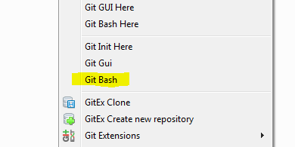  
Window looks something like this:

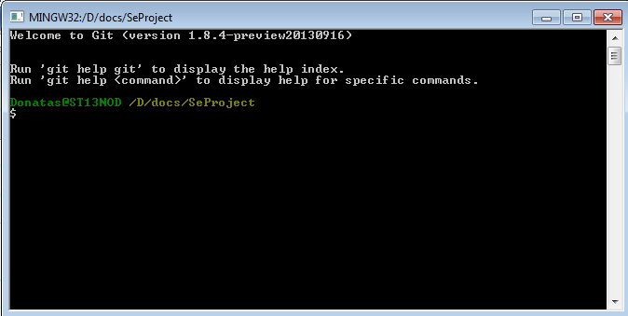

Here we have to setup our user name and email (the same as in BitBucket)“ using those command lines, e.g.:

**git config --global user.name "D*onatasKozlovskis*"**

**git config --global user.email *donatas.kozlovskis@gmail.com***

Afterwards you can install credential helper for password caching as well.

## First data download.

Firstly, you have to go to the same your project folder and run gitBash. Run this command:

**git clone https://DonatasKozlovskis@bitbucket.org/DonatasKozlovskis/seproject.git**

# this command will download all data for from remote server.

**cd seProject** # go inside the folder

Next, Check if tracked repository is set

**git remote** # after this commad you shoud see output „origin“.

## How to renew data from server

Open *git-bash* window.

**git pull** # or (**git pull origin master**) with this command you can dowload all changes made by other team members.

**git status** # with this command you can see changes in your local repository

**git add ‘*newFile.txt’*** # this command adds *newFile.txt*.

**git commit** # This command records changes to the repository. After running this command, you should see message writing window where you should write a short note what changes did you made in new file, E.g.

*Added method to calculate distance between nodes.*

To finish writing the the message, press *Esc* and type **:wq**, then press enter *Enter*. I highly recommend to use shortened version of this command:

**git commit –m ‘*Added method to calculate distance between nodes.’***

Where you can add mesagge in the same window. Finally, run

**git push origin master** # this will send all changes to remote repository.

Help source: <http://gitready.com/beginner/2009/01/21/pushing-and-pulling.html>