**Visual Interface for WiFi Networks Monitoring**

PLANNING

FERRAN SELVA RODRÍGUEZ (122659)

Tasks to be performed:

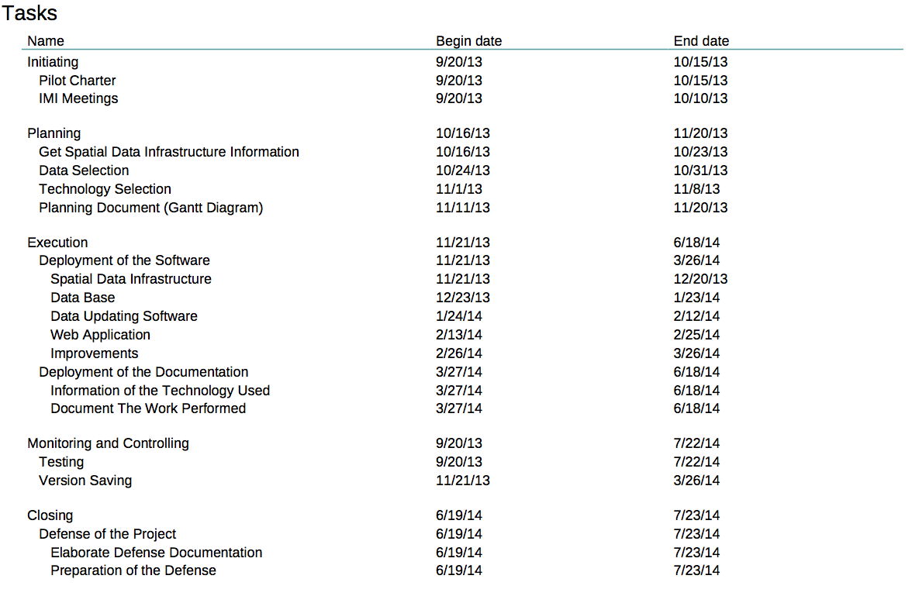

**Initiating.**

**Pilot Charter.**

Elaborate the Pilot charter. Where the idea, the goal, the objectives, and other sections will be collected.

**IMI Meetings.**

Meetings with the “Institut Municipal d'Informàtica”. These meetings have the objective of decide the information that may be of interest to the user, evaluate the best way to present this information and know how is its WiFi structure.

**Planning.**

**Get Spatial Data Infrastructure Information.**

Collect information about Spatial Data Infrastructure. Know how to develop these data, what options can be used, what characteristics have each option and which one is better for de deployment of this project.

**Data Selection.**

Select the data that will be displayed with the IMI recommendations. Define how it will be collected and possible ways to display.

**Technology Selection.**

Define the technology will be used to perform the project.

**Planning Document (Gantt Diagram).**

Document where is defined when will be done the tasks.

**Execution**

**Deployment of the Software.**

**Spatial Data Infrastructure.**

Develop the Spatial Data Infrastructure where the data will be displayed.

**Database.**

Develop the Database where the data will be stored and modified.

**Data Updating Software.**

Develop the program that will modify the data of the Database.

**Web Application.**

Develop de Web Application where the information will be displayed. It is linked with the Spatial Data Infrastructure.

**Improvements.**

Time to improve the performance of the project, adding new features, optimizing components and making other improvements.

**Deployment of the Documentation.**

**Information of the Technology Used.**

Explain the technologies used, what features have and why choose these technologies over other options.

**Document The Work Performed.**

Document everything related to project execution. How the project has been done, what problems have been occurred, how the problems have solved and others related to the work performed.

**Monitoring and Controlling**

**Testing.**

Check the work done throughout the project.

**Version Saving.**

Saving of all versions of the software deployed.

**Closing.**

**Defense of the Project.**

**Elaborate Defense Documentation.**

Elaborate the documents that will be used to defend the project in front of the court.

**Preparation of the Defense.**

Prepare the defense of the project.

