Understanding the PC Boot Process: Writing a Bootloader

SUMMARY:

You are given a partially working assembly code for the (1) bootloader and a fully working assembly code for the (2) kernel. You are expected to “fill in” the missing lines of codes to make boatloader work.

DETAILS:

Create a bootloader that does the following:
- Prompts the user to enter a command (like a shell prompt e.g. user@hostname$).
- Once the user inputs the boot command, the kernel will be loaded. However, if the user inputs any command other than the boot command, the shell prompt (e.g. user@hostname$) will just have to be printed once more.

Sample Output:

In this example, the shell prompt (or command prompt) is grub>.
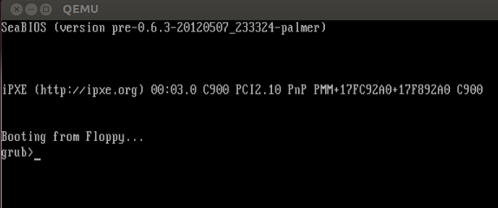

If the user inputs any command other than the boot command this is what happens: It just prints the shell prompt once more.
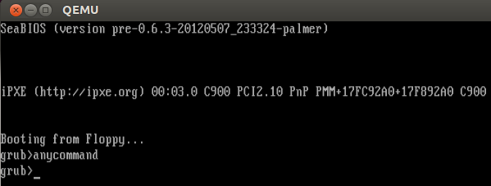

Finally, if the user inputs the boot command, the kernel will now be loaded, as seen in the image below:
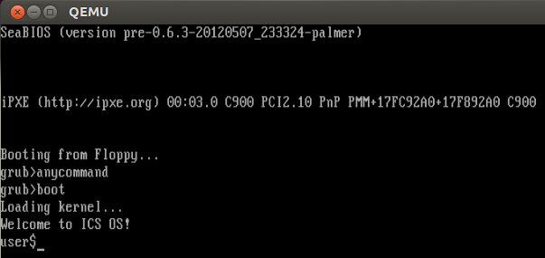

The kernel is now loaded by the bootloader and is now ready to perform its tasks (as specified by the assembly code kernel.asm).
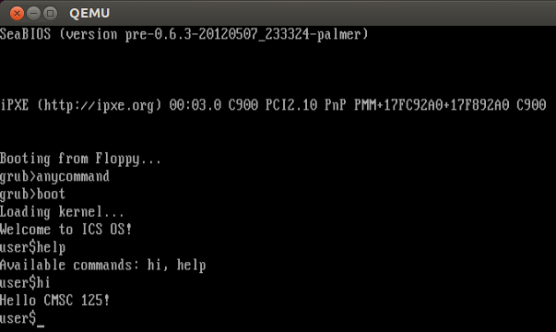

Now for the exercise, be reminded of the following requirements:

- Shell prompt (or command prompt) should be of the form initials@cmsc125-section.
EXAMPLE: jeiencinas@cmsc125-st-1l

- You will need edit the assembly code for the bootloader (bootsect.asm) ONLY. The kernel (kernel.asm) and routine.asm remain as they are. :-p

