**个人智能时钟**

**—基于Arduino实现**

姓名: 陈李锋  学号: 2014081025 14通信

**一．项目目的：**

使用Arduino和其他模块实现个人智能时钟，其中包括温度，湿度显示和时间显示和其他功能。

**二．需要硬件：**

1. Arduino mega
2. LED12864 显示器
3. DHT11 传感器
4. DS1302
5. 四角按钮
6. 杜邦线和面包板等

**三．项目介绍**

相对于传统的时钟，这款智能时钟一共有两个模式。模式一是闪烁显示一个“love you”的图像，代表一个好心情。模式二显示除了时间、日期外还有温度和湿度。其中模式一是一直闪烁的，只有按下按钮出发中断才显示/模式二。

另外时间和日期是DS1302提供的，其时间是通过串口监视器来更改校准，所以代码没有再提供这个功能。温度和湿度是DHT11 提供。

**四．接线和结果：**

接线

1. LCD12864 4位接线法

|  |  |
| --- | --- |
| LCD12864 (第几引脚) | Arduino |
| PIN1(1) | GND |
| PIN2(2) | VCC(5V) |
| RS/CS (4) | D8 |
| RW(SID) (5) | D9 |
| EN(CLK) (6) | D3 |
| PSB (15) | GND |
| VCC (19) | VCC |
| GND (20) | GND |

1. DS1302

|  |  |
| --- | --- |
| DS1302 | Arduino |
| VCC | VCC（5V） |
| GND | GND |
| CLK | D7 |
| DAT | D6 |
| RST | D5 |

1. 其他

|  |  |
| --- | --- |
| DHT11 DAT | Arduino 21 |
| 四脚开关（中断） | Arduino 21 |

传感器的其他VCC和GND分别接在5V和GND上

**结果：**

1. 串口显示：(在串口分钟显示结果是否正确，方便下面查找错误)

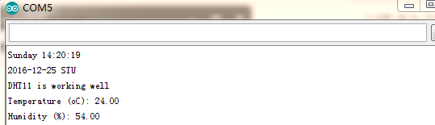

1. 模式一（显示Love you）

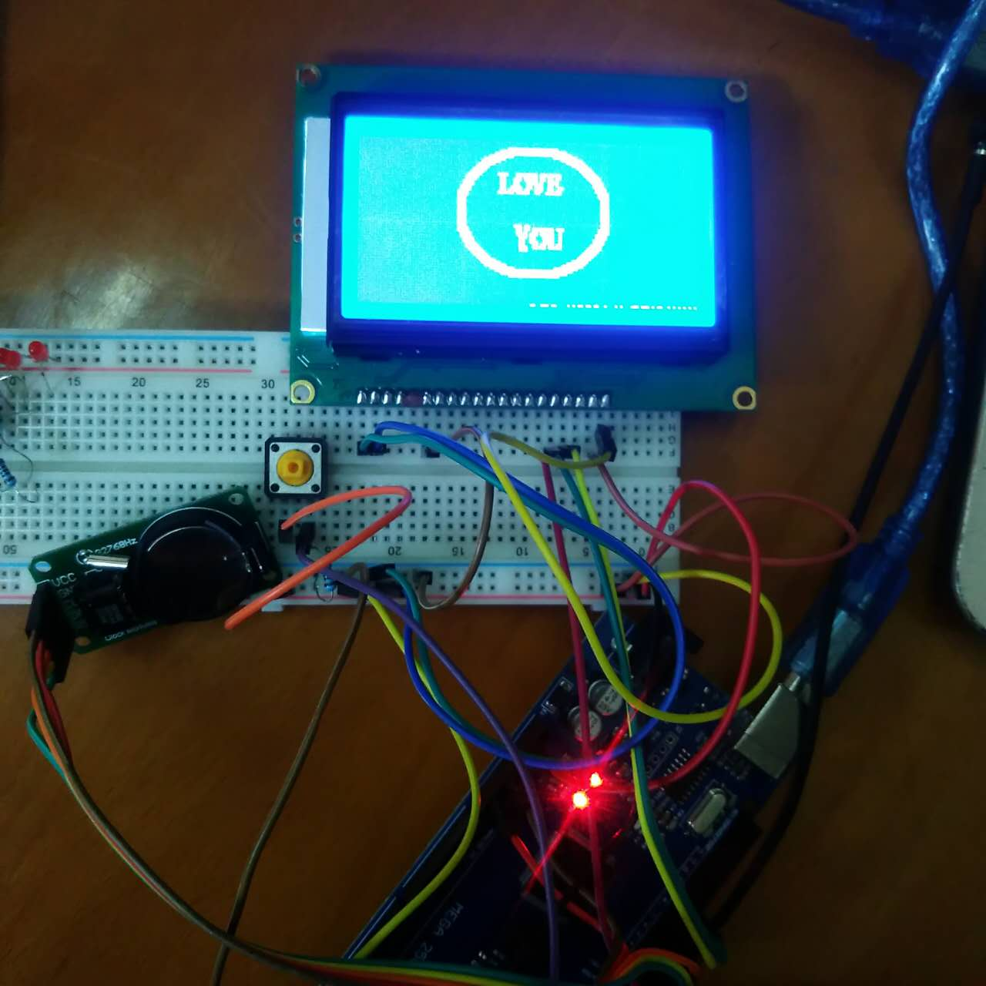

1. 模式二（按下按钮）

显示是不一样的，2016前面没有20，这个bug一直找不到原因,怀疑是LCD12864硬件问题

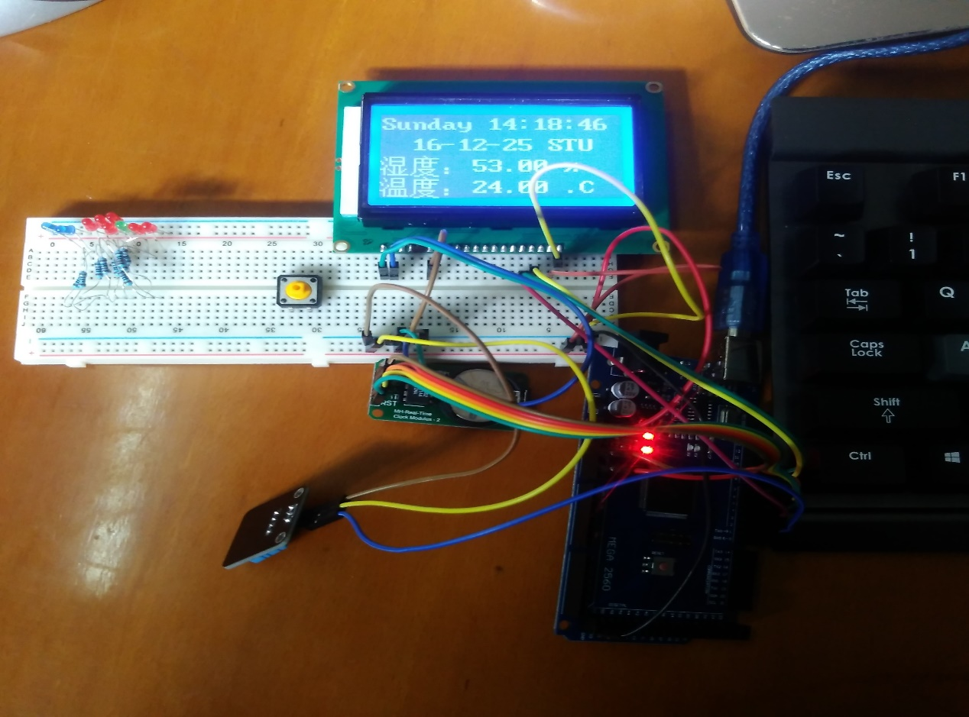

**五．项目体会**

这一次项目做了比较久，不断地收集资料和修改代码。一次一次的查找bug,崩溃到差点想放弃。最后还是做了出来，虽然还是有一点BUG，但自己也感到很兴奋，感觉付出都是有价值的。

另外LCD12864模块用起来不是很顺心，主要是因为时间关系没有读过Datasheet，硬件不懂原理查找BUG也是有一定的困难。这件事让我懂得搞嵌入式还是懂得一定的硬件和软件才行。

这学期过得很快，从一开始就想在树莓派实现的这个功能后来在Arduino上实现了，而且还有一定的扩充。自我感觉这门课学到不少东西，谢谢老师提过这个机会。

**六．程序**

/* LDD12864

LCD Arduino

PIN1 = GND

PIN2 = 5V

RS(CS) = 8;

RW(SID)= 9;

EN(CLK) = 3;

PIN15 PSB = GND;

*/

/* DS1302接口定义

CE(DS1302 pin5) -> Arduino D5

IO(DS1302 pin6) -> Arduino D6

SCLK(DS1302 pin7) -> Arduino D7

*/

#include <LCD12864RSPI.h>

#include <dht11.h>

dht11 DHT11;

#define DHT11PIN 2

#include <DS1302.h>

#include <stdio.h>

#include <string.h>

#define AR_SIZE( a ) sizeof( a ) / sizeof( a[0] )

// 1302的接脚

uint8_t CE_PIN = 5;

uint8_t IO_PIN = 6;

uint8_t SCLK_PIN = 7;

/* 创建 DS1302 对象 */

DS1302 rtc(CE_PIN, IO_PIN, SCLK_PIN);

// 中断开关接脚

int pbIn = 2; // 定义中断引脚为2，也就是D21引脚

volatile int state = LOW; // 定义默认输入状态

/* 创建显示缓存 */

char buf1[50];

char buf2[50];

char buf3[] = {0xCE, 0xC2,0xB6, 0xC8,0xA3,0xBA}; // 温度内码

char buf4[] = {0xCA,0xAA,0xB6,0xC8,0xA3, 0xBA};//湿度内码

char day[10];

char str[5]; //定义温度值存储数组，4位，其中3位为数字，1位为小数点

char str2[5]; //定义湿度度值存储数组，4位，其中3位为数字，1位为小数点

double val =0;

double val2 =0;//定义中间变量，用于将获取的float型温度值转变为unsigned char数组

/* 串口数据缓存 */

String comdata = "";

int numdata[7] ={0}, j = 0, mark = 0;

// love you

unsigned char smile_Face[]={

0x00,0x00,0x00,0x00,0x00,0x00,0x00,0x00,

0x00,0x00,0x00,0x00,0x00,0x00,0x00,0x00,

0x00,0x00,0x00,0x00,0x00,0x00,0x00,0x00,

0x00,0x00,0x00,0x00,0x00,0x00,0x00,0x00,

0x00,0x00,0x00,0x00,0x00,0x00,0x00,0x00,

0x00,0x00,0x00,0x00,0x00,0x00,0x00,0x00,

0x00,0x00,0x00,0x00,0x00,0x00,0x00,0xFF,

0xFF,0xE0,0x00,0x00,0x00,0x00,0x00,0x00,

0x00,0x00,0x00,0x00,0x00,0x00,0x07,0xFF,

0xFF,0xFC,0x00,0x00,0x00,0x00,0x00,0x00,

0x00,0x00,0x00,0x00,0x00,0x00,0x1F,0xFF,

0xFF,0xFF,0x00,0x00,0x00,0x00,0x00,0x00,

0x00,0x00,0x00,0x00,0x00,0x00,0x7F,0xC0,

0x00,0x7F,0xC0,0x00,0x00,0x00,0x00,0x00,

0x00,0x00,0x00,0x00,0x00,0x01,0xFE,0x00,

0x00,0x0F,0xF0,0x00,0x00,0x00,0x00,0x00,

0x00,0x00,0x00,0x00,0x00,0x03,0xF8,0x00,

0x00,0x03,0xF8,0x00,0x00,0x00,0x00,0x00,

0x00,0x00,0x00,0x00,0x00,0x07,0xE0,0x00,

0x00,0x00,0xFC,0x00,0x00,0x00,0x00,0x00,

0x00,0x00,0x00,0x00,0x00,0x0F,0x80,0x00,

0x00,0x00,0x3E,0x00,0x00,0x00,0x00,0x00,

0x00,0x00,0x00,0x00,0x00,0x1F,0x00,0x00,

0x00,0x00,0x1F,0x00,0x00,0x00,0x00,0x00,

0x00,0x00,0x00,0x00,0x00,0x3E,0x00,0x00,

0x00,0x00,0x0F,0x80,0x00,0x00,0x00,0x00,

0x00,0x00,0x00,0x00,0x00,0x7C,0x0F,0x1F,

0xEF,0xF0,0x07,0xC0,0x00,0x00,0x00,0x00,

0x00,0x00,0x00,0x00,0x00,0xF8,0x06,0x1B,

0x6D,0xB0,0x03,0xE0,0x00,0x00,0x00,0x00,

0x00,0x00,0x00,0x00,0x00,0xF0,0x06,0x3B,

0xED,0xA0,0x01,0xE0,0x00,0x00,0x00,0x00,

0x00,0x00,0x00,0x00,0x01,0xE0,0x06,0x31,

0xE9,0xE0,0x00,0xF0,0x00,0x00,0x00,0x00,

0x00,0x00,0x00,0x00,0x01,0xE0,0x06,0x31,

0xB9,0xA0,0x00,0xF0,0x00,0x00,0x00,0x00,

0x00,0x00,0x00,0x00,0x03,0xC0,0x06,0x79,

0xB9,0x98,0x00,0x78,0x00,0x00,0x00,0x00,

0x00,0x00,0x00,0x00,0x03,0xC0,0x06,0xFB,

0x39,0xB0,0x00,0x78,0x00,0x00,0x00,0x00,

0x00,0x00,0x00,0x00,0x07,0x80,0x0F,0xDF,

0x33,0xF0,0x00,0x3C,0x00,0x00,0x00,0x00,

0x00,0x00,0x00,0x00,0x07,0x80,0x00,0x00,

0x00,0x00,0x00,0x3C,0x00,0x00,0x00,0x00,

0x00,0x00,0x00,0x00,0x07,0x00,0x00,0x00,

0x00,0x00,0x00,0x1C,0x00,0x00,0x00,0x00,

0x00,0x00,0x00,0x00,0x07,0x00,0x00,0x00,

0x00,0x00,0x00,0x1C,0x00,0x00,0x00,0x00,

0x00,0x00,0x00,0x00,0x07,0x00,0x00,0x00,

0x00,0x00,0x00,0x1C,0x00,0x00,0x00,0x00,

0x00,0x00,0x00,0x00,0x07,0x00,0x00,0x00,

0x00,0x00,0x00,0x1C,0x00,0x00,0x00,0x00,

0x00,0x00,0x00,0x00,0x07,0x00,0x00,0x00,

0x00,0x00,0x00,0x1C,0x00,0x00,0x00,0x00,

0x00,0x00,0x00,0x00,0x07,0x00,0x00,0x00,

0x00,0x00,0x00,0x1C,0x00,0x00,0x00,0x00,

0x00,0x00,0x00,0x00,0x07,0x00,0x00,0x00,

0x00,0x00,0x00,0x1C,0x00,0x00,0x00,0x00,

0x00,0x00,0x00,0x00,0x07,0x00,0x00,0x00,

0x00,0x00,0x00,0x1C,0x00,0x00,0x00,0x00,

0x00,0x00,0x00,0x00,0x07,0x00,0x00,0x00,

0x00,0x00,0x00,0x1C,0x00,0x00,0x00,0x00,

0x00,0x00,0x00,0x00,0x07,0x00,0x00,0x00,

0x00,0x00,0x00,0x1C,0x00,0x00,0x00,0x00,

0x00,0x00,0x00,0x00,0x07,0x00,0x00,0x00,

0x00,0x00,0x00,0x1C,0x00,0x00,0x00,0x00,

0x00,0x00,0x00,0x00,0x07,0x00,0x00,0x3B,

0x00,0x00,0x00,0x1C,0x00,0x00,0x00,0x00,

0x00,0x00,0x00,0x00,0x07,0x80,0x00,0x1B,

0x7F,0xB8,0x00,0x3C,0x00,0x00,0x00,0x00,

0x00,0x00,0x00,0x00,0x07,0x80,0x00,0x1A,

0x6D,0x90,0x00,0x3C,0x00,0x00,0x00,0x00,

0x00,0x00,0x00,0x00,0x03,0xC0,0x00,0x1E,

0xEF,0x90,0x00,0x78,0x00,0x00,0x00,0x00,

0x00,0x00,0x00,0x00,0x03,0xC0,0x00,0x0E,

0xC7,0x90,0x00,0x78,0x00,0x00,0x00,0x00,

0x00,0x00,0x00,0x00,0x01,0xE0,0x00,0x0C,

0xC7,0x90,0x00,0xF0,0x00,0x00,0x00,0x00,

0x00,0x00,0x00,0x00,0x01,0xE0,0x00,0x0C,

0xE7,0x90,0x00,0xF0,0x00,0x00,0x00,0x00,

0x00,0x00,0x00,0x00,0x00,0xF0,0x00,0x0C,

0x6D,0xB0,0x01,0xE0,0x00,0x00,0x00,0x00,

0x00,0x00,0x00,0x00,0x00,0xF8,0x00,0x0E,

0x7D,0xF0,0x03,0xE0,0x00,0x00,0x00,0x00,

0x00,0x00,0x00,0x00,0x00,0x7C,0x00,0x0E,

0x00,0x00,0x07,0xC0,0x00,0x00,0x00,0x00,

0x00,0x00,0x00,0x00,0x00,0x3E,0x00,0x00,

0x00,0x00,0x0F,0x80,0x00,0x00,0x00,0x00,

0x00,0x00,0x00,0x00,0x00,0x1F,0x00,0x00,

0x00,0x00,0x1F,0x00,0x00,0x00,0x00,0x00,

0x00,0x00,0x00,0x00,0x00,0x0F,0x80,0x00,

0x00,0x00,0x3E,0x00,0x00,0x00,0x00,0x00,

0x00,0x00,0x00,0x00,0x00,0x07,0xE0,0x00,

0x00,0x00,0xFC,0x00,0x00,0x00,0x00,0x00,

0x00,0x00,0x00,0x00,0x00,0x03,0xF8,0x00,

0x00,0x03,0xF8,0x00,0x00,0x00,0x00,0x00,

0x00,0x00,0x00,0x00,0x00,0x01,0xFE,0x00,

0x00,0x0F,0xF0,0x00,0x00,0x00,0x00,0x00,

0x00,0x00,0x00,0x00,0x00,0x00,0x7F,0xC0,

0x00,0x7F,0xC0,0x00,0x00,0x00,0x00,0x00,

0x00,0x00,0x00,0x00,0x00,0x00,0x1F,0xFF,

0xFF,0xFF,0x00,0x00,0x00,0x00,0x00,0x00,

0x00,0x00,0x00,0x00,0x00,0x00,0x07,0xFF,

0xFF,0xFC,0x00,0x00,0x00,0x00,0x00,0x00,

0x00,0x00,0x00,0x00,0x00,0x00,0x00,0xFF,

0xFF,0xE0,0x00,0x00,0x00,0x00,0x00,0x00,

0x00,0x00,0x00,0x00,0x00,0x00,0x00,0x00,

0x00,0x00,0x00,0x00,0x00,0x00,0x00,0x00,

0x00,0x00,0x00,0x00,0x00,0x00,0x00,0x00,

0x00,0x00,0x00,0x00,0x00,0x00,0x00,0x00,

0x00,0x00,0x00,0x00,0x00,0x00,0x00,0x00,

0x00,0x00,0x00,0x00,0x00,0x00,0x00,0x00,

0x00,0x00,0x00,0x00,0x00,0x00,0x00,0x00,

0x00,0x00,0x00,0x00,0x00,0x00,0x00,0x00,

0x00,0x00,0x00,0x00,0x00,0x00,0x00,0x00,

0x00,0x00,0x00,0x00,0x00,0x00,0x00,0x00,

0x00,0x00,0x00,0x00,0x00,0x00,0x00,0x00,

0x00,0x00,0x00,0x00,0x00,0x00,0x00,0x00,

0x00,0x00,0x00,0x00,0x00,0x00,0x00,0x00,

0x00,0x00,0x00,0x00,0x00,0x00,0x00,0x00,

0x00,0x00,0x00,0x00,0x00,0x00,0x00,0x00,

0x00,0x00,0x00,0x00,0x00,0x00,0x00,0x00,

0x00,0x00,0x00,0x00,0x00,0x00,0x00,0x00,

0x00,0x00,0x00,0x00,0x00,0x00,0x00,0x00,

0x00,0x00,0x00,0x00,0x00,0x00,0x00,0x00,

0x00,0x00,0x00,0x00,0x00,0x00,0x00,0x00,

0x00,0x00,0x00,0x00,0x00,0x00,0x00,0x00,

};

void print_time()

{

/* 从 DS1302 获取当前时间 */

Time t = rtc.time();

/* 将星期从数字转换为名称 */

memset(day, 0, sizeof(day));

switch (t.day)

{

case 1: strcpy(day, "Sunday"); break;

case 2: strcpy(day, "Monday"); break;

case 3: strcpy(day, "Tuesday"); break;

case 4: strcpy(day, "Wednesday"); break;

case 5: strcpy(day, "Thursday"); break;

case 6: strcpy(day, "Friday"); break;

case 7: strcpy(day, "Saturday"); break;

}

/* 将日期代码格式化凑成buf等待输出 */

snprintf(buf1, sizeof(buf1), "%s %02d:%02d:%02d ", day, t.hr, t.min, t.sec);

snprintf(buf2, sizeof(buf2), "%04d-%02d-%02d STU ", t.yr, t.mon, t.date);

/* 输出日期到串口 */

Serial.println(buf1);

Serial.println(buf2);

}

void set_dht()

{ /* 配置lcd12864 */

int chk = DHT11.read(DHT11PIN);

switch (chk)

// 检查DHT11是否正常工作

{

case DHTLIB_OK:

Serial.println("DHT11 is working well");

break;

default:

Serial.println("Unknown error");

break;

}

// 读取温度和湿度

val = DHT11.temperature;

dtostrf(val,4,2,str); // 数据转字符串指令

val2 = DHT11.humidity;

dtostrf(val2,4,2,str2);

Serial.print("Temperature (oC): ");

Serial.println((float)DHT11.temperature, 2);

Serial.print("Humidity (%): ");

Serial.println(str2);

//snprintf(buf3, sizeof(buf3), "Temp:%s Humi:%d ", DHT11.temperature, DHT11.humidity);

}

void print_all()

{

Time t = rtc.time();

/* 打印当前时间 */

print_time();

set_dht();

LCDA.CLEAR();//清屏

delay(1000);

LCDA.DisplayString(0,0,buf1,AR_SIZE(buf1));

LCDA.DisplayString(1,0,buf2,AR_SIZE(buf2));

/* 显示温度和湿度 */

LCDA.DisplayString(2,0,buf4,AR_SIZE(buf4));

LCDA.DisplayString(2,3,(unsigned char *)str2,AR_SIZE(str2));

LCDA.DisplayString(2,6,"% ",AR_SIZE("% "));

LCDA.DisplayString(3,0,buf3,AR_SIZE(buf3));

LCDA.DisplayString(3,3,(unsigned char *)str,AR_SIZE(str));

LCDA.DisplayString(3,6,".C ",AR_SIZE(".C "));

delay(10000); //根据LCD12864更改刷新频率

}

void stateChange()

{

delay (20);

state = !state;

print_all();

}

void setup()

{

/* 1302配置 */

Serial.begin(9600);

rtc.write_protect(false);

rtc.halt(false);

/* 12864 配置*/

LCDA.Initialise(); // 屏幕初始化

delay(100);

// 监视中断输入引脚的变化

attachInterrupt(pbIn,stateChange , CHANGE);

}

void loop()

{

for (int i = 0; i < 100; i++)

{

LCDA.CLEAR();//清屏

delay(100);

LCDA.DrawFullScreen(smile_Face);

delay(1000);

}

}