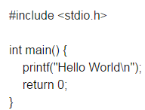
Gcc –o hello hello.c

Sudo apt-get install git-core

Git clone git://git.drogon.net/wiringPi
tar zxvf file.tar.gz
gpio –v gpio readall

gcc led.c -o led –lwiringPi
sudo ./led

