Arduino Timer Interrupt Example
http://homediyelectronics.com/projects/arduino/arduinotimerinterruptexample/

There are countless examples of Arduino sketches on the Internet covering all but the most obscure and complicated projects. Most of these sketches or programmes concentrate on getting the job done in the main loop() function and rarely venture into the world of interrupts.
I'm going to show you how you can take advantage of internal timer interrupts on the Arduino using a couple of LED's and a simple code sketch. Not only will I show you how to get a regular timed interrupt to work but I will also demonstrate the advantages of reentrant routines. That is interrupts that are allowed to interrupt themselves.
It is true that interrupt use can lead to unpredictable code behaviour that is difficult to debug but they can also greatly enhance your projects if you follow a few simple rules.

Why use interrupts in your Arduino projects
In general most tasks can be accomplished without resorting to interrupts but if you do then the use of interrupt service routines can clean up your code and add another dimension to your programmes. ISRs can be used to:
- Provide a fast response to external inputs and user interface.
- Free up your main loop for other things instead of sitting in delay functions.
- Provide accurate timing in conjunction with hardware timers.

Things you need to play with timer interrupts
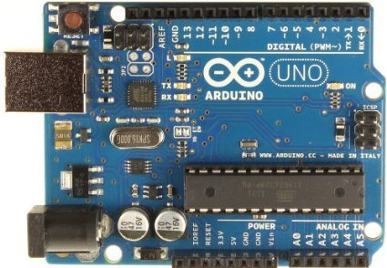 | Arduino Uno Single Board Microcontroller  A computer on a board with everything you need to start running programs and interfacing with the real world. Includes CPU, flash, EEPROM and static RAM memory,digital and analog I/O, timers and more.
 | LEDs  Not only are they fun devices but you can use LEDs in most circuits for indicating state at various points. A well placed LED can give you an awful lot of information about what is happening in your circuit. Magic when things are not working exactly how you think they should.
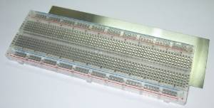 | Solderless BreadBoard  An 830 point breadboard is overkill for this simple demonstration project but I find that this size of breadboard is convenient for all kinds of projects.
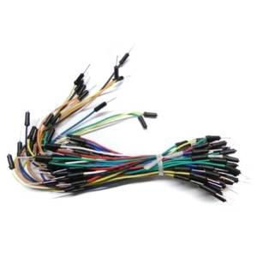 | Hook-Up Jumber Cable Wires  You can make these yourself with some flexible wire, solid copper wire and heat shrink sleeving if you can be bothered to spend the time soldering them all up. Why not make your life easier and buy a fistfull instead. They are not expensive.

The LED Interrupt Circuit diagram
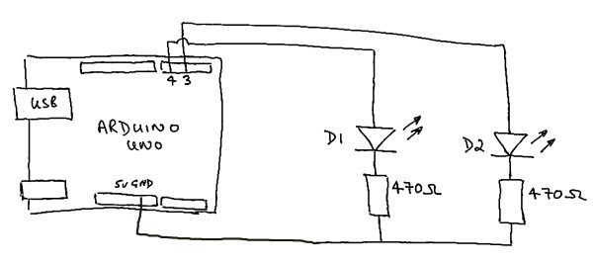
Simple Arduino Interrupt Demonstrator

Connect up the circuit
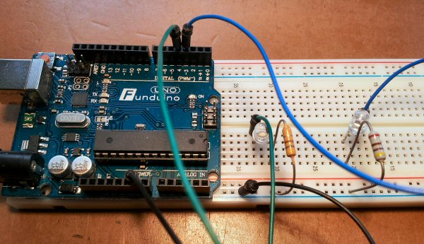
Arduino Interrupt LED Connections
Buy an Arduino Uno now and start building smart electronics projects

Download and install the Arduino Timer One library
It is perfectly possible to write code that directly interfaces with the hardware including the internal ATmega328 timers on the Arduino. This would have been an interesting exercise but it isn't really what this guide is all about and there is a convenient code library available that does just what we need.
This demonstration is based on The ATmega328's Timer 1 so you should download and install the TimerOne library as below.
Download the timerOne library fromhttp://code.google.com/p/arduino-timerone/downloads/detail?name=TimerOne-v9.zip&can=2&q= and install it using the guidehttp://arduino.cc/en/Guide/Libraries

Copy and paste the Arduino interrupt demo sketch below
Load the sketch onto your Arduino Uno and let it run. Both LED's will flash regularly. LED D1 will flash every 4 seconds and LED D2 will flash 5 times a second
/*
Timer interrupt demo using LEDs
Steve Garratt
8th October 2013
http://homediyelectronics.com

Requires the TimerOne library downloadable from
http://code.google.com/p/arduino-timerone/downloads/detail?name=TimerOne-v9.zip&can=2&q=
Note: Download and rename to remove the hyphen before installing.
*/
#include <TimerOne.h> // Header file for TimerOne library
#define LED0 3 // Pin 3
#define LED1 4 // Pin 4
#define TIMER_US 100000 // 100mS set timer duration in microseconds
#define TICK_COUNTS 20 // 2S worth of timer ticks
volatile long tick_count = TICK_COUNTS; // Counter for 2S
volatile bool in_long_isr = false; // True if in long interrupt
// ----------------------------------
// setup() routine called first.
// ----------------------------------
void setup()
{
pinMode(LED0, OUTPUT); // Set the pins as outputs
pinMode(LED1, OUTPUT);
Timer1.initialize(TIMER_US); // Initialise timer 1
Timer1.attachInterrupt( timerIsr ); // attach the ISR routine here
}
// ----------------------------------
// loop() Runs continuously in a loop.
// ----------------------------------
void loop()
{
}
// --------------------------
// timerIsr() 100 milli second interrupt ISR()
// Called every time the hardware timer 1 times out.
// --------------------------
void timerIsr()
{
digitalWrite( LED0, digitalRead( LED0 ) ^ 1 ); // Toggle LED 0
if (!(--tick_count)) // Count to 2S
{
tick_count = TICK_COUNTS; // Reload
tick_2s_isr(); // Call the 2S routine
}
}
// --------------------------
// tick_2s_isr() 2 second routine
// Called every time the count gets to 2S
// --------------------------
void tick_2s_isr()
{
if (in_long_isr) // Prevent reentering this code
{
return;
}
in_long_isr = true; // Indicates we are in the long isr
volatile long i;
interrupts(); // Enable interrupts
digitalWrite( LED1, digitalRead( LED1 ) ^ 1 ); // Toggle LED 1
for (i = 0; i < 400000; i++) // Delay because delay() will not work here
{
}

noInterrupts(); // Disable interrupts
in_long_isr = false; // Indicates exit of the long isr
}

What is happening here?
If you you speed up the flashing rate by adjusting the values of "TIMER_US" and "TICK_COUNTS" you can observe the pulses on an oscilloscope. If you don't have an oscilloscope you can build yourself one very cheaply using my book as a guide: Sound Card Oscilloscope: Build Better Electronics Projects.
When the sketch initializes and setup() is run, the ATmega328's timer 1 is set to interrupt every 100ms and every time it interrupts the state of LED D2 is toggled making it flash on and off 5 times a second.
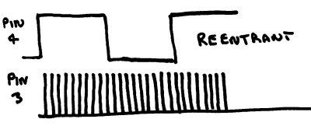
Reentrant timer 1 timing diagram
The interrupt service routine timerIsr() counts down a timer variable starting at 20. When it reaches zero the function tick_2s_isr() is called. This routine is called every 2 seconds as a result. But the tick_2s_isr() function contains a time consuming loop which takes much longer than 100ms so how is it that the interrupt routine can keep flashing D2? It can do this because tick_2s_isr() enables interrupts using the interrupts() function. When interrupts are enabled the timerIsr() is able to service every interrupt even though it calls a function that takes a long time to process. The interrupt ISR is said to be reentrant.
Now what would happen if tick_2s_isr() did not enable interrupts so there was no way for the function to be reentered? Try it. Comment out the lines with "interrupts()"and "noInterrupts()" like this:
// interrupts();
...
// noInterrupts();
Load and run the sketch and you should see that LED D2 now has to pause until the tick_2s_isr() completes before it flashes. The time between calls to the tick_2s_isr() function also increases due to the ISR not maintaining the regular count.
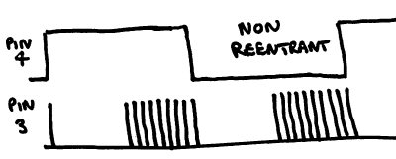
Non reentrant timer 1 timing diagram

Follow the rules of interrupts
The Arduino is an amazing little microcontroller board that could easily find use in the most sophisticated of electronic systems and yet it is so cheap and easy to use. The low cost and easy programming make this board perfect for hobby electronics projects and the ability to use interrupts is an awesome capability but you do have to follow some rules.
- Keep processing in your interrupt service routines to a minimum
- Never allow an interrupt task to reenter time consuming code before it has finished.
- Be careful where you enable and disable interrupts
- Always think "What can go wrong" - Because it will.

