
My Health @ EU
eHealth Digital Service Infrastructure
Electronic cross-border health services in the EU

Interoperability Specifications

DOCUMENT VERSION | 8.0.1
DATE | 24/02/2025
STATUS | Wave 8 Operation Ready

DG SANTE, CEF eHealth DSI, 2025
Reuse is authorised, provided the source is acknowledged.

COVER AND CONTROL PAGE OF DOCUMENT
Document name: | eHDSI Interoperability Specifications
Distribution level*: | PU
Status: | Wave 8 Operation Ready
Author(s):  Organization: | eHealth DSI provider
* Distribution level: PU = Public, PP = Restricted to other programme participants, RE = Restricted to a group specified by the consortium, CO = Confidential, only for members of the consortium.
ABSTRACT

CHANGE HISTORY
Version | Date | Status Changes | From | Review
V8.0.1 | 24/02/2025 | Wave 8 Operation Ready | MyHealth@EU Solution Provider
V8.0.1 | 13/01/2025 | Wave 8 Release candidate | MyHealth@EU Solution Provider
V7.0.0 | 10/07/2023 | Wave 7 Operation Ready: CP-064 IHE ITI Framework Upgrade – audit module integration | eHealth DSI Solution Provider
V7.0.0-RC | 02/06/2022 | Wave 7 Release Candidate: CP-064 IHE ITI Framework Upgrade – audit module integration | eHealth DSI Solution Provider
V6.2.0 | 24/11/2022 | Wave 6 Release Candidate | eHealth DSI Solution Provider
V6.1.0 | 29/07/2022 | Wave 6 Operation Ready | eHealth DSI Solution Provider
V6.0.0 | 28/06/2022 | Wave 6 Release Candidate: CP-064 IHE ITI upgrade – Submitted for eHMSEG adoption | eHealth DSI Solution Provider
V5.0.0 | 30/04/2021 | Wave 4 Operation Ready | eHealth DSI Solution Provider
V4.0.0 | 11/06/2020 | Wave 4 Operation Ready | eHealth DSI Solution Provider
V3.0.0 | 25/06/2019 | Wave 3 Operation Ready | eHealth DSI Solution Provider
V2.2.0 | 30/04/2018 | Wave 2 Operation Ready | eHealth DSI Solution Provider
V2.1.0 | 01/06/2017 | Wave 1 Operation Ready  Released for eHMSEG adoption | eHealth DSI Solution Provider | V2.1.0
V2.0.1 | 21/04/2017 | Integrate the modifications linked to the CP-002 | eHealth DSI provider
V2.0.0 | 28/03/2017 | Remove all references to epSOS and requirements | eHealth DSI provider
V1.1 | 15/09/2015 | Add CP-6 on non repudiation feature | Massimiliano Masi

TABLE OF CONTENTS
1 Introduction 6
1.1 The ECCF Framework 6
1.2 eHealth DSI Specification Artifact Serialization 7
1.3 Conventions 9
1.4 Terms and Definitions 9
1.5 Status of this Document 10
2 eHealth DSI Conceptual Perspective Specification 10
2.1 eHealth DSI Business Principles and Strategies 10
2.1.1 Actors and Roles 10
2.1.2 Connecting eHealth DSI to national eHealth Infrastructures 11
2.1.3 Patient Safety, Patient Privacy and End-to-End Security 12
EC Article 29 Working Group Recommendations 13
2.2 eHealth DSI Semantic Framework 13
2.2.1 Semantic Signifiers 13
2.2.2 eHealth DSI Semantic Services 15
2.3 eHealth DSI Business Functionality 15
2.3.1 Interaction and Communication Patterns 16
2.3.2 "request of data" Pattern 17
Interaction Demands 17
Actors and Roles 17
Interaction Pattern "Request of Data" 17
Prerequisites and Obligations 17
Relationship to eHealth DSI Use Cases 18
2.3.3 "Provisioning of data" Pattern 18
Interaction Demands 18
Actors and Roles 18
Interaction Pattern "Provisioning of Data" 18
Prerequisites and Obligations 19
Relationship to eHealth DSI Use Cases 19
2.3.4 "Request Overview and Pick Details" Pattern 19
Interaction Demands 19
Actors and Roles 19
Interaction Pattern "Request Overview and Pick Details" 20
Prerequisites and Obligations 20
Relationship to eHealth DSI Use Cases 21
2.3.5 "Patient Identification and Authentication" Pattern 21
Interaction Demands 21
Actors and Roles 21
Interaction Pattern "Patient Identification and Authentication" 21
Prerequisites and Obligations 22
Relationship to eHealth DSI Use Cases 22
2.4 eHealth DSI Design Principles 22
2.4.1 Interoperability and use of Standards 22
2.4.2 Business-to-Business Paradigm 23
2.4.3 eHealth DSI Security Foundation 23
2.5 eHealth DSI Layered Architecture Stack 24
2.5.1 eHealth DSI 4-layered Architecture 24
2.5.2 NCPs as Facades 25
3 eHealth DSI Semantic Framework Specification 25
3.1 eHealth DSI Semantic Framework Requirements 26
3.1.1 Design Decisions and Flow of Control 26
3.1.2 Patient Safety and Usability 27
3.2 Transforming, Transcoding and Translating 27
3.2.1 eHealth DSI Friendly Documents (non-normative) 28
3.3 The eHealth DSI Common Semantic Signifier 29
3.3.1 eHealth DSI Common Conceptual Information Model 29
3.3.2 eHealth DSI Common Document Model and Detailed Clinical Models 31
3.4 eHealth DSI Semantic Services 31
3.4.1 eHealth DSI Semantic Services Scenarios 32
Requesting Data 32
Provisioning of Data 33
3.4.2 Transformation Service 33
3.4.3 Key actors and roles 34
3.4.4 Business rules for translation and transcoding 34
3.4.5 Transformation service contract specification 34
3.4.5.1 Transcoding to eHealth DSI pivot 34
3.4.5.2 Translating from eHealth DSI pivot 35
3.5 Bindings and Deployments 36
4 eHealth DSI Application Architecture Specification 37
4.1 eHealth DSI Application Architecture requirements 38
4.2 eHealth DSI Service Architecture 38
4.3 Patient Identification and Authentication Service 38
4.3.1 Requirements 38
4.3.2 Communication Pattern 39
4.3.3 Service Contract and Behavior Specification 39
4.4 Fetch Document Service 40
4.4.1 Requirements 40
4.4.2 Communication Pattern 40
4.4.3 Service Contract Specification 41
4.5 Retrieve Document Service 42
4.5.1 Requirements 42
4.5.2 Communication Pattern 42
4.5.3 Service Contract Specification 43
4.6 Provide Data Service 43
4.6.1 Requirements 43
4.6.2 Communication Pattern 44
4.6.3 Service Contract Specification 44
4.7 Implementation of the eHealth DSI Interaction patterns (informative) 45
4.7.1 "Patient Identification and Authentication" Interaction Pattern 45
4.7.2 "Request of data" Interaction Pattern 45
4.7.3 "Query Overview and Fetch details" Interaction Pattern 45
5 eHealth DSI Security Architecture Specification 46
5.1 Conceptual Foundation and Standard Operational Procedures of eHealth DSI Security 46
5.1.1 Conceptual Entity National Contact Point 48
5.2 Patient Consent Error! Bookmark not defined.
5.2.1 Requirements Error! Bookmark not defined.
5.2.2 Design and Implementation Error! Bookmark not defined.
5.2.3 Patient Consent Interaction patterns Error! Bookmark not defined.
5.2.3.1 Local Fundamental Consent, Local Specific Consent, Foreign Activation Error! Bookmark not defined.
5.2.3.2 Local Fundamental Consent, Local Specific Consent, Foreign Activation Error! Bookmark not defined.
5.3 HP Authentication (AuthN) and Authorization (AuthZ) 49
5.3.1 Requirements Healthcare Professional Authentication 49
5.3.2 Requirements Healthcare Professional Authorization 49
5.3.3 Design and Implementation Authentication 49
5.3.4 Design and Implementation Authorization 50
5.3.5 AuthN and AuthZ Interaction Patterns 51
5.4 Confidentiality 51
5.4.1 Requirements 51
5.5 Originator Authenticity and data Integrity 52
5.5.1 Requirements 52
5.5.2 Design and Implementation 52
5.6 Availability 52
5.6.1 Design and Implementation 52
5.7 Non-Repudiation 52
5.7.1 Requirements 52
5.7.2 Design and Implementation 52
5.8 NCP Secure Deployment / Zoning 53
5.8.1 Requirements 53
5.8.2 Design and Implementation 53
5.9 eHealth DSI Security and privacy Requirements (informative) 53
5.9.1 End-to-End Security: Requirements and Limitations 53
5.9.2 Data Minimization 54
5.9.3 End-toEnd Security Services 54
5.9.3.1 End-to-End Enforcement of Patient Privacy and Rights 55
6 eHealth DSI Messaging Architecture Specification 56
6.1 eHealth DSI Messaging Architecture Requirements 56
6.2 eHealth DSI Node and Service Discovery 56
6.2.1 Trusts Service Lists 57
6.2.2 Implementation and Patterns 58
6.3 eHealth DSI Trusted Node Infrastructure & Message Transportation 59
6.4 eHealth DSI Common Messaging Format (Envelope) and Profiles 59
7 References 60

Introduction
What is eHealth DSI? The answer to this question depends on the viewpoint and the expectations of the stakeholder:
- From a regulatory viewpoint eHealth DSI is a legal, technical and organizational blueprint for medical care processes that cross European borders.
- From a medical doctor’s viewpoint eHealth DSI is a medical document framework for encoding, transcoding and processing foreign patients’ medical data in order to serve use case specific information needs.
- From an IT architects viewpoint eHealth DSI is a document sharing platform that provides means for sending and fetching medical data across borders.
Each of these answers implies an eHealth DSI architecture and design on its own. This holds the more as eHealth DSI indeed is as well a blueprint as a framework or a platform.
This eHealth DSI – Interoperability Specification provides a specification of eHealth DSI that serves all the above viewpoints. It defines the conceptual blueprint for connecting existing healthcare-IT services; it introduces the eHealth DSI semantic framework that paves the way down from an information need to making the respective data available and usable; and it specifies a layered platform of standards-based business, security and messaging services.

The ECCF Framework
In order to serve these multiple viewpoints the eHealth DSI Specification uses the notion of an artifact as a single piece of information that describes a certain dynamic or static characteristic of an eHealth DSI conceptual, logical or technical building block from a certain perspective. Characteristics and perspectives can be organized as a matrix where each field of the matrix covers a certain characteristic from a certain perspective. The matrix used for Specifications is derived from the SAIF-Enterprise Conformance and Compliance Framework (ECCF) (Table 1).
ECCF | Enterprise Dimension  "Why"  Policy | Information Dimension  "What"  Content | Computational Dimension  "How"  Behavior | Engineering Dimension  "Where"  Implementation | Technical Dimension  "Where"  Deployment
Conceptual Perspective
Logical Perspective
Implementable Perspective
Table 1: SAIF Enterprise Conformance and Compliance framework (eHealth DSI Adaptation)

The columns of the matrix focus on certain characteristics of the system to be analyzed and specified:
- The Enterprise Dimension defines the business and reference context and is concerned with business objectives and business processes.
- The Information Dimension is defined by domain analysis models and is concerned with the nature of the information handled by the system and constraints on the use and interpretation of that information.
- The Computational Dimension is concerned with the functional decomposition of the system into a set of components that exhibit specific behaviors and interact at interfaces.
- The Engineering Dimension is defined by existing platform capabilities and is concerned with the mechanisms and functions required to support the interactions of the computational components.
- The Technology Dimension is concerned with the explicit choice of technologies and with the connectivity and deployment of the technical building blocks.
The rows of the matrix reflect different levels of abstraction and are targeted at different expert groups:
- The Conceptual Perspective is almost computational independent as its focus is on the problem space rather than on a concrete solution. Conceptual-level artifacts sketch the essentials and core concepts of eHealth DSI from a domain matter expert’s point of view and as such define the holistic conceptual model of eHealth DSI.
- Artifacts in the Logical Perspective represent traceable translations of conceptual-level artifacts into a form/format usable by and useful to architects and inward-facing analysts. This perspective provides the functional/logical specification of eHealth DSI and defines the eHealth DSI solution space with its classes, services and operations.
- Artifacts in the Implementable Perspective contain all of the necessary technical bindings – e.g. data types, value sets, interface specifications, etc. – that will enable developers to implement the building blocks of the functional/logical specification by standards-based technical components.

eHealth DSI Specification Artifact Serialization
The separation of viewpoints and characteristics into artifacts allows for a structured and manageable evolution of eHealth DSI because it minimizes overlaps and redundancies within the specifications and explicates dependencies among characteristics and across viewpoints. The disadvantage of this modularization and flexibilization is that such a network of artifacts is not documentation in the common sense of a serialized document with a clearly defined reading path. Therefore, eHealth DSI Specification introduces different flavors of documents which serialize parts of the artifact network into documents (see Figure 1).
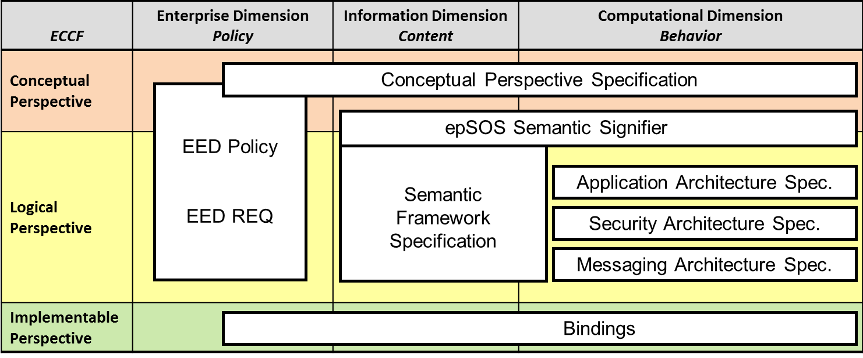
Figure 1: Specification Artifact Serialization

As can be seen in the figure the focus of Specification is on the Information and Computational Dimension while the Enterprise Dimension is covered by various eHealth DSI Policies and the eHealth DSI structured requirements management. In order to reflect the different viewpoints as sketched above, eHealth DSI Interoperability Specifications define three kinds of serializations:
- Specifications cover the principles and design of the eHealth DSI dynamic and static architecture. While the Conceptual Perspective Specification describes the overall strategies and principles of eHealth DSI the semantic framework specification and the layered architecture specifications define logical services for the different layers of the eHealth DSI architecture.
- Bindings map the eHealth DSI logical/functional specifications onto existing standards and profiles (see section 2.4 for details). There may be multiple bindings per logical service.
- eHealth DSI medical information needs, respective data objects and their behavior on the eHealth DSI platform are defined by Semantic Signifiers (see section 2.2.1 for details). These cover the whole track down from a conceptual model to an information model and specific interaction patterns. The information model’s serialized document schema and the interaction patterns’ mapping onto eHealth DSI data sharing transactions are defined through a semantic signifier’s specific binding.
In addition to this core serialization means, eHealth DSI Interoperability Specifications provide several means for documenting eHealth DSI aspects that integrate different perspectives and characteristics.
- Scenarios provide instantiations of the eHealth DSI specifications for a specific use case (e.g. receiving an ePrescription and providing an eDispensation). Even though scenarios are mainly located on the computational independent and platform independent layers they may as well instantiate or configure Semantic Signifiers and their respective bindings.
- Extensions cover optional features a country may wish to implement or additional features for using eHealth DSI to implement non-eHealth DSI bilateral use cases as agreed between two countries. Extensions may be required to be implemented by countries A and B in order to preserve technical interoperability for the respective use case (eHealth DSI Extended Security Safeguards for end-to-end encryption are an example for such an extension).
- Deployments are non-normative recommendations on how certain eHealth DSI services (including their bindings) may be grouped and deployed. E.g. the NCP is considered to be a specific deployment of eHealth DSI services in order to implement a gateway for facilitating all dimensions of cross-border health data sharing.
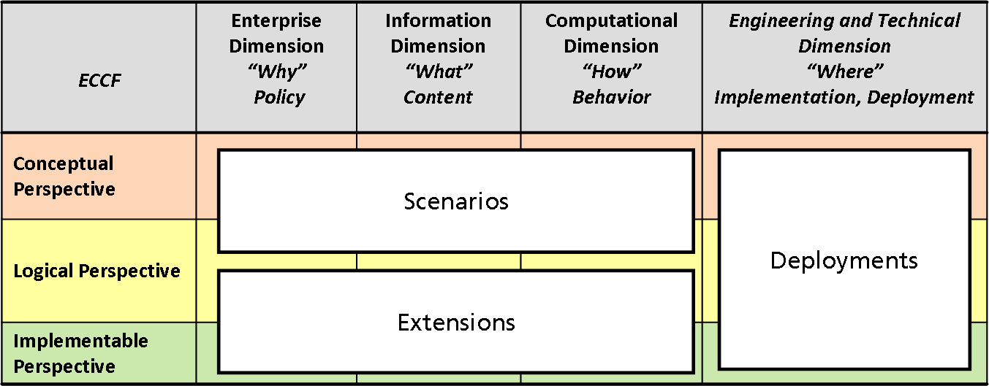
Figure 2: eHealth DSI Specification Cross-Perspective / Dimension Serialization

Conventions
The keywords MUST, SHOULD, MAY, SHOULD NOT, and MUST NOT are used as defined in [RFC 2119].
During the eHealth DSI Interoperability Specifications maintenance lifecycle this artifact should be considered as a living document that serves as a platform for communicating open issues among eHealth DSI stakeholders.

eHealth DSI requirements are managed according to maintenance lifecycle specially designed for this purpose and are available at [Requirements and Recommendations]. References to requirements always use the identifiers to facilitiate the link between both artifacts. Within this document references to requirements use the following notation:
- <REQ Requirement-ID>: Reference to an eHealth DSI requirement.
- <REC Recommendation-ID>: Reference to an eHealth DSI recommendation.
- <!REQ Requirement-ID>: Reference to an external (to eHealth DSI) requirement.
Newly defined requirements are handed over to the requirements management. In case of doubt or conflict, [Requirements and Recommendations] MUST be considered to be the normative phrasing of a requirement.

Terms and Definitions
The country which holds information about a patient, where the patient can be univocally identified and where his data may be accessed is called "country-A" (country of affiliation) [eHealth DSI Glossary]. The country of treatment where cross-border health care is provided when the patient is seeking care abroad is called "country-B" (country of care) [eHealth DSI Glossary].

The term "Healthcare Professional (HP)" denotes a doctor of medicine, a nurse responsible for general care, a dental practitioner, a midwife or a pharmacist within the meaning of Directive 2005/36/EC, or another professional exercising activities in the healthcare sector which are restricted to a regulated profession as defined in Article 3(1)(a) of Directive 2005/36/EC, or a person considered to be a health professional according to the legislation of the country of treatment [eHealth DSI Glossary]. Health professionals are allowed to process medical patient data according to the legislation of the country of the health professional’s residence. An "eHealth DSI Point of Care (PoC)" is a location where an eHealth DSI patient may seek healthcare services [eHealth DSI Glossary].

Status of this Document
This document is part of the eHealth DSI normative specifications.

eHealth DSI Conceptual Perspective Specification
The eHealth DSI Conceptual Perspective Specification defines the eHealth DSI foundation in terms of policies and strategies related to the business level objectives of eHealth DSI (enterprise dimension). By mapping these policies and strategies into the information and computational dimension, the eHealth DSI Conceptual Perspective Specification introduces the notion of the eHealth DSI Semantic Framework, settles core architectural principles and defines the eHealth DSI core business processes and rules.
 | Enterprise Dimension | Information Dimension | Computational Dimension
Conceptual Perspective | Actors and Roles  End-to-End Security  National Contact Points | eHealth DSI Semantic Framework  Patient Safety Principles | Business Processes and Rules  Design Principles  eHealth DSI Layered Architecture
Table 2: eHealth DSI Conceptual Dimension Aspects

eHealth DSI Business Principles and Strategies
According to [eHealth DSI Scope], "the overarching goal of eHealth DSI is to develop a practical eHealth framework and ICT infrastructure that will enable secure access to patient health information [...] between European healthcare systems. [...] The methodology will strive to build a common architecture and core services for the identification of users and institutions, security, confidentiality and privacy aspects, and aim to enhance various semantic aspects of the systems."

Actors and Roles
Within eHealth DSI the European citizen takes the role of a patient. This role is manifested in a way that each patient is assigned medical data that may give valuable information to a healthcare professional (HP). All authoritative medical data of a patient is managed within the patient’s country of affiliation (country-A). Each country MUST take responsibility of providing at least originator authenticity and integrity of its released data. Each country MUST enforce any constraints a patient may have expressed with respect to the processing of his medical data.
eHealth DSI follows the notion of medical end-to-end processes in a way that medical patient data is always created by a healthcare professional and consumed by another healthcare professional. Mapping this medical end-to-end process to a cross-border care scenario, eHealth DSI assigns different roles to healthcare professionals in the involved countries:
- A healthcare professional at the country of the patient’s affiliation assembles medical information (e.g. about findings and therapies) about a patient. This information may be further condensed, structured and/or integrated by other physicians or systems within country-A. The person, organization or system that performs the final approval of that data takes the role of a country-A-data-producer. The person or organization that accounts for the data processing system where approved medical information is managed takes the role of the country-A-data-controller.
- A healthcare professional at a point of care in a country other than country-A (denoted as country-B in eHealth DSI) can access and process medical data about the patient which was investigated by (one or more) health professionals in country-A. The respective role is the country-B-data-consumer.
- A healthcare professional at a point of care in a country B may wish to document on new findings, therapies, etc. for a follow-up in country-A or notify competent actors in country-A on actions taken in country-B. In this setting where a healthcare professional in country-B provides medical information for further processing in country-A, the healthcare professional in country-B takes the role of a country-B-data-producer. An actor in country-A, who further considers the respective information, takes the role of a country-A-data-consumer.
Country-A roles MAY be instantiated by the same or by different health professionals. The same holds for the country-B roles.

Connecting eHealth DSI to national eHealth Infrastructures
eHealth DSI MUST NOT interfere with existing national infrastructures. In particular eHealth DSI participating nations MUST NOT be forced to modify their existing national eHealth infrastructures or legislations in order to participate in eHealth DSI:
- eHealth DSI MUST be based on principles that allow all participating nations to connect their existing national eHealth infrastructures to eHealth DSI without requiring alterations in existing technology, data semantics and legislation.
- eHealth DSI MUST NOT specify normative (technical) approaches that exclude participating nations from taking part in eHealth DSI CBeHIS Network and operations under the legal umbrella of eHealth DSI.
- eHealth DSI cross-border data sharing services SHOULD be as transparent for affected human entities as possible, in a way that eHealth DSI MUST NOT enforce changes in medical and/or administrative processes at the affected points of care.
This implies that eHealth DSI architecture and design SHOULD NOT make any assumptions on services, processes and technologies which are deployed within national infrastructures – unless such assumptions reflect agreed requirements on end-to-end processes or can directly be derived from common European directives (e.g. Data Protection Regulation [REGULATION 2016/679, 27 April 2016]).
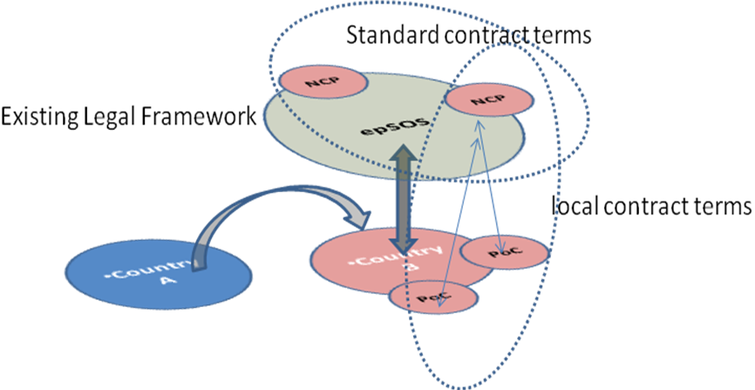
Figure 3: Interplay between regulatory domains and areas of application

In order to cope with this strategy, eHealth DSI introduces the notion of a National Contact Point (NCP) that facilitates the sharing of medical data between a participating country and the eHealth DSI space. Originally mainly considered as a legal and conceptual construction, the eHealth DSI architecture picks up this NCP concept and maps it onto national gateways that act as multi-dimensional communication facilitators. By this existing national infrastructures are almost decoupled from each other’s – national infrastructures always only connect to their national NCP and never directly communicate data into another countries infrastructure: following the well-established security principle of "complete mediation" there MUST NOT be any defined eHealth DSI communication of medical data that bypasses NCPs. This implies that medical data can only leave and enter a national infrastructure through a national gateway (NCP).
NCPs MUST be considered as trusted in a way that any claim stated by an NCP MUST NOT be doubted by any other NCP. E.g. if the NCP of a country-B claims that a country-b-data-consumer was properly authenticated within country-B, a country-A NCP MUST treat the country-b-data-consumer as if he had been authenticated within country-A. This trust relationship holds for all NCPs (as gateways) which are operated by an NCP (as legal entity) who signed the eHealth DSI MultiLateral Agreemenl [MLA] and had proven the proper implementation of the eHealth DSI polices. By this eHealth DSI NCPs set up a circle of trust with this trust even being brokered by each NCP to connected healthcare professionals within its national infrastructure.

Patient Safety, Patient Privacy and End-to-End Security
eHealth DSI MUST NOT impose new risks to patient safety. In addition eHealth DSI MUST implement appropriate policies and technical means to reduce and manage existing risks to patient safety, which are inherent for any kind of electronic data processing/communication.
Proportionality and purpose limitation: Each query about the personal data available through eHealth DSI should be based on a real need of access to the specific information and no personal data returned by country B shall be stored at the NCP.
eHealth DSI MUST be compliant to European security and privacy legislations and directives.

EC Article 29 Working Group Recommendations
For the revised eHealth DSI architecture the recommendations for epSOS of the EC Article 29 Working Party on secure end-to-end processes in cross-border healthcare MUST be considered:
Recommendations by the Article 29 WP as from:
ARTICLE 29 WP, "Working Document 01/2012 on epSOS", 00145/12/EN. WP 189
Vital Interests of the Data Subject | The motivation of the Emergency-Use Case (Breaking Glass Scenario) as outlined in epSOS is explicitly justified and deemed legitimate as long as its activation is addressing the vital medical interests of the patient. Consequently, a PN may agree to override the imperative of a second consent in situations where the patient is unable to state his intentions.
Authentication Strength for HP and Patient’s | Although the patient is traditionally considered to be a passive actor or object regarding authentication services in health care, the Article 29 WG highlights the necessity of providing strong authentication means for both, HP’ and patients.
Strict End-to-End Encryption duty in medical data exchange | The WP explicitly elaborates on the compulsory provision of "secure communication protocols and end-to-end encryption" in electronic communications. Any medical data disclosure to intermediaries that are not explicitly visible to or under the control of the patient or the authorised health care entities must be prohibited by adequate encryption means. It is furthermore stated that the endpoints of any encryption must be located within trusted zones that are either controlled by the patient or the authorised health care entity.
Adequate production of digital evidence chains | The WP is restating the necessity of producing unbroken digital evidence chains that must be preserved accordingly even in cross-border medical data exchange. Digital Certificates are explicitly mentioned as a means to express, transport, and safeguard trust between communication partners as well as for providing the required assurances regarding their claims.

eHealth DSI Semantic Framework
eHealth DSI participating nations (platform characteristics) but as well allows to adapt and extend this platform for serving arbitrary domain-specific use cases (vertical framework characteristics).
In order to emphasize the advantages of both concepts, eHealth DSI clearly separates between a more or less static platform and functionalities which heavily depend on the characteristics of a certain use case. By this off-the-shelf industry standards and components can be used on the platform level, while projects working on new or extended eHealth DSI use cases solely can focus on the eHealth DSI framework mechanisms on top of the platform. Beside the sustainability achieved by this approach, the future evolvement of eHealth DSI can almost be driven by the medical needs of new cross-border care processes and increased demands for semantic interoperability along care processes.
The eHealth DSI framework is called the "eHealth DSI Semantic Framework" as it allows defining use cases, cross-border document sharing scenarios and documents semantics on top of a semantic-agnostic platform.

Semantic Signifiers
The eHealth DSI semantic framework builds upon the perception that semantically interoperable medical information is in the heart of any cross-border use case: a healthcare professional MUST be enabled to express his information needs in a way that the information fulfilling these needs can be discovered even though it was produced within the context of another country’s healthcare system. Information MUST always be provided in a way that the essential original semantics (meaning and expressiveness of sensible information) as imposed by the data-producer is preserved and understandable to the data-consumer. In addition, data MUST always be shared in a way that all information provided by the data-producer is visible to the data-consumer.
eHealth DSI addresses these issues by using "semantic signifiers" for capturing the semantics and behavior of information artifacts to be shared cross-border. A semantic signifier captures all artifacts that are produced during the mapping of defined information need onto a concrete document schema (see Figure 4).
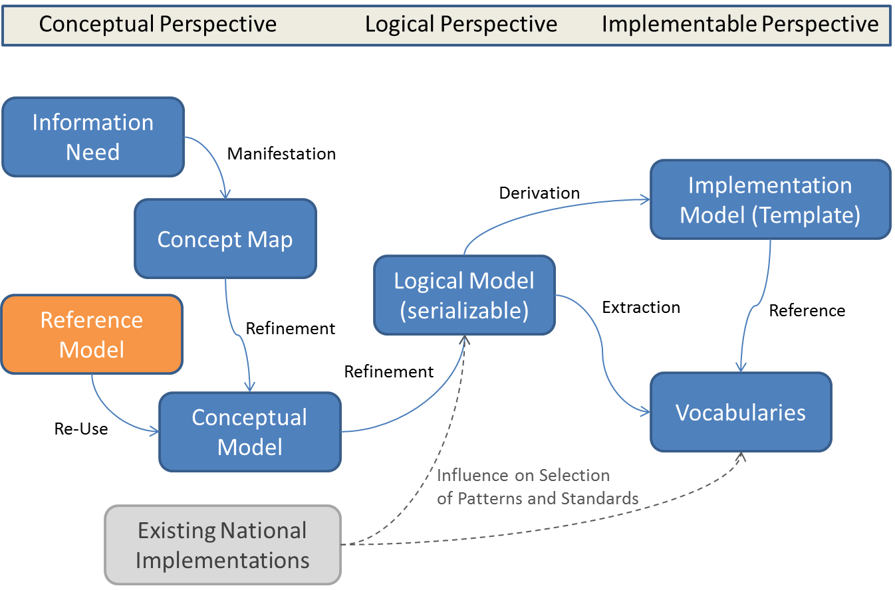
Figure 4: Artifacts of an eHealth DSI Semantic Signifier

By considering the whole set of artifacts beginning from a rough sketch of domain concept interdependencies (concept map) a semantic signifier defines the logical structure and the semantics of information which is required to be shared cross-border within eHealth DSI use cases. Reference Models SHOULD already be considered on the conceptual level in order to ensure that already defined classes (e.g. patient or diagnosis) can be re-used across conceptual models. Controlled vocabularies (e.g. terminologies or taxonomies) MUST be used to express valid value sets of coded concepts.

Table 3 shows how semantic signifiers map onto the ECCF framework.
Semantic Signifier | Enterprise Dimension  "Why"  Policy | Information Dimension  "What"  Content | Computational Dimension  "How"  Behavior
Conceptual Perspective | Requirements catalogue  Information Needs | Concept Map  Conceptual Information Model
Logical Perspective |  | Logical (Serializable) Information Model | Instantiation of Communication Patterns (behavior)
Implementable Perspective |  | Constrained Implementation Model Specifications (including where applicable XML Schema, Schematron, eCore models,…) (template)  Value Sets (MVC) | Mappings and Translations (MTC)
Table 3: Semantic Signifiers Mapping on ECCF tuples

Whenever data is to be shared between eHealth DSI participating nations, the acting parties MUST agree on a semantic signifier in order to uniquely express the semantics of the information needed and the information provided. E.g. the semantic signifier for an ePrescription defines what an "active prescription" is, how to request for it, and how to map it onto a standard encoding. By referring to this semantic signifier a pharmacist in a country-B can express his need for retrieving a patient’s "active prescriptions" and a respective service in country-A can select the "active" ones among the prescriptions stored in a national database. The semantic signifier ensures that the notion of "active" follows the same semantics in both country-A and country-B.

eHealth DSI Semantic Services
The meaning and expressiveness of essential medical information MUST be preserved while this information is shared among countries and it MUST be understandable for the consumer of this information.
A major aspect of document understandability is that a document is provided to the data-consumer in his own language and uses the clinical terms that are commonly used in his home country. In order to avoid the complexity of n:m translations among all European languages, eHealth DSI makes use of "pivot translations". By this eHealth DSI Implementation Models act as standardized document templates that define a normative structure and allow to bind multiple translations to coded values. All eHealth DSI participating nations that support a specific semantic signifier MUST
- be able - depending on the role played (creator / consumer) - to produce and/or accept documents that comply with the structure and coding of the respective eHealth DSI Implementation model (standardized document template).
- provide national translations for all the agreed value sets that are used for encoding essential medical and administrative information within these document templates.
In order to provide document understandability across languages and healthcare systems eHealth DSI MUST provide semantic services that allow for translating essential medical and administrative information within documents that instantiate eHealth DSI standardized document templates into the language of the data-consumer.

The transformation of existing national implementation models (document templates or database schemas) onto the eHealth DSI Implementation Model – and vice versa – is out of the scope of eHealth DSI and MUST be provided by national infrastructure services of the eHealth DSI participating nations.

eHealth DSI Business Functionality
eHealth DSI business functionality is defined through patterns. Patterns are considered to be independent from a specific medical content and use case. By combining and instantiating patterns with concrete actors and medical information objects complex scenarios can be defined that implement a defined healthcare setting. eHealth DSI scenarios are defined in use cases functional specifications ([PS Functional requirements], [eP Functional requirements] and [OrCD Functional requirements]).

Interaction and Communication Patterns
For the specification of eHealth DSI business functionality eHealth DSI Specification Design uses a holistic approach which is based on interaction and communication patterns and which ensures a consistent derivation of service interface contracts from actors’ interaction demands.
From a conceptual perspective each service implements an interaction demand which expresses one or more use cases’ needs for sharing information among human actors. By generalizing interaction demands and concrete actors across use cases, roles and re-usable interaction patterns can be defined. An interaction pattern defines the interaction among roles in a content- and semantic-agnostic way. By this an interaction pattern can be used as the conceptual foundation for fulfilling an interaction demand. Use cases can then be implemented by combining modular interaction patterns and instantiating them with concrete information needs (expressed by the respective semantic signifiers). E.g. the eHealth DSI eP/eD use case can be implemented by combining the "request of data" and "provisioning of data" interaction patterns (see below) and instantiating them with the semantic signifiers "ePrescription" and "eDispensation".
ECCF | Enterprise Dimension  "Why"  Policy | Information Dim.  "What"  Content | Computational Dimension  "How"  Behavior
Conceptual Perspective | Use Cases  Interaction Demands |  | Actors and Roles  Interaction Patterns (end-to-end)
Logical Perspective |  |  | Communication Patterns (NCP-to-NCP)  Service Contracts
Implementable Perspective |  |  | Bindings
Table 4: eHealth DSI Business Functionality mapping on ECCF tuples

Taking the logical perspective, each interaction pattern maps onto a communication pattern within the eHealth DSI application architecture (see section 2.5). A communication pattern abstracts from roles by substituting them by the logical components that either act on behalf of the roles or facilitate logical communication flows within the application architecture. Given the eHealth DSI Business-to-Business paradigm (see section 2.5) eHealth DSI communication patterns are always flows of data and control among NCPs. While the communication pattern reflects the dynamic aspect of a NCP-to-NCP communication, service contracts define the information which is exchanged and the expected behavior of the participating components.
Neither service contracts nor communication patterns indicate specific data encodings or protocols that are to be used for sending commands and data "over the wire". In order to be implementable the communication pattern and the service contract have to be bound to a concrete standard (see section 2.4.1 for details).
By this the design of the system always builds on end-to-end processes but does not require end-to-end protocols and data types on the platform specific level (bindings) because such a constraint would impose that all eHealth DSI participating nations to implement the same standards and control flows within their national infrastructures.
The following sections define the eHealth DSI interaction demands and the eHealth DSI interaction patterns. The communication patterns and service contracts derived from these interaction patterns are specified in sections 4.2 to 4.6. Binding of the communication patterns and service contracts to existing IHE Profiles are defined in a separate document.

"request of data" Pattern

Interaction Demands
eHealth DSI MUST provide functionalities to a country-B-data-consumer that allows him to request medical data of a patient from the patient’s country of affiliation.
eHealth DSI MUST provide functionalities to provide medical data of patient-A to a country-B-data-consumer. The provisioning of medical data by country A MUST only be performed upon request by the country-B-data-consumer.
Due to the synchronous sequencing of these functionalities they are combined into the "Request of Data" pattern.

Actors and Roles
The country-B-data-consumer is acting from within country B. This role MUST be taken by a healthcare professional at a point of care in country-B. The request for patient-A data is processed by a country-A-data-controller in country A on behalf of the patient (eHealth DSI does not impose any constraints on the actor who takes this role in country-A).

Interaction Pattern "Request of Data"
Figure 5 shows the "Request of Data" Interaction Pattern.

eHealth DSI will use parts of a Policy-Based Access Control (PBAC) mechanism for the decisions which are not only based on the roles, but also on attributes (e.g. "Purpose of use", "Locality") and additional modified restrictions following from patient consent.
Figure 5: Interaction Pattern "Request of data"

With this pattern the country-B-data-consumer MUST provide sufficient information to country-A such that country-A is able to discover the requested data from systems within its national infrastructure. The eHealth DSI supported set of identifying attributes (hereafter called "searchStruct") is determined by the common eHealth DSI Medical Document Semantic Signifier (see section 3.3). For each concrete information need a more specialized Semantic Signifier can be derived that constraints the searchStruct attributes and values and defines the concrete semantics of the requested data. The simplest searchStruct is a reference to a Semantic Signifier (e.g. for requesting the patient’s most current patient summary document). More complex seachStructs may apply filters on document formats, creation dates and other document attributes.

Medical data that is returned upon request MAY be accomplished by metadata that provides further administrative and contextual information about the data. eHealth DSI actors MUST NOT rely on the existence and content of transaction level metadata. eHealth DSI actors MAY rely on meta data that is contained within data (e.g. document header data) and specified as part of the eHealth DSI Common Semantic Signifier.

Prerequisites and Obligations
For perfoming this interaction pattern the following prerequisites and obligations MUST be given:
- The country-B-data-consumer MUST have been identified and authenticated within country-B
- The country-B-data-consumer MUST have identified the patient with sufficient accuracy
- The exchange of medical data MUST be documented in a fully traceable, reconstructable, and seamless fashion
- The patient MUST have given consent (willful and documentable act) to cross-border data sharing
- The disclosure of medical data to the country-B-data-consumer is required within the context of an existing treatment relationship with the patient and has been authorized by the patient

Relationship to eHealth DSI Use Cases
The "Request of Data" pattern implements the following eHealth DSI use cases’ functional requirements related to cross-border data sharing:
- ePrescription
- Patient Summary

"Provisioning of data" Pattern

Interaction Demands
eHealth DSI MUST provide functionalities to a country-B-data-producer that allow him to transmit medical data about patient-A to country A.
A country-A that does not implement this functionality MUST reject respective requests from the country-B-data-producer. It is country-B responsibility to define alternative means for transmitting the respective information to country-A (e. g. printing it on paper and handing it to the patient). In any case country-A MUST provide the country-B-data-producer either with an acknowledgment of the data receipt or a notification why the request was rejected.
On the architectural level eHealth DSI MUST NOT make any assumptions on how data actively provided from country B is further processed within country A.

Actors and Roles
The country-B-data-producer is acting from within country B. This role MUST be taken by a healthcare professional at a point of care in country-B. The provided data is processed by a country-A-data-controller in country-A. The country-A NCP MUST take this role and it MUST take responsibility for the secure and privacy-aware transferal of the provided data to the designated data consumer.

Interaction Pattern "Provisioning of Data"
Figure 6 shows the "Provisioning of Data" Interaction Pattern. The dashed lines denote that the depicted kind of processing is optional. The submitted data may e.g. as well be transferred to a patient controlled environment by the country-A-data-controller (eSafe scenario) or be processed directly by the country-A-data-controller (e.g. registration of a consent given in country B).
Figure 6: Interaction Pattern "Provisioning of data"

Medical data that is provided by a country-B-data-producer MAY be accomplished by metadata that provides further administrative and contextual information about the data. eHealth DSI actors MUST NOT rely on the existence and content of transaction level metadata. eHealth DSI actors MAY rely on meta data that is contained within data (e.g. document header data) and specified as part of the eHealth DSI Common Semantic Signifier.

Prerequisites and Obligations
For perfoming this interaction pattern the following prerequisites and obligations MUST be given:
- The country-B-data-producer MUST have been identified and authenticated within country-B
- The country-B-data-producer MUST have identified the patient with sufficient accuracy
- The provisioning of medical data MUST be documented in a fully traceable, reconstructable, and seamless fashion
- The patient MUST have given consent (willful and documentable act) to cross-border data sharing

Relationship to eHealth DSI Use Cases
The "Provisioning of Data" pattern implements the following eHealth DSI use cases’ functional requirements related to cross-border data sharing:
- Informing country-A about a treatment event that occurred in country-B
- Transmitting medical data for updating a country-A patient summary
- Notification on medicine newly prescribed in country-B
- Notification on eDispensation
- Provisioning of consent given in country-B

"Request Overview and Pick Details" Pattern

Interaction Demands
eHealth DSI MUST provide functionalities to a country-B-data-consumer to first obtain an overview report on use case specific data available for a patient and then to just pick the data needed from a foreign country.
eHealth DSI MUST provide functionalities to provide overview reports on (certain kinds of) medical data of patient-A to a country-B-data-consumer. The provisioning of such overview reports by country-A MUST only be performed upon request by the country-B-data-consumer. eHealth DSI MUST provide functionalities to obtain single documents as referenced within such an overview report.
Due to the synchronous sequencing of these functionalities, they are combined into the "Request Overview and Pick Details" pattern.

Actors and Roles
The country-B-data-consumer is acting from within country-B. This role MUST be taken by a healthcare professional at a point of care in country-B. The request for patient-A overview report and patient-A documents is processed by a country-A-data-controller in country-A on behalf of the patient (eHealth DSI does not impose any constraints on the actor who takes this role in country-A).

Interaction Pattern "Request Overview and Pick Details"
Figure 7 shows the "Request Overview and Pick Details" Interaction Pattern.
Figure 7: Interaction Pattern "Request Overview and Pick Details of data"

With this pattern the country-B-data-consumer MUST provide sufficient information to country-A such that country-A is able to discover (or even dynamically assemble) the requested overview report from systems within its national infrastructure. The eHealth DSI supported set of identifying attributes (hereafter called "searchStruct") is determined by the common eHealth DSI Medical Document Semantic Signifier (see section 3.3). For each concrete kind of overview report a more specialized Semantic Signifier can be derived that constraints the searchStruct attributes and values and defines the concrete semantics of the requested data.
Medical data overview reports which are returned upon request MAY be accomplished by metadata that provides further administrative and contextual information about the overview report. eHealth DSI actors MUST NOT rely on the existence and content of transaction level metadata. eHealth DSI actors MAY rely on meta data that is contained within an overview report (e.g. document header data) and specified as part of the eHealth DSI Common Semantic Signifier.
With this pattern, overview reports MUST contain
- information on data available, that is sufficient for the country-B-data-consumer to decide on whether the respective document may be needed for the recent care scenario
- the identifiers to be used by the country-B-data-consumer to fetch a listed document’s full content from country-A
eHealth DSI MUST provide means to a country-B-data-consumer to selectively fetch a single document or a set of documents which were listed within the overview report.
Medical documents which are returned upon request MAY be accomplished by metadata that provides further administrative and contextual information about the document. eHealth DSI actors MUST NOT rely on the existence and content of transaction level metadata. eHealth DSI actors MAY rely on meta data that is contained within an document (e.g. document header data) and specified as part of the eHealth DSI Common Semantic Signifier.

Prerequisites and Obligations
For performing this interaction pattern the following prerequisites and obligations MUST be given:
- The country-B-data-consumer MUST have been identified and authenticated within country-B
- The country-B-data-consumer MUST have identified the patient with sufficient accuracy
- The exchange of medical data MUST be documented in a fully traceable, reconstructable, and seamless fashion
- The patient MUST have given consent (willful and documentable act) to cross-border data sharing
- The disclosure of medical data to the country-B-data-consumer is required within the context of an existing treatment relationship with the patient and has been authorized by the patient

Relationship to eHealth DSI Use Cases
The "Request Overview and Pick Details" pattern implements the following eHealth DSI use cases’ functional requirements related to cross-border data sharing:
- ePrescription

"Patient Identification and Authentication" Pattern
Medical data MUST only be disclosed or shared by means of eHealth DSI after the patient was identified and authenticated with sufficient accuracy (with respect to country-A demands).

Interaction Demands
Each country-B-data-consumer as the intended recipient of medical data MUST identify and authenticate the patient with sufficient accuracy. A country-B-data-producer MUST identify and authenticate the patient with sufficient accuracy before releasing medical information about that patient to a country-A-data-consumer. On successful identification country-A MUST issue a unique patient identifier that can be used for further transactions on the patient’s medical data. Country-A MAY restrict the usability of this identifier to a certain time span or to a certain requestor.

Actors and Roles
The country-B-data-producer and country-B-data-consumer are acting from within country B. These roles MUST be taken by a healthcare professional at a point of care in country-B. Country-B roles MUST only use identity traits that were provided by a patient when that patient was with the data producer or data consumer. The provided identity traits are processed by a patient management service in country-A. The country-A and country-B NCPs MUST mediate messages between the HP at the PoC and the patient management service and they MUST take responsibility for the secure and privacy-aware transferal of all identity related data.

Interaction Pattern "Patient Identification and Authentication"
Figure 8 shows the "Patient Identification and Authentication" Interaction Pattern.
Figure 8: Interaction Pattern "Patient Identification and Authentication"

eHealth DSI scenarios MAY define further constraints on the accuracy and means of patient identification for that specific scenario.
Patient authentication MAY be performed through organizational means by the healthcare professional in country-B. See the "eHealth DSI Extended Security Safeguards Extension" for an implementation of the "Patient Identification and Authentication" pattern, were technical safeguards are used for patient authentication in a foreign country.

Prerequisites and Obligations
For performing this interaction pattern the following prerequisites and obligations MUST be given:
- the country-B-data-consumer/producer MUST have been identified and authenticated within country-B

Relationship to eHealth DSI Use Cases
The "Patient Identification and Authentication" pattern implements the following eHealth DSI use cases’ functional requirements related to cross-border data sharing:
- Patient Identification

eHealth DSI Design Principles
The eHealth DSI architectural design is steered by several strategies and principles on how eHealth DSI non-functional requirements are to be addressed in a holistic fashion.

Interoperability and use of Standards
eHealth DSI MUST consider all levels of interoperability. While the eHealth DSI Semantic Framework (Semantic Signifiers and Semantic Services) fosters semantic interoperability the underlying data sharing and security services MUST implement technical interoperability between NCPs. Such interoperability must be achieved as well on the functional/logical level as on the interface level:
- on the functional/logical level it must be defined which functionalities are provided by the eHealth DSI platform, which prerequisites have to be fulfilled to use these functionalities, how to use these functionalities and how respective services behave at default and at certain exceptional conditions
- on the interface level it must be defined which concrete data types, value sets, and protocols are to be used for implementing the eHealth DSI platform
This Interoperability Specification focuses on functional/logical interoperability (platform independent model) as a prerequisite for connecting eHealth DSI participating nations’ end-to-end processes and for setting up a unique level of security and privacy on top of country-specific security mechanisms. The explication of the logical/functional level makes eHealth DSI architecture and design almost independent from the choice of a specific standard for implementing technical interoperability: generally spoken, eHealth DSI participating nations could even use different standards for implementing the eHealth DSI interoperability specification as standards which are conformant to the eHealth DSI logical/functional model can be mapped onto each other at the interface and protocol level.
Therefore, the mapping of the logical/functional architecture to specific standards is not part of the Interoperability Specification which solely covers the computational and platform independent models of eHealth DSI (ECCF conceptual and logical/functional viewpoints). Standards are bound to the eHealth DSI design through so-called "Bindings" where each binding specifies how an eHealth DSI logical service can be implemented by a specific standard. Even though there may be multiple bindings per logical service, eHealth DSI Interoperability Specification always defines one normative binding in order to ease the implementation of technical interoperability (e.g. the Request-Data-Service can be bound to XCF as well as to XCA. While XCF MUST be supported by each NCP, two interacting NCPs MAY as well agree to perform their data sharing via XCA).

Business-to-Business Paradigm
National Contact Points (NCPs) MUST be implemented federally in order to allow for a virtual integration of autonomous sources of medical data and identity information. The independence of the information sources is preserved as all access to an information source MUST be mediated through the eHealth DSI services which are implemented at NCP level. This complies to a Business-to-Business paradigm where end users and data sources are decoupled by enterprise level entry services that map external requests onto internal operations and vice versa. Part of this mediation is the brokerage of trust that is achieved by matching security objects of the NCP-to-NCP trust domain into a local trust domain and vice versa.

eHealth DSI Security Foundation
eHealth DSI follows the 5-Domain-Model as defined in [IHE AC WP] which allows for a clear separation of concerns in distributed and federated environments.
eHealth DSI use cases rely on a patient from a country-A who is seeking care at a healthcare professional in a country-B. Following the 5-Domain-Model, country-B MUST implement the Subject Domain (e.g. providing information on the identity and authenticity of the HP) and the Context Domain (e.g. providing information on the purpose of use and the contractual relationship between the HCPO and the patient). In the same way country-A MUST implement the Patient Domain (e.g. assuring patient authenticity and patient privacy enforcement) and the Resource Domain (e.g. enforcing a national security policy). The Application Domain is implemented on the eHealth DSI level through a common eHealth DSI security policy and the eHealth DSI MultiLateral Agreement which have to be accepted by all eHealth DSI participating nations.

Figure 9: eHealth DSI Security Domain Mapping and Dependencies

As a prerequisite for a secure and privacy-aware cooperation between data-producers and data-consumers, each actor MUST provide the other actor with assurances on the proper implementation of its security domains (including the Application Domain as a common domain). E.g. if a HP in country-B acts as a data-consumer it MUST provide the data-producer actor in country-A with assertions on the proper implementation of the Context Domain, the Subject Domain and the common eHealth DSI Application Domain. On the other hand the data-consumer MUST NOT accept any data from a data-producer unless the data-producer asserts the proper implementation of the Patient Domain, the Resource Domain and the common eHealth DSI Application Domain. Due to the eHealth DSI Circle-of-Trust among participating nations, a country MUST NOT reject an assurance that is given by another eHealth DSI participating country. The most important assurances implemented by the eHealth DSI security framework are:
- proper identification and authentication of a country-B-data-consumer/producer
- existence of a patient consent to eHealth DSI
- existence of a treatment relationship with the patient and authorization of country-B-data-consumer/provider by the patient
- integrity of the shared data
- verification of the origin and authenticity of the shared data
On the logical and technical level, assurances MAY be brokered through NCPs (e.g. a NCP vouchers for the HP) or be implied through the eHealth DSI Security Policy.

eHealth DSI Layered Architecture Stack
eHealth DSI builds upon a layered architecture stack approach where each layer consumes services provided by lower layers and provides services to higher layers. This approach allows for sharing lower layers among different upper layers (e. g. the eHealth DSI messaging architecture services can be consumed by cross-border projects other than eHealth DSI, too) and for evolving the different layers independently from each other (e.g. upgrading standards in one layer does not affect the other layers as long as the same services are provided and consumed).

eHealth DSI 4-layered Architecture
Figure 10 sketches the four layers of the eHealth DSI architecture.
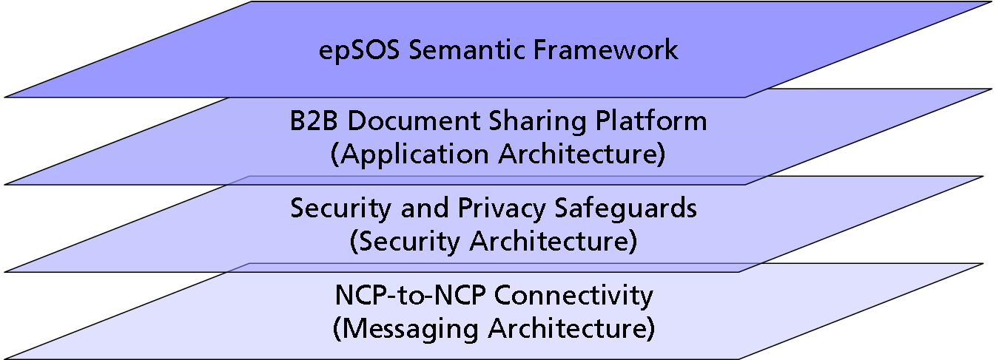
Figure 10: eHealth DSI 4-layer Architecture

The top-most layer of the eHealth DSI architecture stack is the eHealth DSI Semantic Framework (see section 3). Through the concept of semantic signifiers the eHealth DSI Semantic Framework provides data consumers and data producers with end-to-end semantics: the data consumer receives medical information with the full semantics as intended by the data producer. Semantic services of the eHealth DSI Semantic Framework provide usability-enhancing and patient-safety-enhancing services on top of eHealth DSI shared medical documents.
The eHealth DSI B2B Document Sharing Platform provides services for implementing the eHealth DSI business patterns (see section 4). It does so in a B2B manner (see section 2.4.2) and therefore is only defined within the eHealth DSI space (which is NCP-to-NCP). eHealth DSI participating nations MUST provide functionality within their NCPs to connect the eHealth DSI Document Sharing Platform to their existing national data sharing platforms.
eHealth DSI Security and Privacy Safeguards provide means for encoding and sharing security assurances. In addition this architectural layer implements security services for providing a sufficient level of confidentiality, integrity, and non-repudiation to eHealth DSI. Depending on the communicating countries abilities and requirements, all security safeguards and services can either be implemented end-to-end or be brokered by the countries NCPs.
The eHealth DSI NCP-to-NCP Connectivity layer spans a private communication network among NCPs and provides functionalities for eHealth DSI service discovery. It links eHealth DSI Central Services to the eHealth DSI network and provides means for synchronizing local NCP configuration data from eHealth DSI Trusted Service Lists and globally managed terminologies.

NCPs as Facades
The eHealth DSI layered architecture with an end-to-end semantic framework on top of a content-agnostic, NCP-to-NCP platform perfectly matches with the design pattern of a service facade. With this pattern the functional and semantic diversity of different services is hidden behind a simple and generic interface.
eHealth DSI makes use of this pattern in a way that the NCP-terminated document sharing platform acts as a facade to the eHealth DSI business services which are bound to different semantic signifiers. By these services which implement e.g. the semantic signifiers "ePrescription" and "Patient Summary" can be reached by a common interface while nevertheless allowing for a specific handling of requests according to the specific semantics of the semantic signifier. E.g. a data request for an ePrescription can be implemented as "provide me with all active prescriptions of the patient" while a data request for a patient summary can be implemented as "provide me with the currently valid patient summary of the patient". In this example the different end-to-end agreed semantics of "active" and "valid" are implemented by services which can be reached through a common interface at the NCP facade.

eHealth DSI Semantic Framework Specification
The eHealth DSI Semantic Framework is a vertical domain framework that provides means for implementing cross-border healthcare use cases with an end-to-end semantics. The functional/logical specification of the Semantic Framework spans all ECCF dimensions because the framework as well defines the semantics aware encoding of medical information as the processes and services for making this information usable to the data-consumer actors.
This chapter covers the conceptual and logical perspectives of the eHealth DSI Semantic Framework as summarized in Table 5. The implementable perspective technical specification on constraint implementation models (including where applicable XML Schema, Schematron, eCore models, XSL for visualization, etc.), value sets and the mapping/translation tables is part of a separate document, which covers the binding of the common logical information model and codes to existing standards (e.g. HL7v3 CDA and LOINC).
Semantic Framework | Enterprise Dimension | Information Dimension | Computational Dimension
Conceptual Perspective | Requirements Catalogue  Information Needs | Concept Maps  Conceptual Information Models | Design Patterns
Logical Perspective | Functional e-2-e Description | Logical (Serializable) Information Model | Integration with Communication Patterns  Semantic Services Architecture  Semantic Services Contracts
Implementable Perspective |  | Constrained Implementation Model Specifications Value Sets (MVC)  Mappings and Translations (MTC)
Table 5: Semantic Framework Mapping on ECCF tuples

eHealth DSI Semantic Framework Requirements
The eHealth DSI Semantic Framework defines design patterns and flows of control on top of medical document templates and semantic services for making framework-compliant documents understandable and usable across Europe.
This section summarizes the requirements and design decisions that determinate the logical/functional specification of the eHealth DSI Semantic Framework.

Design Decisions and Flow of Control
Legislations, workflows, and standards that are used for sharing documents within an eHealth DSI participating country MUST NOT be influenced by eHealth DSI. Therefore, eHealth DSI MUST NOT rely on a certain structure, coding, and semantics of medical documents that are used within a PN’s healthcare system. Instead, the eHealth DSI Semantic Framework MUST provide design patterns and control flows that allow for specifying eHealth DSI semantic signifiers which include standardized document templates for serving specific information needs (see section 3.3.2). All services within the eHealth DSI space MUST only consider eHealth DSI semantic signifiers. Before a medical document is transferred from a national infrastructure into the eHealth DSI space it MUST be transformed and transcoded into a format and coding according to the respective eHealth DSI semantic signifier. When a document is transferred from the eHealth DSI space into a national infrastructure it MAY be transformed and transcoded into a national document schema. In order to fulfill the requirement of the Grant Agreement, the document provided to the HP in the Country of treatment MUST be rendered in that country language.
In order to enable re-using eHealth DSI classes and in order to provide a common document structure that eases the use of semantic services, eHealth DSI MUST define templates (archetypes) that allow for defining re-usable content elements across all structural levels of medical documents (document, section, statement).
All eHealth DSI semantic signifiers MUST be derived from a common eHealth DSI semantic signifier that defines
- a common reference information model, that defines re-usable classes for common elements (e.g. HP, patient)
- a common document architecture that defines a common document structure and the methodology for deriving this common implementation structure from a common reference information model
- common value sets for coding common concept domains
eHealth DSI use cases define a first conceptual information model identifying the information optionalities and business rules for handling exceptions. Information required for implementing the use case MUST be reflected by eHealth DSI semantic signifiers as the Basic Data Set of the semantic signifier (conceptual perspective). All eHealth DSI participating nations MUST be able to provide and process the implementation of this semantic signifier’s basic data set according to the exceptions management business rules defined for those data. Additional information which is not essential to the use case but may ease or improve the integration of eHealth DSI into existing processes MUST be considered as merely optional information within the eHealth DSI semantic signifiers (conceptual perspective). Together with the basic data set this optional information leads to the Extended Data Set of the semantic signifier. Information within the extended data set which is not included with the basic data set MAY be provided and/or processed by eHealth DSI PNs but in any case MUST be displayable to HPs.

Patient Safety and Usability
eHealth DSI MUST define a structured process for deriving eHealth DSI semantic signifiers from use cases and HPs’ information needs. This process MUST ensure the quality and appropriateness of the medical information that is aggregated as a document and provided to a certain eHealth DSI use case. eHealth DSI semantic signifiers MUST be able to capture not only the structure and coding of a document type specification but even the semantics that is provided by the artifacts of the design process.
Medical documents SHOULD be made available to an HP in the language of the HP. Using fully automated, NLP-based translation techniques may impose risks to patient safety. Therefore, eHealth DSI MUST NOT automatically translate uncoded and plain-text entries within medical documents. Due to the inability to translate uncoded entries and plain text, eHealth DSI pivot schemas SHOULD use coded data wherever possible.
The respective terminologies and value sets SHOULD be taken from existing international standards. eHealth DSI MUST only use terminologies where the semantics of each concept is clearly defined and where a normative natural language description exists for each coded concept.
It is common practice that whenever a document is modified automatically the consumer of this document SHOULD be enabled to access and verify the original document. Therefore, whenever a document is automatically modified or extended for being shared through eHealth DSI, eHealth DSI MUST provide means to the document-consumer to view a rendering of the original data in human readable format (e.g. PDF) according to the specification of its optionality for a particular semantic signifier. The rendering of the original data MUST contain the full information as approved by the document-producer.

Transforming, Transcoding and Translating
The transformation/transcoding between a nationally profiled document and an eHealth DSI pivot coded document is very specific for each country and may even not be automated with all eHealth DSI participating nations. Therefore, this transformation/transcoding MUST be considered to be national concern and by this is out of the scope of eHealth DSI and eHealth DSI Specification. The following figure shows how this affects the boundaries of the eHealth DSI Semantic Framework and the eHealth DSI document sharing platform.
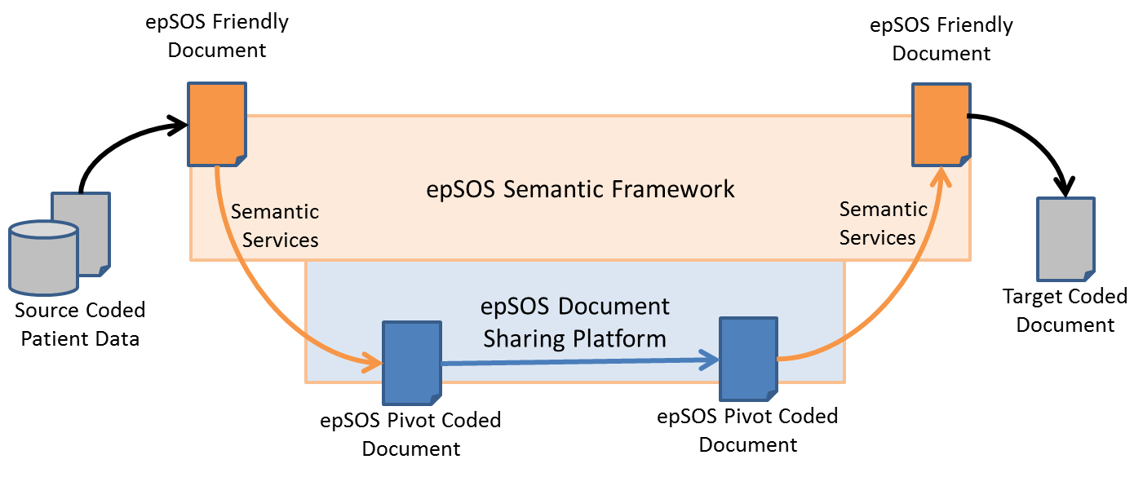
Figure 11: Boundaries of the eHealth DSI Semantic Framework

For reasons of liability, the extended data set coded concepts included in the eHealth DSI semantic signifiers MUST use a representation providing at least both the machine-processable code (concept code) and the human-readable term (label, designation). For reasons of liability, the extended data set coded concepts used in the eHealth DSI coded documents generated from the source coded document/data MUST provide the original concept designation. For eHealth DSI friendly documents that are intended to be displayed to or processed by human users, the human readable term MUST be provided in the language of the user.
Each PN is liable and accountable to the fact that the semantic transformation is performed according to the translation, mapping, and transcoding performed by designated competent legal entities in the eHealth DSI countries:
- the responsibility for the accuracy and integrity of the process is with each national designated competent legal entity for such semantic processing
- liability for errors in the semantic mapping is a shared eHealth DSI liability and it is managed at the level of eHealth DSI and as part of its trust building framework.

eHealth DSI Friendly Documents (non-normative)
For mapping a nationally profiled document/data onto an eHealth DSI semantic signifier, the following steps MAY be required:
- the alignment of the concepts used within the local document/data with those requested by the eHealth DSI semantic signifier must be verified
- the document structure must be transformed into the schema of the respective eHealth DSI implementation model (pivot schema) as defined by the respective eHealth DSI semantic signifier
- coded statements must be transcoded such that they are encoded by the code systems and value sets defined by the eHealth DSI implementation model and the eHealth DSI Master Value Set
The result of these steps is a so-called "eHealth DSI friendly document" which MAY be used by a PN as an intermediary step for decoupling document transformation, transcoding, and translation. An "eHealth DSI friendly document" reflects the semantics and information scope as defined by the selected eHealth DSI semantic signifier and conforms to the pivot schema and value sets of that semantic signifier. By reverting the steps listed above an eHealth DSI friendly document can be transcoded and transformed into a nationally profiled document.

The eHealth DSI Common Semantic Signifier
eHealth DSI coded documents as shared among NCPs follow a common information model. The design of the respective artifacts follows the methodology as sketched in Figure 13 with two adaptations:
- solutions and standards already in use by multiple eHealth DSI PNs SHOULD be considered in the early design stages in order to allow for picking up existing good practices
- medical content MUST be considered to be a modular part of the information model to allow for reusing existing standardized detailed clinical models (DCMs)
Figure 12 shows the artifacts of the eHealth DSI Common Semantic Signifier that is the basis for any eHealth DSI content modeling.
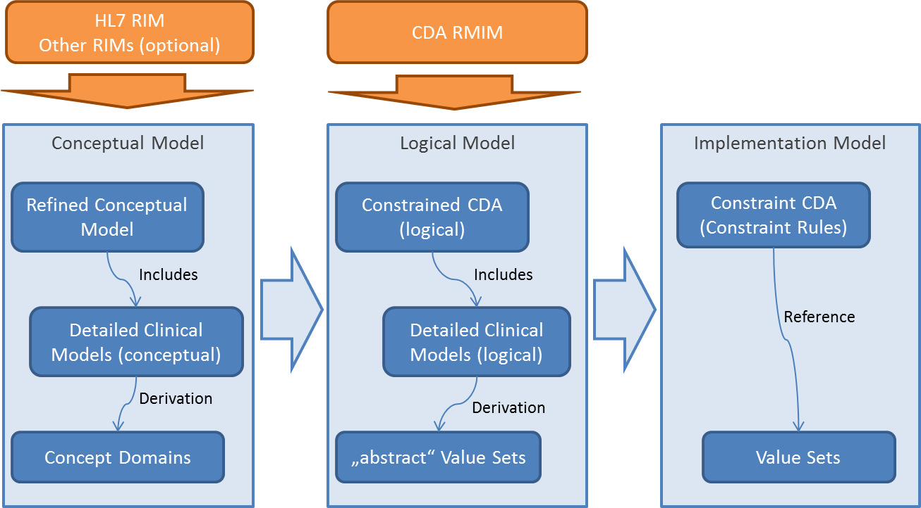
Figure 12: Artifacts of the eHealth DSI Common Semantic Signifier

eHealth DSI Common Conceptual Information Model
The eHealth DSI Common Conceptual Information Model is the basis for all Semantic Signifiers that define the content and semantics of specific kinds of eHealth DSI coded documents. It
- clearly separates information about the context of document processing from detailed clinical models which carry the medical content
- for patient safety reasons allows to accomplish eHealth DSI coded documents by the source coded data (e.g. PDF encoded)
- imposes a common structure for eHealth DSI coded documents and defines the semantics of all medical statements that make up the medical content of the document
- sets a common, hierarchical structure on eHealth DSI medical content that contains medical statements encoded by controlled vocabularies as its leafs
- allows for dynamically linking translations to coded values
Figure 13 shows the major classes of the eHealth DSI Common Refined Conceptual Model.
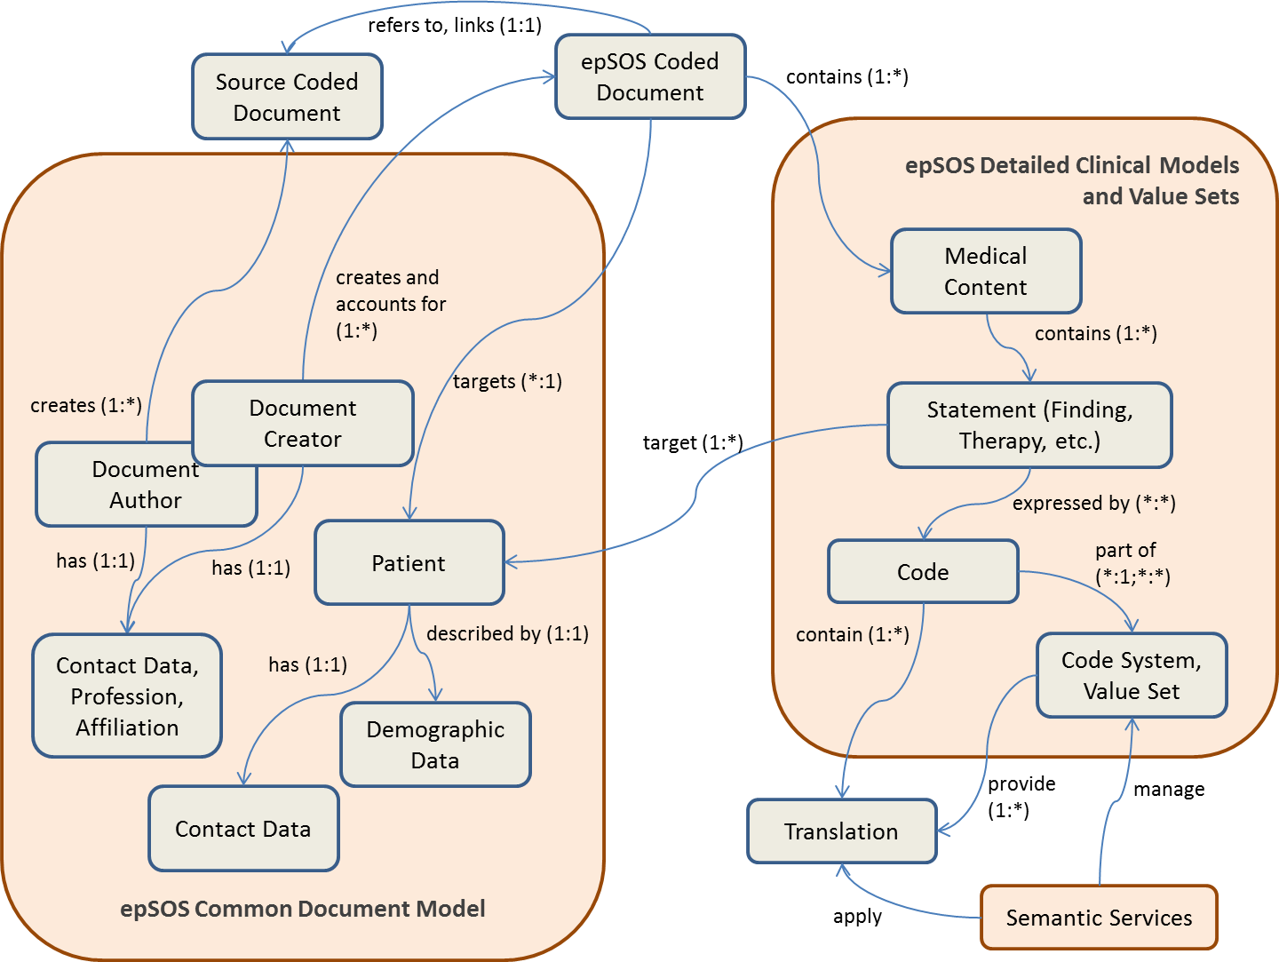
Figure 13: eHealth DSI Semantic Signifier Concept Map

As shown in the figure, the eHealth DSI Common Conceptual Model consists of
- a common document model which scopes the context and actors of the documented findings and activities (see section 3.3.2). This model follows a common model for all semantic signifiers and use cases but shall be instantiated per semantic signifier
- detailed clinical models and value sets which are specific for each semantic signifier (see section 3.3.2). These models steer the documents medical content and statements about a specific patient.
eHealth DSI clinical statements are expressed through coded values. Transcoding and translation of these values is performed by eHealth DSI semantic services (see section 3.4).

eHealth DSI Common Document Model and Detailed Clinical Models
[NCPeH Architecture Specification] and [CDA templates] define the common models to be used as a basis for all documents shared through eHealth DSI. eHealth DSI Detailed Clinical Models are designed to be modular in order to allow the re-use and profiling of existing standardized section and statement semantics.
All document and clinical models expressed by eHealth DSI Semantic Signifiers are normatively bound to the HL7v3 CDA standard by providing a single CDA implementation guide per semantic signifier. All implementation guides build upon a common set of sections which encapsulate a set of medical statements related to a specific aspect of the patient’s health status. Table 6 shows the sections which are defined by eHealth DSI together with the CDA section templates that were used for binding these sections to HL7v3 CDA.

eHealth DSI Section [NCPeH Architecture Specification, CDA templates] | CDA Template OID
Patient Summary
eHDSI Allergies and Other Adverse Reactions | 1.3.6.1.4.1.12559.11.10.1.3.1.2.12
eHDSI Immunizations | 1.3.6.1.4.1.12559.11.10.1.3.1.2.15
eHDSI History of Past Illness | 1.3.6.1.4.1.12559.11.10.1.3.1.2.10
eHDSI List of Surgeries | 1.3.6.1.4.1.12559.11.10.1.3.1.2.11
eHDSI Active Problems | 1.3.6.1.4.1.12559.11.10.1.3.1.2.9
eHDSI Medical Devices | 1.3.6.1.4.1.12559.11.10.1.3.1.2.4
eHDSI Health Maintenance Care Plan | 1.3.6.1.4.1.12559.11.10.1.3.1.2.8
eHDSI Functional Status | 1.3.6.1.4.1.12559.11.10.1.3.1.2.14
eHDSI Social History | 1.3.6.1.4.1.12559.11.10.1.3.1.2.13
eHDSI Pregnancy History | 1.3.6.1.4.1.12559.11.10.1.3.1.2.7
eHDSI Vital Signs | 1.3.6.1.4.1.12559.11.10.1.3.1.2.6
eHDSI Coded Results | 1.3.6.1.4.1.12559.11.10.1.3.1.2.5
eHDSI Medication Summary | 1.3.6.1.4.1.12559.11.10.1.3.1.2.3
eHDSI Advance Directives | 1.3.6.1.4.1.12559.11.10.1.3.1.2.16
ePrescription
eHDSI Prescription | 1.3.6.1.4.1.12559.11.10.1.3.1.2.1
eDispensation
eHDSI Dispensation | 1.3.6.1.4.1.12559.11.10.1.3.1.2.2
Table 6: eHealth DSI CDA section definition

eHealth DSI Semantic Services
The eHealth DSI Semantic Services provide the functionalities needed to perform semantically accurate runtime translation and transcoding of coded elements present in the eHealth DSI pivot documents.
The services MUST support runtime translation of coded elements from pivot to national language and, sometimes, vice versa and transcoding from national coding system and value sets into pivot coding system and value sets.
The eHealth DSI Semantic services MUST also support functionalities for accessing, maintaining, validating, and versioning the content of the eHealth DSI Master Value Set Catalogue (eHealth DSI MVC) that enables the translations and of the eHealth DSI Master Translation/Transcoding Catalogue (eHealth DSI MTC) that allows it.
Master Translation/Transcoding Catalogue MUST be generated from MVC, to include the Transcoding (sometimes the Translation) of the Coding System/Value Sets included in the eHealth DSI Friendly CDA generated by the data producer and the Translation of the eHealth DSI Pivot Document coded elements in the data consumer language.
The eHealth DSI Semantic Services can be divided into two categories: transformation services performing translation and transcoding and terminology access services providing functionalities for access to terminology repository or repositories.
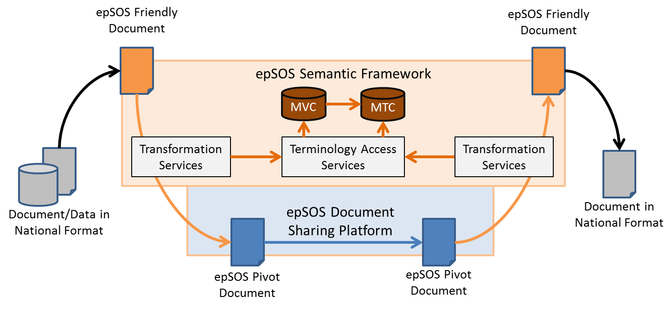
Figure 14: eHealth DSI Semantic Services

eHealth DSI Semantic Services Scenarios
The eHealth DSI Semantic services provide support for the core eHealth DSI services in the following scenarios: Requesting Data, Provisioning of Data and Patient Request for Data Translation.
Figure 15: eHealth DSI Semantic Services – Requesting data

Requesting Data
This is the main scenario implemented in eHealth DSI for Patient summary and ePrescription and is illustrated in Figure 16. A healthcare professional in country-B requests data from patient’s country of affiliation. Transformation service at NCP-A performs transcoding into eHealth DSI pivot by retrieving mappings of concepts into eHealth DSI pivot coding systems and Transformation service at NCP-B then performs translation of concept designations to country-B language.
Figure 16: eHealth DSI Semantic Services – Provioning of data

Provisioning of Data
This scenario was implemented in eHealth DSI only for eDispensation and is illustrated in Figure 16. A health professional in country-B sends data concerning care event in country-B to patient’s country of affiliation. Transformation service at NCP-B performs transcoding into eHealth DSI pivot by retrieving mappings of concepts into eHealth DSI pivot coding systems. Actions at NCP-A depend on country-A decision. The default option is that Transformation service at NCP-A then performs translation of concept designations to country-B language, however country-A MAY choose to forward the eHealth DSI pivot directly into NI A for transcoding or further transformation. Notification of data receipt does not utilize eHealth DSI semantic services.
In eHealth DSI the Transformation Manager (TM), the Terminology Service Access Manager (TSAM or previously epSOS TAS) and Local Terminology Repository (LTR) are placed at the NCP.

Translations and mappings web service
The translations and mappings web service is exposed as a REST API and provides following services:
- Runtime transcoding from eHealth DSI friendly document to eHealth DSI pivot document
- Translation from the eHealth DSI pivot document into any language shared with the country of treatment.
- Retrieval of an available value set with all the concepts translated into a language shared with the country of treatment.
- Retrieval of available translation languages service.
The transformation of eHealth DSI Friendly document created in data-producer country (in the national infrastructure or in the National Connector) to eHealth DSI pivot document MUST support language translation (in terms of the display name) of specified coded elements from data producer language to eHealth DSI pivot language and transcoding of coded concepts from the national to the eHealth DSI value sets when required by the binding rules of the eHealth DSI pivot specification.
The transformation of eHealth DSI pivot document into eHealth DSI Friendly document of data consumer country consists of language translation of specified coded elements from eHealth DSI pivot language to data consumer language.
The transcoding from eHealth DSI pivot to data consumer country coding system MUST be considered national concern.
The transformation of document/data in national format of data producer country into eHealth DSI Friendly document is very specific and MUST be considered national concern.
The service MUST also provide functionalities for automatic validation of eHealth DSI Friendly and eHealth DSI pivot documents with respect to the specified semantic signifier. Furthermore the service SHOULD return feedback about possible transformation errors and warnings.

Key actors and roles
Health Professional in country-B – uses the service in the following 2 roles:
- country-B data-consumer - requesting document from patient’s country of affiliation
- country-B data-provider - sending HCER to patient’s country of affiliation
Patient - requests translation of Patient Summary within eHealth DSI Patient Access.

Business rules for translation and transcoding
- For liability reasons the original coded concept MUST be preserved
- For the same reason not only the concept code but also the designation locally used (e.g. seen by the HP) MUST be provided

Transformation service contract specification

Transcoding to eHealth DSI pivot
Operation | HTTP POST method: /transcode
Description | transcode national data already available as an eHealth DSI Friendly CDA to eHealth DSI pivot
Requestor | Country-A or country-B data-provider gateway (gateway of country acting as data provider within a particular transaction)  or  HP at country A or B who is preparing data for being shared through eHealth DSI (End-to-End secure scenarios only)
Input | friendlyCDA: Base64 encoded String containing the national data in format compliant to eHealth DSI Friendly CDA
Output in successful Case | responseCDA: Base64 encoded String containing the eHealth DSI pivot document with report on validation and transformation errors and warnings
Precondition of success scenario | The following preconditions MUST be met for successful processing:  - Terminology access services available containing complete and valid eHealth DSI MTC for the requestor language
Main success scenario | Actions of the eHealth DSI Translation/transcoding Service provider:  - Validate input data  - Construct eHealth DSI pivot document according to translation/transcoding business rules using terminology access services to retrieve mapping of relevant concepts to eHealth DSI pivot concepts  - Validate the created eHealth DSI pivot document  - Return the eHealth DSI pivot document and a structure with report on the translation/transcoding process
Fault Conditions | Preconditions for a success scenario are not met
Fault Conditions | Unknown code system
Fault Conditions | Unknown code system version
Fault Conditions | Unknown code system concept
Fault Conditions | Missing code system version
Fault Conditions | Mapping for a given concept not available
Fault Conditions | Designation in the requested language not available
 | Input document not compliant to eHealth DSI Friendly CDA
 | Some mandatory sections in the input document are missing

Retrieval of available translation languages
Operation | HTTP GET method: /languages
Description | retrieve a set of all available translation languages for a specific jurisdictional domain
Requestor | data consumer gateway (gateway of country acting as data consumer within a particular transaction)  or  HP at country A or B who is consuming data that was received through eHealth DSI (End-to-End secure scenarios only)  or  national data access portal (scenarios where NCP is bypassed on the NI-side and semantic services are called directly from within the NI)
Input
Output in successful Case | Set of available translation languages for the specific jurisdictional domain
Precondition of success scenario | The following preconditions MUST be met for successful processing:  - The language codes for which translations are available must be linked with the jurisdictional domain
Main success scenario | - Return the list of available translation languages
Fault Conditions | AVAILABLE_TRANSLATION_LANGUAGES property not set in the database

Translating from eHealth DSI pivot
Operation | HTTP POST method: /translate
Description | translate concept designations in eHealth DSI pivot to the language of data consumer
Requestor | data consumer gateway (gateway of country acting as data consumer within a particular transaction)  or  HP at country A or B who is consuming data that was received through eHealth DSI (End-to-End secure scenarios only)  or  national data access portal (scenarios where NCP is bypassed on the NI-side and semantic services are called directly from within the NI)
Input | pivotCDA: Base64 encoded String containing the eHealth DSI pivot document  targetLanguageCode: target language
Output in successful Case | responseCDA: Base64 encoded String containing the eHealth DSI friendly B document with added designations in target language structure with report on validation and transformation errors and warnings
Precondition of success scenario | The following preconditions MUST be met for successful processing:  - Terminology access services available containing complete and valid eHealth DSI MTC for the target language
Main success scenario | Actions of the eHealth DSI Translation/transcoding Service provider:  - Validate input data  - Create eHealth DSI Friendly B document by adding designations of the relevant eHealth DSI pivot concepts in the target language according to translation/transcoding business rules using terminology access services to retrieve the designations  - Validate the created eHealth DSI Friendly B document  - Return the eHealth DSI Friendly B document and a structure with report on the translation/transcoding process
Fault Conditions | Preconditions for a success scenario are not met
Fault Conditions | Unknown code system
Fault Conditions | Unknown code system version
Fault Conditions | Unknown code system concept
Fault Conditions | Missing code system version
Fault Conditions | Mapping for a given concept not available
Fault Conditions | Designation in the requested language not available
Fault Conditions | Input document not compliant to eHealth DSI pivot
Fault Conditions | Some mandatory sections in the input document are missing

Retrieval of a value set with translated concepts
Operation | translateVS
Description | Retreive all concepts of a specified value set translated in a specified language.
Requestor | End users that want to retrieve the full value set with all the concepts translated.
Input | oid: OID of the value set  valueSetVersion: version of the value set to retrieve  targetLanguageCode: target language
Output in successful Case | ValueSet resource with all the concepts translated in the target language
Precondition of success scenario | The following preconditions MUST be met for successful processing:  Terminology access services available containing the value set and translations for all the concepts in the target language.
Main success scenario | Actions of the eHealth DSI Translation/transcoding Service provider:  Retrieve OID of the value set to be translated.  Ensure the translations for he concepts of this value set are shared with your jurisdiction.  Translated concepts are shared using the TSAM synchronization Process.  Value set is retrieved with all the concepts translated in the target language
Fault Conditions | Preconditions for a success scenario are not met
Fault Conditions | Unknown value set
Fault Conditions | Value set not available
Fault Conditions | Translations not shared with jurisdiction.
Fault Conditions | Translations not synchronized in local terminology database

Bindings and Deployments
The implementation level specification of the eHealth DSI CDA Constrain Rules on CDA document headers is provided in [CDA templates].
The implementation level interface specification of the eHealth DSI Translation Service is provided in [OpenNCP Implementation].
Value sets and translation tables MAY be provided by a central terminology service..

eHealth DSI Application Architecture Specification
The eHealth DSI Application Architecture implements communication patterns that map the end-to-end interaction patterns as defined in section 2.3 onto technical transactions between an NCP-A and an NCP-B.
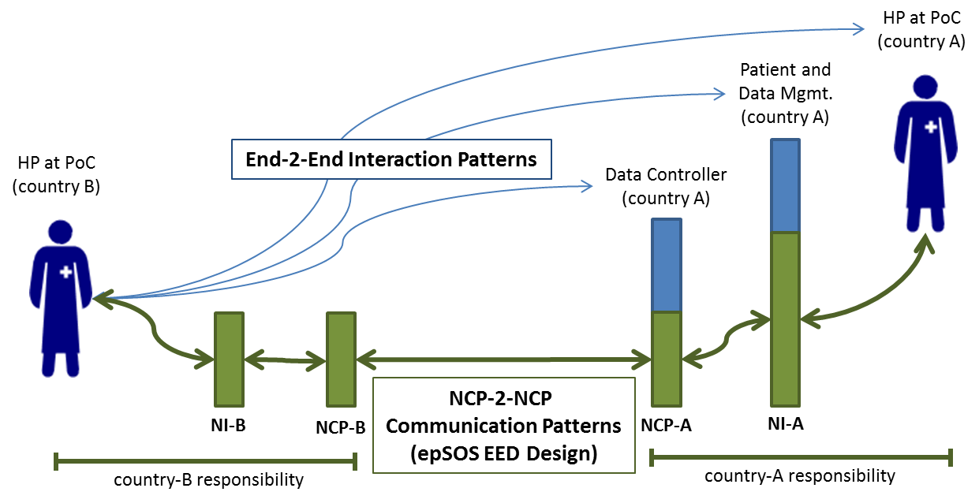
Figure 18: End-to-End Security Patterns

As shown in Figure 18 the eHealth DSI Application Architecture solely defines the patterns for NCP-to-NCP communication. These modular patterns encapsulate all flows of control and data among NCPs which are needed to implement the NCP-to-NCP portion of end-to-end, cross-country interaction among HPs and other business entities. The connectivity from such business entities to NCPs is within national concern.

The eHealth DSI Application Architecture Specification defines the logical perspective onto cross-border data sharing. It is fully content-agnostic. Therefore, its design can be re-used for any existing and future eHealth DSI information dimension specification.
 | Enterprise Dimension | Information Dimension | Computational Dimension
Logical Perspective | Requirements Catalogue |  | Service Architecture Definition  Communication Patterns  Service Contract Specification
Table 7: Application Architecture mapping to ECCF Tuples

The normative parts of the eHealth DSI Application Architecture Specification are located in the computational dimension which is rather streamlined:
- the Service Architecture Definition provides the logical specification on how eHealth DSI core patterns and principles are mapped on the architecture design
- eHealth DSI Communication Patterns specify the logical flow of control and data among NCPs (dynamic model)
- eHealth DSI Service Contract Specifications specify the logical interfaces of eHealth DSI services that face into the eHealth DSI domain (static model)
It must be noted that none of the building blocks of the eHealth DSI Application Architecture Specification is implementable unless it is bound to a specific standard.

eHealth DSI Application Architecture requirements
The eHealth DSI application architecture MUST provide logical functionalities for implementing the business level interaction patterns. Every logical functionality MUST be specified by (1) a communication pattern that determines the sequencing of the messages exchanged between two NCPs, (2) a service contract that determines the content of the messages exchanged between two NCPs, and (3) the expected behavior of the NCP that provides the requested functionality. An NCP located component that implements the communication pattern, the service contract, and the service behavior is called a service.
eHealth DSI MUST follow the paradigms of Service Oriented Architectures (SOAs). eHealth DSI services MUST be stateless from a logical perspective.
eHealth DSI services MUST be content agnostic. The external behavior of the service and the service contract MUST NOT be different for different kinds of data to be shared among NCPs.
eHealth DSI services MUST NOT – from a logical/functional perspective – rely on specific features of a national infrastructure. E.g. the external behavior and service contract of a service is the same regardless if that service is within the NI bound to a web portal, a database or another (web) service.
eHealth DSI services MUST allow for the sharing of encrypted medical data. The service contract and the external behavior of the service MUST not be affected by any protection means which are solely applied to the data being shared (content agnostics).
eHealth DSI services MUST NOT rely on a specific implementation. Every new interaction pattern or every new use case MUST be implementable on top of an existing service implementation as long as this pattern or use case only relies on the defined services.
eHealth DSI services MUST NOT rely on specific security services or mechanisms. Security means MUST solely be applied within the underlying security architecture or onto the data that is shared.

eHealth DSI Service Architecture
The eHealth DSI Service Architecture is made up of 3 services which each implement a single service contract:
- Patient Identification and Authentication Service for identifying a patient who seeks care at an HP at a PoC in country-B
- Request of Data Service for requesting medical data of a patient from country-A
- Provisioning of Data Service for providing medical data of a patient from country-A to country-A

Patient Identification and Authentication Service

Requirements
The user of medical data MUST be able to unambiguously assign medical data (that is obtained from another country) to an identified patient.
Technical means for patient identification MUST NOT use or disclose medical data about this patient.
Patient identifiers SHOULD NOT technically enable any unlawful linkage of the patient’s medical data to other sanctioned personal data beyond any legitimate purpose from other domains.
If technical means for identity protection (e.g. pseudonymization) are used, those MUST NOT disqualify the responsible parties to lawfully provide the patient access to his/her data.
The original identification of the patient MUST NOT rely on the existence of electronic identifiers (eIDs).
Any identity abstraction or alteration, such as the assignment of pseudonyms, MUST be performed by country-A in order to guarantee the correct linkage of medical data to a specific identity regardless of its characteristics (pseudonym, MPI or domain identifier).

Communication Pattern
Figure 19 shows the communication pattern of the Patient Identification and Authentication Service.
Figure 19: Communication Pattern Patient Identification and Authentication Service

The service is always implemented at NCP-A and requested by NCP-B. The service contract consists of two messages: FindIdentityByTraitsRequest and FindIdentityByTraitsResponse.
In order to identify a patient NCP-B MUST firstly send a findIdentityByTraitsRequest message to NCP-A. This message carries identity traits of the patient (e.g. local healthcare id) and optional credentials for verifying the authenticity of the patient. NCP-A MUST respond to a findIdentityByTraitsRequest message by returning a findIdentityByTraitsResponse message to the requestor. If the patient was successfully identified and authenticated, this message carries the shared patient identifier that MUST be used by NCP-B and NCP-A for any further message exchange related to that patient.

Service Contract and Behavior Specification
Operation | findIdentityByTraits()
Description | Obtain a shared patient identifier
Requestor | Consuming Gateway at NCP-B (service consumer at the country of care)
Input Message | FindIdentityByTraitsRequest
Input Message |  | (1) List of patient identity traits as provided by the patient to the HP at the PoC in country-B
Output Message in successful Case | FindIdentityByTraitsResponse
Output Message in successful Case |  | (1) Unique identifier of the patient that has to be used for all subsequent calls for this patient’s medical data.  (2) Optional: further patient identity traits that allow the HP to verify the result of this operation.  If no unique match is found, the service provider MAY respond with a list of candidates. For each candidate body elements (1) and (2) MUST be provided.
Precondition of success scenario | The following preconditions MUST be met for successful processing:  - The patient has given a consent that authorizes NCP-A to disclose his identity  - The patient is able to provide identity traits that are sufficient for a unique identification  - NCP-B has discovered the service endpoint at NCP-A and is able to connect to that endpoint  - A trust relationship and a secure communication channel have been established between NCP-B and NCP-A  - HP-B was successfully authenticated in country-B  - NCP-A is able to verify the authenticity of the requestor and the legitimacy of the request
Main success scenario | Actions of the eHealth DSI Patient Identification and Authentication Service provider:  - Validate the identity and authenticity of the service consumer  - Verify that the requesting HP is authorized to query for patient IDs  - Extract the patient identity traits from the message body  - Search for patients that match the provided ID attributes  - depending on the number of matches:  - If multiple patients match: request for more identity traits or provide a list of candidates (depending on national security policy). If a list of matching candidates is provided it MUST only include patients who gave consent to eHealth DSI.  - If single patient matches and this patient has given consent to eHealth DSI: select ID to be used for subsequent requests  - Any other case: throw respective fault  - Write an audit trail entry for the request and its result  - Apply eHealth DSI protection means to the response message and send it to the requestor
Fault Conditions | Preconditions for a success scenario are not met
Fault Conditions | Requesting HP has insufficient rights to query for a patient’s identity
Fault Conditions | No matching patient is discovered that gave consent to eHealth DSI
Fault Conditions | ID traits are insufficient for country-A to find a matching patient (e.g. provided search criteria are not supported)
Fault Conditions | Patient identification is only performed in conjunction with patient authentication (e.g. as specified for the eHealth DSI Extended Security Safeguards)
Fault Conditions | Confirming the query would lead to a privacy violation acc. to country-A legislation.

Fetch Document Service

Requirements
eHealth DSI MUST provide means to NCP-B to query for patient data by semantic signifiers. In this technical use case NCP-A MUST respond with all documents that match the given semantic signifier (unless the request is discarded e.g. due to security violations).
eHealth DSI MUST allow for NCP-B to either request eHealth DSI pivot coded documents or source coded documents or both kinds of documents together. If both kinds of documents are provided by NCP-A, there MUST be a way for NCP-B to univocally discover the related pairs of documents.
A query result MAY contain multiple documents. These documents MAY be linked to different semantic signifiers.
All data transmitted between NCPs MUST be protected against unauthorized disclosure and alteration. The provider of data MUST bear for the integrity and authenticity of that data.

Communication Pattern
Figure 20 shows the communication pattern of the Fetch Document Service.
Figure 20: Communication Pattern Fetch Service

The service is always implemented at NCP-A and requested by NCP-B. The service contract consists of two messages: fetchDocumentRequest and fetchDocumentResponse.
In order to query and retrieve certain data of an identified patient NCP-B MUST first send a fetchDocumentRequest message to NCP-A. This message carries information to discover the requested data and an optional indicator on the requested data format(s). NCP-A MUST respond to a fetchDocumentRequest message by sending back a fetchDocumentResponse message to the requestor. This message carries the fetched documents and (in case documents are provided in multiple formats) information about the relationship among these documents.

Service Contract Specification
Operation | fetchDocument()
Description | Implements the Query and Fetch Data service interface for obtaining medical data of a certain kind (given by the semantic signifier) for an identified patient
Requestor | Consuming Gateway at NCP-B (service consumer at the country of care)
Input Message | fetchDocumentRequest Message
Input Message |  | (1) Identifier of the patient whose medical data is requested  (2) Semantic Signifier of the requested document(s)  (3) Optional: additional query filters as defined by the given Semantic Signifier (e.g. requested format)
Output Message in successful Case | fetchDocumentResponse Message
Output Message in successful Case |  | (1) eHealth DSI-encoded medical documents (CDA) or/and  (2) source documents  (3) in case that documents are provided in multiple formats: document linkage information
Precondition of success scenario | In the following preconditions MUST be met for successful processing:  - All actors have been identified and authenticated with the requirements of the underlying use case  - Service consumer and service provider share a common identifier for the patient  - Data-producer and data-consumer follow the same definition of the semantic signifier or have previously shared the identifiers of the requested documents  - The patient has given consent to the use of eHealth DSI  - The requested data for the identified patient is accessible for NCP-A  - A treatment relationship exists between the patient and the requesting HP and the patient has been informed by the HP about the use of eHealth DSI (incl. agreement of the patient)  - The HP is authorized to access the requested data
Main success scenario | Actions of the eHealth DSI Request Data Service provider:  - Validate the identity and authenticity of the service consumer  - Verify that the patient has given valid consent to eHealth DSI and that the consent applies to the current usage scenario  - Retrieve requested data  - Enforce national security policy and (if available) patient privacy policy  - Verify authenticity and integrity of the requested data  - Transform requested data into eHealth DSI pivot format (if requested and needed) and write a respective audit trail entry  - Render PDF from source document (if needed)  - Apply eHealth DSI protection means to the response message and send it to the requestor
Fault Conditions | Preconditions for a success scenario are not met
Fault Conditions | Requestor has insufficient rights to access the requested data
Fault Conditions | Requested data is not available for the identified patient
Fault Conditions | No consent for sharing the requested data is registered for the identified patient
Fault Conditions | The data cannot be provided in the requested encoding
Fault Conditions | Temporary failure (e. g. verification of preconditions cannot be performed due to a system failure)

Retrieve Document Service

Requirements
eHealth DSI MUST provide means to NCP-B to query for patient data by document identifiers. In this technical use case NCP-A MUST respond with all identified documents (unless the request is discarded e.g. due to security violations).
A query result MAY contain multiple documents. These documents MAY be linked to different semantic signifiers.
All data transmitted between NCPs MUST be protected against unauthorized disclosure and alteration. The provider of data MUST bear for the integrity and authenticity of that data.

Communication Pattern
Figure 21 shows the communication pattern of the Retrieve Document Service.
Figure 21: Communication Pattern Retrieve Document Service

The service is always implemented at NCP-A and requested by NCP-B. The service contract consists of two messages: retrieveDocumentRequest and retrieveDocumentResponse.
In order to retrieve an identified document for an identified patient NCP-B MUST first send a retrieveDocumentRequest message to NCP-A. This message carries the identifiers of the patient and the requested documents. NCP-A MUST respond to a retrieveDocumentRequest message by sending back a retrieveDocumentResponse message to the requestor. This message carries the retrieved documents.

Service Contract Specification
Operation | retrieveDocument()
Description | Implements the Retrieve Document service interface for obtaining identified medical documents for an identified patient
Requestor | Consuming Gateway at NCP-B (service consumer at the country of care)
Input Message | retrieveDocumentRequest Message
Input Message |  | (1) Identifier of the patient whose data is requested  (2) Document Identifiers of the requested document(s)
Output Message in successful Case | retrieveDocumentResponse Message
Output Message in successful Case |  | (1) eHealth DSI-encoded medical documents (CDA) or/and source documents
Precondition of success scenario | In the following preconditions MUST be met for successful processing:  - All actors have been identified and authenticated with the requirements of the underlying use case  - Service consumer and service provider share a common identifier for the patient  - The patient has given consent to the use of eHealth DSI  - The requested data for the identified patient is accessible for NCP-A  - A treatment relationship exists between the patient and the requesting HP and the patient has been informed by the HP about the use of eHealth DSI (incl. agreement of the patient)  - The HP is authorized to access the requested data
Main success scenario | Actions of the eHealth DSI Request Data Service provider:  - Validate the identity and authenticity of the service consumer  - Verify that the patient has given valid consent to eHealth DSI and that the consent applies to the current usage scenario  - Retrieve and render requested data  - Enforce national security policy and (if available) patient privacy policy  - Verify authenticity and integrity of the requested data  - Write an audit trail entry  - Apply eHealth DSI protection means to the response message and send it to the requestor
Fault Conditions | Preconditions for a success scenario are not met
Fault Conditions | Requestor has insufficient rights to access the requested data
Fault Conditions | Requested data is not available for the identified patient
Fault Conditions | No consent for sharing the requested data is registered for the identified patient
Fault Conditions | The data cannot be provided in the requested encoding
Fault Conditions | Temporary failure (e. g. verification of preconditions cannot be performed due to a system failure)

Provide Data Service

Requirements
eHealth DSI MUST provide means to NCP-B to transmit patient data to NCP-A.
eHealth DSI MUST allow for NCP-B to either provide eHealth DSI pivot coded documents or source coded documents or both kinds of documents together. If both kinds of documents are provided by NCP-B, there MUST be a way for NCP-B to univocally discover the related pairs of documents.
As NCP-A usually is not the final recipient of the provided data; each document MUST be accomplished by metadata that at least contains information about the semantic signifier and the format of the document.
All data transmitted between NCPs MUST be protected against unauthorized disclosure and alteration. The provider of data MUST bear for the integrity and authenticity of that data.

Communication Pattern
Figure 22 shows the communication pattern of the Provide Data Service.
Figure 22: Communication Pattern Provide Data Service

The service is always implemented at NCP-A and requested by NCP-B. The service contract consists of two messages: provideDataRequest and provideDataResponse.
In order to transmit data of an identified patient to country-A, NCP-B MUST first send a provideDataRequest message to NCP-A. This message carries the provided documents and (in case documents are provided in multiple formats) information about the relationship among these documents. NCP-A MUST respond to a provideDataRequest message by sending back a provideDataResponse message to the requestor. This message either acknowledges the receipt of the data or rejects the data (e.g. in cases where country-A does not implement means for processing or forwarding the provided data).

Service Contract Specification
Operation | provideData()
Description | Implements the "Provide Data" service interface for transmitting patient related data from country-B to country-A
Requestor | NCP-B on behalf of the country-B-document-producer
Input Message | provideDataRequest
Input Message | Body | (1) eHealth DSI coded document(s) and/or  (2) rendering of original data (acc. to the semantic signifier)  (3) for each document:  - semantic signifier  - document format indicator  (4) associations describing the relationships among (1) and (2)
Output Message in successful Case | provideDataResponse
Output Message in successful Case | Body | (1) Success indicator
Precondition of success scenario | The following preconditions MUST be met for successful processing:  - All actors have been identified and authenticated with the requirements of the underlying use case  - Service consumer and service provider share a common identifier for the patient  - Data-producer and data-consumer follow the same definition of the semantic signifier or have previously shared the identifiers of the requested documents  - The patient has given consent to the use of eHealth DSI  - The provided data for the identified patient can be accepted by NCP-A  - A treatment relationship exists between the patient and the requesting HP and the patient has been informed by the HP about the use of eHealth DSI (incl. agreement of the patient)  - The HP is authorized to transmit data to the patient’s country of affiliation
Main success scenario | Actions of the eHealth DSI Provisioning of Data Service provider:  - Validate the identity and authenticity of the service consumer  - Verify that the patient has given consent to eHealth DSI and that the consent is valid  - Enforce national security policy and (if available) patient privacy policy  - Accept data and forward to assigned NI services for further processing  - Apply eHealth DSI security measures to the success indicator and send it to the requestor
Fault Conditions | Preconditions for a success scenario are not met
Fault Conditions | Country-A does not accept/support provided data
Fault Conditions | No consent for data sharing is registered for the identified patient
Fault Conditions | The data is not provided in all mandatory encodings
Fault Conditions | Temporary failure (e.g. verification of a signature cannot be performed due to a PKI failure)

Implementation of the eHealth DSI Interaction patterns (informative)
This section describes how the eHealth DSI services are used for implementing the content-agnostic eHealth DSI Interaction Patterns as specified in section 2.3.

"Patient Identification and Authentication" Interaction Pattern
The "Patient Identification and Authentication" interaction pattern makes use of the service of the same name. The findItentityByTraits transaction transmits patient demographics and home country local identifiers to a country-A patient management system, that issues the shared identifier to be used for all further data sharing activities between countries A and B.
Figure 23: "Patient Identification and Authentication" Interaction Pattern

"Request of data" Interaction Pattern
The "Request of Data" interaction pattern is mapped onto a single fetchDocumentRequest communication pattern (which again could be implemented by either an XCF Binding or an XCA Binding – with the latter being an IHE CrossGatewayQuery followed by an IHE CrossGatewayRetrieve).
Figure 24: "Request of data" Interaction Pattern

"Query Overview and Fetch details" Interaction Pattern
The "Query Overview and Fetch Details" interaction pattern is mapped onto a fetchDocumentRequest communication followed by a retrieveDocument communication. The following figure is therefore even an example on how complex end-to-end interaction patterns can be broken down into sequences of communication patterns.
Figure 25: "Query Overview and Fecth Details" Interaction Pattern

eHealth DSI Security Architecture Specification
ECCF | Enterprise Dimension  "Why"  Policy | Information Dim.  "What"  Content | Computational Dimension  "How"  Behavior
Conceptual Perspective | Framework Agreement  Bi-/Multi-Lateral Contract  eHealth DSI Security Policy | Medical Data  Patient Privacy  HP Assurance | eHealth DSI Security Architecture  eHealth DSI Deployment Architecture
Logical Perspective | Requirements Catalogue | Authentication eHealth DSI transactions  Persistent Human Identity | Service Location and Capability Lookup
Implementable Perspective | Secure Channels  Audit Trails  Security Services  NCP Secure Deployment | eHealth DSI Assertions  Patient Consent | Service Metadata Publisher (SMP) and Service Metadata Locator (SML)  Service Discovery  Audit Events
Table 8: Security Architecture Mapping on ECCF tuples

Conceptual Foundation and Standard Operational Procedures of eHealth DSI Security
Within eHealth DSI, two substantial and partially mandatory sets of constraints for operating NCPs and exchanging protected health information are considered:
- the cross-border umbrella and intra-NCP requirements imposed by European law, framework agreements, and bi-lateral contracts
- the country-specific parts of a NCP and its subsequent systems (such as data sources, authentication means, national regulation, etc.)
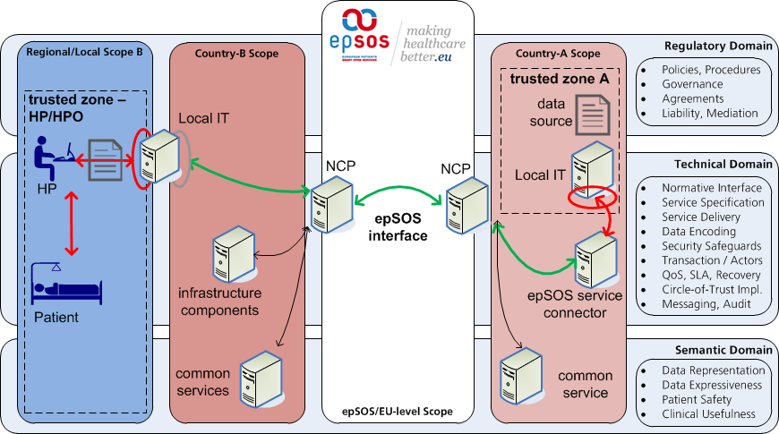
Figure 26: eHealth DSI Scoping and Sectors

Traditionally, eHealth DSI is mandating the proper implementation of the common cross-border umbrella regulation through acceptance and strict adherence to the specific provisions of the mandatory eHealth DSI MultiLateral Agreement (MLA). The MLA establishes a common baseline towards the acceptable behaviors, assurances, and discipline that are binding for all active participants. Those common rules facilitate the formation of a Circle-of-Trust (CoT) and subsequently enable eHealth DSI to deliver a trustworthy, access-restricted, and robust environment for the electronic exchange of protected health information.
In addition to the common ground rules imposed by the MLA, further detail may be introduced on a bi- or multi-lateral scope through additional agreements between CoT-Members or unilateral provisions within the Participating Nation-specific profiling of the common policies. Consequently, eHealth DSI features a flexible regulatory and contractual framework that warrants the proper implementation of umbrella law (inter-Country) in conjunction with tolerating the PN-specific extension (intra-Country) to fully enable the full adherence to local/regional law.
The rather unspecific aspects derived from the contracts and agreements as described above are consolidated into an operational eHealth DSI Security Policy (SP). The SP establishes a secure operational environment for all eHealth DSI services and their specific deployments within the countries. In contrast to the unspecific and common provisions, the SP is stipulating eHealth DSI-adapted aspects by raising a set of eHealth DSI security principles and providing distinct, appropriate security measures and procedures. The SP furthermore safeguards the correct implementation of the CoT by mandating a fully traceable "chain of trust" between all active CoT-Members, as well as highlighting specific security requirements for any eHealth DSI operator/user.
The requirements derived from the SP are subsequently translated into a set of technical, organization, and legal Requirements Catalogues that motivate the specific appointment of technology and their accompanying mitigation means. For every general principle referred to in the SP, a specific approach (consisting of processes, procedures, and technology) is identified, designed, and specified within the subsequent working packages of eHealth DSI.
The eHealth DSI Security Architecture is the implementation of such a requirements catalogue and sanctions artifacts describing the security controls as defined in [Security Services Specification] and how all the eHealth DSI business transaction (both carrying medical data or not) will exploit such controls as end-to-end security, patient consent, HP authentication, authorization, confidentiality, data authentication, non-repudiation, and integrity.

Conceptual Entity National Contact Point
The common provisions towards eHealth DSI legitimacy, security, and specific requirements catalogues assume the existence of an anchoring entity that confines, concentrates, and isolates the imposed responsibilities. In order to enable this entity to simultaneously provide inter- and intra-Country concerns, two distinct pillars need to be featured, ideally at the point of interfacing between the two concerns. Consequently, the concept of the National Contact Point (NCP) was appointed not only bot also by the [MLA] to accommodate the required functionality on the technical, legal, and organizational scope.
Figure 27: NCp-Multi Homing and Sectorial Exposition

The eHealth DSI NCP is passive gateway that facilitates all dimensions of cross-border health data sharing. In order to perform the service, the NCP MUST enforce all the requirements sketched in the [WP 189]. Thus, the following sections will start highlighting the requirement for the Patient Consent, the precondition for any eHealth DSI transaction. In order to enforce the Patient Consent, confidentiality of data in transit has to be in place, for guaranteeing that medical data is not disclosed to unauthorized principals. For this reason, the concepts and requirements of authentication of HP and integrity, Originator Authenticity, and non-repudiation are the keys for achieving the requirements of [WP 189]. In several eHealth DSI participating country is compulsory to have secured communication protocols and end to end security (such as encryption, non-repudiation, and integrity).

HP Authentication (AuthN) and Authorization (AuthZ)

Requirements Healthcare Professional Authentication
The requesting HP MUST have been authenticated in the country of treatment (see [Identity Management Requirements] for details on HP authentication). The service provider MUST be able to validate the attesting HP identity assertion.
The requesting party MUST deliver the requesting HP authentication claim in a form of an in-band (i.e. sent along an eHealth DSI business transaction) authentication assertion.
The service provider MUST NOT deliver access to a medical data to a remote NCP if the HP authentication assertion is valid, but issued by an untrusted Token Service.
The in-band authentication assertion MUST contain additional identity attributes that MUST be used by country-A for authorization decisions and patient consent enforcement. If an additional Treatment Relationship Confirmation (TRC) assertion is needed, it MUST be issued using as security claim the HP authentication assertion. TRC assertion MAY contain additional attributes related to the HP identity.
eHealth DSI does not specify the existence or presence of any specific Authentication Assurance Level (AAL) or Level of Assurance (LoA). Each country MUST define the authentication mechanisms strengths and methods according with [Section I - Security Policies]. However the HP authentication assertion MAY contain a Level of Authentication (LoA). Such LoA MUST follow a common vocabulary (e.g., [NIST 800-63-2]) and they SHALL be identified in [Section I - Security Policies].
Higher LoAs MAY be used to enforce additional access control. As an example, a combination of a higher LoA (e.g., LoA 3, multi-factor remote network authentication) and Purpose of Use (e.g., EMERGENCY) can be used to fulfill the break-the-glass scenario.
If LoAs are used, any trust elevation method (i.e., increasing LoA) MUST be identified in the [Section I - Security Policies].

Requirements Healthcare Professional Authorization
Patient information notice as a prerequisite for explicit patient consent: The Patient Information Notice must be sufficient to enable the patient to give explicit consent to the processing of data in accordance with the requirements stated in the REGULATION 2016/679, 27 April 2016 (Data Protection Regulation) and DIRECTIVE 2011/24/UE (Patients’ Rights Directive).
Authorization of Healthcare Professionals: eHealth DSI shall consider the opportunity to incorporate provisions for authorization of health professionals in compliance to the PRD.
Triggering a cross-country transferal of medical data MUST require a willful act by the patient.
This willful act MUST express the patient’s explicit authorization to allow an identifiable healthcare professional the execution of defined data access operations.
This willful act MUST express the explicit authorization of the patient to transfer medical data to the formerly identified and specifically documented destination.
Countries MAY require that this willful act is documented by an explicit, written and informed consent that is to be signed by the patient.
The documentation of this willful act SHOULD be safeguarded by appropriate cryptographic means. Cryptographic safeguards for »consent-2« MAY be omitted in case that cryptographic means are used that prevent data disclosure to others than the HP authorized by the patient.
Each access control decision MUST throw an auditable event.

Design and Implementation Authentication
The point of care (country-B) and the location of the medical data (country-A) of the treatment encounter in eHealth DSI are separate. The data provider therefore needs a comprehensive set of HP identity information in order to be able to take a legitimate and informed medical data discloser decision that satisfies the regulatory requirements within country-A for such a data disclosure.
Consequently, the identity information of the accessing HP in country-A as well as the specific accessing context need to be properly captured and encoded within the subject domain of country-B. This HP identity information then needs to be conditioned to for cross-organization/cross-border use an potentially authenticated and warranted by the trust anchor of country-B (NCP). The resulting container encodes all HP identity information as well as all required assurances from country-B and is to be communicated alongside with each higher business transaction towards country-A. country-A is extracting this container and applies the contained information artifacts towards its access control systems, and takes an access control decision or requests further supporting information if a decision cannot be taken due to the lack of required pieces.
The fundamental information set that needs to be captured is:
- Issuer and/or legal authenticator of the captured information
- identifier if the HP for which the information was captured and human-readable name of the HP
- the organisation/entity under which the HP was authenticated
- time initiation and expiration of the identity information
- the context under which the HP was identified
- legal authentication of all captured information by the responsible party (usually NCP-B)
The captured authenticated HP identity needs to be communicated in a transaction-persistent fashion to preserve traceability, likability, and support non-repudiation of a data processor.
The specific implementation details of the eHealth DSI HP Authentication are specified in [SAML Profile].

Design and Implementation Authorization
Within eHealth DSI, the local HP-B is unknown to the systems of country-A and the patient is unknown to any local system of country-B. Both NCPs are the only mutual known trust anchors for all subsequent systems regardless of whether those are located in country-A or country-B. However, while NCP-B as a trust anchor for country-B may well vouch for its known HPs, no such warranties may be made for a patient who is located in country-B. Therefore, an additional safeguard needs to be implemented within country-B to assert the correct identification and the establishment of a treatment relationship between the HP and the patient.
Consequently, eHealth DSI is operating a Treatment Relationship Confirmation for capturing and asserting:
- the correct correlation between a patient and patient ID
- the proper establishment of a treatment relationship between a specific patient and HP (context):
  - the HP vouches for the correct identity and authentication of the patient
  - the HP asserts that the specific patient is present and seeks treatment at this PoC
  - the HP vouches for having a valid specific patient consent available
  - the HP vouches for having delivered the proper PIN
This information is communicated alongside with all higher eHealth DSI business functionality (except patient identification workflows) and is used as primary source of treatment context information in the access control systems of country-A. The specific implementation details of the eHealth DSI HP Authorization are specified in [SAML Profile].

AuthN and AuthZ Interaction Patterns
Figure 30 illustrates the interplay and dependencies between AuthN and AuthZ as well as their specific communication and area of applicability within the eHealth DSI system.
Figure 30: AuthN and AuthZ interplay/dependencies within eHealth DSI

Confidentiality

Requirements
Medical data MUST NOT be disclosed to persons or organizations unless they have been authorized by the patient and the disclosure is legally or explicitly required for fulfilling the treatment.
Medical data MUST NOT be disclosed to others than healthcare professionals or healthcare professional organizations in any case.
Medical data MUST NOT be transferred to other destinations unless this disclosure has been authorized by the patient or is mandated by national law. In case that data processing outside the original destination is mandated by national law, the patient SHOULD be informed about this data processing before he authorizes the disclosure of his medical data.
The legitimate disclosure and secure transfer of medical data MUST be safeguarded by appropriate cryptographic means.
The proper enforcement of the willful disclosure acc. to »consent-2« MUST be controllable and verifiable by the patient.

Originator Authenticity and data Integrity

Requirements
eHealth DSI shall deal with clinical governance issues to the appropriate depth as far as issues of quality of data (data coding) is concerned. eHealth DSI shall elaborate commonly accepted and auditable processes for production of the MTCs.
The intended recipient of a medical data communication MUST be able to determine the originator and level of authenticity of the medical data received. Information on the identity and authenticity of the data originator that is assigned to the data or its metadata MUST NOT be altered during cross-border transfer.

Design and Implementation
The safeguards regarding Originator Authenticity are currently only applied to intra-NCP traffic. The protection is derived from the eHealth DSI Secure Messaging Infrastructure (see section 6) and is applied implicitly to all eHealth DSI transactions.

Availability
eHealth DSI healthcare providers shall notify on availability of eHealth DSI services and report on performance data and shall provide clear information on use of eHealth DSI for patients.

Design and Implementation
The safeguards regarding Availability are currently only applied to intra-NCP traffic. The protection is derived from the eHealth DSI Secure Messaging Infrastructure (see section 6) and is applied implicitly to all eHealth DSI transactions.

Non-Repudiation

Requirements
All transactions shall be logged and an audit trail created and stored. For transactions related to message delivery (e.g., Patient Service, Order Service), evidence of the transaction shall be reported and stored. A patient should also have the right to see the log and know who used or saw his medical data.
Cross-border exchange of medical data MUST be documented in a fully traceable, reconstructable, and seamless fashion:
- Cross-border exchange of medical data MUST produce a usable chain of digital evidence that enables both, the patient and his assigned DPA, to pursue, enforce, and proof any assumed or detected violation of the patient’s data protection and privacy rights.
- The chain of digital evidence MUST disclose the minimum of personal health data required to serve its purpose and MUST be specifically safeguarded against wrongdoing. Part of these safeguards MUST be a protocol that is not accessible to HPs.

Design and Implementation
All eHealth DSI transactions are triggering the creation of mandatory Auditable Events. All eHealth DSI transactions related to message delivery are triggering the creation of evidence.
Through the combination of the Audit Trail written in Country-B and Country-A, non-repudiation of origin (NRO) and non repudiation of receipt (NRR) evidence set, the complete chain of events is reconstructable and may be used as supporting evidence regarding Non-Repudiation. Specific provisions regarding Audit Trail, mandatory Auditable Events, Evidence, and their encoding are given in [DICOM Sup 95] [].].

NCP Secure Deployment / Zoning

Requirements
All eHealth DSI infrastructure services operated by the participating nations according MUST follow the regulations defined in the [Section I - Security Policies]. This also implies that the NCP MUST provide the means to separate the inter- and intra-Country concerns appropriately from each other.
Each eHealth DSI transaction sketched in the eHealth DSI Messaging Infrastructure MUST adhere to the security architecture definitions, and the NCP MUST NOT provide any means to circumvent such definitions.

Design and Implementation
According with the [Security Services Specification], each eHealth DSI defined service MUST be confined in a specific trust zone, as depicted in Figure 31. Such trust zones require to have implemented the security services as in [Security Services Specification] and secure deployments.
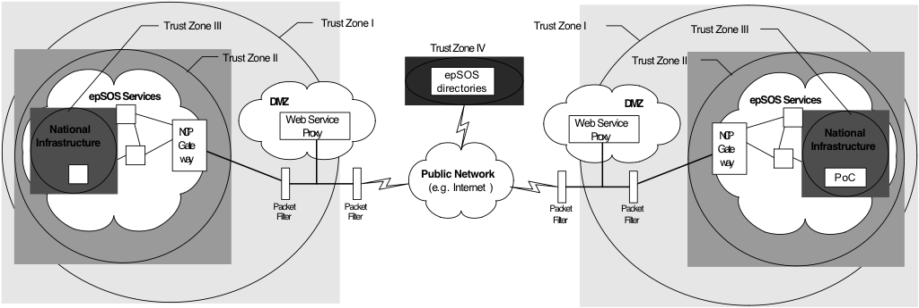
Figure 31: eHealth DSI trust zones

eHealth DSI Security and privacy Requirements (informative)
The following subsections present the optional eHealth DSI Extended Security Safeguards (ESS) that extend all eHealth DSI services by introducing authenticated and secured end-to-end security.

End-to-End Security: Requirements and Limitations
The eHealth DSI NCPs are passive gateways that act as data controller, according with [WP 189]. An NCP MAY manipulate sensitive data. In order [WP 189, Section 6]
to prevent acquisition/disclosure of the information in the presence of any intermediaries not controlled by the patient or the authorized healthcare organizations,
secure communication protocols and end-to-end encryption MUST be adopted based on encryption standards for securing electronic communications. In order to respect the dictates of the patient consent directive,
endpoints of the encryption MUST be located within environments either controlled by the patient directly or by the professional healthcare organizations authorized by the patient for processing his/her medical data

Within participating nations allowing end-to-end security, endpoints either under the direct control of the patient or organization authorized by the patient for processing medical data, SHOULD provide end-to-end security means.
- Endpoints and data originators SHOULD support end to end medical data encryption, without affecting all the other eHealth DSI requirements (e.g., auditing, transformations).
- Endpoints and data originators SHOULD support message authentication (for those message carrying medical data)
- Endpoints and data originators SHOULD support message integrity and non-repudiation
- Endpoints and data originators SHOULD send end-to-end secured message through the NCPs
- Encryption, integrity, and authentication means SHOULD be either controlled by the patient or by organizations authorized by the patient to perform medical data
- End-to-end security SHOULD be expressed in the second consent, if not mandated by the national legislation.

Data Minimization
Cross-border exchange of medical data MUST minimize the amount of personal data that is disclosed and processed (with processing representing a collective term as constituted in national legislation, such as the German Federal Data Protection Act or EU-level in REGULATION 2016/679, 27 April 2016 regulation) in both country A and B:
Cross-border exchange of medical data MUST NOT require the collection or processing of personal data beyond the minimum amount of the envisioned medical purpose, its digital evidence (limited audit trail), its administration, accompanying patient safety aspects, and regulatory provisions, such as mandatory disclosure requirements of key indications, performance and quality assurance) in the affected countries.
Pseudonyms SHOULD be used whenever possible unless this may impose risks to patient safety (e.g. false assignment of data, unacceptable restriction of returning vital medical information).

End-toEnd Security Services
Figure 32: End-to-End Principle

eHealth DSI is operating by an overlay network that may feature several intermediaries between trusted zones (that are either under the control of the patient or an authorized health care entity). Consequently, medical information may be unintentionally disclosed while in transit as well as leaving a protected environment in which specific legal provisions protect that medical information from consumption other than explicitly authorised by the patient (such as confiscation protection for medical data while being under the control of a HP).

Figure 33: ESS-Manager and Crypto Service Access Layer

As recommended by the Article 29 WG (see section 2.1.3), suitable arrangements MUST be made to prevent such data disclosure outside of trusted zones by the application of secure communication protocols and by end-to-end encryption. Consequently, in eHealth DSI phase two, PNs may choose to introduce components that enforce end-to-end compliant exchange processes and provide such functionality with an appropriate level of assurance toward the patients and HPs.
Figure 34: ESS security zoning of the Transformation Manager

End-to-End Enforcement of Patient Privacy and Rights
In eHealth DSI, the traditional organisation-of-work is preserved in which the Health Professional (HP) is engaging in a communication with the patient’s home country on behalf of the patient, with no immediate interaction or control exercised by the patient. The eHealth DSI security means MUST include means to enable a country or data-disclosing entity (trusted zone) to implement an immediate patient authorization beyond a coarse-grained patient consent. Such means MUST authenticate and authorize any medical data request appropriately. Insufficient, forged, or the absence of message authentication and authorization safeguards MUST be detectable by the data-disclosing entity. The additional security safeguards MUST be based on secrets that are under the direct control of the patient.

eHealth DSI Messaging Architecture Specification
All infrastructure services provided by the eHealth DSI Messaging Architecture operate under the following set of principles:
- only intra-NCP communications are sanctioned by the eHealth DSI Messaging Architecture.
- all intra-NCP communications are clearly directed and exclusively point-to-point in characteristics.
- all intra-NCP communications follow a request/response pattern between its participants.
- all intra-NCP communications feature a clearly deterministic role of a service provider and a service consumer at any time.
all eHealth DSI intra-NCP communications are content-agnostic and do not impose unreasonable constraints on the amount, mutual endpoints, payload, and duration of the communication beyond a common messaging format.

eHealth DSI Messaging Architecture Requirements
The eHealth DSI Messaging Architecture layer is providing fundamental infrastructure services to all other layers in the services stack. In order to operate safely, efficiently, and securely, the following requirements MUST be met at any time:
The service consumer MUST be able to securely and reliably locate the service provider.
The service consumer MUST be able to establish or re-use a secure messaging facility between itself and the service provider. If the secure facility is initiated in an on-demand fashion, its successful establishment needs to be performed before exchanging any data.
The service provider, as well as the service consumer MUST be able to mutually authenticate itself to each other. The evidence of its authenticity MUST be provided in a tamper-proof container that is suitable of independent verification as well as being documented as digital evidence chain within an Audit Trail.
The eHealth DSI Messaging Architecture MUST provide reliable communications means that safeguard the in-band integrity of the information in-transfer as well as the capability of preserving the information-specific encoding.
Further general requirements for secure and privacy-aware operations that MUST be considered are defined in [Security Services Specification] and [Section I - Security Policies].

eHealth DSI Node and Service Discovery
eHealth DSI requires the technical means to locate, authenticate, and validate trusted services between PNs. This is a particularly challenging task in a cross-border scenario (listing is not exhaustive but illustrative):
- health care, including Health Information Technology (HIT), are sovereign responsibilities of PNs and as such often excluded from specific EU-level legislation (such as DIRECTIVE 2006/123/EC and consequently DIRECTIVE 1999/93/EC)
- national technology is already deployed and operational in many PNs, however, not necessarily compatible or accessible for cross-border communication (Directory Services, digital certificates)
- specific security provisions hinder a cross-border application (such as the need to authenticate with a security service that only operates with known actors on a national/regional scope)
- disharmonized national HIT legal/technological provisions may cause an "export" of national concerns into another PN as well as complicated liability issues when national rules clash
- eHealth DSI shall not specify the use of redundant technology but re-use potential existing means
Consequently, eHealth DSI needs to specify and mandate the use of technology for eHealth DSI node and service discovery that on one hand satisfies the specific operational requirements, clears the liability aspects, and provides integrative means for not imposing additional requirements on national systems even in a cross-border setting. Naturally, this technology must satisfy the special protection demands for communicating and safeguarding sensible health information about patients.

Trusts Service Lists
All communication and transactions within eHealth DSI are restricted to the legitimate participants of the eHealth DSI Circle-of-Trust. According to the eHealth DSI legal and technological architecture, direct (immediate) trust relationships between PNs are facaded/anchored by the respective NCPs, while the national HIT hinterland is fully opaque to the eHealth DSI intra-NCP services and only subject to the specific national/regional regulations. However, the NCPs are not automatically considered trustworthy but inherit their specific trustworthiness from their appointed authoritative national TSP.
Figure 35: Trust Relationship and TSPs in eHealth DSI

Therefore, the anchor of any trust relationship between eHealth DSI PNs is implemented through the appointed national TSP: the PNs do not immediately trust any foreign NCP per se but the TSP of the other PNs. Consequently, technology and an organizational framework are required that provide:
- the means to locate, validate, and query a TSP from anther PN through a common process
- a minimum data/attribute set to exchange and understand expressive data between TSPs
- the means to encapsulate, publish and transport authoritative information about subsequent TSPs (such as dedicated eHealth TSPs or regional TSPs providing trust services for HIT)
- the means to authenticate and validate the capability, current operational status, and trustworthiness of any given eHealth DSI peer, including but not limited to the specific strength of the authentication means according to the provisions within DIRECTIVE 1999/93/EC
- an authoritative source to identify, select, and suitable TSPs in full compliance with the relevant provisions as laid down in DIRECTIVE 1999/93/EC
- facilitation for trust-bootstrapping without creating the need for additional multi-/bi-lateral agreements between piloting PNs for each and every TSP that is newly introduced into eHealth DSI
- an authoritative source to link traceability and liability for historical, current, and future peer discovery and validation requests
- a cross-border lookup service to identify accredited national Certification Service Providers
Through the framework of 2006/123/EC, the EC "requires that Member States establish and publish by 28 December 2009 the so-called 'trusted lists' of certification-service providers issuing qualified certificates in accordance with the e-Signature Directive (1999/93/EC)." The trusted lists have been consolidated into a technical standard ETSI TS 102 231 "for a Trust-service Status List (TSL) which makes available trust service status information such that interested parties may determine whether a trust service is or was operating under the approval of any recognized scheme at either the time the service was provided, or the time at which a transaction reliant on that service took place."
Each country is required to compile and publish a TSL and therefore the foundation for this technology and its exploitation within eHealth DSI is already fully operational.
The national TSLs are maintaining a list of currently accredited and supervised TSPs and provide technical means to access and verify that information. The location as well as encoding of each TSL is defined by the standard and may therefore serve as the trust anchor for trust bootstrapping (since every NCP now knows the specific location of each other PN’s TSL) and may query and process that information by the encoding specification laid out in the standard. Therefore, any NCP may automatically and routinely validate the trust status of any other NCP’s TSP without human interaction, further configuration or the need for additional contracts between the eHealth DSI PNs. Since subordinated/downstream national TSPs are also anchored within the national TSL, a validation of those is implicitly possible as well and finally provides an on-line validation of TSPs that formerly did not support any cross-border setting.

The specific implementable aspects of TSPs and certification material are specified in [X.509 Certificate Profiles] and [Cryptographic Algorithms], while SMP specifics are processed in [Service Location and Capability Lookup Profile].

Implementation and Patterns
Check the [Service Location and Capability Lookup Profile] section 3 for more details.

eHealth DSI Trusted Node Infrastructure & Message Transportation
Figure 37: eHealth DSI Messaging Infrastructure
Based on the information contained in the national TSLs and NCP's SMP files, a trust bootstrapping between all NCPs in the CoT may be performed that ultimately forms the eHealth DSI Trusted Node Infrastructure (TNI). The TNI implements and provides core security services that ensure the confidentiality of medical data transmission as well as the availability, authenticity, and authorisation of all eHealth DSI nodes and services.
Core elements of the TMI are the following infrastructure responsibilities and services:
- virtual private networks (VPN) to restrict the admission to the CoT and separate eHealth DSI traffic from common public traffic (network/gateway-centric)
- message and channel encryption services for integrity protection (specific node), as well as
- mutual node authentication (specific node)
On top of the TNI, the eHealth DSI NCP-to-NCP Message Transportation Service is providing mechanisms for implementing the derived eHealth DSI security services as well as standardised enveloping of data, documents, and supporting information:
- a commonly agreed transport, message, encoding, and semantic signifier binding profile for eHealth DSI messages
- the eHealth DSI Common Message Format as transmission container for payload contained:
  - transmission of authenticated HP attributes and supporting access control context
  - provision, embedding, and protection of digital evidence token for claims
  - embedding of message elements for auditing and brokering of claims
  - medical documents and related pieces of information (with specific relationship indicator)
- transactional non-repudiation and originator authenticity claims transferal (non- payload)
- embedding of error (permanent, temporal, and partial) indication and reporting

eHealth DSI Common Messaging Format (Envelope) and Profiles
The eHealth DSI Common Messaging Format defines the structure and the characteristic of the messages exchanged through eHealth DSI and establishes the preconditions for any successful communication. The eHealth DSI Common Message Format describes only the structure of messages as they flow between service consumers and service providers. Messages within NCP's or national infrastructures may use any format desired, and need to be translated to the eHealth DSI Common Message Format before transmission to another NCP.
Figure 38: eHealth DSI Common Messaging Format Stack
eHealth DSI follows the approach of providing content-agnostic containers for transporting data between the communication peers. The syntax of each container is specified by the respective binding and the containers are hierarchically fitted into an eHealth DSI message envelope. Table 9 shows the stacking and purpose of the containers within an eHealth DSI message envelope:
Common Messaging Profile | Description
Transport Layer Profile | Specifies the context, environment, and transport protocol binding that MUST be used when eHealth DSI messages are sent over the eHealth DSI Trusted Node Infrastructure.
Message Layer Profile | Specifies the common message format that MUST be used to structure, encode, and legitimate operations on messages, interaction, and data flow.
Message Schema Profile | Specifies the description of all eHealth DSI messages using a formalised and testable
Semantic Signifier / Binding
Payload Embedding | Specifies specific transactional rules for embedding, encoding, and expressing of payloads in any eHealth DSI message.
Table 9: eHealth DSI Common Messaging Format Stack
The specifics about the messaging profiles are specified within their respective bindings.

References
[EC Art 29 WP] EC Article 29 Data Protection Working Party: Working Document 01/2012 on epSOS. 00145/12/EN WP189. January 2012. http://ec.europa.eu/justice/data-protection/article-29/documentation/opinion-recommendation/files/2012/wp189_en.pdf

[IHE AC WP] IHE International: IHE IT Infrastructure Technical Framework Revision 19. June 2022.
https://profiles.ihe.net/ITI/TF/index.html

[RFC 2119] Bradner, S.: Key words for use in RFCs to Indicate Requirement Levels; Harvard University, Boston, Massachusetts, 1997.

[DICOM Sup 95] DICOM PS 3.15 Annex A.5: Security and System Management Profiles, 2018c [DICOM PS3.15].

[NIST 800-63-2] NIST, Electronic Authentication Guideline, August 2013 http://nvlpubs.nist.gov/nistpubs/SpecialPublications/NIST.SP.800-63-2.pdf

The mapping of ehealth DSI core concepts to the ECCF matrix is not always 1:1 (e.g. the semantic framework has several computational aspects, too, and spans the conceptual and logical perspective). The figures on the alignment of eHealth DSI core concepts with the ECCF only describe the concepts’ serialization within this document and therefore emphasize the viewpoints and perspectives a specific concept mainly contributes to.
The general term „actor“ is used here because in the eHealth DSI eDispensation use case (which can be implemented as either an administrative or a medical use case) the final destination of the eDispensation data MAY be a prescription database.
Unless stated otherwise, in this document the term „NCP“ is used to refer to the technical incarnation of the NCP concept (national gateway).
The term uncoded refers to all document entries that contain values which are mainly designated to human readability and which do not link to a specific codesystem.
This is not a MUST because some terminologies may require a licence to be bought by eHealth DSI and/or eHealth DSI PNs. In such cases, eHealth DSI MAY decide to devolop an own, royality-free terminology.
It is not mandatory for a PN to adopt the NCP Common Component implementation, including the Semantic Transformation components. The described steps MAY be considered as “strongly suggested steps” to generate the Semantic Signifiers structure and contents that are COMPULSORY for eHealth DSI interoperability.
These services encompass functionalities that are in eHealth DSI provided by eCRTS and TSAM/LTR.
http://www.etsi.org/technologies-clusters/technologies/security/certification-authorities-and-other-certification-service-providers

