Cyclistics Documentation

Brief
- Business Task
Understand how annual members and casual riders use Cyclistics bike differently based on ride history.

- Key Questions
- What is the proportion of rides made by annual members and casual riders in the past year?
- What patterns differentiate between annual members and casual riders?

- Key Stakeholder
- Lily Moreno as the Director of Marketing
- Marketing Analytics Team
- Executive Team

Preparation
There are 5,860,568 of rows and 13 of columns, with no data quality issues, such as misnamed variables
Data variables other than start_station_name, start_station_id, end_station_name, end_station_id don't have any missing values. Below are the details of the missing values:
- Total Missing -> 4371672
- start_station_name -> 1073951
- start_station_id -> 1073951
- end_station_name -> 1104653
- end_station_id -> 1104653
- end_lat -> 7232
- end_lng -> 7232
These missing values only occur on station related data. This likely represents dockless rides or system errors. Therefore, these missing valued data can still be used for behavioral analysis(e.g., ride duration, day, and member type) but not for location-based insights. Coordinate-related data will be excluded since map-based analysis is outside the current project scope.

## Decision:
All rows in the dataset were retained to ensure completeness for time and member related data analysis. Missing valued station names will be replaced with "Unknown Station" and ids will remain as NA. Then, all the coordinate related data, such as start_lat, end_lat, start_lng, and end_lng were removed as map-based analysis won't be performed this time.

Processed
From 5,860,568 records, 211 records were identified as duplicated based on the ride_id field.

In addition, a total of 723 records were identified as invalid due to inconsistencies in the started_at and ended_at timestamps. Those invalids found either where the end time occurred before or was equal to start time.

## Decision:
All invalid records where the end time occurred before or was equal to start time were removed
Ensuring only unique ride entries remain by deduplicating on ride_id

## Also Added:
Ride length (In Seconds) and day of week variable to support the analysis phase.

Analysis

- Proportion of Casual and Member
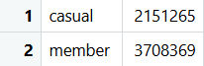
Annual members are the dominant users

- Mean > Median (Ride Length)
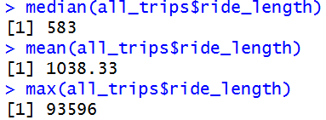
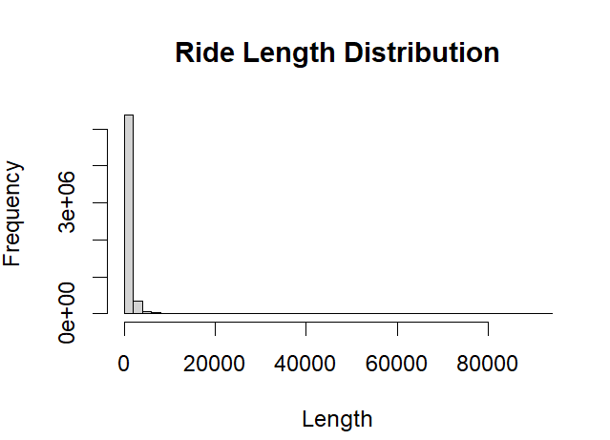
Data is rightly skewed because the longest ride is very large, it makes the mean and median differ greatly.
Decision -> Will use median, instead of mean
- Full Stats of Ride Lengths Between riders
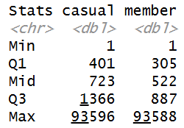

- Median of ride Lengths by Users
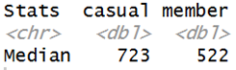
Casual riders tend to take rides longer by median of ride

- Median of Ride Lengths by Day of Week
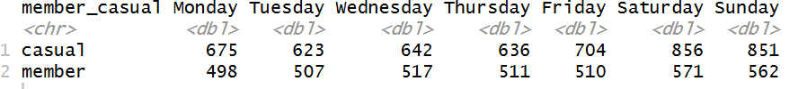
Casual riders exhibit higher median ride duration across all days of the week, with a significant increase on Weekends. In contrast, annual members maintain relatively stable median ride durations throughout the week.

- Number of Rides per Day of Week
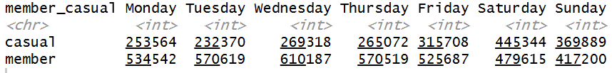
Casual riders tend to take more rides on weekends, while annual members tend to take more rides on weekdays

Key Insights:
Over the past year, 37% of rides were made by casual riders, with 63% of rides by annual members. This indicates that annual members are dominant in ride usage. However, casual riders still make up for more than a third by usage, which opens for conversion opportunities.
Annual members demonstrate a consistent weekday riding pattern, peaking on Wednesday (Mid-week), which strongly suggests routine commuting behavior. In contrast, casual riders show significantly higher rides on weekends, peaking on Saturday, indicating leisure-oriented usage.
Furthermore, casual riders tend to have longer median ride durations, indicating a more relaxed usage, whereas annual members are more efficient.

Recommendations

- Point out the ease and benefits of commuting to work with Cyclistic membership.
- Offer leisure-orientated members benefits, such as an additional discounted rate for weekend rides or reward points for longer rides.
- Offer a limited-time membership trial for casual riders who have completed a certain number of rides or ride distance, encouraging them to experience the benefits of membership.

