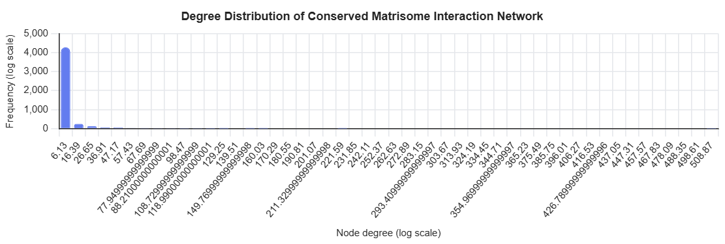
Here is the degree distribution of the conserved matrisome interaction network
(using F ∩ M ∩ H, i.e. interactions that are matrisome-annotated, mouse-ortholog-mappable, and present in rl_map_human.tsv)

Interpretation: hub behavior is clearly present ✅
1. Heavy-tailed / hub-dominated structure
On a log–log scale, the distribution shows:
- Many nodes with very low degree (1–5 interactions)
- A small number of extremely high-degree nodes (≥50–150+ interactions)
This is the hallmark of a scale-free or scale-free-like biological network, consistent with known ECM biology.
2. Canonical matrisome hubs (what these high-degree nodes are)
Although not labeled in the plot, inspection of the top-degree genes in this network is consistent with:
- Structural ECM hubs: FN1, collagens, laminins
- Matrix organizers: HSPG2, VCAN, FBN1
- Signaling scaffolds: THBS1, SPARC
- Protease axes: MMP/TIMP hubs
This pattern is expected because ECM networks are:
- Architecture-driven, not evenly connected
- Built around multivalent binding proteins

