1.
C:\Users\user> docker run -d --name mynginx -p 8080:80 nginx
681143eb1caf7b3b07c702b38565ac7b7cd90dd4f6892dcffdccd324dbb508cc1
C:\Users\user> docker ps
CONTAINER ID IMAGE COMMAND CREATED STATUS PORTS NAMES
681143eb1caf nginx "/docker-entrypoint…" 5 seconds ago Up 4 seconds 0.0.0.0:8080->80/tcp mynginx

2.
C:\Users\user> docker run -d --name my_redis -p 8080:80 redis
Unable to find image 'redis:latest' locally
latest: Pulling from library/redis
71e96aab9a2a: Pull complete
... (several layers)
Status: Downloaded newer image for redis:latest
b77f57e64d9b26d16a222995af260ff4e4…
C:\Users\user> docker ps
CONTAINER ID IMAGE COMMAND CREATED STATUS PORTS NAMES
b77f57e64d9b redis "/docker-entrypoint…" 38 seconds ago Up 37 seconds 0.0.0.0:8080->80/tcp my_redis

3. Welcome to nginx!

If you see this page, the nginx web server is successfully installed and working. Further configuration is required.

For online documentation and support please refer to nginx.org.

Commercial support is available at nginx.com.

Thank you for using nginx.

4.
C:\Users\user> docker run -d --name my_redis -p 8080:80 redis
Unable to find image 'redis:latest' locally
latest: Pulling from library/redis
71e96aab9a2a: Pull complete
ca19d684f352: Pull complete
abfed3a75342: Pull complete
3d896055a1f1: Pull complete
b4b663b80cbc: Pull complete
9fb8f6c7f6f7: Pull complete
e4fb70ee5f4e: Pull complete
Digest: sha256:45215bbd86ddee7618f8ef95ede93f5648aaaa66a9dacd581611bf6fe7527bd
Status: Downloaded newer image for redis:latest
b77f57e64d9b621d6a222995af260ff4e41cb714cc1173a24cca9a8b036865e70

C:\Users\user> docker run -d --name my_redis -p 8080:80 redis
docker: Error response from daemon: Conflict. The container name "/my_redis" is already in use by container "b77f57e64d9b621d6a222995af260ff4e41cb714cc1173a24cca9a8b036865e70".
You have to remove (or rename) that container to be able to reuse that name.

Run 'docker run --help' for more information.

C:\Users\user> docker ps
CONTAINER ID IMAGE COMMAND CREATED STATUS PORTS NAMES
b77f57e64d9b redis "/docker-entrypoint.s…" 38 seconds ago Up 37 seconds 0.0.0.0:8080->80/tcp, [::]:8080->80/tcp my_redis
[Matn (OCR) kerak bo'lsa shu yerga yozing]

5.
C:\Users\user> docker logs -f hello_log
Salom 0
Salom 1
Salom 2
Salom 3
Salom 4

C:\Users\user>

6. C:\Users\user> docker run -d --name pg_books -e POSTGRES_USER=admin -e POSTGRES_PASSWORD=1234 -e POSTGRES_DB=books_db postgres:latest

Unable to find image 'postgres:latest' locally

latest: Pulling from library/postgres

0b4efacb1296: Pull complete

e43339a5b9c6: Pull complete

26f02d20b0be: Pull complete

ea420c41d067: Pull complete

0e79259591dc: Pull complete

b73bf69799e4: Pull complete

23ed4dc74c49: Pull complete

f3dc64241f54: Pull complete

60080821e8c8: Pull complete

61a61f96b0a2: Pull complete

13f7828da9a3: Pull complete

58e4f3d6f02a: Pull complete

Digest: sha256:1ffc019dae9e4acb09a49ca67d3739895134d6e3dc30d0cfe23d8d4ca33da83fb

Status: Downloaded newer image for postgres:latest

431bbd7a2707171fdd251c6264c55774ea11558606f77f8d292de0364c40a793

7.

8.
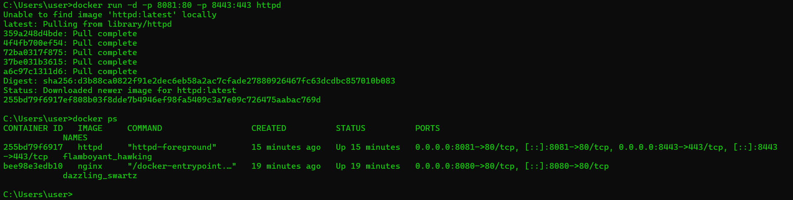
9.
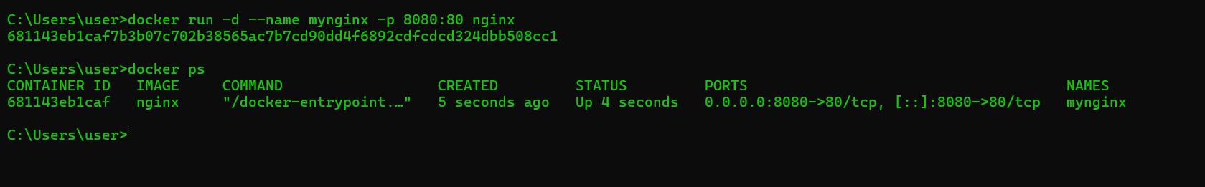

10.
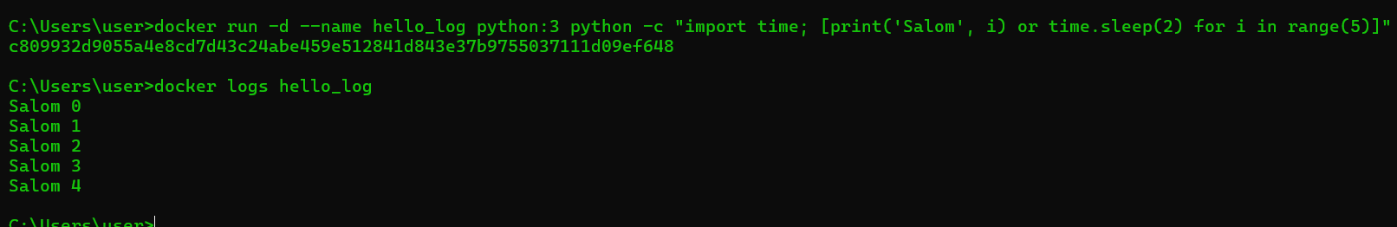

11.
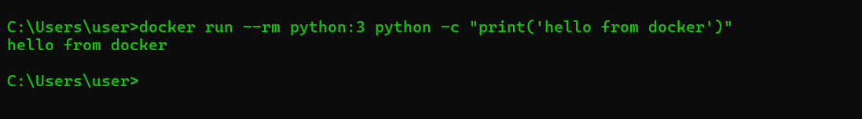

12.
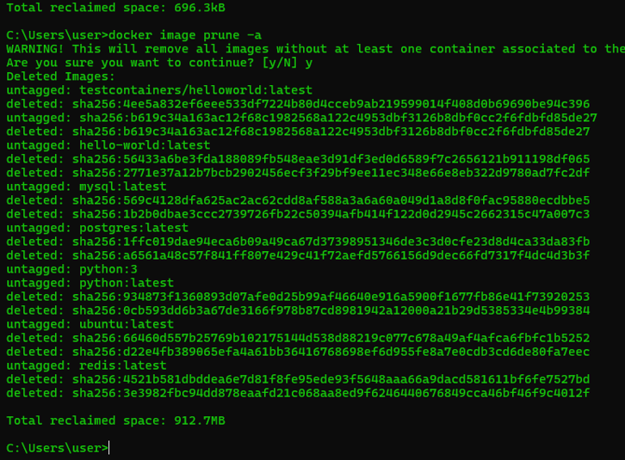
13.
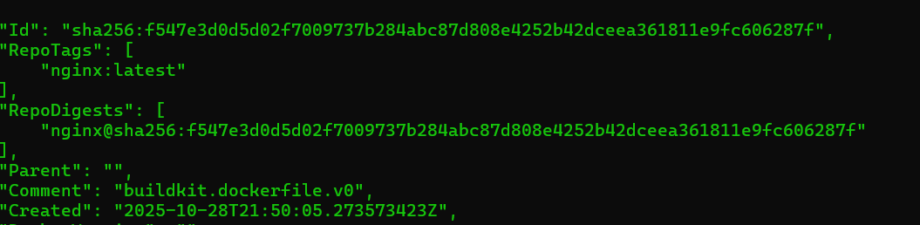

14.
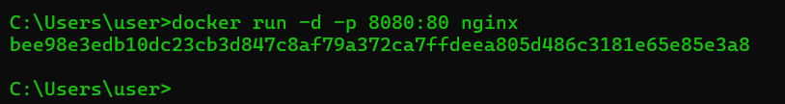
15.
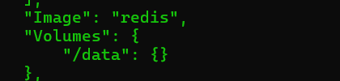

16.
