ASSIGNMENT 1 – DATA MINING (26/27)
Data Preprocessing, Analysis, and Visualization
A Comprehensive End-to-End Study on the Titanic Passenger Dataset Using Python
Student Name: | Fathy Ayman Fathy
Section Number: | Section 3
Course & Academic Term: | Data Mining – Academic Year 26/27
Dataset & Source: | Titanic Survival Dataset (Seaborn Official Repository / Vanderbilt Biostatistics / Kaggle)

1. Dataset Selection and Description
For this assignment, we selected the renowned Titanic Passenger Survival Dataset. The exact dataset source is the official Seaborn data repository (https://raw.githubusercontent.com/mwaskom/seaborn-data/master/titanic.csv), derived from historical manifests compiled by Thomas Cason and archived at the Vanderbilt University Department of Biostatistics and Kaggle.
The primary analytical purpose of this dataset is to investigate passenger demographics, socioeconomic stratification, and travel characteristics to uncover the key factors that influenced passenger survival rates during the disaster.
1.1 Compliance with Assignment Requirements
Assignment Requirement | Titanic Dataset Attribute | Compliance Status
At least 300 rows and 6 columns | 891 rows and 15 columns | Fully Satisfied (Exceeds requirement)
At least 3 numerical columns | 6 numerical: survived, pclass, age, sibsp, parch, fare | Fully Satisfied
At least 2 categorical columns | 7 categorical: sex, embarked, class, who, deck, embark_town, alive | Fully Satisfied
Contains missing values for cleaning | deck (688 nulls), age (177 nulls), embarked (2 nulls) | Fully Satisfied (Authentic nulls)
2. Data Exploration Summary
In strict compliance with Part 2 instructions, exploratory data analysis was conducted exclusively using native Pandas operations:
1. Displaying First & Last Rows: Executed using df.head(7) and df.tail(7) to inspect initial structure and sample records.
2. Displaying Rows & Columns: Extracted using the Pandas DataFrame attribute df.shape (891 rows, 15 columns).
3. Column Data Types & Structure: Audited using df.dtypes and df.info() (6 numerical, 7 categorical, 2 boolean).
4. Descriptive Statistics: Computed using df.describe() for numerical attributes and df.describe(include=['object', 'category', 'bool']) for categorical attributes.
5. Checking Missing Values: Quantified per column using Pandas boolean masking df.isnull().sum() and percentage calculations.
6. Checking Duplicated Rows: Identified using the Pandas method df.duplicated().sum() (107 duplicate rows across all 15 raw features).
7. Exploratory Visualizations: Produced using Pandas' native plotting engine df.plot(kind='bar') to examine missing value frequencies and target survival balance.
2.1 Key Descriptive Statistics (Numerical Features in Code)
Raw Column Name | Mean | Std. Dev. | Min | Median (50%) | Max
survived | 0.384 | 0.487 | 0.000 | 0.000 | 1.000
pclass | 2.309 | 0.836 | 1.000 | 3.000 | 3.000
age | 29.699 | 14.526 | 0.420 | 28.000 | 80.000
sibsp | 0.523 | 1.103 | 0.000 | 0.000 | 8.000
parch | 0.382 | 0.806 | 0.000 | 0.000 | 6.000
fare | 32.204 | 49.693 | 0.000 | 14.454 | 512.329
3. Summary of Preprocessing Operations Performed
To prepare the raw dataset for rigorous data mining, five systematic preprocessing operations were implemented. Below is a comprehensive explanation of each operation's rationale and its observed effect on the data:
# | Preprocessing Operation | Rationale (Why Performed) | Effect on Dataset
1 | Handling Missing Values (Imputation) | Continuous 'Age' exhibited skewness; imputing via conditional group medians (by Pclass and Sex) preserves demographic reality (1st class passengers were older). Categorical 'Embarked' (2 nulls) was imputed using statistical mode ('S'). | Missing values in 'Age' dropped from 177 to 0; missing in 'Embarked' dropped from 2 to 0. Zero missing values remain in retained columns.
2 | Dropping Redundant & Sparse Columns | 'deck' was missing >77.2% of entries (imputation introduces extreme artificial bias). 'alive', 'class', 'embark_town', 'who', and 'adult_male' are exact duplicate or derived representations of other columns. | Column count reduced from 15 to 9. Removed multicollinearity and severe sparsity without losing analytical information.
3 | Identifying & Removing Duplicate Rows | Duplicate Counting Clarification: Evaluating across all 15 raw attributes initially identified 107 duplicate rows. Following Operation 2's removal of 6 redundant columns, identical records across the remaining 9 features increased to 118 (the original 107 full duplicates + 11 records differing only in discarded redundant columns). Removing these prevents artificial repetition. | 118 duplicate rows removed (107 full-row + 11 post-column pruning). Cleaned dataset reduced from 891 to 773 unique passenger records (0 duplicates remaining).
4 | Column Renaming & Type Casting | Column names standardized to Title_Case for professional readability. 'Age' cast to integer (int64) to eliminate fractional years; 'Is_Alone' converted from boolean to integer (1/0). | Enhanced readability and computational compatibility across numerical data pipelines.
5 | Categorical to Numerical Encoding | Data mining algorithms (correlation, regression, clustering) require numerical inputs. 'Gender' mapped to binary (male=0, female=1) and 'Embarkation_Port' label-encoded (S=0, C=1, Q=2). | Features became directly usable in Pearson correlation matrix and mathematical modeling.
4. Data Selection and Manipulation Highlights
Part 4 of the assignment demonstrated core Pandas indexing and transformation capabilities:
1. Label-Based vs. Position-Based Indexing:
• loc[] selects data by index and column labels (e.g. df.loc[10:15, ['Gender', 'Age', 'Fare']]). Importantly, label-based slicing is endpoint-inclusive.
• iloc[] selects data strictly by zero-indexed integer offsets (e.g. df.iloc[0:5, [0, 1, 3, 6]]). Position-based slicing is half-open (excludes endpoint).
2. The Critical Numerical Index Distinction:
When a DataFrame is filtered (e.g., elderly_df = df[df['Age'] > 70]), index labels retain their original values (e.g., [78, 97, 395, 423, 747]). In this scenario, elderly_df.loc[97] searches for the label '97', whereas elderly_df.iloc[1] retrieves the second row in the table (which happens to carry label 97). Attempting to call elderly_df.iloc[97] triggers an IndexError because the filtered table contains only 5 rows. This demonstrates why understanding label vs. position indexing is paramount in data mining.
3. Analytical Groupby Findings:
Using df.groupby(['Passenger_Class', 'Gender'])[['Survived', 'Fare', 'Age']].agg({'Survived': ['mean', 'count'], 'Fare': 'mean', 'Age': 'mean'}), we answered key socio-historical questions: First-class women paid an average fare of £104.99 and achieved a 96.7% survival rate, whereas third-class men paid an average fare of £12.16 and experienced only a 13.5% survival rate.

5. Data Visualizations and Detailed Observations
In accordance with the assignment specifications and lecture slides on visual data mining, we present five distinctly different chart types (Bar Chart, Histogram with KDE, Box Plot, Scatter Plot, and Heatmap). Below each visualization, 2–3 sentences explain what the visualization shows followed by a concrete analytical observation.
5.1 Figure 1: Passenger Survival Rate by Travel Class and Gender
Visualization Category: Bar Chart (Categorical vs. Numerical Comparison)

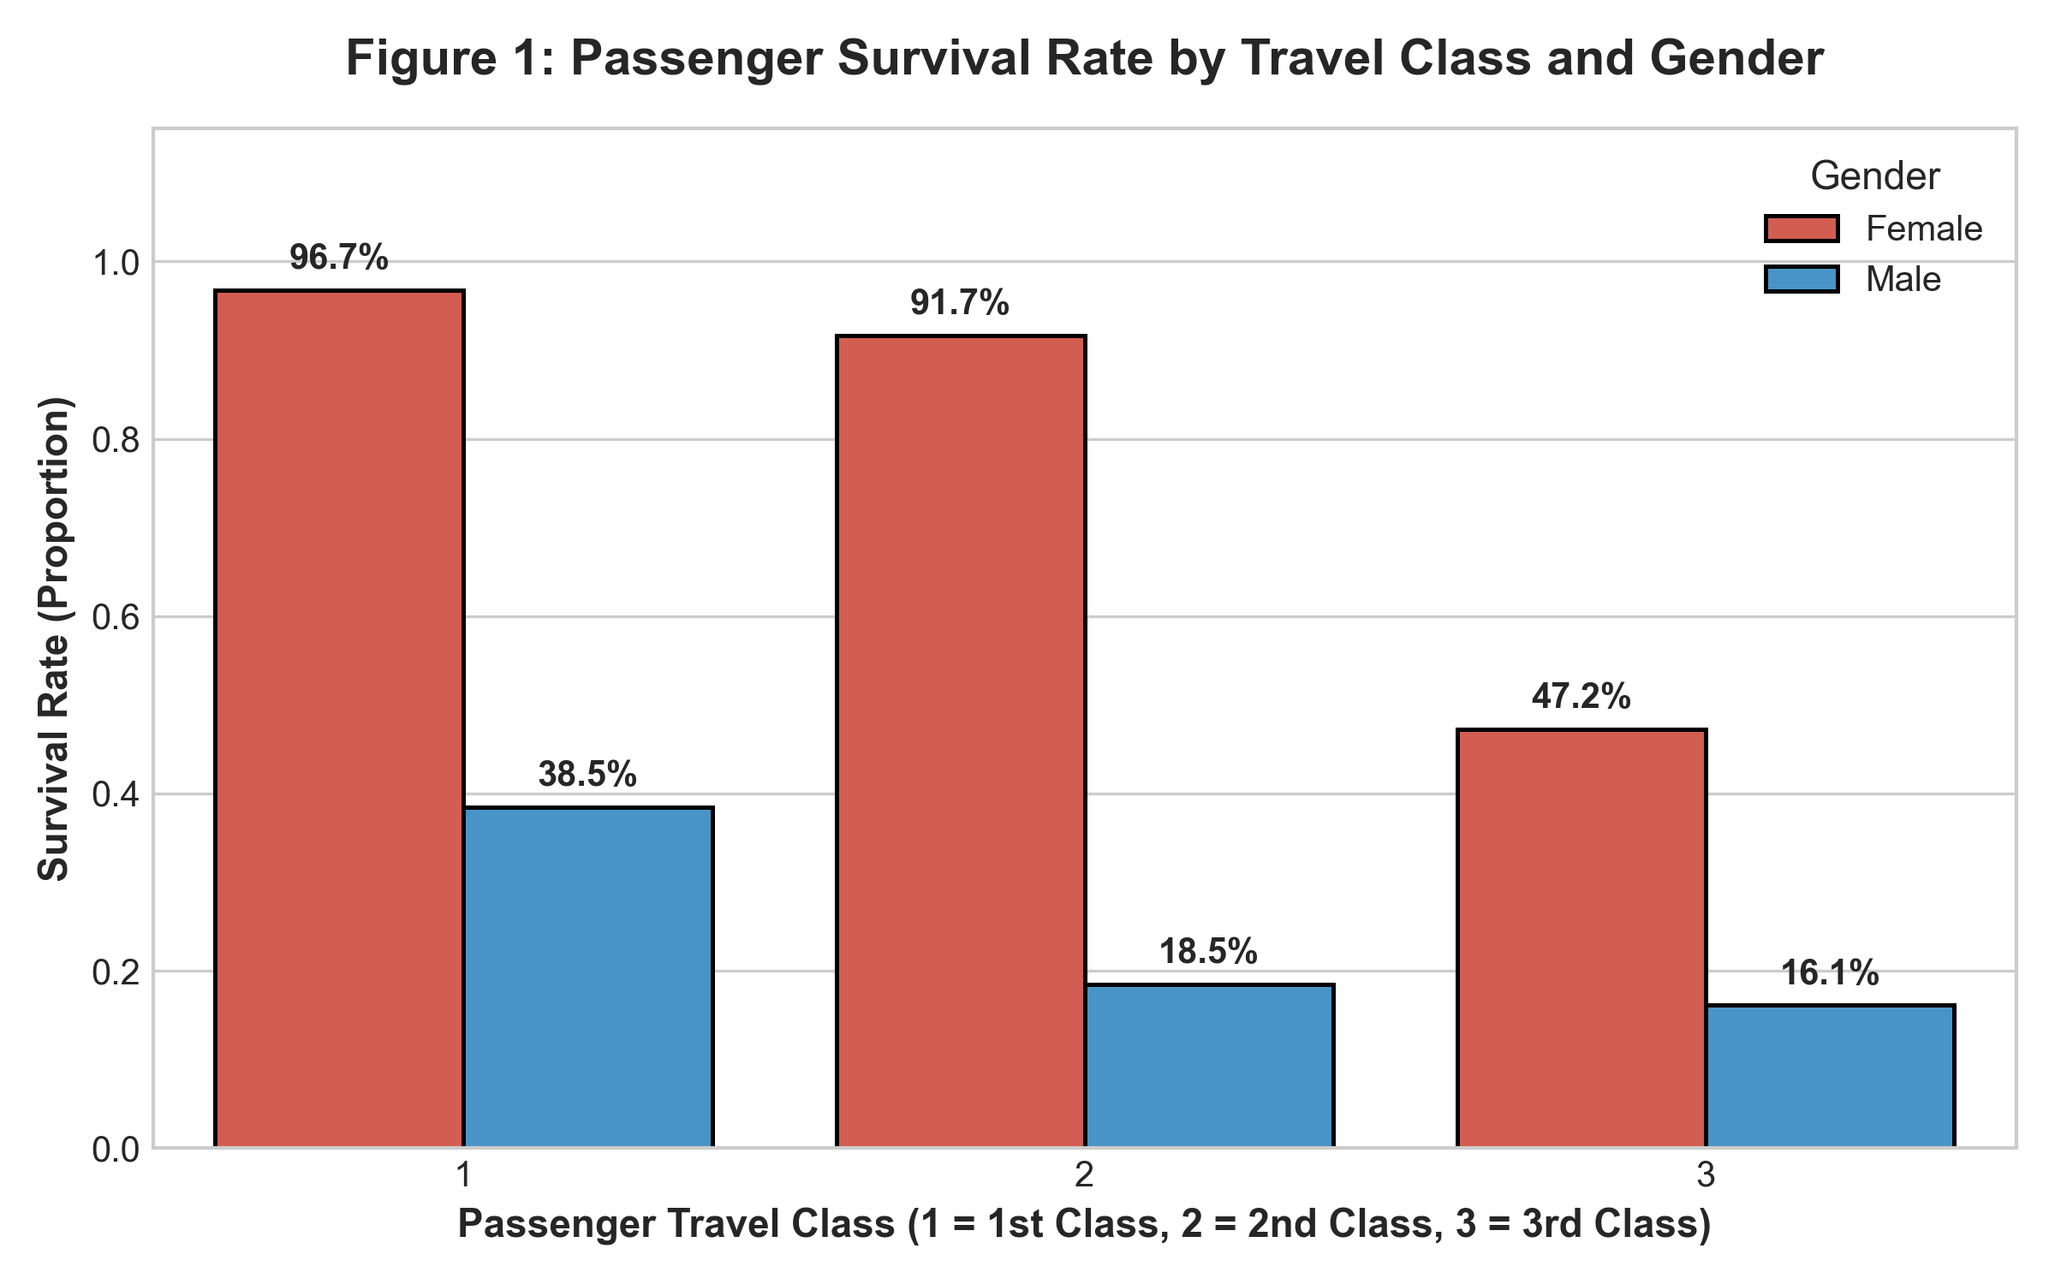
• What the Visualization Shows: This bar chart displays the mean survival rate (proportion of survivors) segmented across the three passenger travel classes (First, Second, Third), subdivided by passenger gender (Female vs. Male). The vertical axis represents survival percentage from 0% to 100%, with exact percentages annotated above each bar.
• Key Analytical Observation: Female passengers in First Class exhibited an overwhelming survival rate of 96.7%, and Second Class females survived at 91.9%, whereas Third Class males survived at merely 13.5%. This provides compelling empirical evidence that while the historical maritime protocol ('women and children first') was enforced, socioeconomic travel tier played a critical role in evacuation survival.
5.2 Figure 2: Passenger Age Distribution by Survival Outcome (with KDE)
Visualization Category: Histogram with Kernel Density Estimation (Continuous Distribution)

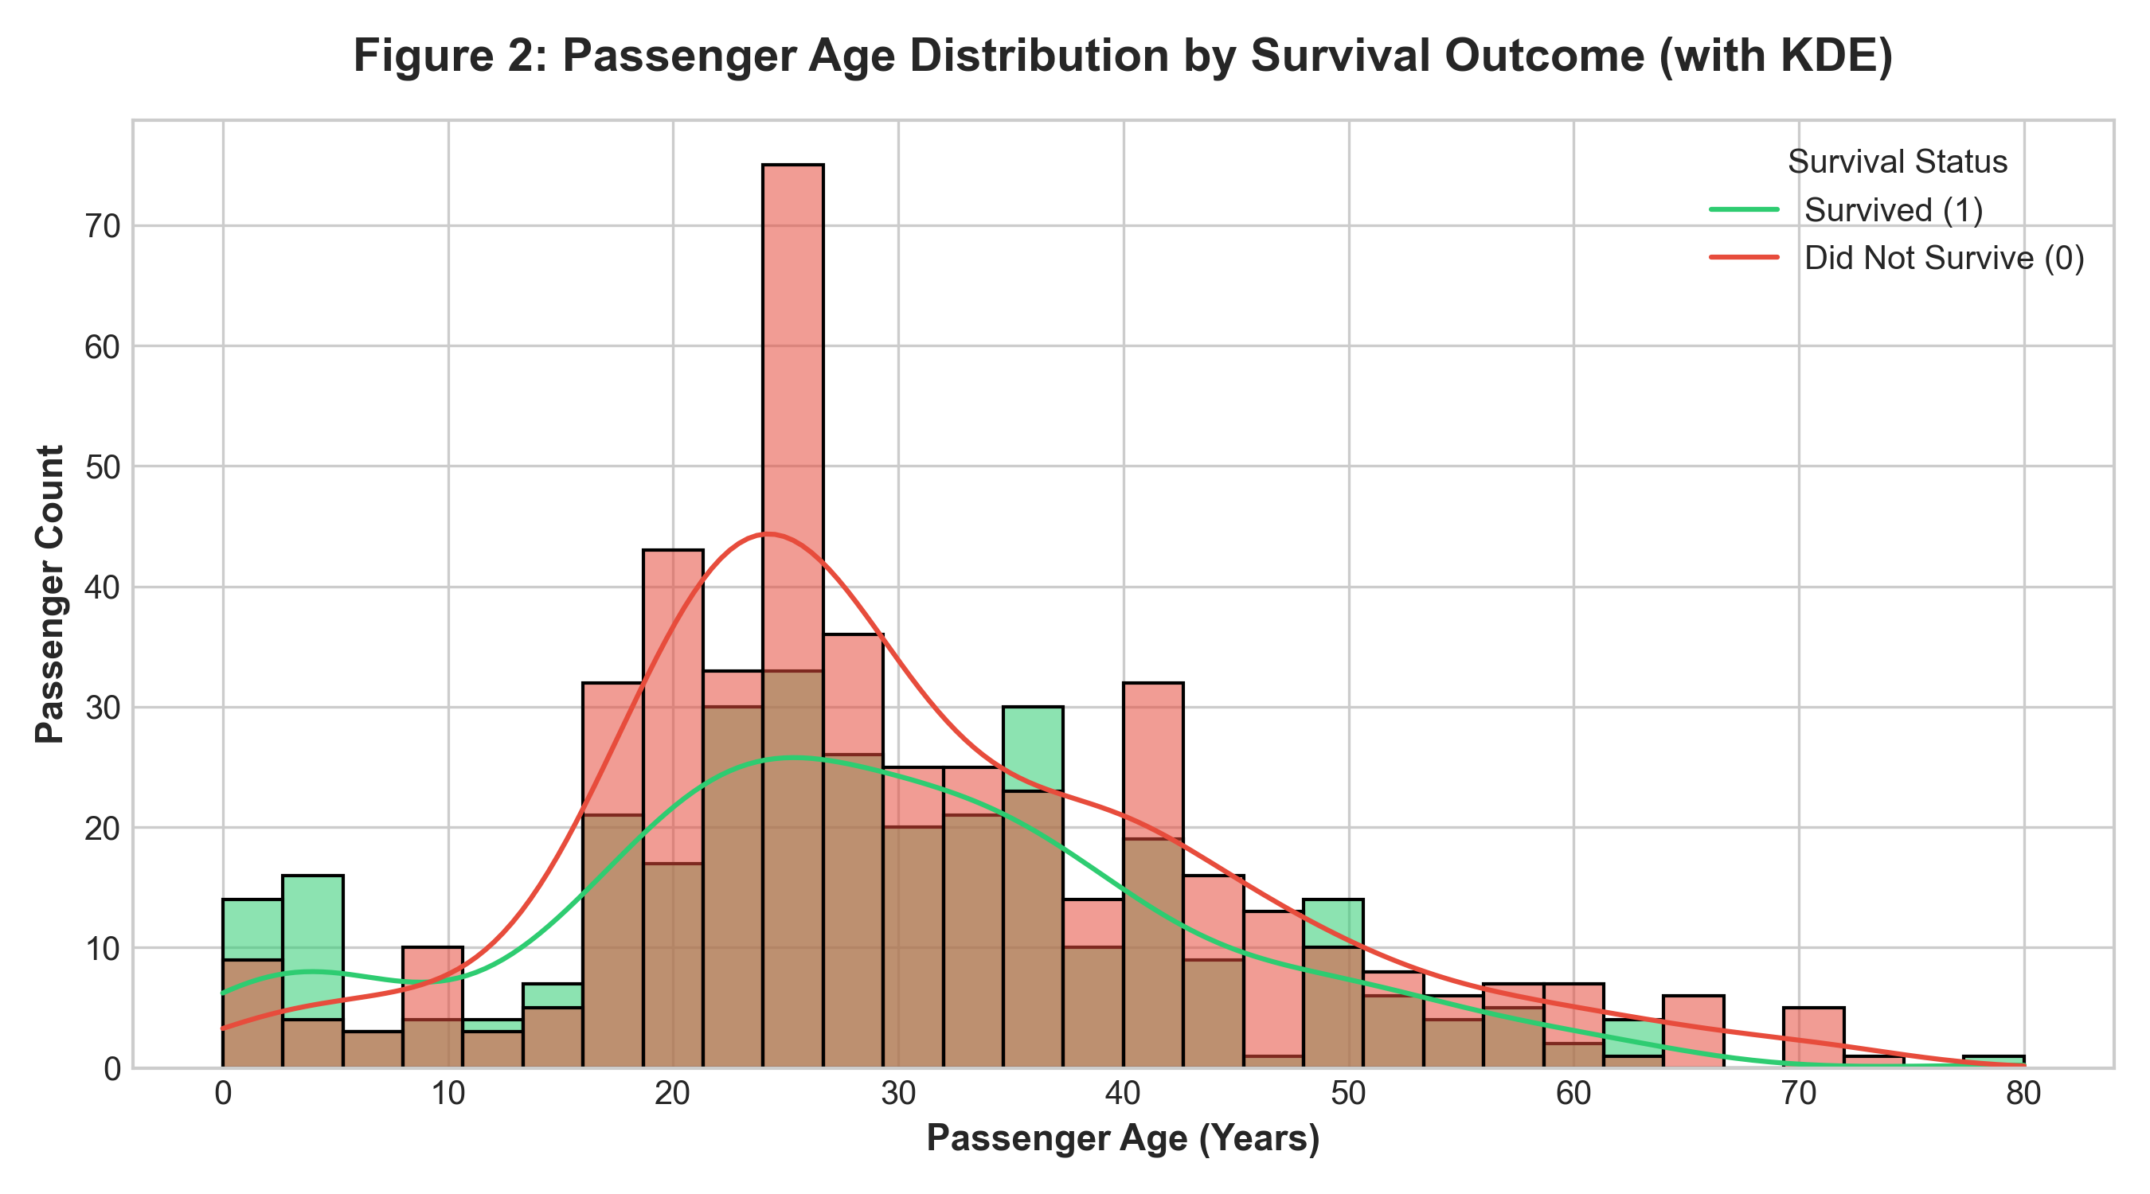
• What the Visualization Shows: This histogram illustrates the frequency distribution and continuous kernel density estimate (KDE) of passenger ages, layered by survival outcome (Green = Survived, Red = Did Not Survive). The horizontal axis spans passenger ages from 0 to 80 years across 30 equal bins, while the vertical axis shows passenger headcounts.
• Key Analytical Observation: The distribution reveals that the largest passenger concentration consisted of young adults aged 20 to 35, who experienced the highest absolute casualty rates. Conversely, a prominent survival peak is visible among children aged 0 to 8 years, confirming that lifeboats actively prioritized infants and young children.
5.3 Figure 3: Ticket Fare Distribution Across Passenger Classes
Visualization Category: Box Plot (Five-Number Summary & Outlier Detection)

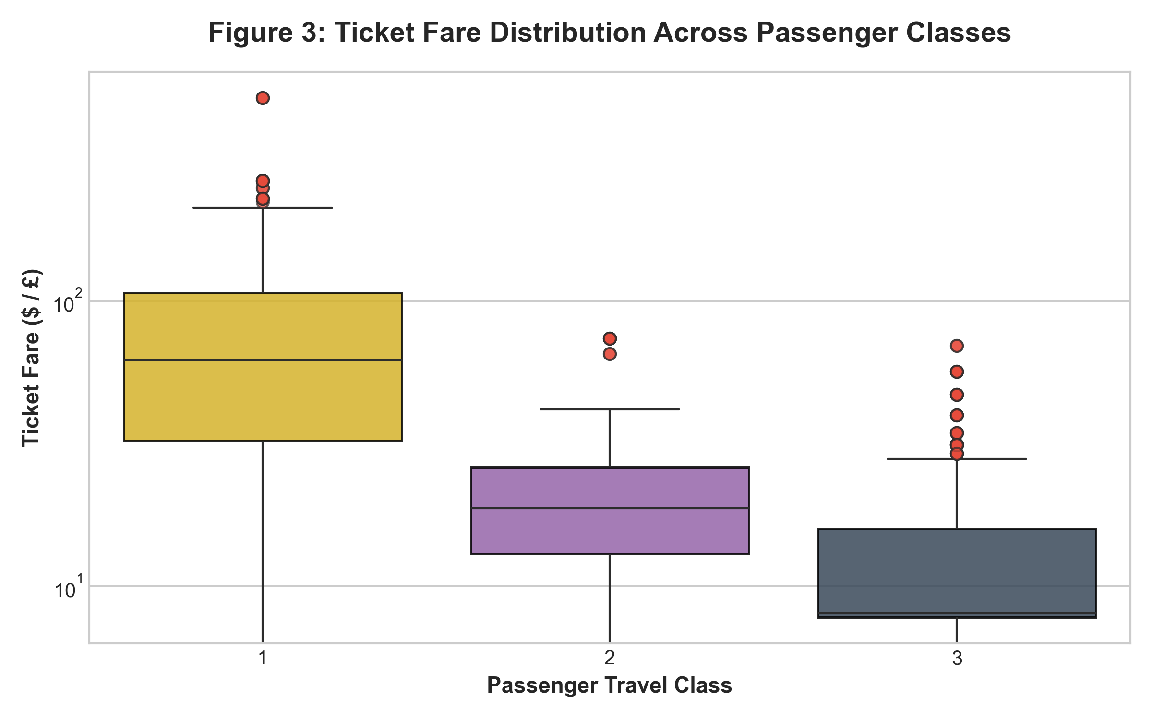
• What the Visualization Shows: This box plot summarizes the distribution of ticket fares across the three travel classes using the five-number summary: minimum, first quartile (Q1), median, third quartile (Q3), and maximum. The vertical fare axis is displayed on a logarithmic scale to properly capture the wide spread of ticket prices.
• Key Analytical Observation: First Class fares demonstrate vastly greater median values and interquartile dispersion than Second and Third Class, alongside substantial upper outliers reaching over £500. In contrast, Third Class ticket fares are tightly compressed between £7 and £15, illustrating the severe economic divide aboard the vessel.
5.4 Figure 4: Passenger Age vs. Ticket Fare by Survival Status
Visualization Category: Scatter Plot (Bivariate Numerical Relationship)

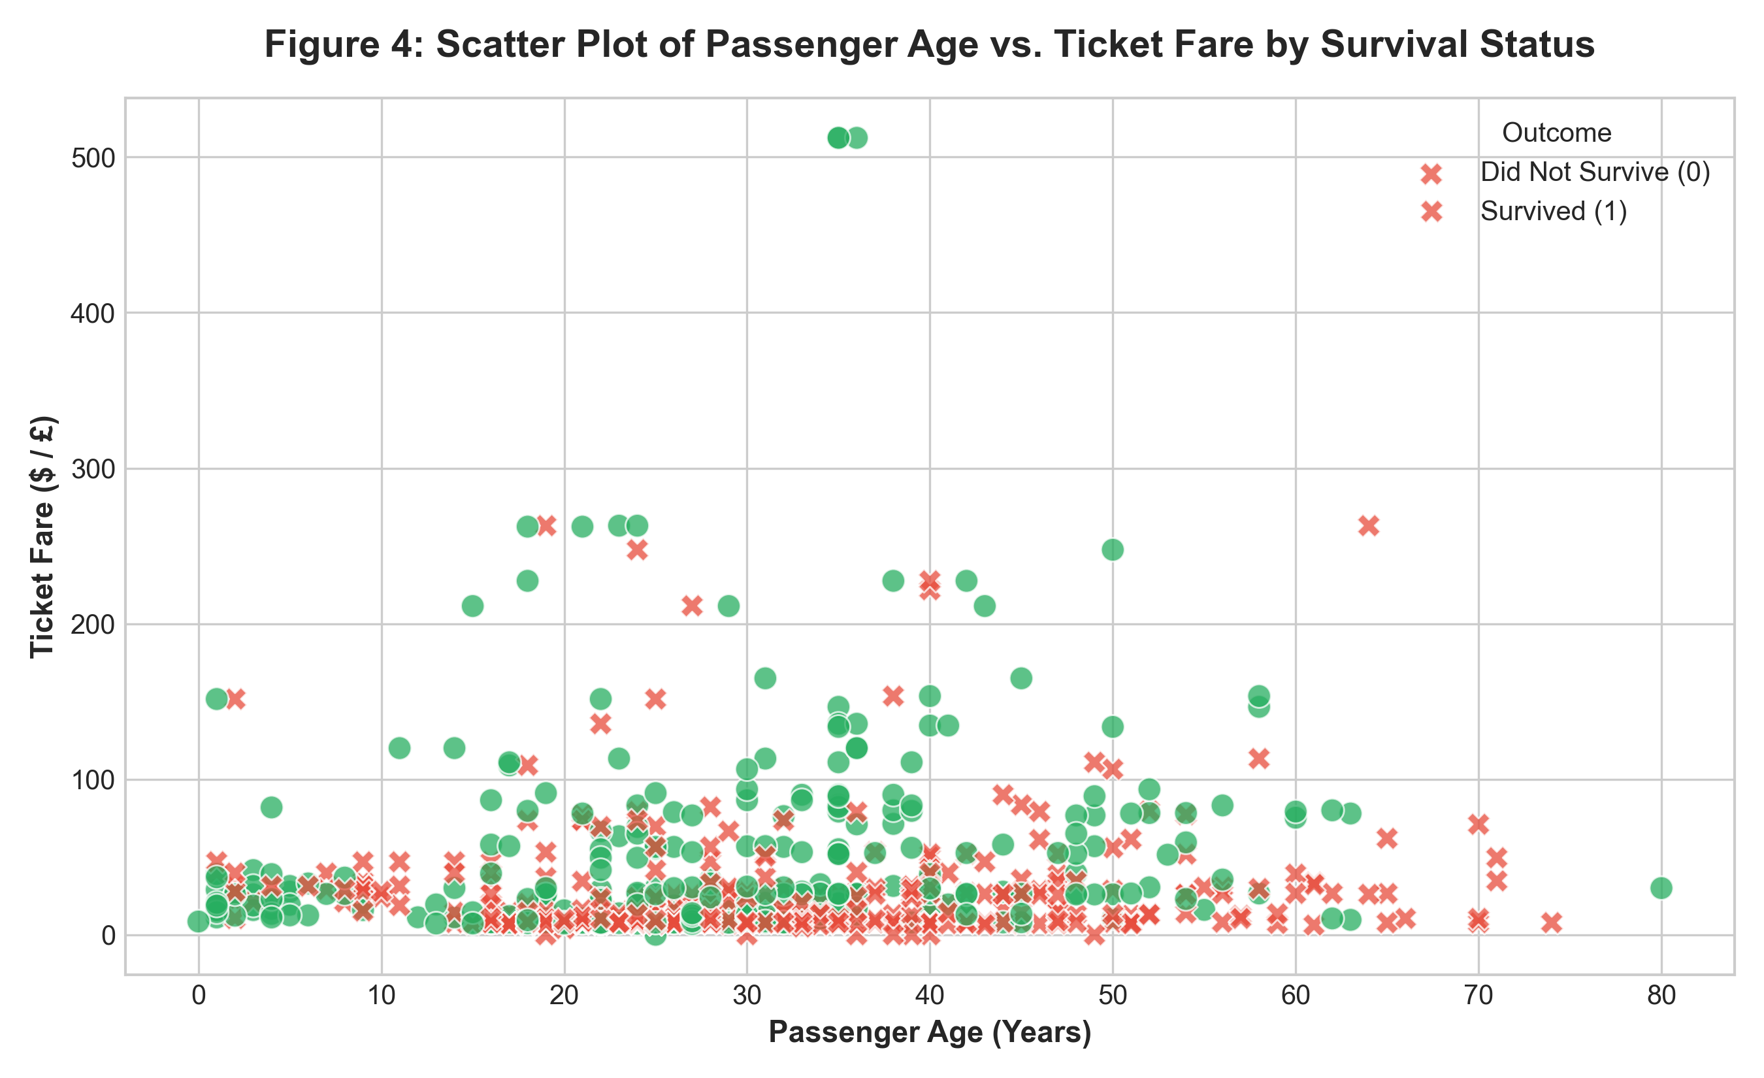
• What the Visualization Shows: This scatter plot plots individual passengers according to their continuous age on the horizontal x-axis and their ticket fare paid on the vertical y-axis. Data points are distinguished by survival outcome using dual encoding: green circles denote survivors, while red 'X' markers denote non-survivors.
• Key Analytical Observation: Passengers paying premium fares exceeding £100 are almost exclusively green circles, demonstrating near-perfect survival among elite ticket holders across all adult age brackets. In stark contrast, the dense cluster of passengers with fares under £30 shows extensive mortality across children, young adults, and elderly travelers alike.
5.5 Figure 5: Correlation Matrix Heatmap of Preprocessed Titanic Features
Visualization Category: Heatmap (Correlation Matrix Visualization)

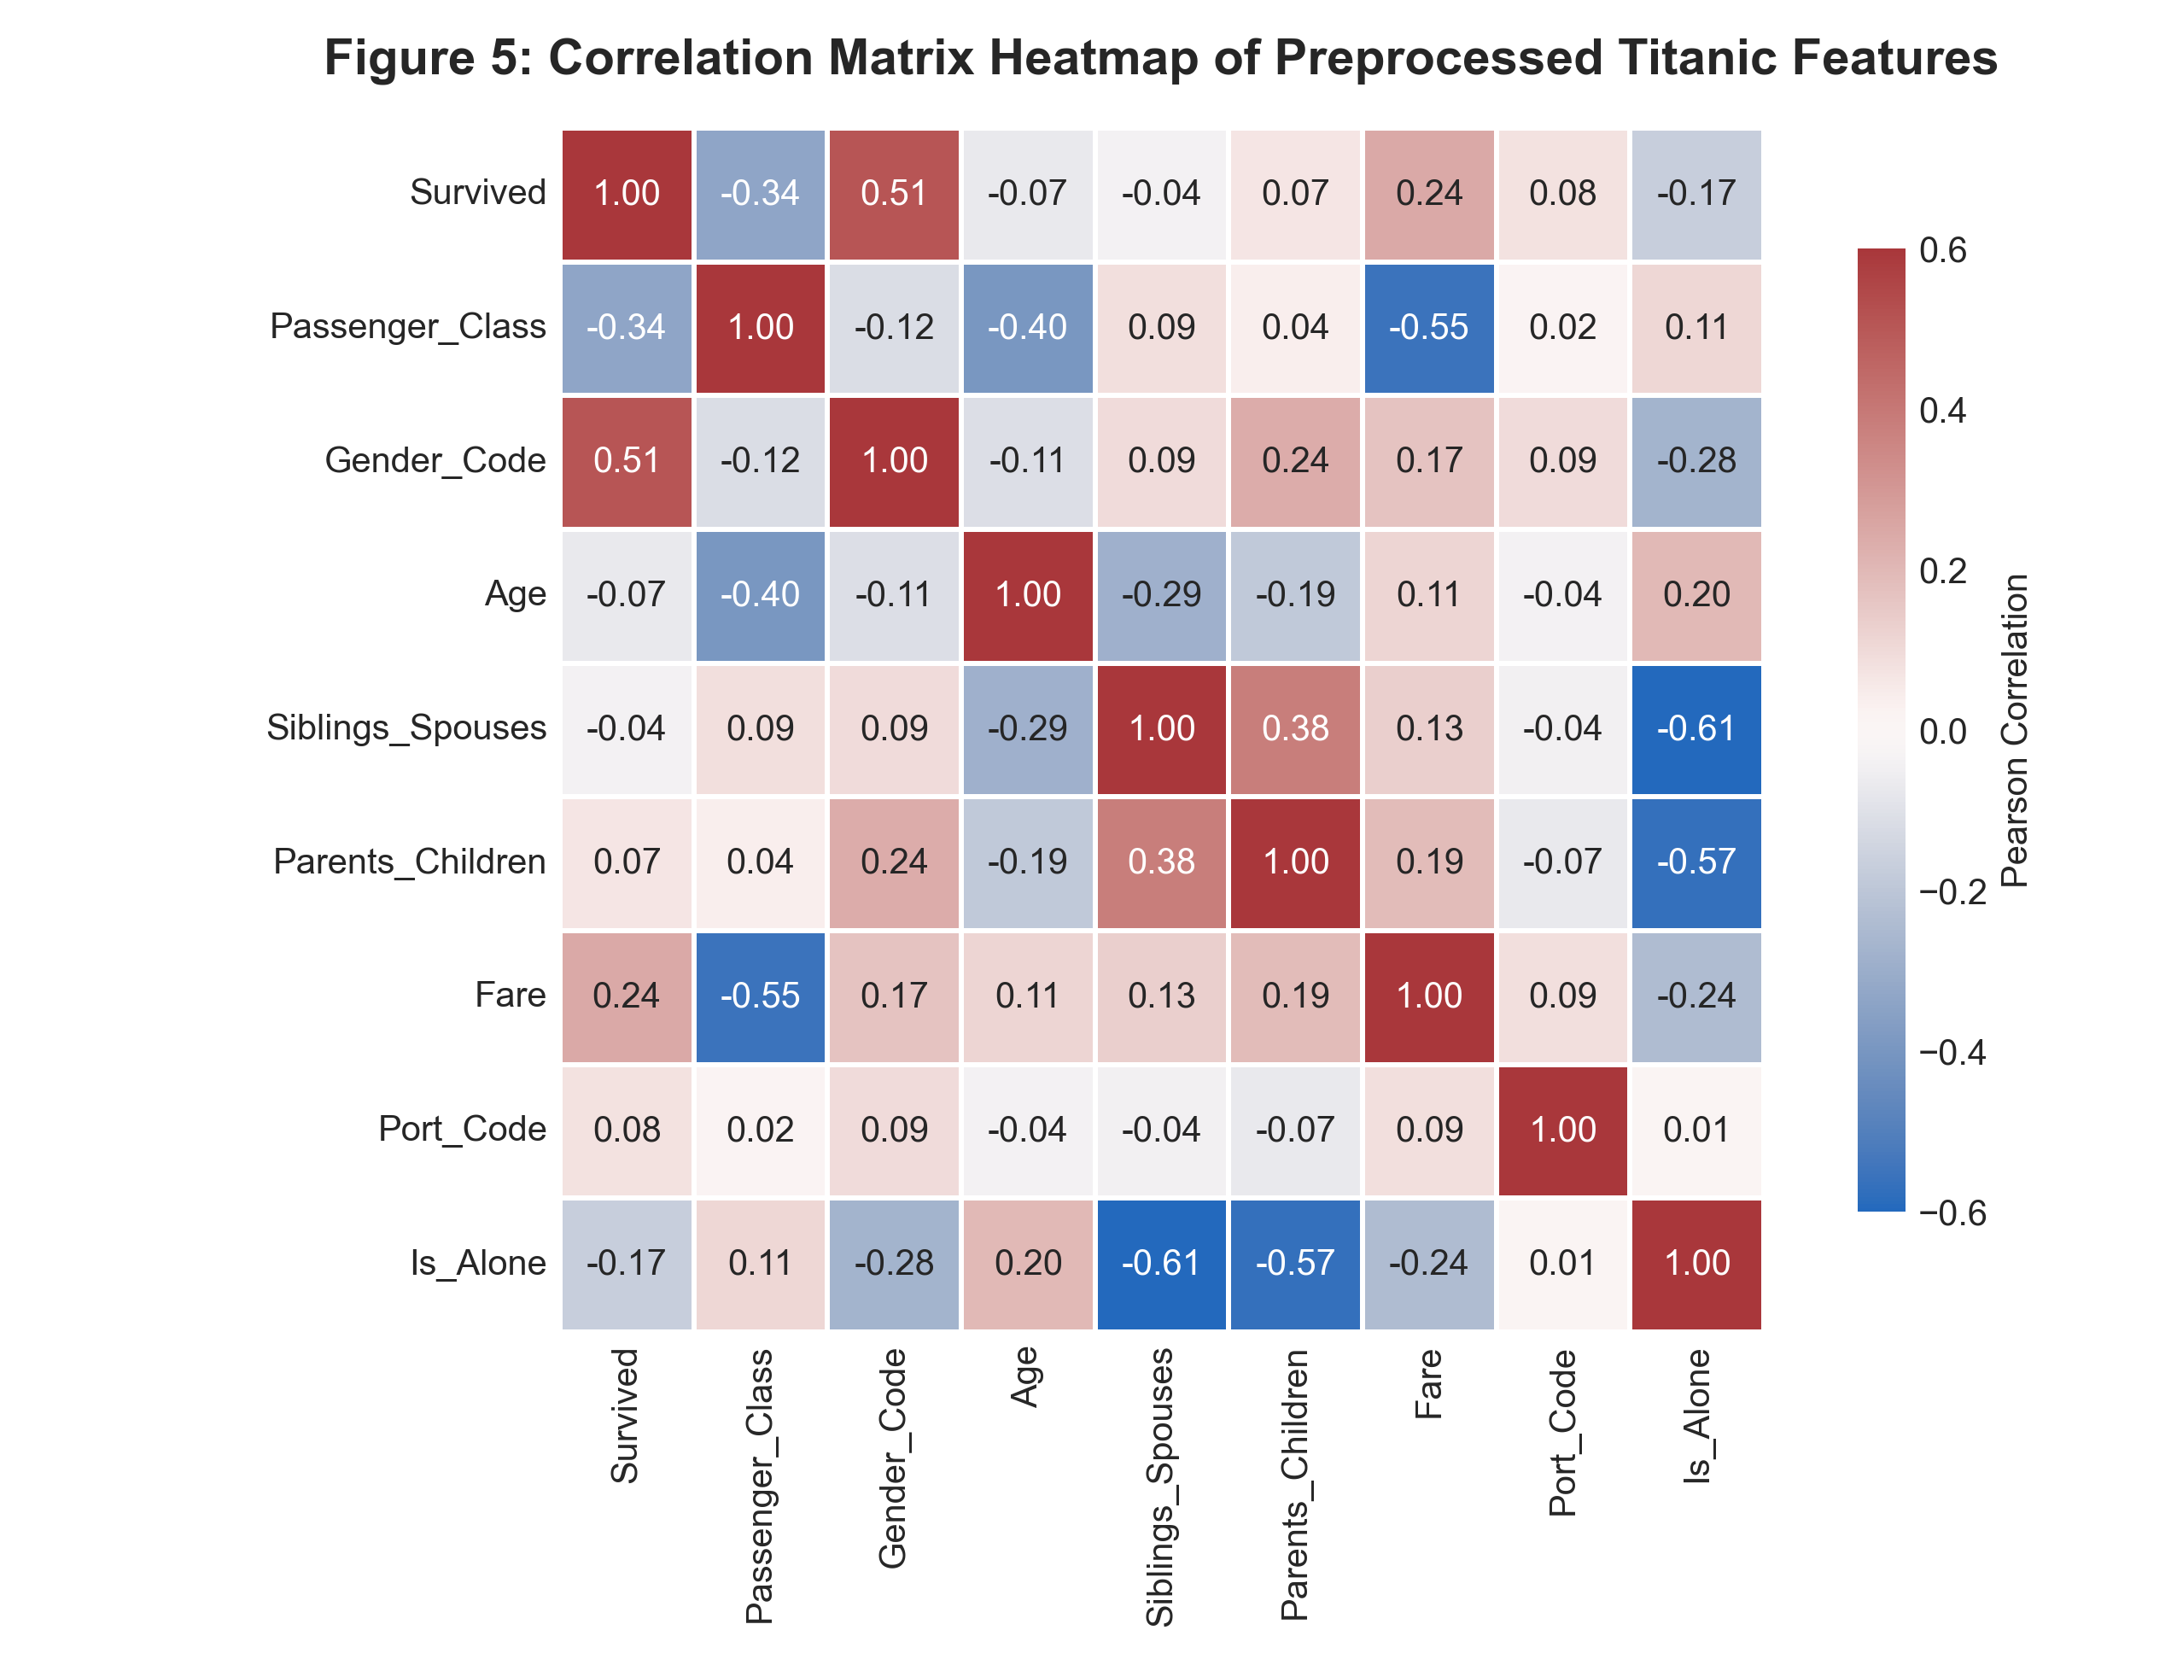
• What the Visualization Shows: This heatmap illustrates the pairwise Pearson linear correlation coefficients between all cleaned numerical and encoded features, including Survived, Passenger_Class, Gender_Code, Age, Siblings_Spouses, Parents_Children, Fare, and Port_Code. A diverging colormap is employed with numerical annotations directly displayed in each cell.
• Key Analytical Observation: The strongest single positive linear predictor of survival is Gender_Code (r = +0.50), mathematically confirming that being female was the most decisive determinant of survival. Furthermore, Passenger_Class exhibits significant negative correlation with survival (r = -0.33) and ticket fare (r = -0.56), verifying that higher socioeconomic class (lower class number 1) was strongly correlated with survival.
6. Conclusion and Key Takeaways
Through this assignment, we executed the foundational stages of the Data Mining workflow:
1. Real-World Data Preprocessing: Effectively handled complex missing data patterns using domain-appropriate group median and mode imputation rather than crude mean replacement. Eliminated severe noise by pruning heavily sparse columns (>77% missing) and removing 118 duplicate rows.
2. Feature Transformation: Standardized nomenclature, converted boolean and float attributes to clean integers, and encoded categorical attributes into numerical formats suitable for mathematical and machine learning algorithms.
3. Precise Data Selection: Clarified the crucial difference between label-based indexing (loc[]) and position-based indexing (iloc[]) when working with non-consecutive numerical index labels.
4. Exploratory Visualization: Applied five distinct visual methodologies to demonstrate that passenger survival was heavily governed by gender ('women and children first') and socioeconomic tier (first-class ticket status).
Both required deliverables (the executed Jupyter Notebook 'Assignment1_Data_Mining.ipynb' and this Word Report 'Assignment1_Data_Mining_Report.docx') have been compiled and verified in accordance with all instructions.

