Requirements Gathering Template   
(Version 1.0)

* **PROJECT NAME: Touché**
* **PHASE: 1**
* **DATE: 06/03/2022**
* **PREPARED BY Tami Shepard**

**VERSION HISTORY**

|  |  |  |  |  |  |
| --- | --- | --- | --- | --- | --- |
| **VERSION #** | **IMPLEMENTED BY** | **REVISION DATE** | **APPROVED BY** | **APPROVAL DATE** | **REASONS** |
| 1.0 | Tami Shepard | 06/03/2022 |  | 06/05/2021 | Created |
|  |  |  |  |  |  |
|  |  |  |  |  |  |

1. **Project Plan**
   1. **DESCRIPTION/PURPOSE OF PROJECT:**

* The purpose of this project is to provide a simple, easy to use, personal fencing score tracker for pools.
  1. **SCOPE OF PROJECT:**
* In scope:
  + Computer interface
  + Tableau minimum of 4 fencers
  + Tableau maximum of 8 fencers
  + GUI based
  + GUI must resemble the USA Fencing official scoresheet for pools: <https://cdn1.sportngin.com/attachments/document/2857-1927901/Pool_Score_Sheet.pdf#_ga=2.130447819.593444068.1654236229-1395729176.1654236229>
* Out of scope:
  + Mobile interface (stretch goal)
  + Barrage
  + Bout order
  + Referee info
  + Warnings
  1. **TIMELINE AND METHODOLOGY**

|  |  |  |  |  |  |
| --- | --- | --- | --- | --- | --- |
| **DATE** | **MILESTONES** | **GOAL** | **DEPENDENCES** | **RESOURCES** | **OUTCOME** |
| 06/04/2022 | Technology decision | Choose Swing, JSP, or other | Response from Prof Foster | Tami Shepard  Prof. Foster |  |
| 06/05/2022 | BRD submitted |  |  | Tami Shepard |  |
| 06/06/2022 | Front end completion |  |  | Tami Shepard |  |
| 06/07/2022 | Back end completed |  |  | Tami Shepard |  |
| 06/08/2022 | Driver/controller completed |  |  | Tami Shepard |  |
| 06/09/2022 | Testing completed |  |  | Tami Shepard |  |
| 06/10/2022 | User Review |  |  | Jazzy Shepard |  |
| 06/12/2022 | Project Submitted |  |  | Tami Shepard |  |

|  |  |  |  |
| --- | --- | --- | --- |
| **MILESTONE** | **RESPONSIBLE** | **ISSUES** | **NEW DATE** |
|  |  |  |  |
|  |  |  |  |

1. **Project Description**
   1. **PROJECT STAKEHOLDER SCENARIOS**

* Current Process
  + Typically, fencers do not record their scores during pools and rely on memory (which can be faulty) to keep track of their bouts. At the end of the pool when the referee requires fencers to sign the scoresheet, there are occasional disagreements on the scores due to faulty memory on the fencer’s part, or incorrect score entry from the referee.
* Proposed Process
  + The Touché application will allow fencers to track their scores on the strip, and optionally other fencer’s scores with an interface that resembles an official scoresheet. The typical way to use the app will be for the fencer to fill out their own bout scores, completing only their row and column. Once the row (touches scored) and the column (touches received) are complete, the fencer’s victories, total touches scored, total touches received, and indicator will be calculated:

|  |  |  |  |  |  |  |  |  |  |  |
| --- | --- | --- | --- | --- | --- | --- | --- | --- | --- | --- |
| Name | # | 1 | 2 | 3 | 4 | V | TS | TR | Ind | Pl |
| Fencer 1 | 1 |  |  | 1 |  |  |  |  |  |  |
| Fencer 2 | 2 |  |  | 3 |  |  |  |  |  |  |
| Jazzy | 3 | 5 | 5 |  | 4 | 2 | 14 | 9 | 5 |  |
| Fencer 4 | 4 |  |  | 5 |  |  |  |  |  |  |

* + If the fencer desires, they can also fill out the entire scoresheet. In this case the victories, total touches scored, total touches received, indicator, and place will be calculated.

|  |  |  |  |  |  |  |  |  |  |  |
| --- | --- | --- | --- | --- | --- | --- | --- | --- | --- | --- |
| Name | # | 1 | 2 | 3 | 4 | V | TS | TR | Ind | Pl |
| Darth | 1 |  | 5 | 5 | 5 | 3 | 15 | 4 | 11 | 1 |
| Obi | 2 | 4 |  | 5 | 5 | 2 | 14 | 7 | 7 | 2 |
| Rey | 3 | 0 | 1 |  | 5 | 1 | 7 | 12 | -5 | 3 |
| Jar-Jar | 4 | 0 | 1 | 2 |  | 0 | 3 | 15 | -12 | 4 |

* 1. **CONSTRAINTS & RESTRICTIONS**

|  |  |
| --- | --- |
| **CONSTRAINT** | **ISSUE/SOLUTION** |
| Tight timeline | Project will be submitted as-is by 6/12/2022. |
|  |  |
|  |  |

* 1. **ASSUMPTIONS & DEPENDENCIES**
* Assumptions
  + n/a
* Dependencies
  + n/a

1. **Project Requirements**
   1. **USER REQUIREMENTS**

* App is to perform similarly to a traditional paper pool sheet.
* Data entry fields should be optional where ever possible, and have defaulted vales since fencers can be rushed when arriving at their strip (especially if they are the first bout).
  1. **FUNCTIONAL REQUIREMENTS**
* Ability to enter the name of the tournament onto the tracker.
* Ability to have a default tournament name in case the user chooses not to enter one.
* Ability to enter fencer’s names into the scoresheet.
* Ability to have default fencer names in case the user chooses not to enter them.
* Ability to enter bout scores onto the grid/scoresheet
* Victories should be calculated after the user completes a row (bout touches scored) and column (bout touches received).
* Total touches scored should be calculated after the user completes a row (bout touches scored) and column (bout touches received).
* Total touches received should be calculated after the user completes a row (bout touches scored) and column (bout touches received).
* Indicator should be calculated after the user completes a row (bout touches scored) and column (bout touches received).
* Place should be calculated if the user completes all rows (bout touches scored) and columns (bout touches received) for each fencer in the pool.

* 1. **SYSTEM REQUIREMENTS & SOFTWARE INTERFACES**
* Java 1.8 or higher
  1. **USER INTERFACE REQUIREMENTS**

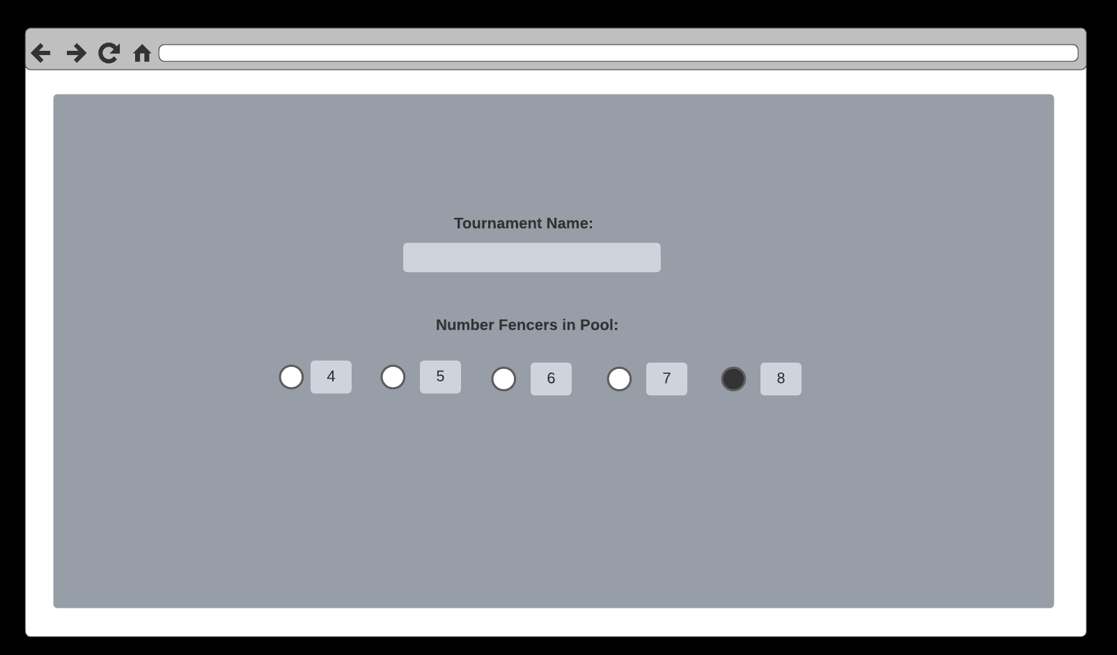

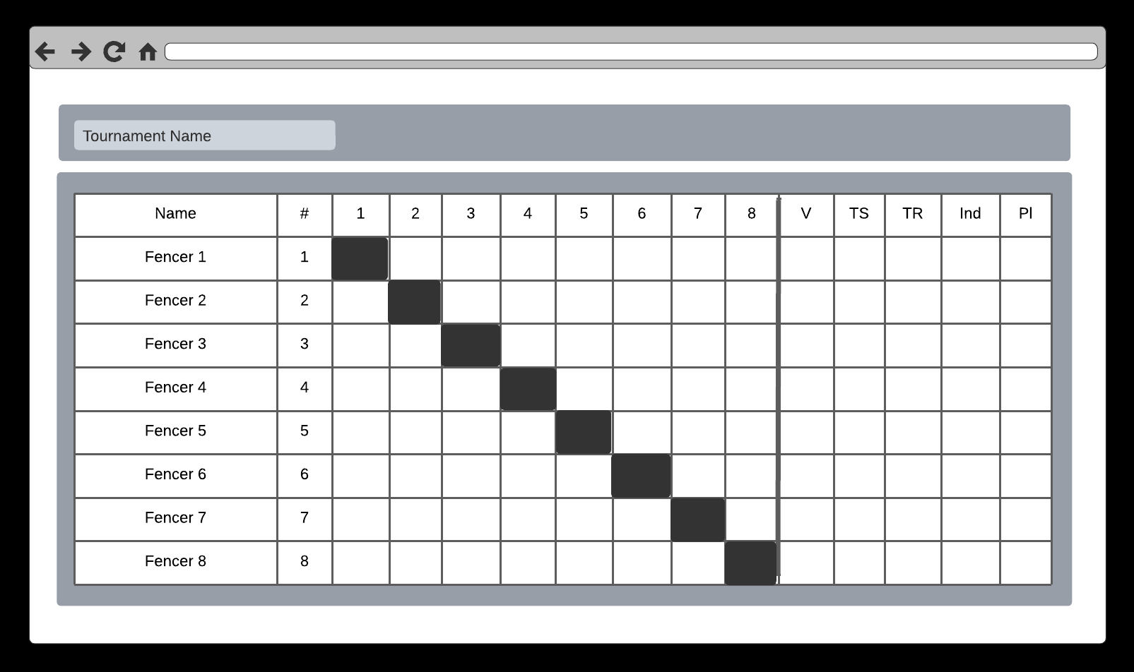

* 1. **WORKFLOW AND ACTIVITIES**

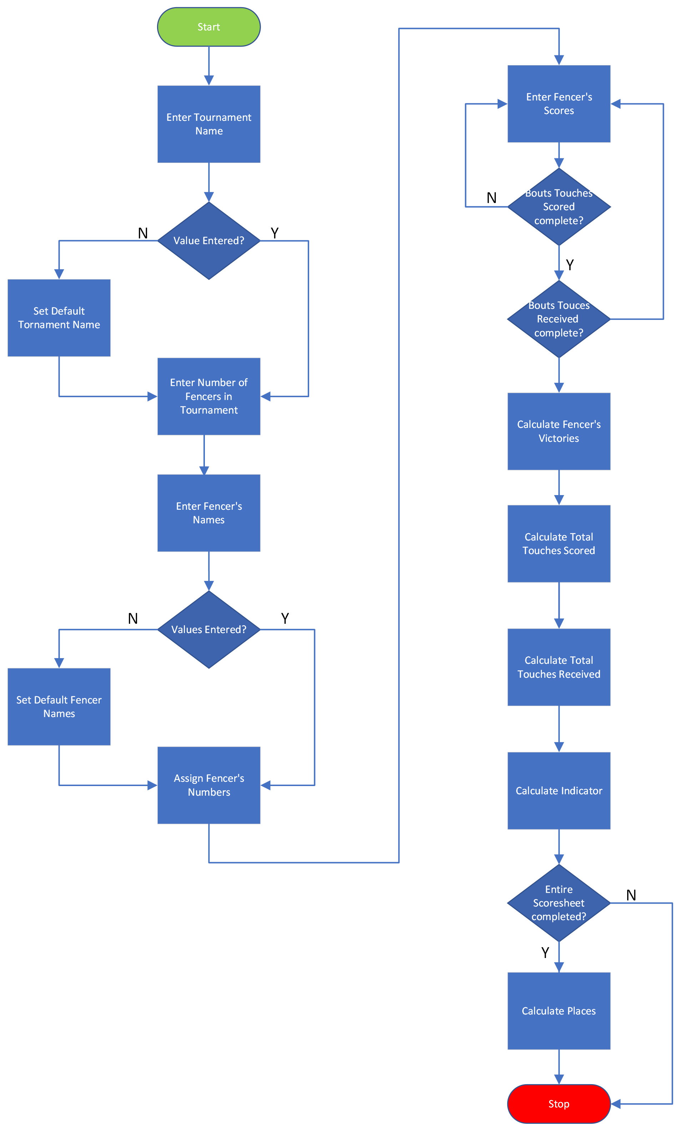

* 1. **CHANGE MANAGEMENT**
* Source Code managed via GitHub
  1. **RISK MANAGEMENT**
* n/a

1. **High-Level Tech Architecture**

* n/a

1. **Maintenance & Support**

* n/a

1. **User Testing & Evaluation**

|  |  |  |
| --- | --- | --- |
| **Test Case** | **Obective** | **Pass/Fail** |
| Default tournament name | Validate when no tournament name is entered that the default is populated |  |
| Tournament name entered | Validate tournament name is populated |  |
| Default fencer names | Validate when no fencer names are entered that the defaults are populated |  |
| One fencer name | Validate when just one fencer name is entered the others are defaulted correctly |  |
| Multiple fencer names | Validate when multiple fencers are entered they are correctly populated |  |
| One fencer - calculations | Validate victories are correct |  |
| One fencer – calculations | Validate touches scored are correct |  |
| One fencer – calculations | Validate touches received are correct |  |
| One fencer – calculations | Validate indicator is correct |  |
| Multiple fencers – calculations | Validate victories are correct |  |
| Multiple fencers – calculations | Validate touches scored are correct |  |
| Multiple fencers – calculations | Validate touches received are correct |  |
| Multiple fencers – calculations | Validate indicator is correct |  |
| Multiple fencers – calculations | Validate place is correct |  |

1. **Sign-Offs**

|  |  |  |  |
| --- | --- | --- | --- |
| Signature: |  | Date: |  |
| Print Name: | Jazzy Shepard |  | 6/10/2022 |
| Title: | Fencer / Referee |  |  |
| Role: | Stakeholder |  |  |

|  |  |  |  |
| --- | --- | --- | --- |
| Signature: |  | Date: |  |
| Print Name: | Tami Shepard |  | 6/10/2022 |
| Title: | Mom |  |  |
| Role: | Developer |  |  |

|  |  |  |  |
| --- | --- | --- | --- |
| Signature: |  | Date: |  |
| Print Name: |  |  |  |
| Title: |  |  |  |
| Role: |  |  |  |

1. **Appendixes**

**REFERENCES**

|  |  |  |
| --- | --- | --- |
| **DOC NAME/VERSION** | **DESCRIPTION** | **LOCATION** |
| ToucheBRD.docx | This BRD | GitHub |
|  |  |  |
|  |  |  |

**KEY TERMS**

|  |  |
| --- | --- |
| **TERM** | **DEFINITION** |
| JSP | Java Server Pages |
| Pool | A small group of fencers that are brought together to fence each other with the intention on setting a ranking prior to direct elimination rounds. |
| Bout | Combat between two fencers in competition. When score is not kept, friendly combat between two fencers is referred to as an assault. |
| Indicator | The difference between touches scored and touches received. If the number of victories are all the same, the bout committee will review the indicators. If the fencers tied all parameters (number of victories, indicator and touches scored) then the fencer’s will be listed as tied in the final standings. |
| Barrage | This type of bout is used as a tie-breaker to determine which fencer is the winner. It is used after the opponents have amassed the same number of bout wins. When the direct elimination format is used in competition, barrages are not necessary. |
| Strip | The field of play on which bouts are contested. It is made of metallic mesh and measures 14 meters long (46 feet) by 1.5 meters wide (4 feet, 10 inches). |
| Tableau | Table that houses the fencer’s scores |
| Match | See Bout |
|  |  |