WorkPulse Wireframe Screen by Screen
WORKPULSE | MVP v0.1 | 9 September 2026
Define the MVP screen inventory, layout hierarchy, actions, and states for implementation. These low fidelity wireframes describe functional placement and behavior rather than a finished visual identity. Screen IDs match the User Flow document; requirements and persistence match the PRD and Database Schema.

1 Application frame
Desktop uses a left navigation rail with Dashboard, Activity, Achievements, Projects, Timeline, and CV. Profile and settings sits at the rail bottom. The Activity destination opens S06 in list mode; Capture opens S05. Keep Quick log as the global primary action. On mobile, use a compact header and labeled menu, with Quick log available without horizontal scrolling.
Pattern | Implementation rule
Visual hierarchy | Page title and one primary action first; summary or filters next; record content below. Distinguish draft, confirmed, and failed with text as well as color.
Forms | Visible labels, optional markers, inline errors, and keyboard focus on the first invalid field. Keep input after failed saves. Disable repeat submit while pending.
Lists | Use compact record rows, newest first, stable pagination of 30. Retain filters on return. Empty states offer the relevant create action.
Responsive behavior | At 360 px, stack side panels below the editor and use full screen forms. At 1440 px, source and editor or selection and preview may sit side by side.
AI controls | Show Saved independently from Analyzing. Make optional follow ups skippable. Present source text next to suggested wording. A failed AI request never hides the original note.
Evidence control | Reusable attachment list in S06, S08, S10. Show filename, size, status, Download, Remove, and explicit Move to achievement where available.
CV behavior | One master CV, one template, source selection, editable wording, reviewable refresh, then a saved revision preview. No vacancy field or job match score.

Screen specification format
Each schematic shows information hierarchy, a secondary panel, and an action area. The text beneath it specifies inputs and states that are not visible in the compact drawing. Screen examples are illustrative placeholders, not user data. Quotas are 10 MiB/file, 3 files/parent, and 50 MiB/account for evidence. CV imports also cap at 20 pages.

Shared dialogs
Use reusable dialogs for AI processing consent, discard unsaved changes, delete with dependency counts, and stale edit conflicts. Consent offers Allow AI and Continue manually. An expired session prompts sign in before retrying a write. A missing or unauthorized record shows Record unavailable. Confirm destructive actions using the affected record name.

2 Account and Import CV

S01 Account
R01 • F01 | /sign-in
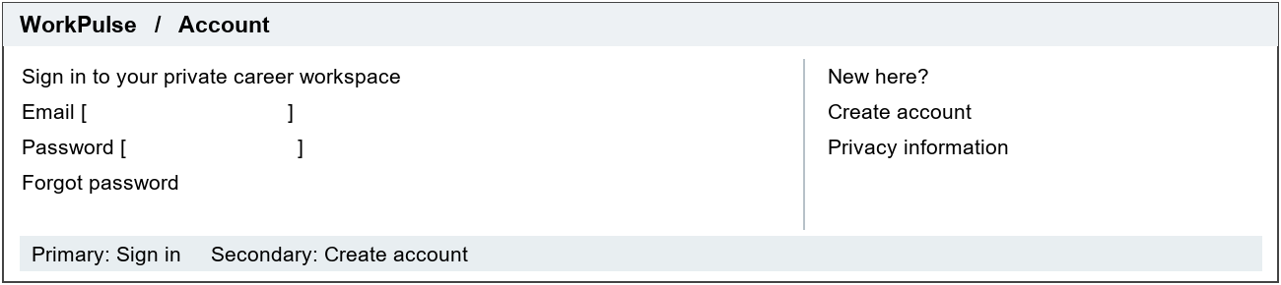
Provide sign in, create account, email verification, and password recovery states through the auth provider. Require valid email and provider password rules. After verification, route new users to S02 and returning users to S04 or their safe deep link.
Show sending, verification pending, invalid credentials, recovery sent, and rate limited states. Use neutral recovery copy. Clear session state on sign out; do not expose career data before authentication.

S02 Import CV
R02 • F01 | /onboarding/import
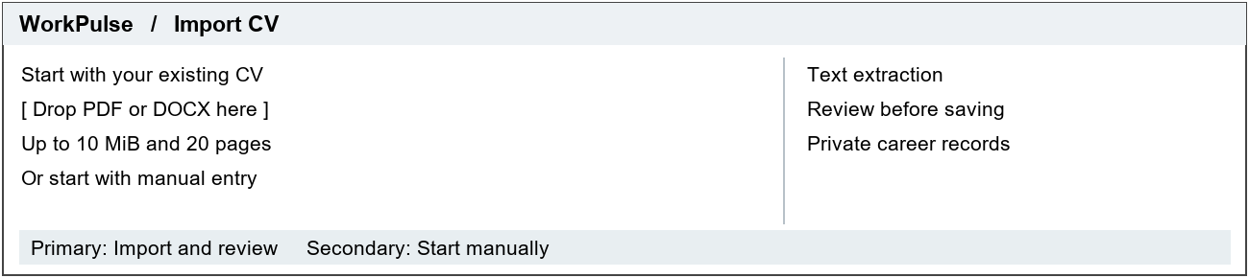
File picker and drop area accept one PDF or DOCX. Display format and size constraints before upload. Show AI consent before extraction. Start manually opens S12 with display name required; returning users enter this screen from S12.
During processing show the saved batch and progress state with Leave and return later. Unsupported, scanned, encrypted, oversized, or corrupt files offer another file or manual entry. Retry reuses the batch; cancel retains no committed career records.

3 Review imported career data and Career dashboard

S03 Review imported career data
R02 • F01 | /imports/:id/review
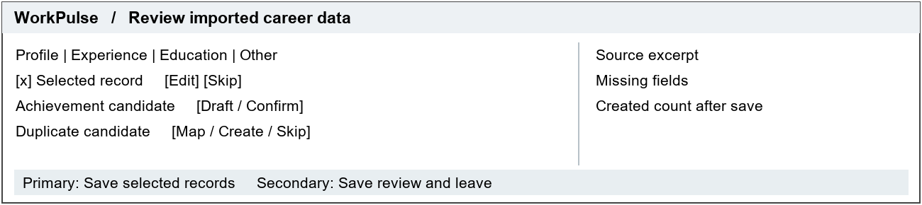
Group candidates into profile, experience, education, certifications, skills, and achievements. Show editable fields, source excerpts, validation errors, and a selection summary. Mapping reuses existing records without overwrite. Require explicit confirmation per achievement candidate.
Persist review choices. Highlight missing required fields. Disable final save if any selected record is invalid. A committed batch shows result counts and Open dashboard; refresh or double click must not duplicate rows. Empty extraction offers manual entry.

S04 Career dashboard
R03 • F01 F02 F06 F07 | /dashboard
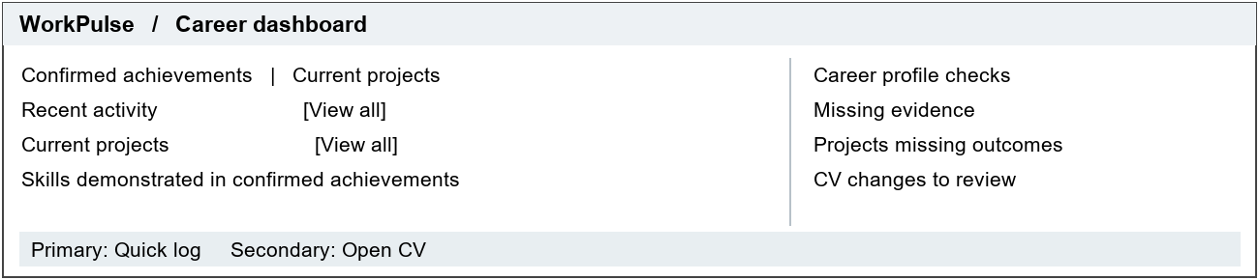
Show real counts and links to filtered records. Recent activities use occurred_on, not creation time. Skills show distinct confirmed achievement counts. Completed projects with blank outcomes and confirmed achievements with no direct ready evidence appear as actionable checks.
For an empty account, show Add your first activity and Import CV. Loading uses skeletons; failure shows Retry. No streaks, proficiency levels, generic readiness percentage, job matching, or career gap inference.

4 Capture work and Activity list and detail

S05 Capture work
R04 R05 • F02 | /activity/new
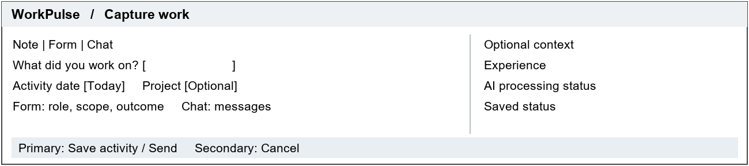
Note requires nonblank text up to 10,000 characters and an exact date. Form exposes optional role, scope, and outcome. Chat stores the first message as raw_text before analysis. Project selection determines experience context; standalone experience is optional.
Show saving, saved, analyzing, and analysis failed independently. AI declined leaves manual capture functional. Saved records open S06; a suggestion opens S08 only when selected. Do not require answers to follow up questions to save.

S06 Activity list and detail
R04 R05 R07 • F02 F05 | /activity and /activity/:id
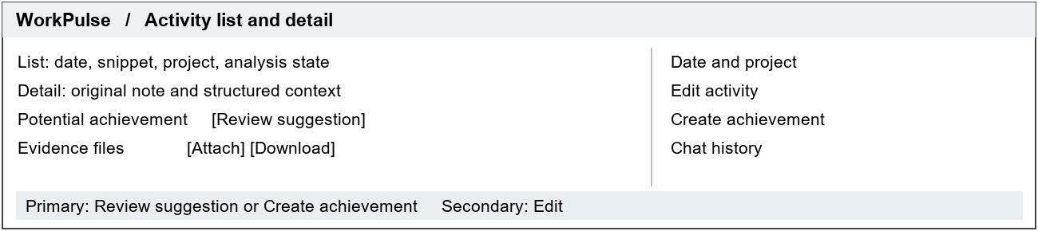
List mode filters by date or project. Detail preserves original text, chat answers, and source context. One derived achievement per activity: if it exists, show Open achievement. Evidence lists status and allows an explicit move to the derived achievement.
AI failure offers Retry. After a note edit, flag the linked achievement as needing source review without overwriting it. Delete previews evidence deletion and retains the derived achievement with its source excerpt. Unsaved edits require discard confirmation.

5 Achievements and Review achievement

S07 Achievements
R05 R09 • F03 | /achievements
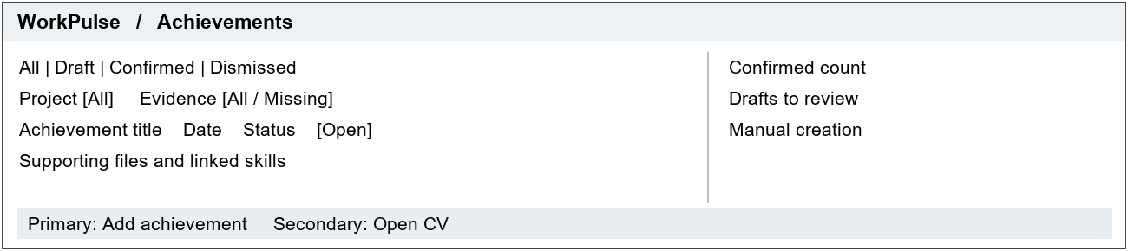
Show a concise outcome snippet, date, project, and text status. Missing evidence means no ready files directly attached. Open a record in S08. Add achievement creates a standalone draft without requiring an activity or employment.
Empty drafts and empty confirmed lists have different copy: capture work or confirm a draft. Keep dismissed suggestions accessible. Loading and error states preserve selected filters. Never include drafts in CV eligible counts.

S08 Review achievement
R05 R07 R09 • F03 F05 | /achievements/:id
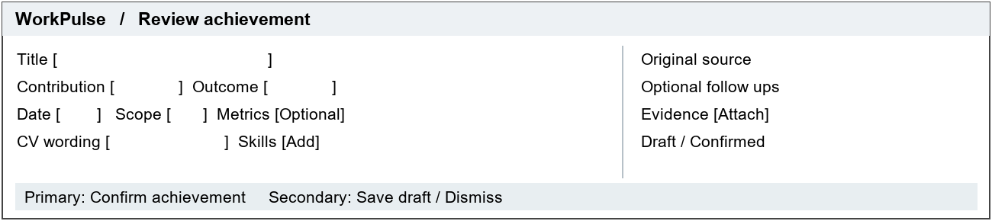
Show role/contribution, outcome, scope, date, optional structured metrics, skill tags, and CV bullet. Required confirmation fields are title, contribution, outcome, date, and CV wording. Generate factual fallback wording from contribution and outcome if needed. Qualitative results are valid.
Questions are optional, with a maximum of three per activity revision. Confirmed mode shows Save changes and Add to CV; Reopen as draft removes eligibility. Show source changed, AI failed, attachment pending, and validation states. Do not assert that uploaded evidence verifies a claim.

6 Projects and Project detail

S09 Projects
R06 • F04 | /projects
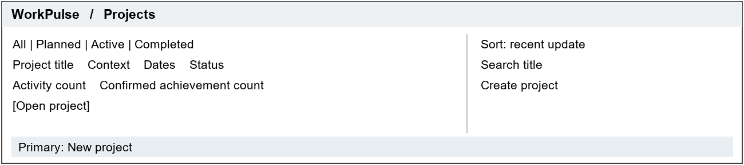
Show title, user role, optional experience context, date range, status, and linked record counts. New project opens S10 in create mode. Academic and volunteering projects need no employer record.
Empty state offers Create a project and explains that projects group related work. Filters remain when returning from detail. Show Date not set rather than invented dates. Completed projects without outcomes display a plain Needs outcome label.

S10 Project detail
R06 R07 • F04 F05 | /projects/:id
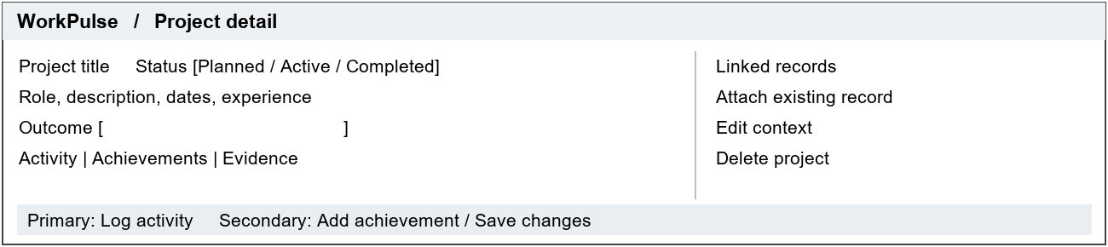
Editable fields include title, description, role, optional date range, experience, status, and outcome. Create linked work or attach existing owned records. Relinking an activity also relinks its derived achievement. Display pending and ready evidence separately.
Completed status allows a missing outcome but explains the dashboard check. Delete previews retained activities/achievements and removed direct attachments. Context changes show a confirmation summary if they affect linked records or CV sources.

7 Career timeline and Profile and settings

S11 Career timeline
R08 • F06 | /timeline
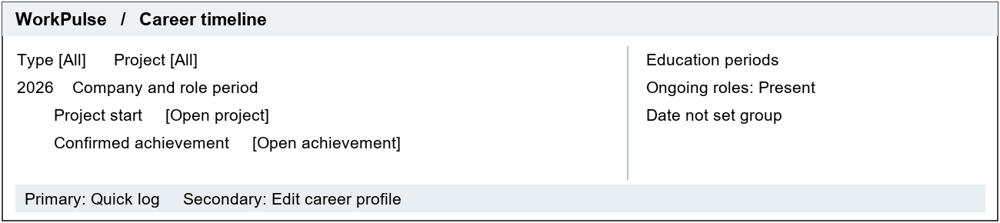
Render a reverse chronological vertical timeline with year headings, employer/role context, project starts, education periods, and confirmed achievement dates. Keep overlapping employment visible. A standalone project or achievement appears without an employer heading.
Date precision controls labels. Unknown dates appear at the bottom under Date not set. Empty state links to profile editing or capture. All events deep link to canonical records; no editable timeline copies or inferred promotions.

S12 Profile and settings
R01 R02 R09 • F01 F06 | /settings/profile
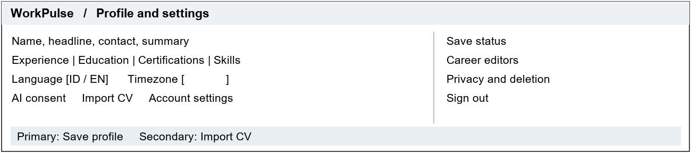
Use inline editors or dialogs for foundational career records and skill labels. Allow partial and unknown dates with precision. Require display name to complete onboarding. Locale changes interface and CV label defaults; it does not translate source content.
Show validation, saving, conflict, and saved states. AI consent can be withdrawn for future requests. Account deletion requires reauthentication and a clear data loss confirmation, then revokes sessions and queues deletion. Explain backup retention in the privacy detail.

8 Master CV builder and PDF preview and export

S13 Master CV builder
R09 • F03 F07 | /cv
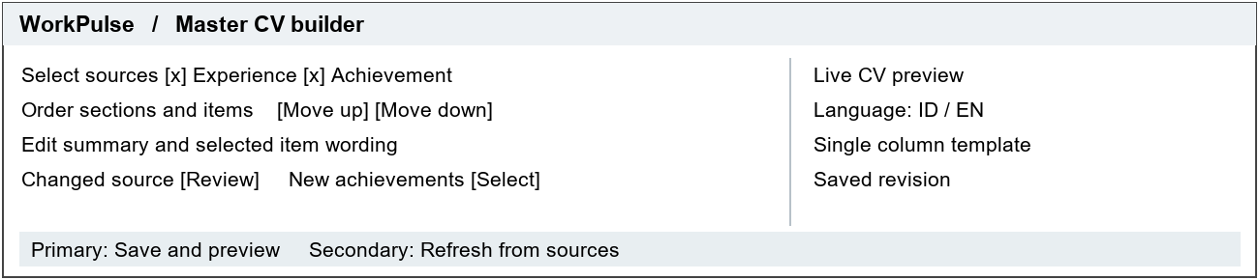
Use selection/editor on the left and preview on the right. Include education, projects, skills, and certifications. Selecting a child includes its parent. An override changes CV wording only. Record ordering through accessible move controls, with drag optional.
Show unsaved, saved, changed source, manual override, deleted source, and unconfirmed source states. Review offers Keep wording or Replace from source; never overwrite manually edited wording automatically. One master CV only; no duplication, vacancy input, or matching.

S14 PDF preview and export
R10 • F07 | /cv/preview
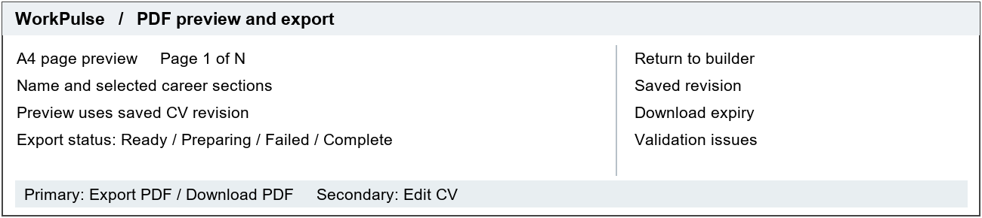
Show the exact saved snapshot, page boundaries, page navigation, and export status. Require a name plus at least one substantive selected career record. Export searchable text in the chosen label language; keep headings with content and avoid split bullets where practical.
Block deleted or unconfirmed sources and unacknowledged source changes with a link to S13. Retry uses the same snapshot. Download remains available for 24 hours, through short lived authorized URLs; an expired file offers Regenerate. Evidence never appears in the PDF.

