**Consolidated Feedback on the ACTUS user guide and demo app from ChainAim team**

Contributors are Sathya Krishnasamy and interns, including students from master’s programs in finance in eminent colleges in India - 3 students worked on it.

**1. Basic Understanding of ACTUS from the student group in 3 calendar days**

ACTUS attempts to create globally accepted standards to represent all financial contracts. Actus focuses on organizing financial instruments and products into constituent algorithmic contract types. The algorithmic contract types produce the time series of input cash flows.

ACTUS strives to achieve architectural simplicity by modularizing its functionality through an external risk factor API that can feed risk modeling scenarios. The API then computes the expected normal versus potential risk scenarios in terms of cash flow deviations.

2. **UserGuide-related feedback -** A reorganization proposal is also indicated for your review.

The user guide has a lot of information, and maybe it might be helpful to have

1. a simplified version ( as markup in gitbook ), with a simple layout as explained in the reorganization document ( with screenshots from other gitbooks on tech solutions that we had recently participated in knowledge and hackathons ).
2. links to the detailed version as needed, but it is heavily hyperlinked, so whoever needs the details can go there. However, whoever can actually proceed quicker through the steps will also have a fast track.

**2.1 Strengths:**

1. User Guide has very useful information, and it is beneficial for first-time users to implement.
2. There is a lot of substantial information and explanations. However, it can be refined a little differently to have both quick routes and longer routes through hyperlinks for people who need more context.

**2.2 Improvements:**

1. User Guide pdf should be consolidated in a simple format and should be linked to the home page of ACTUS . From there, any user can access the guide .

The User guide can be on the website homepage rather than a separate PDF. When clicked, it automatically opens the demo app. For first-time users, it would be easier to start using the app by itself rather than searching for a place for the user guide PDFs.

1. A markup of the user guide with Introduction and Simple Quick Start tutorial can be organized better, including a logical frame on the left for a gradual introduction, key concepts, a very simple example, and an advanced example. This will help new students.

The reorganization document has some example screenshot of mockups, copy to clipboard code snippets, etc.

Details on refinement of the userguide proposal is attached in a separate document

**3. Demo App related Feedback**

3.1 **No adequate Legends ,axis labeling in the demo app graphs and Download options will be helpful.**

**Steps to recreate:** Demo app -> Choose a contract type(for eg. ANN) -> Click on Demo case -> Choose any case ( for eg. case 101) -> Click on send

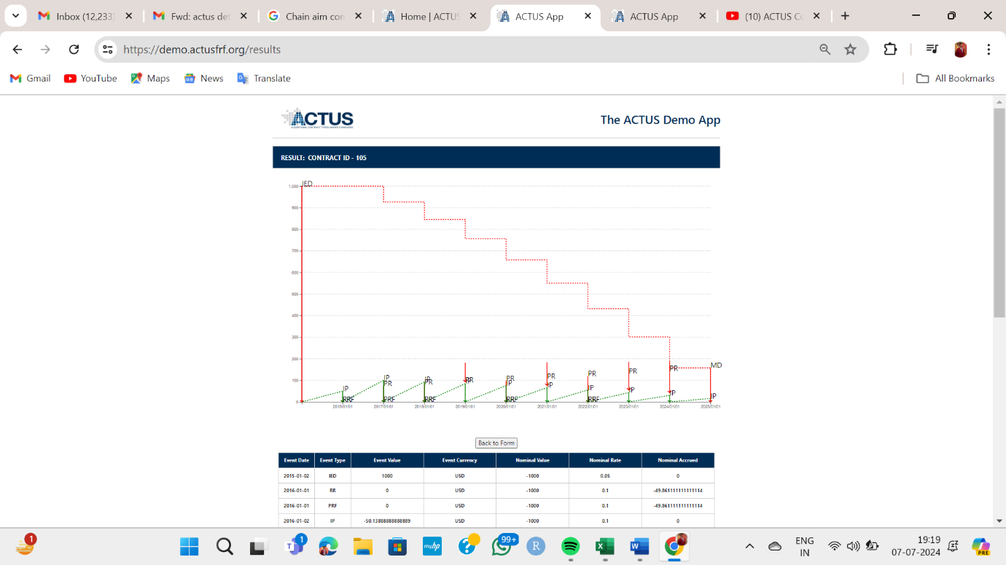

Above diagram and table shows a demo case of a contract type . Demo app depicts tabular and graphical representation but it would be more useful if there is any download option of the csv file of data.

On the graph , legend should be added and it would be more attractive if (x, y) values are displayed on a graph where the mouse pointer would be pointed on .

For the same graph, sometimes we get this error message. intermittently.

3.2  **Some Demo cases are throwing errors**

Sometimes it’s showing this type of error.

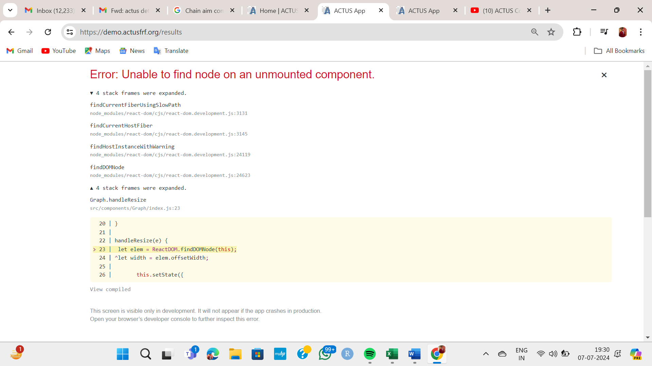

Following Typeerror occurs when demo case 105 under Stock (STK) is run .

Step: Demo app -> STK -> Demo case-> case 105 -> send

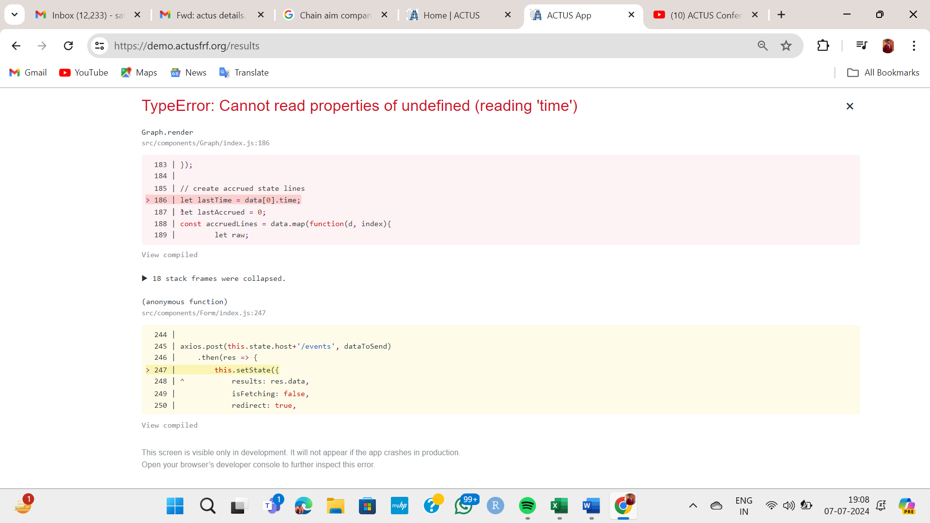

**3.3 Demo cases of all contracts are not available.**

Some contracts like cash(CSH), cap floor(CAPFL), cash(CSH) , commodity(COM), call money(CLM) , Undefined Maturity Profile (UMP) , and demo cases are not available there.

**3.4 Direct link of DaDFiR3 demo app in ACTUS homepage**

For portfolio analysis user is redirected to DaDFiR3 site through this link hEps://dadfir3.shinyapps.io/DaDFiR3demo

If it is linked to actus demo use interface then it would be easier to access this DaDFiR3 shiny app. And we can separate the user guide for actus demo and shinyapps demo make a separate user guide tab where these will be uploaded.

**3.5 Under interest rate scenario plot should be revised.**

Interest rate scenario graph shows the relationship between % pa interest(y axis) and date (x axis). Here from choosing the dataset dropdown we can get 1) steady rates, (2) decreasing rates (3) recovering rates and (4) increasing rates. But for all of these till 2022 plots are identical . It would be more prominent if the scenario is reframed after 2022 . As after 2022 we get only 2 years we can use quarterly time series. 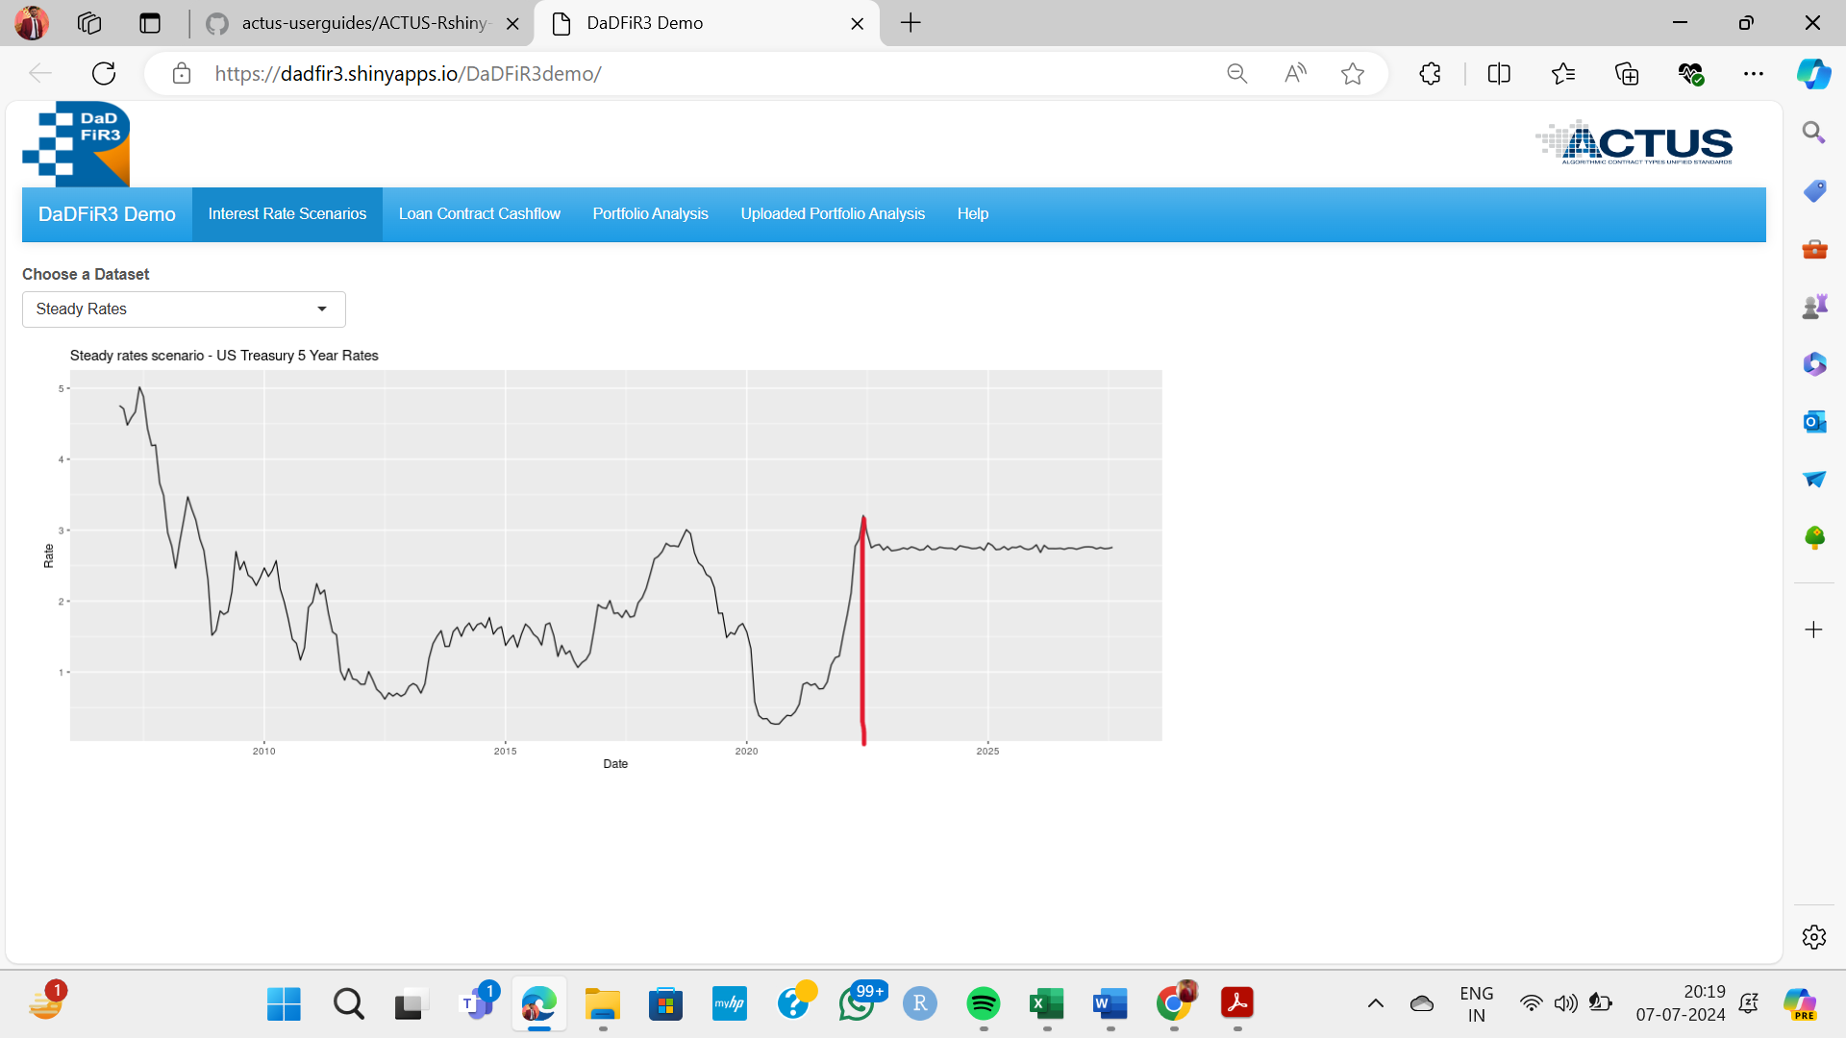



**4. Videos:** We went through some of the ACTUS conference videos. It was helpful in bits and pieces where very important information was available. However they are too lengthy

A couple of options to make it more useful.

**Video Tutorials:**

Produce clear and engaging video tutorials that explain key concepts and processes.

Break down complex topics into shorter, easily digestible videos.

Solution options:

1. An edit of those videos where there is introductory content not exceeding 30-45 minutes., with module sizes of 5-10 minutes
2. *Stretch goal - A redo of the video potentially from this group to run through the concepts and a working session with 1 simple example ( roughly 30 minutes ). paraphrasing from the perspective of first time or early stage user

Indicative content

1. introduction to actus - 5 mins
2. walking thru the demo app - 5 mins
3. walking thru the userguide - 5 mins
4. setting up the environment - 5 mins
5. simple example run thru - 5 mins
6. where is what - 5 mins

**5. Links to resources we expect challenge participants will look for**

* Link to potential data sets ( Kaggle, risk modeling frameworks, data sets etc ) model financial contracts using ACTUS standards.
* Provide detailed notebooks and code examples showing the step-by-step process from data cleaning to contract modeling.

**6.FAQs and Troubleshooting:**

* Develop a comprehensive FAQ section addressing common questions and issues.
* Include troubleshooting guides for common problems users might encounter.