Companion User Guide for ACTUS Demonstrations

The user guide has a lot information and may be it might be useful to have

1. a simplified version ( as a markup in gitbook ), with a simple layout as explained in the reorganization document ( with screenshots from other gitbooks on tech solutions that we had recently participated in knowledge and hackathons ).
2. links to the detailed version as needed, but heavily hyperlinked, so whoever needs the details can go there, but whoever can actually proceed quicker through the steps ,there will be a fast track for them as well.This is specifically useful if the intent of this quickstart is to help challenge / hackathon participants.

Basically the idea is to make this document a quickstart, a markup which is action oriented and have the original user guide as a reference manual, along with the data dictionary and the demo website.

Following are some example screens from other implementations that were used for hackathons

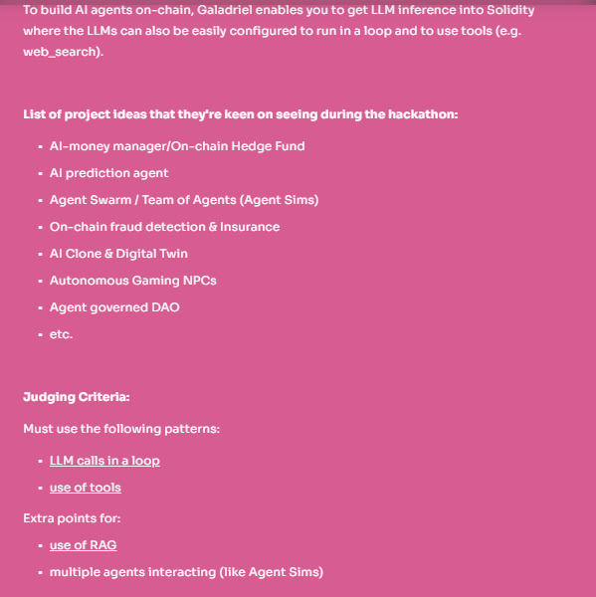

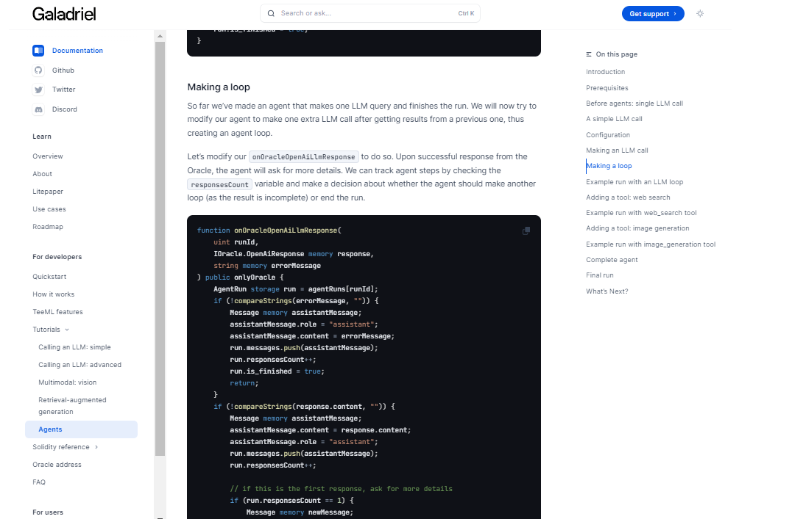

Reorganizing along these lines, the suggestions are

Narrative Form: of the simplified version

Document purpose and overview.

This document provides guidance to a user of the ACTUS demonstrations:

• Sample ACTUS contract cashflows – hEps://demo.actusfrf.org

• ACTUS portfolio analysis with interest rate risk scenarios-hEps://dadfir3.shinyapps.io/DaDFiR3demo

Sample ACTUS contract cashflows demo -- a companion user guide

The purpose of the demonstration is to show the actual cash flows generated by ACTUS for different contract types and run risk analysis simulations. More information can be found in the demo site.

Click on - hEps://demo.actusfrf.org

Or go to <https://www.actusfrf.org/> and click on Demo app

Steps in working this demo: For any details of the steps and explanations the details can be found in the detailed reference guide. ( A link to the original user guide as a reference manual - anchored to specific sections ).

1. Point a browser at hEps://demo.actusfrf.org to start the demo

o This will bring up a list of contract types

1. Select and click on the contract type name (e.g. ANN, PAM etc ) of particular contract type

box for which you would like to run and display the results of ACTUS contract simulations

o This will bring up a display with:

* a title bar labelled “DEMO CASE”
* underneath that, a bar with a short description of the contract type you selected
* underneath that, input areas for mandatory and optional terms of the contract.

1. Click on the “DEMO CASE” title bar

o This will trigger a display of available preloaded sample contracts each with its case

name and a short text description of that sample contract.

BUT the above will only happen of the contract type you initially selected is in the set : { ANN, LAX, FXOUT, LAM, NAM, SWPPV, PAM, STK, SWAPS }. For detailed description of the acronym visit data dictionary on Actus homepage.

1. After clicking demo case just hit the send button. A tabular and graphical representation will be displayed on screen.
2. To return to the start of the demo from any display with the ACTUS logo in the top left , just click on the A of the ACTUS (overlaid with a grid of squares). This will bring up the opening display of the demo with a list of available contract types.

Portfolio analysis for interest rate scenarios – a companion user guide For any details of the steps and explanations the details can be found in the detailed reference guide. ( A link to the original user guide as a reference manual - anchored to specific sections ).

This demo is started EITHER by pointing a browser to hEps://dadfir3.shinyapps.io/DaDFiR3demo or

by installing a standalone workstation instance of the server and demo following the instructions in

hEps://github.com/actusfrf/actus-userguides/blob/main/ACTUS-Rshiny-demo/UserGuide.md

Steps in working this demo:

**1**. The demo comes up in a display with five tabs in the title bar:

o Interest Rate Scenarios

o Loan Contract cashflow

o Portfolio analysis

o Uploaded Portfolio Analysis

o Help

**2**. ‘Help’ is logically the first tab to open

o This tab provides a short description of the content of the other tabs

o If you are using the – on local workstation – version of the ACTUS-Rshiny-demo,

there is an option to configure it to work either with the remote ACTUS server at

hEps://demo.actusfrf.org:8080/ or to a local ACTUS service typically at

hEp://host.docker.internal:8083/

o If you are using the -on Rshiny cloud – version of the ACTUS-RShiny-demo, it is

always configured to use the ACTUS server at hEps://demo.actusfrf.org:8080/ and

there is no option to change this.

**3**. The ‘Interest Rate Scenarios’ tab displays the market risk scenario data available in the demo

o Clicking on the ‘Choose a dataset’ dropdown allows you to select a different

interest rate scenario from:

(1) steady rates

(2) decreasing rates

(3) recovering rates

(4) increasing rates

o In each case a plot of interest rates over time is shown: the y-axis is %pa interest

rate; the x-axis is date.

o Since this particular demo was developed in Sep 2022, the rates shows before that

date are historical rates. The plots for all four scenarios are identical up until that

date.

**4**. The ‘Loan Contract Cashflow’ tab displays the computed cashflows for one ACTUS contract

o The terms of the ACTUS contract being simulated are shown in the leP side of the

display.

You can select (1) a PAM or an ANN contract type, (2) an issue date, (3) a maturity,

(4) a loan amount, (5) a starting (or fixed) interest rate, (6) a payment frequency, (7)

a Rate Reset Frequency (setting this = ‘Fixed Rate’ implies no Rate Resetting), (8)

the rate reset spread and (9) the interest Scenario.

**5**. The ‘Portfolio Analysis’ tab will report on the income and liquidity over time of a portfolio of

ACTUS contracts.

o In the left side of the display it is possible to select (1) either a portfolio of PAM or a

portfolio of ANN contracts, (2) the type of analysis to perform and display and (3)

the (Interest rate ) risk factor scenario to use for this report.

**6**. The ‘Uploaded Portfolio Analysis’ allows you to upload a portfolio of ACTUS contracts from

your workstation and perform the same analyses as in the ‘Portfolio Analysis’ tab

o The format of the uploaded files must match the format of the example files

AnnuityPorHolio.csv and BondPorHolio.csv. Mixed files with both PAM and ANN

contracts are of course permitted.

o Click on the ‘Browse’ button. It will open a window to allow you to select a file on

your workstation. Clicking on ‘open’ will then (up)load that portfolio into the demo.

If the file is a correctly formatted csv file of ACTUS contracts, the analysis selected

by the current choices for analysis type and Risk factor scenario will be performed

and displayed.

**Attached is first cut layout of the above suggestions in a mockup**

