Core of data analysis

Report

team: Car sales

members:
Melnikov Artem
Smirnov Aleksandr

Section 1.

Dataset: Used cars scraped from Ebay Kleinanzeigen

Link: https://www.kaggle.com/orgesleka/used-cars-database

Metadata:
- price : the price on the ad to sell the car
- yearOfRegistration : at which year the car was first registered
- gearbox : {manuell,automatik}
- powerPS : power of the car in PS
- kilometer : how many kilometers the car has driven
- fueltype : {benzin, diesel}
- brand
- vehicleType : {andere, bus, cabrio, coupe, kleinwagen, kombi, limousine, suv}

This dataset was chosen because of its rather full information about different cars and their prices.

Assignment 2
- Reasonably select several features in your dataset
- Apply K-Means at two or three different K
- Take a clustering of your liking and interpret all the clusters by comparing their centers with grand mean
- Answer this question in your report: is it an interesting partition?

Selected features: powerPS, price.

First of all it is better to standartize our data by extracting mean number and dividing by its std.

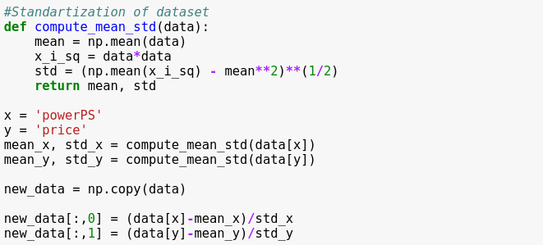
Then apply K-means at several K.
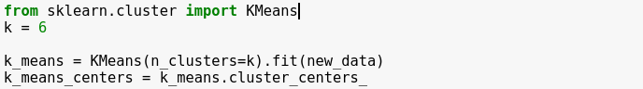
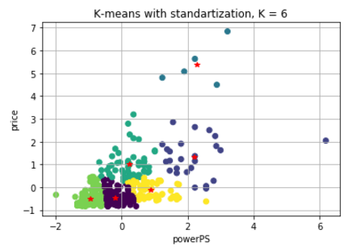
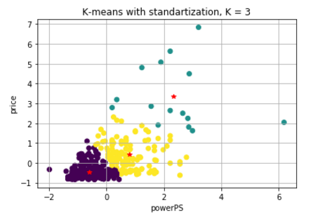

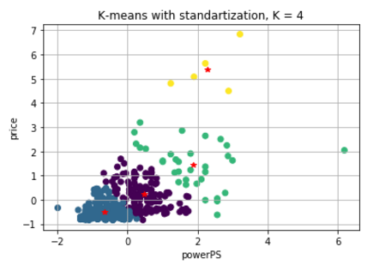

The most interesting clustering came out when K=4.
Compute grand mean.
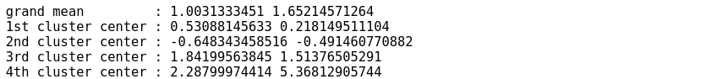

Assignment 3
- Reasonably select two clusters in the clustering you dealt with in HW2
- Take one of the features at one of the clusters and validate its within-cluster mean using bootstrap
- Take one more cluster and compare the within-cluster means of the feature by using bootstrap

Lets select blue and green clusters from HW2 when K=4 and validate their within-cluster mean, using bootstrap.
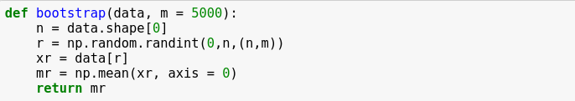
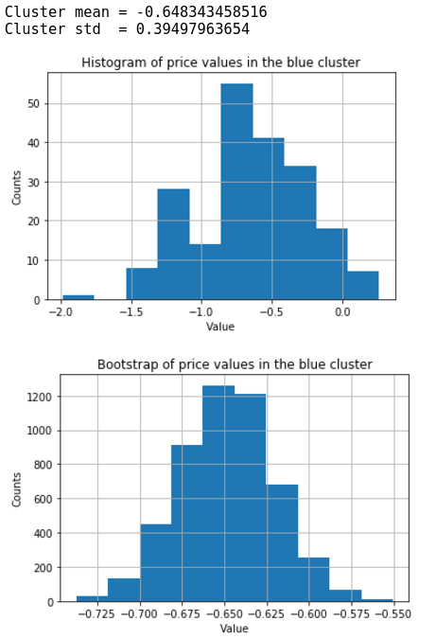
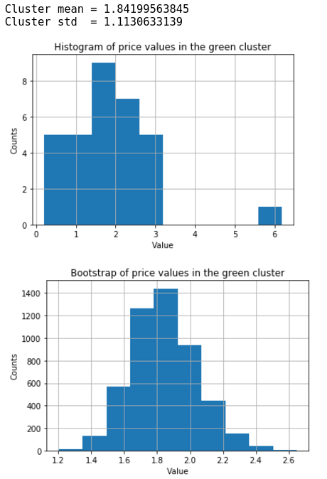
Assignment 6
- Find two features in your dataset with more or less “linear-like” scatterplot.
- Display the scatter-plot.
- Build a linear regression of one of them over the other. Make a comment on the meaning of the slope.
- Find the correlation and determinacy coefficients, and comment on the meaning of the latter.
- Make a prediction of the target value, given two or three predictor’ values; make a comment
- Compare the relative absolute error of the regression on all points of your set and the determinacy coefficient and make comments

Selected features: yearOfRegistration, price.
Firstly, lets divide prices by 100, to get more accurate plot.
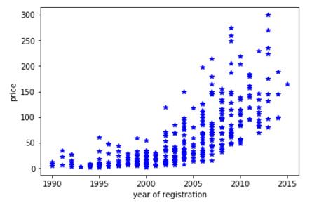

Compute slope:
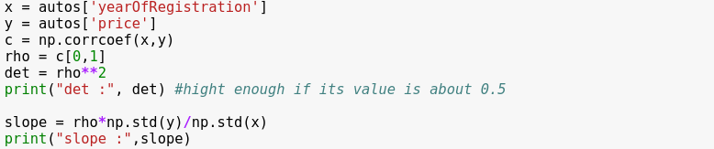
correlation coefficient : [[ 1. 0.70177415]
[ 0.70177415 1. ]]

determinacy coefficient : 0.492486951524
slope : 7.25854188734

Slope equals to 7.26, this means that with every year car falls in price by 726 euros.

Visualisation of prediction over X.
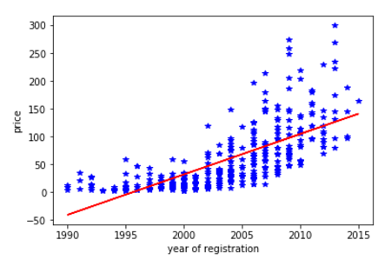

Test for the errors at predictions:
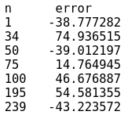

Compute relative absolute error of the regression on all points of the set
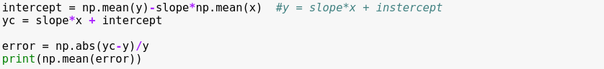
relative absolute error : 1.2158537247

