1.分别使用向前、向后、中心差分对风场求散度，结果输出至文件，并将结果使用mathlab画出图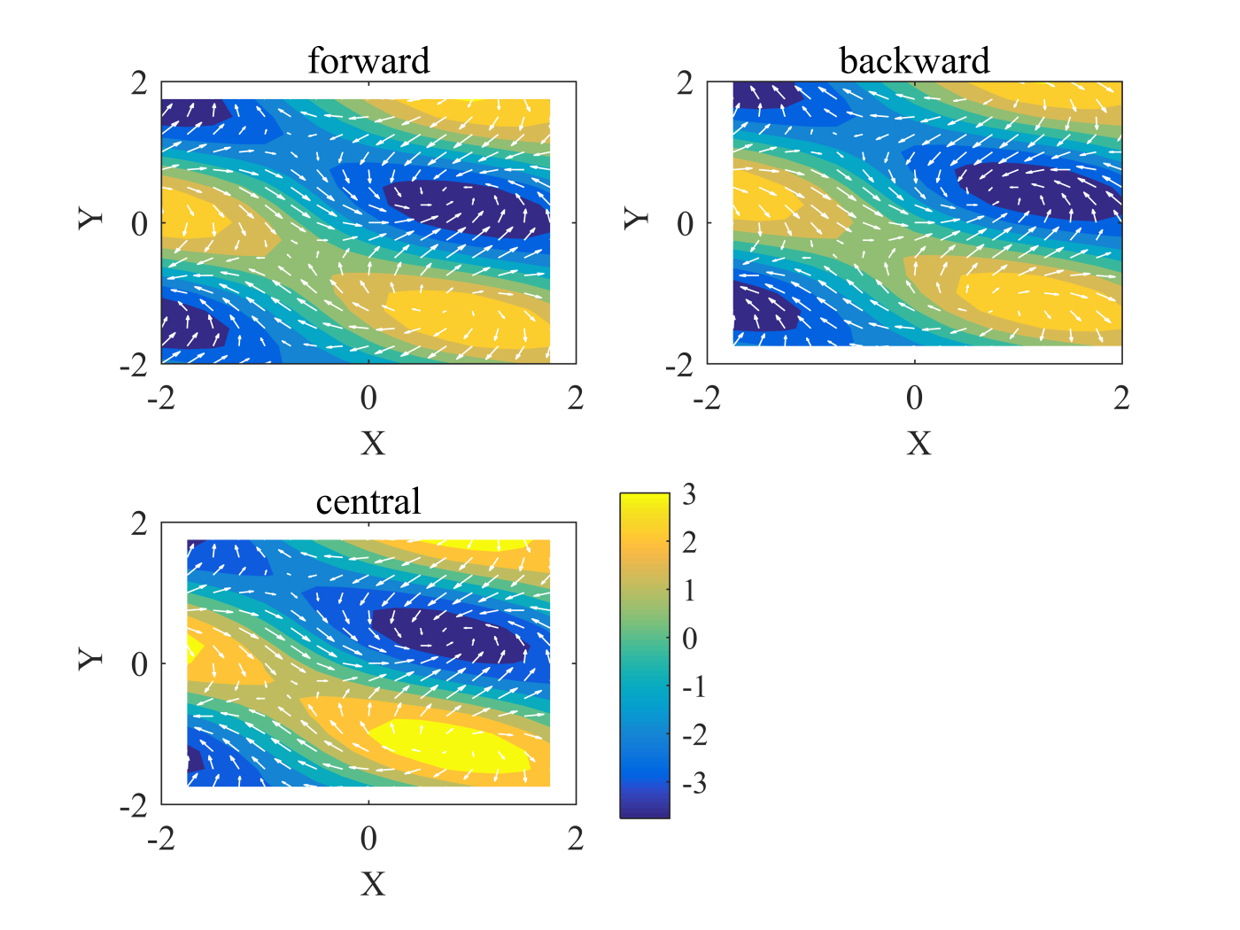

2.对杆上的一维扩散方程进行差分，最终求出杆上的温度分布

一维扩散方程为抛物型差分方程，所用格式为下



结果输出至文件，使用excel表格画出图

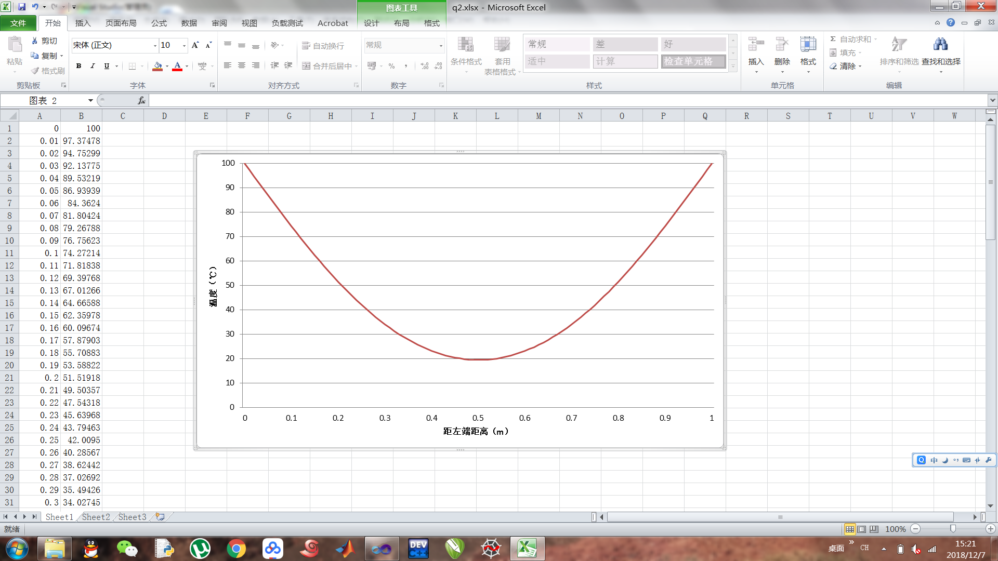

流程图如下：

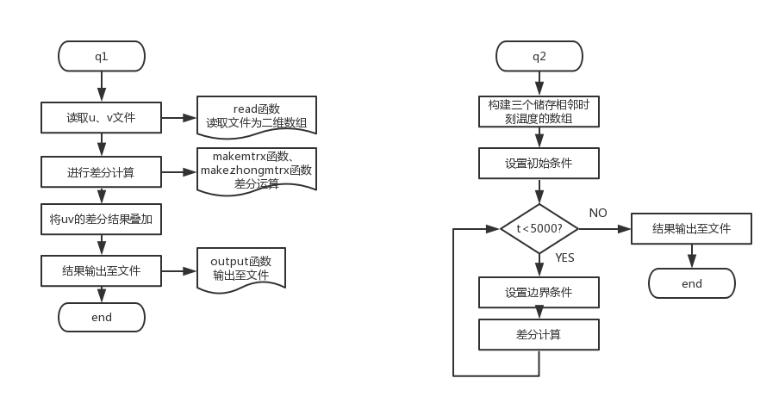

两题所用C语言代码如下:

#include<stdio.h>

#include<stdlib.h>

#define dxy 0.25

#define N 16

double qian(double q,double h)

{

double ans = 0;

ans = (h - q) / dxy;

return ans;

}

double zhong(double q,double h)

{

double ans = 0;

ans = (h - q) / dxy / 2;

return ans;

}

double **makemtrx(double **p,int n)

{

double **ans = (double**)malloc(n*sizeof(double*));

int i,j;

for(i = 0;i < n;i++)

{

ans[i] = (double*)malloc(n*sizeof(double));

}

for(i = 0;i < n;i++)

{

for(j = 0;j < n;j++)

{

ans[i][j] = qian(p[i][j],p[i+1][j]);

}

}

for(i = 0;i < n;i++)

{

for(j = 0;j < n;j++)

{

ans[i][j] += qian(p[i][j],p[i][j+1]);

}

}

return ans;

}

double **makezhongmtrx(double **p,int n)

{

n -= 1;

double **ans = (double**)malloc(n*sizeof(double*));

int i,j;

for(i = 0;i < n;i++)

{

ans[i] = (double*)malloc(n*sizeof(double));

}

n+=1;

for(i = 1;i < n;i++)

{

for(j = 1;j < n;j++)

{

ans[i-1][j-1] = zhong(p[i-1][j],p[i+1][j]);

}

}

for(i = 1;i < n;i++)

{

for(j = 1;j < n;j++)

{

ans[i-1][j-1] += zhong(p[i][j-1],p[i][j+1]);

}

}

return ans;

}

double **read(FILE *fp,int n)

{

n += 1;

double **ans = (double**)malloc(n*sizeof(double*));;

int i,j;

for(i = 0;i < n;i++)

{

ans[i] = (double*)malloc(n*sizeof(double));

}

for (i = 0; i < n; i++)

{

for(j = 0;j < n;j++)

{

fscanf(fp,"%lf\t",&ans[i][j]);

}

}

fclose(fp);

return ans;

}

void output(double **r,FILE *fp,int n)

{

int i,j;

for(i = 0;i < n;i++)

{

for(j = 0 ;j < n;j++)

{

fprintf(fp,"%lf\t",r[i][j]);

}

fprintf(fp,"\n");

}

fclose(fp);

}

void q1()

{

int i,j;

double **pu = NULL,**pv = NULL;

double **result1 = NULL,**result2 = NULL;

FILE *fp = NULL;

fp = fopen("D:\\numerical\\7\\v.txt", "r");

pv = read(fp,N);

fp = fopen("D:\\numerical\\7\\u.txt", "r");

pu = read(fp,N);

result1 = makemtrx(pu,N);

result2 = makemtrx(pv,N);

for(i = 0;i < N;i++)

{

for(j=0;j<N;j++)

{

result1[i][j] += result2[i][j];

}

}

fp = fopen("D:\\numerical\\7\\ouv.txt", "w+");

output(result1,fp,N);

result1 = makezhongmtrx(pu,N);

result2 = makezhongmtrx(pv,N);

for(i = 0;i < N-1;i++)

{

for(j=0;j<N-1;j++)

{

result1[i][j] += result2[i][j];

}

}

fp = fopen("D:\\numerical\\7\\ozuv.txt", "w+");

output(result1,fp,N-1);

}

void q2()

{

int t=0,i,j;

double *p1,*p2,*p3=NULL;

p1 = (double*)malloc(101*sizeof(double));

p2 = (double*)malloc(101*sizeof(double));

p3 = (double*)malloc(101*sizeof(double));

p1[0]=50,p1[100]=50;

for(i=1;i<100;i++)

{

p1[i]=0;

p2[i]=0;

}

for(;t<5000;t++)

{

for(i=1;i < 100;i++)

{

for(j=0;j<101;j++)

{

p3[j] = p2[j];

}

p2[0]=100,p2[100]=100;

p2[i] = (p2[i+1] + p2[i-1])/12 + p1[i]/1.2;

p1 = p3;

}

}

FILE *fp;

fp = fopen("D:\\numerical\\7\\q2.txt", "w+");

for(i=0;i<101;i++)

{

fprintf(fp,"%lf\n",p3[i]);

}

fclose(fp);

}

int main()

{

q1();

q2();

}

第一题所用matlab绘图代码如下：

clear all;close all;clc

file_u = 'D:\numerical\7\u.xls';

file_v = 'D:\numerical\7\v.xls';

data_u = importdata(file_u);

data_v = importdata(file_v);

u = data_u(2:18,2:18);

v = data_v(2:18,2:18);

scale = 0.8;

filef = 'D:\numerical\7\ouy.xlsx';

fileb = 'D:\numerical\7\ouy.xlsx';

filec = 'D:\numerical\7\ozuv.xlsx';

DIV_F = importdata(filef);

DIV_B = importdata(fileb);

DIV_C = importdata(filec);

DIV_C = DIV_C.Sheet1;

DIV_F = DIV_F.Sheet1;

DIV_B = DIV_B.Sheet1;

figure(4)

subplot(2,2,1)

x = linspace(-2,2,17);

y = linspace(-2,2,17);

contourf(x(1:16),y(1:16),DIV_F,'linestyle','none')

hold on

quiver(x,y,u,v,scale,'-w');

xlim([min(x),max(x)]);

ylim([min(y),max(y)])

xlabel('\fontsize{12} X');

ylabel('\fontsize{12} Y');

title('forward');

set (gca,'FontName','Times New Roman','FontSize',12);

subplot(2,2,2)

x = linspace(-2,2,17);

y = linspace(-2,2,17);

contourf(x(2:17),y(2:17),DIV_B,'linestyle','none')

hold on

quiver(x,y,u,v,scale,'-w');

xlim([min(x),max(x)]);

ylim([min(y),max(y)])

xlabel('\fontsize{12} X');

ylabel('\fontsize{12} Y');

title('backward');

set (gca,'FontName','Times New Roman','FontSize',12);

subplot(2,2,3)

x = linspace(-2,2,17);

y = linspace(-2,2,17);

contourf(x(2:16),y(2:16),DIV_C,'linestyle','none')

hold on

quiver(x,y,u,v,scale,'-w');

xlim([min(x),max(x)]);

ylim([min(y),max(y)])

xlabel('\fontsize{12} X');

ylabel('\fontsize{12} Y');

title('central');

set (gca,'FontName','Times New Roman','FontSize',12);

hBar = colorbar;

h=get(hBar, 'Position')

set(hBar, 'Position',[0.5 0.12 0.04 0.35])

print('-dpng','-r900','D:\numerical\7\ps7_1_sum.png');