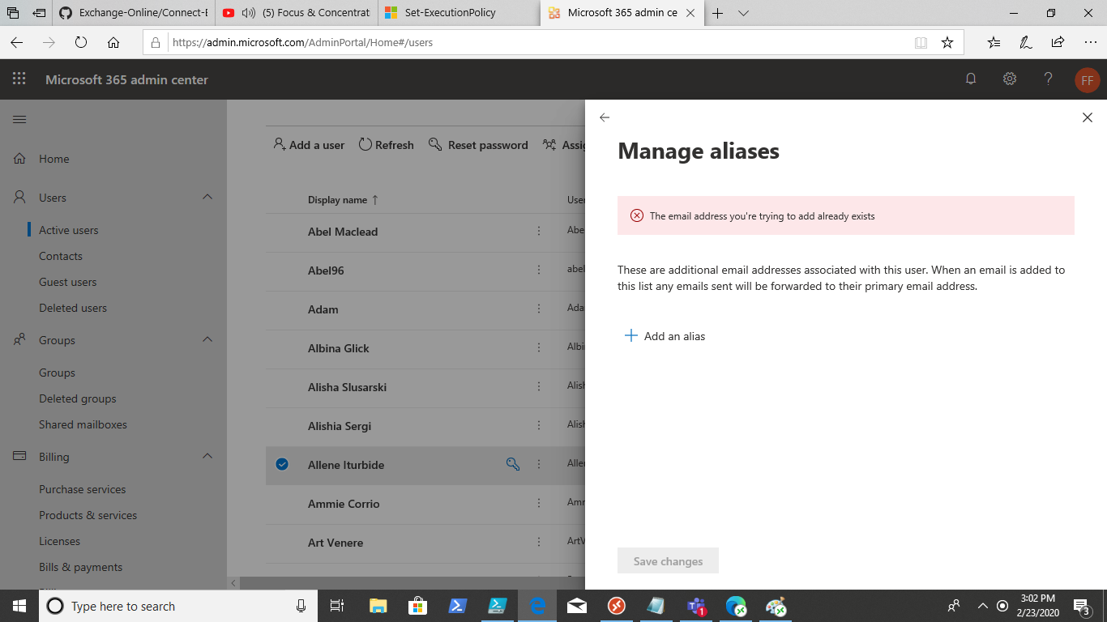

Were going to open a PS session with Exchange, run this command in PS

Step 1) in Alias Companion, just copy and paste it into PowerShell or an ISE, it’s alittle easier to see what’s going on as opposed to just running the script (Which you can’t/shouldn’t try to do)

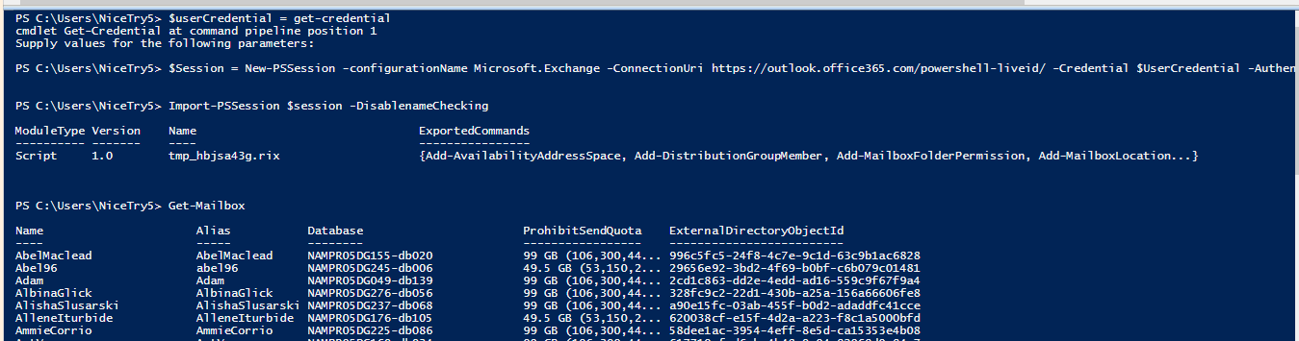

You should get Something looking like this after you connect to exchange.

If you get this error Disconnect-PSsession previous Exchange Sessions, or just enter them it’s easier (shouldn’t happen)

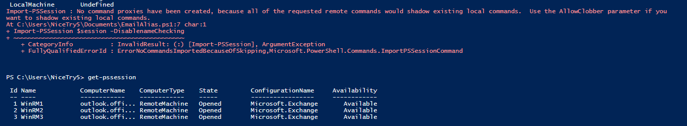

(You need to investigate your remote sessions if you do because you have left sessions open)

Type the alias you are trying to find **This is the alias that office 365 is claiming is assigned that you want assigned to another user**

Step 2) alias companion

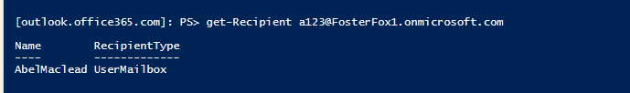

This is another way to see if emails are associated with the alias you want to assign

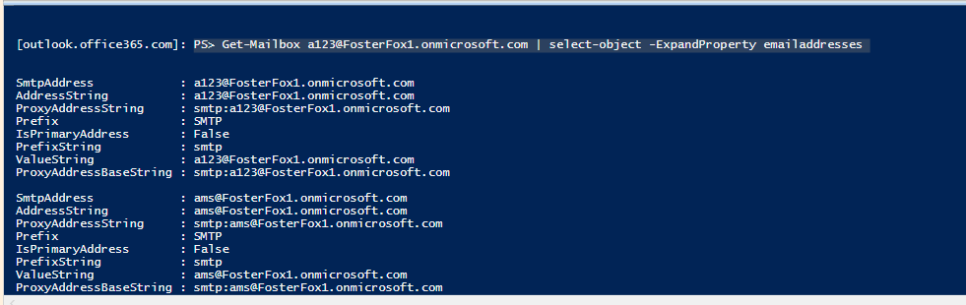

Will be working under the theory that an alias appeared and we will then delete it.

Step 3) Alias Companion

Will delete this alias in PS and then Add the alias in PS. If nothing comes up, will skip to adding the alias

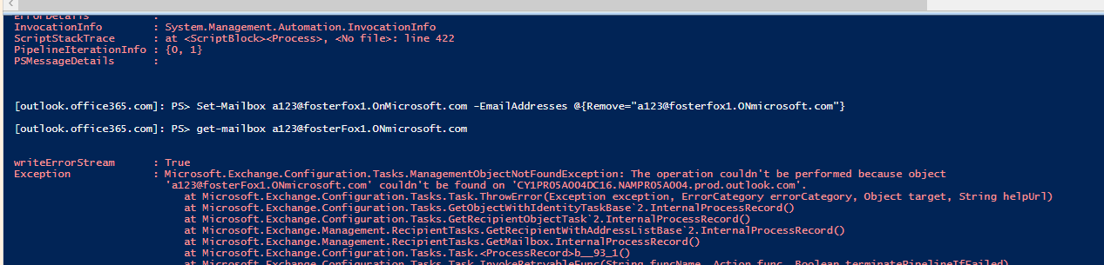

Will Now add ([a123@fosterfox1.onmicrosoft.com](mailto:a123@fosterfox1.onmicrosoft.com)) to a different email

Step 4) alias Companion

