WORKFLOW
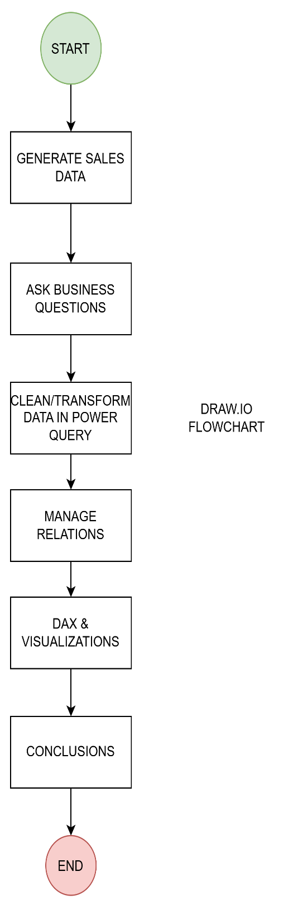

GENERATE SALES DATA

- For this solo learning project I decided to use a Claude AI generated dataset based off of a real Kaggle dataset, the reason behind this is because most datasets on Kaggle only have one sheet (no need to check relations) and are mostly already cleaned which takes away an important part of the Data Analyst role

- The data has flaws just like real world data would(missing values, duplicates…) to simulate real work environment and to test myself

- Some limitations are orders with customers that dont exist, orders without customers, generated(not real) data…
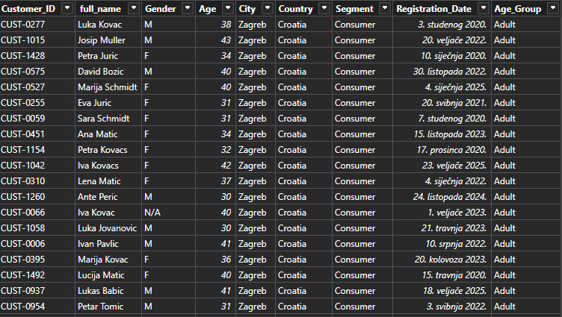

ASK BUSINESS QUESTIONS

Since this is a ecommerce sales dataset, its important to ask questions that will increase total sales, customer satisfaction and of course revenue and profit.
- Where are our customers from?
- What product do we profit from the most?
- What channel is used the most?
- How does payment method distribution look like?
- How do we increase profit?
- Are there products we should remove?
- At which time of the year we have most revenue and sales(so we can make sales, coupons or targeted campaigns)

DATA CLEANING – Power query
- Loaded data into power query from excel
- Removed columns that will not be used
- Trimmed every column from every table
Customers :
Customer_ID –used Uppercase, removed duplicates
Full_name – had a lot of issues with capitalization and format, used capitalize each word, used Split column with delimiter comma, then merged them together so they become a real full name without commas(format was: surname, first name). Realized there is a lot of names where there are more spaces in between used split columns with delimiter space and then merged and deleted the rest, did a trim again just to make sure there is no spaces after the full name
Gender – Used replace values to make sure only three values are M, F and N/A.
Age – Used split columns to get rid of text, converted N/A to null, converted to numeric value
City – Used Capitalize each word, replace value so every city has only one name, else was turned into N/A
Country – Used Capitalize each word, replace value so every country has only one name, else was turned into N/A
Segment – capitalize each word
Registration_Date – converted to Date type
Order_Items:
Line_ID – Removed duplicates(trimming was the first step)
Order_ID – used Uppercase for future data loads
Order_Date – converted to Date type
Product_ID – used Uppercase
Quantity – used split columns to remove text, converted N/A to null, converted everything to numeric value type and then did number filter
Unit_Price – Removed the step that converted its data type, converted N/A to null, removed text with split columns, converted to decimal
Discount_Pct – Converted to decimal value
Did merge querys because a lot of product IDs don’t actually exist in the product table

Suppliers:
Country – used capitalize each word
Orders:
Order_ID – Uppercase and used remove duplicates
Customer_ID – Uppercase
Sales_Channel – Capitalize each word
Payment_Method – Capitalize each word, cod Cash On Delivery
Order_Status – Capitalize each word, Canceled Cancelled
Shipping_Method – Capitalize each word
Shipping_Cost – split columns to get rid of text, converted to decimal value, converted negative values to null
Return_Reason – null Did not return
Coupon_Code – Uppercase
Customer_Rating – converted to whole number, replaced impossible values

Products:
Category – Capitalize each word
Brand – Capitalize each word
Supplier – Capitalize each word, replace so there are only six suppliers that are listed in the Supplier table, Adria Trade had to be split and removed and then merged again
Unit_Price – Split columns to remove text, converted to decimal
Product_Cost – replaced N/A to null and converted it into decimal number
Product_Rating – N/A into null, converted to decimal

MANAGE RELATIONS
- Now that we don’t have duplicates we can create relationships between tables
Customers 1-------* Orders (customer can have many orders, orders are made by 1 customer)
Order_Items *------1 Orders (Order items are in one order, one order has multiple order_items)
Order_Items *----1 Products(Order items have one product, one product can be in multiple order items
- Figured the problem that caused many-many link between Order_Items and Products and fixed it(Products had duplicate Product_IDs)
Supplier 1-----* Products (Supplier can have many products, one product has only one supplier)
Also later on added Calendar 1-------*Orders
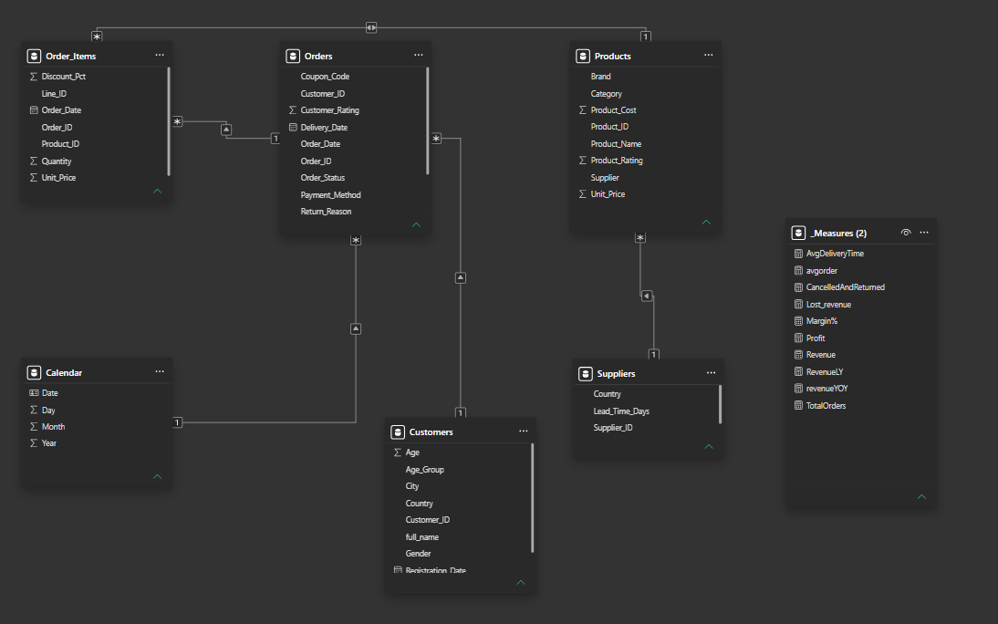

DAX & VISUALIZATIONS

USED MEASURES:
avgorder = AVERAGEX(Orders, [Revenue])
- Calculates the average order revenue
CancelledAndReturned = CALCULATE(DISTINCTCOUNT(Orders[Order_ID]), Orders[Order_Status]<>"Completed")

- Calculates the number of cancelled and returned orders
Lost_revenue = CALCULATE(SUMX(Order_Items, Order_Items[Unit_Price]*Order_Items[Quantity]*(1-Order_Items[Discount_Pct])),Orders[Order_Status] <> "Completed")
- Calculates how much revenue is the company losing with cancelled or returned orders
Margin% = DIVIDE([Profit],[Revenue])
- Calculates the margin percentage
Profit = CALCULATE(SUMX(Order_Items, (Order_Items[Quantity] * Order_Items[Unit_Price] * (1- Order_Items[Discount_Pct])) - (Order_Items[Quantity]* RELATED(Products[Product_Cost]))), Orders[Order_Status] = "Completed")
- Calculates the profit
Revenue = CALCULATE( SUMX(Order_Items,Order_Items[Quantity]*Order_Items[Unit_Price]*(1-Order_Items[Discount_Pct])),Orders[Order_Status] = "Completed")
- Calculates the revenue
RevenueLY = CALCULATE([Revenue], SAMEPERIODLASTYEAR('Calendar'[Date]))
- Calculates the revenue last year
revenueYOY = DIVIDE([Revenue] - [RevenueLY], [RevenueLY])
- Calculates the revenue year over year
TotalOrders = DISTINCTCOUNT(Orders[Order_ID])
- Calculates total orders(including cancelled and returned)

- This project consists of three PowerBI sheets, The main dashboard, Country drill down and Supplier drill down

MAIN DASHBOARD
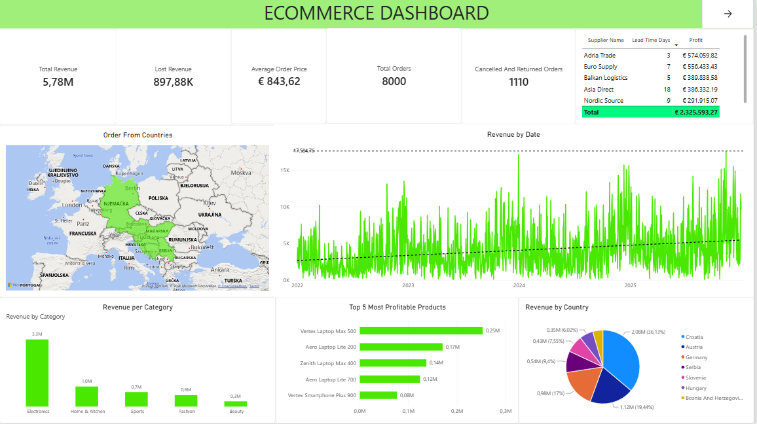

- Shows the overall state of our ecommerce business
- Uses measures like revenue, lost revenue, profit, total orders and so on so we can determine where our buyers are from, which products are doing well, which suppliers bring the most profit, which category to focus on and so we can see revenue over time(I used a date table) and also max revenue and the trend line shows us growth in this case

COUNTRY DRILL DOWN
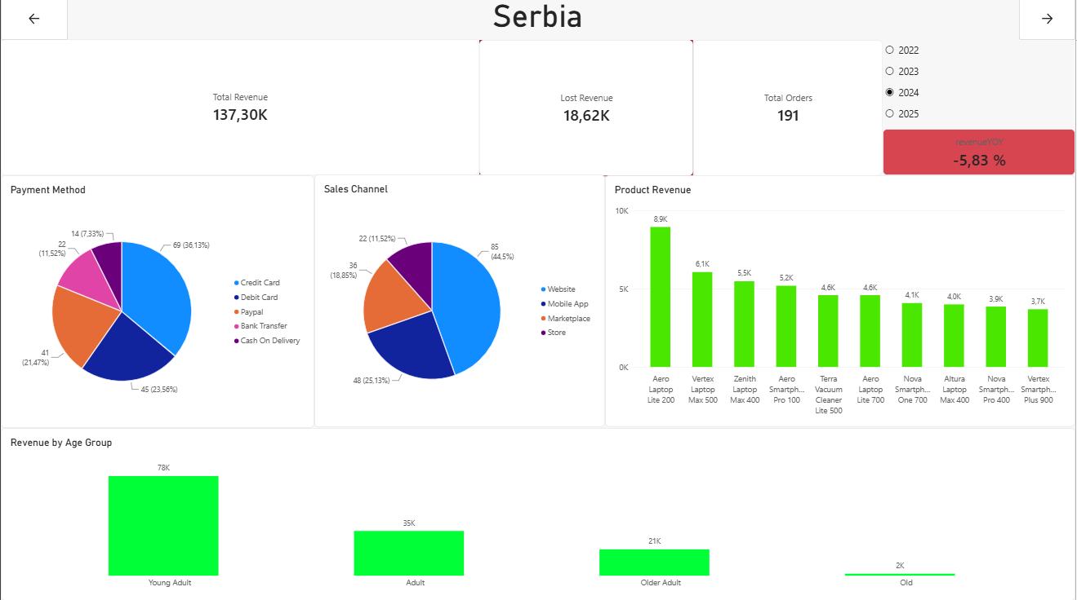

- Focuses more on the country itself
- The main thing is revenue year over year that shows our increase (or decrease) from last year and we can also select the year using the slicer
- We can also see payment method and sales channel distribution, from which age group we get the most revenue and basic KPI’s such as total revenue, lost revenue(cancelled and returned orders) and so on

SUPPLIER DRILL DOWN
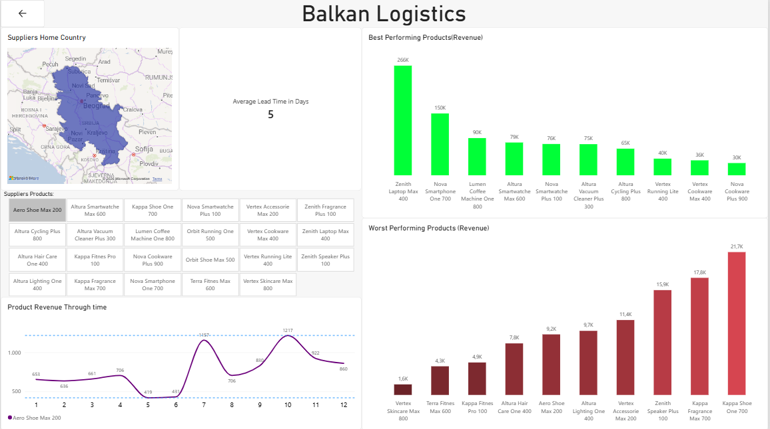

- Focuses on the supplier
- We can see the suppliers home country, average lead days, best performing products from that supplier, worst performing products from that supplier(all sorted by revenue), there is also a slicer that we can use to select a specific product that interacts with the graph below it(Product revenue through time), that shows that specific products revenue over the months

CONCLUSIONS
- From these visualisations we can get help with important business decisions such as: what products to focus on, when to order more of which product, what products to remove or focus less on, on which age group should we focus our marketing campaigns on, what sales channels should we focus more on…
- We can also get insights on our ecommerce business overall and see if we are making or losing money, are we improving our business over the year or not(using YOY revenue)
- If I was the manager of this ecommerce this would show me that I should focus on making marketing campaigns, sales and promo codes around november – january as there is most revenue around that time of year so we can get even more people to buy stuff, those marketing campaigns should be focused more on countries that people already buy from, that we should focus on our most profitable products and maybe make sales specific for those products

ANSWERING THE BUSINESS QUESTIONS:

- Where are our customers from?
- Our customers are from Germany, Austria, Hungary, Slovenia, Croatia, Bosnia and Serbia

- What product do we profit from the most?
- Vertex Laptop Max 500 is our most profitable product

- What sales channel is used the most?
- Across all countries website is the most used sales channel

- How does payment method distribution look like?
- Credit card is the most used payment method across all countries

- How do we increase profit?
- We increase profit by focusing on products that make us the most money(for example Zenith Laptop Max 400 from supplier Balkan Logistics that has the revenue of 266k) and make marketing campaigns at the time of our peak revenue (early and late periods of the year)

- Are there products we should remove?
- From every supplier there is a couple of products that we might consider removing, for example for Balkan Logistics, Vertex Skincare Max 800 only makes 1.6k revenue, Terra Fitness Max 600 only makes 4.3k and so on. It is easy to make that decision when we see data from our top performers from the same supplier, for example Zenith Laptop Max 400 that has the revenue of 266k

- At which time of the year we have most revenue and sales(so we can make sales, coupons or targeted campaigns)
- We have the most revenue at the end of the year and the beginning of the year(november-january), for example our max revenue was 30.12.2024 with 17.5k in a day

REFLECTION
- This project helped me understand business logic and what visualisations I should focus on to make it easy to understand and to answer most asked questions like are we losing or gaining money
- It taught me how to get data(this time only generating it), think what useful insights can I get that management could use from this data, what columns I will not use, cleaning data using power query, writing DAX and creating visualisations that are appealing, easy to understand and not oversaturated

