AROHA Project Report
AI powered skill intelligence and career decision support
Team Syntax Society | SAS Hackathon 2026 | AI and Workforce Analytics
AROHA is a decision-support MVP that turns job-market evidence and an individual profile into a focused recommendation for what to learn next.
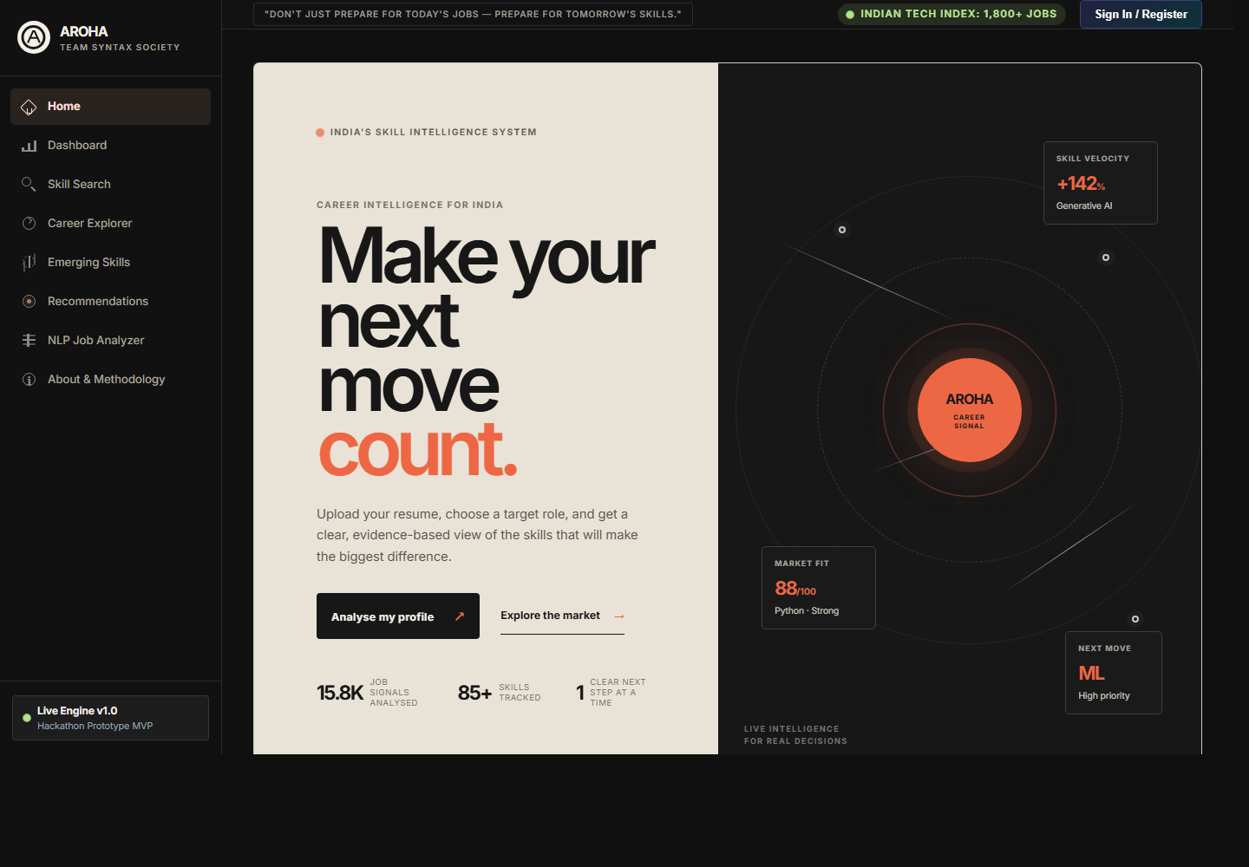
Figure 1. AROHA MVP home screen and career-signal interface.

Project Summary
AROHA addresses a practical career-planning problem: candidates often see job listings and skill lists but cannot determine which capability to prioritise. The MVP combines market evidence, transparent scoring, machine-learning outputs and an individual profile into a single decision flow.
Area | MVP implementation | User value
Skill intelligence | Normalises and analyses job-posting skills | Clarifies what employers are asking for
Role fit | Compares existing skills with target-role requirements | Makes gaps visible and prioritised
Resume import | Reads PDF, DOCX or TXT in memory and extracts indexed skills | Removes manual profile entry
Explainable score | Weights demand, role coverage, salary association and frontier signals | Shows why a skill is recommended
Learning roadmap | Ranks next skills with evidence | Converts analysis into action

Problem and Target User
Students, early-career professionals and placement stakeholders need a credible way to translate fragmented job-market information into a personal plan. Existing job boards show vacancies; AROHA explains the capability signals behind those vacancies and maps them to a target role.
- Candidate: identify the few skills with the strongest potential impact for a target role.
- Placement or educator: understand recurring employer requirements and curriculum gaps.
- Recruiter or workforce planner: inspect market demand, role patterns and salary context.

MVP Demonstration
The implemented MVP is a local web application with a navigable product interface, interactive role and skill exploration, resume upload, recommendation analysis and API-backed data services.
Workflow | What happens | Evidence in MVP
1. Import | User uploads a resume or enters skills | Resume upload accepts PDF, DOCX and TXT files up to 5 MB
2. Extract | Text is parsed in memory and passed to the existing skill extractor | Detected skills are added to the user profile
3. Compare | Profile is compared against a selected career role | Match score, missing core skills and radar chart update
4. Act | Recommendation service ranks next capabilities | Learning roadmap explains what to learn and why

Unique Selling Proposition
The core USP is the bridge from market data to an individual next action. AROHA combines observable hiring evidence with an explainable score and then applies that evidence to a specific user profile. This is more useful than a static demand dashboard and more credible than an unexplained generic recommendation.
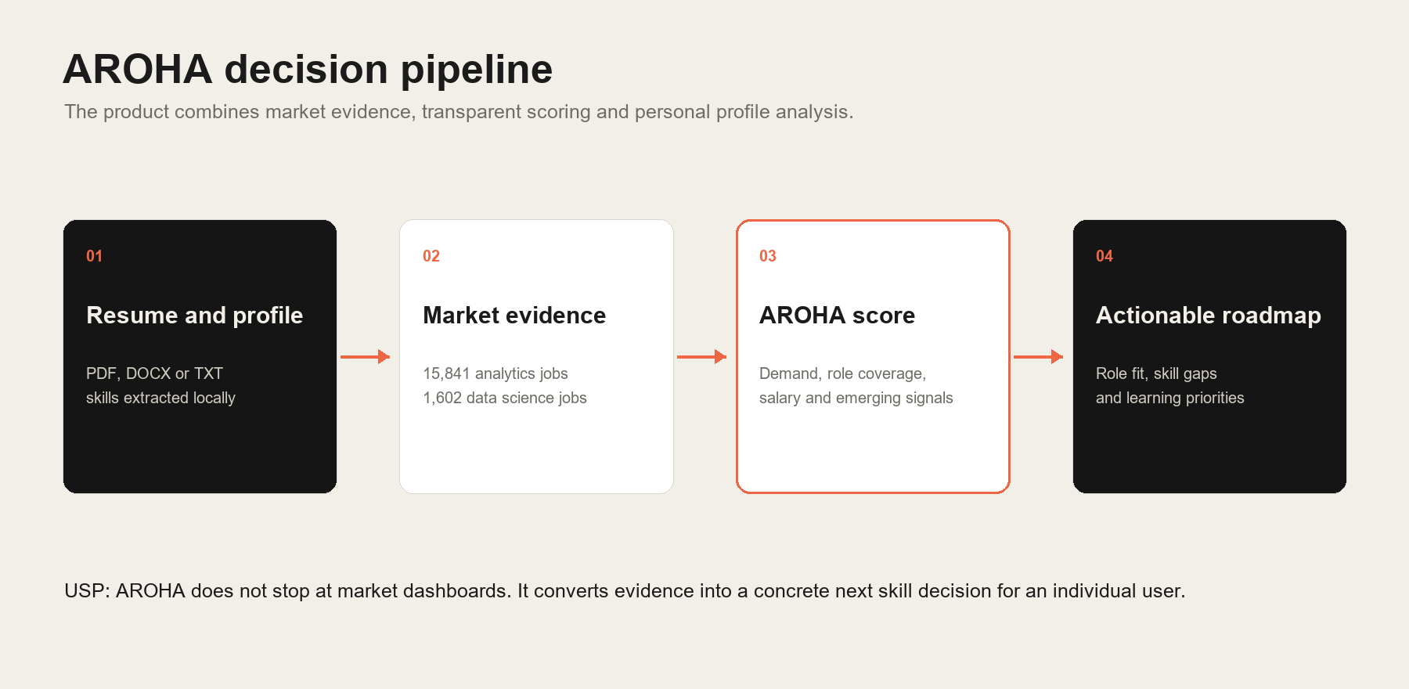
Figure 2. AROHA USP: evidence flows from resume and market data to a specific learning decision.
- Explainable: the score exposes its four component signals and weights.
- Personal: resume extraction removes manual setup and starts from the candidate's actual profile.
- Evidence-based: recommendations are tied to demand, role coverage and salary context.
- Responsible: frontier signals are labelled as analytical indicators rather than fabricated historical facts.

Data and Analytical Method
Dataset | Records | Use in AROHA
Analytics Jobs | 15,841 | Skill frequency, role coverage, location and salary parsing
DataScience Jobs | 1,602 | Employer, role and compensation intelligence
JDS Skill Traits | 139 | Junior salary-hike classification and feature analysis
SDS Personality Traits | 161 | Senior success-classification exploratory model

The AROHA score uses a transparent weighted formula: 35 percent demand, 25 percent role coverage, 25 percent salary association and 15 percent emerging-skill alignment. Salary signals are described as associations, not causal effects.

Implementation Evidence

Explainable Skill Score
The score service explicitly derives its components, applies the documented weights and returns both the score and the underlying empirical metrics. This makes the product result inspectable during a demo.
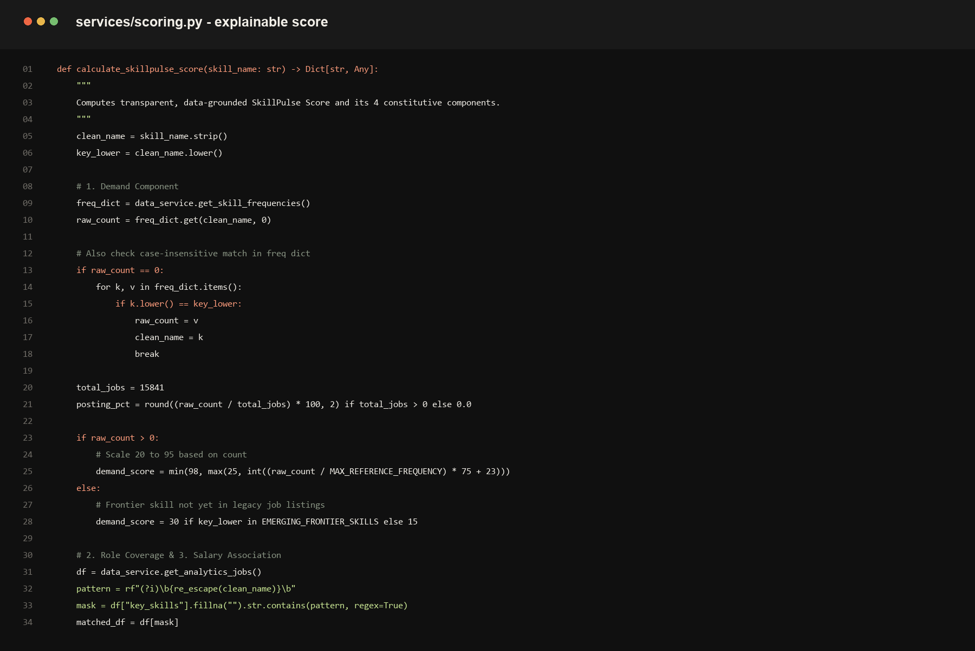
Figure 3. Production code excerpt for the transparent weighted skill score.

Resume Import and Extraction
The API validates file type and size, reads the document in memory, extracts text with format-specific readers, and routes the text through the existing normalisation pipeline. The endpoint does not persist uploaded resumes.
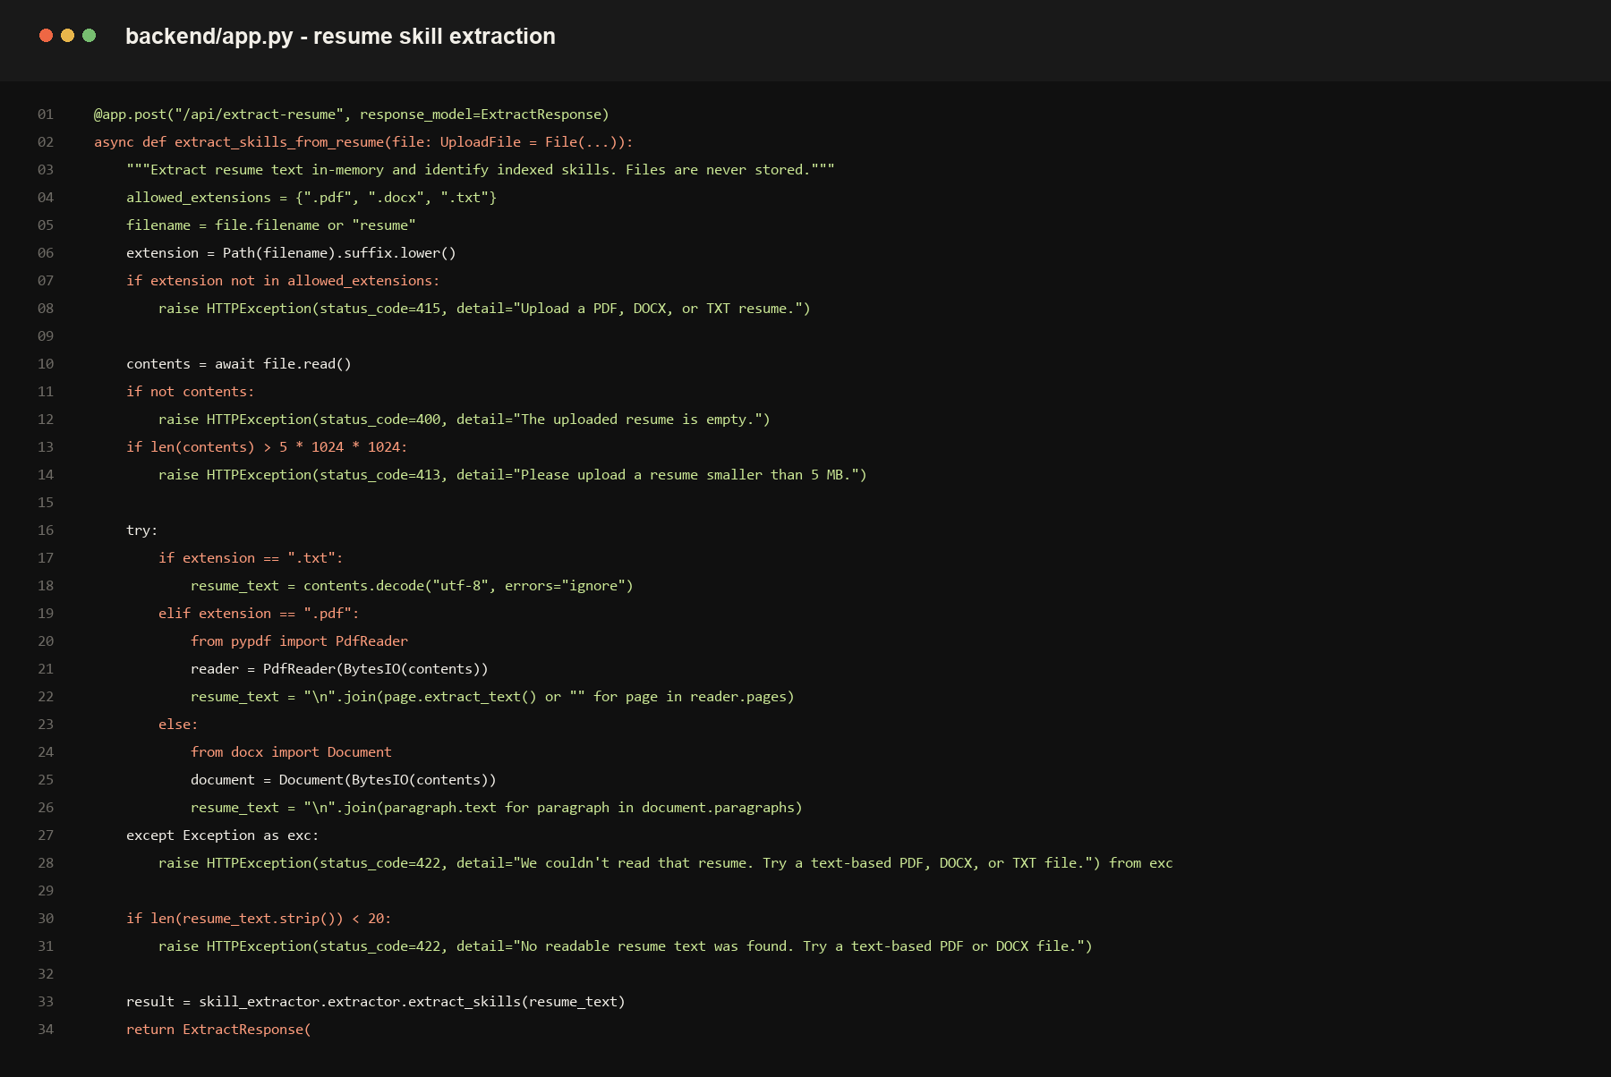
Figure 4. Production code excerpt for secure in-memory resume skill extraction.

Technical Architecture
Layer | Technology | Responsibility
Frontend | HTML, CSS and JavaScript | Interactive AROHA interface, charts, profile flow and resume upload
API | FastAPI and Pydantic | Typed endpoints for analytics, extraction and recommendations
Analytics | Pandas and scikit-learn | Data preparation, market intelligence and predictive models
Storage | SQLite | Local job-market data access
Document parsing | pypdf and python-docx | In-memory PDF, DOCX and TXT skill extraction

Evaluation and Responsible Use
The project includes automated tests for extraction, scoring, analytics, recommendation services and FastAPI endpoints. The documented ML evaluation compares Logistic Regression and Random Forest models, with the Junior Data Scientist model reporting 88.6 percent accuracy and 0.889 F1 for the stated validation split.
- Forecast and frontier signals are shown as indicators, not guarantees.
- Skill and salary relationships are communicated as observational associations.
- Resume files are processed in memory for extraction and are not stored by the endpoint.
- Personality outputs are labelled with ethical limits and are not presented as psychological diagnosis.

Conclusion
AROHA is a complete MVP rather than a static concept: it accepts a user profile, reads a resume, analyses market evidence, identifies role gaps and produces a concrete learning roadmap. Its distinctive strength is the transparent connection between data, model outputs and a user decision.

Feature Catalogue and Screen Evidence
This section documents the complete user-facing MVP. Screens are captured from the running AROHA application at the local product viewport. Each feature is connected to the implementation layer responsible for it.

1. Home
Sets the product context and gives users direct paths to profile analysis or market exploration.
Implementation: frontend/templates/index.html and frontend/static/css/style.css
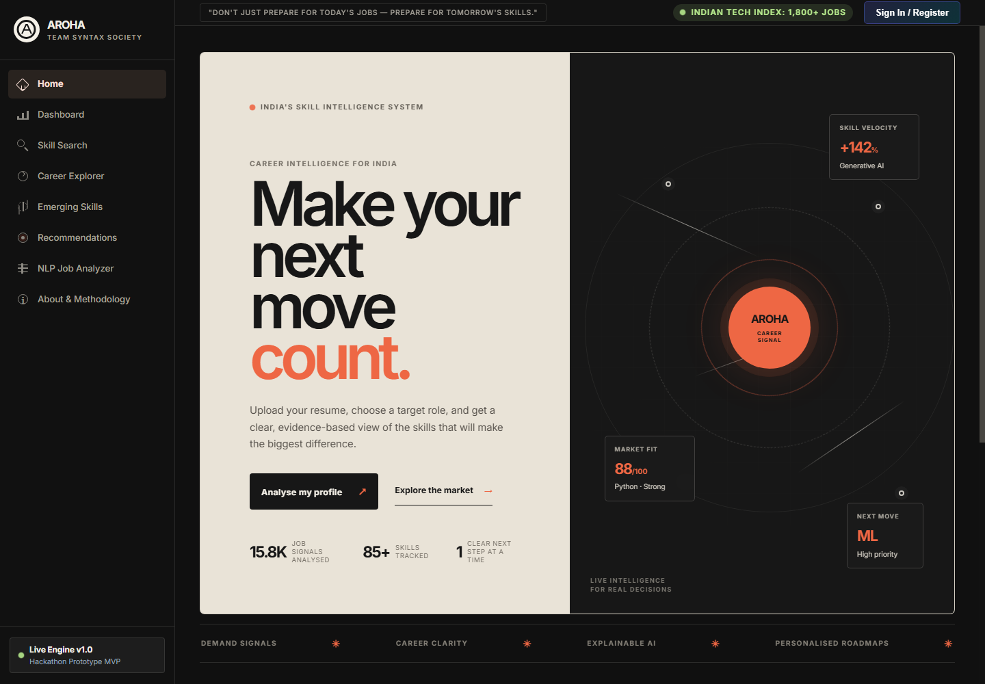
Figure 5. AROHA Home feature screen.

2. Market Dashboard
Presents current job-market signals, in-demand skills and industry spread using API-backed charts.
Implementation: frontend/static/js/app.js and backend/analytics_service.py
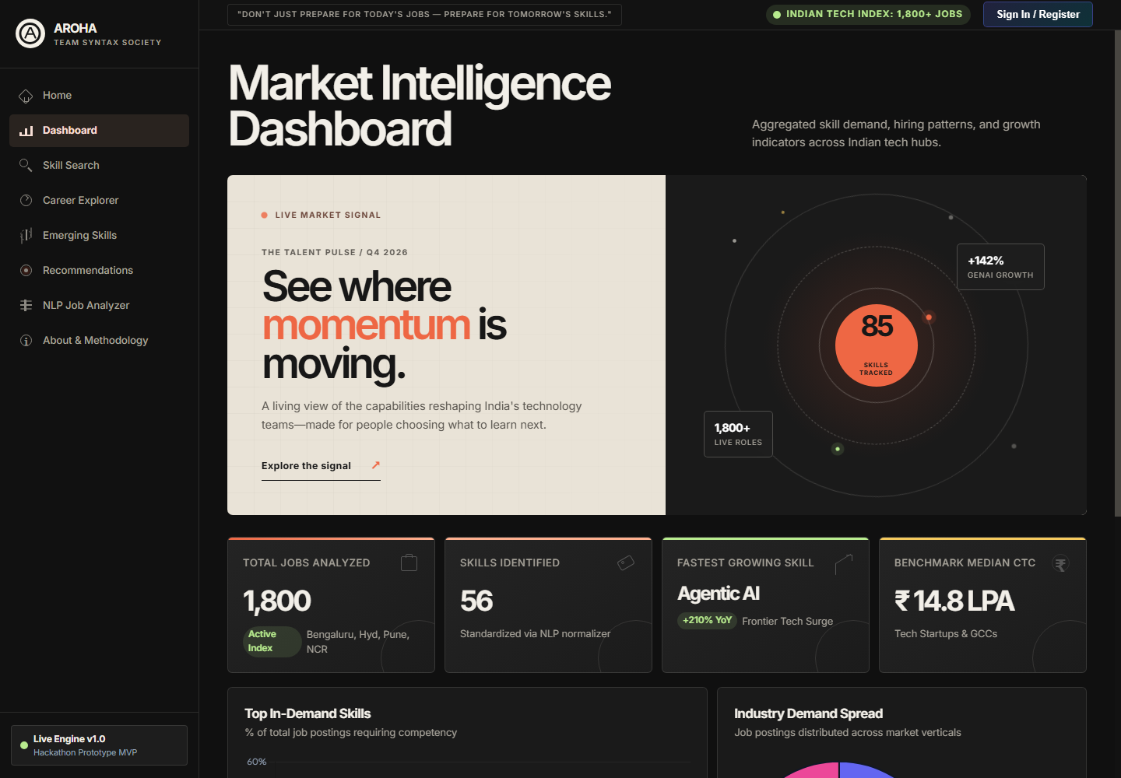
Figure 6. AROHA Market Dashboard feature screen.

3. Skill Search
Lets users inspect demand score, observed job presence, trends, related skills and top industries for a selected technology.
Implementation: frontend/static/js/app.js and backend/analytics_service.py
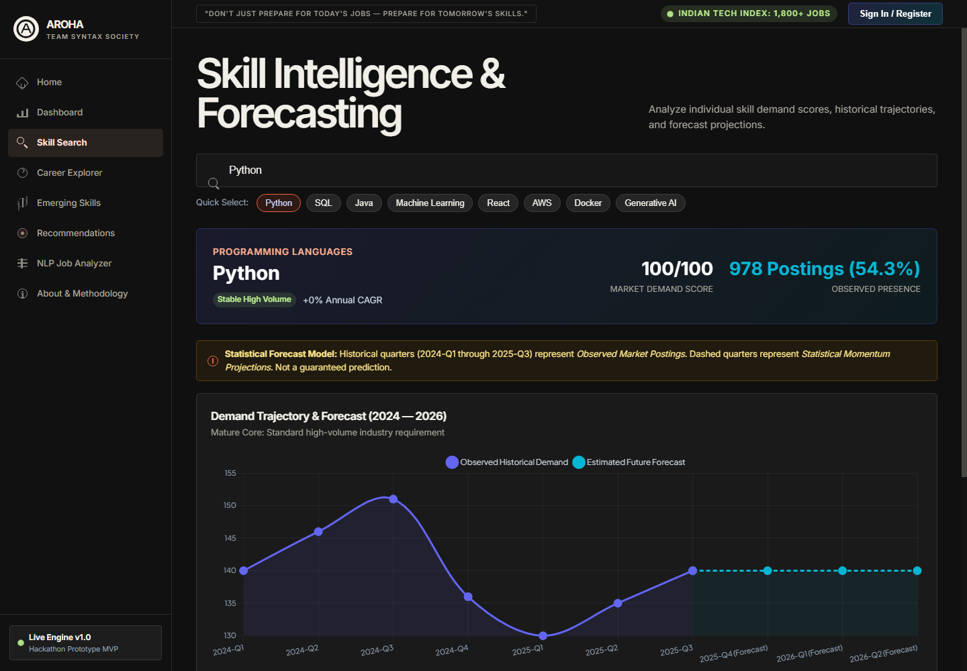
Figure 7. AROHA Skill Search feature screen.

4. Career Explorer
Compares job roles through salary, skills, locations and role-level evidence.
Implementation: frontend/static/js/app.js and backend/analytics_service.py
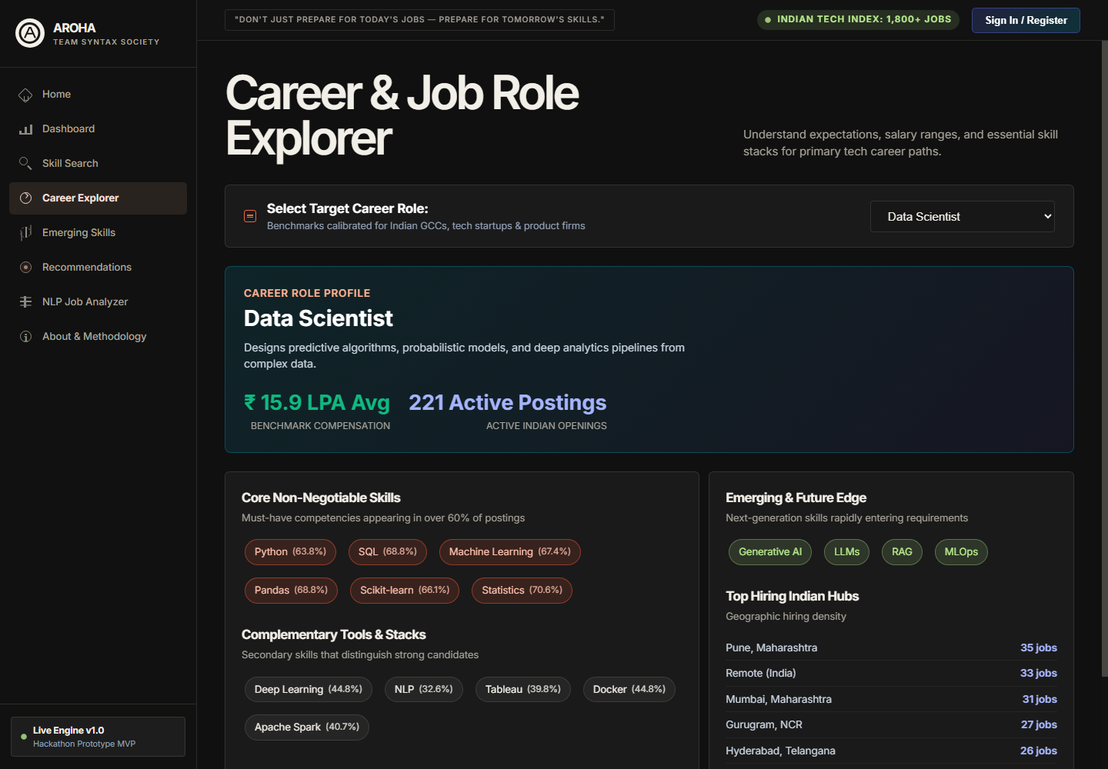
Figure 8. AROHA Career Explorer feature screen.

5. Emerging Skills
Shows frontier capabilities with adoption labels and explicit forecast caveats.
Implementation: backend/analytics_service.py
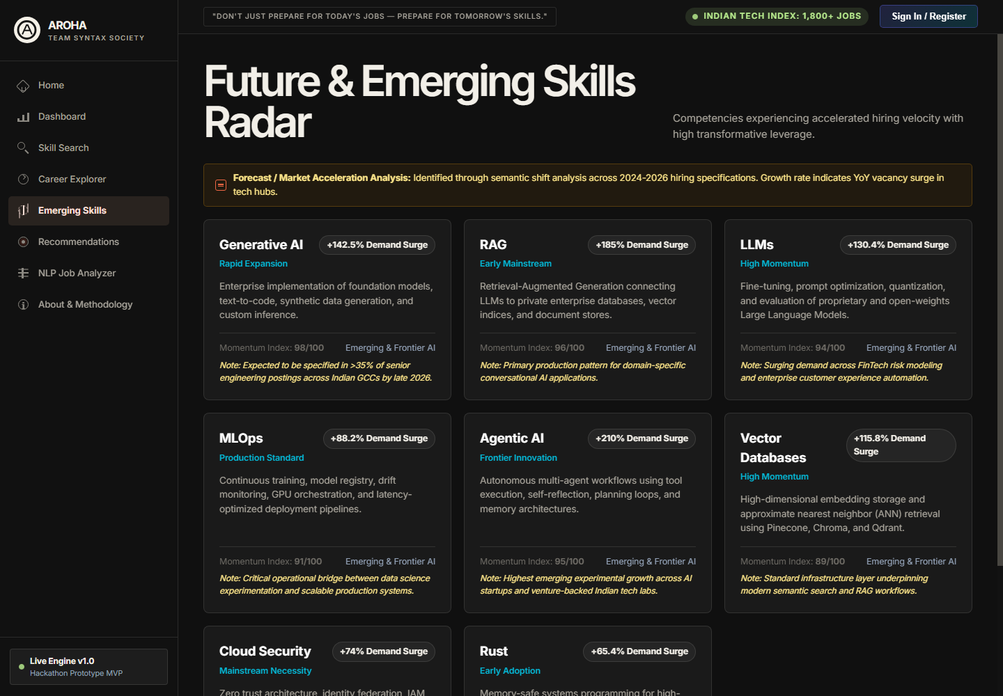
Figure 9. AROHA Emerging Skills feature screen.

6. Skill Gap and Resume Import
Accepts a candidate profile or resume, identifies skills, calculates alignment and returns a structured roadmap.
Implementation: backend/app.py, services/recommender_service.py and frontend/static/js/app.js
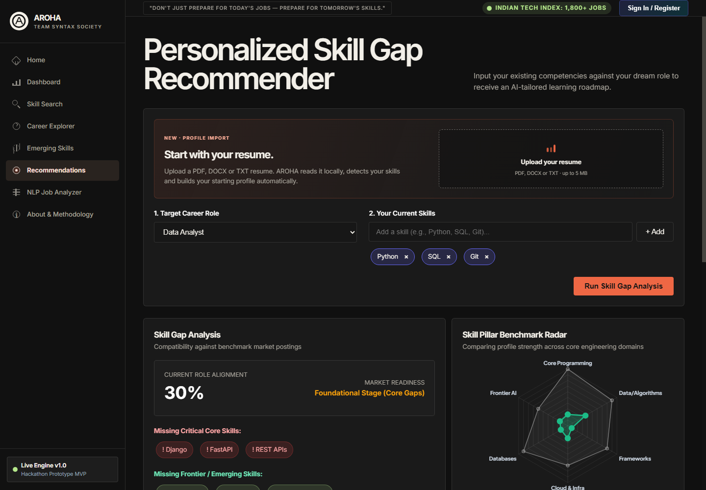
Figure 10. AROHA Skill Gap and Resume Import feature screen.

7. NLP Job Analyzer
Extracts and normalises skills from a pasted job description, then suggests matching roles.
Implementation: services/skill_extractor.py and backend/app.py
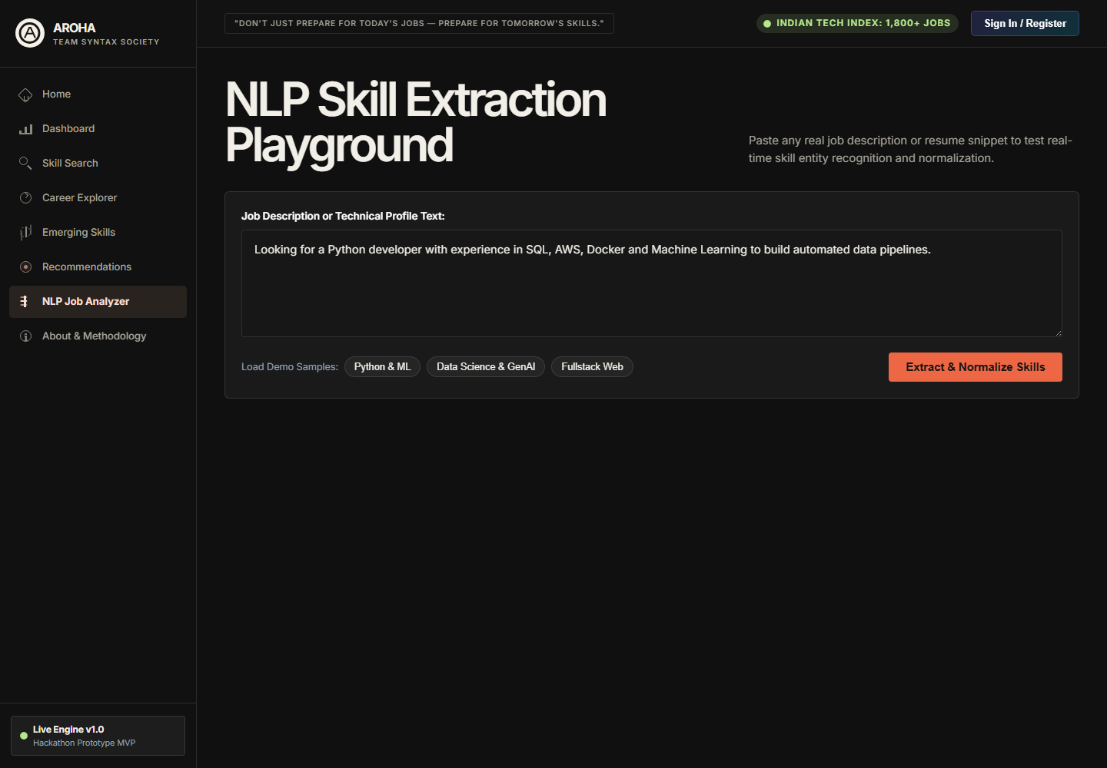
Figure 11. AROHA NLP Job Analyzer feature screen.

8. About and Methodology
Explains source data, analytical scope and the project methodology for judges and stakeholders.
Implementation: frontend/templates/index.html and services/data_service.py
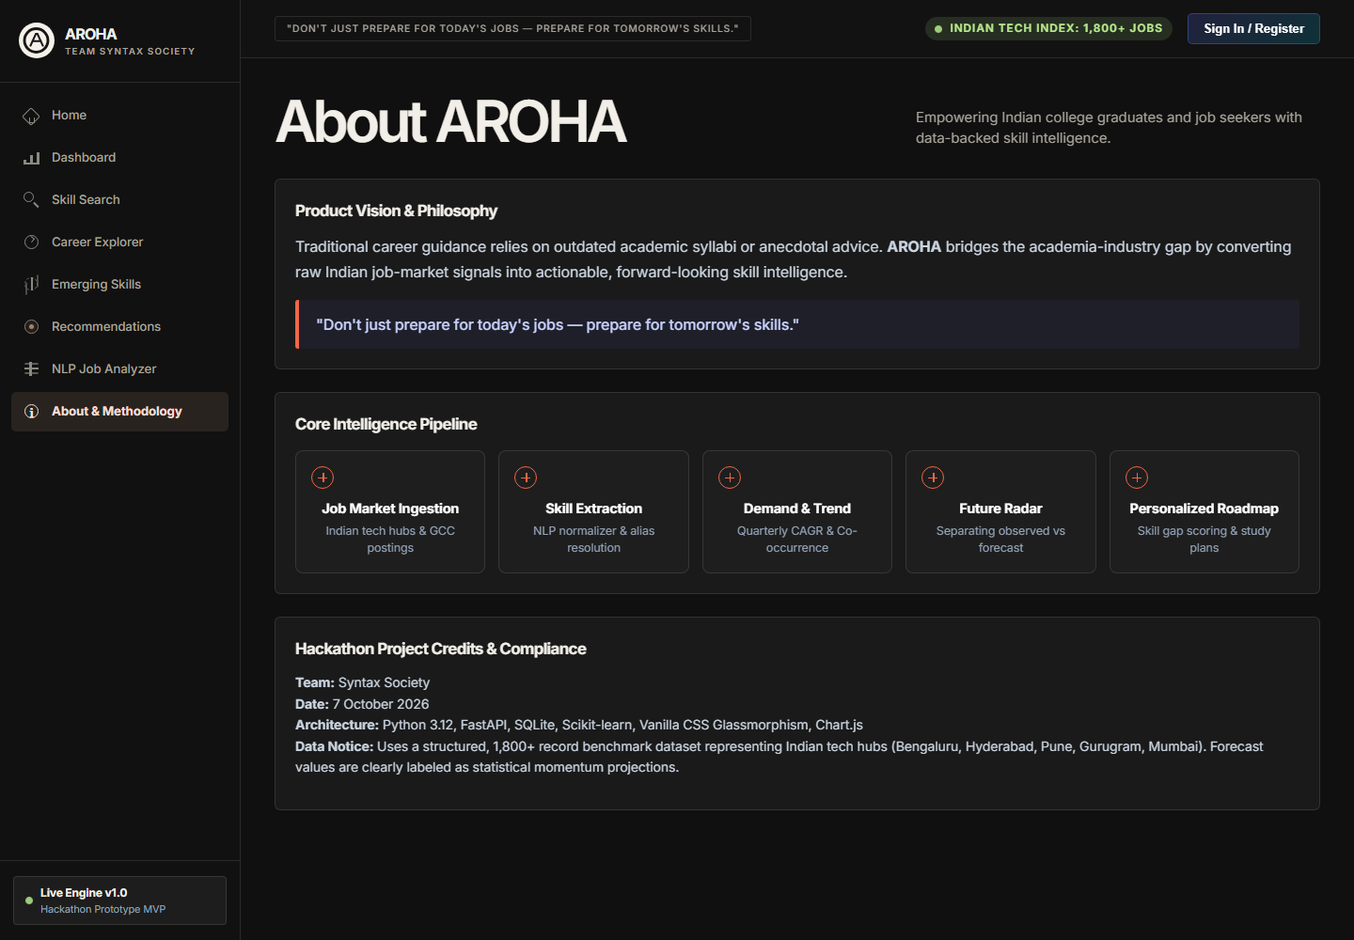
Figure 12. AROHA About and Methodology feature screen.

Feature to Code Traceability
The following map makes it straightforward for judges to connect the visible product capabilities with the relevant source code.
Feature | Primary source files | Key implementation
Navigation and views | frontend/templates/index.html; frontend/static/js/app.js | switchView controls the single-page application views
Dashboard and charts | frontend/static/js/app.js; frontend/static/js/charts.js; backend/analytics_service.py | Fetches API summaries and renders interactive charts
Skill intelligence | services/scoring.py; backend/analytics_service.py | Computes explainable score and market metrics
Role analysis | backend/analytics_service.py; utils/constants.py | Returns role requirements, salary and skill evidence
Resume upload | backend/app.py; frontend/static/js/app.js | Validates document, extracts text in memory and maps skills
Recommendations | services/recommender_service.py | Ranks capability gaps and creates learning roadmap
NLP extraction | services/skill_extractor.py; utils/normalizer.py | Extracts aliases and normalises canonical skills

Client Workflow Code
The browser-side upload workflow validates the selected file, posts it as multipart form data and refreshes the user profile with detected skills before requesting a new recommendation.
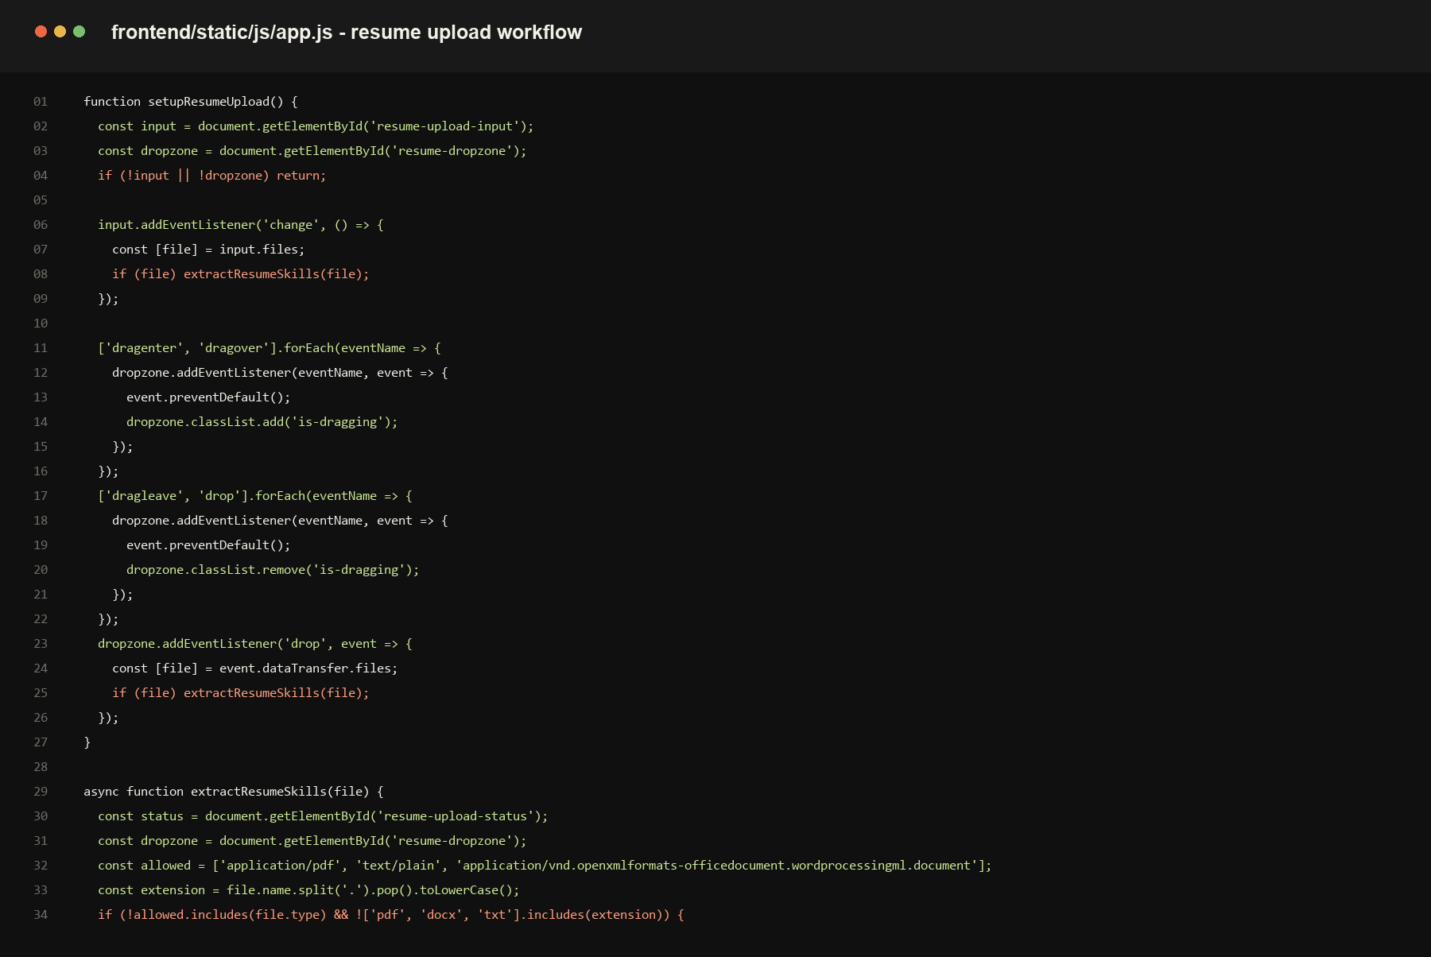
Figure 13. Client-side resume upload and profile refresh workflow.

Recommendation Service Code
The recommendation service compares the profile with the selected target role and returns prioritised gaps together with evidence-oriented learning steps.
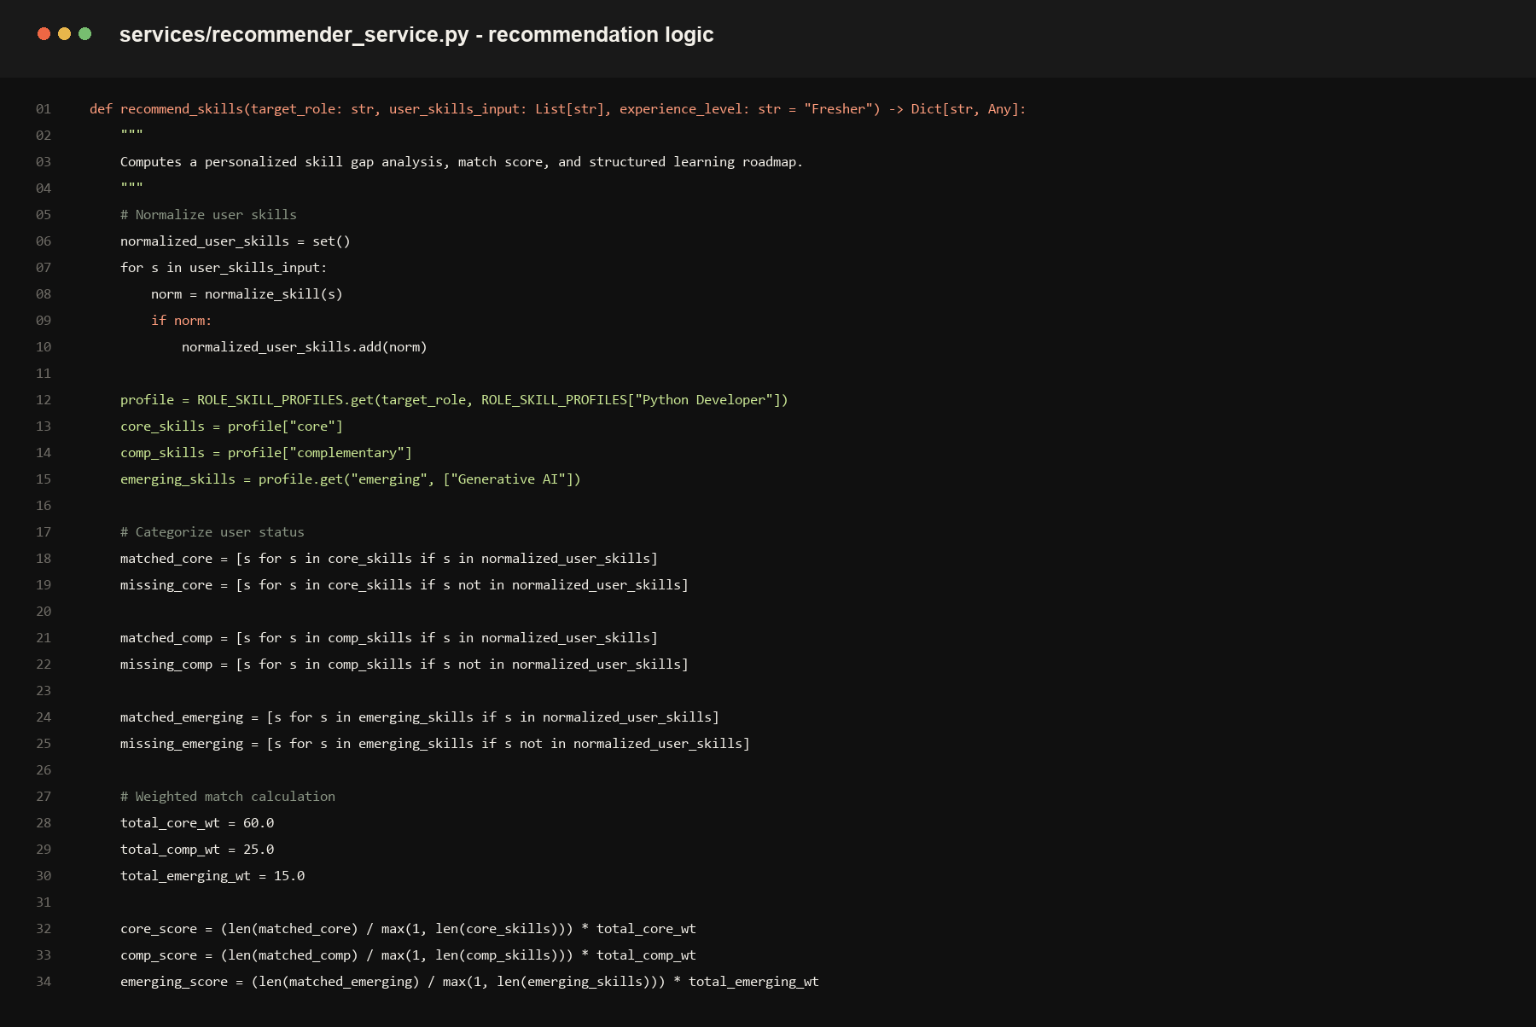
Figure 14. Server-side recommendation service excerpt.

User Manual
This manual describes how a judge or first-time user can use the MVP from the home screen to a personalised recommendation.

Starting the Application
- Install requirements with: python -m pip install -r requirements.txt.
- Run the FastAPI experience with: python run.py --fastapi.
- Open http://127.0.0.1:8000 in a browser.
- Use the Home page to begin with either Analyse my profile or Explore the market.

Using Market Intelligence
- Open Dashboard to review high-level market volume, leading skills and industry demand charts.
- Open Skill Search, enter a skill such as Python or SQL, then inspect its demand, related skills and forecast panel.
- Open Career Explorer, select a target role and review salary, core skills and location information.
- Open Emerging Skills to review frontier technologies. Treat these as labelled analytical signals rather than guarantees.

Creating a Personal Skill Gap Analysis
- Open Recommendations from the left navigation.
- Choose the target career role from the first selector.
- Upload a PDF, DOCX or TXT resume up to 5 MB, or add skills manually.
- After extraction, confirm the skill chips that were added to your profile. Remove a chip if it does not apply.
- Select Run Skill Gap Analysis.
- Review role alignment, missing core capabilities, frontier skills, the benchmark radar and the learning roadmap.

Analysing a Job Description
- Open NLP Job Analyzer.
- Paste a job description into the text area and select Extract and Normalize Skills.
- Use the returned canonical skills and matching-role suggestions to compare the listing with your current profile.

Data and Privacy Notes
- Uploaded resumes are read in memory for extraction and are not stored by the API endpoint.
- Text-based PDFs work best. Scanned image-only PDFs may not provide readable text.
- The tool provides decision support, not a hiring or psychological assessment. Salary relationships are observational, not causal.

Appendix A Professional Approach and Analytics Document
Detailed problem framing, data preparation plan, analytical methodology, validation approach, and responsible-use guidance.

AROHA
Professional Approach & Analytics Document

THE IDEA IN ONE SENTENCE
Aroha converts workforce data into simple, evidence-based insights that help people and organizations understand skill demand, capability gaps and development priorities.

Data → Intelligence → Action → Impact
Document detail | Description
Product | Aroha — workforce skill, capability-gap and career intelligence platform
Challenge | Build For Bharat 2.0, SAS CU Hackathon
Team | Syntax Society
Data used | Four official hackathon datasets (Analytics Jobs, Data Science Jobs, JDS Skill Traits, SDS Personality Traits)
Audience | Hackathon judges, mentors and technical reviewers

Contents

No. | Section | What it answers
1 | Executive Summary | What Aroha is, who it serves and what it delivers
2 | Problem & Opportunity | Why workforce data does not yet become workforce intelligence
3 | Problem Definition & Objectives | The measurable questions, scope and success criteria
4 | Official Data & Why It Matters | The four datasets and the role each one plays
5 | Data Preparation | How raw data becomes trustworthy, traceable data
6 | Analysis 1 — Market & Skill Intelligence | What employers are asking for
7 | Analysis 2 — Skill & Outcome Intelligence | Which technical capabilities are linked with better outcomes
8 | Analysis 3 — Career Intelligence | Which traits are associated with observed success
9 | Emerging Skills & Recommendations | How analysis becomes a prioritized development roadmap
10 | Technical Architecture | How the product is built and how data flows through it
11 | Aroha Product Experience | What a judge or user sees, screen by screen
12 | Validation, Impact & Judge Story | How credibility is proven and who benefits
13 | Risks, Limitations & Responsible Use | What could go wrong and how we handle it
14 | Delivery Plan & Demonstration Flow | Build sequence and how the final demo will run
A | Glossary | Plain-language definitions of key terms

What Aroha is
Aroha is a workforce intelligence product. It takes four official datasets covering job postings, company roles, technical skill scores and personality traits, and turns them into a small number of clear answers: what the market needs, which capabilities are linked with better outcomes, which traits are associated with observed success, and what a person or organization should develop next.

The three layers of intelligence
Layer | Data source | Question it answers
Market & Skill Intelligence | Analytics Jobs, Data Science Jobs | What skills, roles, locations and salaries does the market currently show?
Skill & Outcome Intelligence | JDS Skill Traits | Which technical skill scores are associated with a high or low salary-hike outcome?
Career Intelligence | SDS Personality Traits | Which OCEAN traits are associated with the observed success classification?

What the user receives
- A market picture — most requested skills, role and location distribution, experience requirements and salary patterns.
- Evidence-based capability signals — interpretable relationships between skill scores and outcomes, described as association, never as cause.
- A prioritized roadmap — for a chosen target role, a ranked list of skills to develop, with the evidence behind every recommendation.
- A transparent methodology — datasets, cleaning decisions, models and limitations are all visible inside the product.
THE IDEA IN ONE SENTENCE
Aroha converts workforce data into simple, evidence-based insights that help people and organizations understand skill demand, capability gaps and development priorities.

Guiding principles
- Evidence first. A result that cannot be traced from raw data through a documented transformation is not presented as a key finding.
- Honest language. We say "associated with" and "signal", not "causes" or "guarantees".
- Decisions over decoration. Every chart must help explain a decision.
- No invented values. Row counts, fields and results are verified from the files before use.

2. Problem & Opportunity
Why Aroha is needed
The workforce is changing quickly. Data Science, Artificial Intelligence, Analytics and other technology-driven roles continuously introduce new tools and skill requirements. However, useful workforce information is often scattered across job postings, skill assessments and workforce data.
- Students and professionals may know the job they want, but not the skills they should prioritize.
- Educational institutions need evidence about changing industry requirements so that training and curriculum remain relevant.
- Organizations need better visibility into workforce capabilities and the skills required for future roles.
- Job-market data contains valuable signals, but raw data alone does not tell a stakeholder what action to take.
THE GAP
There is a difference between having workforce data and having workforce intelligence. Aroha is designed to close that gap.

Where the problem shows up today
The difficulty is not a lack of data. It is that the data answers the wrong questions in the wrong form for the person who needs to act.
Situation | What the person has | What they actually need
A student choosing what to learn | Hundreds of job postings listing dozens of tools | A short ranked list of skills that matter most for one target role
A college updating its curriculum | Anecdotes and outdated syllabi | Evidence of which skills the market asks for and how demand is distributed
A workforce team planning training | Assessment scores with no link to outcomes | An understanding of which capabilities are associated with better outcomes
A training provider designing a program | General trend articles | Evidence-backed priorities by role, experience level and location

Our focus
- Skill Intelligence — understanding what skills are in demand and how they relate.
- Skill Gap Analysis — comparing a target role with current capability and priorities.
- Career Intelligence — studying observed patterns linked with success.
- Talent Development — turning evidence into a clear development path.
These areas directly match the challenge's intended workforce ecosystem.

Who Aroha serves
Stakeholder | Primary need | How Aroha helps
Students & early-career professionals | Know which skills to build first | Role-based skill priorities with visible evidence
Educational institutions | Keep curriculum aligned with industry | Market demand views by role and skill
Organizations & workforce teams | Understand capability needs for future roles | Capability signals and development priorities
Training providers | Focus programs where demand is strongest | Ranked, evidence-backed skill priorities

The opportunity
The four official datasets are small enough to analyze rigorously and varied enough to cover demand (job postings), capability (skill scores) and career patterns (personality traits). That combination makes it possible to build a product that does more than describe: it can connect demand to capability to action, which is exactly the step most workforce dashboards leave to the reader.

3. Problem Definition & Objectives
Turning the challenge into measurable questions
Aroha will not attempt to solve every workforce problem. We will focus on a small set of measurable questions that can be answered using the official datasets.
Business Question | What Aroha will measure
What does the market need? | Skill demand, job roles, locations, experience and salary patterns.
Which technical capabilities are linked with better observed outcomes? | Relationships between JDS skill scores and high/low salary-hike classification.
Which workforce traits are associated with observed success? | Relationships between OCEAN traits and success classification in SDS.
What should stakeholders prioritize? | Evidence-based skill and development priorities for selected roles.

ANALYTICS OBJECTIVE
Move from descriptive information to useful decisions: understand demand, identify capability signals, explain relationships, and recommend development priorities.

Specific objectives
# | Objective | How we will know it is met
1 | Build a clean, documented version of each official dataset | Every cleaning decision is recorded and reproducible
2 | Describe market demand for skills, roles and locations | Dashboard values match the processed data
3 | Identify skill scores associated with the salary-hike outcome | An interpretable model with documented evaluation
4 | Identify personality traits associated with observed success | Trait comparisons and, where supported, a model with documented limits
5 | Generate a ranked development roadmap for a chosen role | Each recommendation shows its supporting evidence
6 | Present everything in a simple, judge-friendly product | A judge can follow the story without technical knowledge

Scope
In scope
- Analysis of the four official datasets only.
- Descriptive analytics, statistical association and interpretable classification.
- A working prototype with dashboard, skill search, gap analysis and recommendations.
- A methodology page that explains data, cleaning, models and limitations.
Out of scope
- Causal claims about salary growth or career success.
- Individual-level psychological diagnosis or hiring decisions.
- Predictions presented as certainties, or forecasts without reliable time data.
- Any figure that cannot be traced back to the official files.

Success criteria
- Credibility — every number on screen is traceable to the processed data.
- Clarity — each analysis ends in a plain-language takeaway a non-technical judge can repeat.
- Actionability — the product always finishes with "what should be developed next?".
- Honesty — limitations are stated next to the results they affect.

4. Official Data & Why It Matters
We use the datasets supplied for the challenge
The hackathon provides four datasets. We will use each for a specific analytical purpose rather than combining everything blindly.
Dataset | Approx. rows | Main information | Aroha use
Analytics Jobs | 15,800+ | Job description, designation, skills, experience, location, salary | Market and skill demand
Data Science Jobs | 1,600+ | Company, title, experience, salary, number of jobs | Role, company and compensation analysis
JDS Skill Traits | 140 | Technical skill scores + salary-hike outcome | Skill/outcome intelligence
SDS Personality Traits | 160 | OCEAN traits + success classification | Career/success intelligence

Important: the exact final row counts and usable fields will be verified directly from the files before analysis. We will never invent values.

Why we keep the datasets separate
The four files describe different populations and were collected for different purposes. Job postings describe what employers ask for. JDS scores describe junior data scientists. SDS traits describe senior or customer-facing data scientists. Merging them row by row would imply connections that the data does not contain, so Aroha links them at the level of roles and skills, where the connection is meaningful, and never at the level of individual people.

Dataset profiles
Analytics Jobs — the market view
- Largest dataset; the main source for skill demand, roles, locations and experience.
- Skills are likely to appear as free text inside descriptions or skill fields, so careful normalization is essential.
- Salary and experience fields need range and format checks before any comparison.
Data Science Jobs — the role and company view
- Adds company and title information that supports role-level and company-level comparison.
- Used alongside Analytics Jobs to cross-check that role and compensation patterns are consistent.
- Job-count information is used as a demand indicator only where its meaning is clear.
JDS Skill Traits — the capability view
- Small, structured dataset: five technical skill scores plus a high/low salary-hike outcome.
- Because the sample is small, we emphasize interpretable models and cross-validation rather than complex ones.
SDS Personality Traits — the career view
- Small, structured dataset: five OCEAN dimensions plus a success classification.
- Used to study observed association only; it is not a personality assessment tool.

How each dataset feeds the product
Dataset | Product screens it powers | Type of evidence
Analytics Jobs | Dashboard, Market Intelligence, Skill Intelligence, Skill Gap Analysis | Demand and distribution
Data Science Jobs | Market Intelligence, Skill Gap Analysis | Role and compensation context
JDS Skill Traits | Career Intelligence, Recommendations | Capability / outcome association
SDS Personality Traits | Career Intelligence | Trait / success association

Verification before use
- Load each file and record the true row and column counts.
- Confirm each column's meaning and data type against the challenge description.
- Record which fields are usable, partly usable or unusable, and why.
- Only then design the analysis that depends on those fields.

5. Data Preparation
The challenge instructions warn that the datasets may contain missing, meaningless, misspelled or mistyped entries, as well as outliers. Therefore, data preparation is part of the solution, not a hidden technical step.
- Profile each dataset: row count, column types, missing values and unique values.
- Remove or investigate duplicate records.
- Check invalid salary, experience and categorical values.
- Standardize text fields and categorical labels.
- Normalize skill names and common aliases carefully.
- Inspect extreme values and decide whether they are valid observations or data errors.
- Create derived fields only when their logic is clear and reproducible.
- Keep raw data separate from processed data.
- Record every major cleaning decision so the analysis can be reproduced.

Data issues and how we will handle them
Issue | Check | Planned handling
Missing values | Count and pattern of blanks per column | Keep, impute or exclude depending on the field; document the choice
Duplicates | Exact and near-duplicate records | Remove clear duplicates; investigate near-duplicates before removal
Misspellings | Frequency list of distinct category values | Map variants to one standard label
Invalid ranges | Negative or impossible salary / experience | Flag, then correct or exclude with a recorded reason
Outliers | Distribution, box plots, domain sense | Decide valid vs error; report results with and without if influential
Mixed formats | Salary written as ranges, text or units | Parse to a consistent numeric form with documented rules
Skill aliases | Variants of the same skill | Controlled mapping to a normalized label

Skill normalization
Skill counts are only meaningful if the same skill is counted once. Aroha uses a controlled normalization list: a reviewed mapping from common variants to a standard label. Matching is done carefully so that distinct skills are never merged by accident.
Raw form (illustrative) | Normalized label | Reason
Different spellings or capitalization of one skill | One standard label | Counts become consistent
Abbreviation and full name of the same tool | One standard label | Avoids splitting demand across two entries
Closely related but different skills | Kept separate | Prevents false merging

EXAMPLE
Different spellings or forms of a skill can be mapped to a common normalized label. This makes skill counts meaningful without changing the underlying meaning.

Reproducibility
- Raw and processed data are stored separately, so the original files are never overwritten.
- A cleaning log records each decision: what was found, what was done and why.
- Transformations are scripted, so the whole pipeline can be re-run from the raw files.
- Derived fields have written definitions that appear on the Methodology page.

6. Analysis 1 — Market & Skill Intelligence
Understanding what employers are asking for
The first analytical layer uses Analytics Jobs and Data Science Jobs to create a picture of the market.
- Identify the most frequently requested skills.
- Measure the share of job postings containing important skills.
- Analyze common job roles and job types.
- Compare opportunities across locations where location data supports it.
- Study experience requirements.
- Compare salary distributions and salary against experience.
- Identify skill combinations that commonly appear together.
- Map important skills to Data Science and Analytics roles.
Key outputs
- Top Skill Demand chart
- Role and location distribution
- Salary vs experience visualization
- Skill co-occurrence view
- Role-to-skill map
- Individual Skill Profile
WHY IT MATTERS
This layer answers: "What does the market currently ask for, and how is that demand distributed across roles and opportunities?"

Methods in more detail
Question | Method | Output
Which skills are most requested? | Count postings that mention each normalized skill | Ranked skill list and share of postings
How is demand spread across roles? | Group postings by standardized role | Role distribution and role-to-skill map
Where are opportunities? | Group by cleaned location | Location distribution where data supports it
What experience is expected? | Summarize experience ranges per role | Experience profile by role
How does pay relate to experience? | Salary distribution and salary-vs-experience comparison | Visualization with medians and spread
Which skills travel together? | Pairwise co-occurrence counts across postings | Skill co-occurrence view

Measuring demand responsibly
- Share of postings, not raw counts. A percentage is easier to interpret and compare across datasets of different size.
- Medians alongside averages. Salary data often has outliers that distort the mean.
- Minimum sample sizes. Groups with very few postings are flagged rather than ranked, so small groups do not create misleading headlines.
- Cross-checking. Role and salary patterns from the two job datasets are compared to confirm they tell a consistent story.

Individual Skill Profile
A user can search any normalized skill and see a single evidence page. Aroha will show how often the skill appears, which roles ask for it, which skills commonly appear alongside it, and the experience and salary context of the postings that mention it.
Profile section | Content
Demand | Share of postings that mention the skill
Roles | Roles in which the skill appears most often
Companions | Skills that commonly appear together with it
Context | Typical experience range and salary distribution of related postings
Evidence note | Sample size and any caution about reliability

From description to decision
Each chart in this layer is paired with a one-sentence takeaway, for example "this skill appears in a large share of Data Scientist postings" or "these two skills are usually requested together". The wording will be filled in only after the numbers are verified.

7. Analysis 2 — Skill & Outcome Intelligence
Using JDS to understand technical capability signals
The JDS dataset measures technical capabilities for junior data scientists and includes an observed high/low salary-hike outcome. Aroha will use this dataset to investigate which skill scores are associated with that outcome.
Skills measured
- Big Data
- Mathematics & Statistics
- Coding
- AI & Machine Learning
- Dashboard & Storytelling
Analytical process
- Compare skill-score distributions between high and low salary-hike groups.
- Use appropriate statistical association analysis.
- Build an interpretable Logistic Regression model.
- Optionally compare with a Decision Tree or Random Forest.
- Evaluate the model using appropriate metrics and class-balance checks.
- Use coefficients or feature importance to explain the strongest signals.
HOW WE WILL SPEAK ABOUT THE RESULT
We will say "associated with" or "predictive signal," not "causes salary growth." The dataset supports an analytical relationship, not a causal conclusion.

Step-by-step plan
Step | Activity | Purpose
1 | Inspect outcome balance | Check how many records are in the high and low groups before modelling
2 | Describe each skill score | Understand range, spread and any unusual values
3 | Compare groups | See whether score distributions differ between high and low outcome groups
4 | Test association | Use suitable statistical tests, with effect size as well as significance
5 | Check relationships among skills | Detect correlated skills so coefficients are interpreted carefully
6 | Fit a baseline | Establish what a trivial prediction would achieve
7 | Fit Logistic Regression | Produce an interpretable model with readable coefficients
8 | Compare optional models | Test whether a tree-based model adds anything meaningful
9 | Explain the strongest signals | Translate coefficients or importances into plain language

Why an interpretable model first
With a dataset of this size, a simple model is more trustworthy than a complex one. Logistic Regression gives each skill a direction and a strength that a non-technical reader can follow. A Decision Tree or Random Forest is added only as a comparison: if it does not clearly outperform the simple model, we keep the simple one.

Evaluation approach
Check | Why it matters
Train/test split or cross-validation | Shows how the model behaves on data it has not seen; cross-validation is preferred for small samples
Class-balance check | A model can look accurate simply by predicting the larger group
Multiple metrics | Accuracy alone can mislead; precision, recall and F1 give a fuller picture
Comparison with a baseline | Confirms the model adds value beyond a trivial rule
Stability of coefficients | Signals that change wildly between samples should not be headlined

Presenting the result
- A simple chart comparing skill-score distributions for the high and low groups.
- A ranked bar chart of the strongest skill signals.
- A plain-language sentence for each top signal, always using association wording.
- A visible note on sample size and model limitations.

8. Analysis 3 — Career Intelligence
Using SDS to study observed success patterns
The SDS dataset contains the Big Five personality dimensions for senior/customer-facing data scientists and a success classification. Aroha will examine whether certain dimensions are associated with the observed success outcome.
The five dimensions
- Openness to experience
- Conscientiousness
- Extraversion
- Agreeableness
- Neuroticism
Approach
- Inspect the distribution of each trait.
- Compare trait patterns between success classifications.
- Use suitable association analysis.
- Build an interpretable classification model if supported by sample size and class balance.
- Use coefficients or feature importance to explain model signals.
- Present the result as workforce/career intelligence rather than a psychological diagnosis.
LIMITATION
Personality is only one dataset and one observed context. Aroha will not claim that a personality trait guarantees success.

What each dimension represents
Dimension | Plain-language meaning
Openness | Curiosity and willingness to try new ideas and approaches
Conscientiousness | Organization, reliability and attention to detail
Extraversion | Energy in social and collaborative settings
Agreeableness | Cooperation and consideration of others
Neuroticism | Tendency toward stress and emotional reactivity

Analytical steps
- Check the success classification balance to see whether both outcome groups are large enough for a fair comparison.
- Describe each trait by group, looking at the centre and spread rather than only the average.
- Test association between each trait and the success classification, reporting effect size.
- Model only if supported. If the sample size and class balance allow it, fit an interpretable classifier; otherwise report the comparisons alone.
- Explain the signals in simple language, with caution about sample size.

Responsible interpretation
- Traits are shown as patterns in an observed group, never as a score that ranks individuals.
- The product does not recommend hiring, rejecting or labelling any person.
- Results are presented as one contributing piece of career intelligence next to skill and market evidence.
- The Methodology page states the sample size, the context of the data and what cannot be concluded.

How Career Intelligence supports the user
For a student or professional, the value is a better understanding of which working styles are observed among successful data scientists in this dataset, as a complement to technical skills. For an organization, it supports conversations about development and team composition without making claims about any one person.

9. Emerging Skills & Recommendations
Turning analysis into action
Aroha should only call something an "emerging skill" when the data supports that interpretation.
If reliable time information is available, we can measure growth across periods. If it is not, the product will use the more accurate label "Emerging Skill Signals" and base those signals on cross-role adoption, recent observations where possible, and other defensible evidence.
Recommendation flow
- User selects a target role.
- Aroha identifies the most relevant skills from the market analysis.
- Skill/outcome evidence is added where the role and dataset are compatible.
- Emerging-skill signals are added only when supported by evidence.
- The system ranks development priorities.
- Each recommendation shows the evidence behind it.
EXAMPLE
Target role: Data Scientist → Market skills → Capability signals → Emerging-skill signals → Prioritized development roadmap.

Evidence types and how they are labelled
Evidence type | Source | Label shown to the user
Market demand | Analytics Jobs, Data Science Jobs | Demand in postings for the selected role
Capability signal | JDS Skill Traits | Associated with higher salary-hike outcome
Cross-role adoption | Analytics Jobs, Data Science Jobs | Emerging Skill Signal (appears across several roles)
Growth over time | Only if reliable time data exists | Emerging Skill (measured growth)

How priorities are ranked
Ranking is deliberately simple and explainable. Each candidate skill receives a transparent priority based on the evidence available for it. No hidden score is used; the user can always see why a skill appears where it does.
Ranking factor | How it is used
Role relevance | How often the skill appears in postings for the selected role
Capability evidence | Whether the skill is linked with a favourable outcome where compatible data exists
Signal strength | Emerging-skill signal, shown only when supported
Evidence confidence | Sample size and consistency; weaker evidence is ranked lower and flagged

What a recommendation looks like
Element | Content
Skill | The recommended skill to develop
Priority | High, medium or lower, with the reason for that position
Evidence | The demand, capability or emerging-signal evidence behind it
Confidence note | Sample size and any caution
Suggested next step | A practical development focus for the stakeholder

RULE
If the evidence for a recommendation is weak or incompatible, Aroha says so instead of producing a confident-looking result.

10. Technical Architecture
How the product will be implemented
The architecture separates the user interface, API, analytical services and data so that the system remains easy to test and extend.
Layer | Technology | Role
Frontend | React + Vite + Tailwind CSS | Dashboard and user interactions
Backend | Python + FastAPI | APIs and application logic
Analytics | Pandas + NumPy | Cleaning, transformation and analysis
ML | Scikit-learn | Interpretable classification and prediction
NLP | spaCy / controlled normalization | Skill extraction and normalization
Storage | SQLite / processed files | Prototype data storage
Charts | Recharts / Plotly | Evidence-focused visualizations

The system is designed so that new datasets or improved models can be added without rebuilding the entire product.

Data flow
- Raw files are loaded read-only into the raw data area.
- The preparation pipeline profiles, cleans and normalizes the data, writing results to the processed area and a cleaning log.
- Analytical services compute market metrics, statistical comparisons and model outputs from processed data only.
- The API serves these results to the interface in a consistent format.
- The frontend renders charts, skill profiles and recommendations, each linked to its evidence.

Planned API endpoints
Endpoint (illustrative) | Purpose
/api/overview | Headline market metrics and top findings for the dashboard
/api/market/skills | Skill demand, shares and co-occurrence
/api/market/roles | Role, location, experience and salary distributions
/api/skills/{name} | Evidence profile for one normalized skill
/api/outcomes/jds | Skill/outcome associations and model summary
/api/career/sds | Trait/success associations and model summary
/api/recommendations?role= | Ranked development priorities with evidence
/api/methodology | Datasets, cleaning log, models and limitations

Design decisions
- Separation of concerns — analysis code is independent of the interface, so each can be tested alone.
- Processed data only — the product never reads raw files, which protects traceability.
- Interpretable models — chosen for explainability over marginal accuracy gains.
- Prototype-appropriate storage — SQLite or processed files keep setup simple and the demo reliable.
- Extensibility — a new dataset or model plugs in behind the same API.

Quality in the codebase
- Automated checks that dashboard values equal the processed-data values.
- Unit tests for cleaning and normalization rules.
- A fixed random seed so model results are repeatable.

11. Aroha Product Experience
How a judge or user sees the analysis
The interface should communicate the analysis in a simple sequence rather than overwhelming the user with charts.
- Dashboard — high-level market KPIs and the most important findings.
- Market Intelligence — demand, roles, locations, experience and salary.
- Skill Intelligence — search a skill and see its evidence-based profile.
- Skill Gap Analysis — compare a target role with development priorities.
- Career Intelligence — inspect observed skill/outcome and success patterns.
- Emerging Skills — show evidence-based emerging signals or validated forecasts.
- Recommendations — present the prioritized development roadmap.
- Methodology — explain datasets, cleaning, models and limitations.
DESIGN RULE
Every visualization should answer a question. If a chart does not help explain a decision, it should not be included.

Screen-by-screen plan
Screen | Question it answers | Main elements
Dashboard | What is the headline story? | KPI cards, top skills, key findings
Market Intelligence | What does the market look like? | Role, location, experience and salary views
Skill Intelligence | What is the evidence for this skill? | Search box, skill profile, companion skills
Skill Gap Analysis | What matters most for my target role? | Role selector, ranked skills, evidence notes
Career Intelligence | What patterns are linked with outcomes? | Skill-outcome and trait-success comparisons
Emerging Skills | What is rising in importance? | Emerging signals with clear labels
Recommendations | What should I develop next? | Prioritized roadmap with evidence
Methodology | Can I trust this? | Data sources, cleaning log, model notes, limitations

Experience principles
- One question per screen. Each page has a clear purpose and a plain-language headline.
- Evidence one click away. Any recommendation can be expanded to show its sources.
- Plain language. Technical terms are explained in context, with a glossary available.
- Honest labelling. Signals, associations and limitations are labelled exactly as such.
- Consistent visual language. The same colours and chart styles carry the same meaning everywhere.

Example user journey
- A student opens the Dashboard and sees the strongest market signals.
- They choose Data Scientist as the target role in Skill Gap Analysis.
- Aroha lists the skills that matter most and shows the evidence for each.
- They open a skill in Skill Intelligence to see which roles and companion skills go with it.
- They finish on Recommendations with a prioritized roadmap and clear next steps.

12. Validation, Impact & Judge Story
How we prove the solution is credible
Aroha will be evaluated at three levels: data quality, analytical reliability and usefulness of the final recommendation.
Validation
- Check all dashboard values against processed datasets.
- Use train/test split or cross-validation for supervised models where appropriate.
- Check class balance before interpreting classification results.
- Compare simple baselines with ML models.
- Use interpretable model outputs.
- Document limitations and uncertainty.
Stakeholder impact
- Students and professionals: prioritize skills and development areas.
- Institutions: align training and curriculum with industry signals.
- Workforce teams: understand capability needs and support talent development.
- Training providers: focus programs on evidence-backed skill priorities.
THE FINAL STORY
Aroha does not stop at showing what the data says. It connects market demand, capability signals and career intelligence to a clear action: what should be developed next?

Three levels of validation
Level | What we check | Evidence we can show
Data quality | Completeness, duplicates, ranges, consistent labels | Cleaning log and before/after profile
Analytical reliability | Correct calculations, balanced evaluation, stable results | Reconciled dashboard values, model metrics, baselines
Usefulness | Whether the output leads to a clear action | Worked role example with a ranked roadmap

Impact by stakeholder
Stakeholder | Decision supported | Benefit
Students & professionals | Which skill to learn next | Less guesswork, more focused effort
Institutions | Which topics to emphasize in curriculum | Training closer to industry need
Workforce teams | Which capabilities to develop internally | Better-targeted talent development
Training providers | Which programs to prioritize | Offerings backed by evidence

The judge story
The demonstration is built around a single clear narrative so a judge can follow it in minutes:
- The problem: data exists, but intelligence does not.
- The market: here is what employers ask for, and how it is distributed.
- The capability signal: here is what the skill data associates with better outcomes.
- The career pattern: here is what the personality data associates with success, and what it cannot tell us.
- The action: here is the ranked roadmap for a chosen role, with evidence for every line.

13. Risks, Limitations & Responsible Use
What could go wrong, and how Aroha handles it
A credible analytical product is honest about its limits. This section lists the main risks and the safeguards built into the approach.
Risk | Why it matters | Safeguard
Small samples (JDS, SDS) | Results may be unstable or over-interpreted | Cross-validation, simple models, visible sample sizes, cautious wording
Dirty data | Errors can distort counts and averages | Documented cleaning, outlier review, reproducible pipeline
Skill aliasing errors | Wrong merging or splitting changes rankings | Controlled normalization list with manual review of top skills
Confusing association with cause | Misleads users about what drives outcomes | Association language throughout; limitation notes beside results
Unreliable time data | Growth claims could be wrong | Use "Emerging Skill Signals" unless time data is reliable
Class imbalance | Accuracy can look high for the wrong reason | Balance checks, multiple metrics, baseline comparison
Over-complex product | Judges lose the story | One question per screen; remove charts that do not support a decision
Misuse of personality results | Could be used to judge individuals | Group-level presentation only; explicit non-diagnostic statement

Known limitations
- The datasets are samples; findings describe these datasets, not the whole workforce.
- JDS and SDS describe different groups and are not linked at the individual level.
- Salary information in postings may differ from what is eventually paid.
- Personality is one observed context and does not determine success.

Responsible use commitments
- No individual judgments. Aroha supports development decisions, not hiring or rejection decisions.
- Transparency. Data sources, methods and limitations are always accessible.
- Proportionate claims. Wording matches the strength of the evidence.
- Privacy-minded. Only the supplied challenge datasets are used.
PRINCIPLE
A smaller claim that is true is more valuable than a larger claim that cannot be defended.

14. Delivery Plan & Demonstration Flow
From approach to working product
The build follows the same order as the analytical story, so the foundations are always in place before the features that depend on them.
Phase | Focus | Deliverables
1 | Data verification & preparation | Verified row counts and fields, cleaning log, processed datasets
2 | Market & skill analysis | Skill demand, role, location, experience and salary analysis; skill normalization list
3 | Outcome & career analysis | JDS and SDS comparisons, interpretable models, evaluation notes
4 | Recommendation logic | Role-based ranking with evidence and emerging-skill signals
5 | Product build | API and interface for all eight screens
6 | Validation & polish | Reconciled values, tests, Methodology page, demo rehearsal

Demonstration flow
- Open on the Dashboard to frame the problem and the headline findings.
- Move to Market Intelligence and Skill Intelligence to show demand and a skill profile.
- Show Career Intelligence to present capability and trait signals with their limitations.
- Select a target role in Skill Gap Analysis and show the ranked priorities.
- Finish on Recommendations and the Methodology page to show the evidence and honesty of the approach.

Definition of done
- Every dashboard number reconciles with the processed data.
- Every recommendation shows its evidence and a confidence note.
- The Methodology page lists datasets, cleaning decisions, models and limitations.
- A non-technical judge can explain the product's purpose after one walkthrough.

Conclusion
Aroha is built on a simple belief: workforce data becomes valuable only when it leads to a decision. By combining market demand, capability signals and career intelligence under strict standards of evidence, Aroha answers the question that matters most to students, institutions and organizations alike — what should be developed next?
Data → Insight → Action → Workforce Impact

Appendix A. Glossary

Term | Meaning
Skill Intelligence | Evidence about which skills are in demand and how they relate to roles
Skill Gap Analysis | Comparing the skills a role needs with development priorities
Career Intelligence | Patterns in the data associated with observed career success
Normalization | Mapping different spellings or forms of a skill to one standard label
Co-occurrence | Two skills appearing together in the same job posting
Outlier | A value far from the others, which may be real or an error
OCEAN / Big Five | Five personality dimensions: Openness, Conscientiousness, Extraversion, Agreeableness, Neuroticism
JDS | Dataset of technical skill scores for junior data scientists with a salary-hike outcome
SDS | Dataset of personality traits for senior or customer-facing data scientists with a success classification
Logistic Regression | A simple, interpretable model that estimates how each input relates to a yes/no outcome
Decision Tree / Random Forest | Tree-based models used only as a comparison to the simpler model
Cross-validation | Repeatedly splitting the data to test a model on records it has not seen
Class balance | Whether the outcome groups are of similar size
Baseline | A trivial prediction rule used to check that a model adds value
Association | A relationship between two things that does not prove one causes the other
Emerging Skill Signal | Evidence that a skill is gaining relevance, labelled cautiously unless time data supports growth

