AROHA Project Report
AI powered skill intelligence and career decision support
Team Syntax Society | SAS Hackathon 2026 | AI and Workforce Analytics
AROHA is a decision-support MVP that turns job-market evidence and an individual profile into a focused recommendation for what to learn next.
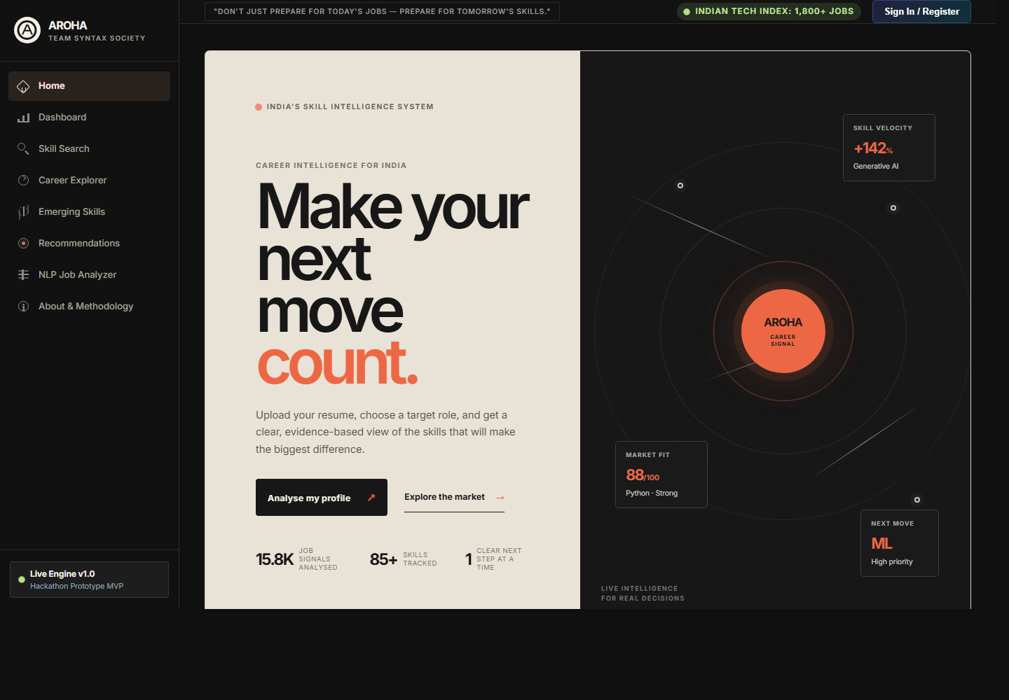
Figure 1. AROHA MVP home screen and career-signal interface.

Project Summary
AROHA addresses a practical career-planning problem: candidates often see job listings and skill lists but cannot determine which capability to prioritise. The MVP combines market evidence, transparent scoring, machine-learning outputs and an individual profile into a single decision flow.
Area | MVP implementation | User value
Skill intelligence | Normalises and analyses job-posting skills | Clarifies what employers are asking for
Role fit | Compares existing skills with target-role requirements | Makes gaps visible and prioritised
Resume import | Reads PDF, DOCX or TXT in memory and extracts indexed skills | Removes manual profile entry
Explainable score | Weights demand, role coverage, salary association and frontier signals | Shows why a skill is recommended
Learning roadmap | Ranks next skills with evidence | Converts analysis into action

Problem and Target User
Students, early-career professionals and placement stakeholders need a credible way to translate fragmented job-market information into a personal plan. Existing job boards show vacancies; AROHA explains the capability signals behind those vacancies and maps them to a target role.
- Candidate: identify the few skills with the strongest potential impact for a target role.
- Placement or educator: understand recurring employer requirements and curriculum gaps.
- Recruiter or workforce planner: inspect market demand, role patterns and salary context.

MVP Demonstration
The implemented MVP is a local web application with a navigable product interface, interactive role and skill exploration, resume upload, recommendation analysis and API-backed data services.
Workflow | What happens | Evidence in MVP
1. Import | User uploads a resume or enters skills | Resume upload accepts PDF, DOCX and TXT files up to 5 MB
2. Extract | Text is parsed in memory and passed to the existing skill extractor | Detected skills are added to the user profile
3. Compare | Profile is compared against a selected career role | Match score, missing core skills and radar chart update
4. Act | Recommendation service ranks next capabilities | Learning roadmap explains what to learn and why

Unique Selling Proposition
The core USP is the bridge from market data to an individual next action. AROHA combines observable hiring evidence with an explainable score and then applies that evidence to a specific user profile. This is more useful than a static demand dashboard and more credible than an unexplained generic recommendation.
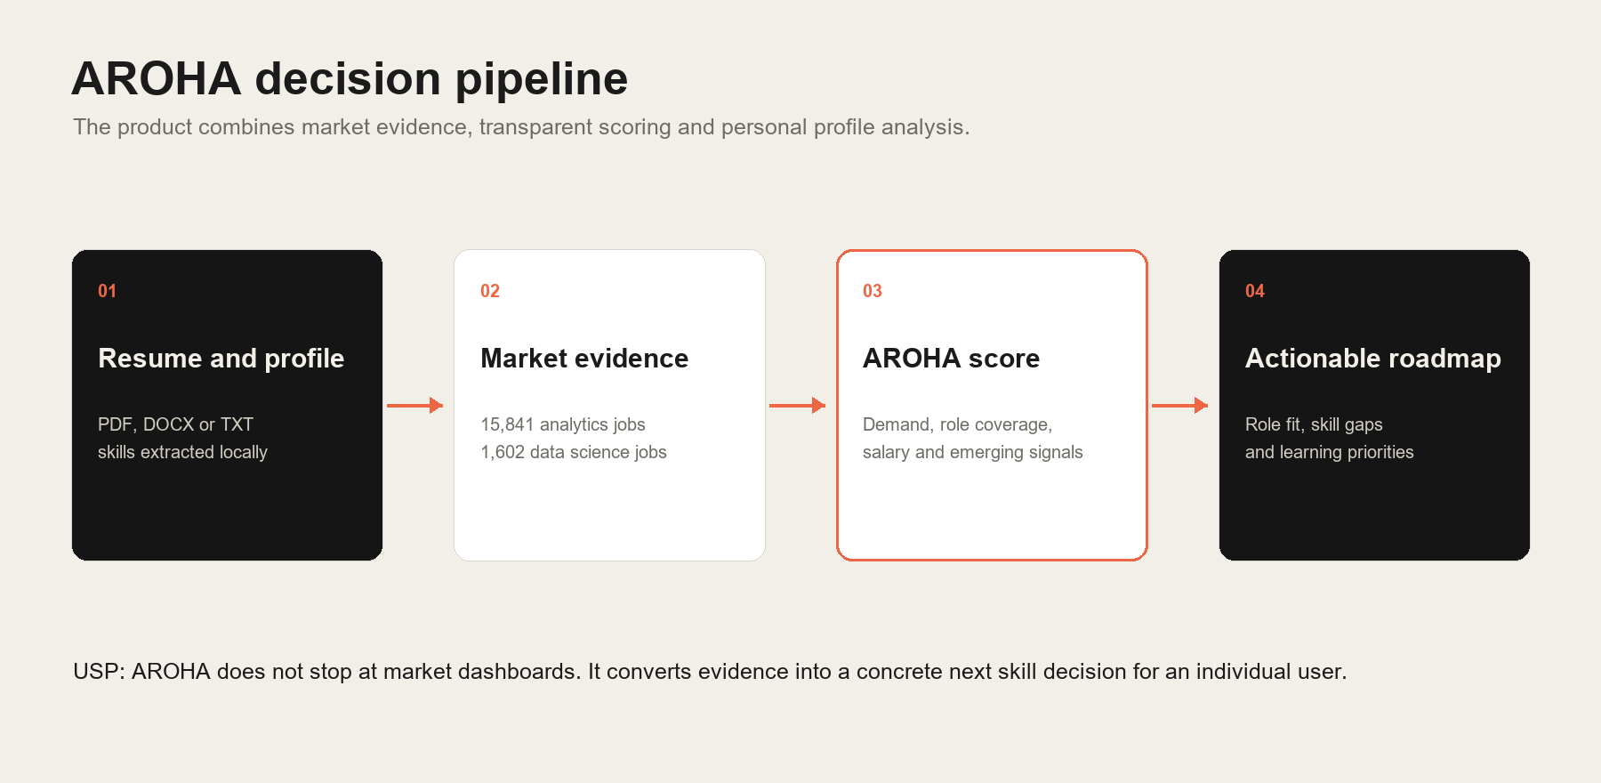
Figure 2. AROHA USP: evidence flows from resume and market data to a specific learning decision.
- Explainable: the score exposes its four component signals and weights.
- Personal: resume extraction removes manual setup and starts from the candidate's actual profile.
- Evidence-based: recommendations are tied to demand, role coverage and salary context.
- Responsible: frontier signals are labelled as analytical indicators rather than fabricated historical facts.

Data and Analytical Method
Dataset | Records | Use in AROHA
Analytics Jobs | 15,841 | Skill frequency, role coverage, location and salary parsing
DataScience Jobs | 1,602 | Employer, role and compensation intelligence
JDS Skill Traits | 139 | Junior salary-hike classification and feature analysis
SDS Personality Traits | 161 | Senior success-classification exploratory model

The AROHA score uses a transparent weighted formula: 35 percent demand, 25 percent role coverage, 25 percent salary association and 15 percent emerging-skill alignment. Salary signals are described as associations, not causal effects.

Implementation Evidence

Explainable Skill Score
The score service explicitly derives its components, applies the documented weights and returns both the score and the underlying empirical metrics. This makes the product result inspectable during a demo.
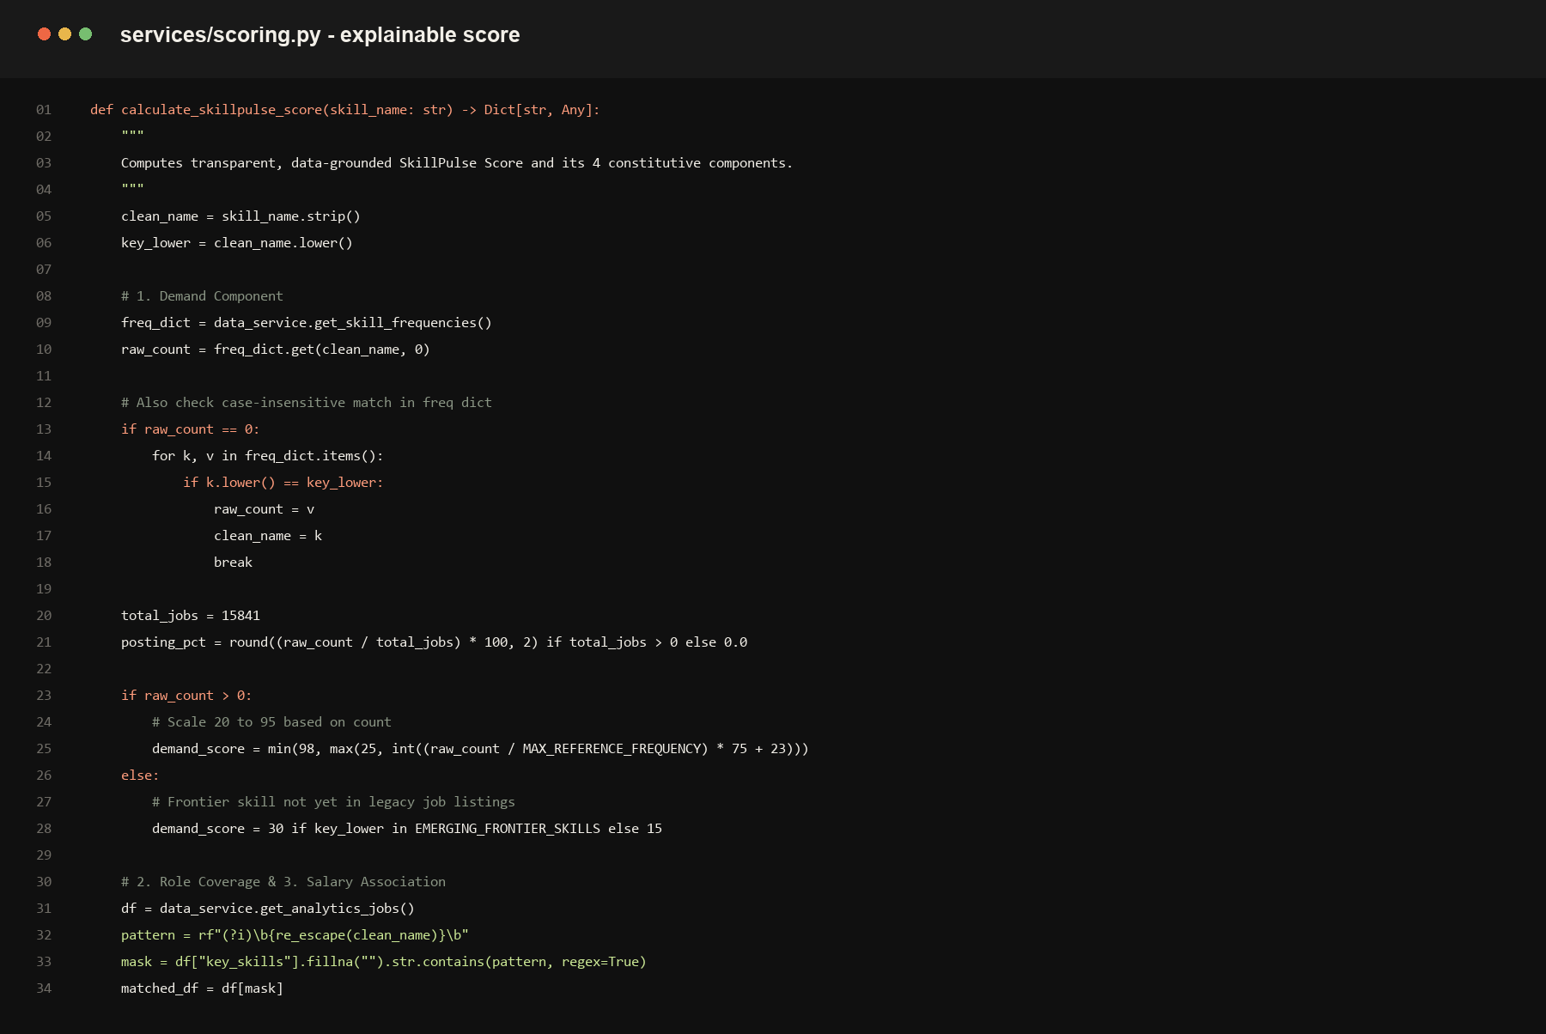
Figure 3. Production code excerpt for the transparent weighted skill score.

Resume Import and Extraction
The API validates file type and size, reads the document in memory, extracts text with format-specific readers, and routes the text through the existing normalisation pipeline. The endpoint does not persist uploaded resumes.
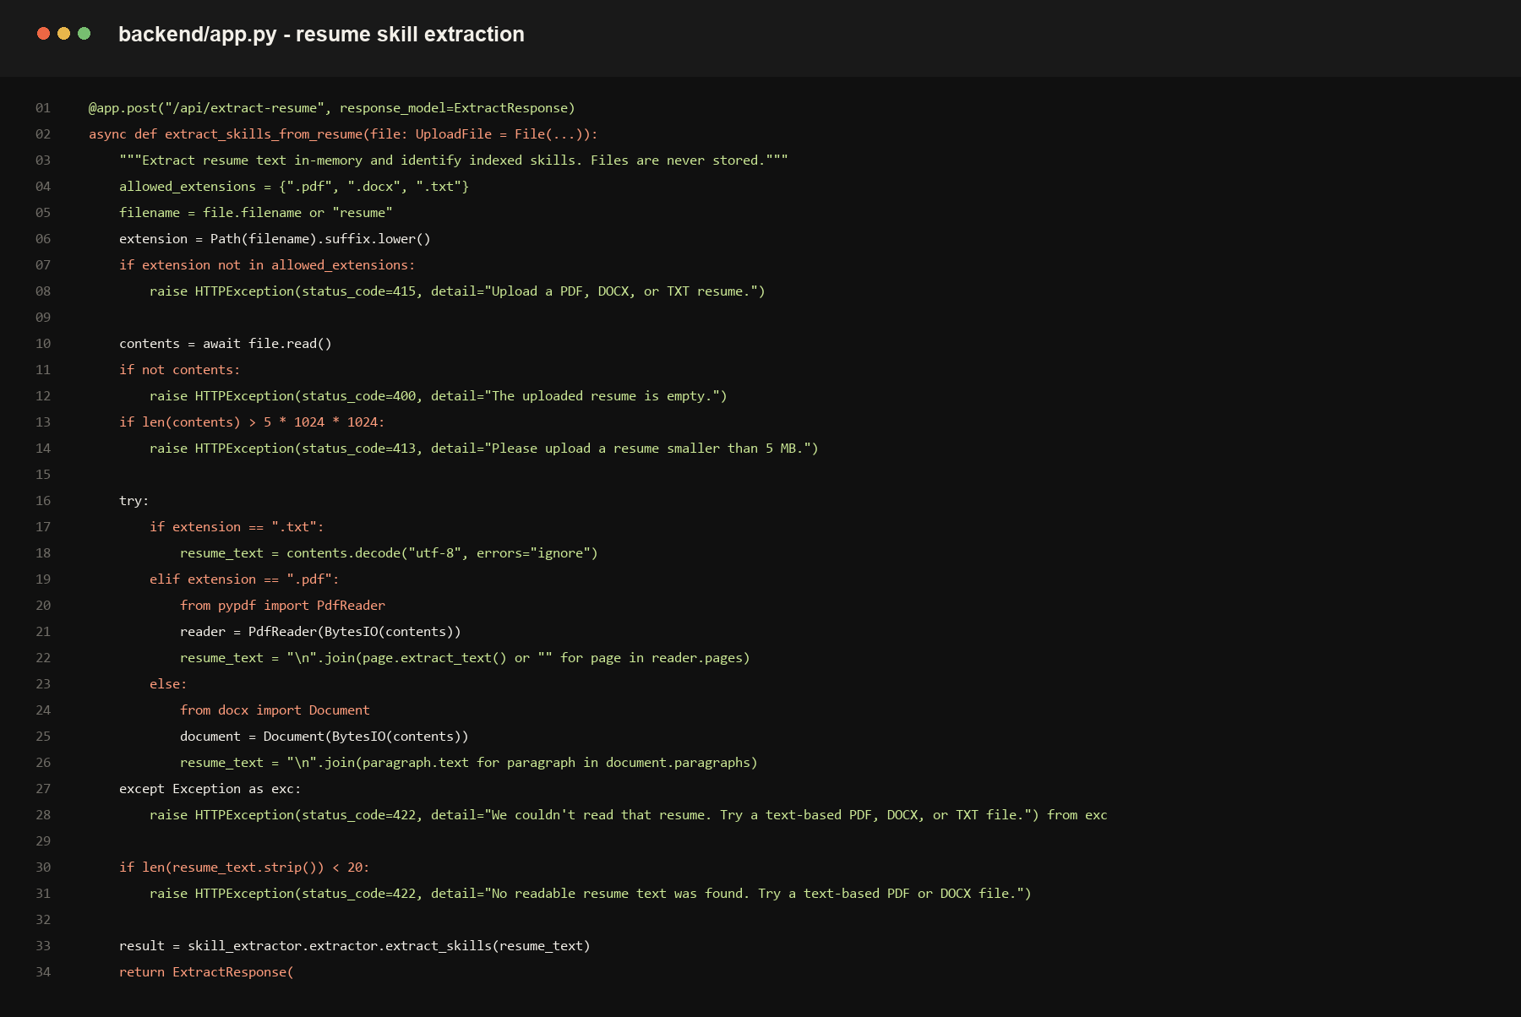
Figure 4. Production code excerpt for secure in-memory resume skill extraction.

Technical Architecture
Layer | Technology | Responsibility
Frontend | HTML, CSS and JavaScript | Interactive AROHA interface, charts, profile flow and resume upload
API | FastAPI and Pydantic | Typed endpoints for analytics, extraction and recommendations
Analytics | Pandas and scikit-learn | Data preparation, market intelligence and predictive models
Storage | SQLite | Local job-market data access
Document parsing | pypdf and python-docx | In-memory PDF, DOCX and TXT skill extraction

Evaluation and Responsible Use
The project includes automated tests for extraction, scoring, analytics, recommendation services and FastAPI endpoints. The documented ML evaluation compares Logistic Regression and Random Forest models, with the Junior Data Scientist model reporting 88.6 percent accuracy and 0.889 F1 for the stated validation split.
- Forecast and frontier signals are shown as indicators, not guarantees.
- Skill and salary relationships are communicated as observational associations.
- Resume files are processed in memory for extraction and are not stored by the endpoint.
- Personality outputs are labelled with ethical limits and are not presented as psychological diagnosis.

Conclusion
AROHA is a complete MVP rather than a static concept: it accepts a user profile, reads a resume, analyses market evidence, identifies role gaps and produces a concrete learning roadmap. Its distinctive strength is the transparent connection between data, model outputs and a user decision.

Feature Catalogue and Screen Evidence
This section documents the complete user-facing MVP. Screens are captured from the running AROHA application at the local product viewport. Each feature is connected to the implementation layer responsible for it.

1. Home
Sets the product context and gives users direct paths to profile analysis or market exploration.
Implementation: frontend/templates/index.html and frontend/static/css/style.css
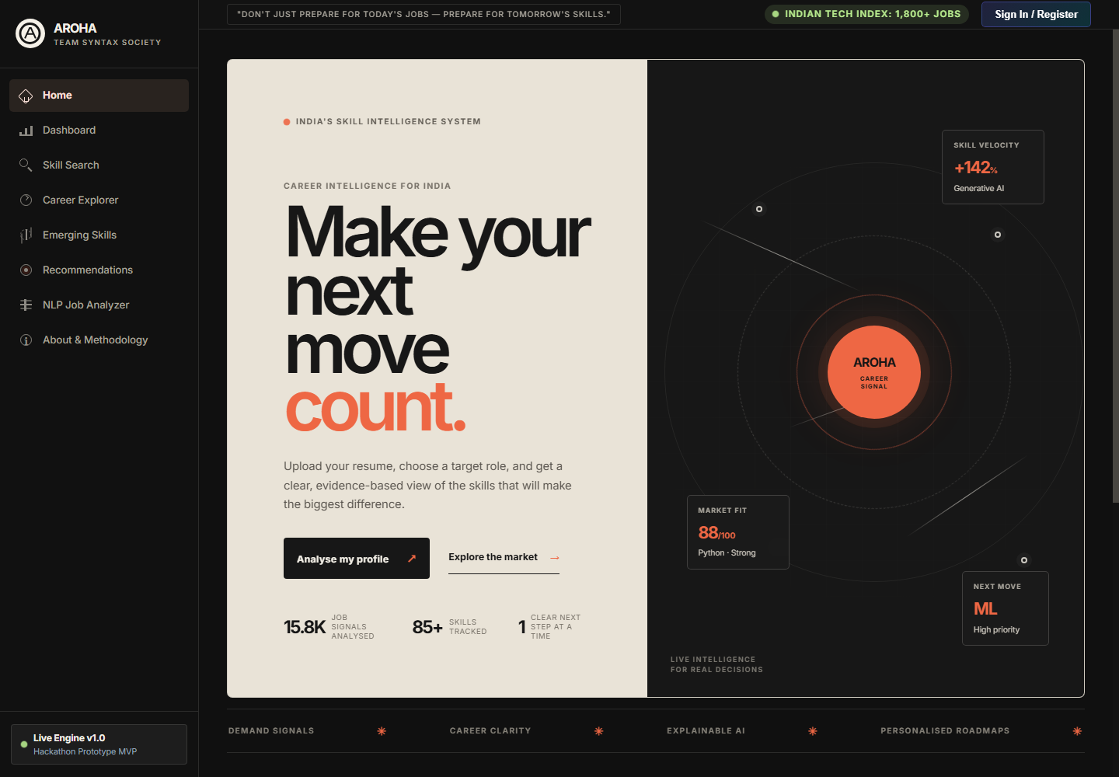
Figure 5. AROHA Home feature screen.

2. Market Dashboard
Presents current job-market signals, in-demand skills and industry spread using API-backed charts.
Implementation: frontend/static/js/app.js and backend/analytics_service.py
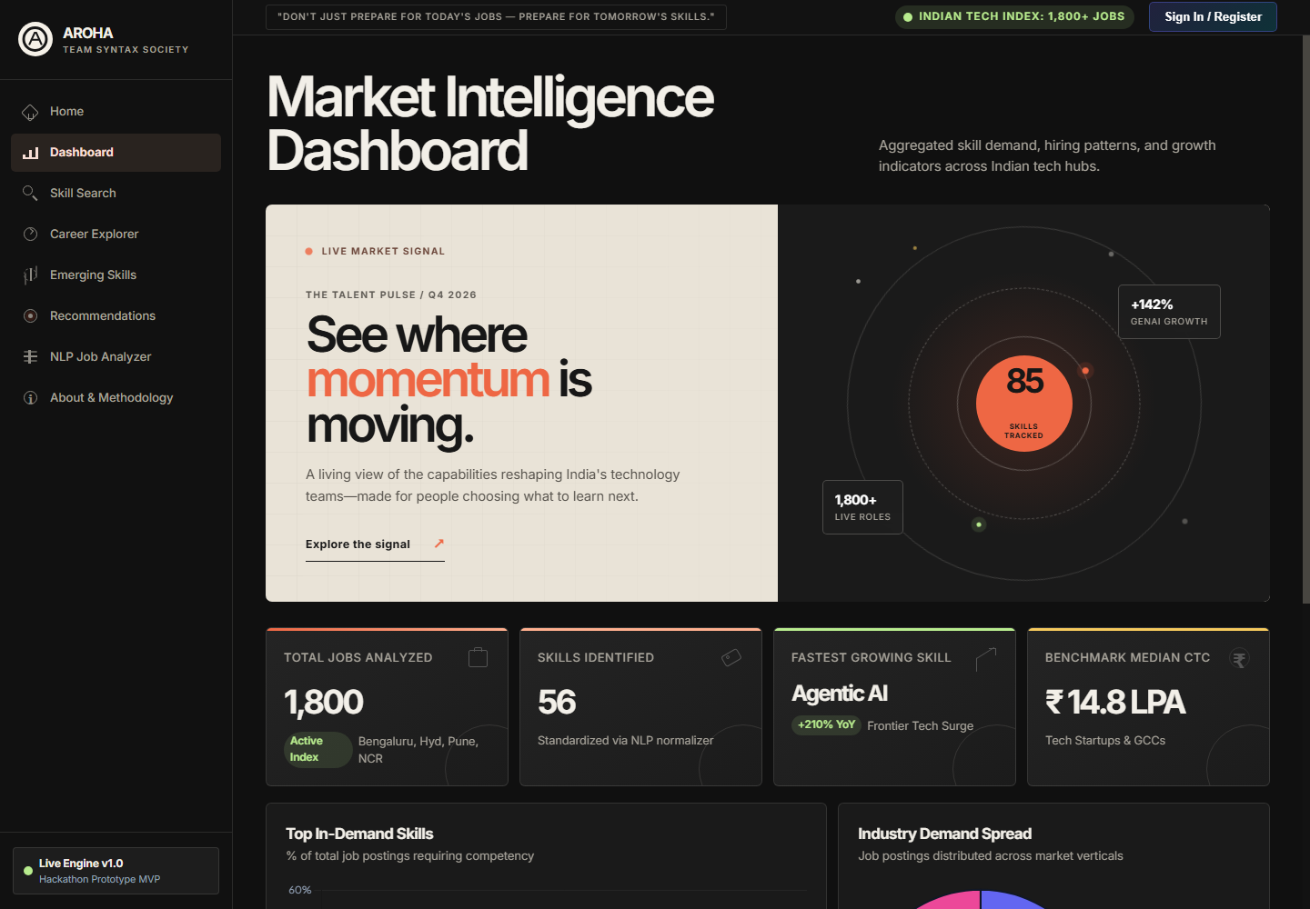
Figure 6. AROHA Market Dashboard feature screen.

3. Skill Search
Lets users inspect demand score, observed job presence, trends, related skills and top industries for a selected technology.
Implementation: frontend/static/js/app.js and backend/analytics_service.py
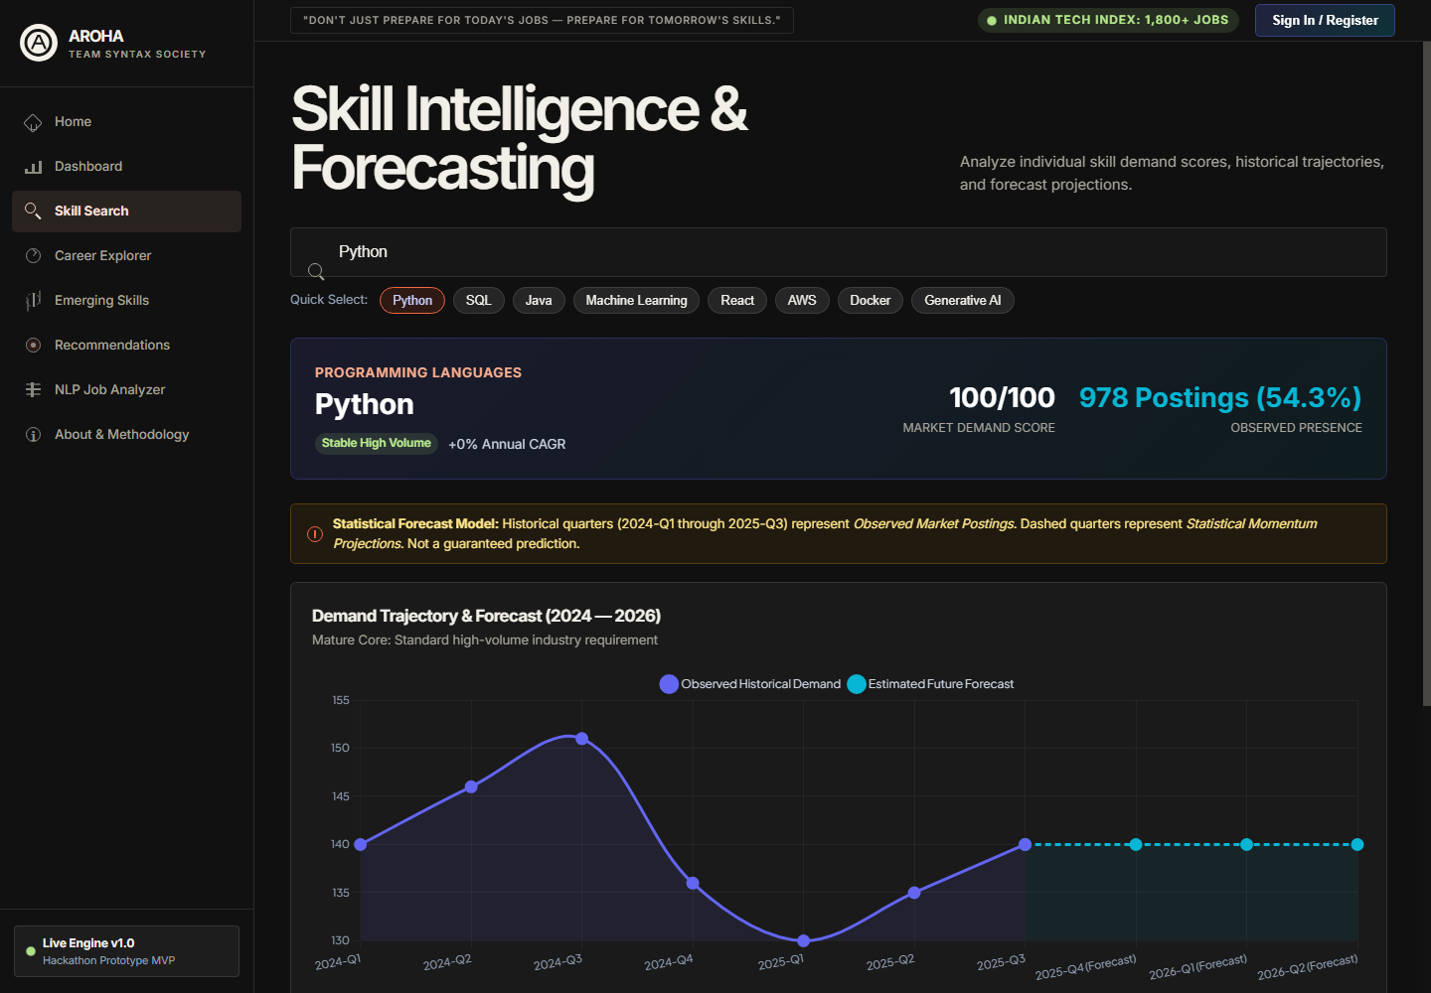
Figure 7. AROHA Skill Search feature screen.

4. Career Explorer
Compares job roles through salary, skills, locations and role-level evidence.
Implementation: frontend/static/js/app.js and backend/analytics_service.py
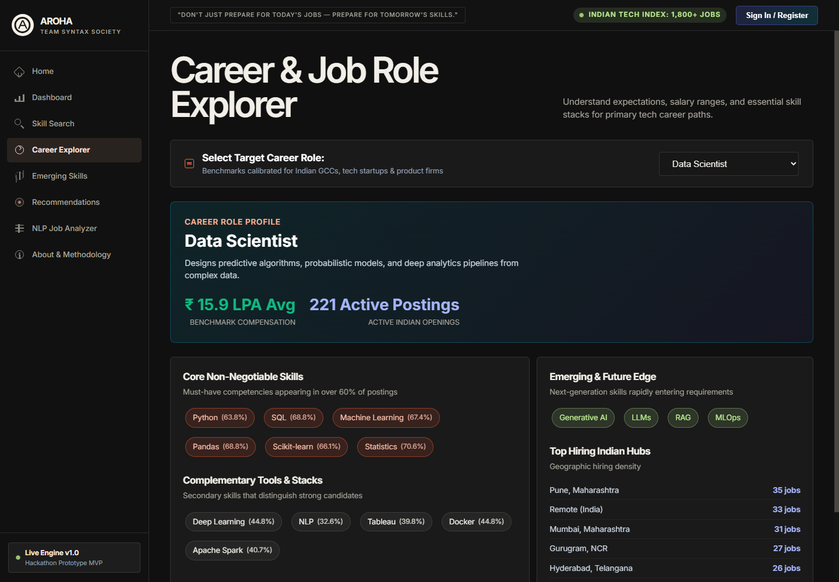
Figure 8. AROHA Career Explorer feature screen.

5. Emerging Skills
Shows frontier capabilities with adoption labels and explicit forecast caveats.
Implementation: backend/analytics_service.py
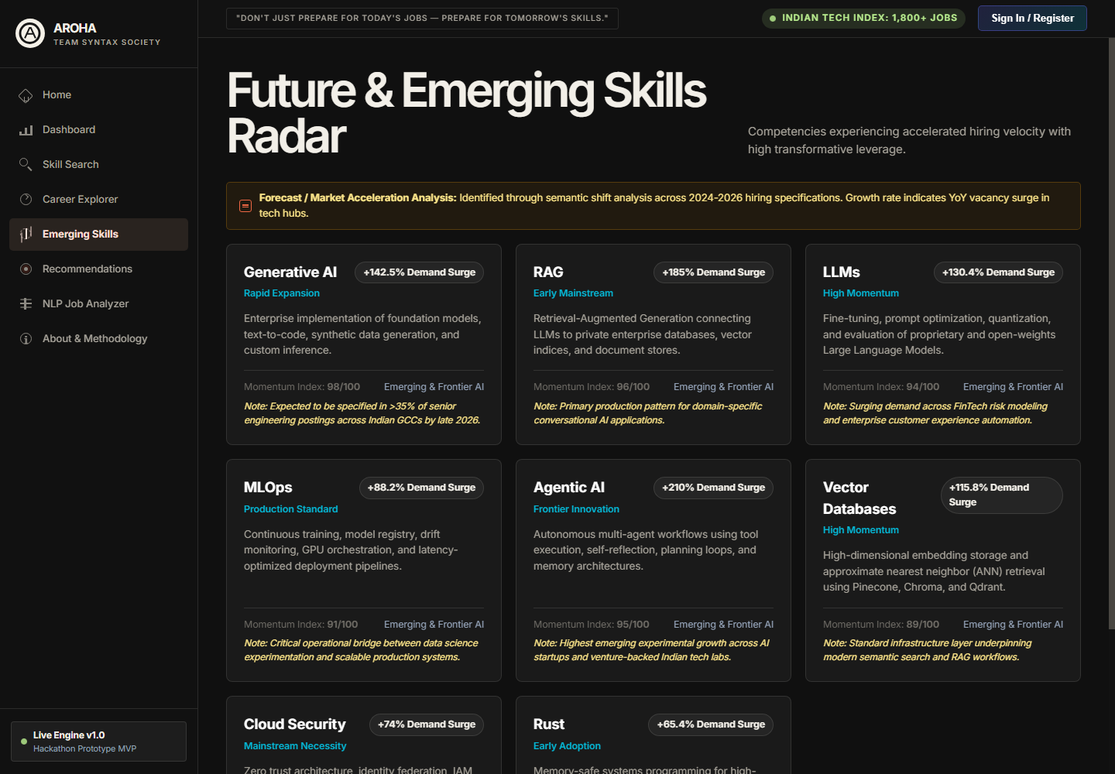
Figure 9. AROHA Emerging Skills feature screen.

6. Skill Gap and Resume Import
Accepts a candidate profile or resume, identifies skills, calculates alignment and returns a structured roadmap.
Implementation: backend/app.py, services/recommender_service.py and frontend/static/js/app.js
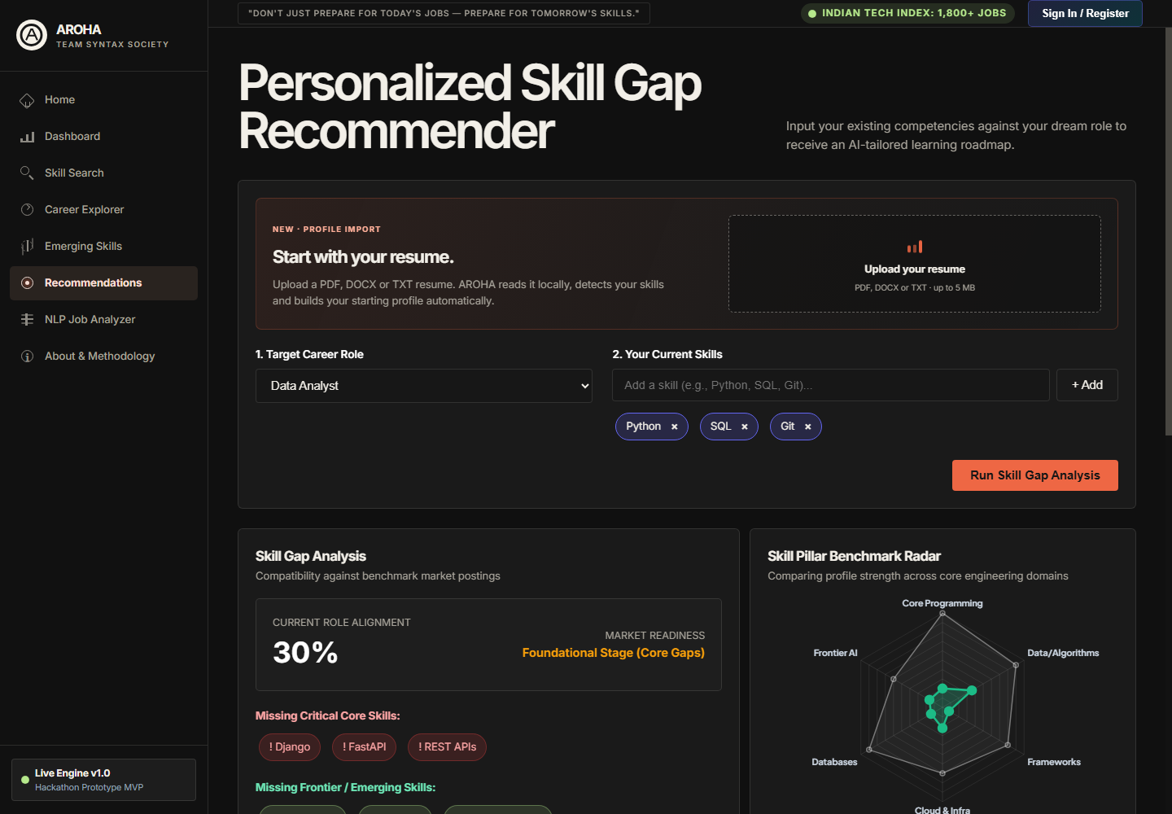
Figure 10. AROHA Skill Gap and Resume Import feature screen.

7. NLP Job Analyzer
Extracts and normalises skills from a pasted job description, then suggests matching roles.
Implementation: services/skill_extractor.py and backend/app.py
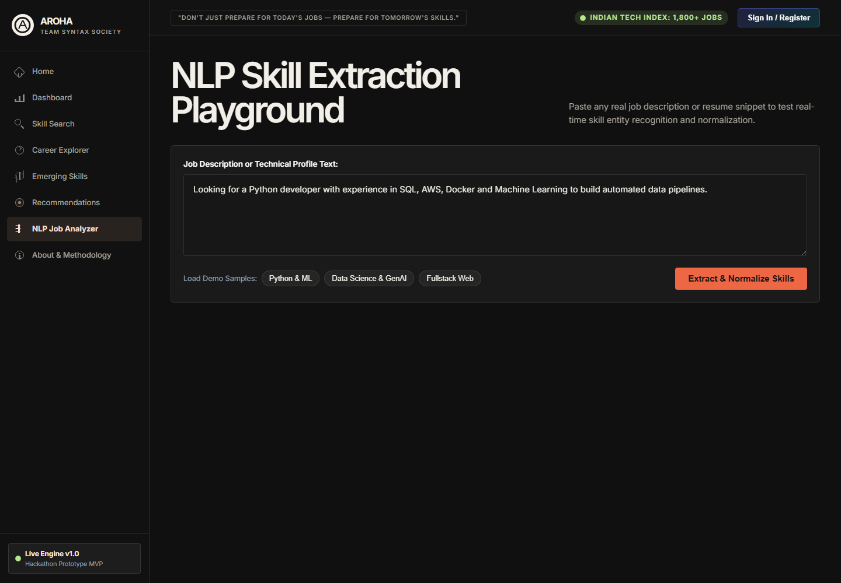
Figure 11. AROHA NLP Job Analyzer feature screen.

8. About and Methodology
Explains source data, analytical scope and the project methodology for judges and stakeholders.
Implementation: frontend/templates/index.html and services/data_service.py
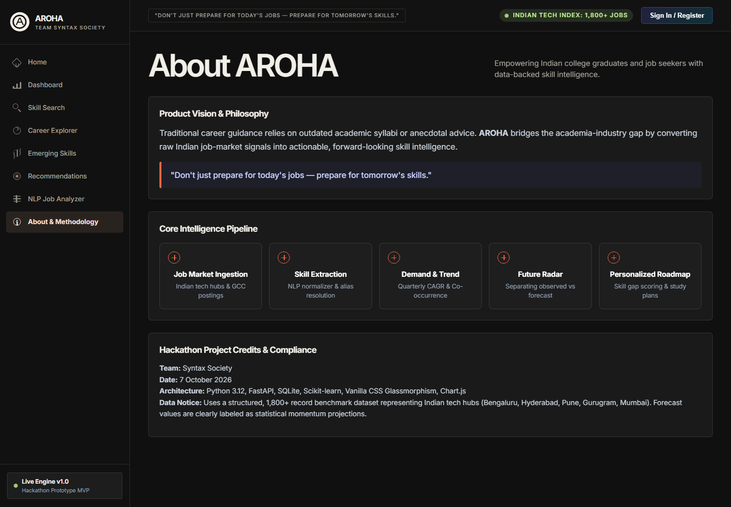
Figure 12. AROHA About and Methodology feature screen.

Feature to Code Traceability
The following map makes it straightforward for judges to connect the visible product capabilities with the relevant source code.
Feature | Primary source files | Key implementation
Navigation and views | frontend/templates/index.html; frontend/static/js/app.js | switchView controls the single-page application views
Dashboard and charts | frontend/static/js/app.js; frontend/static/js/charts.js; backend/analytics_service.py | Fetches API summaries and renders interactive charts
Skill intelligence | services/scoring.py; backend/analytics_service.py | Computes explainable score and market metrics
Role analysis | backend/analytics_service.py; utils/constants.py | Returns role requirements, salary and skill evidence
Resume upload | backend/app.py; frontend/static/js/app.js | Validates document, extracts text in memory and maps skills
Recommendations | services/recommender_service.py | Ranks capability gaps and creates learning roadmap
NLP extraction | services/skill_extractor.py; utils/normalizer.py | Extracts aliases and normalises canonical skills

Client Workflow Code
The browser-side upload workflow validates the selected file, posts it as multipart form data and refreshes the user profile with detected skills before requesting a new recommendation.
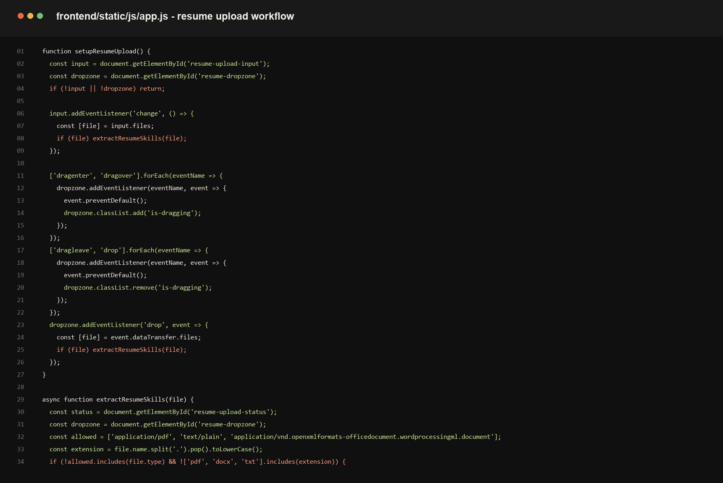
Figure 13. Client-side resume upload and profile refresh workflow.

Recommendation Service Code
The recommendation service compares the profile with the selected target role and returns prioritised gaps together with evidence-oriented learning steps.
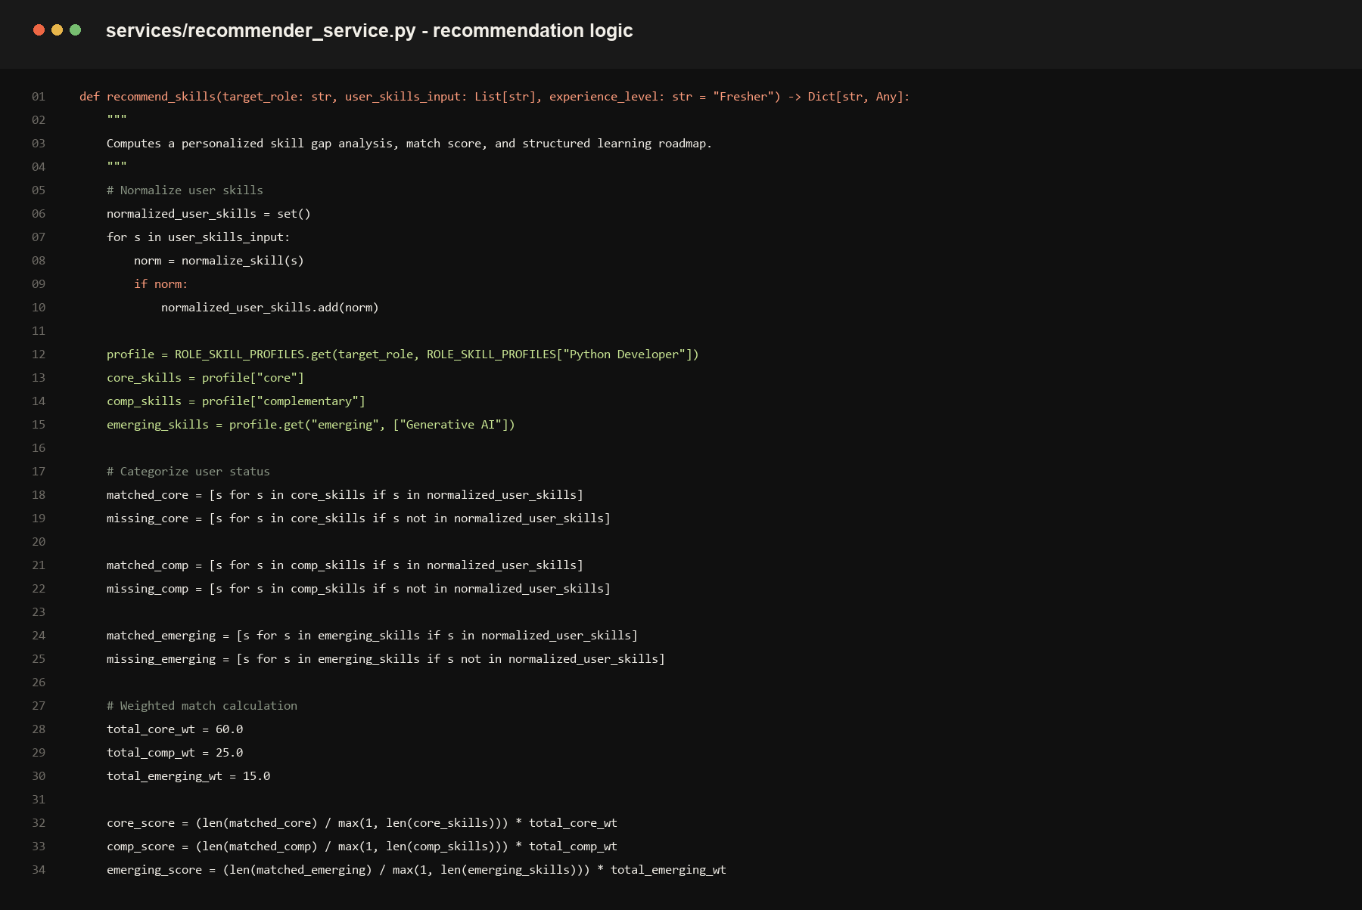
Figure 14. Server-side recommendation service excerpt.

User Manual
This manual describes how a judge or first-time user can use the MVP from the home screen to a personalised recommendation.

Starting the Application
- Install requirements with: python -m pip install -r requirements.txt.
- Run the FastAPI experience with: python run.py --fastapi.
- Open http://127.0.0.1:8000 in a browser.
- Use the Home page to begin with either Analyse my profile or Explore the market.

Using Market Intelligence
- Open Dashboard to review high-level market volume, leading skills and industry demand charts.
- Open Skill Search, enter a skill such as Python or SQL, then inspect its demand, related skills and forecast panel.
- Open Career Explorer, select a target role and review salary, core skills and location information.
- Open Emerging Skills to review frontier technologies. Treat these as labelled analytical signals rather than guarantees.

Creating a Personal Skill Gap Analysis
- Open Recommendations from the left navigation.
- Choose the target career role from the first selector.
- Upload a PDF, DOCX or TXT resume up to 5 MB, or add skills manually.
- After extraction, confirm the skill chips that were added to your profile. Remove a chip if it does not apply.
- Select Run Skill Gap Analysis.
- Review role alignment, missing core capabilities, frontier skills, the benchmark radar and the learning roadmap.

Analysing a Job Description
- Open NLP Job Analyzer.
- Paste a job description into the text area and select Extract and Normalize Skills.
- Use the returned canonical skills and matching-role suggestions to compare the listing with your current profile.

Data and Privacy Notes
- Uploaded resumes are read in memory for extraction and are not stored by the API endpoint.
- Text-based PDFs work best. Scanned image-only PDFs may not provide readable text.
- The tool provides decision support, not a hiring or psychological assessment. Salary relationships are observational, not causal.

