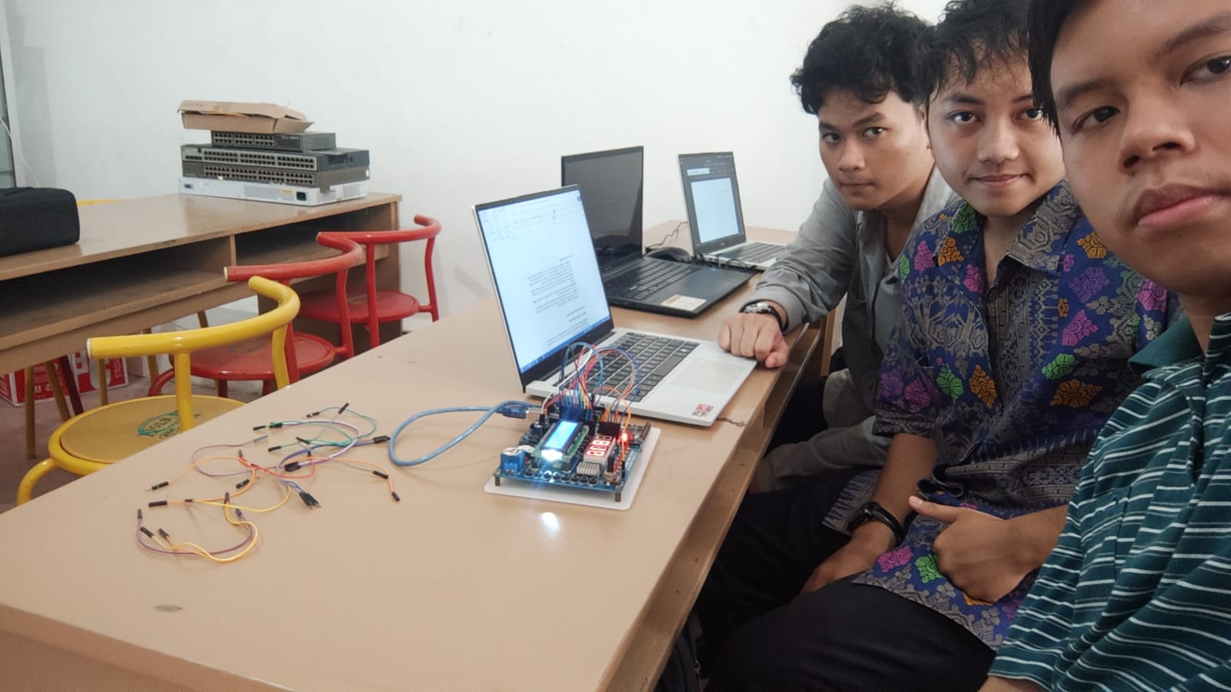
Kelompok 1 kelas 46
Nama dan NIM : - Nazril Anbiya Rasyada (310124023851)
- Jonathan Andrew Wijaya (310124023844)
- Muhammad Iqbal Fahrezi (310124023855)
Tanggal : 07 Mei 2026
1. Modifikasi : Percobaan menggabungkan B dan D. Jika potensiometer diputar maksimal maka akan menampilkan tulisan “FULL”.
Code nya :
const int potPin = A0;
int digitPins[4] = { 10, 11, 12, 13 };
int lastValue = 0;

void setup() {
for (int i = 2; i <= 9; i++) pinMode(i, OUTPUT);
for (int i = 0; i < 4; i++) {
pinMode(digitPins[i], OUTPUT);
digitalWrite(digitPins[i], HIGH);
}
Serial.begin(19200);
}

void angkaNol() {
digitalWrite(2, LOW);
digitalWrite(3, LOW);
digitalWrite(4, LOW);
digitalWrite(5, LOW);
digitalWrite(6, LOW);
digitalWrite(7, LOW);
digitalWrite(8, HIGH);
digitalWrite(9, HIGH);
}
void angkaSatu() {
digitalWrite(2, HIGH);
digitalWrite(3, LOW);
digitalWrite(4, LOW);
digitalWrite(5, HIGH);
digitalWrite(6, HIGH);
digitalWrite(7, HIGH);
digitalWrite(8, HIGH);
digitalWrite(9, HIGH);
}
void angkaDua() {
digitalWrite(2, LOW);
digitalWrite(3, LOW);
digitalWrite(4, HIGH);
digitalWrite(5, LOW);
digitalWrite(6, LOW);
digitalWrite(7, HIGH);
digitalWrite(8, LOW);
digitalWrite(9, HIGH);
}
void angkaTiga() {
digitalWrite(2, LOW);
digitalWrite(3, LOW);
digitalWrite(4, LOW);
digitalWrite(5, LOW);
digitalWrite(6, HIGH);
digitalWrite(7, HIGH);
digitalWrite(8, LOW);
digitalWrite(9, HIGH);
}
void angkaEmpat() {
digitalWrite(2, HIGH);
digitalWrite(3, LOW);
digitalWrite(4, LOW);
digitalWrite(5, HIGH);
digitalWrite(6, HIGH);
digitalWrite(7, LOW);
digitalWrite(8, LOW);
digitalWrite(9, HIGH);
}
void angkaLima() {
digitalWrite(2, LOW);
digitalWrite(3, HIGH);
digitalWrite(4, LOW);
digitalWrite(5, LOW);
digitalWrite(6, HIGH);
digitalWrite(7, LOW);
digitalWrite(8, LOW);
digitalWrite(9, HIGH);
}
void angkaEnam() {
digitalWrite(2, LOW);
digitalWrite(3, HIGH);
digitalWrite(4, LOW);
digitalWrite(5, LOW);
digitalWrite(6, LOW);
digitalWrite(7, LOW);
digitalWrite(8, LOW);
digitalWrite(9, HIGH);
}
void angkaTujuh() {
digitalWrite(2, LOW);
digitalWrite(3, LOW);
digitalWrite(4, LOW);
digitalWrite(5, HIGH);
digitalWrite(6, HIGH);
digitalWrite(7, HIGH);
digitalWrite(8, HIGH);
digitalWrite(9, HIGH);
}
void angkaDelapan() {
digitalWrite(2, LOW);
digitalWrite(3, LOW);
digitalWrite(4, LOW);
digitalWrite(5, LOW);
digitalWrite(6, LOW);
digitalWrite(7, LOW);
digitalWrite(8, LOW);
digitalWrite(9, HIGH);
}
void angkaSembilan() {
digitalWrite(2, LOW);
digitalWrite(3, LOW);
digitalWrite(4, LOW);
digitalWrite(5, LOW);
digitalWrite(6, HIGH);
digitalWrite(7, LOW);
digitalWrite(8, LOW);
digitalWrite(9, HIGH);
}

void tampilkanAngka(int num) {
switch (num) {
case 0: angkaNol(); break;
case 1: angkaSatu(); break;
case 2: angkaDua(); break;
case 3: angkaTiga(); break;
case 4: angkaEmpat(); break;
case 5: angkaLima(); break;
case 6: angkaEnam(); break;
case 7: angkaTujuh(); break;
case 8: angkaDelapan(); break;
case 9: angkaSembilan(); break;
default: angkaNol(); break;
}
}

void tampilkanF() {
//F
digitalWrite(2, LOW);
digitalWrite(3, HIGH);
digitalWrite(4, HIGH);
digitalWrite(5, HIGH);
digitalWrite(6, LOW);
digitalWrite(7, LOW);
digitalWrite(8, LOW);
digitalWrite(9, HIGH);
}
void tampilkanU() {
digitalWrite(2, HIGH);
digitalWrite(3, LOW);
digitalWrite(4, LOW);
digitalWrite(5, LOW);
digitalWrite(6, LOW);
digitalWrite(7, LOW);
digitalWrite(8, HIGH);
digitalWrite(9, HIGH);
}

void tampilkanL() {
digitalWrite(2, HIGH);
digitalWrite(3, HIGH);
digitalWrite(4, HIGH);
digitalWrite(5, LOW);
digitalWrite(6, LOW);
digitalWrite(7, LOW);
digitalWrite(8, HIGH);
digitalWrite(9, HIGH);
}

void tampilkanADC(int nilai) {
int ribuan = nilai / 1000;
int ratusan = (nilai % 1000) / 100;
int puluhan = (nilai % 100) / 10;
int satuan = nilai % 10;
int d = 3;

if (nilai < 10) {
digitalWrite(digitPins[3], LOW);
tampilkanAngka(satuan);
delay(d);
digitalWrite(digitPins[3], HIGH);
} else if (nilai < 100) {
digitalWrite(digitPins[2], LOW);
tampilkanAngka(puluhan);
delay(d);
digitalWrite(digitPins[2], HIGH);
digitalWrite(digitPins[3], LOW);
tampilkanAngka(satuan);
delay(d);
digitalWrite(digitPins[3], HIGH);
} else if (nilai < 1000) {
digitalWrite(digitPins[1], LOW);
tampilkanAngka(ratusan);
delay(d);
digitalWrite(digitPins[1], HIGH);
digitalWrite(digitPins[2], LOW);
tampilkanAngka(puluhan);
delay(d);
digitalWrite(digitPins[2], HIGH);
digitalWrite(digitPins[3], LOW);
tampilkanAngka(satuan);
delay(d);
digitalWrite(digitPins[3], HIGH);
} else if (nilai < 1016) {
digitalWrite(digitPins[0], LOW);
tampilkanAngka(ribuan);
delay(d);
digitalWrite(digitPins[0], HIGH);
digitalWrite(digitPins[1], LOW);
tampilkanAngka(ratusan);
delay(d);
digitalWrite(digitPins[1], HIGH);
digitalWrite(digitPins[2], LOW);
tampilkanAngka(puluhan);
delay(d);
digitalWrite(digitPins[2], HIGH);
digitalWrite(digitPins[3], LOW);
tampilkanAngka(satuan);
delay(d);
digitalWrite(digitPins[3], HIGH);
} else {
digitalWrite(digitPins[0], LOW);
tampilkanF();
delay(d);
digitalWrite(digitPins[0], HIGH);
digitalWrite(digitPins[1], LOW);
tampilkanU();
delay(d);
digitalWrite(digitPins[1], HIGH);
digitalWrite(digitPins[2], LOW);
tampilkanL();
delay(d);
digitalWrite(digitPins[2], HIGH);
digitalWrite(digitPins[3], LOW);
tampilkanL();
digitalWrite(digitPins[3], HIGH);
}
}

void loop() {
long total = 0;
for (int i = 0; i < 10; i++) {
total += analogRead(potPin);
}
int sensorValue = total / 10;

if (abs(sensorValue - lastValue) > 2) {
lastValue = sensorValue;
}

Serial.print("Nilai potensiometer: ");
Serial.println(lastValue);

for (int i = 0; i < 100; i++) {
tampilkanADC(lastValue);
}
}
Ini adalah foto pada board modul mikro master V2 :
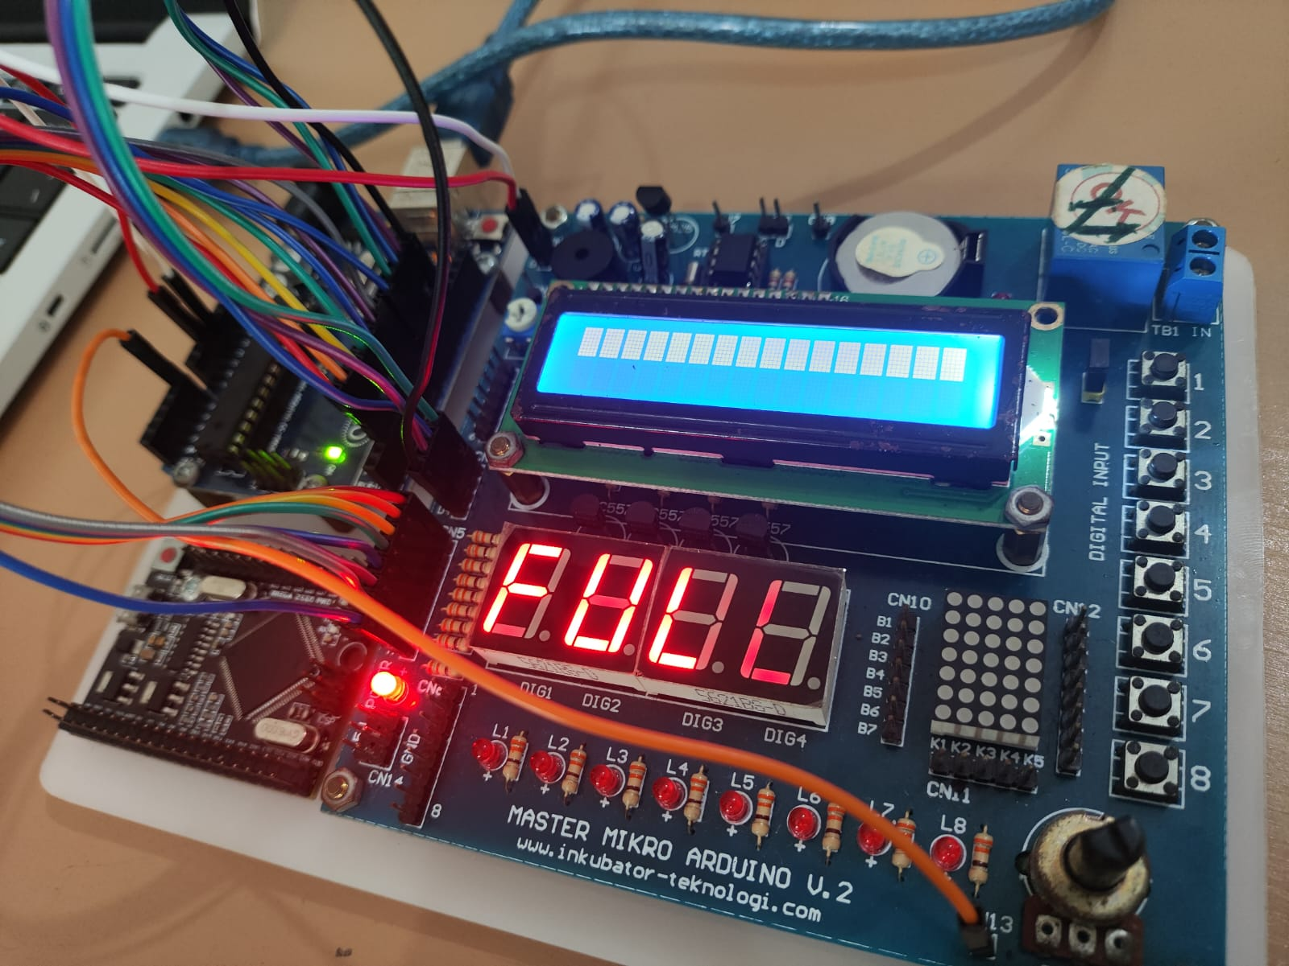

2. Analisis : Mengapa penggunaan delay(1000) di dalam void loop pada Percobaan D akan merusak tampilan pada display? Jelaskan solusinya
Code :
// Scanning 7-Segmen Display & Input Potensiometer (Right Aligned, Stabil)

const int potPin = A0;
int digitPins[4] = { 10, 11, 12, 13 }; // Digit 1 (kiri) sampai Digit 4 (kanan)
int lastValue = 0; // menyimpan nilai terakhir

// ---------------------------
// SETUP
// ---------------------------
void setup() {
for (int i = 2; i <= 9; i++) pinMode(i, OUTPUT);
for (int i = 0; i < 4; i++) {
pinMode(digitPins[i], OUTPUT);
digitalWrite(digitPins[i], HIGH); // default OFF
}
Serial.begin(19200);
}

// ---------------------------
// PROSEDUR ANGKA 0–9
// ---------------------------
void angkaNol() {
digitalWrite(2, LOW);
digitalWrite(3, LOW);
digitalWrite(4, LOW);
digitalWrite(5, LOW);
digitalWrite(6, LOW);
digitalWrite(7, LOW);
digitalWrite(8, HIGH);
digitalWrite(9, HIGH);
}
void angkaSatu() {
digitalWrite(2, HIGH);
digitalWrite(3, LOW);
digitalWrite(4, LOW);
digitalWrite(5, HIGH);
digitalWrite(6, HIGH);
digitalWrite(7, HIGH);
digitalWrite(8, HIGH);
digitalWrite(9, HIGH);
}
void angkaDua() {
digitalWrite(2, LOW);
digitalWrite(3, LOW);
digitalWrite(4, HIGH);
digitalWrite(5, LOW);
digitalWrite(6, LOW);
digitalWrite(7, HIGH);
digitalWrite(8, LOW);
digitalWrite(9, HIGH);
}
void angkaTiga() {
digitalWrite(2, LOW);
digitalWrite(3, LOW);
digitalWrite(4, LOW);
digitalWrite(5, LOW);
digitalWrite(6, HIGH);
digitalWrite(7, HIGH);
digitalWrite(8, LOW);
digitalWrite(9, HIGH);
}
void angkaEmpat() {
digitalWrite(2, HIGH);
digitalWrite(3, LOW);
digitalWrite(4, LOW);
digitalWrite(5, HIGH);
digitalWrite(6, HIGH);
digitalWrite(7, LOW);
digitalWrite(8, LOW);
digitalWrite(9, HIGH);
}
void angkaLima() {
digitalWrite(2, LOW);
digitalWrite(3, HIGH);
digitalWrite(4, LOW);
digitalWrite(5, LOW);
digitalWrite(6, HIGH);
digitalWrite(7, LOW);
digitalWrite(8, LOW);
digitalWrite(9, HIGH);
}
void angkaEnam() {
digitalWrite(2, LOW);
digitalWrite(3, HIGH);
digitalWrite(4, LOW);
digitalWrite(5, LOW);
digitalWrite(6, LOW);
digitalWrite(7, LOW);
digitalWrite(8, LOW);
digitalWrite(9, HIGH);
}
void angkaTujuh() {
digitalWrite(2, LOW);
digitalWrite(3, LOW);
digitalWrite(4, LOW);
digitalWrite(5, HIGH);
digitalWrite(6, HIGH);
digitalWrite(7, HIGH);
digitalWrite(8, HIGH);
digitalWrite(9, HIGH);
}
void angkaDelapan() {
digitalWrite(2, LOW);
digitalWrite(3, LOW);
digitalWrite(4, LOW);
digitalWrite(5, LOW);
digitalWrite(6, LOW);
digitalWrite(7, LOW);
digitalWrite(8, LOW);
digitalWrite(9, HIGH);
}
void angkaSembilan() {
digitalWrite(2, LOW);
digitalWrite(3, LOW);
digitalWrite(4, LOW);
digitalWrite(5, LOW);
digitalWrite(6, HIGH);
digitalWrite(7, LOW);
digitalWrite(8, LOW);
digitalWrite(9, HIGH);
}

void tampilkanAngka(int num) {
switch (num) {
case 0: angkaNol(); break;
case 1: angkaSatu(); break;
case 2: angkaDua(); break;
case 3: angkaTiga(); break;
case 4: angkaEmpat(); break;
case 5: angkaLima(); break;
case 6: angkaEnam(); break;
case 7: angkaTujuh(); break;
case 8: angkaDelapan(); break;
case 9: angkaSembilan(); break;
default: angkaNol(); break;
}
}

// ---------------------------
// FUNGSI MENAMPILKAN NILAI ADC KE DISPLAY (RATA KANAN)
// ---------------------------
void tampilkanADC(int nilai) {
int ribuan = nilai / 1000;
int ratusan = (nilai % 1000) / 100;
int puluhan = (nilai % 100) / 10;
int satuan = nilai % 10;

if (nilai < 10) {
digitalWrite(digitPins[3], LOW);
tampilkanAngka(satuan);
delay(1000);
digitalWrite(digitPins[3], HIGH);
} else if (nilai < 100) {
digitalWrite(digitPins[2], LOW);
tampilkanAngka(puluhan);
delay(1000);
digitalWrite(digitPins[2], HIGH);
digitalWrite(digitPins[3], LOW);
tampilkanAngka(satuan);
delay(1000);
digitalWrite(digitPins[3], HIGH);
} else if (nilai < 1000) {
digitalWrite(digitPins[1], LOW);
tampilkanAngka(ratusan);
delay(1000);
digitalWrite(digitPins[1], HIGH);
digitalWrite(digitPins[2], LOW);
tampilkanAngka(puluhan);
delay(1000);
digitalWrite(digitPins[2], HIGH);
digitalWrite(digitPins[3], LOW);
tampilkanAngka(satuan);
delay(1000);
digitalWrite(digitPins[3], HIGH);
} else {
digitalWrite(digitPins[0], LOW);
tampilkanAngka(ribuan);
delay(1000);
digitalWrite(digitPins[0], HIGH);
digitalWrite(digitPins[1], LOW);
tampilkanAngka(ratusan);
delay(1000);
digitalWrite(digitPins[1], HIGH);
digitalWrite(digitPins[2], LOW);
tampilkanAngka(puluhan);
delay(1000);
digitalWrite(digitPins[2], HIGH);
digitalWrite(digitPins[3], LOW);
tampilkanAngka(satuan);
delay(1000);
digitalWrite(digitPins[3], HIGH);
}
}

// ---------------------------
// LOOP UTAMA
// ---------------------------
void loop() {
// ambil rata-rata 10 pembacaan untuk stabilisasi
long total = 0;
for (int i = 0; i < 10; i++) {
total += analogRead(potPin);
}
int sensorValue = total / 10;

// update hanya jika beda cukup besar
if (abs(sensorValue - lastValue) > 2) {
lastValue = sensorValue;
}

Serial.print("Nilai potensiometer: ");
Serial.println(lastValue);

// scanning berulang agar tampilan solid
for (int i = 0; i < 100; i++) {
tampilkanADC(lastValue);
}
}

Penjelasan dan solusi :
Apabila code tersebut diganti dengan delay(1000) pada percobaan D maka, display angkanya menjadi yang awalnya 2 milisecond menjadi 1000 milisecond (1 second) jadi yang awalnya menampilkan sepersekian detik (sangat cepat) menjadi satu detik yang mana kedipan angka nya menjadi lambat karena jeda atau delay nya menjadi satu detik.
Solusi yang bisa kami berikan adalah, apabila tetap ingin menstabilkan display angka maka delay yang ditetapkan sebaiknya tetap berkisar antara 2-5 milisecond agar jeda pada setiap munculnya angka tidak terlalu lama.

3. Analisis Kode: Mengapa kita harus memberikan perintah digitalWrite(dig[i], HIGH) setelah melakukan delay(3)? Apa yang akan terjadi jika baris tersebut dihapus?

Jawaban : Ketika digitalWrite(dig[i], HIGH) diaktifkan maka digit pada index i tersebut akan mati entah itu digit index 3 (sebagai ribuan), 2 (sebagai ratusan), 1 (sebagai puluhan), dan 0 (sebagai satuan) akan mati. Jadi yang sebenarnya terjadi itu digitalWrite(digitalPins[i], HIGH ) digunakan untuk bergantian dengan index i lainnya.
Misalnya kita punya angka 25, pertama angka puluhan nya menyala dalam kasus ini 2 akan menyala terlebih dahulu dalam 3 miliseconds, lalu kita matikan angka puluhan nya ( yaitu angka 2) dengan digitalWrite(dig[i], HIGH) dan kita menyalakan angka satuan nya (yaitu angka 5) dengan digitalWrite(dig[i], LOW) setelahnya.
Jadi yang sebenarnya terjadi itu angka 2 dan 5 menyala bergantian selama 3 miliseconds dan mata manusia tidak bisa melihatnya, jadi terlihat seperti 2 dan 5 menyala terus secara bersamaan.
Apa yang terjadi jika baris tersebut dihapus ? Jika baris tersebut dihapus (yang ada HIGH) maka dampaknya akan membuat angka (kita gunakan 25 lagi sebagai contoh), maka 25 nya akan menyala bersamaan, bisa dibilang 2 nya tampil tapi 5 nya juga ditampilkan tanpa perlu mematikan 2. Ini akan menjadi masalah karena digit puluhan dan satuan menjadi LOW didalam waktu yang sama. Angka 25 akan menjadi ter overwrite atau bertumpuk apabila kita putar potensiometer entah itu ke kiri atau ke kanan nya yang mengakibatkan angka menjadi samar yang awalnya 25 bisa menjadi 28, 85, 55, dsb sesuai dengan pola pada segment tampilanAngka()
4. Eksperimen: Ubah angka 3026 pada kode di atas menjadi 4 digit terakhir NIM Anda masing-masing. Amati hasilnya.

Jawaban :
Karena tidak tertera apakah wajib menggunakan ADC atau tidak dengan ADC nya scaling ke 3800-an atau boleh mengganti angka statis nya saja, maka karena tidak adanya modul arduino yang bisa kami pakai untuk melakukan scaling, kami akan mencoba mengganti angka statis nya saja.

Nazril Anbiya Rasyada (3851), Code nya :

const int digitPins[4] = {10, 11, 12, 13};

void setup() {

// pin a sampe g + dp
for (int i = 2; i <= 9; i++) {
pinMode(i, OUTPUT);
}

// pin digit
for (int i = 0; i < 4; i++) {
pinMode(digitPins[i], OUTPUT);
digitalWrite(digitPins[i], HIGH);
}
}

void allDigitOff() {
for (int i = 0; i < 4; i++) {
digitalWrite(digitPins[i], HIGH);
}
}

void printNumbers(int number) {

switch(number) {

case 0:
digitalWrite(2, LOW);
digitalWrite(3, LOW);
digitalWrite(4, LOW);
digitalWrite(5, LOW);
digitalWrite(6, LOW);
digitalWrite(7, LOW);
digitalWrite(8, HIGH);
break;

case 1:
digitalWrite(2, HIGH);
digitalWrite(3, LOW);
digitalWrite(4, LOW);
digitalWrite(5, HIGH);
digitalWrite(6, HIGH);
digitalWrite(7, HIGH);
digitalWrite(8, HIGH);
break;

case 2:
digitalWrite(2, LOW);
digitalWrite(3, LOW);
digitalWrite(4, HIGH);
digitalWrite(5, LOW);
digitalWrite(6, LOW);
digitalWrite(7, HIGH);
digitalWrite(8, LOW);
break;

case 3:
digitalWrite(2, LOW);
digitalWrite(3, LOW);
digitalWrite(4, LOW);
digitalWrite(5, LOW);
digitalWrite(6, HIGH);
digitalWrite(7, HIGH);
digitalWrite(8, LOW);
break;

case 4:
digitalWrite(2, HIGH);
digitalWrite(3, LOW);
digitalWrite(4, LOW);
digitalWrite(5, HIGH);
digitalWrite(6, HIGH);
digitalWrite(7, LOW);
digitalWrite(8, LOW);
break;

case 5:
digitalWrite(2, LOW);
digitalWrite(3, HIGH);
digitalWrite(4, LOW);
digitalWrite(5, LOW);
digitalWrite(6, HIGH);
digitalWrite(7, LOW);
digitalWrite(8, LOW);
break;

case 6:
digitalWrite(2, LOW);
digitalWrite(3, HIGH);
digitalWrite(4, LOW);
digitalWrite(5, LOW);
digitalWrite(6, LOW);
digitalWrite(7, LOW);
digitalWrite(8, LOW);
break;

case 7:
digitalWrite(2, LOW);
digitalWrite(3, LOW);
digitalWrite(4, LOW);
digitalWrite(5, HIGH);
digitalWrite(6, HIGH);
digitalWrite(7, HIGH);
digitalWrite(8, HIGH);
break;

case 8:
digitalWrite(2, LOW);
digitalWrite(3, LOW);
digitalWrite(4, LOW);
digitalWrite(5, LOW);
digitalWrite(6, LOW);
digitalWrite(7, LOW);
digitalWrite(8, LOW);
break;

case 9:
digitalWrite(2, LOW);
digitalWrite(3, LOW);
digitalWrite(4, LOW);
digitalWrite(5, LOW);
digitalWrite(6, HIGH);
digitalWrite(7, LOW);
digitalWrite(8, LOW);
break;
}
digitalWrite(9, HIGH); // dp nya mati soalnya tidak butuh utk menulis NIM
}

void loop() {

// digit 1 = 3
allDigitOff();
digitalWrite(digitPins[0], LOW);
printNumbers(3);
delay(3);
digitalWrite(digitPins[0], HIGH);

// digit 2 = 8
allDigitOff();
digitalWrite(digitPins[1], LOW);
printNumbers(8);
delay(3);
digitalWrite(digitPins[1], HIGH);

// digit 3 = 5
allDigitOff();
digitalWrite(digitPins[2], LOW);
printNumbers(5);
delay(3);
digitalWrite(digitPins[2], HIGH);

// digit 4 = 1
allDigitOff();
digitalWrite(digitPins[3], LOW);
printNumbers(1);
delay(3);
digitalWrite(digitPins[3], HIGH;
}

Jonathan Andrew Wijaya (3844), Code nya sama tapi kita ubah dibagian loop nya saja :

void loop() {

// digit 1 = 3
allDigitOff();
digitalWrite(digitPins[0], LOW);
printNumbers(3);
delay(3);
digitalWrite(digitPins[0], HIGH);

// digit 2 = 8
allDigitOff();
digitalWrite(digitPins[1], LOW);
printNumbers(8);
delay(3);
digitalWrite(digitPins[1], HIGH);

// digit 3 = 4
allDigitOff();
digitalWrite(digitPins[2], LOW);
printNumbers(4);
delay(3);
digitalWrite(digitPins[2], HIGH);

// digit 4 = 4
allDigitOff();
digitalWrite(digitPins[3], LOW);
printNumbers(4);
delay(3);
digitalWrite(digitPins[3], HIGH);
}

Muhammad Iqbal Fahrezi (3855), Code nya :

void loop() {
// digit 1 = 3
allDigitOff();
digitalWrite(digitPins[0], LOW);
printNumbers(3);
delay(3);
digitalWrite(digitPins[0], HIGH);

// digit 2 = 8
allDigitOff();
digitalWrite(digitPins[1], LOW);
printNumbers(8);
delay(3);
digitalWrite(digitPins[1], HIGH);

// digit 3 = 5
allDigitOff();
digitalWrite(digitPins[2], LOW);
printNumbers(5);
delay(3);
digitalWrite(digitPins[2], HIGH);

// digit 4 = 5
allDigitOff();
digitalWrite(digitPins[3], LOW);
printNumbers(5);
delay(3);
digitalWrite(digitPins[3], HIGH);

}

5. Logika: Jika kita ingin menambahkan tanda titik (Decimal Point) di antara angka 30 dan 26 (sehingga tampil 30.26), pin digital nomor berapa yang harus diberi logika HIGH? (Rujuk pada tabel wiring Pin 9).

Jawaban :

Mungkin maksudnya disini digitPins berapa yang harus diberi logika LOW karena ini active LOW, Untuk menampilkan titik atau decimal point diantara angka 30 dan 26 maka berarti kita harus mengaktifkan nya pada digit 2 atau indeks 1.

Kira-kira seperti ini :

const int digitPins[4] = {10, 11, 12, 13};

void setup() {

// pin a sampe g + dp
for (int i = 2; i <= 9; i++) {
pinMode(i, OUTPUT);
}

// pin digit
for (int i = 0; i < 4; i++) {
pinMode(digitPins[i], OUTPUT);
digitalWrite(digitPins[i], HIGH);
}
}

void allDigitOff() {
for (int i = 0; i < 4; i++) {
digitalWrite(digitPins[i], HIGH);
}
}

void printNumbers(int number) {

switch(number) {

case 0:
digitalWrite(2, LOW);
digitalWrite(3, LOW);
digitalWrite(4, LOW);
digitalWrite(5, LOW);
digitalWrite(6, LOW);
digitalWrite(7, LOW);
digitalWrite(8, HIGH);
break;

case 1:
digitalWrite(2, HIGH);
digitalWrite(3, LOW);
digitalWrite(4, LOW);
digitalWrite(5, HIGH);
digitalWrite(6, HIGH);
digitalWrite(7, HIGH);
digitalWrite(8, HIGH);
break;

case 2:
digitalWrite(2, LOW);
digitalWrite(3, LOW);
digitalWrite(4, HIGH);
digitalWrite(5, LOW);
digitalWrite(6, LOW);
digitalWrite(7, HIGH);
digitalWrite(8, LOW);
break;

case 3:
digitalWrite(2, LOW);
digitalWrite(3, LOW);
digitalWrite(4, LOW);
digitalWrite(5, LOW);
digitalWrite(6, HIGH);
digitalWrite(7, HIGH);
digitalWrite(8, LOW);
break;

case 4:
digitalWrite(2, HIGH);
digitalWrite(3, LOW);
digitalWrite(4, LOW);
digitalWrite(5, HIGH);
digitalWrite(6, HIGH);
digitalWrite(7, LOW);
digitalWrite(8, LOW);
break;

case 5:
digitalWrite(2, LOW);
digitalWrite(3, HIGH);
digitalWrite(4, LOW);
digitalWrite(5, LOW);
digitalWrite(6, HIGH);
digitalWrite(7, LOW);
digitalWrite(8, LOW);
break;

case 6:
digitalWrite(2, LOW);
digitalWrite(3, HIGH);
digitalWrite(4, LOW);
digitalWrite(5, LOW);
digitalWrite(6, LOW);
digitalWrite(7, LOW);
digitalWrite(8, LOW);
break;

case 7:
digitalWrite(2, LOW);
digitalWrite(3, LOW);
digitalWrite(4, LOW);
digitalWrite(5, HIGH);
digitalWrite(6, HIGH);
digitalWrite(7, HIGH);
digitalWrite(8, HIGH);
break;

case 8:
digitalWrite(2, LOW);
digitalWrite(3, LOW);
digitalWrite(4, LOW);
digitalWrite(5, LOW);
digitalWrite(6, LOW);
digitalWrite(7, LOW);
digitalWrite(8, LOW);
break;

case 9:
digitalWrite(2, LOW);
digitalWrite(3, LOW);
digitalWrite(4, LOW);
digitalWrite(5, LOW);
digitalWrite(6, HIGH);
digitalWrite(7, LOW);
digitalWrite(8, LOW);
break;
}
digitalWrite(9, HIGH); // set DP defaultnya mati
}

void loop() {

// digit 1 = 3
allDigitOff();
digitalWrite(digitPins[0], LOW);
printNumbers(3);
delay(3);
digitalWrite(digitPins[0], HIGH)

// digit 2 = 0
allDigitOff();
digitalWrite(digitPins[1], LOW);
printNumbers(0);

digitalWrite(9, LOW); // nyalakan titik (DP)

delay(3);

digitalWrite(digitPins[1], HIGH);
digitalWrite(9, HIGH); // matikan titik lagi

// digit 3 = 2
allDigitOff();
digitalWrite(digitPins[2], LOW);
printNumbers(2);
delay(3);
digitalWrite(digitPins[2], HIGH)

// digit 4 = 6
allDigitOff();
digitalWrite(digitPins[3], LOW);
printNumbers(6);
delay(3);
digitalWrite(digitPins[3], HIGH)

}
Hasil akhirnya akan menjadi 30.26

Tugas Tambahan : Instruksi: Buatlah sebuah program mandiri (bukan penggalan) untuk menampilkan angka 3026 (yang merepresentasikan tanggal 30 dan tahun 2026) secara solid dan stabil pada modul 7-segment 4-digit.

Jawab :

Karena untuk nomor sebelumnya kami sudah membuatnya maka, akan kami melakukan copy + paste saja.

const int digitPins[4] = {10, 11, 12, 13};

void setup() {

// pin a sampe g + dp
for (int i = 2; i <= 9; i++) {
pinMode(i, OUTPUT);
}

// pin digit
for (int i = 0; i < 4; i++) {
pinMode(digitPins[i], OUTPUT);
digitalWrite(digitPins[i], HIGH);
}
}

void allDigitOff() {
for (int i = 0; i < 4; i++) {
digitalWrite(digitPins[i], HIGH);
}
}

void printNumbers(int number) {

switch(number) {

case 0:
digitalWrite(2, LOW);
digitalWrite(3, LOW);
digitalWrite(4, LOW);
digitalWrite(5, LOW);
digitalWrite(6, LOW);
digitalWrite(7, LOW);
digitalWrite(8, HIGH);
break;

case 1:
digitalWrite(2, HIGH);
digitalWrite(3, LOW);
digitalWrite(4, LOW);
digitalWrite(5, HIGH);
digitalWrite(6, HIGH);
digitalWrite(7, HIGH);
digitalWrite(8, HIGH);
break;

case 2:
digitalWrite(2, LOW);
digitalWrite(3, LOW);
digitalWrite(4, HIGH);
digitalWrite(5, LOW);
digitalWrite(6, LOW);
digitalWrite(7, HIGH);
digitalWrite(8, LOW);
break;

case 3:
digitalWrite(2, LOW);
digitalWrite(3, LOW);
digitalWrite(4, LOW);
digitalWrite(5, LOW);
digitalWrite(6, HIGH);
digitalWrite(7, HIGH);
digitalWrite(8, LOW);
break;

case 4:
digitalWrite(2, HIGH);
digitalWrite(3, LOW);
digitalWrite(4, LOW);
digitalWrite(5, HIGH);
digitalWrite(6, HIGH);
digitalWrite(7, LOW);
digitalWrite(8, LOW);
break;

case 5:
digitalWrite(2, LOW);
digitalWrite(3, HIGH);
digitalWrite(4, LOW);
digitalWrite(5, LOW);
digitalWrite(6, HIGH);
digitalWrite(7, LOW);
digitalWrite(8, LOW);
break;

case 6:
digitalWrite(2, LOW);
digitalWrite(3, HIGH);
digitalWrite(4, LOW);
digitalWrite(5, LOW);
digitalWrite(6, LOW);
digitalWrite(7, LOW);
digitalWrite(8, LOW);
break;

case 7:
digitalWrite(2, LOW);
digitalWrite(3, LOW);
digitalWrite(4, LOW);
digitalWrite(5, HIGH);
digitalWrite(6, HIGH);
digitalWrite(7, HIGH);
digitalWrite(8, HIGH);
break;

case 8:
digitalWrite(2, LOW);
digitalWrite(3, LOW);
digitalWrite(4, LOW);
digitalWrite(5, LOW);
digitalWrite(6, LOW);
digitalWrite(7, LOW);
digitalWrite(8, LOW);
break;

case 9:
digitalWrite(2, LOW);
digitalWrite(3, LOW);
digitalWrite(4, LOW);
digitalWrite(5, LOW);
digitalWrite(6, HIGH);
digitalWrite(7, LOW);
digitalWrite(8, LOW);
break;
}
digitalWrite(9, HIGH); // set DP defaultnya mati
}

void loop() {

// digit 1 = 3
allDigitOff();
digitalWrite(digitPins[0], LOW);
printNumbers(3);
delay(3);
digitalWrite(digitPins[0], HIGH)

// digit 2 = 0
allDigitOff();
digitalWrite(digitPins[1], LOW);
printNumbers(0);

delay(3);

digitalWrite(digitPins[1], HIGH);

// digit 3 = 2
allDigitOff();
digitalWrite(digitPins[2], LOW);
printNumbers(2);
delay(3);
digitalWrite(digitPins[2], HIGH)

// digit 4 = 6
allDigitOff();
digitalWrite(digitPins[3], LOW);
printNumbers(6);
delay(3);
digitalWrite(digitPins[3], HIGH)

}

