|  |  |
| --- | --- |
| **Topic** | ORACLE Analytic SQL |
| **Document Name** | AnalyticSQL01-EX-01-05 |
|  |  |

## Exercise EX -01:

**Definiton :** 1-List employees’ first name and last name in same department in one row.  
 Firstname Lastname; Firstname Lastname ;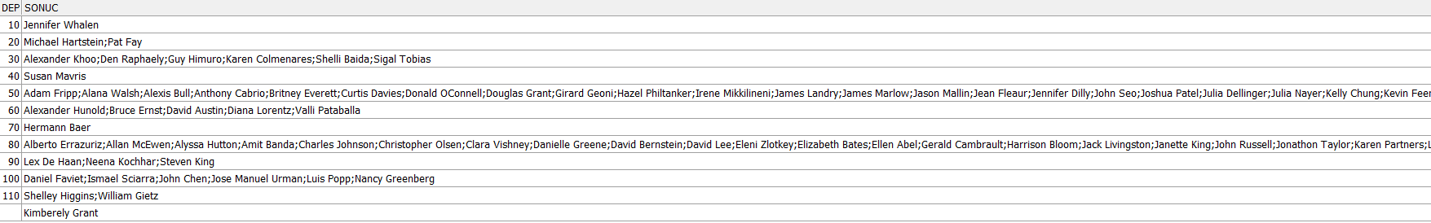

**SQL:**

**Screenshot:**

## Exercise EX -02:

**Definiton :** Write a SQL statement that shows employees’ preceeding 1 and following 1 salary totals in same job_id and ordered by hiredate.

**SQL:**

**Screenshot:**

## Exercise EX -03:

**Definiton :** List employees’ salary orders in their department and exclude higest salaried employee.

(Hint: ROW_NUMBER)

**SQL:**

**Screenshot:**

## Exercise EX -04:

**Definiton :** Listemployees’ hire order according to hiredate year value.

**SQL:**

**Screenshot:**

## Exercise EX -05:

**Definiton :** List employees’ firstname, lastname, salary and salaries of employees’ hired before and after this employee according to hirededate.

**SQL:**

**Screenshot:**