Evan Fiordeliso

CIS 4360-005

February 11, 2021

# Assignment 3: Domain Driven Design

## 1. Business Problem or Opportunity

Our business is a large photography studio that handles customers on an appointment basis. The studio handles appointments for in-studio or out-of-studio photos-shoots as well as professional editing to tailor the photos to the customer’s liking. There is an approval process in place for allowing customers to make changes to the photos when the need arises. Approved photos can be purchased as either prints or for digital download.

## 2. Main Domain Events

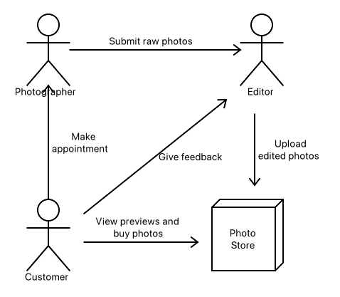

This photo demonstrates the general flow of the business’ operations. The process starts with a customer making an appointment with a photographer through an online scheduling portal. The photos from the photo-shoot are then sent to the team of editors to professionally edit them which are uploaded into a photo store. The customer can then review the previews from the edited photos and either approve them or make requests for changes or additions. The editor will then make the requested changes then re-upload the new photos for the customer to review again. Once the customer is satisfied with the resulting photos they can order them for digital download or prints to be mailed to them.

### 2.a. Sub-Teams

* Appointments and Scheduling
* Photos and Feedback
* Prints Ordering

## 3. Sub-Team

The sub team I will focus on is the Photos and Feedback sub-team. This sub-team’s responsibility is to create the systems to handle the edited photos and previews as well as the feedback process for said photos.

### 3.**a**. Requirements

* Must allow for photo editors to submit the edited photos
* Must allow for customer to access previews of the edited photos
* Must allow for the customer to approve or request changes to photos
* Must allow for the photo editors to re-submit the updated photos and mark changes as completed

### 3.b. Architectural Design

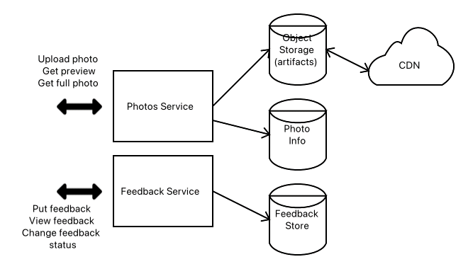

This is the overall architecture design for the Photos and Feedback sub-team.

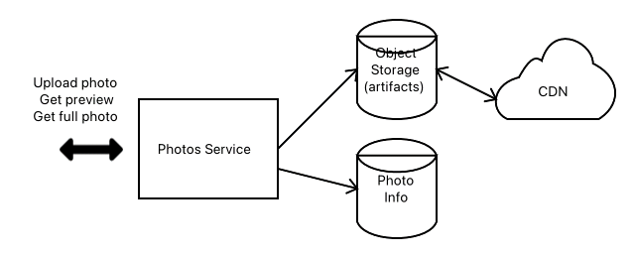This is the architecture of the photos service. The photos service will expose three endpoints: one for uploading a photo, one for getting a preview of a photo, and the last one for getting a full photo.

The actual photos will be stored in an object storage which will also be sent to a content delivery network (or CDN) for quicker access from around the globe. The metadata for the photos will be stored in a key/value database.

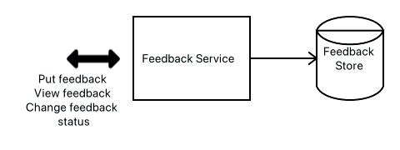This is the architecture of the feedback service. The feedback service will expose three endpoints: one for submitting feedback, one for retrieving feedback, and the last one for changing the status of the feedback. This feedback will be stored in a key/value database.

This service should not need access to the Photos Service but it could be possible that it would need information about the photo the feedback is for.