**FRA**

Video 1.1

SS7(R21-R23) 5-6 题

SS8(24-27) & SS9(28-31) 40题

SS10(R32,R33) 1-2 题应用

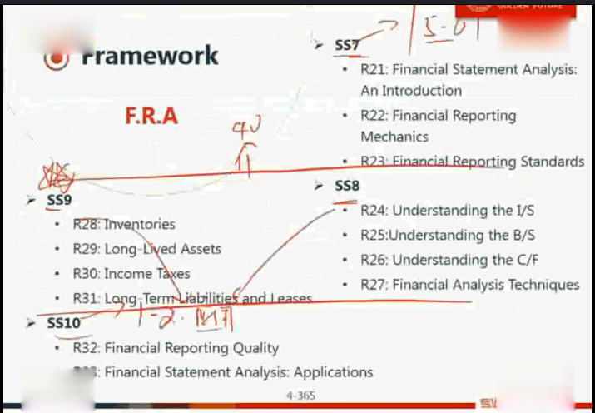

**SS7 考点**

1. B/S，I/S，C/F勾稽关系

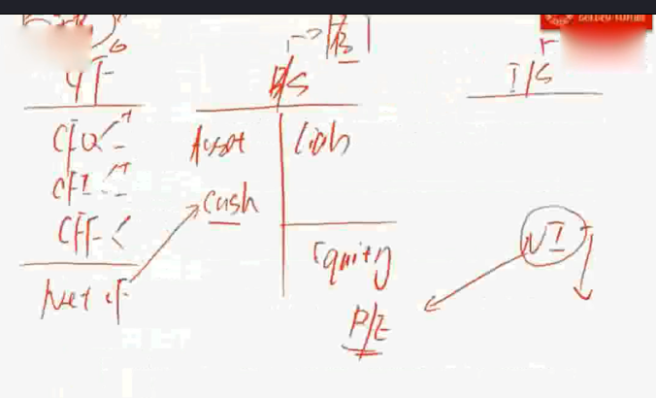

1. HC， FV（6大Cost）

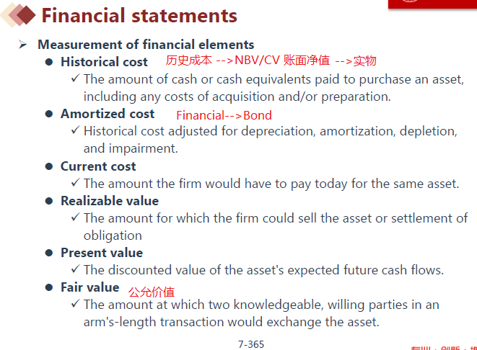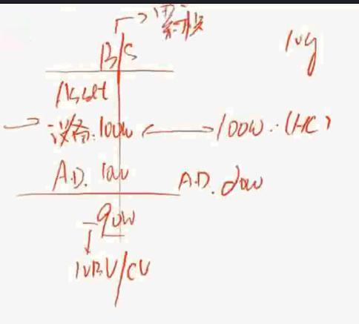

CI = NI + OCI

NI 和OCI 都影响的是Equity，不是R/E

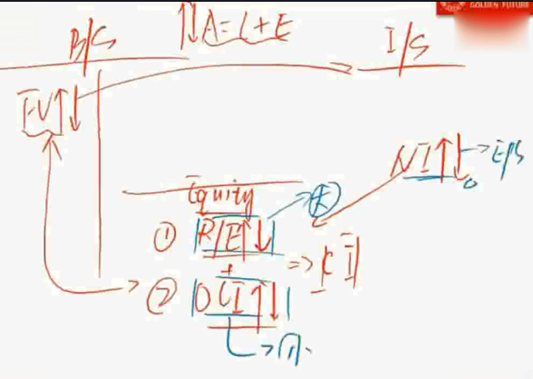

1. Other relevant info

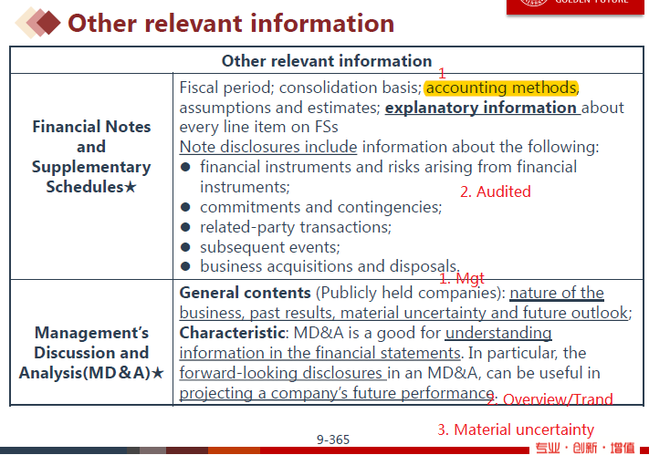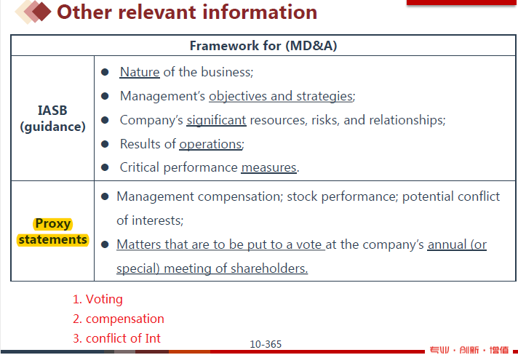

1. Audit Opinion

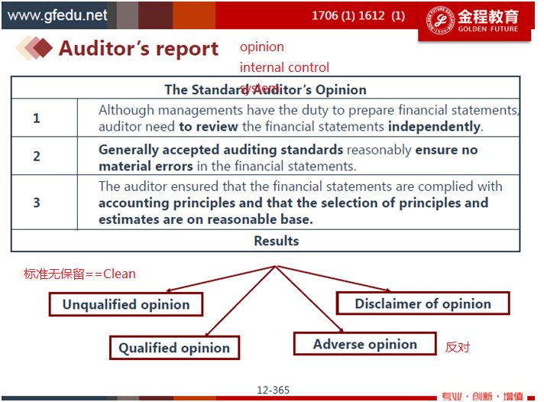

备抵账户

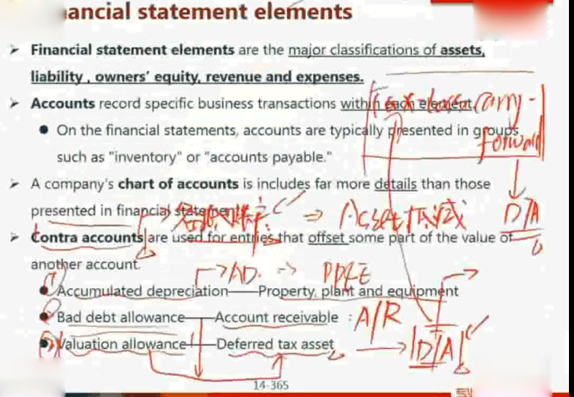

1. OCI "4+1"

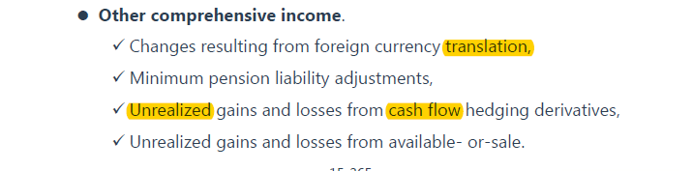

1. BASE法则 ==>B/S

Inv 和R/E

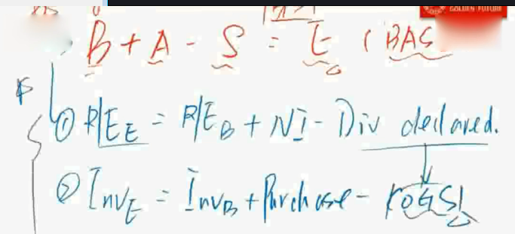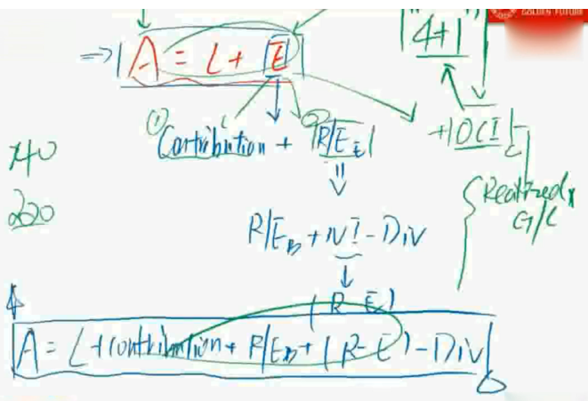

1. IFRS framework 定性（2个） & 定量（Enhancement)

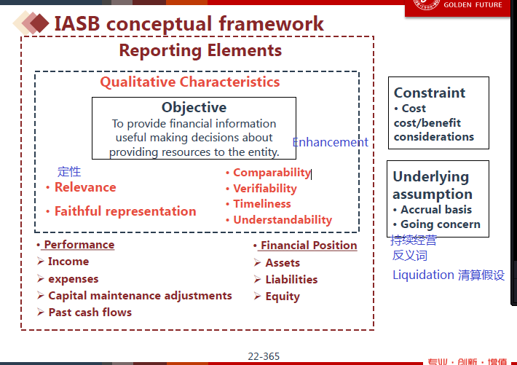

1. Accrual Basis ==>四大账户

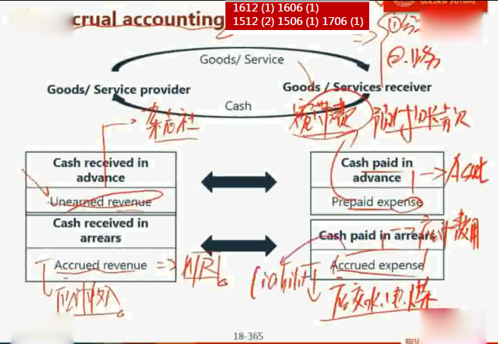

1. I/S 结构

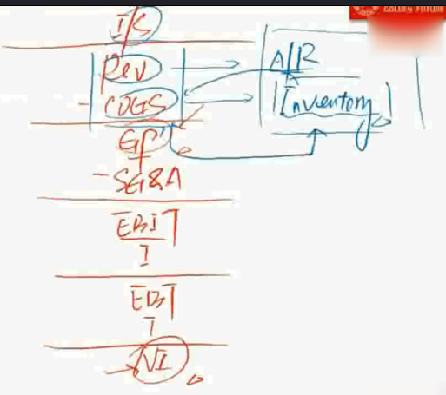

 **By nature**

✓ Depreciation expenses are displayed in one account regardless of

whether they come from manufacturing or administration.

 **By function** (cost of sales method)

✓ Cost of goods sold is composed of all manufacturing costs, such as

raw materials, depreciation, labor, etc.

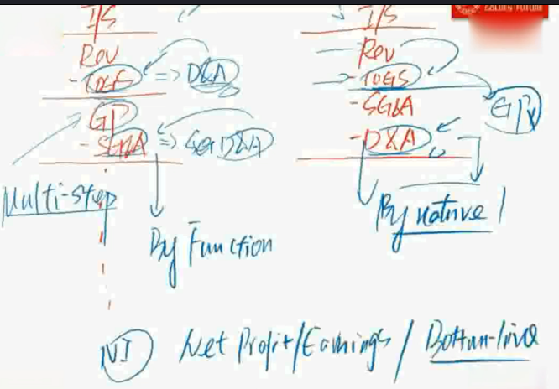

 **Form 10-K**

✓ Annual financial statements.

 **Form 10-Q**

✓ Quarterly financial statements .

 Form DEF-14A

✓ Proxy statements.

 **Form 8-K**

✓ Material events relating to

Significant assets acquisition and disposal.

Changes in management or corporate governance.

 **Form 144**

✓ Issue securities to certain

SS8考点(3,5,6每年必考）

I/S & B/S

1. Unusual or infrequent items & Extraordinary

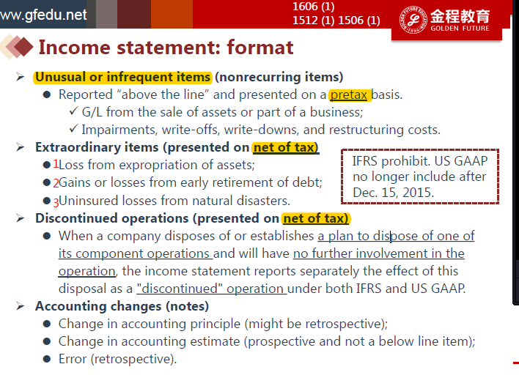

Discontinued operation

决定卖到卖掉之间产生的费用

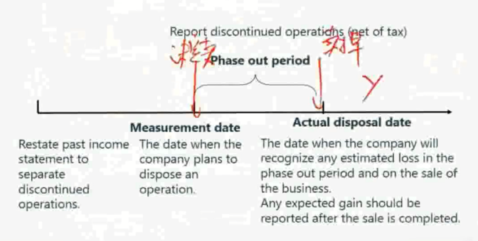

1. 普通收入确认 ：Delivery Method（1706 (1) 1506 (1)）

IFRS & GAAP**共有的两个原则**

1. 货物交割，服务提供，跟该货物和服务相关的**权利和义务发生转移**
2. 收回款项可以确信

**IFRS 特有**：Cost可以被可靠计量

**GAAP特有**：arrangement

1. **特殊收入确认1612 (1) 1606 (1) 1512 (3) 1506 (1) 1706 (1)**
2. LT(Long Term) contract POC(Percentage of completion)法和 CC(completed-contract)法，无名法

收入成本可靠计量用POC，不可靠计量用CC

**POC** = 当年Cost/总成本 ×Revenue =>确认Rev

当期Rev-当期cost=当期profit

**CC** 合同完成前，不确认Rev，cost，profit，完工后，一次性确认

**IFRS无名法** 根据当期cost-->确认同等金额Rev，不确认profit

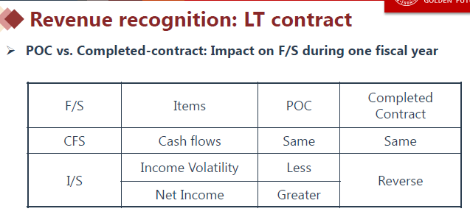

1. 分期收款 ：installment sales & cost recovery(两个都不靠谱，但Cost recovery更不靠谱）

I**nstallment sales** (Collectability cannot be reasonably estimated.)类似POC

当年Cash/总cash × 总Cost确认当期cost

当年Cash-当期Cost=>确认为Profit

**Cost recovery(**Collectability is highly uncertain.) 类似CC

当年Cash-->确认同等cost

收回Cash 大于总Cost，确认profit

IFRS 回收成本，用的是discounted CF，用现金流现值算

GAAP用名义

1. Gross report revenue (4个条件同时满足)/ Net Profit Revenue 携程例子

**Under GAAP, to report gross revenue, the firm must:**

 Be the primary obligor of the contract; 义务人

 Independently choose its supplier;有权选择supplier

 Tolerate risks involved, including inventory risk and credit risk;承担存货风险

 Free to determine the price.定价权

1. **EPS Earning per share** video 1.2
   1. Basic

Basic EPS = (NI - Prefer Div)/ Weighted average number of common shares outstanding

weighted by time(days or months)

 New issue, repurchase is **weighted by time (days or months).**

 Stock dividend and split

✓ **Stock dividends**. Additional shares are distributed as a proportion of current holding shares.

10% stock dividend: the holder of 100 shares of stock would receive 10 additional shares.

✓ **Stock splits**. Divide current shares into a post-determined number of shares.

2-for-1 split: 100 shares will be converted to 200 shares;

3-for-2 split: 100 shares will be converted to 150 shares.

1. **Diluted** 1612 (4) 1606 (2) 1512 (1) 1506 (1) 1706 (1)

三种情况（convertible debt可转债，convertible preferred stock可转换优先股，stock option/warrants（上市公司发行）)

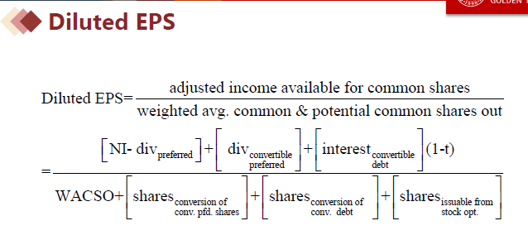

DEPS 和BEPS 取其低

反稀释(Anti-Dilutive)只有option不可能发生反稀释，因为只有分母加

1. **B/S Financial Asset**
   1. HTM
   2. AFS
   3. Trading

**Net Revenue** = Revenue - adjustments (e.g., cash discounts, volume discounts, or estimated returns);

收入减去预估的三包费用

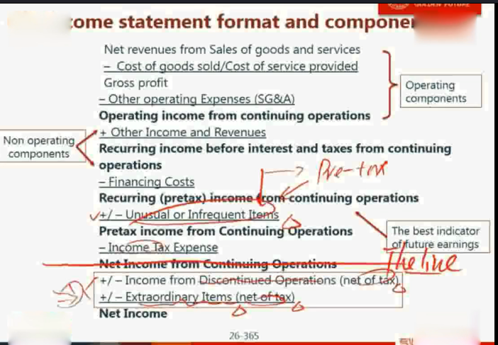

**Accounting changes**

•Change in accounting principle

→retrospective application 追溯调整

•Change in accounting estimate

→prospective application

(and not a below line item).

•Errors

→restate financial 追溯调整

statement

→Notes disclosure