Střední průmyslová škola elektrotechnická Ječná
Information Technology
Ječná 30, Praha 2
Pedagogium Merge
.
Pavel Halík, Maksym Solonitsyn, Lukáš Dvořák, Vilma Tomanová, Jan Vavroušek
Web Applications
2026
Summary
1 Objective of the work 3
2 Stakeholders 3
3 Use cases 4
4 Features 4
5 Goals 5
6 List of teacher 5
7 Assets 5
8 Marketing strategy 6
9 System requirements 7
10 System architecture 8
11 Tech stack 11
12 Timeline 13
13 Requirement traceability 14
14 Testing 14
15 Measured data 16
16 Work evidence 16
17 Economic evaluation 17
18 Project evaluation 18
19 Attachments 18

Objective of the work
The objective of this project is to develop a fully functional, browser-based video game inspired by the popular title Suika Game, adapted for the school environment of SPŠE Ječná. The core gameplay mechanic revolves around dropping and merging circles, where each circle displays a custom image designed to humorously resemble one of the school's teachers. As players merge identical circles, they progress through a hierarchy of increasingly larger ones, aiming to achieve the highest possible score before the playing field overflows. The project is intended primarily for students of SPŠE Ječná, for whom the teacher-themed content adds a layer of familiarity and entertainment that makes the game more engaging and shareable. Beyond the game itself, the project also serves as a practical demonstration of full-stack web development, combining a modern frontend with a backend that handles user accounts, score tracking, and content moderation. Submission date: 25.3.2026

Stakeholders
Development team (Students of SPŠE Ječná)
Pavel Halík (Scrum Master), Maksym Solonitsyn (Sysadmin), Lukáš Dvořák(Backend), Vilma Tomanová (Frontend) and Jan Vavroušek (Documentation)
Role: They are responsible for all aspects of the project, from the design of game mechanics and frontend to backend infrastructure and deployment.
Expectations: Create a fully functional web application to demonstrate skills in full-stack development and obtain a quality sample of work for a personal portfolio.
End Users (Students of SPŠE Ječná)
The primary target group of the game
Role: Players who interact with the game, place objects on the playing field and use the user account system.
Expectations: Fun and networking within the school, the possibility of friendly competition with classmates via online leaderboards and seamless access to the game from a browser without the need for installation.
Teachers of the SPŠE Ječná (Content subject)
Identification: A group of teachers whose portraits appear in the game (e.g. Ing. Ondřej Mandík, MUDr. Kristýna Studénková and others).
Role: Serve as a visual basis for the main game mechanics. They do not directly use the system, but create its specific school character.
Expectations: Maintain a safe and welcoming environment. They expect that their image will not be misused for inappropriate behavior, for which the integrated content reporting system is used.

Use cases
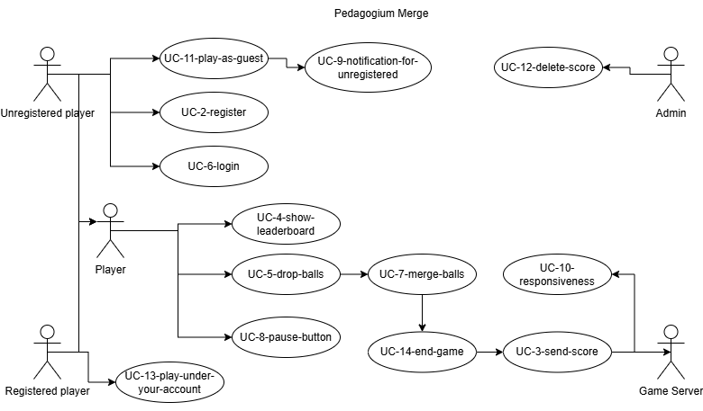

Features
Pedagogium merge is a browser-based game accessible from any device with an internet connection, requiring no installation or downloads. Players position and drop balls onto a playing field, where a realistic physics engine determines how they fall, bounce, and stack against each other. When two balls of the same size collide, they automatically merge into a single, larger ball and award points — the bigger the merge, the higher the score. A single session can trigger satisfying chain reactions, where one merge sets off several more in quick succession. Each ball displays a custom portrait of a teacher from SPŠE Ječná, adding a personal and humorous touch that grows more entertaining as the balls evolve through merging. Players can create an account to save their scores across sessions and compete against classmates on a persistent online leaderboard. A built-in reporting system allows users to flag any inappropriate content, ensuring the game remains a safe and welcoming environment for the whole school community.

Goals
The primary goal of the project is to deliver a fully functional, browser-based game built with modern web technologies, demonstrating practical full-stack development skills. On the technical side, the project aims to implement a working backend with user authentication, a persistent leaderboard, and a reporting system, alongside automated deployment using Ansible. Beyond the technical scope, the project aims to create an entertaining experience tailored to the students of SPŠE Ječná — one that encourages friendly competition and organic sharing within the school community. It also serves as a portfolio piece showcasing what students at the school are capable of building.

List of teachers
- Ing. Ondřej Mandík
- MUDr. Kristýna Studénková
- Ing. Lukáš Masopust
- Bc. Daniel Adámek
- Bc. Adam Papula
- Bc. Martin Váňa
- Michaela Meitnerová
- Petr Procházka

Assets
Sample of some assets



Marketing strategy
The marketing strategy for Pedagogium merge is designed to maximize engagement and adoption within the school community of SPŠE Ječná. Unlike commercial software products that rely on paid advertising channels, this projects greatest marketing asset is its inherently social and humorous nature — the game features the faces of real teachers from the school, making it immediately recognizable and amusing to the target audience. The strategy therefore centers on organic, community-driven marketing that costs nothing but generates genuine interest and word-of-mouth spread.
Target Audience
The primary target audience is the student body of SPŠE Ječná. These are students, who are active on social media, comfortable with browser-based tools, and have a direct personal connection to the teachers featured in the game. This familiarity creates a natural incentive to share the game with classmates.
Secondary target audience includes the schools teachers themselves

Core Marketing Approach
Word-of-mouth is expected to be the most powerful distribution channel. Once a handful of students discover the game, the curiosity factor ("have you seen which teachers you can merge?") will naturally prompt them to tell others. This is amplified by the competitive element — the leaderboard system encourages players to share their high scores and challenge classmates. To further encourage word-of-mouth, the game could be informally presented in classrooms or mentioned by students during breaks, creating a buzz that spreads face-to-face.
School Community Engagement
the project can be presented as a technical showcase, attracting interest from students interested in programming and game development
Summary
The marketing strategy for Pedagogium merge leverages the project's unique, school-specific character to drive organic adoption without any budget. By relying on the humor and familiarity of teacher-themed gameplay, the campaign is designed to spread naturally through the student community via social sharing, word-of-mouth, and direct school engagement. The goal is not mass reach, but deep, enthusiastic adoption within the tight-knit community of SPŠE Ječná.

System requirements

Identifier | Name | Description | Type | Source | Verification criterion
REQ-FUNC-01 | Drop & Merge | System calculates physics and merges identical balls | Functional | UC-07,UC-05 | Function test, drop ball and merge
REQ-FUNC-02 | Registration | System allows users to create an account | Functional | UC-02 | Test registration
REQ-FUNC-03 | Save score after end | System sends the final score to the backend | Functional | UC-03 | Test save score
REQ-FUNC-04 | Show leaderboard | System display a sorted list of the highest scores | Functional | UC-04 | Test show leaderboard
REQ-FUNC-05 | Start game, un/registered until end | System start the game with login | Functional | UC-01,UC-13,UC-11, UC-14 | Function test, play the game
REQ-FUNC-06 | Login | System allows users to login | Functional | UC-06 | Function test, login to account
REQ-FUNC-07 | Pause button | System allows to stop game | Functional | UC-08 | Function test, pause the game
REQ-QUAL-02 | Notification | System display a message for unregistered players | Qualitative | UC-09 | Performance test
REQ-QUAL-01 | Responsive | System must be playable on mobile | Qualitative | UC-10 | Performance test

System architecture

Diagram
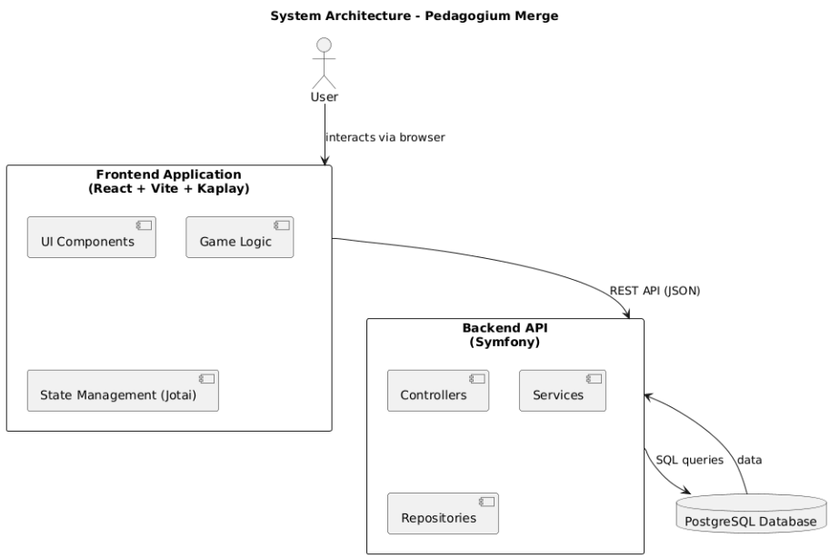

Backend architecture
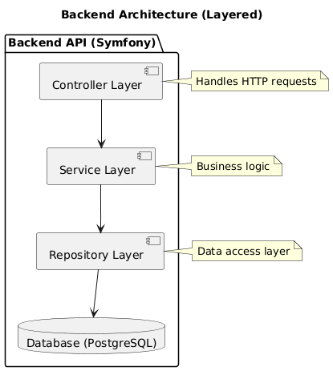

Data Model
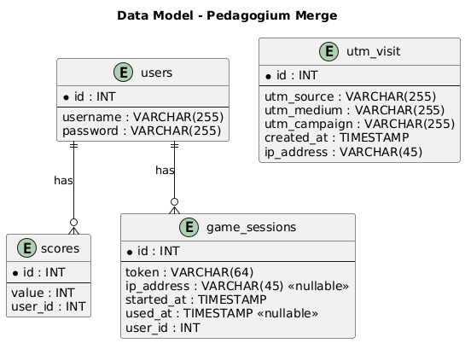

Sequence diagram
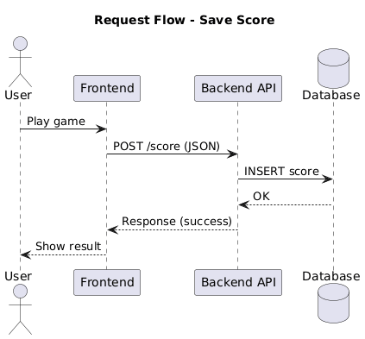

Tech stack

Backend
Category | Technology | Experience (3) | Ease of administration (4) | Total score
Backend | Symfony (PHP) | 4 | 4 | 28
Backend | Spring (Java) | 2 | 3 | 18

ORM / DB Layer
Category | Technology | Experience (3) | Manipulation (5) | Safety (5) | Total score
ORM / DB layer | Raw SQL | 5 | 2 | 3 | 40
ORM / DB layer | Doctrine | 3 | 4 | 4 | 49

Language
Category | Technology | Experience (3) | Deployment (4) | Total score
Language | PHP 8 | 4 | 5 | 32
Language | Java | 2 | 2 | 14

Database
Category | Technology | Experience (3) | Functions (5) | Total score
Database | PostgreSQL | 3 | 5 | 34
Database | MySQL | 4 | 3 | 27

API
Category | Technology | Experience (3) | Implementation (5) | Query simplicity (3) | Total score
API | REST API (JSON) | 4 | 4 | 5 | 47
API | GraphQL | 1 | 4 | 3 | 32

Frontend
Category | Technology | Experience (3) | Functions (5) | Total score
Frontend | React | 4 | 5 | 37
Frontend | Vue.js | 2 | 3 | 21

Game logic
Category | Technology | Experience (3) | Easier syntax (5) | Total score
Game logic | Kaplay | 1 | 5 | 28
Game logic | Phaser.js | 0 | 0 | 0

Timeline

Week 1 - Planning
The first week was dedicated to laying the foundations of the project. The team was assembled and roles were assigned according to individual strengths — Pavel as Scrum Master, Maksym as Sysadmin, Lukáš as Backend Developer, Vilma as Designer, and Hana as Documentation lead. The project idea was selected: a browser-based merge game inspired by Suika Game, featuring portraits of school teachers. The tech stack was agreed upon (React, Symfony, Docker), the GitHub repository was created, and the first documentation was written — covering the project abstract, stakeholders, use cases, and initial requirements. The designer produced the first wireframes and visual concepts.

Week 2 - Development
Active development began. The sysadmin configured the web server and made the application accessible on a domain. The backend team set up the database, implemented endpoints for user profiles and score submission, and developed the core game logic including the merging mechanic. The designer worked on the visual appearance of the game elements. The Scrum Master tracked progress and the documentation lead validated completed requirements.

Week 3 - Security
This week was focused on mandatory security training covering vulnerabilities, best practices, and safe development. All team members completed the training. Alongside the training, development continued — the backend was extended with password encryption and database security measures, and the game's frontend received further refinements.

Week 4 - Marketing
The final phase focused on production deployment and user acquisition. The sysadmin set up the production server and purchased a domain. UTM tracking was implemented in the application to monitor traffic sources, and server logs were analysed using GoAccess. The designer created a physical marketing poster with a QR code, and the team defined its marketing strategy targeting students via QR codes, Discord, and direct sharing. Final technical documentation was also completed during this week.

Requirement traceability

Requirement ID | Use Case | Components | Implementation | Test
REQ-FUNC-01 | Drop & Merge | Frontend, Kaplay mechanics | GameController | test_score_submission
REQ-FUNC-02 | Registration | Frontend event | RegistrationPanel | test_user_creation
REQ-FUNC-03 | Save score after end | Score service, API | ScoreService | test_score_submission
REQ-FUNC-04 | Show leaderboard | Leaderboard API | LeaderboardController | test_game_session_creation
REQ-FUNC-05 | Start game, un/registered until end | Frontend,Backend | MainMechanics | test_game_session_creation
REQ-FUNC-06 | Login | Frontend event, API | LoginPanel | test_user_creation
REQ-FUNC-07 | Pause button | Pause function | PauseIcon | test_game_session_creation

Testing
The system was tested using a combination of manual testing and basic unit testing.
Testing was focused on verifying:
- correct communication between frontend and backend
- correct data storage in the database
- correct behavior of core features (user handling, score saving, session handling)
The testing process included:
- manual testing through the web interface
- API testing using HTTP requests
Test Scenarios
The following key scenarios were tested:
1. User creation
- Input: valid username and password
- Expected result: user is successfully stored in the database
2. Score submission
- Input: score value from frontend
- Input: score value from frontend
3. Game session creation
- Input: request to create session
- Expected result: session with unique token is created
4. Game session usage
- Input: valid session token
- Input: valid session token
5. UTM visit tracking
- Input: request with UTM parameters
- Input: request with UTM parameters
Performance Testing
The application performance was evaluated using Google Lighthouse.
Results:
- Performance: 99
- Accessibility: 100
- Best Practices: 96
- SEO: 91
These results indicate that the application achieves excellent performance and high overall quality.
Security Testing
Security was verified using browser DevTools.
Results:
- HTTPS is correctly configured
- Valid SSL certificate (trusted issuer)
- Secure TLS 1.3 connection
- All resources are served securely
This confirms that communication between client and server is encrypted and secure.

Core Web Vitals
This confirms that communication between client and server is encrypted and secure:
- Largest Contentful Paint (LCP): 0.32 s
→ Excellent (recommended < 2.5 s)
- Cumulative Layout Shift (CLS): 0
→ Perfect visual stability (recommended < 0.1)
- Interaction to Next Paint (INP): 16 ms
→ Excellent responsiveness (recommended < 200 ms)
These results indicate that the application provides a very fast and responsive user experience

Measured data

Total visit: 249,
Total unique users: 177,
The most used source: QR code
second is discord and than instagram

Work evidence
All the work that was done on this project can be found at this link

Economic evaluation
The estimated cost of the project is around 22,000 Czech crowns, with up to 700 CZK for monthly maintenance.
All data comes from this link

Project evaluation

Successes:
The team successfully developed a fully functional, browser-based game.
The application achieved exceptional results in Google Lighthouse testing, scoring 99 in Performance and 100 in Accessibility.
The organic marketing strategy proved effective within the school community, reaching 177 unique users

Challenges:
Implementing core game logic and merging mechanics using the Kaplay engine
Coordinating the initial project foundations, such as setting up the Docker environment and GitHub repository

Future Development:
Future iterations could include direct social media sharing of high scores
The project could be expanded by adding unique abilities for different teacher characters or introducing time-limited challenge modes

Attachments

https://spsejecnacz-my.sharepoint.com/:x:/g/personal/halik_spsejecna_cz/IQCLS5TqJAi4RZn6IjzCDzIYAXxjYTx5fiTpdOzOhaBsaP0?e=H0uJJ0&nav=MTVfezMxREFGQ0U3LTg3ODQtNDFEOC1BNzQ0LUUxRkExODQ2ODBBNn0
https://github.com/Fialovi-lososi-F-CK-AI/Pedagogium-Merge/tree/main/src/frontend/src
https://pedagogium-merge.org/
https://spsejecnacz-my.sharepoint.com/:x:/r/personal/vavrousek_spsejecna_cz/_layouts/15/Doc.aspx?sourcedoc=%7B4EE06FED-0415-48FC-8A7F-F7E566B2CEDE%7D&file=WA.xlsx&action=default&mobileredirect=true&DefaultItemOpen=1&wdOrigin=WAC.EXCEL.HOME-BUTTON%2CAPPHOME-WEB.FILEBROWSER.RECENT&wdPreviousSession=bceb2d25-d56c-01ae-acdd-feb914d19e52&wdPreviousSessionSrc=Wac&ct=1774453853923

