Final Project — Exploratory Data Analysis
Dataset: FIFA World Cup 1930–2014
Course: Exploratory Data Analysis — UNIFEI — 2026.1

Stage 1 — Data Understanding

1.1 Context and Purpose of the Data Collection
The dataset brings together the complete history of official FIFA World Cup matches, covering 20 editions, from 1930 (Uruguay) to 2014 (Brazil), totaling 850 match records. Each row represents a match and provides information on venue, teams, score, attendance, and officiating. The likely purpose of the collection is to enable historical and statistical analyses of national team performance, the evolution of stadium attendance, competition formats (group stages, knockout stages), and match characteristics over nearly a century of tournaments.

1.2 Description and Classification of the Variables
Variable | Description | Classification
Year | Year the World Cup was held | Discrete quantitative
Datetime | Date and time of the match | Nominal qualitative (date/time)
Stage | Competition stage (group, round of 16, final...) | Ordinal qualitative
Stadium | Name of the stadium | Nominal qualitative
City | Host city of the match | Nominal qualitative
Home.Team.Name | Name of the home team | Nominal qualitative
Away.Team.Name | Name of the away team | Nominal qualitative
Home.Team.Goals | Goals scored by the home team | Discrete quantitative
Away.Team.Goals | Goals scored by the away team | Discrete quantitative
Half.time.Home.Goals | Home team goals at halftime | Discrete quantitative
Half.time.Away.Goals | Away team goals at halftime | Discrete quantitative
Attendance | Attendance at the stadium | Continuous quantitative
Win.conditions | Tiebreaker condition (penalties, extra time) | Nominal qualitative
Referee / Assistant.1/2 | Referee and assistants | Nominal qualitative
RoundID / MatchID | Internal identifiers for the round/match | Nominal qualitative (code)
Home/Away.Team.Initials | 3-letter team abbreviation | Nominal qualitative
Note: RoundID and MatchID are numeric only in format, but function as identifier codes (keys), not as quantities — therefore they are treated as nominal qualitative. The Stage variable is ordinal because there is a logical order of progression in the tournament (group stage → round of 16 → quarterfinals → semifinal → final).

Stage 2 — Data Audit
# Missing values
print(df.isnull().sum())
# Duplicates
print(df.duplicated().sum())
print(df.duplicated(subset=["MatchID"], keep=False).sum())
# Inconsistencies: halftime goals greater than final goals
inc_home = df[df["Half.time.Home.Goals"] > df["Home.Team.Goals"]]
inc_away = df[df["Half.time.Away.Goals"] > df["Away.Team.Goals"]]
# Attendance outliers via IQR
q1, q3 = df["Attendance"].quantile([0.25, 0.75])
iqr = q3 - q1
lim_sup = q3 + 1.5*iqr
outliers = df[df["Attendance"] > lim_sup]

2.1 Missing Values
There are no null values (NaN) in any of the 21 columns. This is common in historical datasets manually consolidated by curators, but it does not mean the absence of quality issues — as the following items show, ‘filled-in’ data can still be incorrect or duplicated.

2.2 Duplicate Records
A naive check for identical rows (df.duplicated()) finds no duplicates, since the ‘Unnamed: 0’ column functions as a unique sequential index. However, when checking for duplicates by the match identifier (MatchID) — the actual key of the match — we found 15 duplicated matches (30 rows), all concentrated in the 2014 World Cup. Comparing these rows across all other columns, they are byte-for-byte identical, confirming a data loading/export error rather than rescheduled matches. Furthermore, even after removing the duplicates, the 2014 World Cup shows only 63 unique matches, when the 32-team format (the same as 1998–2010) should produce 64 games — an indication that at least one match is missing from the dataset.
Recommended strategy: remove the 30 duplicated rows, keeping only one occurrence per MatchID (df.drop_duplicates(subset='MatchID')), and document the missing 2014 match as a known limitation of the dataset.

2.3 Logical Inconsistencies
A test was performed to check whether the halftime score (Half.time.Goals) could exceed the final score — which would be logically impossible, since the final score is cumulative. No inconsistency of this type was found, suggesting good referential integrity between these columns. There are also no attendance values equal to zero or negative. Another textual inconsistency noted informally: the Win.conditions column mixes, within the same column, the winner's name with the winning condition (e.g., ‘Germany FR win on penalties (4-1)’), making direct use of the column difficult — ideally it should be split into two variables: ‘tiebreak_winner’ and ‘tiebreak_type’.

2.4 Outliers
Using the 1.5×IQR criterion, 10 matches show attendance above the upper limit (~108 thousand spectators), almost all games played at Azteca Stadium (Mexico) or Maracanã (Brazil), stadiums historically known for their exceptional capacities — these are not typos, but genuine extreme values reflecting the reality of these venues. In terms of goal counts, three matches stand out as outlier candidates: Hungary 9x0 South Korea (1954), Yugoslavia 9x0 Zaire (1974), and Hungary 10x1 El Salvador (1982). These are documented, real historic blowouts, and therefore should be kept in the analysis — legitimate outliers should not be removed, only flagged, as they represent true extreme events rather than measurement errors.

Stage 3 — Univariate Analysis
num_vars = ["Home.Team.Goals","Away.Team.Goals","Attendance",
"Half.time.Home.Goals","Half.time.Away.Goals"]
resumo = pd.DataFrame({
"media": df[num_vars].mean(),
"mediana": df[num_vars].median(),
"moda": df[num_vars].mode().iloc[0],
"variancia": df[num_vars].var(),
"desvio_padrao": df[num_vars].std(),
"cv_%": df[num_vars].std()/df[num_vars].mean()*100,
"assimetria": df[num_vars].skew(),
"q1": df[num_vars].quantile(.25),
"q3": df[num_vars].quantile(.75),
})
sns.histplot(df[col], kde=True) # for each variable
sns.boxplot(y=df[col])

Variable | Mean | Median | Mode | SD | CV% | Skewness | Q1 | Q3
Home Goals | 1.81 | 2 | 1 | 1.61 | 89% | 1.12 | 1.0 | 3.0
Away Goals | 1.02 | 1 | 0 | 1.09 | 107% | 1.25 | 0.0 | 2.0
Attendance | 45,165 | 41,580 | — | 23,485 | 52% | 0.68 | 30000.0 | 61374.5
1st-Half Home Goals | 0.71 | 0 | 0 | 0.94 | 132% | 1.58 | 0.0 | 1.0
1st-Half Away Goals | 0.43 | 0 | 0 | 0.69 | 161% | 2.01 | 0.0 | 1.0

3.1 Histograms
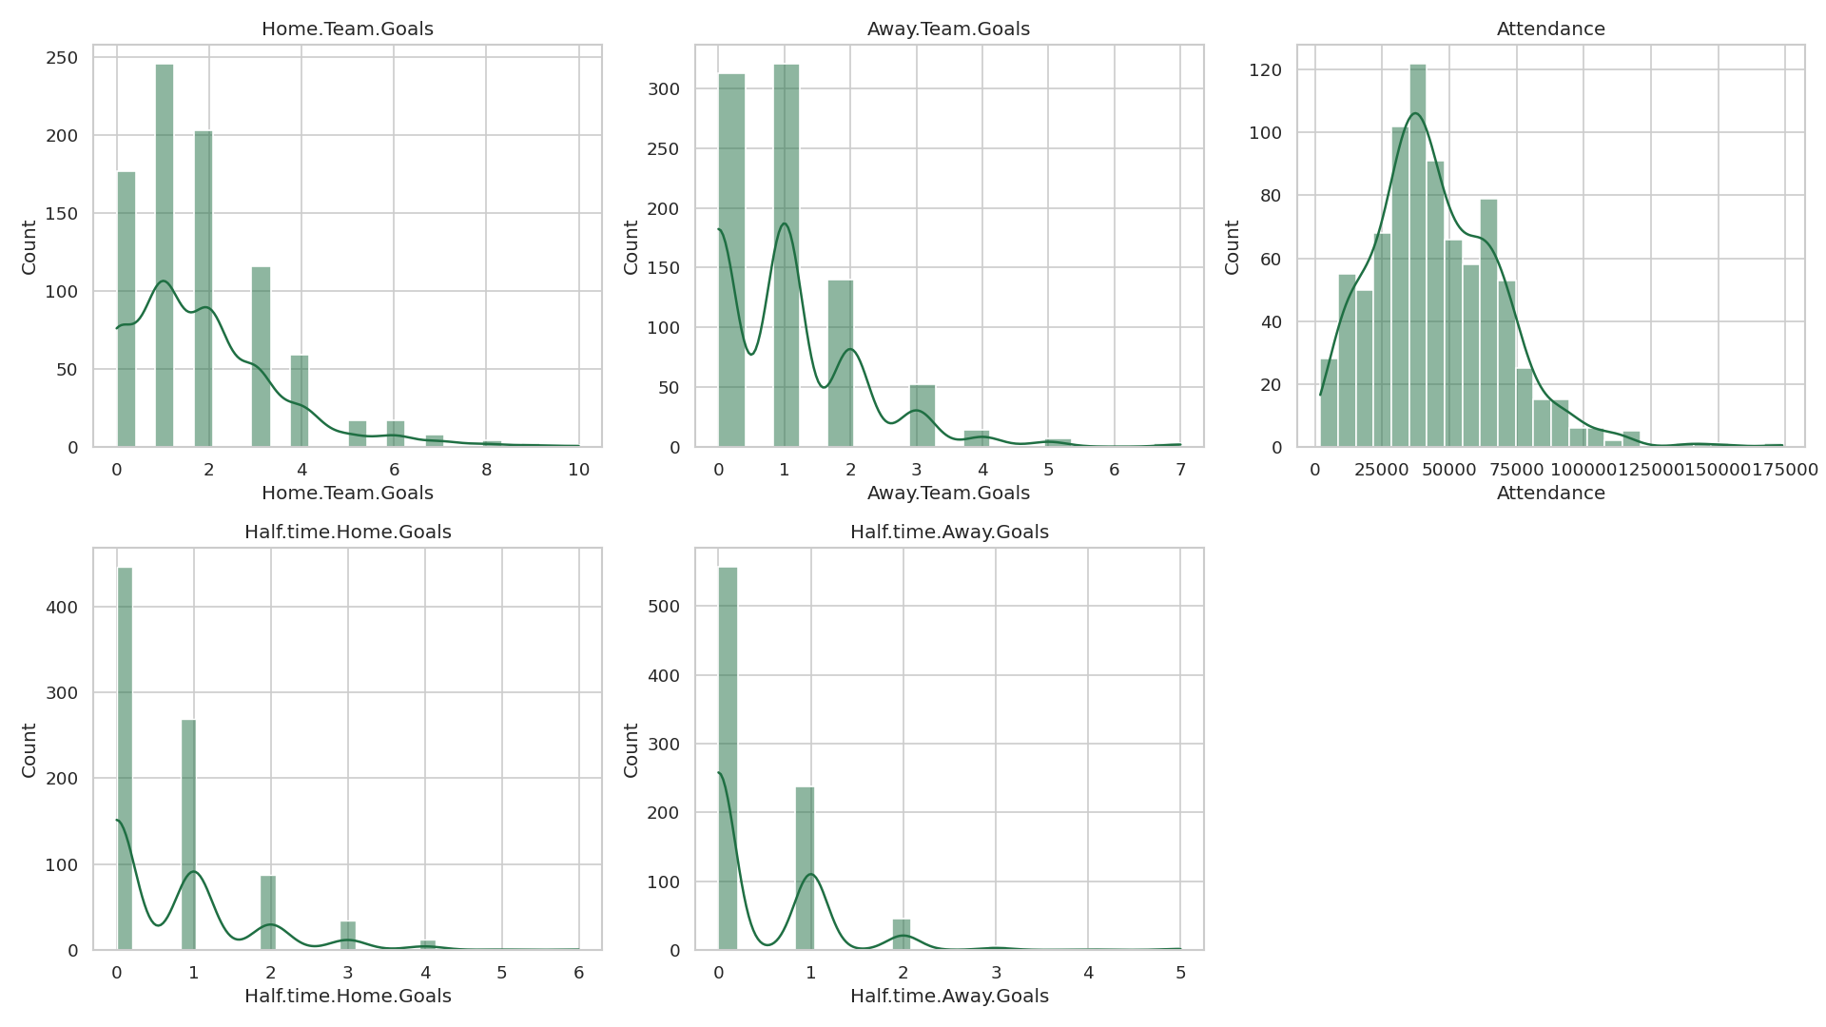
Figure 1 — Distributions of the main numeric variables.
All goal-related variables are strongly right-skewed (positive skewness between 1.1 and 2.0): most matches have few goals (0 to 2) and a long tail of games with rare blowouts. This is typical of counts in low-scoring sports such as soccer, where scoring many goals is a relatively infrequent event. Halftime goals (1st half) are even more concentrated at zero, with a more pronounced skew, since half the match has not yet occurred. Attendance shows a distribution closer to normal, though also slightly right-skewed, with a tail of sold-out stadiums (Azteca, Maracanã).

3.2 Boxplots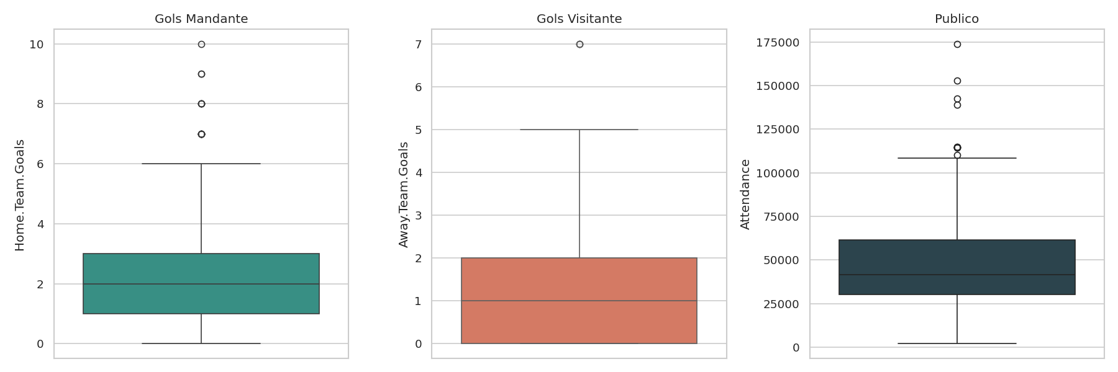
Figure 2 — Boxplots of home team goals, away team goals, and attendance.
The boxplots visually confirm the skewness: the boxes are ‘pushed’ toward low values, with several points beyond the upper whisker (blowouts). The home team shows more goal outliers than the away team, suggesting an offensive advantage of playing at home — a phenomenon known in soccer as ‘home-field advantage.’ The attendance boxplot shows greater dispersion and clear outliers from exceptionally packed stadiums.

Stage 4 — Bivariate Analysis
corr = df[num_vars].corr()
sns.heatmap(corr, annot=True, cmap="RdBu_r", center=0)
sns.scatterplot(data=df, x="Home.Team.Goals", y="Away.Team.Goals")
sns.scatterplot(data=df, x="Year", y="Attendance")
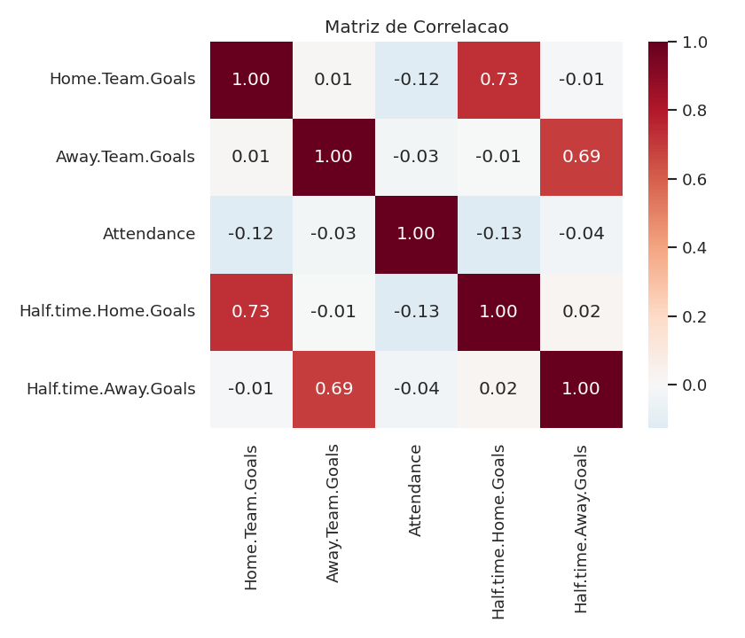

Figure 3 — Linear correlation matrix (Pearson).

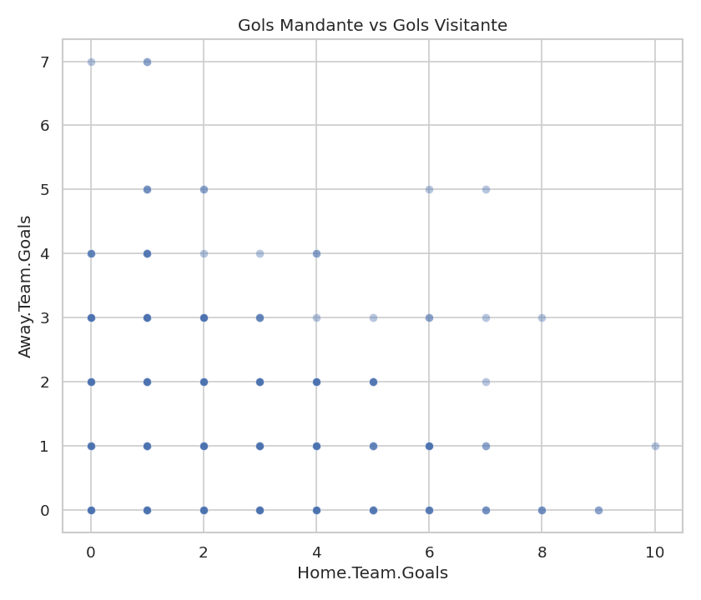

Figure 4 — Home team goals vs. away team goals.
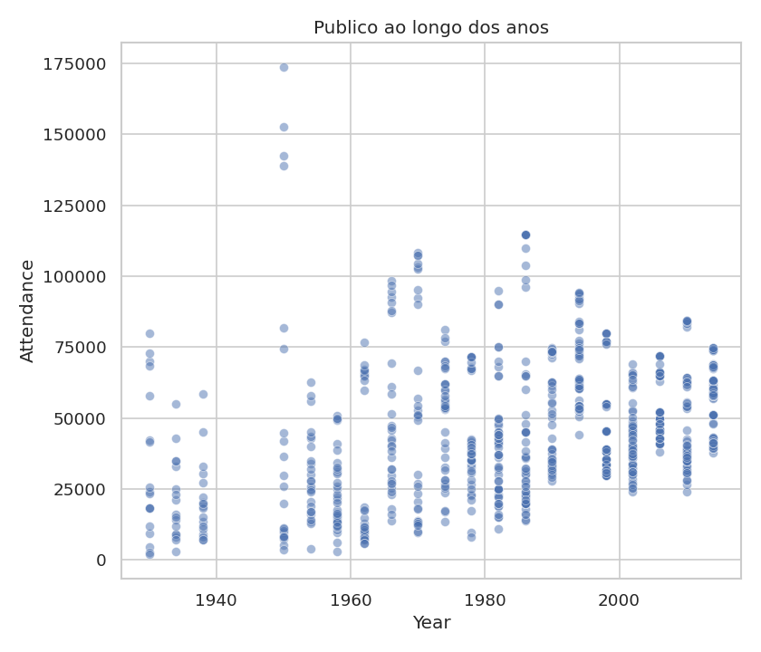

Figure 5 — Attendance trends across editions.
The strongest correlation in the dataset (r ≈ 0.73) occurs between Home Team Goals in full time and at halftime — which is natural, since the final score is built from the partial score. The same pattern repeats, somewhat more weakly, for the away team (r ≈ 0.69). Aside from these ‘structural’ (part-whole) relationships, the remaining correlations are weak: home team goals and away team goals show virtually no correlation (r ≈ 0.01), indicating that a team's offensive performance does not depend on the opponent's performance — each team attacks relatively independently. Attendance shows a weak, negative correlation with home team goals (r ≈ -0.12), suggesting that full stadiums are not associated with more goals from the home team. In the Year x Attendance scatter plot, a nonlinear trend is noticeable: sharp growth up to the 1970s–1990s (global popularization of soccer and greater stadium capacity) followed by stabilization/slight decline in the most recent editions, as modern stadiums prioritize comfort over maximum capacity.

Stage 5 — Multicollinearity
c = corr.abs()
pairs = c.where(np.triu(np.ones(c.shape), k=1).astype(bool)).stack()
print(pairs[pairs > 0.5].sort_values(ascending=False))
Only two pairs exceed the |r| > 0.5 threshold: Home Team Goals x 1st-Half Home Goals (0.73) and Away Team Goals x 1st-Half Away Goals (0.69). These pairs do not constitute problematic multicollinearity in the classic statistical sense (redundancy between independent predictors), since there is an obvious causal/compositional relationship — the halftime goal is a subset of the final goal. In any future predictive model using the final score as the target, it would be necessary to exclude halftime goals from the explanatory variables (or use them as a proxy for ‘game pace,’ never both simultaneously), avoiding data leakage and redundancy. The other numeric variables (Attendance, Year) show no relevant collinearity with the others and can be freely used together.

Stage 6 — Multivariate Visualization
df["Total.Goals"] = df["Home.Team.Goals"] + df["Away.Team.Goals"]
df["Is.Final"] = df["Stage"].isin(["Final","Match for third place",...])
sns.scatterplot(data=df, x="Year", y="Total.Goals",
hue="Is.Final", size="Attendance")
sns.boxplot(data=df[df.Stage.isin(top_stages)], x="Stage", y="Attendance")
sns.pairplot(df[[...]].assign(Epoca=pd.cut(df.Year,...)), hue="Epoca")
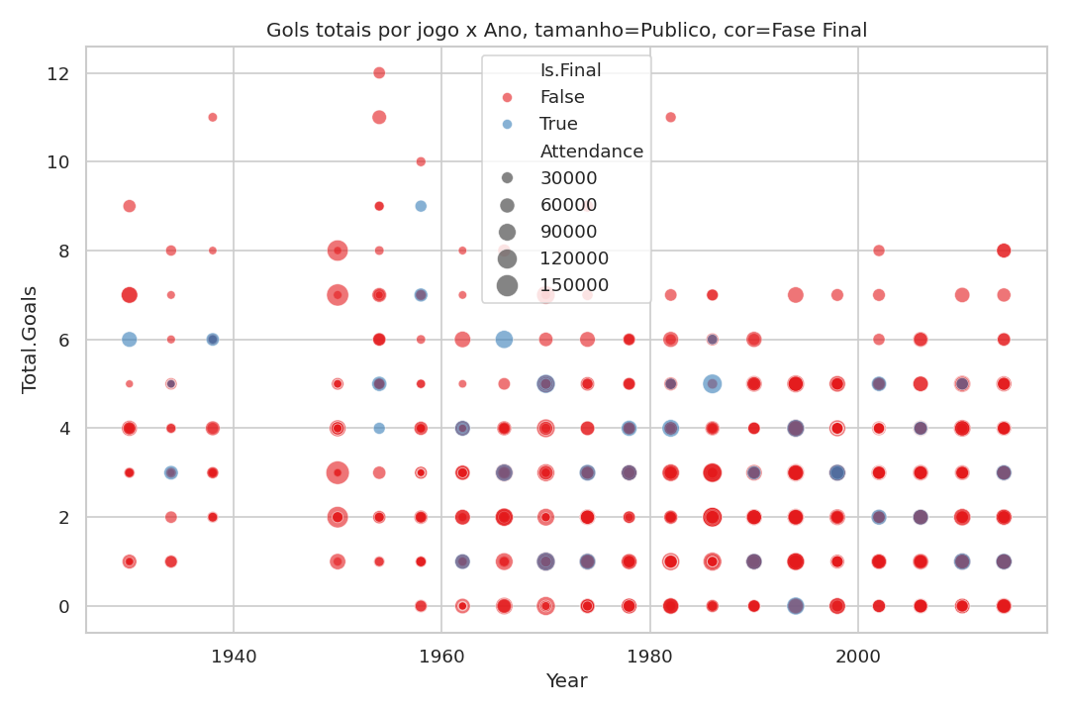
Figure 6 — Total goals per match over the years, with color indicating final-stage games and size representing attendance.
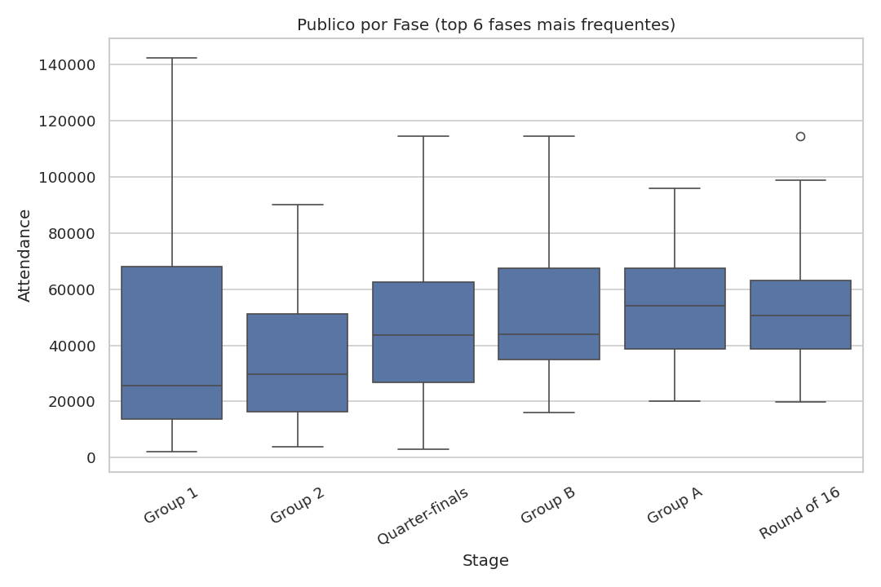
The total number of goals per match (sum of both teams) shows no clear upward or downward trend over the century — soccer has remained statistically stable in average goals, ranging between 2 and 3 per game in most decades, with the exception of the 1930–1954 World Cups, which were more offensive. Final-stage matches (semifinals, final, third-place match) tend to have higher attendance (larger bubbles), as expected, but not necessarily more goals — many finals are truncated, defensive games.

Figure 7 — Attendance by competition stage (6 most frequent stages).
A strong heterogeneity between stages is evident: the ‘Group A/B/C...’ stage (modern group stages) has a lower median attendance and less variability, while ‘Round of 16’ and knockout stages concentrate games with higher and more dispersed attendance — reflecting matches in larger stadiums and growing fan interest as the competition progresses.
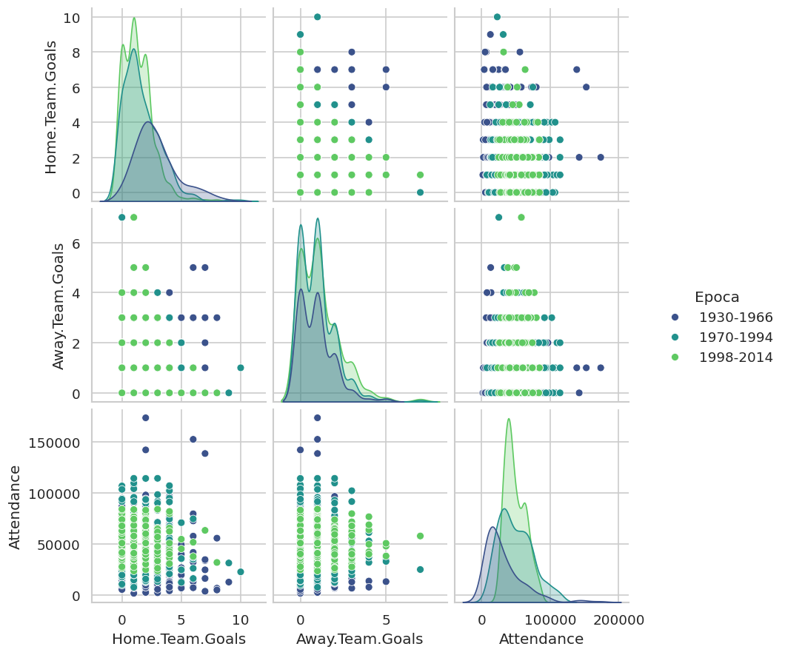
Figure 8 — Pairplot of Home Team Goals, Away Team Goals, and Attendance, segmented by tournament era.
The pairplot segmented by era (1930–1966, 1970–1994, 1998–2014) reveals that the oldest era (green/purple, according to the palette) concentrates higher and more dispersed scores, while the most recent era shows distributions more ‘compressed’ around low scores (1 to 2 goals) — visual evidence that soccer has become tactically and defensively more balanced over time. Attendance also increases in level between eras, consistent with the tournament's global expansion.

Stage 7 — Notable Statistical Findings

Phenomenon 1 — Severe Skewness in the Goal Variables
All goal-count variables (home, away, 1st half) show strong positive skewness (0.7 to 2.0), evidenced in the Stage 3 histograms and in the mode = 0 or 1 measures, well below the mean. This reflects the nature of soccer as a low-scoring sport: most games have few goals, and blowouts (9x0, 10x1) are rare events that pull the tail of the distribution to the right.

Phenomenon 2 — Heterogeneity Across Competition Stages
Stage 6 showed that attendance varies systematically by tournament stage (group stage vs. knockout stage), with distinct medians and dispersions — it is not a homogeneous variable, but rather a set of subpopulations with different behaviors, which reinforces the importance of always segmenting attendance analyses by stage/era, rather than treating the World Cup as a uniform block.

Phenomenon 3 — Structural Relationship (Not True Redundancy) Between Partial and Final Goals
Stage 5 identified the only strong correlations in the dataset, between halftime goals and final goals (r ≈ 0.7). Unlike spurious collinearity, this is a logical compositional relationship, an important warning for any future modeling to avoid data leakage.

Phenomenon 4 — Change in Game Patterns Over the Decades
The pairplot by era (Stage 6) revealed a visual shift in scores over time: older World Cups (1930–1966) had more dispersed goal distributions with higher scores; recent World Cups show more balanced, defensive games — a historical-tactical pattern consistent with increased professionalization and greater technical parity among national teams.

