

**แบบรายงานผลปฏิบัติการทดลอง**

**เรื่อง Transmission Line Filter Design**

**sec 11**

**กลุ่ม เต๊นยอดนักบิด**

**จัดทำโดย**

**นาย สุรวิทย์ คุปตานนท์ 6410502435**

**นาย พีรวัส ยนตมุติ 6410502231**

**นาย เรืองอรุณ สุกิจพิมลพันธุ์ 6410502303**

**นาย สุวภัทร จันทรศร 6410502443**

**เสนอ ผศ.ดร.เด่นชัย วรเศวต**

**รายงานนี้เป็นส่วนหนึ่งของรายวิชา ปฏิบัติการสถาปัตยกรรมและอุปกรณ์สื่อสาร รหัสวิชา 01205381 ภาควิชาวิศวกรรมไฟฟ้า คณะวิศวกรรมศาสตร์ มหาวิทยาลัยเกษตรศาสตร์ ปีการศึกษา 2566**

**การทดลอง**

ออกแบบ filter โดยใช้โปรแกรม Sonnet

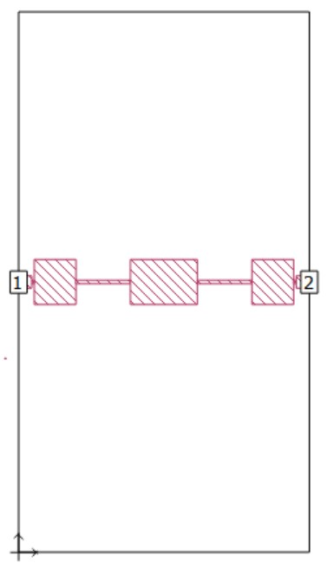

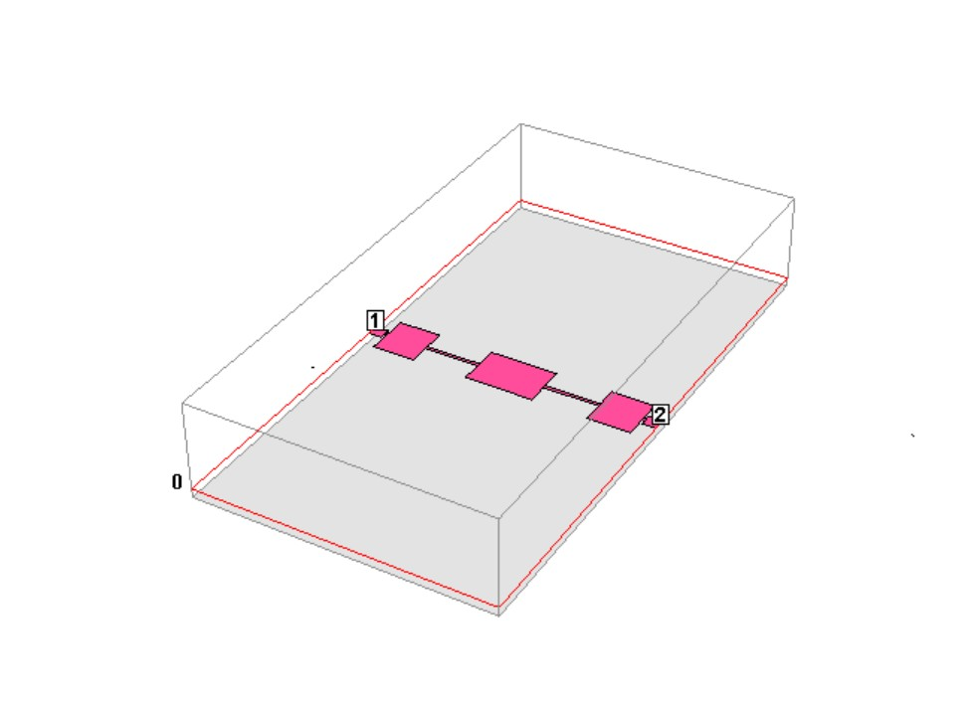

หลังจากออกแบบโดยโปรแกรม Sonnet เสร็จเรียบร้อยแล้ว ก็ทำการสร้างกราฟออกมาได้ดังนี้

**จาก Port 1 ไป Port 1**

|  |  |  |  |  |  |
| --- | --- | --- | --- | --- | --- |
| 0.013694 | -0.04672 | 0.048686 | -26.252 | 1 | -26.252 |
| -3.03E-03 | -0.06264 | 0.062713 | -24.0528 | 1.1 | -24.0528 |
| -0.02213 | -0.05711 | 0.061248 | -24.2582 | 1.2 | -24.2582 |
| -0.02277 | -0.02816 | 0.036214 | -28.8225 | 1.3 | -28.8225 |
| 0.019512 | 0.008806 | 0.021407 | -33.3888 | 1.4 | -33.3888 |
| 0.118323 | 0.01437 | 0.119192 | -18.475 | 1.5 | -18.475 |
| 0.249384 | -0.06746 | 0.258347 | -11.7559 | 1.55 | -11.7559 |
| 0.33182 | -0.26379 | 0.423898 | -7.45477 | 1.6 | -7.45477 |
| 0.278232 | -0.5145 | 0.584913 | -4.65817 | 1.65 | -4.65817 |
| 0.088097 | -0.70835 | 0.713807 | -2.92838 | 1.7 | -2.92838 |
| -0.16115 | -0.78685 | 0.803183 | -1.90371 | 1.75 | -1.90371 |
| -0.39826 | -0.76298 | 0.860668 | -1.30329 | 1.8 | -1.30329 |
| -0.59164 | -0.67414 | 0.896941 | -0.94473 | 1.85 | -0.94473 |
| -0.73647 | -0.55163 | 0.920154 | -0.72279 | 1.9 | -0.72279 |
| -0.83831 | -0.41517 | 0.935484 | -0.57928 | 1.95 | -0.57928 |
| -0.90486 | -0.27584 | 0.94597 | -0.48245 | 2 | -0.48245 |
| -0.94316 | -0.13956 | 0.953429 | -0.41423 | 2.1 | -0.41423 |
| -0.95885 | -9.25E-03 | 0.958895 | -0.36458 | 2.2 | -0.36458 |
| -0.95624 | 0.113981 | 0.963009 | -0.32739 | 2.3 | -0.32739 |
| -0.93803 | 0.231084 | 0.966075 | -0.29979 | 2.4 | -0.29979 |
| -0.89918 | 0.356775 | 0.967374 | -0.28811 | 2.5 | -0.28811 |
| 0.935755 | 0.317548 | 0.988167 | -0.10339 | 2.6 | -0.10339 |
| 0.953729 | 0.12327 | 0.961662 | -0.33955 | 2.7 | -0.33955 |
| 0.969199 | 0.020264 | 0.969411 | -0.26984 | 2.8 | -0.26984 |
| 0.950235 | -0.10737 | 0.956282 | -0.38828 | 2.9 | -0.38828 |
| 0.859893 | -0.12171 | 0.868464 | -1.22497 | 3 | -1.22497 |

**จาก Port 1 ไป Port 2**

|  |  |  |  |  |  |
| --- | --- | --- | --- | --- | --- |
| -0.93533 | -0.2601 | 0.970821 | -0.25721 | 1 | -0.25721305 |
| -0.96602 | 0.032774 | 0.966576 | -0.29528 | 1.1 | -0.295281656 |
| -0.90584 | 0.326835 | 0.962999 | -0.32748 | 1.2 | -0.32748258 |
| -0.75257 | 0.596118 | 0.960062 | -0.35402 | 1.3 | -0.354018017 |
| -0.50733 | 0.80942 | 0.955272 | -0.39746 | 1.4 | -0.397459646 |
| -0.1822 | 0.923487 | 0.941289 | -0.52554 | 1.5 | -0.525539851 |
| 0.177263 | 0.887307 | 0.90484 | -0.86856 | 1.55 | -0.86856175 |
| 0.475051 | 0.683598 | 0.832454 | -1.5928 | 1.6 | -1.59279501 |
| 0.614552 | 0.38391 | 0.724611 | -2.7979 | 1.65 | -2.797901983 |
| 0.590693 | 0.110466 | 0.600933 | -4.42347 | 1.7 | -4.423473069 |
| 0.479613 | -0.06876 | 0.484517 | -6.29382 | 1.75 | -6.293822494 |
| 0.353306 | -0.15909 | 0.387472 | -8.23519 | 1.8 | -8.235187525 |
| 0.245216 | -0.19192 | 0.311391 | -10.1339 | 1.85 | -10.13388702 |
| 0.162566 | -0.19409 | 0.253177 | -11.9315 | 1.9 | -11.93151236 |
| 0.102351 | -0.18203 | 0.208832 | -13.6041 | 1.95 | -13.60407459 |
| 0.059336 | -0.16447 | 0.174846 | -15.1469 | 2 | -15.14688341 |
| 0.028805 | -0.14567 | 0.148491 | -16.566 | 2.1 | -16.56601709 |
| 0.007156 | -0.12752 | 0.127721 | -17.8748 | 2.2 | -17.87477912 |
| -8.15E-03 | -0.11051 | 0.11081 | -19.1084 | 2.3 | -19.10841153 |
| -0.01862 | -0.09386 | 0.095689 | -20.3828 | 2.4 | -20.38275054 |
| -0.02156 | -0.06799 | 0.071327 | -22.935 | 2.5 | -22.93497823 |
| -6.80E-03 | 0.019985 | 0.02111 | -33.5102 | 2.6 | -33.51015615 |
| -0.01706 | -0.02677 | 0.031744 | -29.9668 | 2.7 | -29.96678869 |
| -1.12E-03 | 0.082149 | 0.082157 | -21.7071 | 2.8 | -21.70714719 |
| -0.02194 | -0.1533 | 0.154862 | -16.2011 | 2.9 | -16.20110009 |
| 0.10236 | 0.162667 | 0.192193 | -14.3253 | 3 | -14.32525183 |

หลังจากนั้นจึงนำแบบที่ได้ออกแบบมา ไปใส่ใน Easy EDA

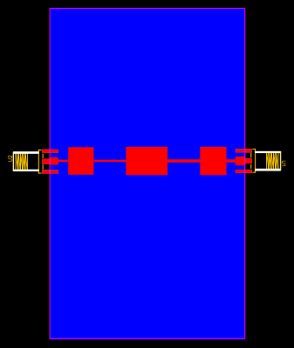

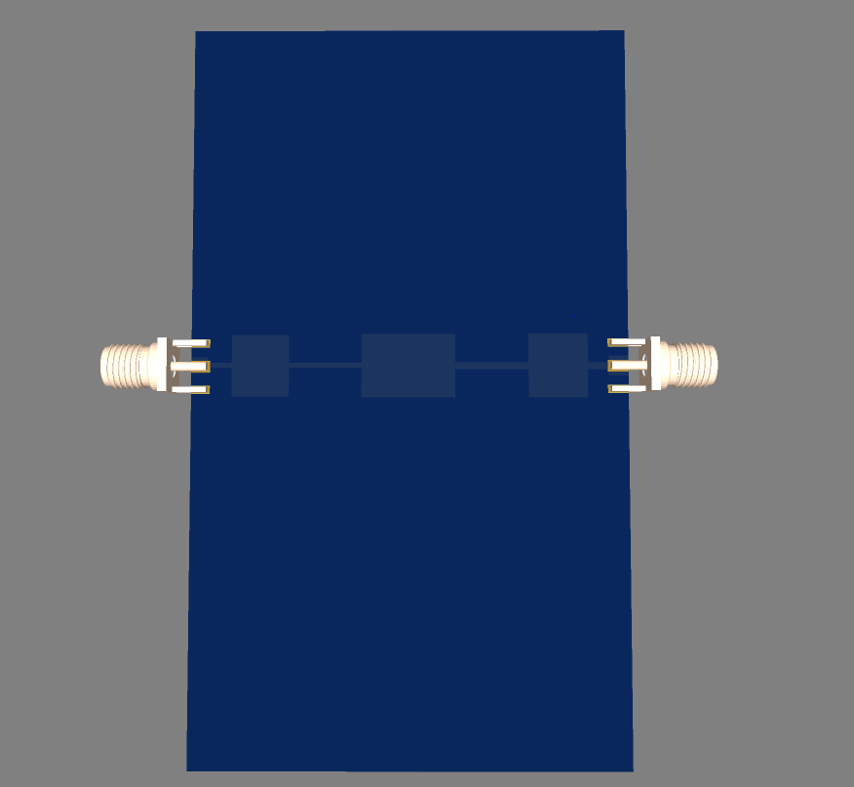

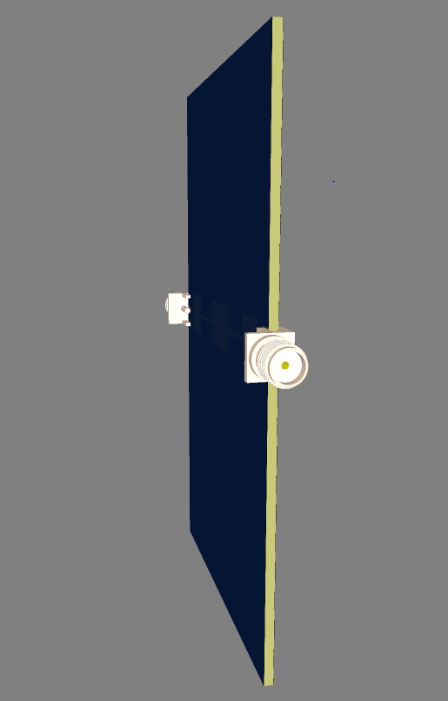

จากนั้นนำไปทำการทดสอบ โดยได้ผลลัพธ์เป็นดังตารางข้างล่างนี้

**จาก Port 1 ไป Port 1**

|  |  |  |  |  |  |
| --- | --- | --- | --- | --- | --- |
| -0.89738 | -0.26326 | 0.935202 | -0.58189 | 0.4 | -0.58189 |
| -0.92905 | -0.05348 | 0.930584 | -0.62489 | 0.44 | -0.62489 |
| -0.91078 | 0.160364 | 0.924794 | -0.6791 | 0.48 | -0.6791 |
| -0.84783 | 0.360674 | 0.921361 | -0.7114 | 0.52 | -0.7114 |
| -0.72906 | 0.542231 | 0.908595 | -0.8326 | 0.56 | -0.8326 |
| -0.57538 | 0.695135 | 0.90237 | -0.8923 | 0.6 | -0.8923 |
| -0.37416 | 0.79765 | 0.881047 | -1.10002 | 0.64 | -1.10002 |
| -0.15986 | 0.852265 | 0.867128 | -1.23833 | 0.68 | -1.23833 |
| 0.072714 | 0.848021 | 0.851133 | -1.40005 | 0.72 | -1.40005 |
| |  | | --- | | 0.296684 | | 0.778196 | 0.832833 | -1.58884 | 0.76 | -1.58884 |
| 0.496782 | 0.650529 | 0.818523 | -1.73938 | 0.8 | -1.73938 |
| 0.66163 | 0.463643 | 0.80791 | -1.85274 | 0.84 | -1.85274 |
| 0.768396 | 0.216794 | 0.798393 | -1.95566 | 0.88 | -1.95566 |
| 0.779978 | -0.04762 | 0.78143 | -2.1422 | 0.92 | -2.1422 |
| 0.704317 | -0.30852 | 0.768924 | -2.28233 | 0.96 | -2.28233 |
| 0.542663 | -0.52183 | 0.752857 | -2.46575 | 1 | -2.46575 |
| 0.325808 | -0.65546 | 0.731965 | -2.71019 | 1.04 | -2.71019 |
| 0.096814 | -0.71194 | 0.718495 | -2.87153 | 1.08 | -2.87153 |
| -0.11342 | -0.68404 | 0.693375 | -3.18064 | 1.12 | -3.18064 |
| -0.29164 | -0.6135 | 0.679287 | -3.35893 | 1.16 | -3.35893 |
| -0.44047 | -0.52488 | 0.685207 | -3.28356 | 1.2 | -3.28356 |
| -0.54866 | -0.38279 | 0.668997 | -3.49152 | 1.24 | -3.49152 |
| -0.63835 | -0.2286 | 0.678046 | -3.37481 | 1.28 | -3.37481 |
| -0.68456 | -0.0456 | 0.686079 | -3.27251 | 1.32 | -3.27251 |
| -0.66799 | 0.171499 | 0.689654 | -3.22738 | 1.36 | -3.22738 |
| -0.55636 | 0.390251 | 0.679582 | -3.35516 | 1.4 | -3.35516 |
| -0.36233 | 0.564404 | 0.670695 | -3.4695 | 1.44 | -3.4695 |
| -0.09513 | 0.64394 | 0.650928 | -3.72934 | 1.48 | -3.72934 |
| 0.197454 | 0.595012 | 0.626919 | -4.05577 | 1.52 | -4.05577 |
| 0.434301 | 0.429309 | 0.610675 | -4.2838 | 1.56 | -4.2838 |
| 0.579455 | 0.189728 | 0.609725 | -4.29732 | 1.6 | -4.29732 |
| 0.626795 | -0.07141 | 0.63085 | -4.00148 | 1.64 | -4.00148 |
| 0.592981 | -0.32682 | 0.67708 | -3.3872 | 1.68 | -3.3872 |
| 0.489059 | -0.54458 | 0.731948 | -2.7104 | 1.72 | -2.7104 |
| 0.334329 | -0.70118 | 0.776806 | -2.19375 | 1.76 | -2.19375 |
| 0.137922 | -0.80439 | 0.816128 | -1.76484 | 1.8 | -1.76484 |
| -0.04648 | -0.83212 | 0.833416 | -1.58276 | 1.84 | -1.58276 |
| -0.23046 | -0.83014 | 0.861533 | -1.29456 | 1.88 | -1.29456 |
| -0.36205 | -0.792 | 0.870826 | -1.20137 | 1.92 | -1.20137 |
| -0.49244 | -0.72846 | 0.879292 | -1.11734 | 1.96 | -1.11734 |
| -0.58483 | -0.67536 | 0.893386 | -0.97921 | 2 | -0.97921 |
| -0.66779 | -0.60464 | 0.900851 | -0.90694 | 2.04 | -0.90694 |
| -0.72825 | -0.53169 | 0.901686 | -0.89889 | 2.08 | -0.89889 |
| -0.78591 | -0.47739 | 0.919539 | -0.7286 | 2.12 | -0.7286 |
| -0.82639 | -0.39638 | 0.916535 | -0.75702 | 2.16 | -0.75702 |
| -0.85998 | -0.33823 | 0.924101 | -0.68561 | 2.2 | -0.68561 |
| -0.90565 | -0.26814 | 0.94451 | -0.49587 | 2.24 | -0.49587 |
| -0.91481 | -0.21417 | 0.939547 | -0.54163 | 2.28 | -0.54163 |
| -0.94433 | -0.14181 | 0.954921 | -0.40065 | 2.32 | -0.40065 |
| -0.9526 | -0.08403 | 0.956298 | -0.38813 | 2.36 | -0.38813 |
| -0.95689 | -0.01377 | 0.956991 | -0.38184 | 2.4 | -0.38184 |
| -0.9561 | 0.052227 | 0.957524 | -0.377 | 2.44 | -0.377 |
| -0.96101 | 0.085555 | 0.964814 | -0.31113 | 2.48 | -0.31113 |
| -0.94889 | 0.139995 | 0.959165 | -0.36213 | 2.52 | -0.36213 |
| -0.93589 | 0.19585 | 0.956166 | -0.38934 | 2.56 | -0.38934 |
| -0.93534 | 0.251649 | 0.968596 | -0.27714 | 2.6 | -0.27714 |
| -0.92423 | 0.284036 | 0.966891 | -0.29245 | 2.64 | -0.29245 |
| -0.90497 | 0.339154 | 0.966435 | -0.29655 | 2.68 | -0.29655 |
| -0.90388 | 0.384502 | 0.982265 | -0.15543 | 2.72 | -0.15543 |
| -0.88085 | 0.436808 | 0.983207 | -0.1471 | 2.76 | -0.1471 |
| -0.8551 | 0.461099 | 0.971494 | -0.2512 | 2.8 | -0.2512 |
| -0.83479 | 0.505297 | 0.97581 | -0.21269 | 2.84 | -0.21269 |
| -0.80287 | 0.538961 | 0.966992 | -0.29155 | 2.88 | -0.29155 |
| -0.78443 | 0.576129 | 0.973272 | -0.23532 | 2.92 | -0.23532 |
| -0.75558 | 0.604777 | 0.967808 | -0.28422 | 2.96 | -0.28422 |
| -0.73167 | 0.640684 | 0.972528 | -0.24196 | 3 | -0.24196 |
| -0.7023 | 0.667674 | 0.969024 | -0.27331 | 3.04 | -0.27331 |
| -0.67255 | 0.706065 | 0.975117 | -0.21886 | 3.08 | -0.21886 |
| -0.65176 | 0.739708 | 0.98588 | -0.12352 | 3.12 | -0.12352 |
| -0.62022 | 0.774363 | 0.992123 | -0.06869 | 3.16 | -0.06869 |
| -0.58433 | 0.774199 | 0.969963 | -0.2649 | 3.2 | -0.2649 |
| -0.56418 | 0.79795 | 0.977253 | -0.19986 | 3.24 | -0.19986 |
| -0.5305 | 0.830681 | 0.985628 | -0.12574 | 3.28 | -0.12574 |
| -0.50464 | 0.83606 | 0.976555 | -0.20606 | 3.32 | -0.20606 |
| -0.46465 | 0.876809 | 0.992315 | -0.06701 | 3.36 | -0.06701 |
| -0.43132 | 0.878108 | 0.978322 | -0.19037 | 3.4 | -0.19037 |
| -0.41126 | 0.889864 | 0.980302 | -0.1728 | 3.44 | -0.1728 |
| -0.37841 | 0.920891 | 0.995608 | -0.03823 | 3.48 | -0.03823 |
| -0.34289 | 0.91248 | 0.97478 | -0.22187 | 3.52 | -0.22187 |
| -0.29154 | 0.954478 | 0.998011 | -0.0173 | 3.56 | -0.0173 |
| -0.25238 | 0.964199 | 0.996683 | -0.02886 | 3.6 | -0.02886 |
| -0.22023 | 0.938675 | 0.964163 | -0.31699 | 3.64 | -0.31699 |
| -0.20483 | 0.969432 | 0.990835 | -0.07998 | 3.68 | -0.07998 |
| -0.13592 | 0.951522 | 0.96118 | -0.3439 | 3.72 | -0.3439 |
| -0.09846 | 0.953134 | 0.958206 | -0.37082 | 3.76 | -0.37082 |
| -0.07624 | 0.958852 | 0.961878 | -0.3376 | 3.8 | -0.3376 |
| -0.03381 | 0.970127 | 0.970716 | -0.25816 | 3.84 | -0.25816 |
| 0.000421 | 0.949741 | 0.949741 | -0.4479 | 3.88 | -0.4479 |
| 0.062956 | 0.948979 | 0.951065 | -0.4358 | 3.92 | -0.4358 |
| 0.110216 | 0.933983 | 0.940464 | -0.53316 | 3.96 | -0.53316 |
| 0.094058 | 0.911857 | 0.916695 | -0.7555 | 4 | -0.7555 |
| 0.12664 | 0.907559 | 0.916352 | -0.75875 | 4.04 | -0.75875 |
| 0.23841 | 0.924948 | 0.95518 | -0.3983 | 4.08 | -0.3983 |
| 0.187814 | 0.896043 | 0.915515 | -0.76669 | 4.12 | -0.76669 |
| 0.254613 | 0.855444 | 0.892531 | -0.98753 | 4.16 | -0.98753 |
| 0.282371 | 0.852497 | 0.898045 | -0.93404 | 4.2 | -0.93404 |
| 0.325376 | 0.819572 | 0.881798 | -1.09262 | 4.24 | -1.09262 |
| 0.354482 | 0.824686 | 0.897644 | -0.93792 | 4.28 | -0.93792 |
| 0.393564 | 0.789232 | 0.881918 | -1.09143 | 4.32 | -1.09143 |
| 0.444312 | 0.759847 | 0.880216 | -1.10821 | 4.36 | -1.10821 |
| 0.409553 | 0.675833 | 0.790243 | -2.04479 | 4.4 | -2.04479 |

**จาก Port 1 ไป Port 2**

|  |  |  |  |  |  |
| --- | --- | --- | --- | --- | --- |
| 0.251936 | -0.03932 | 0.254986 | -11.8697 | 0.4 | -11.8697 |
| 0.265449 | -0.07837 | 0.276775 | -11.1575 | 0.44 | -11.1575 |
| 0.271226 | -0.12308 | 0.297846 | -10.5202 | 0.48 | -10.5202 |
| 0.268638 | -0.16743 | 0.31654 | -9.99143 | 0.52 | -9.99143 |
| 0.267195 | -0.21237 | 0.341312 | -9.33696 | 0.56 | -9.33696 |
| 0.266467 | -0.26749 | 0.377566 | -8.46014 | 0.6 | -8.46014 |
| 0.251862 | -0.34225 | 0.424934 | -7.43357 | 0.64 | -7.43357 |
| 0.201855 | -0.43084 | 0.475784 | -6.45181 | 0.68 | -6.45181 |
| 0.115058 | -0.50451 | 0.517463 | -5.72242 | 0.72 | -5.72242 |
| 0.001164 | -0.53714 | 0.537144 | -5.39818 | 0.76 | -5.39818 |
| -0.1089 | -0.53538 | 0.546343 | -5.2507 | 0.8 | -5.2507 |
| -0.21299 | -0.51107 | 0.553671 | -5.13497 | 0.84 | -5.13497 |
| -0.30724 | -0.46203 | 0.554858 | -5.11636 | 0.88 | -5.11636 |
| -0.37184 | -0.39478 | 0.542321 | -5.31487 | 0.92 | -5.31487 |
| -0.41137 | -0.32815 | 0.526217 | -5.5767 | 0.96 | -5.5767 |
| -0.44787 | -0.28426 | 0.530467 | -5.50684 | 1 | -5.50684 |
| -0.5007 | -0.24418 | 0.557068 | -5.08184 | 1.04 | -5.08184 |
| -0.57619 | -0.17245 | 0.601445 | -4.41608 | 1.08 | -4.41608 |
| -0.63748 | -0.05769 | 0.640087 | -3.87522 | 1.12 | -3.87522 |
| -0.63325 | 0.086713 | 0.639162 | -3.88778 | 1.16 | -3.88778 |
| -0.5867 | 0.191163 | 0.617054 | -4.19354 | 1.2 | -4.19354 |
| -0.53422 | 0.258958 | 0.593675 | -4.52902 | 1.24 | -4.52902 |
| -0.50586 | 0.323697 | 0.600559 | -4.42889 | 1.28 | -4.42889 |
| -0.48962 | 0.400077 | 0.632287 | -3.98172 | 1.32 | -3.98172 |
| -0.43657 | 0.5338 | 0.68959 | -3.22818 | 1.36 | -3.22818 |
| -0.31353 | 0.654725 | 0.725926 | -2.78215 | 1.4 | -2.78215 |
| -0.14296 | 0.714739 | 0.728896 | -2.74669 | 1.44 | -2.74669 |
| 0.009609 | 0.696117 | 0.696183 | -3.14553 | 1.48 | -3.14553 |
| 0.141903 | 0.660701 | 0.675768 | -3.40405 | 1.52 | -3.40405 |
| 0.273813 | 0.602838 | 0.662108 | -3.58142 | 1.56 | -3.58142 |
| 0.378961 | 0.508255 | 0.633983 | -3.95845 | 1.6 | -3.95845 |
| 0.457413 | 0.386695 | 0.598966 | -4.45196 | 1.64 | -4.45196 |
| 0.492119 | 0.266634 | 0.55971 | -5.04075 | 1.68 | -5.04075 |
| 0.482608 | 0.138727 | 0.502151 | -5.98331 | 1.72 | -5.98331 |
| 0.441836 | 0.038877 | 0.443543 | -7.06128 | 1.76 | -7.06128 |
| 0.382666 | -0.02964 | 0.383812 | -8.31762 | 1.8 | -8.31762 |
| 0.320508 | -0.0585 | 0.325804 | -9.74088 | 1.84 | -9.74088 |
| 0.278341 | -0.06761 | 0.286434 | -10.8595 | 1.88 | -10.8595 |
| 0.252018 | -0.07338 | 0.262485 | -11.6179 | 1.92 | -11.6179 |
| 0.237379 | -0.08009 | 0.250526 | -12.023 | 1.96 | -12.023 |
| 0.233628 | -0.0954 | 0.252355 | -11.9598 | 2 | -11.9598 |
| 0.22438 | -0.1262 | 0.257433 | -11.7867 | 2.04 | -11.7867 |
| 0.201052 | -0.1616 | 0.257946 | -11.7694 | 2.08 | -11.7694 |
| 0.149762 | -0.18628 | 0.239018 | -12.4314 | 2.12 | -12.4314 |
| 0.100449 | -0.17868 | 0.204978 | -13.7659 | 2.16 | -13.7659 |
| 0.075502 | -0.15605 | 0.173356 | -15.2212 | 2.2 | -15.2212 |
| 0.080747 | -0.13943 | 0.161123 | -15.8569 | 2.24 | -15.8569 |
| 0.067863 | -0.13346 | 0.149719 | -16.4944 | 2.28 | -16.4944 |
| 0.069645 | -0.1368 | 0.153504 | -16.2776 | 2.32 | -16.2776 |
| 0.064105 | -0.14553 | 0.159025 | -15.9707 | 2.36 | -15.9707 |
| 0.050282 | -0.16108 | 0.168745 | -15.4554 | 2.4 | -15.4554 |
| 0.026604 | -0.17314 | 0.175173 | -15.1307 | 2.44 | -15.1307 |
| -0.00629 | -0.17634 | 0.176447 | -15.0677 | 2.48 | -15.0677 |
| -0.03419 | -0.16023 | 0.163835 | -15.7119 | 2.52 | -15.7119 |
| -0.04761 | -0.1333 | 0.141552 | -16.9817 | 2.56 | -16.9817 |
| -0.04799 | -0.1175 | 0.12692 | -17.9294 | 2.6 | -17.9294 |
| -0.044 | -0.11256 | 0.120854 | -18.3547 | 2.64 | -18.3547 |
| -0.0429 | -0.10987 | 0.117945 | -18.5664 | 2.68 | -18.5664 |
| -0.04807 | -0.11776 | 0.127189 | -17.911 | 2.72 | -17.911 |
| -0.06173 | -0.12701 | 0.141215 | -17.0024 | 2.76 | -17.0024 |
| -0.09174 | -0.12841 | 0.157816 | -16.037 | 2.8 | -16.037 |
| -0.12686 | -0.10667 | 0.165746 | -15.6112 | 2.84 | -15.6112 |
| -0.13608 | -0.07008 | 0.153069 | -16.3022 | 2.88 | -16.3022 |
| -0.12809 | -0.04032 | 0.134286 | -17.4394 | 2.92 | -17.4394 |
| -0.11531 | -0.02696 | 0.11842 | -18.5315 | 2.96 | -18.5315 |
| -0.10797 | -0.02083 | 0.109962 | -19.1752 | 3 | -19.1752 |
| -0.10555 | -0.01586 | 0.106733 | -19.434 | 3.04 | -19.434 |
| -0.10881 | -0.01427 | 0.10974 | -19.1927 | 3.08 | -19.1927 |
| -0.11479 | -4.7E-05 | 0.114793 | -18.8017 | 3.12 | -18.8017 |
| -0.11691 | 0.015496 | 0.117933 | -18.5673 | 3.16 | -18.5673 |
| -0.11081 | 0.030359 | 0.114895 | -18.7939 | 3.2 | -18.7939 |
| -0.09848 | 0.043615 | 0.10771 | -19.3549 | 3.24 | -19.3549 |
| -0.0884 | 0.051319 | 0.102217 | -19.8095 | 3.28 | -19.8095 |
| -0.07544 | 0.05631 | 0.094136 | -20.5249 | 3.32 | -20.5249 |
| -0.06907 | 0.056574 | 0.08928 | -20.9849 | 3.36 | -20.9849 |
| -0.06424 | 0.060318 | 0.088119 | -21.0986 | 3.4 | -21.0986 |
| -0.05727 | 0.061678 | 0.084165 | -21.4973 | 3.44 | -21.4973 |
| -0.05241 | 0.064963 | 0.083467 | -21.5697 | 3.48 | -21.5697 |
| -0.04773 | 0.065592 | 0.081118 | -21.8177 | 3.52 | -21.8177 |
| -0.04445 | 0.067547 | 0.080858 | -21.8455 | 3.56 | -21.8455 |
| -0.04124 | 0.075281 | 0.085838 | -21.3264 | 3.6 | -21.3264 |
| -0.02702 | 0.0794 | 0.08387 | -21.5278 | 3.64 | -21.5278 |
| -0.01479 | 0.079557 | 0.080919 | -21.839 | 3.68 | -21.839 |
| -0.00682 | 0.074165 | 0.074478 | -22.5595 | 3.72 | -22.5595 |
| -0.00087 | 0.067773 | 0.067779 | -23.3782 | 3.76 | -23.3782 |
| 0.000048 | 0.060996 | 0.060996 | -24.294 | 3.8 | -24.294 |
| -0.00224 | 0.058104 | 0.058147 | -24.7094 | 3.84 | -24.7094 |
| -0.00305 | 0.057824 | 0.057904 | -24.7458 | 3.88 | -24.7458 |
| -0.00616 | 0.058675 | 0.058998 | -24.5833 | 3.92 | -24.5833 |
| -0.00594 | 0.065775 | 0.066043 | -23.6035 | 3.96 | -23.6035 |
| 0.000476 | 0.075704 | 0.075705 | -22.4175 | 4 | -22.4175 |
| 0.014764 | 0.081968 | 0.083287 | -21.5885 | 4.04 | -21.5885 |
| 0.033335 | 0.076471 | 0.083421 | -21.5745 | 4.08 | -21.5745 |
| 0.043661 | 0.059095 | 0.073474 | -22.6773 | 4.12 | -22.6773 |
| 0.039347 | 0.051128 | 0.064516 | -23.8067 | 4.16 | -23.8067 |
| 0.03785 | 0.044028 | 0.058061 | -24.7223 | 4.2 | -24.7223 |
| 0.033508 | 0.042372 | 0.05402 | -25.3489 | 4.24 | -25.3489 |
| 0.03305 | 0.044696 | 0.055588 | -25.1004 | 4.28 | -25.1004 |
| 0.034089 | 0.049622 | 0.060203 | -24.4076 | 4.32 | -24.4076 |
| 0.037397 | 0.059709 | 0.070454 | -23.0419 | 4.36 | -23.0419 |
| 0.054394 | 0.069151 | 0.08798 | -21.1123 | 4.4 | -21.1123 |

**สรุปผลการทดลอง**

การทดลองข้างต้นนี้ เป็นการทดลองที่ผิดพลาดจากที่ตั้งใจไว้ เนื่องจากเป็นผลจากการออกแบบที่ผิดพลาด (ชื้นงานและการออกแบบผิดพลาด ส่วน connector ของ port ไปทับกับส่วนของตัว filter ที่ออกแบบ ความตั้งใจจริงๆคือ -3Db ที่ 2 GHz) จึงทำการทดลองส่วนที่เหลือต่อโดยจุดประสงค์เพื่อทำการวัดค่าที่ได้จากโปรแกรม Sonnet (จากการออกแบบ) มาเปรียบเทียบกับผลที่ได้จริงๆ ซึ่งจากผลการทดลองและเปรียบเทียบพบว่า ที่ -3 Db ผลที่ได้จริงๆ อยู่ที่ 1.48 GHz แต่จากการออกแบบ ในโปรแกรม sonnet ที่ -3 Db อยู่ที่ 1.65 GHz จะเห็นว่าค่ามีความคลาดเคลื่อนเล็กน้อย ชิ้นงานจริงเกิดการ cutoff ที่เร็วกว่าในโปรแกรม sonnet ที่ออกแบบมา ซึ่งอาจะเป็นผลจากการบัดกรี หรือ การออกแบบที่คลาดเคลื่อน