**Broadway Apartments**

1066 Budapest, Ó Street 24-26, Hungary

*This accomodation is recommended for group reservations!*

# "Youth for Jesus Conference"

# BUDAPEST, 2016.01.25-29.

# Accommodation booking form

The housing will be in apartments for 4 people, which include 2 non-seperable double beds. A kitchen and a bathroom belong to every apartment. Seperate application is also possible, but in this case the conference organisers will house the applicants on one of the double beds, along with a participant, who applied similarly.

|  |  |  |
| --- | --- | --- |
|  | Prices (Ft/person/night) | Prices for the whole conference  (Ft/person) |
| In case of booking for 4 people | 3 500 | 14 000 |
| Other cases | 3 800 | 15 200 |
| Vegan breakfasts are included in the prices. | | |

You are not required to pay deposit for housing. Nevertheless, we ask you to pay the fee of the other costs of registration as a deposit. If this amount will not be settled, then the ordered services, including housing, will not be booked. The remaining amount of the full conference fee (which equals the housing fee) can be settled at the conference registration venue in cash.

**Please note that if you can use only a non-Hungarian bank for transfer, then you are not required to pay deposit at all - due to high amount of transfer costs. You can settle your housing fee and the remaining registration fee at the conference registration venue. In this case, please expect an email from the organizers right before the conference when we ask you for a second confirmation of your application.**

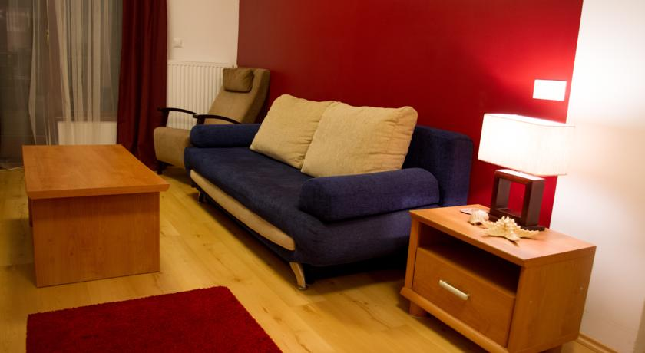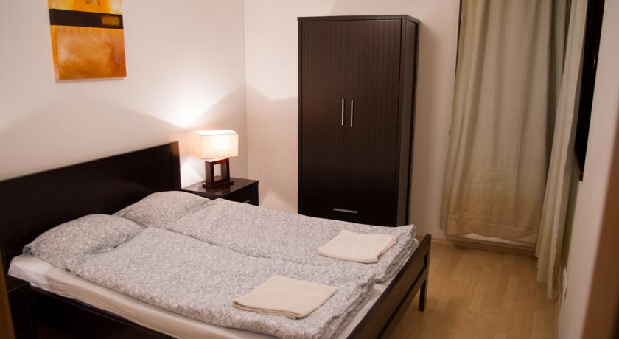

**Please underline the right answer. This reservation will be for**

* 4 participants
* Individual reservation
* Other: ……………………………..

**Nights:**

* Wednesday - Sunday (4 nights)
* Friday - Sunday (2 nights)

**RESEVATION DETAILS**

**Please complete one form per room**

|  |  |
| --- | --- |
| **1st Participant** | |
| Last name: |  |
| First name: |  |
| Address: |  |
| Phone: |  |
| Email: |  |
| **2nd Participant** | |
| Last name: |  |
| First name: |  |
| Address: |  |
| Phone: |  |
| Email: |  |
| **3rd Participant** | |
| Last name: |  |
| First name: |  |
| Address: |  |
| Phone: |  |
| Email: |  |
| **4th Participant** | |
| Last name: |  |
| First name: |  |
| Address: |  |
| Phone: |  |
| Email: |  |