**Instagram User Analytics**

**Project Description :**

Instagram, as we all must be knowing that is one of the most used social sites in today’s world. It’s really addicting right! , This project helps to analyse the raw data/metadata to create useful insights .

**Approach :**

Approach towards the project was fairly simple In order to execute the project, SQL was used. SQL queries were used to create a database using the raw data provided After that I wrote all the queries needed to find out the solutions as asked in the questions , to get the data/insights required.

**Tech-Stack Used :**

Tech stack used was MySQL Workbench v8.0.30.0 was used during project execution in order to query the database.

**Insights:**

1. - Task- Find the 5 oldest users of the Instagram from the database provided by the team.

QUERY - SELECT *

# FROM users

# ORDER BY created_at

# LIMIT 5;

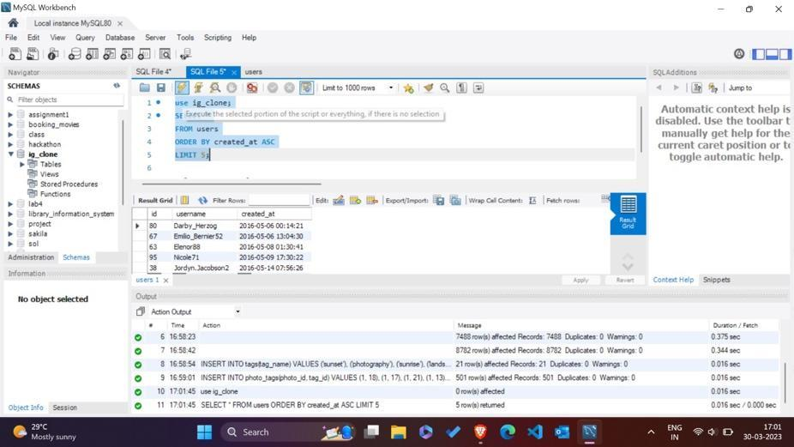

**Result :** The result shows the 5 oldest users using the instagram.

**2- Task - Find the users who have never posted a single photo on Instagram**

Query - SELECT username

FROM users

LEFT JOIN photos

ON users.id = photos.user_id

WHERE photos.id IS NULL;

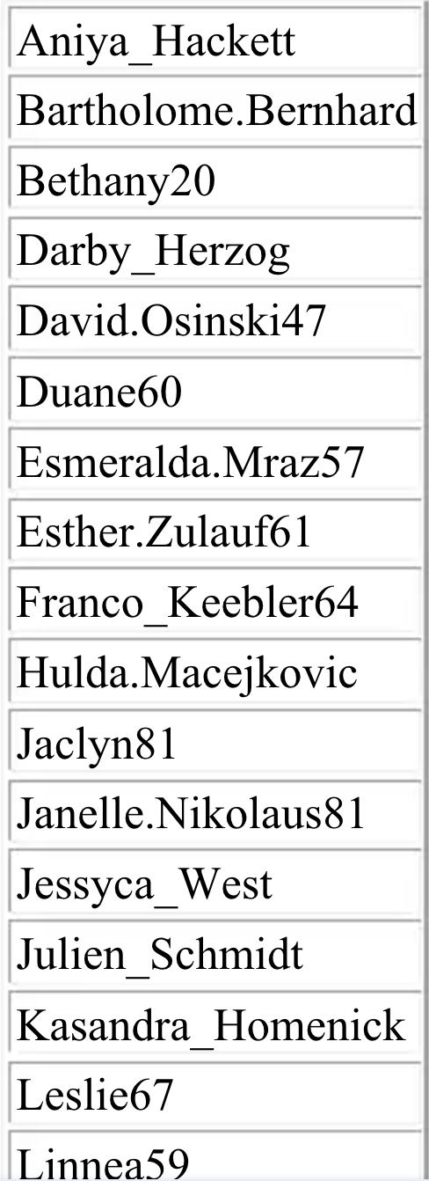

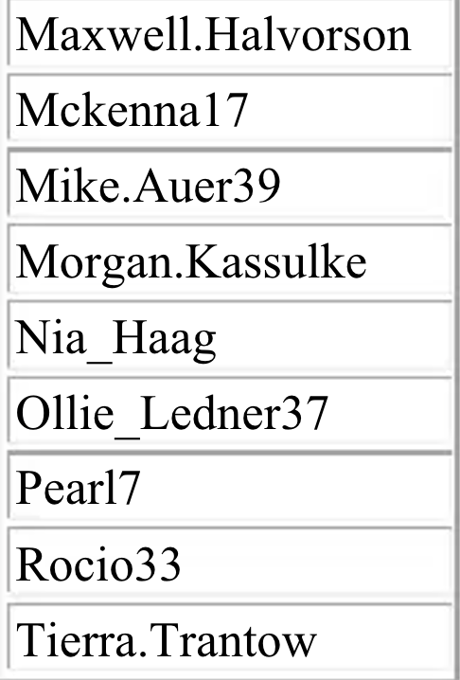

3 -Task: Identify the winner of the contest and provide their details to the team.

SQL QUERY-

SELECT username,

photos.id,

photos.image_url,

COUNT(*)

AS total

FROM photos

INNER JOIN likes

ON likes.photo_id = photos.id

INNER JOIN users

ON photos.user_id = users.id

GROUP BY photos.id

ORDER BY total DESC

LIMIT 1;

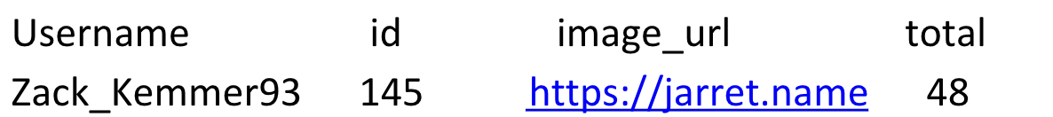

4 -Task: Identify and suggest the top 5 most commonly used hashtags on the platform.

SQL QUERY-

 SELECT tags.tag_name,

COUNT(*) AS total

FROM photo_tags

JOIN tags

ON photo_tags.tag_id = tags.id

GROUP BY tags.id

ORDER BY total DESC

LIMIT 5;

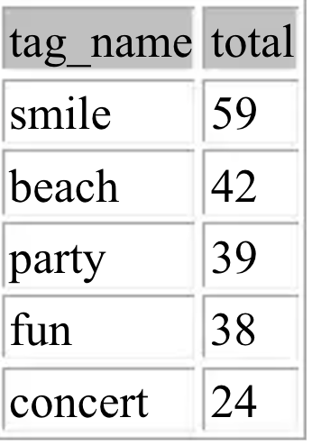

Result: Query shows the most used hashtags on instagram by the users

5- Task: What day of the week do most users register on? Provide insights on when to schedule an ad campaign.

**SQL QUERY –**

**SELECT**

**DAYNAME (created_at) AS day,**

**COUNT(*) AS total**

**FROM users**

**GROUP BY day**

**ORDER BY total DESC**

**LIMIT 2;**

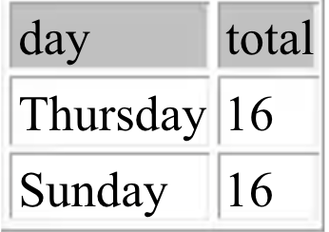

**Result -** The query result shows two days of the week when the users register mostly According to me the most suitable day to launch the ad campaign would be Sunday because users mostly have leisure time on Sunday and more interaction would happen on Sunday.

**B) Investor Metrics: Our investors want to know if Instagram is performing well**

**1 -Task: Provide how many times does average user posts on Instagram. Also, provide the total number of photos on Instagram/total number of users.**

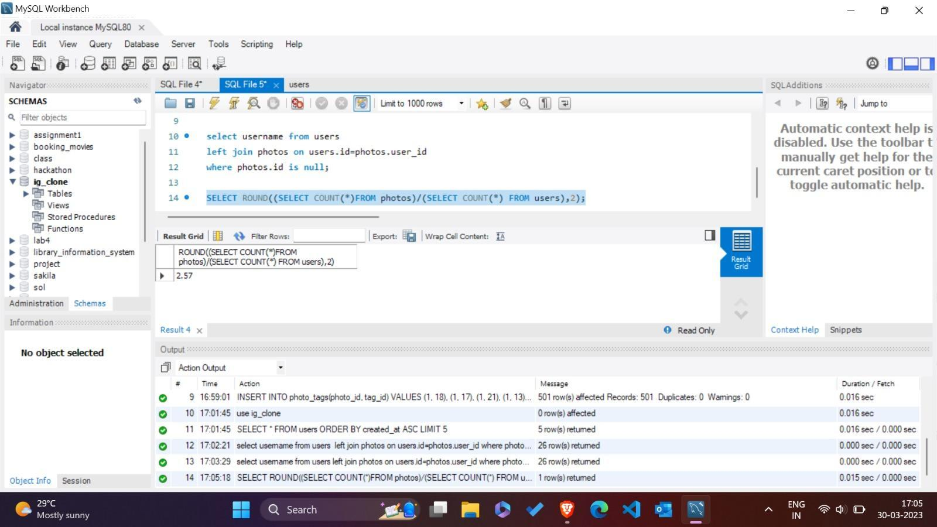

**2- Task: Provide data on users (bots) who have liked every single photo on the site (since any normal user would not be able to do this).**

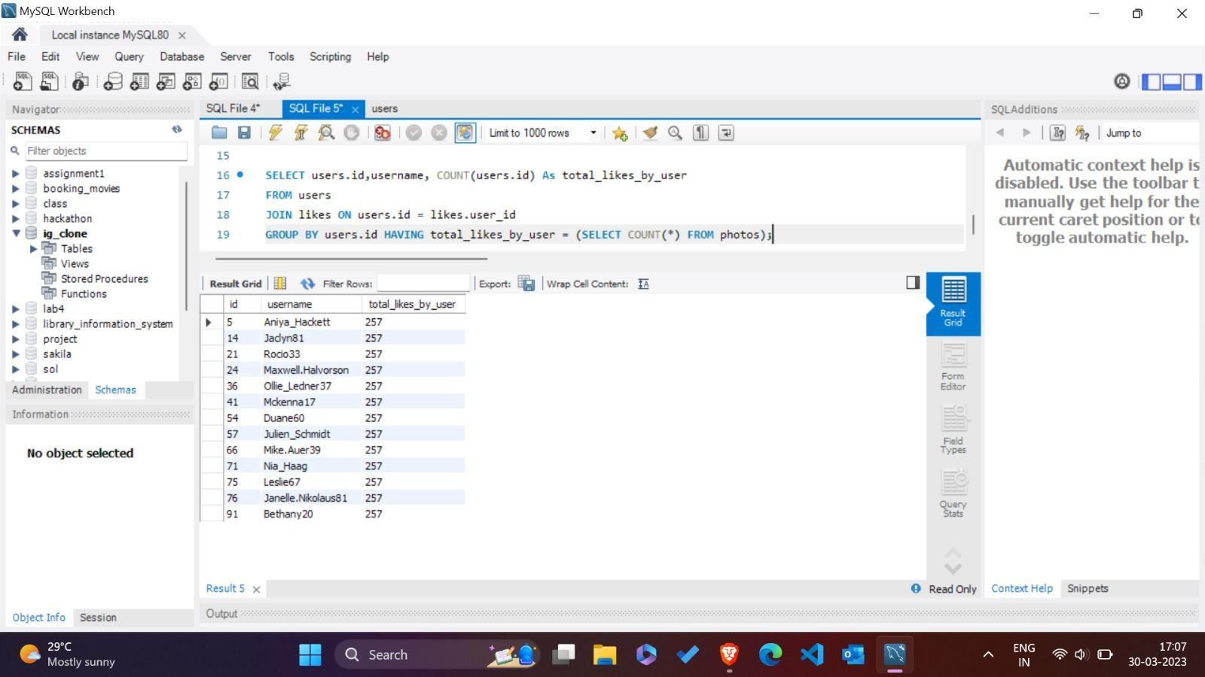

**RESULT-** From the query I found out there 13 fake accounts on the instagram.

**Result :**

While doing this project I found out so many important terms of MYSQL that helps in solving complex problems irrespective of how large the database is. I got to learn about using SQL and whereabouts of SQL workbench and I believe it will help me in future a lot. I have provided the solutions to every questions asked and I believe they are correct to the best of my knowledge and it solves all the query.

# NAME – YASH CHOUDHARY