PES UNIVERSITY, BANGALORE
Department of Computer Science and Engineering
Software Architecture and Design Specification
Project: Student Record Management System (SRMS)
Version: 1.0
Authors: Team 17 (Project ID SRMS-2026-17)
B Varun (PES1UG24CS109) • Bhavyaa Garg (PES1UG24CS116)
Chaithanya N (PES1UG24CS124) • Arabhi Bhat (PES1UG24CS927), Team Lead
Date: 1 October 2026
Status: Draft

Revision History
Version | Date | Author | Change Summary
1.0 | 1 Oct 2026 | Team 17 | Initial draft: architecture, component diagram, 4 sequence diagrams, API design, security architecture.

Approvals
Role | Name | Signature/Date
Team Lead | Arabhi Bhat
Course Coordinator

1. Introduction

1.1 Purpose
This document specifies the software architecture and detailed design of the Student Record Management System (SRMS) v1.0. It describes the component structure, the chosen architecture pattern and its rationale, the dynamic behaviour of the system's four core flows (as UML sequence diagrams), the module interface (API) design, error-handling strategy, and the security architecture that realises the objectives and requirements defined in the SRS (v2.0). It is the Design-phase deliverable that developers use to implement each owned module consistently.

1.2 Scope
Covers the internal software architecture of SRMS v1.0: the layered component structure (Presentation → Controller → Service → Data Access → Data); sequence diagrams for Administrator Login, Add Student Record, Search Student Record and Generate/Export Report; the API (function-interface) design for the Auth, Record, Search and Report services; and the security architecture addressing the threats identified in SRS Section 6.3.3. Excludes hardware design (SRMS has no custom hardware interfaces) and any future GUI/web front-end, which is explicitly out of scope for v1.0 per the Synopsis.

1.3 Audience
Primary audience: the four Team 17 developers (B Varun, Bhavyaa Garg, Chaithanya N, Arabhi Bhat), each implementing the module they own. Secondary audience: course faculty and evaluators assessing architectural soundness, modularity and requirements traceability; and any future maintainer extending SRMS (e.g., adding a GUI layer).

1.4 Definitions
Acronyms and terms used here follow SRS Appendix A. Additional architecture-specific terms:
- DAO (Data Access Object): the module that issues parameterized SQL statements against SQLite on behalf of exactly one entity (StudentDAO, AdminDAO).
- Service: a module containing business logic and validation for one owned feature, with no direct console I/O (NFR-MNT-01).
- Controller: the thin layer that reads console menu choices and dispatches to the corresponding Service.
- STRIDE: Spoofing, Tampering, Repudiation, Information disclosure, Denial of service, Elevation of privilege — the threat-modelling categories used in Section 3.9.

2. Document Overview

2.1 How to use this document
Each developer should read Section 3 (Architecture) before writing any code for their module, to confirm which layer their functions belong in and which other components they call. Before implementing a specific flow, read the matching sequence diagram and API table in Section 4.2–4.3. Testers should read Section 3.9 and 4.4 when designing security and negative test cases for the Test Plan. Evaluators can use Section 3.8 (Traceability to Requirements) to check that every SRS requirement has an architectural home.

2.2 Related Documents
- Software Requirements Specification (SRS), SRMS, Version 2.0 — source of all REQ/NFR/SEC/UC IDs referenced throughout this document.
- Software Test Plan (STP), SRMS, Version 1.0 — consumes this document's component/interface design for test-case design and the RTM.
- Team 17 — SRMS Synopsis / Project Proposal, Version 1.0.

3. Architecture

3.1 Goals & Constraints
Goals: a modular, maintainable, independently-testable layered design in which each of the four owned features (Auth, CRUD, Search, Reports) can be implemented, unit-tested and reviewed in isolation; secure-by-default behaviour realising security objectives SO-01 to SO-05; response times within the NFR-PERF-01..06 targets even at the 10,000-record reference scale.
Constraints: implementation language restricted to C/C++ (C++17); console-only UI, no GUI; SQLite as the only persistent store, accessed solely through the sqlite3 C API with prepared statements; only one Administrator session active at a time (SRS Section 2.7); the codebase must build and pass all tests unchanged on both Ubuntu 22.04 (gcc) and Windows 11 (MinGW-w64), per NFR-PORT-01.

3.2 Stakeholders & Concerns
Stakeholder | Concerns
Administrator (end user) | Accurate, up-to-date records; fast search/sort/filter; simple, forgiving console menus; confidence that deletions cannot happen by accident.
Course faculty / evaluators | Clean, modular design matching individual ownership; clear requirements-to-architecture-to-code traceability; demonstrable, executed security validation.
Development team (Team 17) | Well-defined interfaces between the four owned modules so integration doesn't block any one person; straightforward unit testing without a running console.
Future maintainer | Ability to add a GUI or networked front-end later without rewriting the Service/DAO layers (per Synopsis ‘Future Enhancements’).

3.3 Component (UML) Diagram
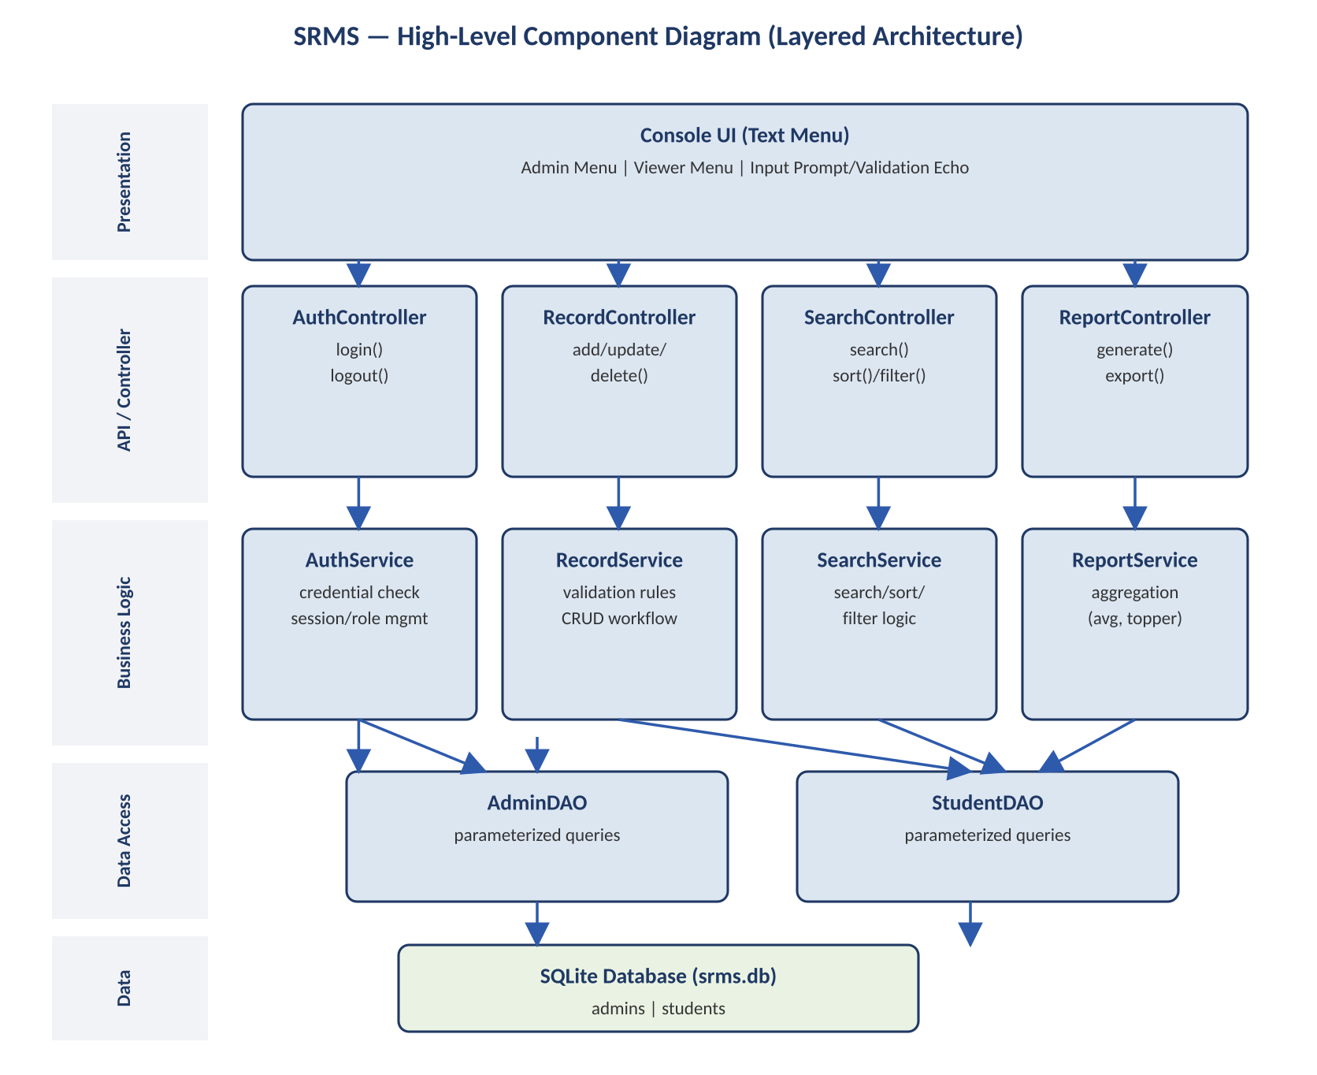
Figure 3.1 — SRMS High-Level Component Diagram (Layered Architecture)
Two cross-cutting Business Logic components are shared by every Service and omitted above for clarity: Validator (field/record validation) and AuditLogger (writes to audit_log). Both are detailed in Section 3.4.

3.4 Component Descriptions
Component | Responsibility | Owner
Console UI | Renders numbered text menus (Main / Administrator), reads input, echoes validation errors per UI-01..05. | B Varun
AuthController / AuthService | Login/logout, credential verification, session and role management, account lockout (REQ-AUTH, SEC-01, 03, 04, 06, 07, 08). | B Varun
RecordController / RecordService | Add/Update/Delete/List workflow and field validation orchestration (REQ-CRUD, REQ-DATA). | Bhavyaa Garg
Validator | Per-field and whole-record validation rules from SRS Appendix B; shared by every Service before a write (REQ-DATA-02..05). | Bhavyaa Garg
AuditLogger | Writes RECORD_ADDED / RECORD_UPDATED / RECORD_DELETED / login events to the audit_log table (SEC-04); used by all Services. | Shared (defined with CRUD)
SearchController / SearchService | Search by roll no./name, sort, filter, and Viewer field-visibility enforcement (REQ-SRCH, SEC-09). | Chaithanya N
ReportController / ReportService | Class list / average CGPA / topper computation and file export (REQ-RPT). | Arabhi Bhat
AdminDAO, StudentDAO | Only components permitted to touch SQL; issue exclusively parameterized statements (SEC-02); schema owner. | Chaithanya N (schema) / shared
SQLite Database (srms.db) | Persistent storage for students, admins and audit_log tables (SRS Section 4.4); file permissions 0600 (SEC-08). | Shared

3.5 Chosen Architecture Pattern and Rationale
Pattern: classic layered architecture (Presentation → API/Controller → Business Logic → Data Access → Data), with strictly one-directional, adjacent-layer-only calls.
Rationale: the layering maps one-to-one onto the team's product-ownership split (Synopsis Section 1), so each member can implement, unit-test and demo their Controller+Service pair independently. Keeping console I/O (Presentation) separate from business logic (Service) satisfies NFR-MNT-01 and makes Services testable with GoogleTest without any console interaction. Centralising all SQL in two DAOs makes SEC-02 (parameterized queries only) easy to enforce and review in one place. A microservices or event-driven style was considered and rejected: SRMS is a single-process console tool for one department (complexity rated ‘Easy’ by the course), so the operational overhead of multiple processes or a message bus would add risk and complexity with no corresponding benefit.

3.6 Technology Stack & Data Stores
Layer / Concern | Technology | Notes
Language / compiler | C++17, gcc/g++ 11+ or clang 14+ | Per SRS Section 2.4
Build system | GNU Make or CMake 3.16+ | Single build graph for app + tests
Persistence | SQLite 3.31+ via sqlite3 C API | Single file srms.db; 3 tables (students, admins, audit_log)
Cryptography | OpenSSL libcrypto 1.1.1+ | PBKDF2-HMAC-SHA256 password hashing (SEC-01)
Testing | GoogleTest 1.12+ | Unit tests per module, ≥70% line coverage (NFR-TST-01)
Static analysis | cppcheck 2.x | Run before every sprint review (NFR-MNT-03)
CI | GitHub Actions | Build + run all tests on every push (NFR-TST-02)

3.7 Risks & Mitigations
Risk | Mitigation
SQL injection through search/add/update fields | All SQL is parameterized (SEC-02); input validated against Appendix B rules before reaching the DAO (REQ-DATA-02..05).
Credential or password-hash leakage | PBKDF2 + per-account salt (SEC-01); never written to logs/console (SEC-05); srms.db and audit log created with 0600 permissions (SEC-08).
Single-admin-session assumption violated in practice | Every write wrapped in a SQLite transaction (NFR-REL-01); limitation documented as an explicit assumption (SRS Section 2.7), not silently handled.
Cross-platform build breakage (Ubuntu vs. Windows/MinGW) | CI matrix builds both targets; no platform-specific APIs used outside a small, isolated platform-adapter file (NFR-PORT-01).
Schema drift between developers' machines | schema.sql is version-controlled and applied automatically on first run if srms.db does not exist (REQ-DATA-08).

3.8 Traceability to Requirements
Architecture Component | Requirements Realised
AuthController / AuthService | REQ-AUTH-01..08; SEC-01, 03, 04, 06, 07, 08; UC-01, 02, 10
RecordController / RecordService / Validator / AuditLogger | REQ-CRUD-01..08; REQ-DATA-02..05; SEC-04, 07; UC-03, 04, 05, 06, 11, 12
SearchController / SearchService | REQ-SRCH-01..07; SEC-09; UC-07, 09
ReportController / ReportService | REQ-RPT-01..05; UC-08, 13
AdminDAO / StudentDAO / SQLite DB | REQ-DATA-01..08; SEC-02, 08, 10
Console UI (all Controllers) | UI-01..05; NFR-USE-01, 02

3.9 Security Architecture
Threats are analysed using STRIDE and mapped to the architecture components responsible for mitigating each (consistent with the threat table in SRS Section 6.3.3):
STRIDE Category | Threat (SRMS-specific) | Mitigating Component(s) / Requirement
Spoofing | An attacker impersonates the Administrator | AuthService salted-hash verification (SEC-01); forced change of default password (SEC-06)
Tampering | Student records altered outside normal workflow | RecordService validation + transactional DAO writes (NFR-REL-01); session check inside every data-modifying function, not just the menu (SEC-07)
Repudiation | An Administrator denies having made a change | AuditEvent logging of every state-changing action in AdminDAO/StudentDAO write path (SEC-04)
Information Disclosure | SQL injection, or a Viewer seeing sensitive fields | Parameterized statements in all DAOs only (SEC-02); SearchService field-filtering for Viewer role (SEC-09, REQ-SRCH-04)
Denial of Service | Brute-force login attempts; oversized input crashing the console | AuthService account lockout after 5 failures (SEC-03); input length checked before any buffer copy (SEC-10)
Elevation of Privilege | A Viewer session invokes an Administrator-only function directly | Role check inside every Service function (SEC-07), not solely at the Controller/menu layer, per REQ-AUTH-06

4. Design

4.1 Design Overview
SRMS is designed as four vertical, independently-ownable feature slices (Authentication, Record CRUD, Search/Sort/Filter, Reports) sitting on top of a shared Persistence & Validation layer, each slice following the same Controller → Service → DAO shape described in Section 3. This section details the dynamic behaviour of the four core user-facing flows as UML sequence diagrams, followed by the module (API) interface design, the error-handling strategy, and the console UX design.

4.2 UML Sequence Diagrams
Four sequence diagrams are provided — one per owned module — covering the highest-value flow in each (exceeding the minimum of two required).

4.2.1 Administrator Login (Owner: B Varun)
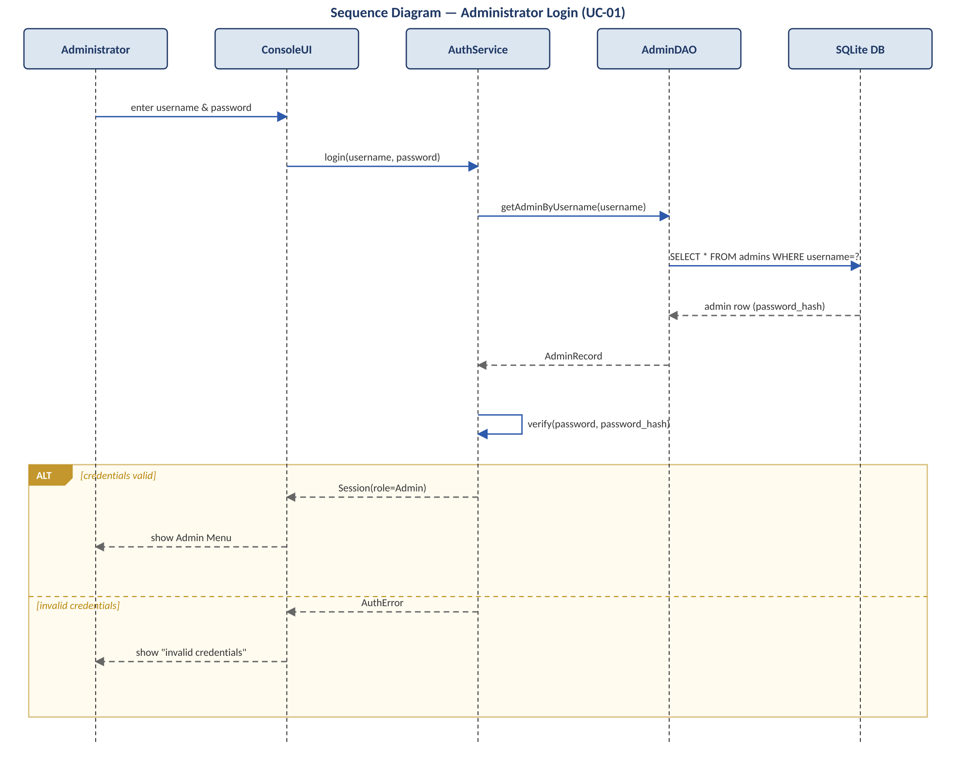
Figure 4.1 — Sequence Diagram: Administrator Login (UC-01; REQ-AUTH-01..04)

4.2.2 Add Student Record (Owner: Bhavyaa Garg)
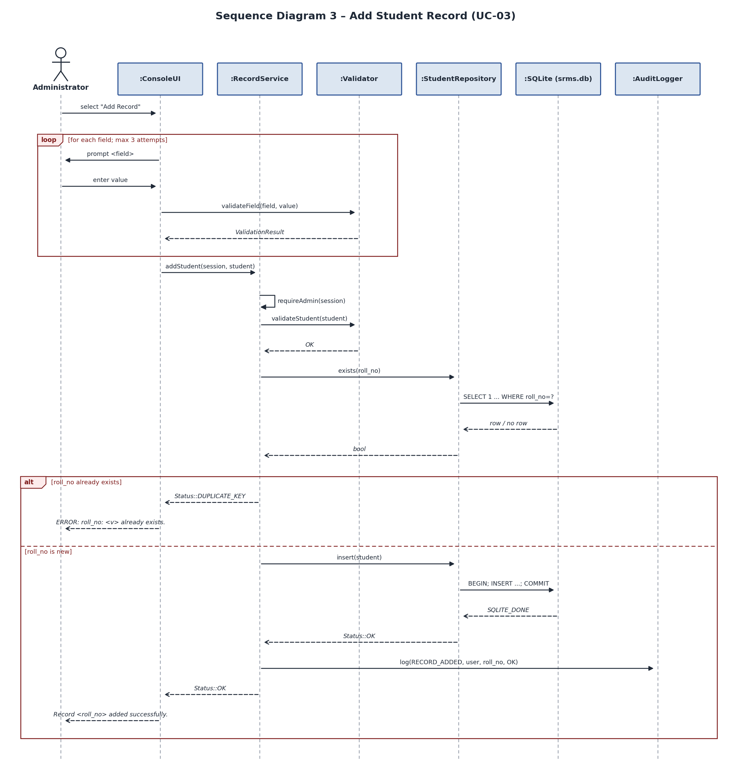
Figure 4.2 — Sequence Diagram: Add Student Record (UC-03, includes UC-11; REQ-CRUD-01, 02, 08; REQ-DATA-01..06; SEC-02, 04, 07)
ConsoleUI validates each field through Validator::validateField() as it is entered (max 3 attempts per field, else CANCELLED). RecordService::addStudent() re-checks the session (requireAdmin, SEC-07) and re-validates the whole record server-side as defence in depth, then StudentRepository::exists() runs a parameterized SELECT before StudentRepository::insert() commits the row as a single transaction and AuditLogger records RECORD_ADDED (SEC-04).

4.2.3 Update Student Record (Owner: Bhavyaa Garg)
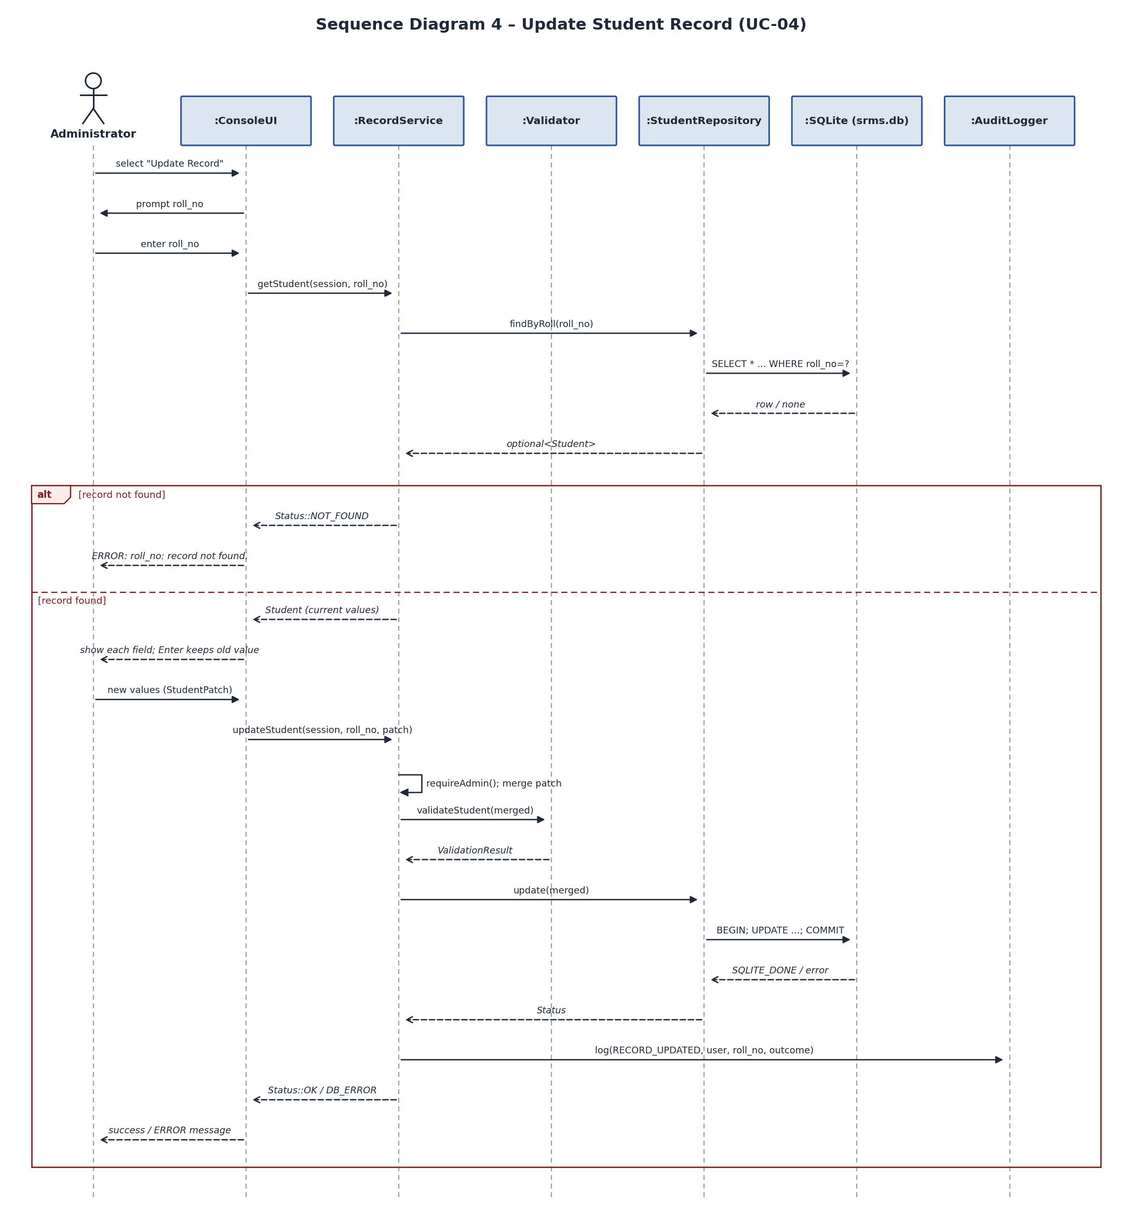
Figure 4.3 — Sequence Diagram: Update Student Record (UC-04, includes UC-11; REQ-CRUD-03, 04, 07, 08; REQ-DATA-01, 07; SEC-04, 07)
Only changed fields are sent as a StudentPatch (roll_no is immutable, BR-02); RecordService::updateStudent() merges the patch into the stored record and validates the merged result as a whole (catching cross-field rules, not just per-field ones) before StudentRepository::update() commits inside a transaction and logs RECORD_UPDATED.

4.2.4 Search Student Record (Owner: Chaithanya N)
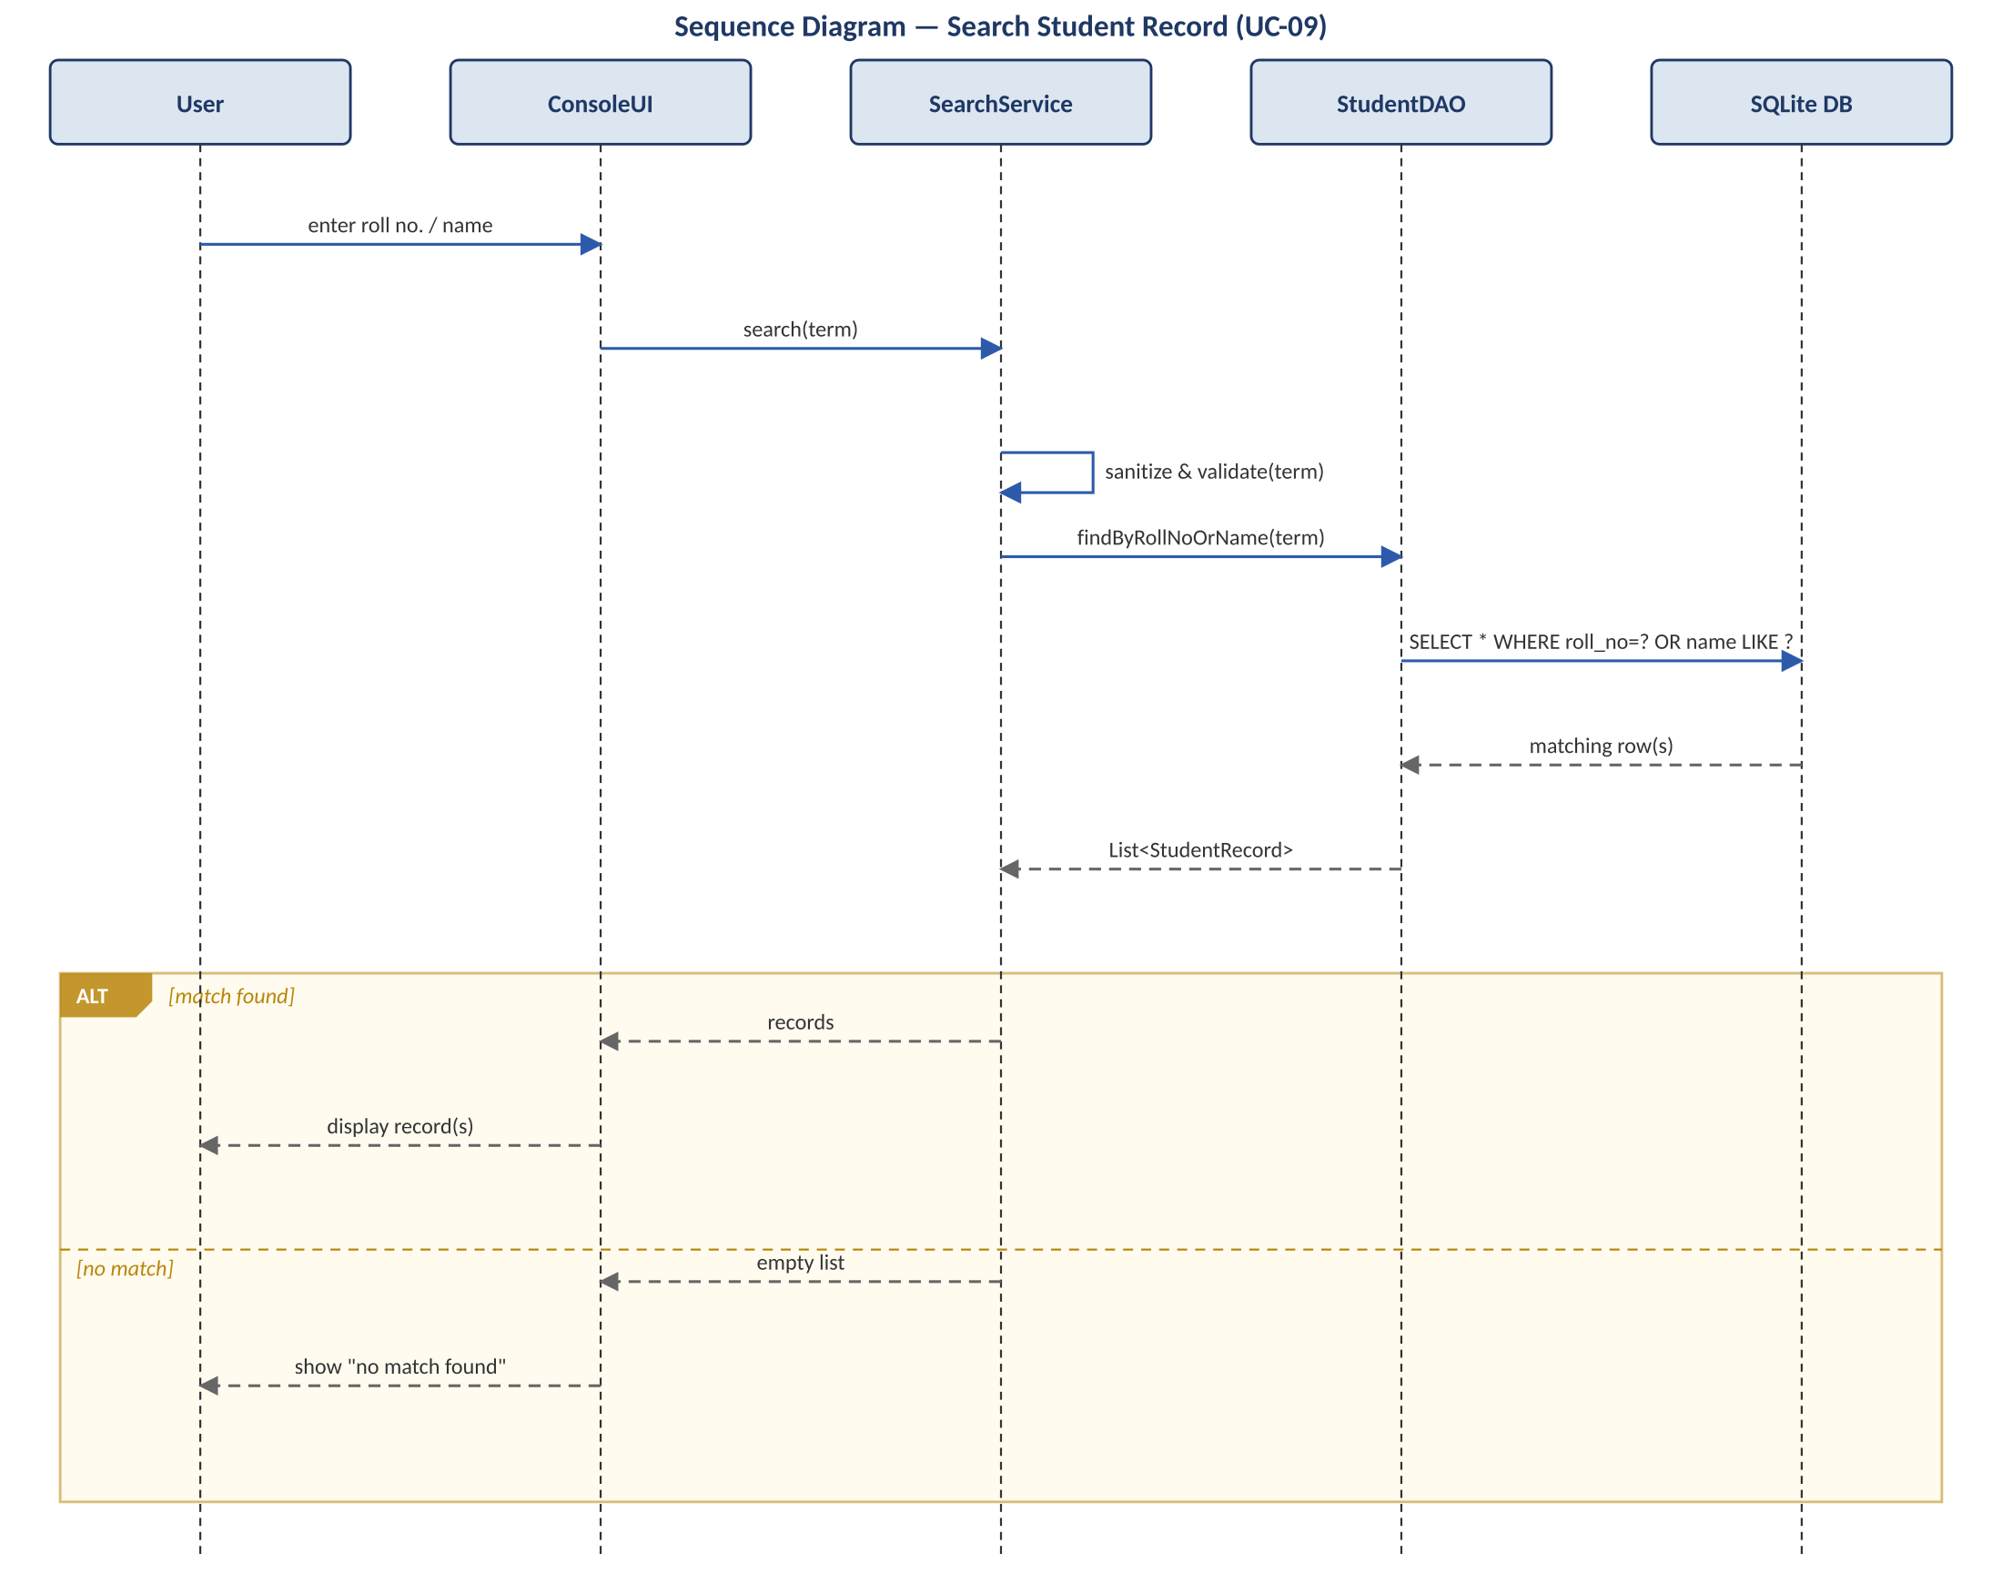
Figure 4.4 — Sequence Diagram: Search Student Record (UC-09; REQ-SRCH-01..04)
SearchService::search() sanitizes and validates the query term, then StudentDAO issues a single parameterized SELECT matching roll_no exactly or name by substring (both case-insensitive, SEC-02). A zero-row result is a valid OK (empty Page), not an error — ConsoleUI displays “No matching record found.” (REQ-SRCH-03). For a Viewer session, SearchService strips contact and the timestamp fields from each Student before returning the Page (REQ-SRCH-04, SEC-09).

4.2.5 Sort / Filter Records (Owner: Chaithanya N)
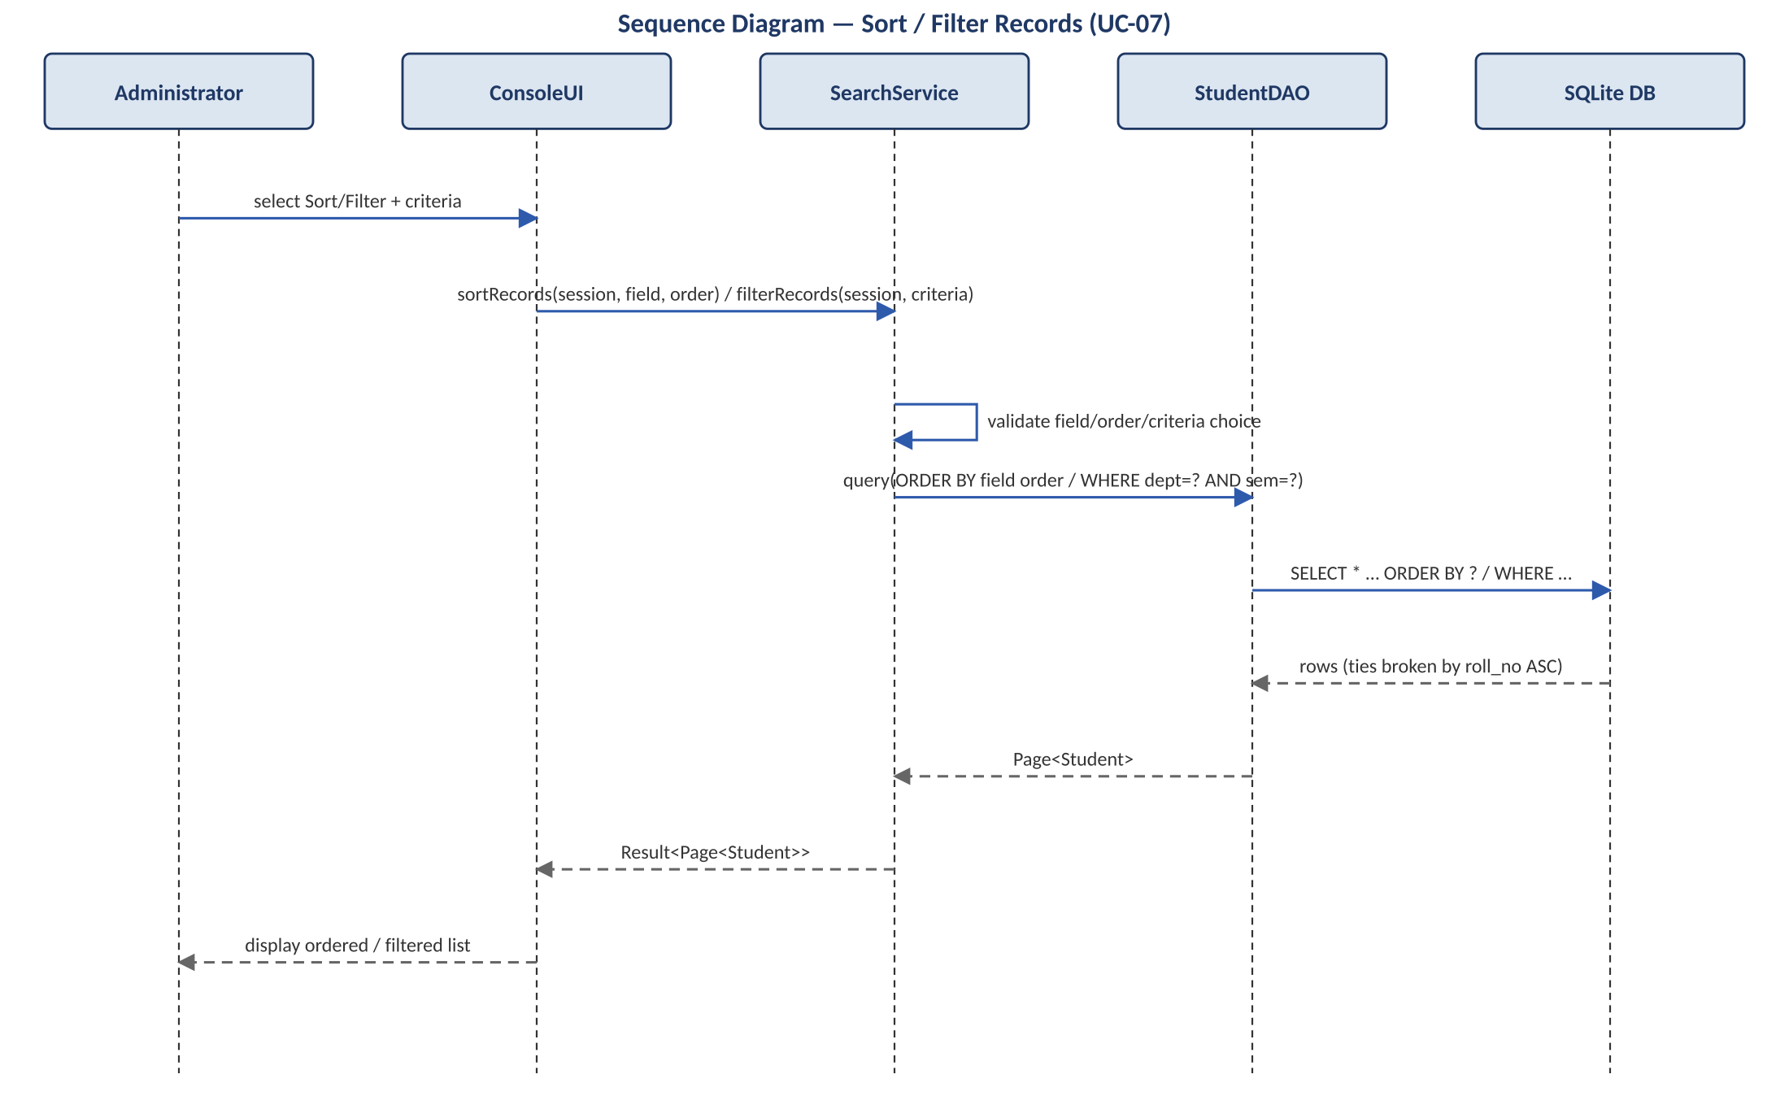
Figure 4.5 — Sequence Diagram: Sort / Filter Records (UC-07; REQ-SRCH-05..07)
sortRecords() and filterRecords() share the same StudentDAO query path: the chosen field/order or department/semester criteria are validated against a fixed allow-list before being used to build a parameterized ORDER BY / WHERE clause (never string-concatenated, SEC-02). Sort ties are always broken by roll_no ascending (REQ-SRCH-06).

4.2.6 Generate & Export Report (Owner: Arabhi Bhat)
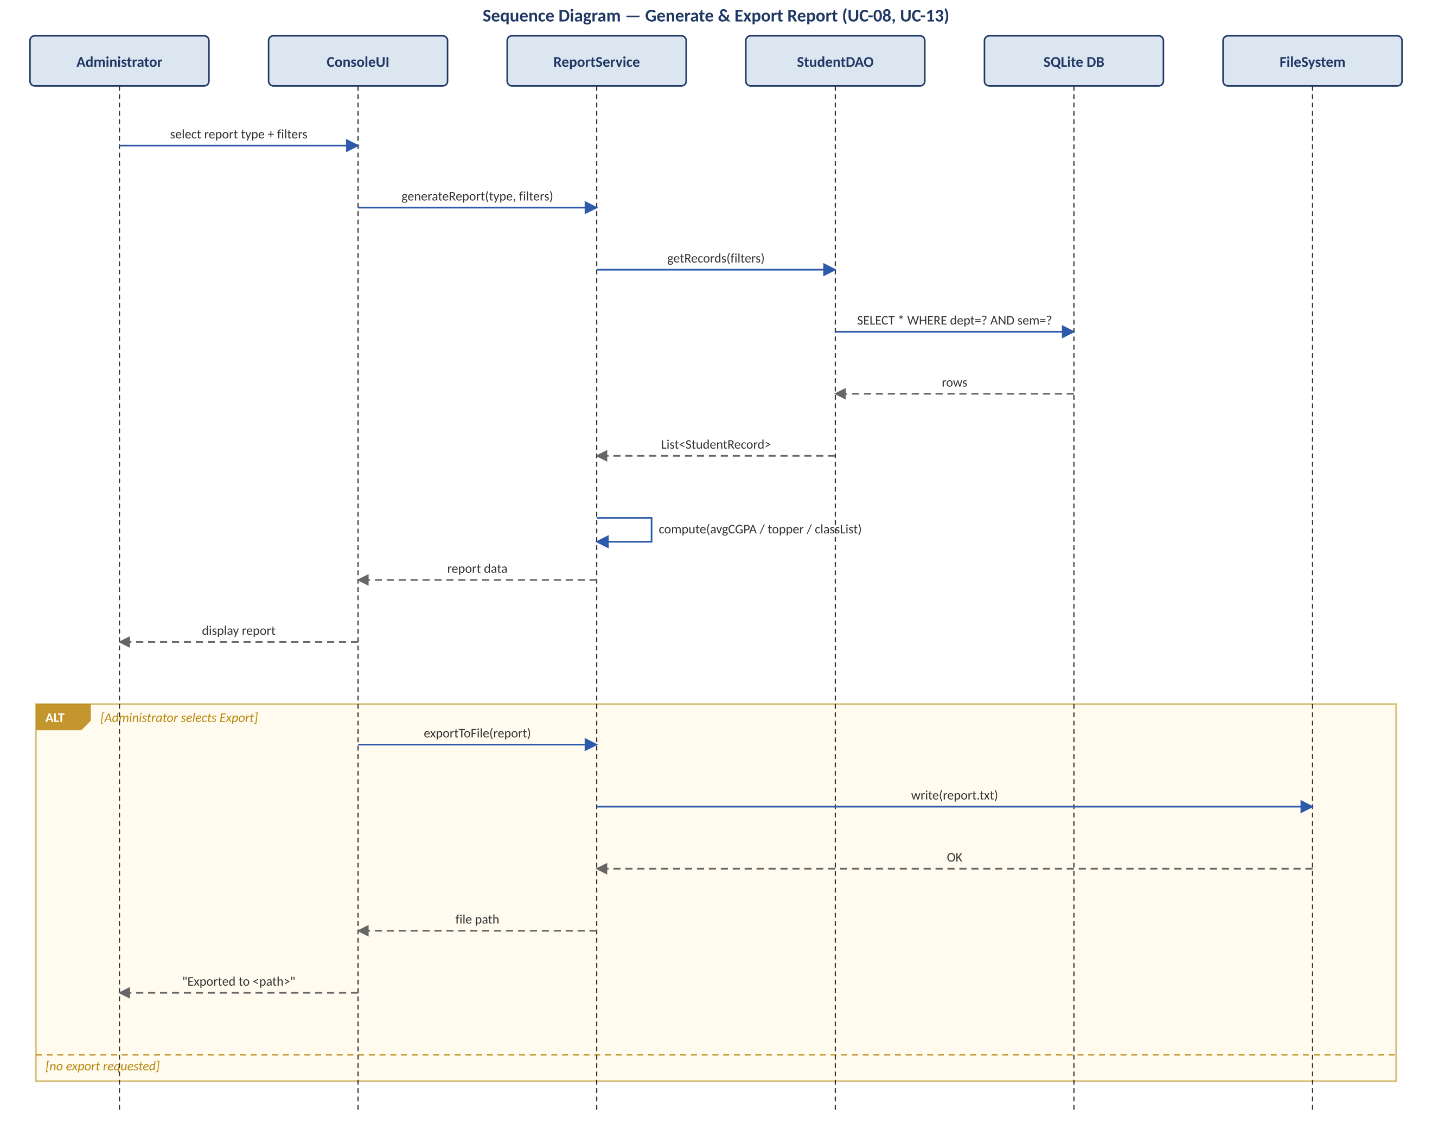
Figure 4.6 — Sequence Diagram: Generate & Export Report (UC-08, UC-13; REQ-RPT-01..04)

4.3 API Design
SRMS is a single-process console application with no network layer, so ‘API’ here means the in-process module interface (function signatures) between a Controller and its Service — not a REST/HTTP API. Interfaces are given for all four owned components (exceeding the minimum of two).

4.3.1 Shared Types (src/core/types.h)
Defined by Bhavyaa Garg as part of the CRUD component design; adopted as the single canonical type set for every module so that Auth, Search and Reports return the same Status/Result<T> shapes rather than each inventing its own error handling.
- enum class Status { OK, VALIDATION_ERROR, DUPLICATE_KEY, NOT_FOUND, ACCESS_DENIED, ACCOUNT_LOCKED, CANCELLED, DB_ERROR, IO_ERROR, INTERNAL_ERROR };
- struct Session { std::string username; bool is_admin; std::time_t last_activity; };
- struct Student { roll_no, name, department, semester, contact, cgpa, created_at, updated_at; } — field rules per SRS Appendix B.
- struct StudentPatch { optional<...> name, department, contact, semester, cgpa; } — only changed fields are set (used by RecordService::updateStudent).
- template<typename T> struct Result { Status status; T value; std::string detail; }; and template<typename T> struct Page { vector<T> items; int page, total_pages, total_items; };

4.3.2 Per-Component Interfaces
Component | Interface (signature) | Errors / Notes
AuthService | Result<Session> login(const string& username, const string& password)  void logout(Session&)  bool hasRole(const Session&, Role) | Status::ACCESS_DENIED, ACCOUNT_LOCKED (SEC-03) — same shared Status enum as CRUD
RecordService  (Bhavyaa Garg) | Status addStudent(const Session&, const Student&)  Result<Student> getStudent(const Session&, const string& roll_no)  Status updateStudent(const Session&, const string& roll_no, const StudentPatch&)  Status deleteStudent(const Session&, const string& roll_no) | Status::VALIDATION_ERROR, DUPLICATE_KEY, NOT_FOUND, ACCESS_DENIED — see Section 4.2.2–4.2.3
SearchService  (Chaithanya N) | Result<Page<Student>> search(const optional<Session>&, const string& term)  Result<Page<Student>> sortRecords(const Session&, Field, Order)  Result<Page<Student>> filterRecords(const Session&, const FilterCriteria&) | Field visibility depends on role (SEC-09, uses shared Session); an empty Page is a valid OK result, not an error
ReportService  (Arabhi Bhat) | Result<Report> generate(const Session&, ReportType, const Filters&)  Result<string> exportToFile(const Session&, const Report&, Format) | Status::IO_ERROR on export failure; empty dataset is OK with zero rows (REQ-RPT-05)

4.4 Error Handling, Logging & Monitoring
Lead: Bhavyaa Garg. CI/monitoring angle: Arabhi Bhat.

4.4.1 Error-Handling Strategy
- Detect early: input errors are caught by Validator at entry, before any Service or database call (REQ-DATA-02..05).
- Return, don't throw: errors travel upward as Status values (Section 4.3.1). Each layer either handles an error or passes it up unchanged; no layer swallows one.
- Translate once: only ConsoleUI turns a Status into text, via ErrorCatalog::message(), always in the format “ERROR: <field>: <rule>.” (UI-03). Internal details (SQLite codes, file paths) are logged but never shown to the user.
- Fail safe: every write is a single transaction; any failure triggers ROLLBACK, so the database is never left half-written (NFR-REL-01).
- Never crash on user input: the only fatal errors are the start-up conditions below; after start-up every error returns the user to the previous menu (NFR-REL-02).
- Deny by default: a missing or expired session always yields ACCESS_DENIED, never partial access.

4.4.2 Error Catalogue
Status | Raised by | User message (console) | Log level
VALIDATION_ERROR | Validator | ERROR: <field>: <rule>. | WARN
DUPLICATE_KEY | RecordService | ERROR: roll_no: <value> already exists. | WARN
NOT_FOUND | RecordService | ERROR: roll_no: record not found. | INFO
ACCESS_DENIED | All services | ERROR: access: administrator login required. | WARN + audit
ACCOUNT_LOCKED | AuthService | ERROR: login: account locked, try again in <n>s. | WARN + audit
CANCELLED | ConsoleUI | Operation cancelled. / Deletion cancelled. | INFO
DB_ERROR | Repository | ERROR: database: <operation> failed. | ERROR
IO_ERROR | ReportService | ERROR: file: could not write <file name>. | ERROR
INTERNAL_ERROR | Service boundary catch | ERROR: internal: unexpected error, see srms.log. | ERROR

4.4.3 Start-up / Fatal Conditions
Condition at start-up | Action | Exit code
srms.db missing | Create it with schema.sql (REQ-DATA-08); continue | —
srms.db cannot be opened (permissions, locked) | Print “FATAL: cannot open database srms.db.”, log, exit | 2
PRAGMA integrity_check does not return “ok” | Print “FATAL: database integrity check failed.”, log, exit without writing | 3
srms.log cannot be opened | Warn and continue, logging to stderr only | —

4.4.4 Transaction & Recovery Rules
- Every insert/update/delete uses BEGIN IMMEDIATE … COMMIT; any failure between the two issues ROLLBACK before returning DB_ERROR.
- SQLite runs with PRAGMA journal_mode=WAL and PRAGMA foreign_keys=ON, so an interrupted write is never visible after a crash (NFR-REL-01).
- SQLITE_BUSY is retried via sqlite3_busy_timeout(db, 2000); after 2 s it becomes DB_ERROR.
- Every sqlite3_stmt is finalised on every path via an RAII wrapper (StmtGuard), so nothing leaks on early returns (NFR-REL-03).

4.4.5 Logging & Monitoring
SRMS keeps two separate logs with different purposes: an application log (srms.log, written by Logger across all modules, for diagnosing failures) and the audit_log table in srms.db (written only by AuditLogger from within Services, for security accountability per SEC-04). Passwords, hashes and salts are never written to either (SEC-05). Monitoring in this version is CI- and log-based rather than live: the GitHub Actions build/test pass rate is the team's health signal (NFR-TST-02), and audit_log is queryable via the sqlite3 CLI for post-hoc review.

4.5 UX Design
Console UX follows the numbered-menu design in SRS Section 3.1: every screen shows a title line (UI-01); an out-of-range or non-numeric menu choice re-displays the menu rather than crashing (UI-02); tabular output (record lists, reports) is kept within an 80-character terminal width, truncating long names with “…” (UI-04); and every operation returns to the previous menu on completion or cancellation (UI-05). Password entry is never echoed to the console (REQ-AUTH-03). Owner: B Varun (menu/session owner), consumed by all four Controllers.

4.6 Open Issues & Next Steps
- Decide whether CSV export (REQ-RPT-04) uses a hand-rolled writer or a small header-only CSV library — to be resolved in Sprint 5.
- Confirm the exact buffer-size constants enforcing SEC-10 for each field in Appendix B, and add them to a shared constants header.
- Spike needed in Sprint 1: verify the OpenSSL libcrypto build works unchanged on Windows/MinGW-w64 (NFR-PORT-01) before other modules depend on password hashing.
- Future enhancement (explicitly out of v1.0 scope): an optional GUI or web front-end, per the Synopsis ‘Future Enhancements’ section — the layered design is intended to make this additive rather than a rewrite.

5. Appendices

5.1 Glossary
See SRS Appendix A for product-level terms. Architecture-specific terms are defined in Section 1.4 of this document (DAO, Service, Controller, STRIDE).

5.2 References
- Software Requirements Specification (SRS), SRMS, Version 2.0, Team 17.
- Team 17 — SRMS Synopsis / Project Proposal, Version 1.0.
- OWASP Foundation — “Password Storage Cheat Sheet” and “SQL Injection Prevention Cheat Sheet.”
- OMG Unified Modeling Language (UML) Specification, Version 2.5.1.

5.3 Tools
- Diagramming: diagrams in this document were generated programmatically to an SVG/UML sequence-diagram convention; Draw.io/PlantUML are acceptable alternatives for future revisions.
- GoogleTest (unit testing), cppcheck (static analysis), GitHub Actions (CI).

