**Movie recommender**

We have to select the most similar movie to “*The Usual Suspects*”.

|  |  |  |  |
| --- | --- | --- | --- |
| **Title** | **Genre** | **IMDB rating** | **Duration(minutes)** |
| Se7en | Crime, Drama, Mystery | 8.6 | 127 |
| Midnight in Paris | Comedy, Fantasy, Romance | 7.7 | 94 |
| Suspiria(1977) | Horror | 7.3 | 99 |
| The Godfather | Crime, Drama | 9.2 | 175 |
| Psycho | Horror, Mystery, Thriller | 8.5 | 109 |
| The Shining | Drama, Horror | 8.4 | 146 |
| The Game | Drama, Mystery, Thriller | 7.7 | 129 |
| Little Miss Sunshine | Comedy, Drama | 7.8 | 101 |
| Annie Hall | Comedy, Romance | 8.0 | 93 |
| The Usual Suspects | Crime, Drama, Mystery | 8.5 | 106 |

First step is calculating the Euclidean distance:

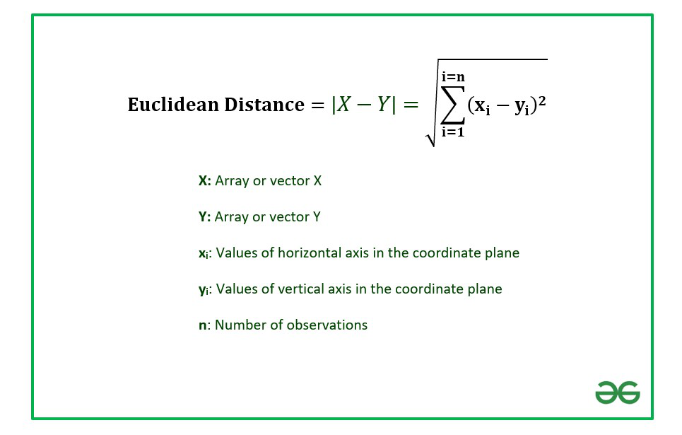

We should calculate Euclidean distance for all data points

1. dist(d) = sqrt(x1 – y1)^2 + (x2-y2)^2 = sqrt((8.5-8.6)^2 + (106-127)^2) = sqrt(0.01 + 441) = 21.0002381
2. dist(d) = sqrt(x1 – y1)^2 + (x2-y2)^2 = sqrt((8.5-7.7)^2 + (106-94)^2) = sqrt(0.64 + 144) = 12.0266371
3. dist(d) = sqrt(x1 – y1)^2 + (x2-y2)^2 = sqrt((8.5-7.3)^2 + (106-99)^2) = sqrt(1.44 + 49) = 7.10211236
4. dist(d) = sqrt(x1 – y1)^2 + (x2-y2)^2 = sqrt((8.5-9.2)^2 + (106-175)^2) = sqrt(0.49 + 4761) = 69.0035506
5. dist(d) = sqrt(x1 – y1)^2 + (x2-y2)^2 = sqrt((8.5-8.5)^2 + (106-109)^2) = sqrt(0+ 9) = 3
6. dist(d) = sqrt(x1 – y1)^2 + (x2-y2)^2 = sqrt((8.5-8.4)^2 + (106-146)^2) = sqrt(0.01 + 1600) = 40.000125
7. dist(d) = sqrt(x1 – y1)^2 + (x2-y2)^2 = sqrt((8.5-7.7)^2 + (106-129)^2) = sqrt(0.64 + 529) = 23.0139088
8. dist(d) = sqrt(x1 – y1)^2 + (x2-y2)^2 = sqrt((8.5-7.8)^2 + (106-101)^2) = sqrt(0.49 + 25) = 5.04876222
9. dist(d) = sqrt(x1 – y1)^2 + (x2-y2)^2 = sqrt((8.5-8.0)^2 + (106-93)^2) = sqrt(0.25 + 169) = 13.0096118

|  |  |  |  |  |
| --- | --- | --- | --- | --- |
| **Title** | **Genre** | **IMDB rating** | **Duration(minutes)** | **Euclidean distance** |
| Se7en | Crime, Drama, Mystery | 8.6 | 127 | 21.0002381 |
| Midnight in Paris | Comedy, Fantasy, Romance | 7.7 | 94 | 12.0266371 |
| Suspiria(1977) | Horror | 7.3 | 99 | 7.10211236 |
| The Godfather | Crime, Drama | 9.2 | 175 | 69.0035506 |
| Psycho | Horror, Mystery, Thriller | 8.5 | 109 | 3 |
| The Shining | Drama, Horror | 8.4 | 146 | 40.000125 |
| The Game | Drama, Mystery, Thriller | 7.7 | 129 | 23.0139088 |
| Little Miss Sunshine | Comedy, Drama | 7.8 | 101 | 5.04876222 |
| Annie Hall | Comedy, Romance | 8.0 | 93 | 13.0096118 |
| The Usual Suspects | Crime, Drama, Mystery | 8.5 | 106 |  |

Second step is finding minimum Euclidean distance and ranking in order(ascending).

Lets assume that, K = 3

So, we have to find top 3 movies that similar to “The Usual Suspect” and select the most compatible one amoung them.

|  |  |  |  |  |
| --- | --- | --- | --- | --- |
| **Title** | **Genre** | **IMDB rating** | **Duration(minutes)** | **Euclidean distance** |
| Se7en | Crime, Drama, Mystery | 8.6 | 127 |  |
| Midnight in Paris | Comedy, Fantasy, Romance | 7.7 | 94 |  |
| Suspiria(1977) | Horror | 7.3 | 99 | 3 |
| The Godfather | Crime, Drama | 9.2 | 175 |  |
| Psycho | Horror, Mystery, Thriller | 8.5 | 109 | 1 |
| The Shining | Drama, Horror | 8.4 | 146 |  |
| The Game | Drama, Mystery, Thriller | 7.7 | 129 |  |
| Little Miss Sunshine | Comedy, Drama | 7.8 | 101 | 2 |
| Annie Hall | Comedy, Romance | 8.0 | 93 |  |
| The Usual Suspects | Crime, Drama, Mystery | 8.5 | 106 |  |

After ranking distances, we get alike movies that named:

1. Psycho
2. Little Miss Sunshine
3. Suspiria

Now, we have to select one. We’re looking at their genres. And we see that the most suitable movie is “*Psycho*”