**A QUICK AND DIRTY GUIDE TO ASD2TIFF_GUI AND CONNECTED GUIs**

The ***asd2tiff_gui*** is a MatLab-based GUI meant at swift and handy inspection of HS-AFM movies (in *.asd* binary format, as those from RIBM microscopes softwares *eagle, falco*n etc.,), easy sharing of the movies within MatLab *workspace* for advanced processing (*e.g.* using the image processing toolbox) and batch conversion into widespread *.tiff* format.

NB; some of the features are not available in the *stand-alone* version

* To launch the GUI type **asd2tiff_GUI** into the MatLab command window (or double-click the stand-alone asd2tiff_GUI icon)

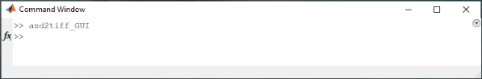

* From the menu, choose “load files>directory” to read all the files in a chosen folder. If any .asd file will be found, it will be shown in the “*Files in the directory*” listbox. If no suitable file is found, an error message will be displayed. By default, a new window called *“treeview”* will be opened, expanding and displaying all subfolder and files present within the chosen directory.

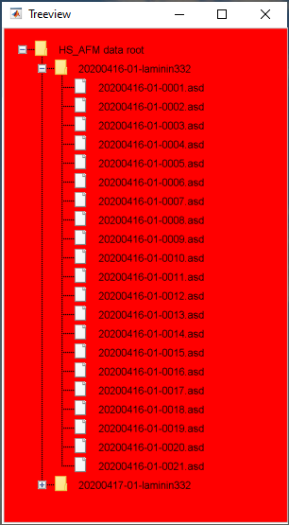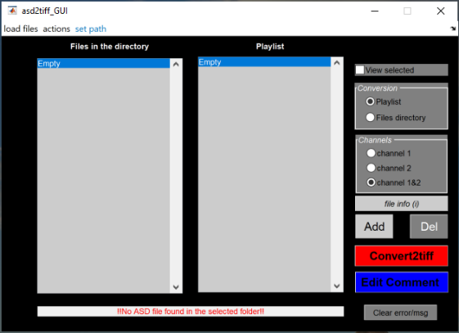

error message

* To import all the .asd files within a folder just select one .asd file within the “*Treeview*” window.
* To view a video check “View selected” within the asd2tiff_GUI window. You can choose which channel to view by clicking the intended radio-button in the “Channels” panel within the main asd2tiff_GUI window. To display the video choose the desired file from the “Files in the directory” listbox. A *video player*, named according to the selected file name, will be launched.

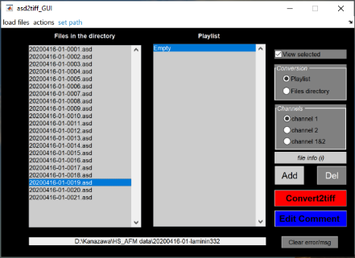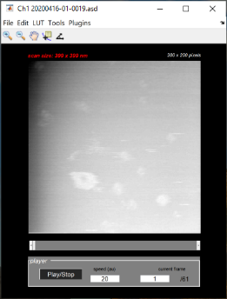

Check to display the video

Choose which channel

Video Player

* If the brightness of the video was not normalized, to adjust automatically the contrast flag the player “*Tools >autocontrast*” menu to “*on*”. Apply the desired colormap to the data by choosing among the available ones in the “LUT” menu of the player.

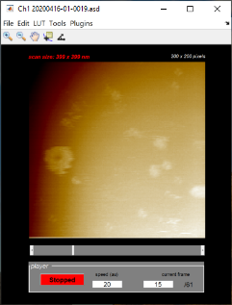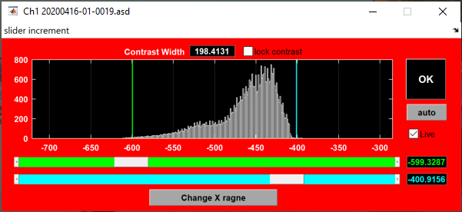

Histogram corresponding to frame 15

Colormap applied within this range

Saturated

Saturated

Player displaying frame 15

Contrast window

**TIP:** if you want to fine tune the contrast manually, switch the autocontrast to “off”, normalize the brightness of the video (“*Tools>normalize brightness>trimmed*”) and open the *contrast window*

*(“Tools>contrast”*). Notice that the modification applied to the video is temporary and will be lost when you display a new .asd file in the player. If you wish to save the video with the adjusted brightness you have to pick from one of the “Save” options in the “File” menu of the player. However, this will not overwrite the original uploaded .asd file but save a new file according to the chosen format (or transfer the data (class structure) in the MatLab workspace for further processing)

* To access the metadata present in the .asd file header click the button “*file info (i)*” in the asd2tiff_GUI main window

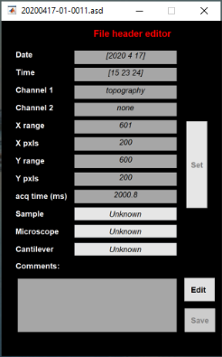



File info button

File metadata editor

* You can permanently edit and overwrite the “Comment” section of the .asd file header if you need to. To do so click the blue pushbutton “Edit Comment” in the asd2tiff_GUI main window. An “input dialog box” will be displayed and allow you to edit the comment section

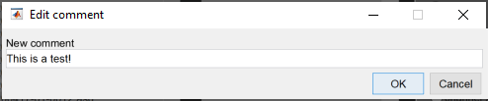

Radiobuttons in the main asd2tiff GUI window are used to choose among a file selected in one of the two listboxes. By reselecting the same file in the “Files in the directory” listbox you can verify that the comment has been successfully updated in the “File header editor” window

* **Tips for efficient data browsing:**

First, bring the “asd2tiff_GUI” window on focus by clicking it. To display the videos within the “Files and directory” listbox press **1** on the keyboard (**1** and **2** **keys** are used to switch between the “Files in the directory” and “playlist” listboxes) and use the **up** and **down arrow keys** to move to the next or previous files. The video will be uploaded and displayed into the player. **x** and **z keys** are used to play forward and backward the video, respectively.

Other shortcuts:

* + - **Right** (and left) **arrow keys** to add (remove) the selected video to the “Playlist” listbox
    - **d key** to definitively delete the selected .asd file from your system (not recommended: the file will be permanently erased without asking for confirmation)

PS: to safely delete useless files from the system proceed as follow:

1. add them to the “Playlist” listbox with the right arrow key
2. When done, check one-by-one the files present in the “Playlist” (press 2 key and use up and down arrow keys to navigate through the “Playlist”)
3. Remove from the playlist files you might have reconsidered (left arrow key)
4. From the asd2tiff_GUI menu chose “actions>delete all files” to delete from the system all the files present in the “playlist” listbox.
   * + **s key** will synchronize Channel1 and Channel2 videos to the same frame for simultaneous playing of the two videos (by x and z keys press)
     + **i key** will open the “File header editor” window to display files metadata

* To make a playlist, add one by one the desired files to the playlist listbox using left and right arrows. When done, from the “*actions”* menu select *“export playlist”*. If the original data are moved to a different directory, to locate the files in your system (or on remote servers) select *“retrive lost paths”* from the *actions* menu.
* To convert “.asd” or “.smat” files to tiff, press the red button “Convert2Tiff”. Before doing so, specify which listbox will be converted (i.e. “Files in the directory” or “Playlist”) and which channels you wanna convert by using the dedicated radiobuttons. Note that if you choose both channels, to read such files in third parties software like ImageJ you will need dedicated plugins (e.g. BioImporter https://imagej.net/Bio-Formats)



Radiobuttons for listboxes

Radiobuttons for channels