Individual participant data meta-analysis. When? Why? How? A scoping review

Michail Belias

May 13, 2019

###### 

# Abstract

## Background

Individual participant data(IPD) meta-analysis(MA) is considered the gold standard for evidence based inference. It is well established that IPD-MA offers great advantages compared to aggregate MA and single studies, thus systematic reviews have been conducted in order to investigate current practice and propose guidance. Preferred Reporting Items for Systematic Reviews and Meta-Analyses (PRISMA) guidelines help authors in reporting systematic reviews and meta-analyses. Nevertheless, the extended PRISMA guidelines were introduced in 2015 and no review has been performed since then.

**Objective:** Our goal is to conduct a scoping review of IPD-MA and summarise their reporting quality and statistical approaches used. Consequently, we aim to inform how IPD-MA are performed, what is their goal, which statistical approach they use and whether reporting was described according to PRISMA guidelines and/or to the level that the analysis can be reproduced.

## Methods

We searched MEDLINE, PubMed and Cochrane IPD-MA Library for IPD-MAs related articles published the last five years. We screened the titles and abstracts and extracted where possible the size of the meta-analysis, their primary goal, type of outcome(s), study designs, statistical analysis and modelling approaches performed. Subsequently we excluded diagnostic, network, predictive and opportunistic IPD-MAs and articles with poor reporting and sampled the remaining for full text consideration. Finally, we assessed the quality of -within full text- reporting according to the PRISMA-IPD guidelines.

## Results

Our search resulted in 1538 articles, after exclusion criteria we ended with *702*. We sampled 100 and considered their full texts. IPD-MAs have seen considerable growth over the last five years. Random-effects are most often used and one-stage are almost equally performed as two-stage approaches. Most IPD-MAs have not clearly stated the goal, statistical approach and characteristics of their meta-analysis in their abstract and title.

*Temporary*

**Most of the IPD-MAs had as a goal to investigate for subgroups effects.** **Reporting type of**

## Conclusions

*Not yet*

###### 

# Introduction

Meta-analysis (MA) is a statistical method that involves combining information from multiple sources. While initially meta-analyses were limited in aggregated data (AD) in the early 1990s individual participant data meta-analysis (IPD-MA or IPDMA) was introduced by Chalmers et al. (CHALMERS 1993). In IPD-MA the participant level information is available and therefore evidence from multiple studies can be analysed as a whole. Collecting the IPD may be a difficult and time consuming task, but IPD-MA offers great opportunities (Walraven 2010) that in AD-MA and single studies may not be possible. Therefore, IPD-MA is considered the gold standard in evidence synthesis (Stewart and Parmar 1993 ; and 1995 ; Stewart and Tierney 2002).

Due to these advantages literature exists in order to provide guidance. This guidance can be classified in two main trajectories : 1) guidance over the reporting of an IPD-MA and 2) guidance over statistical approaches that should be preferred. For the first, an extended version of Preferred Reporting Items for Systematic Review and Meta-Analyses (PRISMA) for individual participant data (IPD) (Stewart et al. 2015) has been developed. PRISMA-IPD offers guidance in the reporting of both the title and abstact, and the full article (introduction, methods, results, discussion and funding). For instance, researchers should identify in the title their report as a systematic review and/or meta-analysis of individual participant data. Furthermore, they should provide in the abstract a clear background statement, describe the eligibility criteria and search strategy, provide the number of studies and participants, report the summary effect estimates and measures of heterogeneity and finally, they should state the main strengths and limitations, interpret the results and report funding sources. Subsequently, reporting should be more detailed in the full text.

On the other hand, guidance over the statistical approaches is associated with the goal of the IPD-MA. For instance, Simmonds et al. (Simmonds, Stewart, and Stewart 2015) showed that IPD-MA are frequently performed in order to detect treatment effect modification. The approaches that were mostly used were meta-regression (an AD-MA approach) and three IPD-MA approaches, per-subgroup meta-analysis, meta-analysis of interaction terms and one-stage IPD-MA. A series of comparisons of these methods has provided guidance on which to choose. Specifically, Simmonds and Higgins (Simmonds and Higgins 2007) mathematically proved that, one-stage IPD-MA is always more powerful than meta-analysis of interaction terms and meta-regression. Nevertheless, in order to provide a closed mathematical form they made unrealistic assumptions. Fisher et al. (Fisher et al. 2011) critically reviewed all four approaches and concluded that one-stage IPD-MA allows for more complex analysis, but is more difficult to perform than pooling within-trial interaction terms. Furthermore, Hua et al. (Hua et al. 2016) noted that these one-stage IPD-MAs using mixed-effects modelling should also centre the effect modifiers to their mean, in order to separate across and within trial information and therefore account for ecological bias.

Furthermore, IPD-MA may be performed in order to investigate the role of risk-factors in the prevalence of a disease. In that case observational studies are typically included and statistical analysis involves multi-variable modelling and occasionally non-linear functional forms. Sauerbrei and Royston (Sauerbrei and Royston 2011) suggested the use of a two stage approach. At the first stage a fractional polynomial is selected and as a second stage their estimates are pooled using a point-wise weighted meta-analytical process. In a subsequent article they extended their approach to include interactions (Royston and Sauerbrei 2013).

Part of the aforementioned characteristics have been investigated in systematic reviews over the years. For instance, Simmonds et al (Simmonds et al. 2005) identified 44 IPD-MAs performed during 2000-2005 time period and summarized 1) whether IPD-MAs obtained all the data they sought 2) if they clearly described the statistical approaches they used 3) if the effects of co-variables have also been investigated and 4) their medical field. On a subsequent paper, 10 years later Simmonds et al. (Simmonds, Stewart, and Stewart 2015) identified 1371 potential IPD-MAs performed during 2010-2015 time period, sampled 184 of them and after obtaining full texts included 100 IPD-MAs. Then along with the topics investigated in the initial paper they investigated also the quality of IPD-MA reporting. Riley et al. (Riley, Lambert, and Abo-Zaid 2010) identified 383 IPD-MAs performed from instance until 2009 and summarised only: 1) their medical field topic and 2) whether they assessed risk or prognostic factors. Finally, Schuit and Ioannidis (Schuit, Li, and Ioannidis 2018) identified 327 IPD-MAs performed from inception until 2014. Nevertheless, they restricted their interest in treatment effects investigation.

As far as we know no other Scoping or systematic review has been available since 2015, while new guidance is present. Therefore, our goal is to conduct a scoping review of IPD-MA from 2015 and onwards and summarise their aforementioned properties. Consequently, we aim to inform why and how IPD-MA are performed, which statistical approaches are preferred and whether they are clearly described according to the PRISMA-IPD guidelines.

###### 

# Methods

This study is a scoping review of current practices in IPD-MAs. We report our study according to the Preferred Reporting Items for Systematic reviews and Meta-Analyses extension for Scoping Reviews (PRISMA-ScR) guidelines. *(bold are checkpoints in the PRISMA-ScR check-list)*

**Protocol and registration** No formal protocol exists for this study.

**Information sources** A MEDLINE, PubMed and Cochrane library search was performed in $1^{st}$ of May using the following search terms: *((“Meta-Analysis”[Publication Type] OR meta-analys $*$ [tiab] OR metaanalys $*$ [tiab]) AND (individual participant[tiab] OR individual participants[tiab] OR individual participant’s[tiab] OR individual patient[tiab] OR individual patients[tiab] OR individual patient’s[tiab] OR individualized participant[tiab] OR individualized participants[tiab] OR individualized participant’s[tiab] OR individualized patient[tiab] OR individualized patients[tiab] OR individualized patient’s[tiab] OR individualised participant[tiab] OR individualised participants[tiab] OR individualised participant’s[tiab] OR individualised patient[tiab] OR individualised patients[tiab] OR individualised patient’s[tiab]) AND data[tiab]) OR IPDMA[tiab] OR IPD-MA[tiab] AND (“2015/01/01”[PDat] : “2019/05/01”[PDat])*

**Eligibility criteria** We included studies describing an IPD-MA published between 01/01/2015 and 01/05/2019. We removed duplicate papers and from series of articles we included only the most recent. Our scoping review has been performed in two stages, one evaluating the title and abstract of all IPD-MAs and one evaluating the full text of a subset of them. Specifically, in the first stage we considered all available IPD-MAs and screened their titles and abstracts. Thereto, we extracted information -if present- over the year, medical field, number of included studies and participants, the goal, types of outcomes and statistical approaches preferred. Subsequently, we excluded diagnostic test and predictive IPD-MAs. Other reasons for further exclusion were: 1) full text was not published in English, 2) IPD-MAs were given as examples (for instance in methodological, health-technology assessments and cost-effectiveness studies) 3) we had no access to the full text and 4) the studies were protocols. Finally, we sampled 100 of these eligible studies and extracted information over the statistical analysis and evaluated the reporting quality according to the PRISMA-IPD guidelines.

**Data items**

We summarised our results using descriptive statistics such as frequency tables and bar-plots.

# Results

Our search identified 1538 potential records. We removed 61 duplicates and series of articles. We screened the titles and abstracts of the remaining 1477 studies. Approximately 36% of the papers were not identified as a systematic review, or meta-analysis or meta-analysis of individual participant data.

Table 1. Percentage of articles indicating their type of study in the title

|  |  |  |
| --- | --- | --- |
| Type of study in title | Frequency | Percentage |
| Yes | 943 | 63.85% |
| No | 534 | 36.15% |

We show an increasing trend over the years of articles involved with IPD-MA. IPD methods seem to gain popularity in medical fields such as pregnancy and childbirth, mental health and neurology

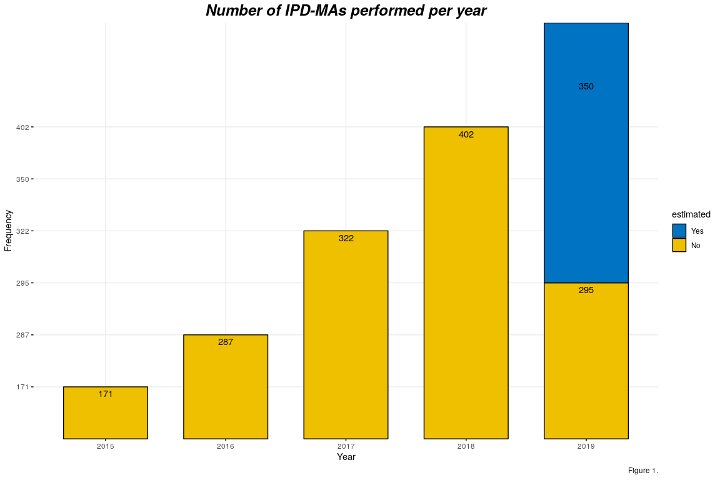

*Title results*

*Synthesis of results*

Table 2. Individual participant meta-analysis per medical field (top 5 reported) ####### The medical fields with the most articles were Cardiovascular diseases, cancer, neurology and mental health.

|  |  |  |
| --- | --- | --- |
| General Medical Field | Frequency | Percentage |
| Cardiovascular diseases | 59 | 18.04% |
| Cancer | 51 | 15.6% |
| Neurology | 33 | 10.09% |
| Mental health | 30 | 9.17% |
| Pregnancy and childbirth | 25 | 7.65% |

##### 

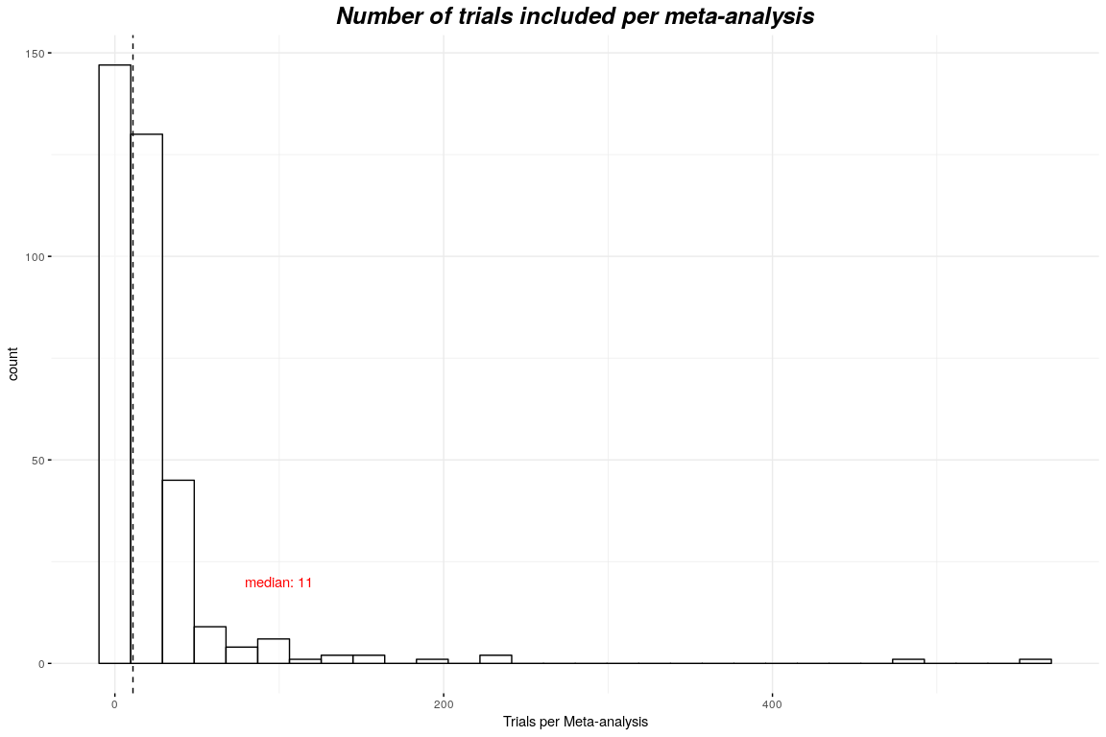

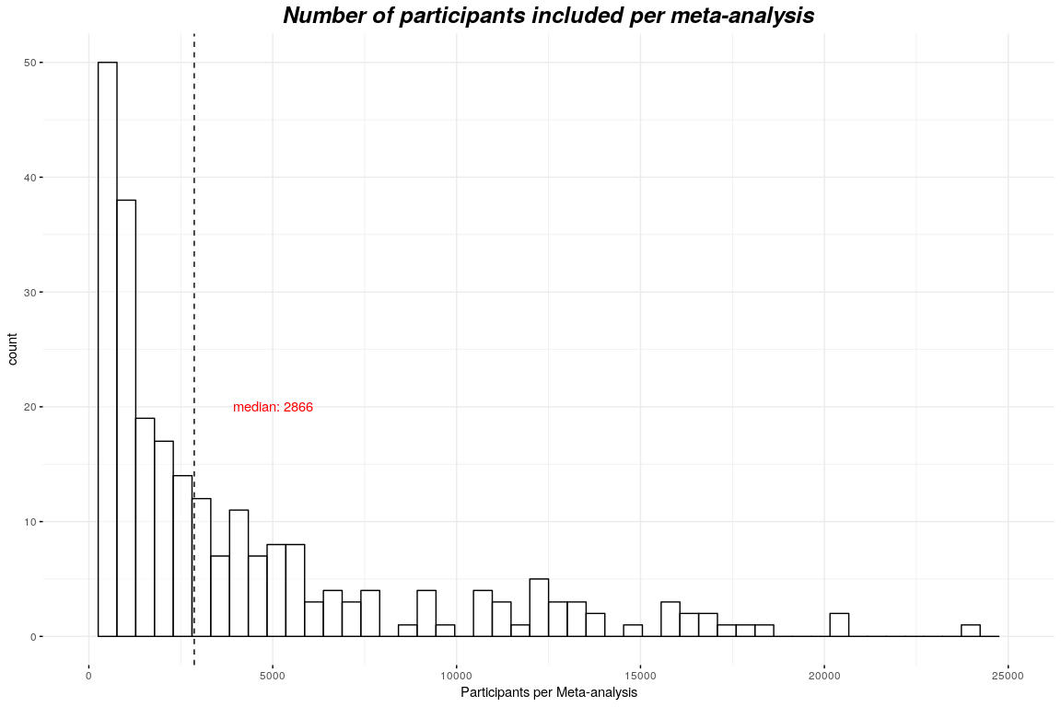

Table 3. Type of outcomes investigated

|  |  |  |
| --- | --- | --- |
| Binary | Continuous | Time-to-event |
| 362 | 113 | 265 |

##### 

Table 4. Statistical approaches performed to detect treatment-effect modification

|  |  |  |  |  |  |
| --- | --- | --- | --- | --- | --- |
|  | One-stage IPD-MA | Meta-analysis of interaction terms | Per subgroup meta-analysis | Meta-regression | Centered one-stage IPD-MA |
|  |  | Fixed vs | random effects |  |  |
| Fixed effect | x | x | x | x | x |
| Random effects | x | x | x | x | x |
|  |  | Reporting of | heterogeneity |  |  |
| $$I^{2}$$ | x | x | x | x | x |
| Cochran’s Q (without $I^{2}$) | x | x | x | x | x |
| $$τ^{2}$$ | x | x | x | x | x |
| Prediction intervals | x | x | x | x | x |
| From one-stage model | x | x | x | x | x |
| Other | x | x | x | x | x |
| Not reported | x | x | x | x | x |

###### 

# Discussion

###### 

# References

and, Lesley A. Stewart. 1995. “Practical Methodology of Meta-Analyses (Overviews) Using Updated Individual Patient Data.” *Statistics in Medicine* 14 (19): 2057–79. <https://doi.org/10.1002/sim.4780141902>.

CHALMERS, IAIN. 1993. “The Cochrane Collaboration: Preparing, Maintaining, and Disseminating Systematic Reviews of the Effects of Health Care.” *Annals of the New York Academy of Sciences* 703 (1 Doing More Go): 156–65. <https://doi.org/10.1111/j.1749-6632.1993.tb26345.x>.

Fisher, D. J., A. J. Copas, J. F. Tierney, and M. K.B. Parmar. 2011. “A Critical Review of Methods for the Assessment of Patient-Level Interactions in Individual Participant Data Meta-Analysis of Randomized Trials, and Guidance for Practitioners.” *Journal of Clinical Epidemiology* 64 (9): 949–67. <https://doi.org/10.1016/j.jclinepi.2010.11.016>.

Hua, Hairui, Danielle L. Burke, Michael J. Crowther, Joie Ensor, Catrin Tudur Smith, and Richard D. Riley. 2016. “One-Stage Individual Participant Data Meta-Analysis Models: Estimation of Treatment-Covariate Interactions Must Avoid Ecological Bias by Separating Out Within-Trial and Across-Trial Information.” *Statistics in Medicine* 36 (5): 772–89. <https://doi.org/10.1002/sim.7171>.

Riley, R. D., P. C. Lambert, and G. Abo-Zaid. 2010. “Meta-Analysis of Individual Participant Data: Rationale, Conduct, and Reporting.” *BMJ* 340 (feb05 1): c221–c221. <https://doi.org/10.1136/bmj.c221>.

Royston, Patrick, and Willi Sauerbrei. 2013. “Interaction of Treatment with a Continuous Variable: Simulation Study of Significance Level for Several Methods of Analysis.” *Statistics in Medicine* 32 (22): 3788–3803. <https://doi.org/10.1002/sim.5813>.

Sauerbrei, Willi, and Patrick Royston. 2011. “A New Strategy for Meta-Analysis of Continuous Covariates in Observational Studies.” *Statistics in Medicine* 30 (28): 3341–60. <https://doi.org/10.1002/sim.4333>.

Schuit, Ewoud, Alvin H Li, and John P A Ioannidis. 2018. “How Often Can Meta-Analyses of Individual-Level Data Individualize Treatment? A Meta-Epidemiologic Study.” *International Journal of Epidemiology* 48 (2): 596–608. <https://doi.org/10.1093/ije/dyy239>.

Simmonds, Mark C, Julian P T Higginsa, Lesley A Stewartb, Jayne F Tierneyb, Mike J Clarke, and Simon G Thompson. 2005. “Meta-Analysis of Individual Patient Data from Randomized Trials: A Review of Methods Used in Practice.” *Clinical Trials: Journal of the Society for Clinical Trials* 2 (3): 209–17. <https://doi.org/10.1191/1740774505cn087oa>.

Simmonds, Mark, Gavin Stewart, and Lesley Stewart. 2015. “A Decade of Individual Participant Data Meta-Analyses: A Review of Current Practice.” *Contemporary Clinical Trials* 45 (November): 76–83. <https://doi.org/10.1016/j.cct.2015.06.012>.

Simmonds, M. C., and J. P. T. Higgins. 2007. “Covariate Heterogeneity in Meta-Analysis: Criteria for Deciding Between Meta-Regression and Individual Patient Data.” *Statistics in Medicine* 26 (15): 2982–99. <https://doi.org/10.1002/sim.2768>.

Stewart, L. A, and M. K.B Parmar. 1993. “Meta-Analysis of the Literature or of Individual Patient Data: Is There a Difference?” *The Lancet* 341 (8842): 418–22. <https://doi.org/10.1016/0140-6736(93)93004-k>.

Stewart, Lesley A., Mike Clarke, Maroeska Rovers, Richard D. Riley, Mark Simmonds, Gavin Stewart, and Jayne F. Tierney. 2015. “Preferred Reporting Items for a Systematic Review and Meta-Analysis of Individual Participant Data.” *JAMA* 313 (16): 1657. <https://doi.org/10.1001/jama.2015.3656>.

Stewart, Lesley A., and Jayne F. Tierney. 2002. “To IPD or Not to IPD?” *Evaluation & the Health Professions* 25 (1): 76–97. <https://doi.org/10.1177/0163278702025001006>.

Walraven, Carl van. 2010. “Individual Patient Meta-Analysisrewards and Challenges.” *Journal of Clinical Epidemiology* 63 (3): 235–37. <https://doi.org/10.1016/j.jclinepi.2009.04.001>.