Individual participant data meta-analysis. When? Why? How? A scoping review

Michail Belias

May 13, 2019

# Abstract (200 words)

## Background

Individual participant data(IPD) meta-analysis(MA) is considered the gold standard for evidence based inference. It is well established that IPD-MA offers great advantages compared to aggregate MA and single studies. Nevertheless, it is unclear which advantages are mostly addressed when IPD-MAs are conducted. Furthermore, it is unclear which statistical approaches are preferred, how they are the results presented, which medical fields are involved and to what extent guidelines are followed. **Objective:** Our objective is to conduct a scoping review of existing IPD-MA, and summarise their properties. Furthermore, we aim to inform when and how IPD-MA are performed, whether state-of the art methods are used and whether they are clearly described.

*We can propose the use of a statistical ID*

## Methods

We performed a scoping review to identify IPD-MA performed the last five years. We searched MEDLINE and the Cochrane Library for IPD-MA, written in English and from 01/01/2015 to 01/05/2019 time period. We included both IPD meta-analyses of randomised clinical trials and observational studies, but excluded diagnostic IPD-MA. We screened the abstracts and extracted their goal.

**(we can include more databases i.e. EMBASE etc)**

## Results

Our search resulted in 1538 articles. We included only IPD-MAs with at least one treatment comparison. We showed an increase per year in IPD-MAs performed. The two most predominant medical fields were Cancer *(16%)*, Cardiovascular diseases *(16%)* and Mental health *(10%)*. Nevertheless, more information should be provided in both the abstract and the article over the statistical approaches followed.

**An increasing trend in one-stage methods frequency by year has been showed.** **Most of the IPD-MAs had as a primary goal to pool an overall treatment effect and only few to investigate for subgroups.** **For instance, some report a one-stage mixed effects model has been used to account for within trial clustering, but they don’t provide more info such as (stratified or random effects intercept is the interaction term random effects or fixed? etc)**

## Conclusions

Goal and statistical approach description is still unclear. One-stage methods are increasing per year. Subgroups analysis is not the primary goal of IPD-MAs.

# Introduction

Meta-analysis (MA) is a statistical method that involves combining information from multiple sources. While initially, meta-analyses were limited in aggregated data (AD) in the early 1990s individual participant data meta-analysis (IPD-MA or IPDMA) was introduced (CHALMERS 1993). In IPD-MA the participant level information is available and therefore evidence from multiple studies can be analysed centrally. Collecting the IPD may be a difficult and time consuming task, but neverthetheless IPD-MA is considered the gold standard in evidence synthesis (Stewart and Parmar 1993 ; and 1995 ; Stewart and Tierney 2002) and offers great opportunities (Walraven 2010) that in AD-MA are considered impossible. Besides when investigating overall treatment effects where AD-MA and IPD-MA are mathematically equivalent, IPD-MA offers (1) the possibility to standardize subgroup definitions and outcomes across studies, (2) higher validity and credibility of subgroup findings, (3) increased flexibility to search for subgroups based on combinations of patient and/or disease characteristics (4) the possibility to avoid ecological BIAS (5) investigate non-linear functional forms (6) training better prediction models and (7) efficiently synthesizing evidence from different designs. *we can place extra stuff*

**Reporting** IPD-MA may be conducted in either one stage or two stages. In one-stage IPD-MA, a statistical model of choice is applied and IPD from all studies are analysed simultaneously, whilst accounting for within-studies clustering of the participants. On the other hand, in two-stage IPD-MA a statistical model of choice is fitted per study. Subsequently the estimates extracted are pooled using inverse-variance meta-analytical methods. Both approaches have a variety of parameters and results that should be reported in the abstract, the methods and the results section. An extented version of PRISMA for IPD (Stewart et al. 2015) offers guidance on how to report results in IPD-MA. For instance, in two-stage IPD-MA 1) heterogeneity measures ( $I^{2}$, Cochran’s Q $τ^{2}$) 2) and their corresponding methods used 3) forest plots (if applicable) and 4) use of fixed or random effects models and any other model assumptions should be described in the Methods section. Furthermore, in’t Hout (IntHout et al. 2016) suggested that prediction intervals of estimates are also a valuable information and sould be included. On the other hand, in one-stage IPD-MA 1) specification of one-stage models 2) use of fixed-effect, stratified or random-effects in the terms of the model and 3) how clustering of patients within studies was accounted for should be reported in the methods section.

**Effect modification** Simmonds et al. (Simmonds, Stewart, and Stewart 2015) showed that IPD-MA are frequently performed in order to detect treatment effect modificaiton. The approaches that were mostly used were one agreegated data meta-analysis approach ‘meta-regression’ and three IPD-MA approaches, per-subgroup meta-analysis, meta-analysis of interaction terms and one-stage IPD-MA. Guidance on which method to choose is available. Specifically, Simmnond and Higgins (Simmonds and Higgins 2007) mathematically proved that, given some unrealistic assumptions, one-stage IPD-MA is always more powerful than meta-analysis of interaction terms and meta-regression. Fisher et al. (Fisher et al. 2011) also critically reviewed all four approaches. They concluded that one-stage IPD-MA allows for more complex analysis, but is more difficult to perform than pooling within-trial interaction terms. Furthermore, Hua et al. (Hua et al. 2016) noted that these one-stage IPD-MA using mixed-effects modeling should also centre the effect modifiers to their mean, in order to separate across and within trial information and therefore accounting for ecological bias.

**Modeling functional forms** IPD-MA may be performed in order to investigate the role of risk-factors in the prevalence of a disease. In that case observational studies are typically meta-analysed. Thereto, IPD-MA may involve modeling also non-linear functional forms. Sauerbrei and Royston (Sauerbrei and Royston 2011) suggested the use of a two stage approach. As a first stage a fractional polynomial is selected and pooling their estimates through a point-wise weighted meta-analytical process. Subsequently they extended these non-linear associations to include interactions (Royston and Sauerbrei 2013). Furthermore, splines may also be applied to detect non-linear associations.

**Reviews like ours and goal** So far systematic reviews over the IPD-MA practices are limited until 2014. For instance, Simmonds et al (Simmonds et al. 2005) identified 44 IPD-MAs performed during 2000-2005 time period and 1) summarized whether IPD-MAs obtained all the data they sought 2) reported the types of approaches that were used in the analysis 3) and whether the effects of covariates have been investigated and 4) report which medical field was their topic. On a subsequent paper, 10 years kater Simmonds et al. (Simmonds, Stewart, and Stewart 2015) identified 1371 potential IPD-MAs performed during 2010-2015 time period, sampled 184 of them and after obtaining full texts included 100 IPD-MAs. Then they investigated along with the topics investiagted in the initial paper they investigated also the quality of IPD-MA reporting. Riley et al. (Riley, Lambert, and Abo-Zaid 2010) identified 383 IPD-MAs performed form instance until 2009 and summarised 1) theier medical field topic and 2) whether they assessed risk or prognostic factors. Finally, Schuit and Ioannidis (Schuit, Li, and Ioannidis 2018) identified 327 IPD-MAs performed from inception until 2014. Nevertheless, they restricted their interest in subgroup effects investigation. Our objective is to conduct a systematic review of IPD-MA from 2015 onwrds and and summarise their properties. Furthermore, we aim to inform when and how IPD-MA are performed, whether state-of the art methods are used and whether they are clearly described.

# Methods

This study is a scoping review of IPDMAs, i.e. a meta-epidemiological assessment. We report our study according to the Preferred Reporting Items for Systematic Reviews and Meta-Analyses (PRISMA) guidelines.

## IPD-MA search and selection strategy

We searched MEDLINE, pubmed, Cochrane library **(we can place more)** for IPD-MA conducted from 01/01/2015 until 01/05/2019, query in *Supplementary material*.

# Results

We identified 1538 IPD-MAs. s

## TypeError: Attempting to change the setter of an unconfigurable property.  
## TypeError: Attempting to change the setter of an unconfigurable property.



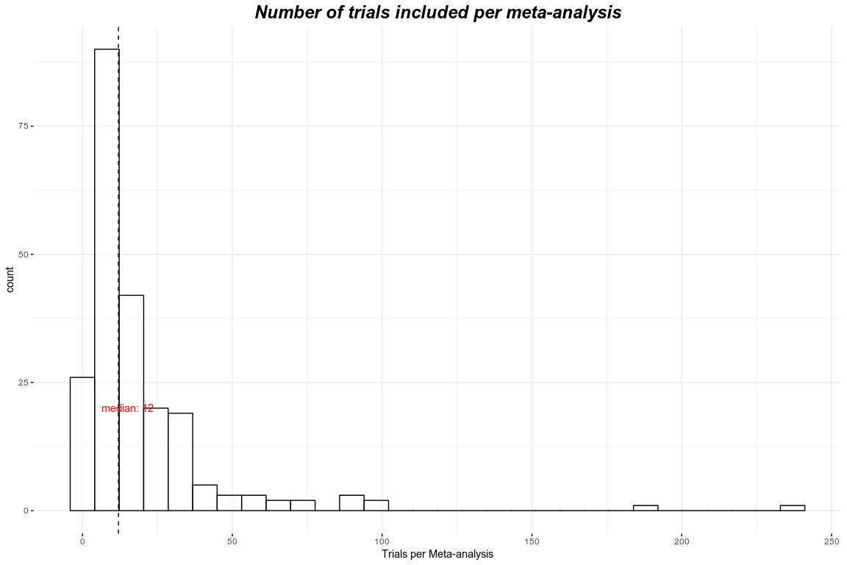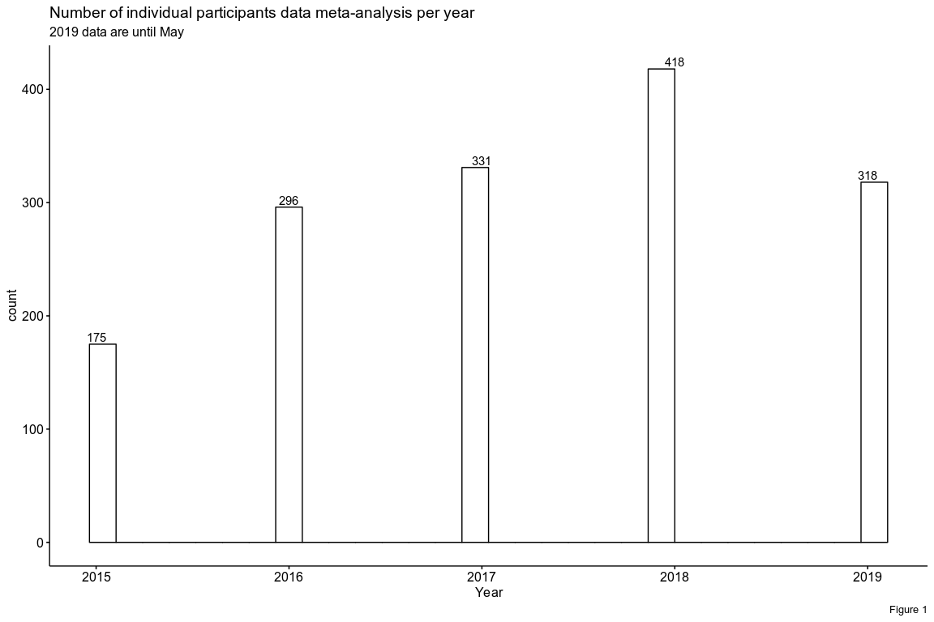

# References

and, Lesley A. Stewart. 1995. “Practical Methodology of Meta-Analyses (Overviews) Using Updated Individual Patient Data.” *Statistics in Medicine* 14 (19): 2057–79. <https://doi.org/10.1002/sim.4780141902>.

CHALMERS, IAIN. 1993. “The Cochrane Collaboration: Preparing, Maintaining, and Disseminating Systematic Reviews of the Effects of Health Care.” *Annals of the New York Academy of Sciences* 703 (1 Doing More Go): 156–65. <https://doi.org/10.1111/j.1749-6632.1993.tb26345.x>.

Fisher, D. J., A. J. Copas, J. F. Tierney, and M. K.B. Parmar. 2011. “A Critical Review of Methods for the Assessment of Patient-Level Interactions in Individual Participant Data Meta-Analysis of Randomized Trials, and Guidance for Practitioners.” *Journal of Clinical Epidemiology* 64 (9): 949–67. <https://doi.org/10.1016/j.jclinepi.2010.11.016>.

Hua, Hairui, Danielle L. Burke, Michael J. Crowther, Joie Ensor, Catrin Tudur Smith, and Richard D. Riley. 2016. “One-Stage Individual Participant Data Meta-Analysis Models: Estimation of Treatment-Covariate Interactions Must Avoid Ecological Bias by Separating Out Within-Trial and Across-Trial Information.” *Statistics in Medicine* 36 (5): 772–89. <https://doi.org/10.1002/sim.7171>.

IntHout, Joanna, John P A Ioannidis, Maroeska M Rovers, and Jelle J Goeman. 2016. “Plea for Routinely Presenting Prediction Intervals in Meta-Analysis.” *BMJ Open* 6 (7): e010247. <https://doi.org/10.1136/bmjopen-2015-010247>.

Riley, R. D., P. C. Lambert, and G. Abo-Zaid. 2010. “Meta-Analysis of Individual Participant Data: Rationale, Conduct, and Reporting.” *BMJ* 340 (feb05 1): c221–c221. <https://doi.org/10.1136/bmj.c221>.

Royston, Patrick, and Willi Sauerbrei. 2013. “Interaction of Treatment with a Continuous Variable: Simulation Study of Significance Level for Several Methods of Analysis.” *Statistics in Medicine* 32 (22): 3788–3803. <https://doi.org/10.1002/sim.5813>.

Sauerbrei, Willi, and Patrick Royston. 2011. “A New Strategy for Meta-Analysis of Continuous Covariates in Observational Studies.” *Statistics in Medicine* 30 (28): 3341–60. <https://doi.org/10.1002/sim.4333>.

Schuit, Ewoud, Alvin H Li, and John P A Ioannidis. 2018. “How Often Can Meta-Analyses of Individual-Level Data Individualize Treatment? A Meta-Epidemiologic Study.” *International Journal of Epidemiology* 48 (2): 596–608. <https://doi.org/10.1093/ije/dyy239>.

Simmonds, Mark C, Julian P T Higginsa, Lesley A Stewartb, Jayne F Tierneyb, Mike J Clarke, and Simon G Thompson. 2005. “Meta-Analysis of Individual Patient Data from Randomized Trials: A Review of Methods Used in Practice.” *Clinical Trials: Journal of the Society for Clinical Trials* 2 (3): 209–17. <https://doi.org/10.1191/1740774505cn087oa>.

Simmonds, Mark, Gavin Stewart, and Lesley Stewart. 2015. “A Decade of Individual Participant Data Meta-Analyses: A Review of Current Practice.” *Contemporary Clinical Trials* 45 (November): 76–83. <https://doi.org/10.1016/j.cct.2015.06.012>.

Simmonds, M. C., and J. P. T. Higgins. 2007. “Covariate Heterogeneity in Meta-Analysis: Criteria for Deciding Between Meta-Regression and Individual Patient Data.” *Statistics in Medicine* 26 (15): 2982–99. <https://doi.org/10.1002/sim.2768>.

Stewart, L. A, and M. K.B Parmar. 1993. “Meta-Analysis of the Literature or of Individual Patient Data: Is There a Difference?” *The Lancet* 341 (8842): 418–22. <https://doi.org/10.1016/0140-6736(93)93004-k>.

Stewart, Lesley A., Mike Clarke, Maroeska Rovers, Richard D. Riley, Mark Simmonds, Gavin Stewart, and Jayne F. Tierney. 2015. “Preferred Reporting Items for a Systematic Review and Meta-Analysis of Individual Participant Data.” *JAMA* 313 (16): 1657. <https://doi.org/10.1001/jama.2015.3656>.

Stewart, Lesley A., and Jayne F. Tierney. 2002. “To IPD or Not to IPD?” *Evaluation & the Health Professions* 25 (1): 76–97. <https://doi.org/10.1177/0163278702025001006>.

Walraven, Carl van. 2010. “Individual Patient Meta-Analysisrewards and Challenges.” *Journal of Clinical Epidemiology* 63 (3): 235–37. <https://doi.org/10.1016/j.jclinepi.2009.04.001>.