A new approach to investigate treatment effect modification over continuous co-variables in IPD-MA by using smoothing splines

Michail Belias

14 June, 2019

## Background

Individual participant data(IPD) meta-analysis(MA) of randomised clinical trials are considered the gold standard to investigate treatment efficiency. It is important to also investigate treatment-effect modification as the one-treatment fits all may not be true. Effect modification over a continuous co-variable may be challenging, when non-linear associations are present. Current statistical guidance involves: 1) categorising the effect modifier, 2) assuming linear or known polynomial shapes 3) or performing stepwise methods that rely on arbitrary statistical tests.

## Objective

We propose two new approaches to detect treatment-effect modification while modeling non-linear associations using smoothing splines.

## Methods

For the one-stage IPD-MA approach we fitted a generalised additive mixed effects model with smoothing splines and compared the results with a generalised linear mixed effects model. For the two-stage approach, we fitted a smoothing spline per trial and pooled the results using point-wise meta-analytical methods and compared the results with the same approach assuming linearity.

## Results

## Conclusion

##### 

# 1. Introduction

Randomised clinical trials (RCTs) are prospective interventional studies were patients are randomly allocated to different treatment arms. Randomisation reduces bias due to confounding and is considered [1] the gold standard to investigate treatment effectiveness but not without a cost. RCTs are cost and time-consuming and may involve experimental interventions that may have adverse effects. Hence, due to both ethical and financial reasons RCTs are designed to include the minimum number of patients needed to detect an overall treatment effect with a pre-specified power. On the other hand, the assumption that all patients have the same response to treatment also known as one-treatment fits all may not be true. Therefore, in order to preserve adequate power while simultaneously investigating treatment effect differences we may need to combine multiple RCTs in a meta-analysis(MA). Meta-analyses may be conducted either using patient level or study level information and are known as individual participant data meta-analysis (IPD-MA) and aggregated data meta-analysis (AD-MA) respectively. Subgroup analysis and meta-regression are commonly applied AD-MA approaches, to detect effect modification [2]. Nevertheless, both approaches are considered prone to ecological bias [3–6] and low power [7,8]. On the other hand, IPD-MA offers opportunities that in AD-MA are considered impossible such as: 1) the possibility to standardise subgroup definitions and outcomes across studies, 2) increased power to model non-linear functional forms, 3) increased validity and reliability of the resulting subgroups and 4) flexibility to search for subgroups based on combinations of patient and/or disease characteristics [9–11]. Therefore, whenever IPD is available it is suggested to perform an IPD-MA rather than AD-MA [7,12–14].

IPD-MA may be conducted in either one or two stages. In one-stage IPD-MA, all IPD from every trial are analysed simultaneously, whilst accounting for the clustering of participants within studies. Hereby, researchers may model interactions between treatment and patient-level co-variables. Recent guidance suggests centring per trial the potential effect modifier [15], in order to separate within and across trial information and therefore avoid potential ecological bias. In two-stage IPD-MA on the other hand each trial is first analysed separately using an appropriate statistical model. For instance, the first stage may estimate different effects observed per subgroup, or the treatment-covariate interaction effect. Subsequently these effects are pooled using typical meta-analytical methods.

Nevertheless, inferences driven from a single interaction term or from treatment effect differences between subgroups are unbiased when the co-variable domain is similar across studies and/or the effects are linear [13]. This assumption may not true and effect modification may have to be modelled using a non-linear function. Royston and Sauerbrei [16] proposed a strategy to model treatment effects over a continuous co-variable by fitting fractional polynomials (FPs) in single studies. In a subsequent article they extended their approach to IPD-MA using a two-stage approach. In the fist stage, a fractional polynomial is selected using one of the following three methods : 1) the best fitting overall fractional polynomial, 2) the best fitting -per trial- second degree FPs 3) the best fitting -per trial- FPs (any combination of linear, FP1 or FP2). Then treatment effect function per trial is estimated. As a second step the per trial treatment effect functions are pooled using a pointwise meta-analysis. Nevertheless, the assumption that the outcome-effect modifier association has the same shape in both treatment arms may not be true. Furthermore, fractional polynomial rely on tests with arbitrary $α$ significance level. Finally, FPs are global polynomial functions and may not fit well on the boundaries of the continuous effect modifier.

We propose the use of generalised additive mixed effect models with smoothing splines to model the outcome-effect modifier. Since effect modification may not be constant and therefore detected by a single term, we propose the use of treatment effect function and the corresponding treatment effect plot. We present two extreme cases applied in simulated data and 2 empirical examples

# 2. Example data-sets

## 2.1 Empirical data-sets

We use 2 IPD-sets to illustrate aforementioned methods. The first IPD-MA investigates the effect of antibiotics in children with acute otitis media [17]. Rovers et al. collected IPD from 6 randomised clinical trials with a total of 1643 children, aged from 0-12 years old. The primary outcome was fever and/or ear-pain after 3-7 days (yes/no). They concluded that antibiotics were more beneficial in younger children (less than 2 years old) with bilateral acute otitis media. Bilateral acute otitis media (yes/no), age, otorrhea were investigated also separately for potential effect modification and only bilateral acute otitis media showed a significant result. The second [18] considers an IPD-MA to investigate the effect of Somatostatin on liver volume reduction. Gevers et al. collected IPD from 3 randomised placebo-controlled trials with a total of 107 participants. In this example, the outcome was continuous (liver volume reduction), and age, sex, baseline liver volume, and diagnosis of either autosomal dominant polycystic liver or kidney disease were investigated for effect modification . They concluded that use of Somatostatin was more beneficial for younger (<47) female patients. One of the 3 trials had a cross-over design, therefore participants were treated both with the active and the control treatment in different time periods. In order to use these data for our illustrative purposes, we removed the cross-over design and used all patients only once, by selecting half of the patients from the active period and the other half (sex and age-matched) from the control period. Therefore, differences between our results and those reported in the original article may occur.

## 2.2 Simulated data-sets

We simulated 2 data-sets which we consider extreme cases. The first data-set has

# 3. Methods

In our study we a the use of generalised mixed effects models with smoothing splines to investigate the effect modification of a treatment across a continuous variable. We will also fit the equivalent generalised linear mixed effects model and compare their results.

## 2.1 Statistical approaches

## Generalised additive mixed models

In generalised additive mixed models we

# Results

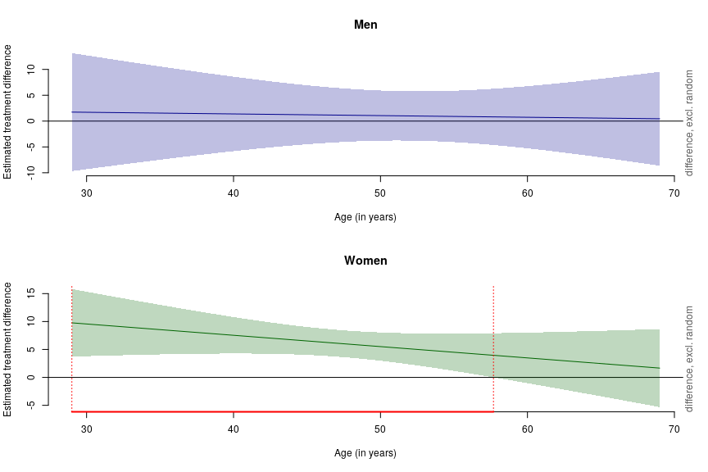

Summary:  
 * Drug : factor; set to the value(s): placebo, somatostatin. (Might be canceled as random effect, check below.)   
 * Gender : factor; set to the value(s): Female. (Might be canceled as random effect, check below.)   
 * Age : numeric predictor; with 30 values ranging from 29.000000 to 69.000000. (Might be canceled as random effect, check below.)   
 * Study : factor; set to the value(s): Keimpema. (Might be canceled as random effect, check below.)   
 * NOTE : The following random effects columns are canceled: s(Study,Age),s(Study,Gender),s(Study,Drug)

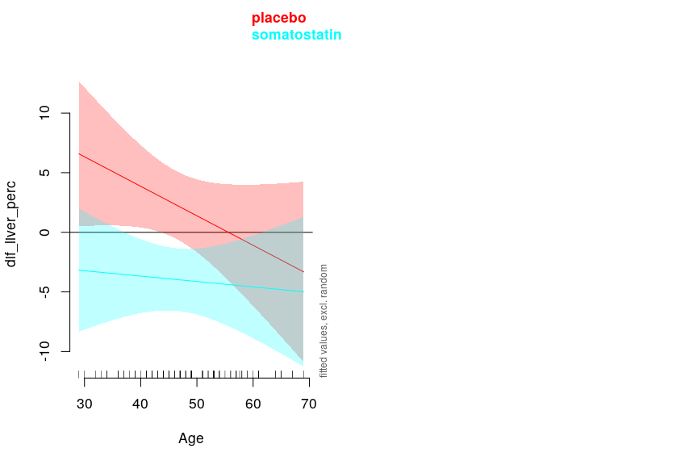

Summary:  
 * bilat_0 : factor; set to the value(s): No. (Might be canceled as random effect, check below.)   
 * treat : factor; set to the value(s): Antibiotics, Placebo. (Might be canceled as random effect, check below.)   
 * age : numeric predictor; with 30 values ranging from 0.000000 to 12.655556.   
 * study : factor; set to the value(s): Saux. (Might be canceled as random effect, check below.)   
 * NOTE : The following random effects columns are canceled: s(study,age),s(study,bilat_0),s(study,treat)

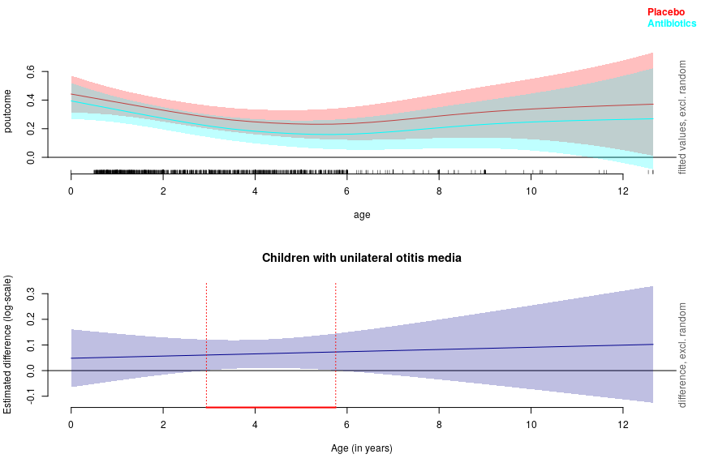

Summary:  
 * bilat_0 : factor; set to the value(s): Yes. (Might be canceled as random effect, check below.)   
 * treat : factor; set to the value(s): Antibiotics, Placebo. (Might be canceled as random effect, check below.)   
 * age : numeric predictor; with 200 values ranging from 0.000000 to 12.655556.   
 * study : factor; set to the value(s): Saux. (Might be canceled as random effect, check below.)   
 * NOTE : The following random effects columns are canceled: s(study,age),s(study,bilat_0),s(study,treat)  
   
 * Simultaneous 58%-CI used :   
 Critical value: 1.865  
 Proportion posterior simulations in pointwise CI: 0.01 (10000 samples)  
 Proportion posterior simulations in simultaneous CI: 0.59 (10000 samples)

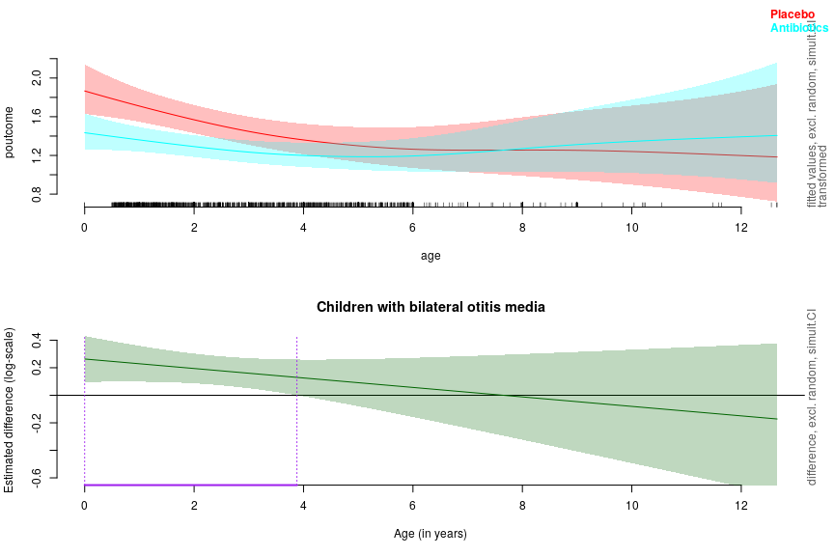

[1] Hariton E, Locascio JJ. Randomised controlled trials - the gold standard for effectiveness research. BJOG: An International Journal of Obstetrics & Gynaecology 2018;125:1716–6. doi:[10.1111/1471-0528.15199](https://doi.org/10.1111/1471-0528.15199).

[2] Simmonds M, Stewart G, Stewart L. A decade of individual participant data meta-analyses: A review of current practice. Contemporary Clinical Trials 2015;45:76–83. doi:[10.1016/j.cct.2015.06.012](https://doi.org/10.1016/j.cct.2015.06.012).

[3] GREENLAND S, MORGENSTERN H. Ecological bias, confounding, and effect modification. International Journal of Epidemiology 1989;18:269–74. doi:[10.1093/ije/18.1.269](https://doi.org/10.1093/ije/18.1.269).

[4] Palmowski A, Nielsen SM. Pitfalls in meta-analysis. Inflammopharmacology 2019. doi:[10.1007/s10787-019-00606-4](https://doi.org/10.1007/s10787-019-00606-4).

[5] Reade MC, Delaney A, Bailey MJ, Angus DC. Bench-to-bedside review: Avoiding pitfalls in critical care meta-analysis funnel plots, risk estimates, types of heterogeneity, baseline risk and the ecologic fallacy. Critical Care 2008;12:220. doi:[10.1186/cc6941](https://doi.org/10.1186/cc6941).

[6] Berlin JA, Santanna J, Schmid CH, Szczech LA, and HIF. Individual patient- versus group-level data meta-regressions for the investigation of treatment effect modifiers: Ecological bias rears its ugly head. Statistics in Medicine 2002;21:371–87. doi:[10.1002/sim.1023](https://doi.org/10.1002/sim.1023).

[7] Lambert PC, Sutton AJ, Abrams KR, Jones DR. A comparison of summary patient-level covariates in meta-regression with individual patient data meta-analysis. Journal of Clinical Epidemiology 2002;55:86–94. doi:[10.1016/s0895-4356(01)00414-0](https://doi.org/10.1016/s0895-4356(01)00414-0).

[8] Riley RD, Lambert PC, Abo-Zaid G. Meta-analysis of individual participant data: Rationale, conduct, and reporting. BMJ 2010;340:c221–1. doi:[10.1136/bmj.c221](https://doi.org/10.1136/bmj.c221).

[9] Debray TPA, Moons KGM, Valkenhoef G van, Efthimiou O, Hummel N, Groenwold RHH, et al. Get real in individual participant data (IPD) meta-analysis: A review of the methodology. Research Synthesis Methods 2015;6:293–309. doi:[10.1002/jrsm.1160](https://doi.org/10.1002/jrsm.1160).

[10] Rovers M, Reitsma JB. [The meta-analysis of data from individual patients]. Nederlands Tijdschrift Voor Geneeskunde 2012;156:A4743.

[11] Tierney JF, Vale C, Riley R, Smith CT, Stewart L, Clarke M, et al. Individual participant data (IPD) meta-analyses of randomised controlled trials: Guidance on their use. PLOS Medicine 2015;12:e1001855. doi:[10.1371/journal.pmed.1001855](https://doi.org/10.1371/journal.pmed.1001855).

[12] Fisher DJ, Copas AJ, Tierney JF, Parmar MK. A critical review of methods for the assessment of patient-level interactions in individual participant data meta-analysis of randomized trials, and guidance for practitioners. Journal of Clinical Epidemiology 2011;64:949–67. doi:[10.1016/j.jclinepi.2010.11.016](https://doi.org/10.1016/j.jclinepi.2010.11.016).

[13] Simmonds MC, Higgins JPT. Covariate heterogeneity in meta-analysis: Criteria for deciding between meta-regression and individual patient data. Statistics in Medicine 2007;26:2982–99. doi:[10.1002/sim.2768](https://doi.org/10.1002/sim.2768).

[14] Stewart LA, Tierney JF. To IPD or not to IPD? Evaluation & the Health Professions 2002;25:76–97. doi:[10.1177/0163278702025001006](https://doi.org/10.1177/0163278702025001006).

[15] Hua H, Burke DL, Crowther MJ, Ensor J, Smith CT, Riley RD. One-stage individual participant data meta-analysis models: Estimation of treatment-covariate interactions must avoid ecological bias by separating out within-trial and across-trial information. Statistics in Medicine 2016;36:772–89. doi:[10.1002/sim.7171](https://doi.org/10.1002/sim.7171).

[16] Royston P, Sauerbrei W. A new approach to modelling interactions between treatment and continuous covariates in clinical trials by using fractional polynomials. Statistics in Medicine 2004;23:2509–25. doi:[10.1002/sim.1815](https://doi.org/10.1002/sim.1815).

[17] Rovers MM, Glasziou P, Appelman CL, Burke P, McCormick DP, Damoiseaux RA, et al. Antibiotics for acute otitis media: A meta-analysis with individual patient data. The Lancet 2006;368:1429–35. doi:[10.1016/s0140-6736(06)69606-2](https://doi.org/10.1016/s0140-6736(06)69606-2).

[18] Gevers TJG, Inthout J, Caroli A, Ruggenenti P, Hogan MC, Torres VE, et al. Young women with polycystic liver disease respond best to somatostatin analogues: A pooled analysis of individual patient data. Gastroenterology 2013;145:357–365.e2. doi:[10.1053/j.gastro.2013.04.055](https://doi.org/10.1053/j.gastro.2013.04.055).