**Sales Dashboard Analysis**

Understanding sales performance is crucial for any business aiming to optimize revenue and customer engagement. **Imagine running a store without knowing which products are thriving or which customers keep coming back. It’s like sailing without a map—possible, but full of missed opportunities.** With the right insights, businesses can make smarter decisions, focus on what works, and turn challenges into growth opportunities.

This **Sales Dashboard Analysis** project provides a clear visualization of key sales metrics, helping to identify top customers, analyze revenue distribution, and track trends over time. By leveraging SQL for data cleaning and exploration and Power BI for intuitive visualizations, this project transforms raw sales data into actionable insights. Using the Superstore Sales Dataset from Kaggle, it offers a comprehensive view of customer behavior, product performance, and overall business growth, enabling data-driven decision-making.

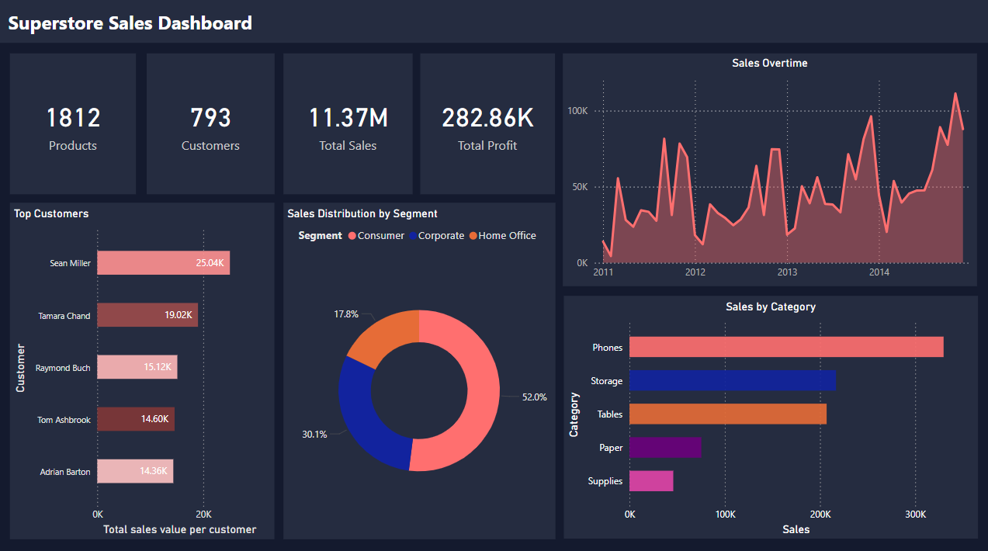

This dashboard addresses key questions such as how sales are performing over time, who the top customers are, and which segments or categories are most profitable. By analyzing these insights, businesses can identify growth opportunities, optimize marketing strategies, and improve product offerings to maximize profitability.

These insights highlight that while sales have shown growth over time, there are certain years where sales declined, indicating potential market fluctuations or external factors affecting performance. The Consumer segment remains the highest revenue contributor, while Phones and Tables are among the top-performing product categories. Additionally, identifying high-value customers provides opportunities for targeted marketing and retention strategies. These insights help businesses analyze sales declines, improve products, and refine strategies for steady growth.

Key Features & Insights

* KPIs: Tracks Total Sales, Total Profit, Number of Customers, and other essential business indicators.
* Sales Overtime: Analyzes sales trends, identifying growth patterns and seasonal fluctuations to enhance forecasting.
* Sales by Segment: Categorizes sales into Consumer, Corporate, and Home Office, offering insights into customer behavior and profitability.
* Top Customers: Highlights high-value buyers, helping businesses target retention and loyalty strategies.
* Sales by Category: Evaluates product performance to determine which categories drive the most revenue and profitability.