**PHASE 1**

Deliverables 1

* *Build use case diagrams*
* *Build process flows to assist in understanding the project objectives*
* Begin building your business case document
* *Profile the data provided in excel*
* *Identify issues in the data that may need to be resolved as you move forward*
* *Build a data model that you feel could be used to represent the data provided*
* *Plan for Importing the data into oracle and implement it*

Deliverables - 2

*Develop a SQL solution/code-set of report-ready views based on the 3 scenarios from the database concepts section and the additional requirements provided above*

Deliverables - 3

Produce a series of functions and procedures to support dynamic reporting in later activities.

Files required:

1. ER_Diagram.drawio
2. Use_case.drawio
3. Process_flow.drawio
4. All.sql
5. Phase1_queries.sql

**PHASE 2**

Getting to Know Your Data Through Data Analytics

Deliverables

* Customer segmentation
  + 5 Segments:
    - Asset obj 5, 3+ dependents
    - Married, 60-70 age
    - Female, 0-1 dependents
    - 30-40 age group
    - Florida state
* Risk Tolerance analysis

Files Required:

1. Folder - Customer_Segmentation_and_Data_Analytics_ipynb

**PHASE 3**

Data Exploration with Python

Deliverables

* You will be using your Python skills to access and extrapolate information from the provided data.
* Use the information gleaned to determine the most important aspects of your data to analyze and comment on.

Screenshots of important plots found:

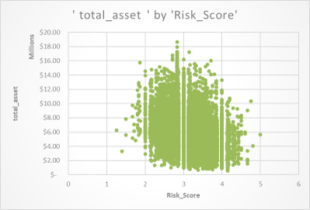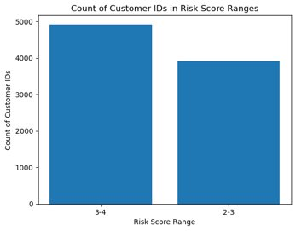

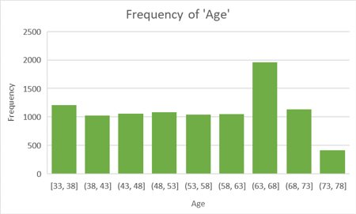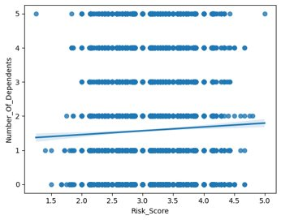

**PHASE 4**

Statistical Programming

Deliverables

* A detailed description of the sentiment methodology your team has chosen to implement
* The development of your sentiment dictionary
* Development of your sentiment analysis model
* Implementation of your model in Python

Files Required:  
  
1. Sentiment_Analysis_v3.ipynb  
2. Sentiment_Analysis_v4_stopwords.ipynb

**PHASE 5**

Data Visualization Part I

Deliverables -1

* Report requirement assessment for each scenario

Data Visualization and Reporting Part II

Deliverables - 2

* Develop interactive report/dashboards for the fund and for customer analysis.
* Produce a report that incorporates the findings of your analysis and a narrative to support them

Files Required:

1. Final_ph5.pbix
2. Scenario_report.txt

**PHASE 6**

Explore Data Through Web Services

Deliverables

* A Jupyter notebook that demonstrated pulling yahoo finance data from the existing API
* Utilization of the acquired data in visualizations within the notebook to perform exploration and analysis of the anew data
* Creation of a power bi report utilizing the new data to help customers perform due diligence on potential stocks to be included in the portfolio

Files Required:

1. Sentiment_Analysis_SP_v1_phase_6.ipynb
2. Case_Study_Phase_6_AAPL_v1.ipynb
3. ph6_v2.pbix

**PHASE 7**

Data Integration

Deliverables

* Create an ETL Project using Talend to handle data flows and transformations

Files Required:

1. Zip file of Project in Talend

**PHASE 8**

Data Deployment in the Cloud

Deliverables

* Collect, transform and deploy your data to the MongoDB Atlas cloud as appropriate.