Sage 300 Web Screens SDK

Code Generation Wizard

October 2024

The MIT License (MIT)

Copyright © 2024 The Sage Group plc or its licensors. All rights reserved.

Permission is hereby granted, free of charge, to any person obtaining a copy of this software and associated documentation files (the “Software”), to deal in the Software without restriction, including without limitation the rights to use, copy, modify, merge, publish, distribute, sublicense, and/or sell copies of the Software, and to permit persons to whom the Software is furnished to do so, subject to the following conditions:

The above copyright notice and this permission notice shall be included in all copies or substantial portions of the Software.

THE SOFTWARE IS PROVIDED “AS IS”, WITHOUT WARRANTY OF ANY KIND, EXPRESS OR IMPLIED, INCLUDING BUT NOT LIMITED TO THE WARRANTIES OF MERCHANTABILITY, FITNESS FOR A PARTICULAR PURPOSE AND NONINFRINGEMENT. IN NO EVENT SHALL THE AUTHORS OR COPYRIGHT HOLDERS BE LIABLE FOR ANY CLAIM, DAMAGES OR OTHER LIABILITY, WHETHER IN AN ACTION OF CONTRACT, TORT OR OTHERWISE, ARISING FROM, OUT OF OR IN CONNECTION WITH THE SOFTWARE OR THE USE OR OTHER DEALINGS IN THE SOFTWARE.

Contents

1. Overview 4

2. Installing the Wizard 5

3. Accessing the Wizard 6

4. Using the Wizard - Web Solution Type Path 7

4.1 Step 1: Select Code Type and Credentials 7

4.2 Step 2: Add/Edit Entities 9

4.2.1 Entity Tab 10

4.2.2 Options Tab 12

4.2.3 Properties Tab 14

4.2.4 Composition Tab 15

4.3 Step 3: Generate a UI Layout 16

4.3.1 Working with the UI Layout 17

4.4 Step 4: Generate Code 24

4.5 Step 5: Generated Code 25

5. Using the Wizard - Web API Solution Type Path 26

5.1 Step 1: Enter Credentials 26

5.2 Step 2: Add/Edit Web API Entities 27

5.2.1 Entity Tab 28

5.2.2 Properties Tab 29

5.2.3 Verbs Tab 30

5.3 Step 2 (cont): Generate Code 31

5.4 Step 3: Generated Code 32

6. Examining the Solution 33

6.1 Web Type Solution 33

6.1.1 Business Repository Project 34

6.1.2 Interfaces Project 34

6.1.3 Models Project 35

6.1.4 Resources Project 35

6.1.5 Services Project 36

6.1.6 Web Project 37

6.2 Web API Type Solution 39

6.2.1 Web API Project 39

6.2.2 Models Project 40

1. Overview

This document presents instructions for using the Code Generation Wizard to create Sage 300 Web User Interfaces (“UIs”), including screens and reports, or to create a Sage 300 Web API endpoints.

The Code Generation Wizard is a Visual Studio Plugin and is compatible with Visual Studio 2022.

The intent of the wizard is to generate code files in a Sage 300 Web UI solution or a Sage 300 Web API solution. The Solution Wizard has already created a solution which provides the necessary scaffolding and structures to accommodate the generated code files by this wizard.

The wizard will create code files in the following projects for Web Screens:

|  |  |
| --- | --- |
| Business Repository | Contains the code files for the Entity Repositories, Entity Mappers, Menu Navigation XML, Security Constants, and so on. |
| **Interfaces** | Contains the code files for the Entity Repository/Service Interfaces. |
| **Models** | Contains the code files for the Models, Model Enumerations, and Model Fields. |
| **Resources** | Contains the code files for the Resources (Resx Files) for supported languages. |
| **Services** | Contains the code files for the Services. |
| **Web** | Contains the standard code files based upon MVC patterns (Controllers, View Models, JavaScript, Razor Views, Configuration files, and so on.) |

The wizard will create code files in the following projects for Web API:

|  |  |
| --- | --- |
| **Models** | Contains the code files for the Models |
| **WebApi** | Contains the standard code files based upon MVC patterns (Controllers, Routes, Versioning, Configuration files, and so on.) |

Like the Solution Wizard, this wizard is embedded directly into the Visual Studio IDE.

1. Installing the Wizard

The Code Generation Wizard is a Visual Studio Plugin and is compatible with Visual Studio 2022. The Sage 300 Code Generation Wizard tool is bundled with the Sage 300 Wizard Package (Code Generation Wizard, Finder Generator, Upgrade Wizard, Language Wizard, and Sync Assemblies Wizard)

**Note:** If the previous Sage 300 Wizard Package is installed, it must be uninstalled first (Visual Studio - Tools, Extensions, Uninstall option, select the Sage 300 Wizard Package to uninstall).

To install the utility:

1. Run Sage.CA.SBS.ERP.Sage300.WizardPackage.vsix.
2. Select the Install the Wizard Package option.
3. Note: Installing this package installs the above-mentioned wizards since they are combined in the same package.

1. Accessing the Wizard

The wizard is embedded in Visual Studio 2022 as a plugin. To open it, click the **Extensions** menu on the Visual Studio toolbar, select the **Sage 300** menu, and click Code Generation Wizard.

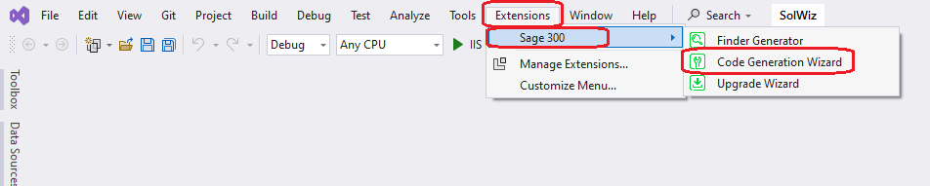

The wizard will perform validation to ensure that the invoking solution is a Sage 300 Web UI or Sage 300 Web API solution. If it is not (due to the required projects not being present), a message informs you that the solution does not include all required Sage 300 projects.

1. Using the Wizard - Web Solution Type Path
   1. Step 1: Select Code Type and Credentials

Code Types

* Flat
* To be used for simple setup screens
* Will use the FlatRepository base class
* Will use a Business View to generate code files
* Process
* To be used for process screens
* Will use the ProcessRepository base class
* Will use a Business View to generate code files
* Report
* To be used for reports
* Will use the ReportRepository base class
* Will use a Report INI file to generate code files
* Header Detail
* To be used for screens with business views with a header/detail relationship
* Will use the BaseHeaderDetailRepository base class
* Will use Business Views to generate code files

Application Credentials are defaulted and may be overridden to connect to the Business View.

The Module list contains a list of Modules discovered in the solution. If only one Module is discovered, it is defaulted.

Click Next to proceed.

* 1. Step 2: Add/Edit Entities

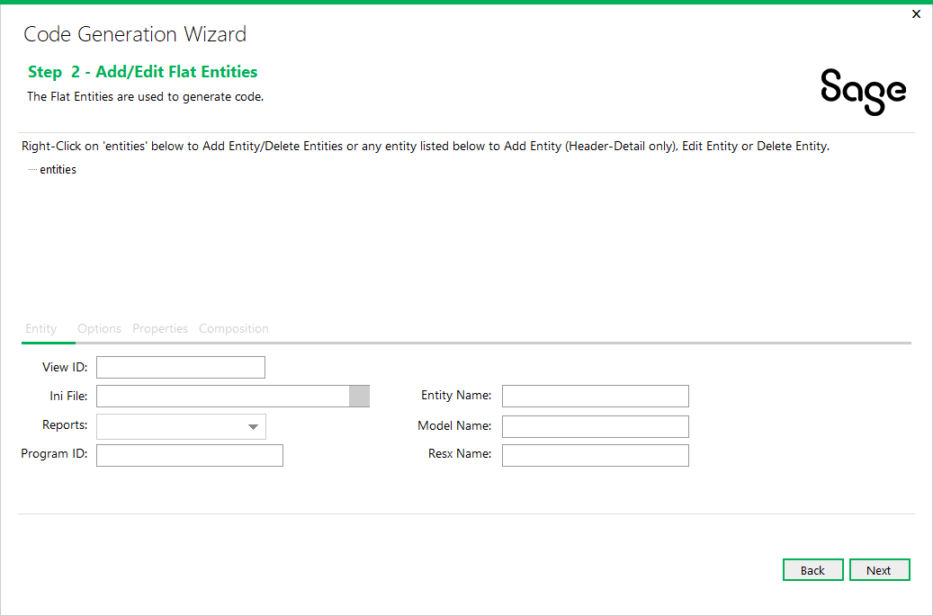

As of 2018.1, this step combines the actions for all code types with certain fields and functionality disabled based upon the code type.

The wizard is now able to generate multiple entities which is required to support the header detail code type. Only the header detail code type allows for hierarchical entities to be created.

Right-click on the ‘**entities**’ tree node and select **Add Entity** to add a new entity or select **Delete Entities** to delete all entities already added. If the code type is **HeaderDetail**, select **Edit Container Name** to display a dialog for specifying the name of the container for the header detail entities (i.e. Receipt for a Receipt Entry screen).

Right-click on **{entity}** in the tree and select **Edit Entity** to edit an already added entity.

Right-click on **{entity}** in the tree and select **Delete Entity** to delete an already added entity.

If the code type is **HeaderDetail**, child entities may be added by right-clicking on **{entity}** in the tree and select **Add Entity**.

Click Next to proceed or Back to go back to the previous step.

* + 1. Entity Tab

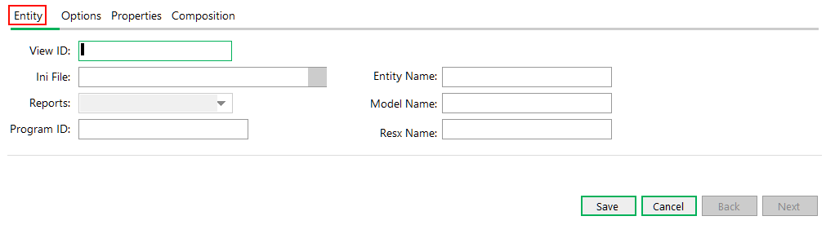

The Entity Tab has properties specific to the entity:

**View ID**

If the code type is **Report**, the generation of the code files are based upon a Sage 300 report definition from an INI file. Therefore, the View ID is a randomly generated static GUID and the field is disabled.

When editing an entity, the field is disabled.

Upon selecting a View ID, the Application Credentials from the previous step will be used to access the Business View and the **Entity** Name, Model Name and Resx Name will be defaulted. These may be overridden but the Resx Name must have the “Resx” suffix.

**Ini File**

If the code type is **Report**, Report definitions for Sage 300 are in INI files. Click on the magnifying glass button to display an Open File dialog to search for an existing INI file, or enter the file name manually.

**Reports**

If the code type is **Report**, this list is populated from the INI file. It contains the report names in alphabetical order. The report name selected will be used to populate the Model Fields grid in the Properties tab.

Program ID

If the code type is **Report**, this field is assigned from the INI file and will be used in the Model Mapper class.

**Entity Name**

This field is defaulted from the retrieved Business View and may be overridden as required. It is used as the prefix name for the code files that will be created. For **Report** code type, this field must be manually entered as there is no source to default it from.

**Model Name**

This field is defaulted from the retrieved Business View and may be overridden as required. It is used as the name for the model that will be created. For **Report** code type, this field must be manually entered as there is no source to default it from.

**Resx Name**

This field is defaulted from the retrieved Business View and may be overridden as required. It is used as the name for the Resx file that will be created. For **Report** code type, this field must be manually entered. It has a requirement that it must have the “Resx” suffix. This field will also be synchronized with any changes made to the entity name.

Up to five Resx files will be generated based upon the languages selected in the Solution Wizard. The main Resx file is English and will contain the descriptions for the Model properties and Enumerations from the Business View.

The other Resx files, if selected in the Solution Wizard, are Spanish (es), French (fr), Chinese Simplified (zh-Hans) and Chinese Traditional (zh-Hant). These files will contain only keys and will require manual translation.

When done adding or editing an entity, click **Save** to save the entity when finished or **Cancel** to disregard any changes.

* + 1. Options Tab

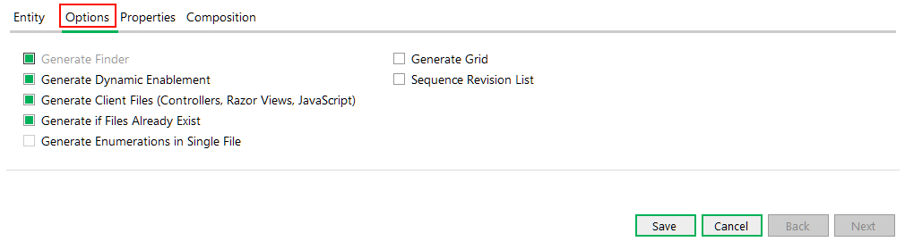

The Options Tab has options specific to the entity:

**Generate Finder**

If selected, this option will generate a finder for the entity. Certain code types have this option disabled as a finder is not applicable to all code types.

Generate Dynamic Enablement

If selected, this option provides a reverse mapping of the Business View fields. Within the Sage accounting modules, the Inventory Control, Order Entry, and Purchase Orders Business Views contain more functionality for determining if a field is editable or not. This will generate the code for determining if the UI or Business View is responsible for checking the editable state. Certain code types have this option disabled.

Generate Client Files

If selected, this option will generate the client files for a Business View (controllers, Razor Views, and JavaScript files) and thus provides for the ability to generate certain code files without the client files being generated. Certain code types have this option disabled.

Generate if Files Already Exist

If selected, this option provides a warning dialog if a code file to be generated already exists. The developer may choose to override an existing file, skip the file from being generated, or exit the wizard all together.

Generate Enumerations in Single File

If selected this option will generate all enumerations in a single file instead of in individual files.

This option is not yet enabled and is for future use.

Generate Grid

[TODO] This is the description text for the ‘Generate Grid’ checkbox.

Sequence Revision List

[TODO] This is the description text for the ‘Sequence Revision List’

When done adding or editing an entity, click **Save** to save the entity when finished or **Cancel** to disregard any changes.

* + 1. Properties Tab

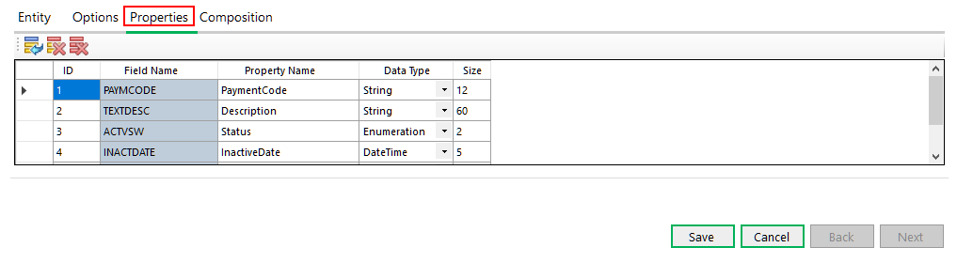

The Properties Tab has the fields that are associated with the Business View.

The above screenshot shows properties for the **AR0012** Business View.

For **Report** code type, this information must be manually entered.

For all other code types that use a Business View for the View ID, this grid allows for the modification of the Property Name before the code is generated. This can be very useful if the default names are not sufficient, or the developer wishes to use another name. Additionally, fields may be added or deleted as required by the developer to add fields to the model that are not found in the Business View.

If the code type is Report, the Field Name column is read-only and is the server field name whereas the Property Name column is the name for the model properties. A simple algorithm will be applied to the property name column based upon the server field name. The Size column is used for the Display annotation on the Model property and for the Finder attributes if the option to generate a Finder is selected.

All properties are defined as String data type based upon the requirements of the report engine.

When done adding or editing an entity, click **Save** to save the entity when finished or **Cancel** to disregard any changes.

* + 1. Composition Tab

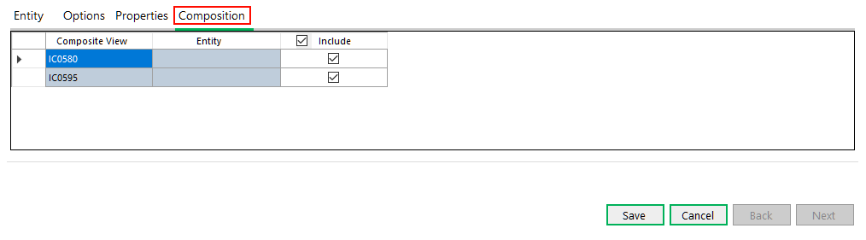

The Composition Tab has the compositions that are associated with the Business View.

This tab is only available if the code type is **HeaderDetail**.

The above screenshot shows compositions for the **IC0590** Business View.

The compositions are defaulted to be included and these should be included for any header entities.

The **Include** option, if selected, will ensure that the **Composite View** is associated with an entity specified in the list of entities. Once a Composite View has been specified in the list of entities, the Entity will be assigned from the **Entity Name** field of that entity. The validation logic will ensure this functionality.

The **Include** option, if not selected, will not require the entity to be in the list of entities while still allowing the composition code to assign a Null value to the entity in the composition routine. In the above **IC0590** example, when adding the child to this entity (**IC0595**), there will be numerous Composite Views specified, however, not all should be included.

Refer to the Receipt Sample in the Sage 300 Web SDK for the composition routine generated by the wizard.

Familiarity with the compositions is a requirement for the developer using the **HeaderDetail** code type.

When done adding or editing an entity, click **Save** to save the entity when finished or **Cancel** to disregard any changes.

* 1. Step 3: Generate a UI Layout

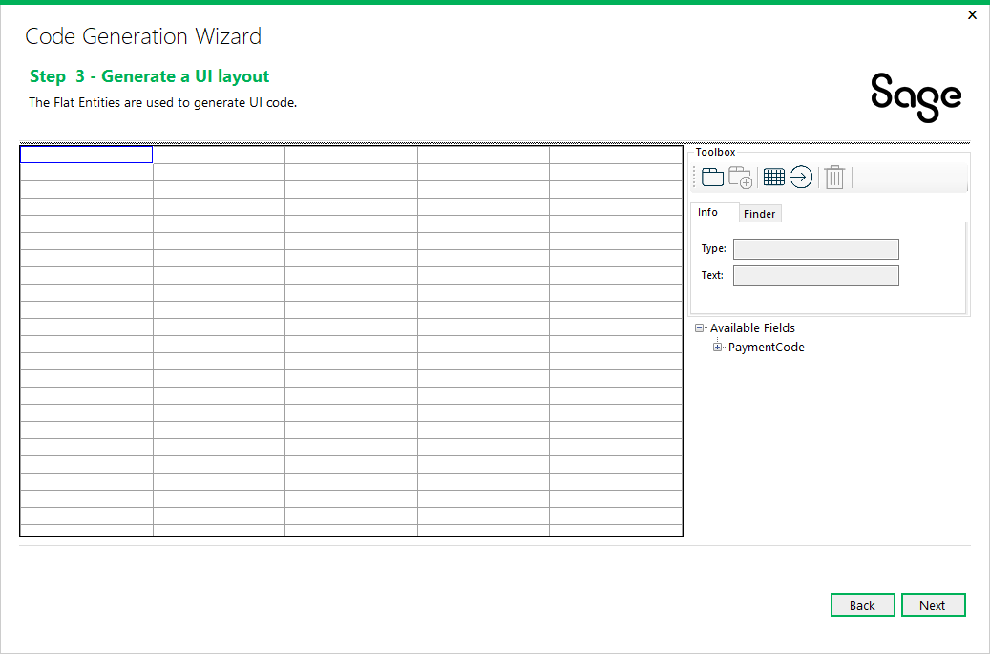

For the 2022.0 release, a new step has been added to the Code Generation Wizard. This step, entitled ‘Generate a UI layout’ is used to visually layout the controls that will make up the page..

Click Next to proceed or Back to go back to the previous step.

* + 1. Working with the UI Layout

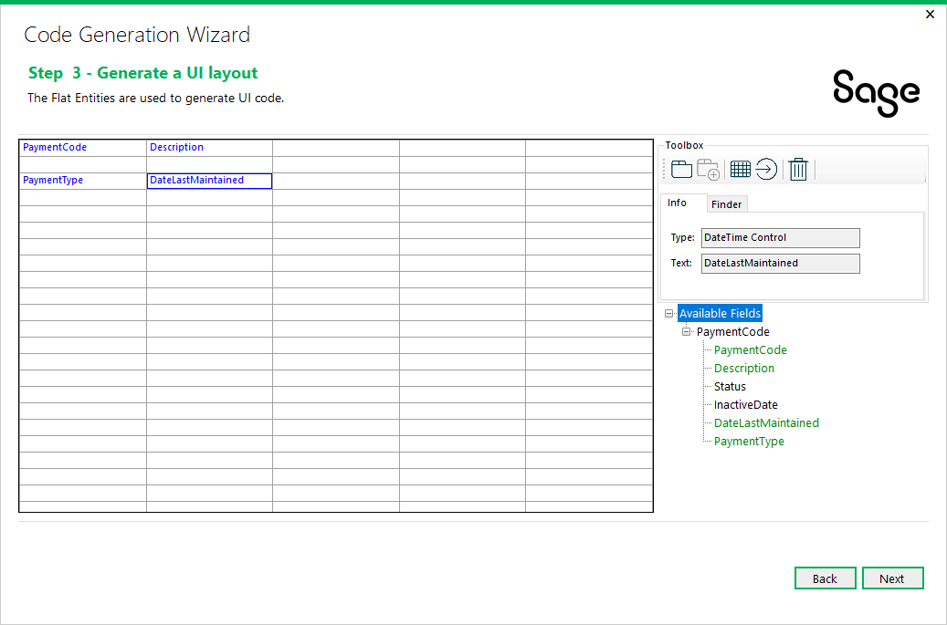

Fields may be dragged onto the layout canvas from the **Available Fields** tree control in the bottom-right corner of the wizard.

The field may only be dropped onto an open cell in the palette.

The field may be moved (dragged) to any other open cell in the palette.

Once the field is dropped onto the palette, it may not be dropped more than once.

To delete a field from the palette, click on the field in the palette and selected the Trash icon in the toolbox to delete the field and return it to the list of Available fields.

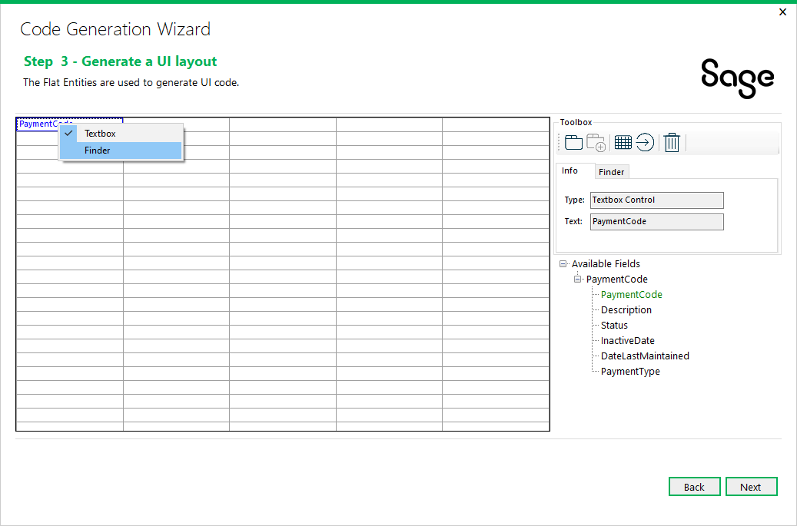

Each field on the canvas may be able to have its properties manipulated via a combination of right-clicking on the dropped field in the layout canvas and property modifications in the Info | Finder property area.

The UI Layout wizard does not know what fields are to be considered finders. Therefore, by right-clicking on a field that is assigned a textbox, you will be able to change the widget that will be created to be that of one that supports a finder.

A field with a presentation list will default to a Dropdown widget, but by right-clicking on the field, you will be able to change this to a Radio Button widget.

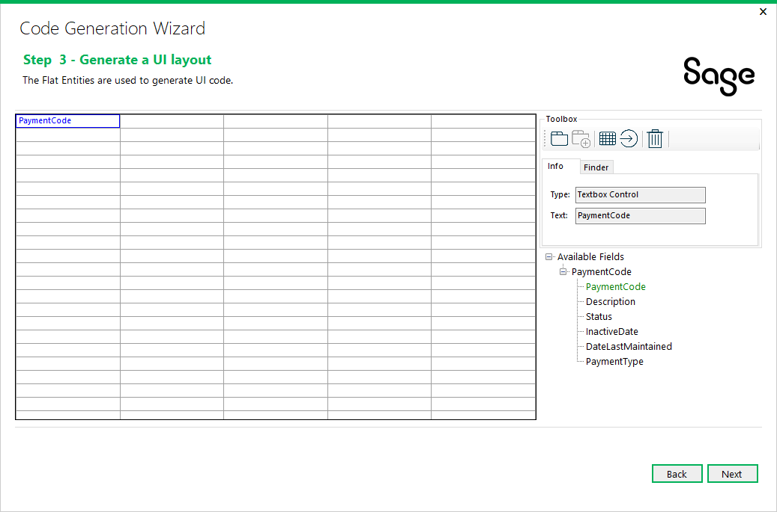

If a field is selected to be a finder, the “Finder” tab is enabled, and a configuration file may be selected as well as a finder definition.

Finder definitions MUST be defined prior to the code generation process by using the Finder Definition Generator. See the SDK for documentation. This is a new requirement introduced in 2022 as previously the finder definition was simply generated inline in the Behavior JavaScript file.

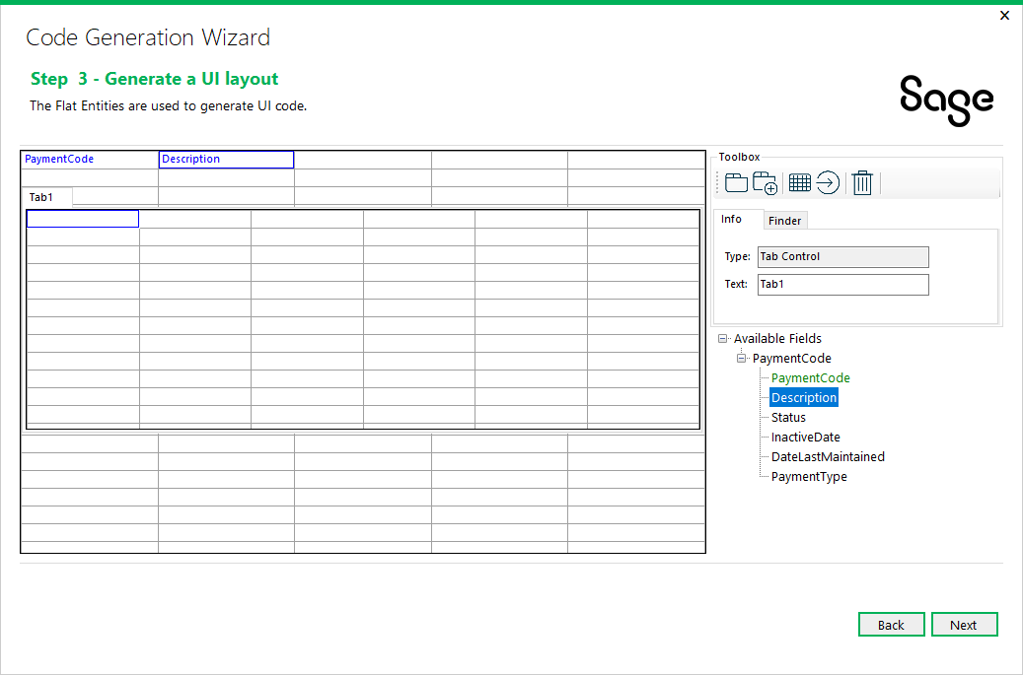

If a tab widget is required for the screen, select the Tab Control icon in the toolbox and drag it onto the palette. The text for the tab page can be changed in the Info section’s text field.

This value is added to the Resx file for localization.

Only 1 tab control per screen is allowed in the wizard, however, more may be created manually.

The tab control can only be dropped on an open cell.

The tab control may be moved (dragged) to any other open cell in the palette.

To delete a tab page (and control if only 1 tab page) from the palette (and any fields dropped onto the palette in the tab page), click on the tab page in the palette and selected the Trash icon in the toolbox to delete the tab page and return any fields to the list of Available fields.

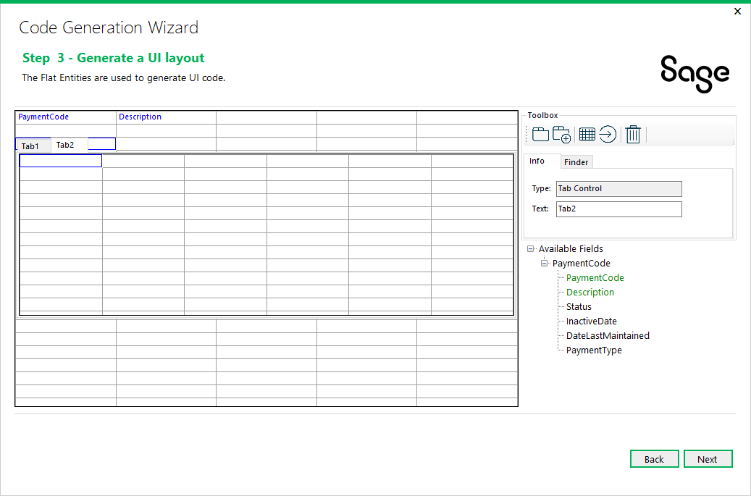

If another tab page is required for the screen, click the Add Tab Page Control icon in the toolbox and another tab page is added to the tab control in the palette. The text for the tab page can be changed in the Info section’s text field.



If a grid widget is required for the screen, select the Grid Control icon in the toolbox and drag it onto the palette. The name for the grid can be changed in the Info section’s text field and will be used as the name of the grid.

The grid control can only be dropped on an open cell.

The grid control may be moved (dragged) to any other open cell in the palette.

To delete a grid from the palette (and any fields dropped onto the grid), click on the grid in the palette and selected the Trash icon in the toolbox to delete the grid and return any fields to the list of Available fields.

Fields dropped into the grid control are ordered from left to right and at this time, we do not allow for inserting or re-ordering. Therefore, if reordering is required, simply delete the fields and re-drop.

For the 2024.0 release, the entity from the Available Fields tree may be dragged and dropped onto the grid instead of adding each property manually. This saves time when all properties are required to be added to the grid.

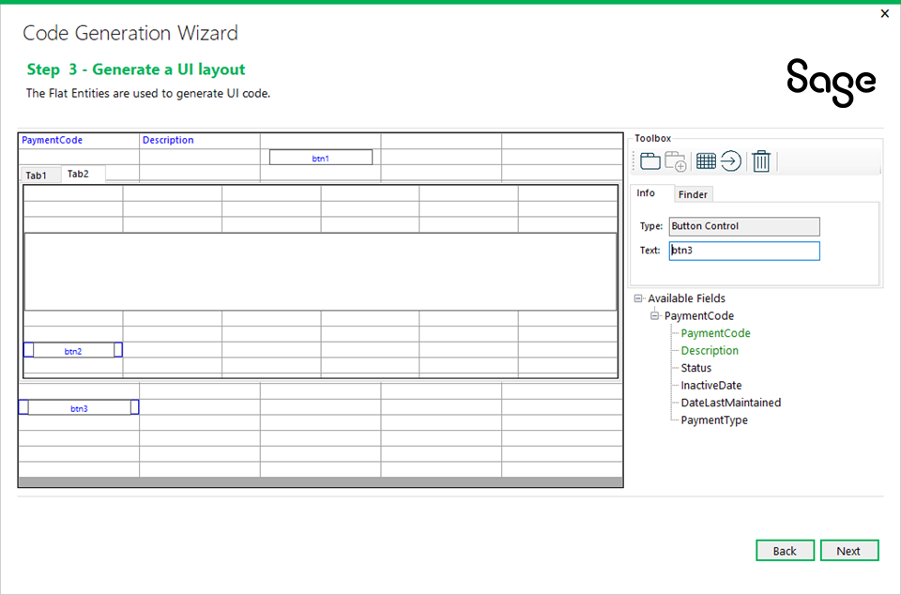

If a button is required for the screen, select the Button Control icon in the toolbox and drag it onto the palette. The text for the button can be changed in the Info section’s text field.

The button control can only be dropped on an open cell.

The button control may be moved (dragged) to any other open cell in the palette.

To delete a button from the palette, click on the button in the palette and selected the Trash icon in the toolbox to delete the button.

Click Next to proceed or Back to go back to the previous step.

* 1. Step 4: Generate Code

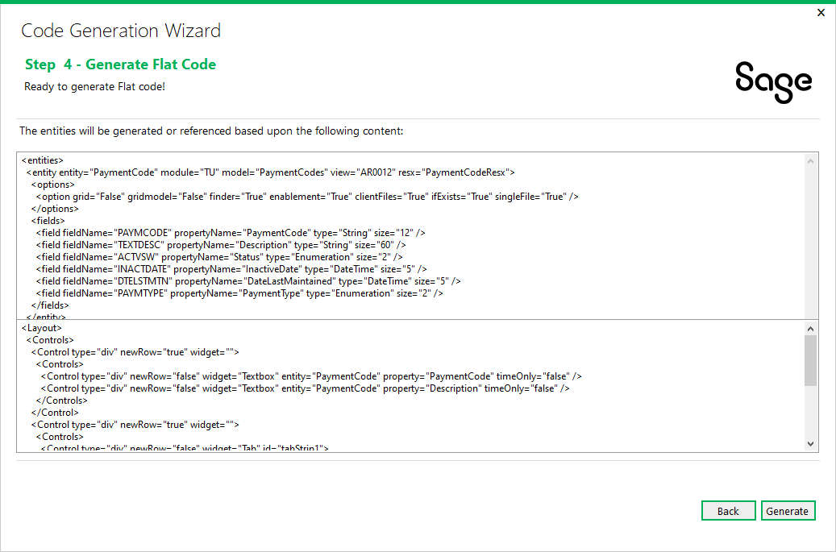

This is the confirmation prior to the wizard generating the code based upon the wizard inputs.

The wizard will generate code based on the XML shown in the preview.

If the UI Layout step specified a layout, the razor view will create the appropriate widgets and required JavaScript code to support the widgets.

Click Generate to proceed or Back to go back to the previous step.

* 1. Step 5: Generated Code

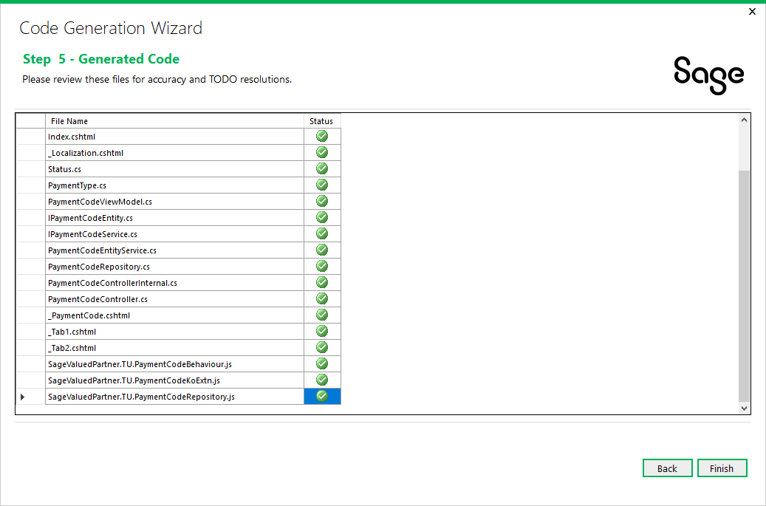

The wizard displays the code files that were generated. It is now time to review the generated files for accuracy and resolve any TODO issues.

TODO issues are C# comments (i.e. // TODO something…) that provide explicit instructions for a developer to resolve or verify wizard generated code.

Click Finish to exit the wizard or Back to go back to the previous step.

1. Using the Wizard - Web API Solution Type Path
   1. Step 1: Enter Credentials

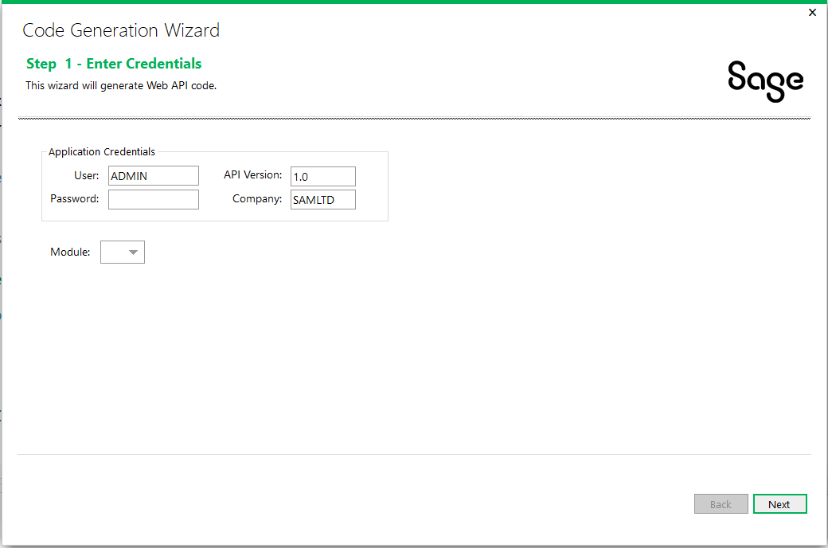

Application Credentials are defaulted and may be overridden to connect to the Business View.

The Sage 300 Web API is versioned and therefore the version must be specified.

The Module list contains a list of Modules discovered in the solution.

Click Next to proceed.

* 1. Step 2: Add/Edit Web API Entities

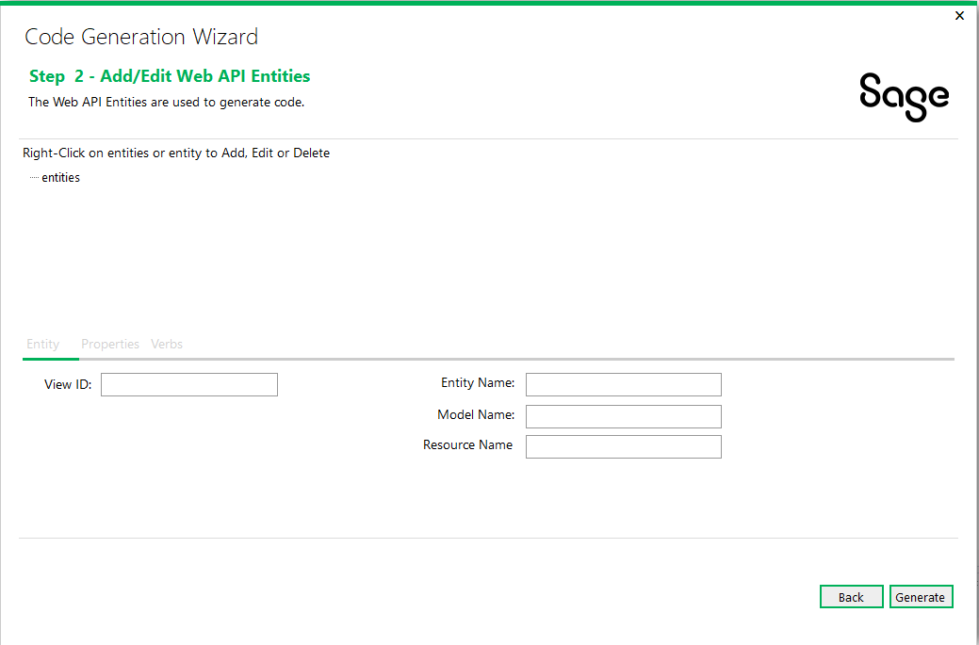

Right-click on the ‘**entities**’ tree node and select **Add Entity** to add a new entity or select **Delete Entities** to delete all entities already added.

Right-click on **{entity}** in the tree and select **Edit Entity** to edit an already added entity.

Right-click on **{entity}** in the tree and select **Delete Entity** to delete an already added entity.

Click Next to proceed or Back to go back to the previous step.

* + 1. Entity Tab

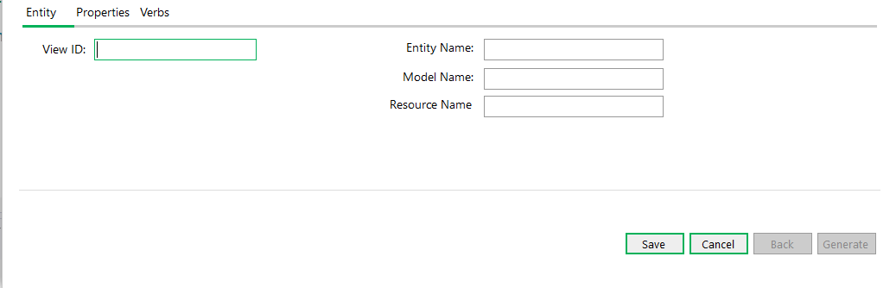

The Entity Tab has properties specific to the entity:

**View ID**

The Business View Id.

When editing an entity, the field is disabled.

Upon selecting a View ID, the Application Credentials from the previous step will be used to access the Business View and the **Entity** Name, Model Name and Resource Name will be defaulted. These may be overridden.

**Entity Name**

This field is defaulted from the retrieved Business View and may be overridden as required. It is used as the prefix name for the code files that will be created.

**Model Name**

This field is defaulted from the retrieved Business View and may be overridden as required. It is used as the name for the model that will be created.

**Resource Name**

This field is defaulted from the retrieved Business View and may be overridden as required. This field will also be synchronized with any changes made to the entity name.

When done adding or editing an entity, click **Save** to save the entity when finished or **Cancel** to disregard any changes.

Properties Tab

* + 1. Properties Tab

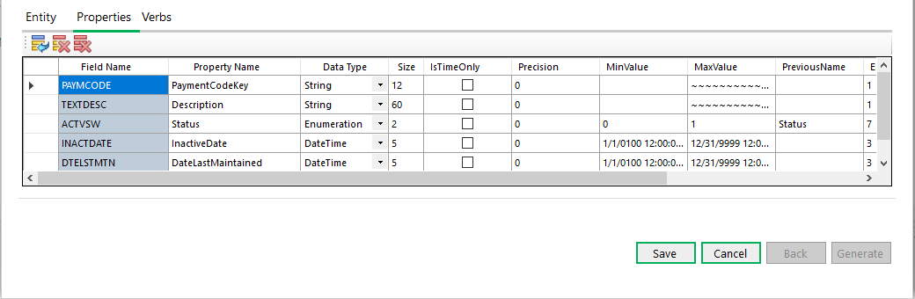

The Properties Tab has the fields that are associated with the Business View.

The above screenshot shows properties for the **AR0012** Business View.

This grid allows for the modification of the Property Name before the code is generated. This can be very useful if the default names are not sufficient, or the developer wishes to use another name. Additionally, fields may be added or deleted as required by the developer to add fields to the model that are not found in the Business View.

When done adding or editing an entity, click **Save** to save the entity when finished or **Cancel** to disregard any changes.

* + 1. Verbs Tab

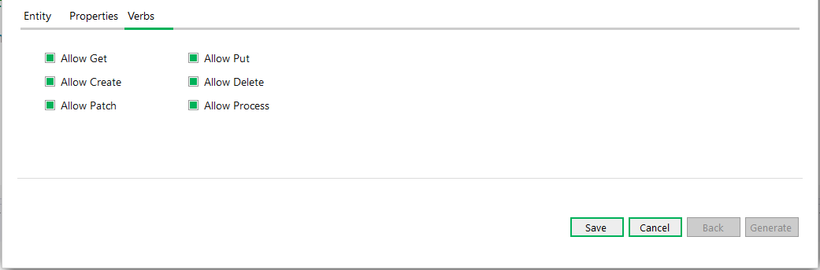

The Verbs Tab has verbs or Actions that can be performed on the endpoint.

The verbs are self-explanatory.

By default, all verbs are selected, and the partner will need to determine which verbs they may not want to allow via the Web API. This selection can be changed in code after generation if it is later decided to include or exclude a verb.

When done adding or editing an entity, click **Save** to save the entity when finished or **Cancel** to disregard any changes.

* 1. Step 2 (cont): Generate Code

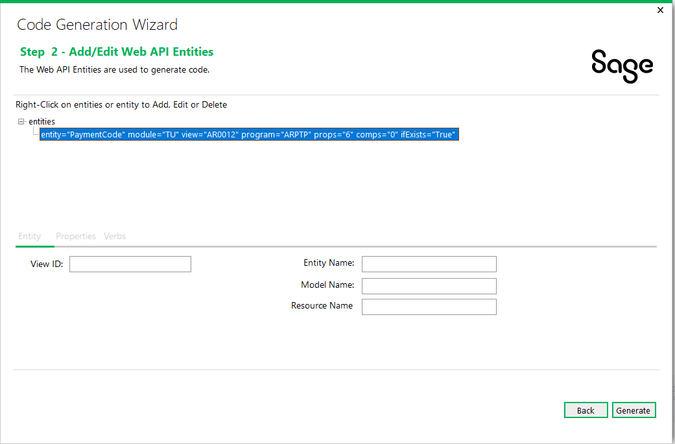

This is the confirmation prior to the wizard generating the code based upon the wizard inputs.

Click Generate to proceed or Back to go back to the previous step.

* 1. Step 3: Generated Code

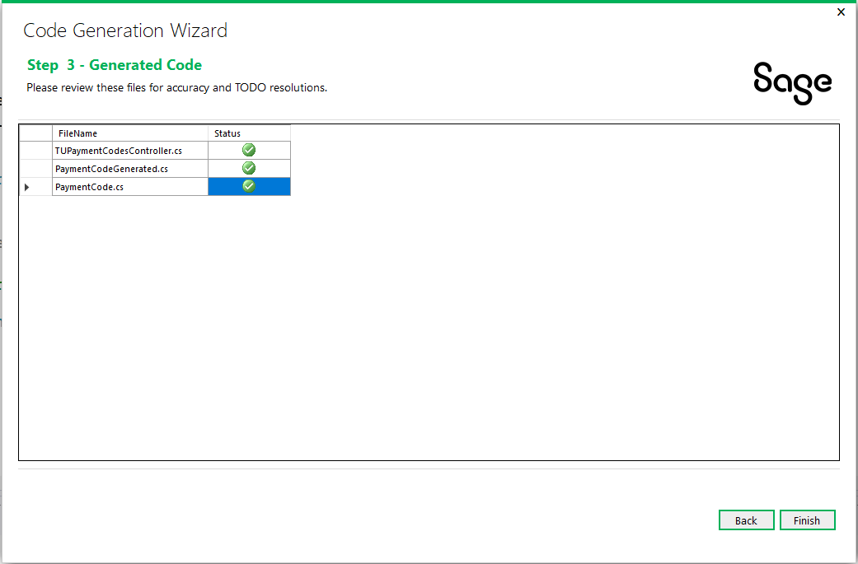

The wizard displays the code files that were generated. It is now time to review the generated files for accuracy and resolve any TODO issues.

TODO issues are C# comments (i.e. // TODO something…) that provide explicit instructions for a developer to resolve or verify wizard generated code.

Click Finish to exit the wizard or Back to go back to the previous step.

1. Examining the Solution

It is time to examine the solution and get familiar with the class and folder scaffolding.

* 1. Web Type Solution

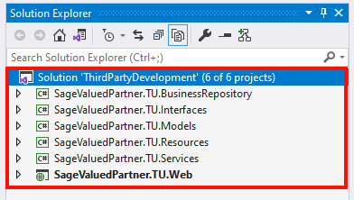

Note the following information:

* The solution name supplied in the New Project dialog.
* The namespace of the projects supplied in the wizard dialog.
  + 1. Business Repository Project

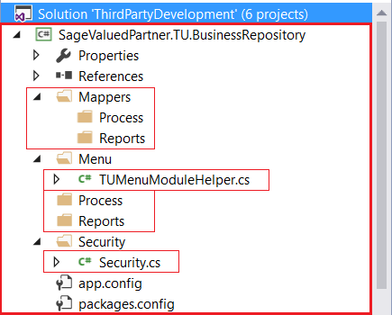

The wizard has created the required folders and a couple of classes that will be used by the Code Generation Wizard.

Note the presence of the Process and Reports folders. In the Code Generation Wizard, if a Code Type of Process or Reports is selected, the appropriate Mapper and Repository class will be generated in these subfolders as opposed to the root folders.

The TUMenuModuleHelper.cs file already has generated code for Menu Navigation.

The Security.cs file already has constants generated for the Import and Export constants for the generated Module ID.

* + 1. Interfaces Project

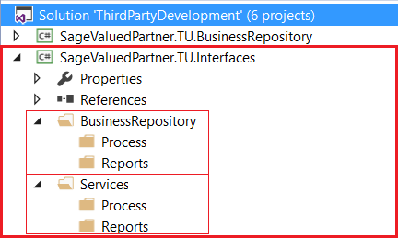

The wizard has created the required folders that will be used by the Code Generation Wizard.

Note the presence of the Process and Reports folders. In the Code Generation Wizard, if a Code Type of Process or Reports is selected, the appropriate Interface classes will be generated in these subfolders as opposed to the root folders.

* + 1. Models Project

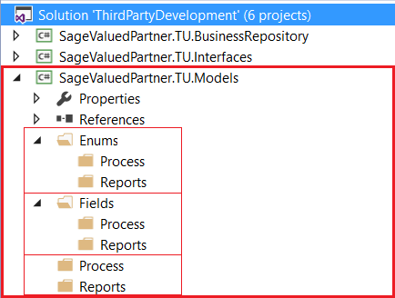

The wizard has created the required folders that will be used by the Code Generation Wizard.

Note the presence of the Process and Reports folders. In the Code Generation Wizard, if a Code Type of Process or Reports is selected, the appropriate Enumerations, Fields and Model classes will be generated in these subfolders as opposed to the root folders.

* + 1. Resources Project

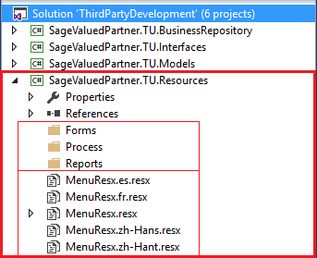

The wizard has created the required folders that will be used by the Code Generation Wizard.

Note the presence of the Forms, Process, and Reports folders. In the Code Generation Wizard, if a Code Type of Process or Reports is selected, the appropriate Resx files will be generated in these subfolders as opposed to the Forms folders.

Note the generated Resx files:

* MenuResx.resx is the English resource.
* MenuResx.es.resx is the Spanish resource, if Spanish is included via the Solution Wizard Resource Files Step.
* MenuResx.fr.resx is the French resource, if French is included via the Solution Wizard Resource Files Step.
* MenuResx.zh-Hans.resx is the Chinese Simplified resource, if Chinese Simplified is included via the Solution Wizard Resource Files Step.
* MenuResx.zh-Hant.resx is the Chinese Traditional resource, if Chinese Traditional is included via the Solution Wizard Resource Files Step.

Only the English Resx file is marked as Public. All other resx files are marked as No Code Generation.

Any Resx file that is common to all screens/reports/whatever in a module is to be placed in the root folder.

* + 1. Services Project

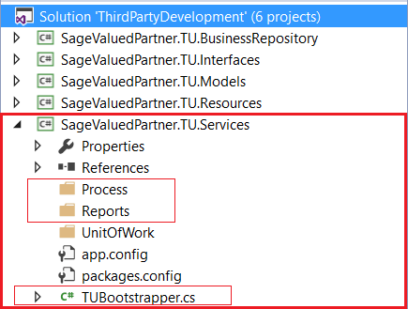

The wizard has created the required folders and a class that will be used by the Code Generation Wizard.

Note the presence of the Process and Reports folders. In the Code Generation Wizard, if a Code Type of Process or Reports is selected, the Service class will be generated in these subfolders as opposed to the root folders.

The TUBootstrapper.cs file already has generated code for Unity Dependency Injection which will be added to by the Code Generation Wizard.

* + 1. Web Project

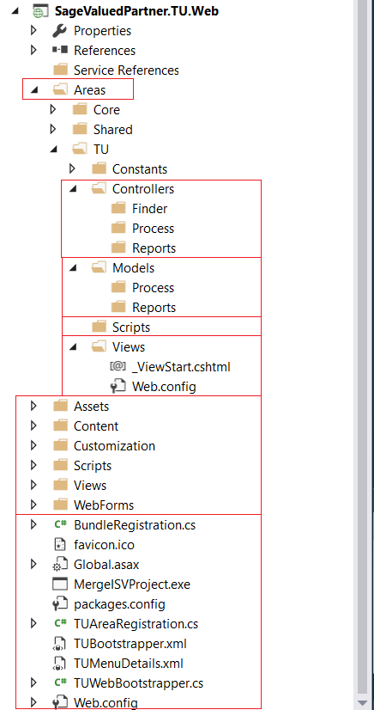

The wizard has created the required folders, files and classes that will be used by the Code Generation Wizard.

Note the presence of the Finder, Process, and Reports folders. In the Code Generation Wizard, if a Code Type of Process or Reports is selected, the appropriate classes will be generated in these subfolders as opposed to the root folders. If selected in the Code Generation Wizard Options, the Finder will be created in the Finder folder.

The TUBootstrapper.cs, TUAreaRegistration.cs, TUMenuDetails.xml and TUWebBootstrapper.cs files already have generated code for Unity Dependency Injection, which will be added to by the Code Generation Wizard.

* 1. Web API Type Solution

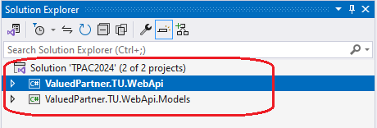

Note the following information:

* The solution name supplied in the New Project dialog.
* The namespace of the projects supplied in the wizard dialog.
  + 1. Web API Project

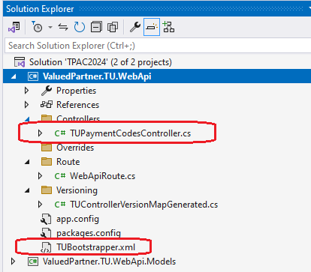

The wizard has created the endpoint (TUPaymentCodes) for the requested entity.

The TUBootstrapper.xml file describes how the Sage 300 Web API will discover the binaries (endpoints) from this solution to incorporate into the Sage 300 Web API.

* + 1. Models Project

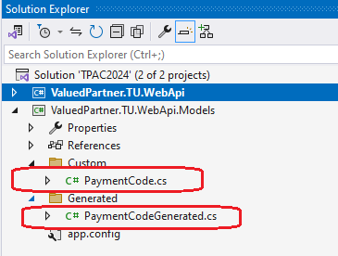

The wizard has created the models for the requested entity.

The model in the Custom folder is where partners will write any custom code for the endpoint.