Sage 300 Web Screens SDK

Solution Wizard

October 2024

The MIT License (MIT)

Copyright © 2024 The Sage Group plc or its licensors. All rights reserved.

Permission is hereby granted, free of charge, to any person obtaining a copy of this software and associated documentation files (the “Software”), to deal in the Software without restriction, including without limitation the rights to use, copy, modify, merge, publish, distribute, sublicense, and/or sell copies of the Software, and to permit persons to whom the Software is furnished to do so, subject to the following conditions:

The above copyright notice and this permission notice shall be included in all copies or substantial portions of the Software.

THE SOFTWARE IS PROVIDED “AS IS”, WITHOUT WARRANTY OF ANY KIND, EXPRESS OR IMPLIED, INCLUDING BUT NOT LIMITED TO THE WARRANTIES OF MERCHANTABILITY, FITNESS FOR A PARTICULAR PURPOSE AND NONINFRINGEMENT. IN NO EVENT SHALL THE AUTHORS OR COPYRIGHT HOLDERS BE LIABLE FOR ANY CLAIM, DAMAGES OR OTHER LIABILITY, WHETHER IN AN ACTION OF CONTRACT, TORT OR OTHERWISE, ARISING FROM, OUT OF OR IN CONNECTION WITH THE SOFTWARE OR THE USE OR OTHER DEALINGS IN THE SOFTWARE.

Contents

1. Overview 4

2. Installing the Wizard 6

3. Accessing the Wizard 7

4. Wizard Inputs 9

4.1 Solution Type 9

4.2 Web Solution Type Path 10

4.2.1 Solution Information 10

4.2.2 Kendo UI Information 11

4.2.3 Resource Files 12

4.2.4 Generate Solution 13

4.2.5 Web Project Start Page 13

4.3 Web API Solution Type Path 14

4.3.1 Solution Information 14

4.3.2 Generate Solution 15

5. Examining the Solution 16

5.1 Web Solution Type 16

5.1.1 Business Repository Project 16

5.1.2 Interfaces Project 17

5.1.3 Models Project 18

5.1.4 Resources Project 18

5.1.5 Services Project 19

5.1.6 Web Project 20

5.2 Web API Solution Type 22

5.2.1 Web Api Project 22

5.2.2 Models Project 23

1. Overview

This document is intended to serve as a guide for illustrating how to use the Solution Wizard to create a Visual Studio Solution for Sage 300 Web User Interfaces (“UIs”) or for the Sage 300 Web API for partner endpoints.

The Solution Wizard is a Visual Studio Plugin and is compatible with Visual Studio 2022.

The intent of the wizard is to create a solution for Sage 300 Web UIs or for the Sage 300 Web API. The wizard will provide the necessary scaffolding and structures to accommodate the new Sage 300 Web UIs and Web APIs whether they are created manually or generated via the Sage 300 Code Generation Wizard.

The wizard will create the required projects in preparation for creating screens, reports, inquiries, etc.

The projects created for the Web Screens are:

|  |  |
| --- | --- |
| Business Repository | Contains the code files for the Entity Repositories, Entity Mappers, Menu Navigation XML, Security Constants, and so on. |
| **Interfaces** | Contains the code files for the Entity Repository/Service Interfaces. |
| **Models** | Contains the code files for the Models, Model Enumerations, and Model Fields. |
| **Resources** | Contains the code files for the Resources (Resx Files) for supported languages. |
| **Services** | Contains the code files for the Services. |
| **Web** | Contains the standard code files based upon MVC patterns (Controllers, View Models, JavaScript, Razor Views, Configuration files, and so on.) |

The projects created for the Web API are:

|  |  |
| --- | --- |
| **Models** | Contains the code files for the Models |
| **WebApi** | Contains the standard code files based upon MVC patterns (Controllers, Routes, Versioning, Configuration files, and so on.) |

The solution created is aligned with how the ASP.Net tools create solutions and allows the wizard to leverage everything built into Visual Studio. Therefore, instead of a separate utility, the wizard is embedded directly into the Visual Studio IDE.

1. Installing the Wizard

The Solution Wizard is a Visual Studio Plugin and is compatible with Visual Studio 2022.

**Note:** If the previous Sage 300 Solution Wizard Package is installed, it must be uninstalled first (Visual Studio - Tools, Extensions, Uninstall option, select the Sage 300 Solution Wizard Package to uninstall).

To install the utility:

1. Run Sage.CA.SBS.ERP.Sage300.SolutionWizardPackage.vsix.
2. Select the Install the Wizard Package option.
3. Accessing the Wizard

Because the wizard is embedded in Visual Studio as a plugin, when selecting the option to create a new project, you will see the Sage 300 Solution Wizard option. You can first type in ‘**Sage**’ in the textbox at the top to filter the results list. Once done, you shall see the entry for **Sage 300 Solution Wizard**:

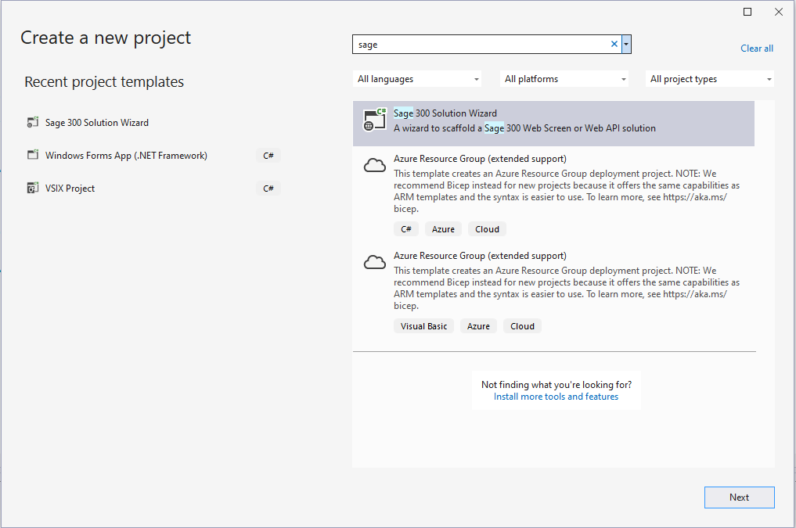

Once you have selected **Sage 300 Solution Wizard**, click on the **Next** button to go to the next page.

The next step is to simply select the project name that is to be used for the solution, and specify any other options as needed in the **Configure your new project** dialog.

Once completed, press the **Create** button to start the **Solution Wizard**.

1. Wizard Inputs
   1. Solution Type

After supplying the information required to create a new project (solution), the following dialog box appears:

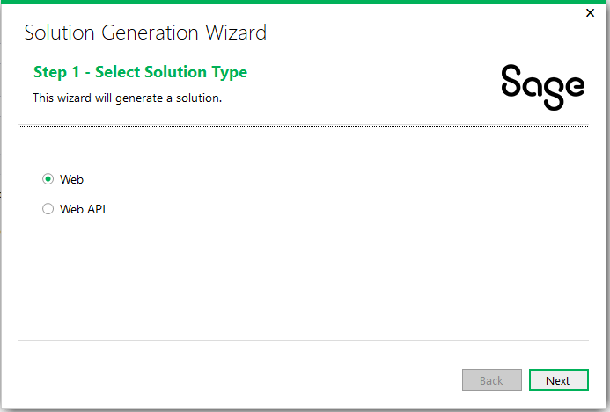

The following information is required by the wizard:

Select either **Web** to create a solution for the Sage 300 Web Screens or **Web API** to create a solution for the Sage 300 Web API.

Click X to exit the wizard or click Next to proceed.

* 1. Web Solution Type Path
     1. Solution Information

After supplying the information required to create a new project (solution), the following dialog box appears:

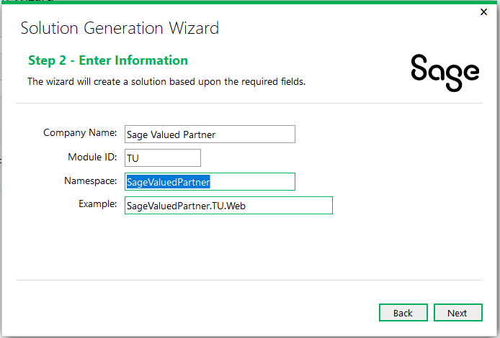

The following information is required by the wizard:

* Company Name

Used for copyright information and to provide a default value for the Namespace field.

* Module ID

Used as a Module designator that will be used to segregate the projects and will also become part of the namespace.

* Namespace

Used as the base Namespace value. The namespace will become a composite of this field and the Module ID. This field is defaulted from the Company Name field but may be overridden.

* Example

This is a read-only field to give the end user an example of what a full namespace will look like based on the entered information.

Click X to exit the wizard or click Next to proceed.

* + 1. Kendo UI Information

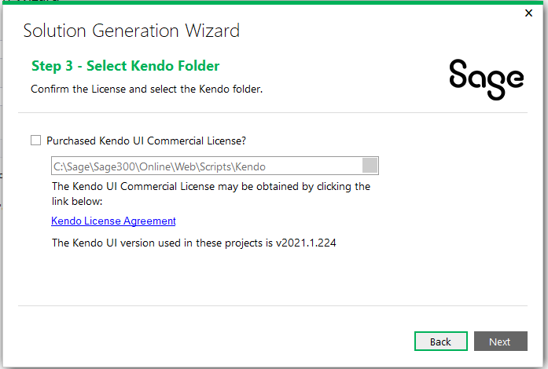

The following information is required by the wizard:

* Purchased Kendo Commercial License

This checkbox must be selected, or the Solution Wizard will not proceed. This is the acknowledgment that the user/consumer has purchased a Kendo License since Sage does not distribute the Kendo files for development purposes.

* Kendo Folder

Defaults to the location of the Sage 300 Web installation in order to consume that version of the Kendo file. An alternate folder may be entered, but the Kendo folder must have the version specified as being compatible with Sage 300c Web Screens

Click Back to return to the previous step or click Next to proceed.

* + 1. Resource Files

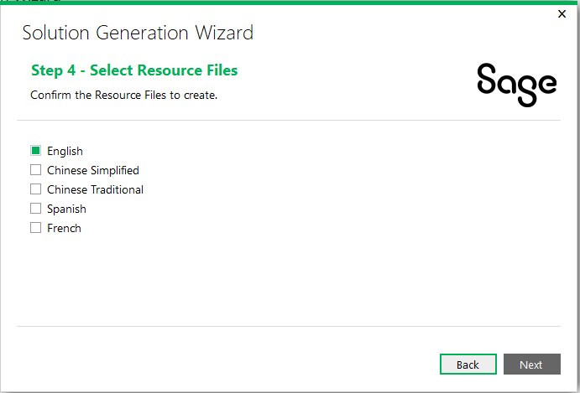

The following information is required by the wizard:

* English

This checkbox is selected by default and cannot be unselected in order to ensure that at least the English Resource Files will be generated in the Resources Project.

* Chinese Simplified, Chinese Traditional, Spanish, and French

Select these checkboxes to generate the appropriate language files in the Resources Project. For these optional languages, the keys will be generated with blank values. These blank values must be translated prior to deployment.

Click Back to return to the previous step or click Next to proceed.

* + 1. Generate Solution

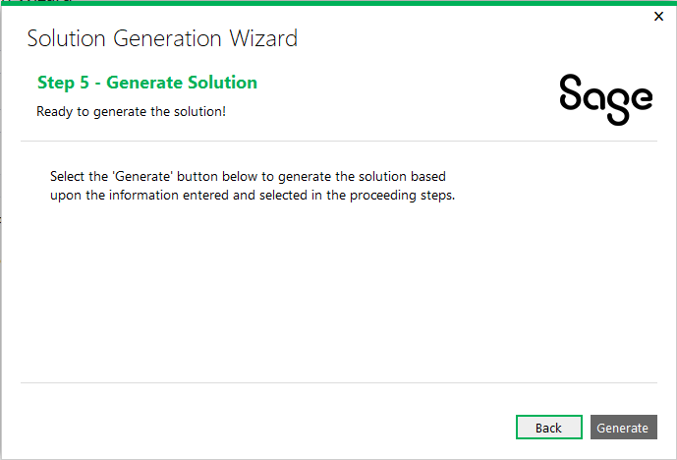

Click Back to return to the previous step or click Generate to generate the solution.

* + 1. Web Project Start Page

Start in Sage 300 version 2022, a login page named login.aspx has been added to the SDK Samples and generated partner solutions, which replaced hardcoded login credentials in the Global.asax.cs file. The Sage 300 Solution Wizard will automatically do the following:

* Set the **Web** project as the startup project
* Set **Login.aspx**, located in the root of the Web project folder, as the Start Page when debugging
  1. Web API Solution Type Path
     1. Solution Information

After supplying the information required to create a new project (solution), the following dialog box appears:

The following information is required by the wizard:

* Company Name

Used for copyright information and to provide a default value for the Namespace field.

* Module ID

Used as a Module designator that will be used to segregate the projects and will also become part of the namespace.

* Namespace

Used as the base Namespace value. The namespace will become a composite of this field and the Module ID. This field is defaulted from the Company Name field but may be overridden.

* Example

This is a read-only field to give the end user an example of what a full namespace will look like based on the entered information.

Click X to exit the wizard or click Next to proceed.

* + 1. Generate Solution

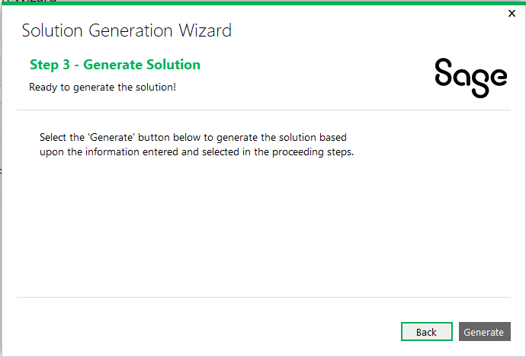

Click Back to return to the previous step or click Generate to generate the solution.

1. Examining the Solution

It is time to examine the solution and get familiar with the class and folder scaffolding.

* 1. Web Solution Type

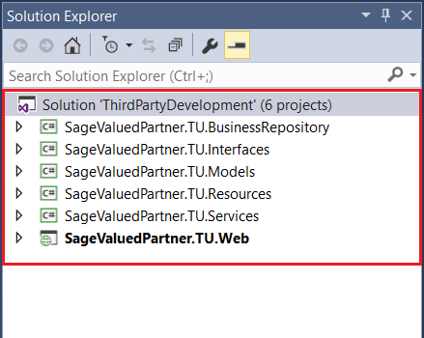

Note the solution name supplied in the New Project dialog box.

Note the namespace of the projects as specified in the Sage 300 Solution Wizard dialog box.

* + 1. Business Repository Project

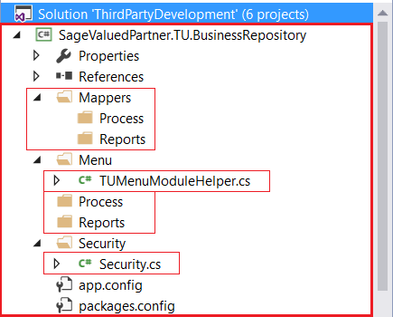

The wizard has already created the required folders and a few classes that will be used by the Code Generation Wizard.

Note the presence of the Process and Reports folders. In the Code Generation Wizard, if a Code Type of Process or Reports is selected, the appropriate Mapper and Repository class will be generated in these subfolders as opposed to the root folders.

The TUMenuModuleHelper.cs file already has generated code for Menu Navigation.

The Security.cs file already has constants generated for the Import and Export constants for the generated Module ID.

* + 1. Interfaces Project

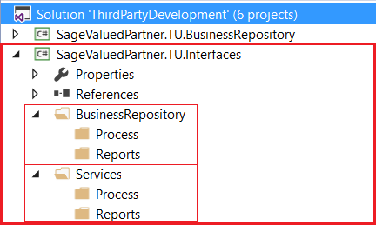

The wizard has already created the required folders that will be used by the Code Generation Wizard.

Note the presence of the Process and Reports folders. In the Code Generation Wizard, if a Code Type of Process or Reports is selected, the appropriate Interface classes will be generated in these subfolders as opposed to the root folders.

* + 1. Models Project

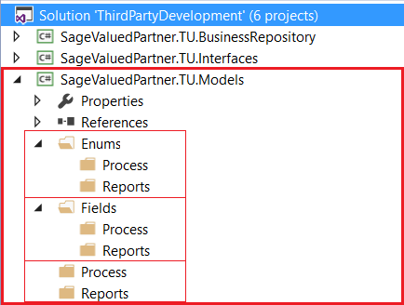

The wizard has already created the required folders that will be used by the Code Generation Wizard.

Note the presence of the Process and Reports folders. In the Code Generation Wizard, if a Code Type of Process or Reports is selected, the appropriate Enumerations, Fields, and Model classes will be generated in these subfolders as opposed to the root folders.

* + 1. Resources Project

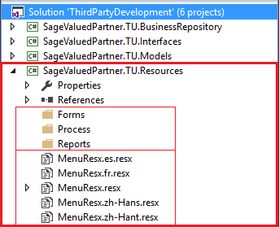

The wizard has already created the required folders that will be used by the Code Generation Wizard.

Note the presence of the Forms, Process, and Reports folders. In the Code Generation Wizard, if a Code Type of Process or Reports is selected, the appropriate Resx files will be generated in these subfolders as opposed to the Forms folders.

Note the generated Resx files:

* Any Resx file that is common to all screens or reports in a module is to be placed in the root folder.
* Only the English Resx file is marked as Public. All other Resx files are marked as No Code Generation.
* MenuResx.resx is the English resource.
* MenuResx.es.resx is the Spanish resource, if selected in the Resource Files Step.
* MenuResx.fr.resx is the French resource, if selected in the Resource Files Step.
* MenuResx.zh-Hans.resx is the Chinese Simplified resource, if selected in the Resource Files Step.
* MenuResx.zh-Hant.resx is the Chinese Traditional resource, if selected in the Resource Files Step.
  + 1. Services Project

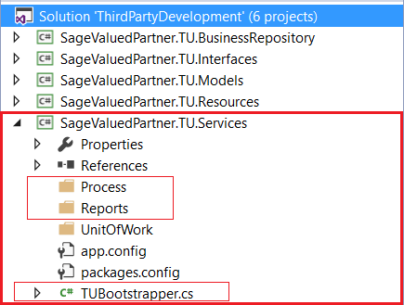

The wizard has already created the required folders and a class that will be used by the Code Generation Wizard.

Note the presence of the Process and Reports folders. In the Code Generation Wizard, if a Code Type of Process or Reports is selected, the Service class will be generated in these subfolders as opposed to the root folders.

The TUBootstrapper.cs file already has generated code for Unity Dependency Injection which will be added to by the Code Generation Wizard.

* + 1. Web Project

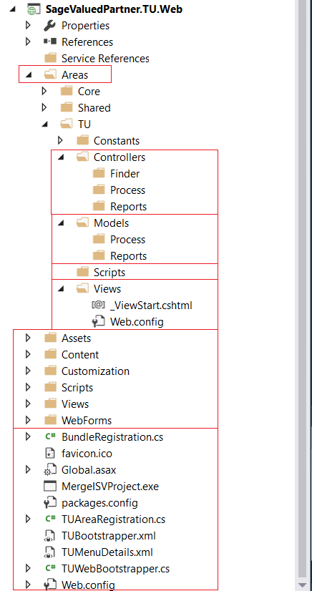

The wizard has already created the required folders, files and classes that will be used by the Code Generation Wizard.

Note the presence of the Finder, Process, and Reports folders. In the Code Generation Wizard, if a Code Type of Process or Reports is selected, the appropriate classes will be generated in these subfolders as opposed to the root folders. If selected in the Code Generation Wizard Options, the Finder will be created in the Finder folder.

The TUBootstrapper.cs, TUAreaRegistration.cs, TUMenuDetails.xml, and TUWebBootstrapper.cs files already have generated code for Unity Dependency Injection which will be added to by the Code Generation Wizard.

* 1. Web API Solution Type

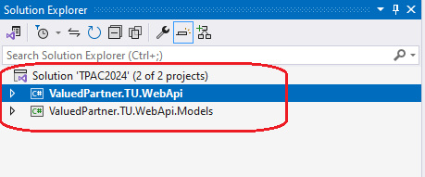

Note the solution name supplied in the New Project dialog box.

Note the namespace of the projects as specified in the Sage 300 Solution Wizard dialog box.

* + 1. Web Api Project

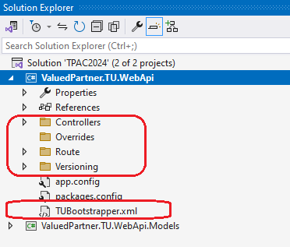

The wizard has already created the required folders, Controllers and Route and Versioning, that will be used by the Code Generation Wizard.

Note the presence of the Controllers folder as this is where all endpoints are created

The TUBootstrapper.xml file describes how the Sage 300 Web API will discover the binaries (endpoints) from this solution to incorporate into the Sage 300 Web API.

* + 1. Models Project

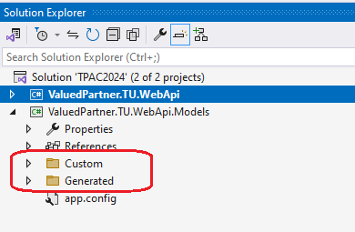

The wizard has already created the required folders, Custom and Generated, that will be used by the Code Generation Wizard.