**COMPILATION ON DIFFERENT TARGETS**

Document outlining the compilation steps on different targets (x86 Ubuntu, Raspberry Pi, and BeagleBone), follow these general steps:

**************************

# **Build steps for X86**

**************************

Issue the make command to Build.

$ make

**************************

# **Build steps for BBB**

**************************

## **Step 1: Environment Variables Setup**

1. **Set the ARCH and CROSS_COMPILE** **environment variables**

$ export ARCH=arm

$ export CROSS_COMPILE=arm-linux-gnueabihf-

1. **Set the PATH to the Cross-Toolchain:**

$ export PATH=${HOME}/ela_lab_exercises/bbb_build/toolchain/gcc-linaro-7.5.0-2019.12-x86_64_arm-linux-gnueabihf/bin/:$PATH

## **Step 2: Compilation**

$ make

## **Step 3:** **Transfer Binary file to target**

$ scp <binary_file> <username>@<ip_address>:<destination_directory>

**Example:** $scp Child_Process_execl [root@10.10.3.233:/User_Programs](mailto:root@10.10.3.233:/User_Programs)

****************************************

# **Build steps for Raspberry Pi 4B**

****************************************

## **Step 1: Environment Variables Setup**

1. **Set the ARCH and CROSS_COMPILE environment variables**

$ export ARCH=arm64

$ export CROSS_COMPILE=aarch64-linux-gnu-

1. **Set the PATH to the Cross-Toolchain**

$ export PATH=${HOME}/ela_lab_exercises_rpi/rpi_build/toolchain/gcc-linaro-7.5.0-2019.12-x86_64_aarch64-linux-gnu/bin/:$PATH

## **Step 2: Compilation**

$ make

## **Step 3: Transfer Binary file to target**

$ scp <binary_file> <username>@<ip_address>:<destination_directory>

**Example:** $scp Child_Process_execl [root@10.10.1.27:/User_Programs](mailto:root@10.10.1.27:/User_Programs)

***************************************************************************

**Running on platforms (x86, Raspberry Pi, Beagle Bone Black)**

***************************************************************************

1. Once you are in the correct directory, execute the generated executable file using the **./filename** command.

$ ./filename

**Example : $ ./ Child_Process_execl**

1. The overall output will be as given below:

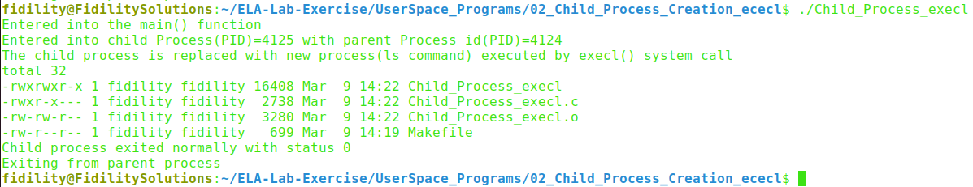

**********************************************************************************

# **Understanding Processes using /proc Interface and ps Command**

**********************************************************************************

## **Using /proc Interface**

1. First, let's identify the PID (Process ID) of a running process -> 4124
2. Now, let's use the ‘cat’ command to read information about this process from ‘/proc/$pid/status’.

$ cat /proc/4124/status

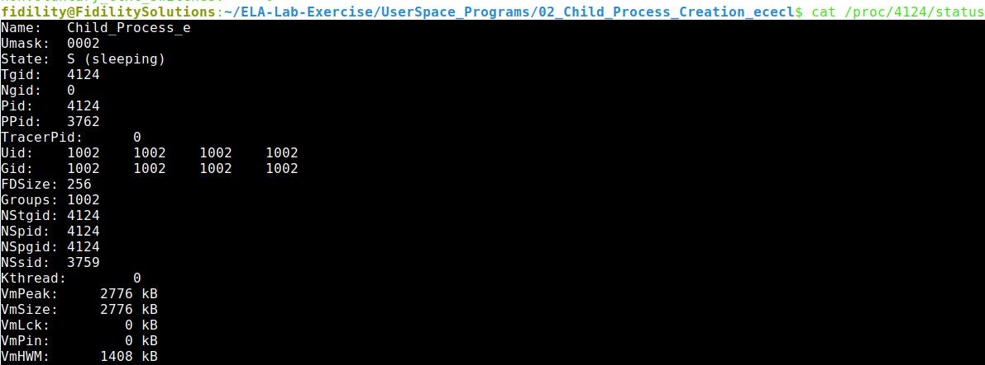

## **Using ps Command**

1. The **ps -ef/ps aux** command provides a concise overview of all processes running on the system, displaying detailed information in a full-format listing.
2. The following image shows the child process being replaced with a new program (**ls -l**).

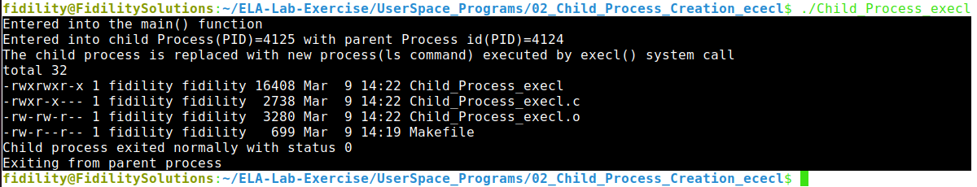

1. The image depicts entry of process present in process table: one main parent process and child process exited after replacing another process.