Appendix A: Supplementary Evaluation Figures
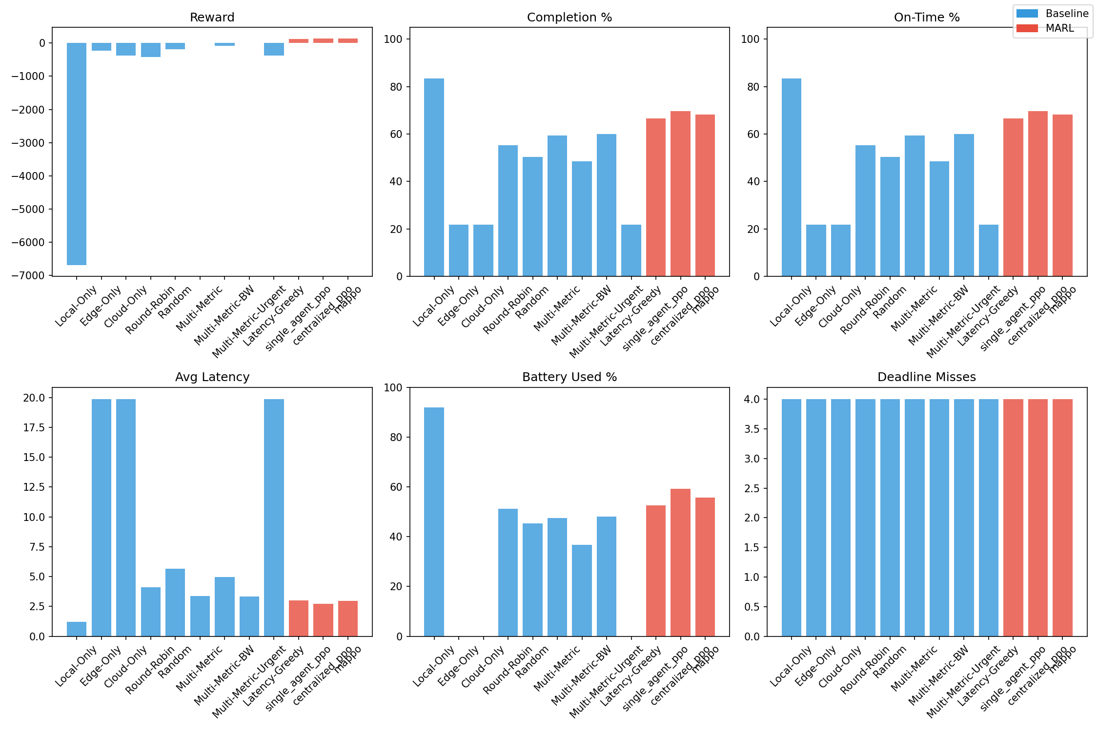
Fig 1: System-level performance across all evaluated task offloading strategies under dynamic network conditions.
Figure 1 presents a consolidated view of system-level performance across all evaluated task offloading strategies under dynamic network conditions.
The figures below summarize reliability, efficiency, and execution behavior.

Figure A: Task Completion Rate
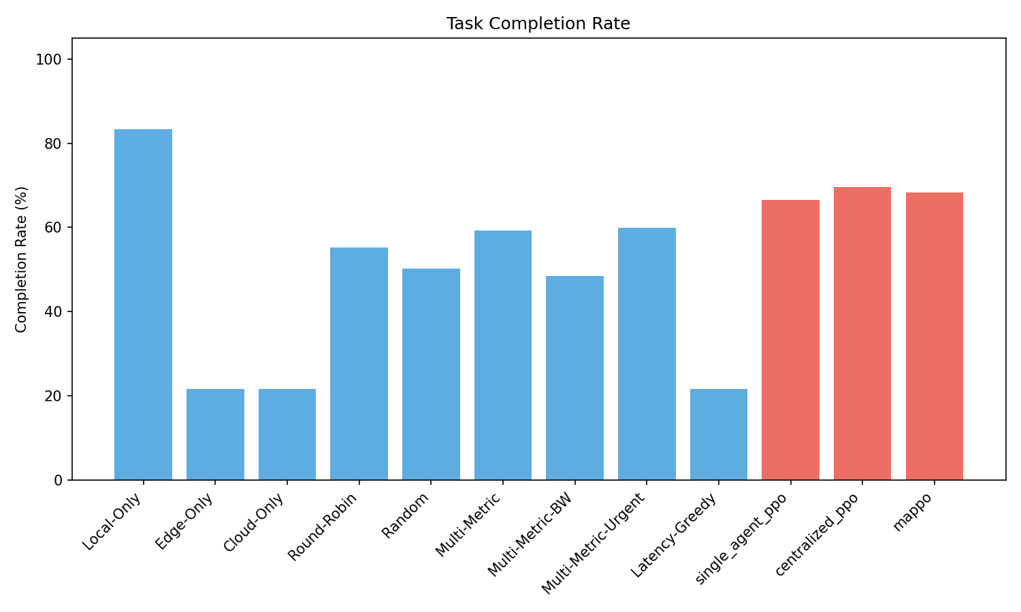
Fig A: Percentage of tasks successfully completed by each policy.
This figure shows the percentage of tasks successfully completed by each offloading strategy. FieldVision achieves one of the highest completion rates among decentralized approaches, indicating robust task execution under dynamic network conditions. Heuristic and single-tier baselines suffer from lower completion due to either uncoordinated decisions or excessive reliance on constrained resources.

Figure B: Offloading Action Distribution
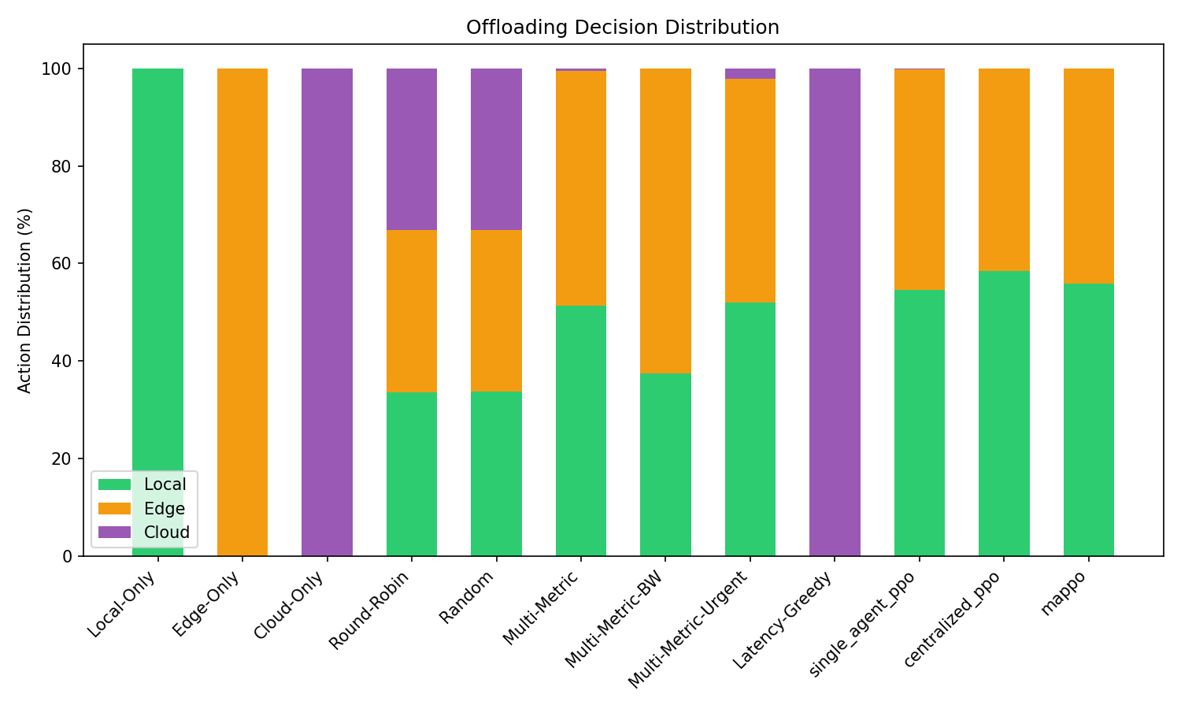
Fig B: Fraction of tasks executed locally, at the edge, and in the cloud.
This figure illustrates how tasks are distributed across local (onboard), edge, and cloud execution tiers. FieldVision maintains a balanced offloading pattern that avoids overloading any single tier. In contrast, heuristic baselines exhibit strong bias toward specific execution targets, leading to congestion and degraded performance under contention.

Figure C: Task Processing Latency
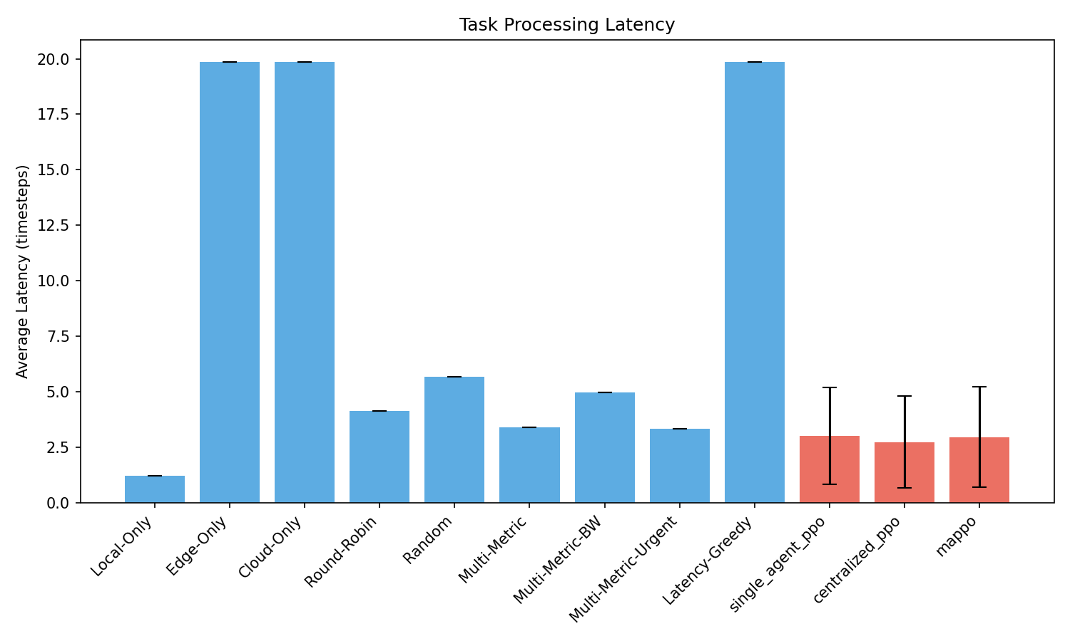
Fig C: Average and median end-to-end task latency across policies.
This figure compares average and median end-to-end task latency across policies. FieldVision achieves consistently lower median latency with reduced variance, demonstrating its ability to adapt offloading decisions to fluctuating network conditions. Policies that overuse cloud or edge resources experience higher latency due to transmission delay and queuing effects.

Figure D: Episode Reward Distribution
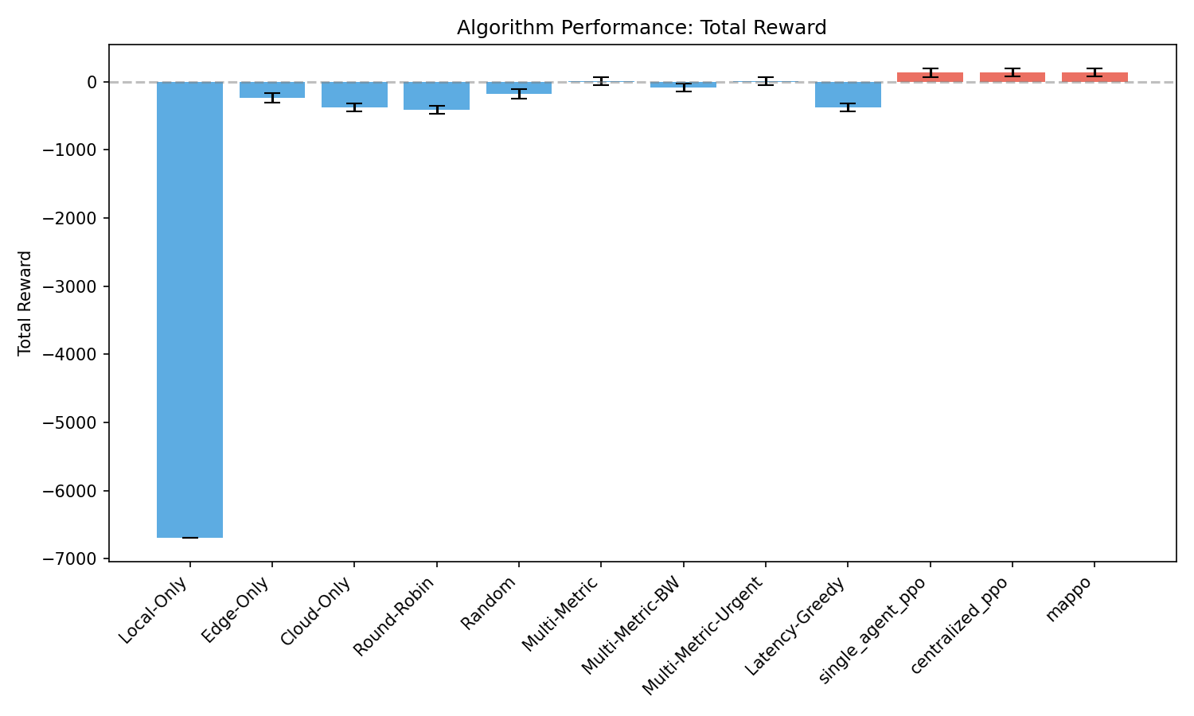
Fig D: Distribution of cumulative episode rewards reflecting overall policy effectiveness.
This figure presents the distribution of cumulative episode rewards, capturing the combined impact of latency, deadline adherence, and energy efficiency. FieldVision achieves the highest reward distribution among decentralized policies, reflecting stable and well-coordinated offloading behavior. Heuristic strategies show wider variance and lower rewards due to sensitivity to transient network fluctuations.

Figure E: Battery Consumption
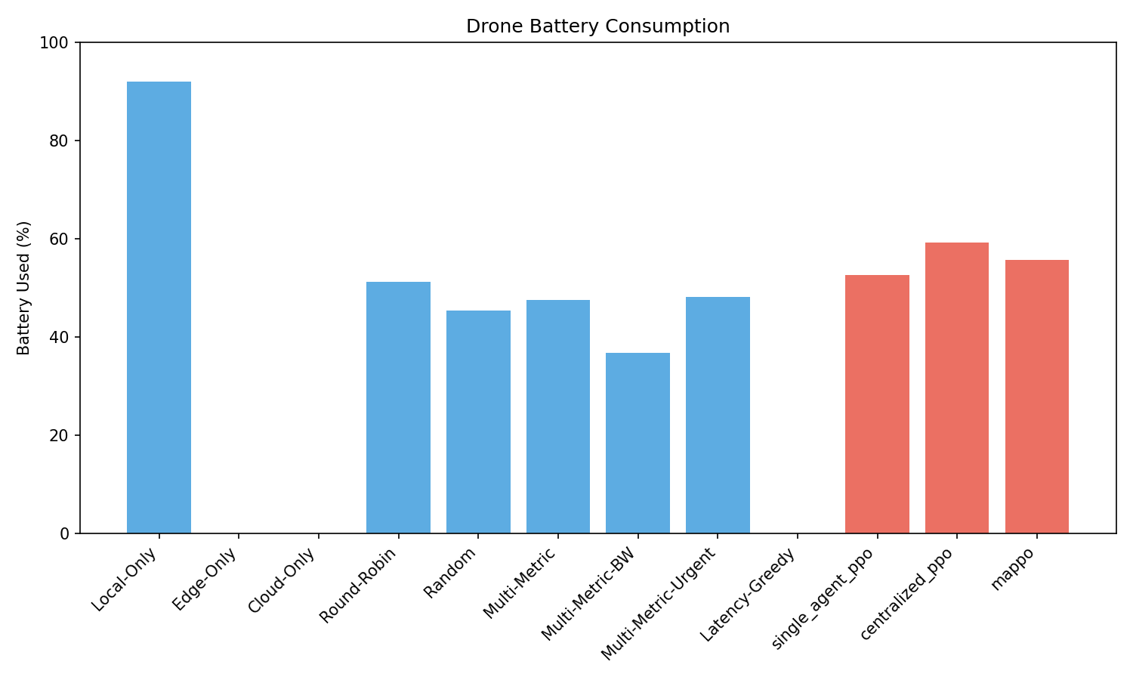
Fig E: Percentage of drone battery consumed per episode.
This figure shows the percentage of drone battery consumed per episode. Local-only execution incurs the highest energy cost due to sustained local computation, while FieldVision reduces battery usage by selectively offloading tasks when beneficial. The results highlight the energy–latency trade-off managed by cooperative learning.

Figure (F): Deadline Compliance
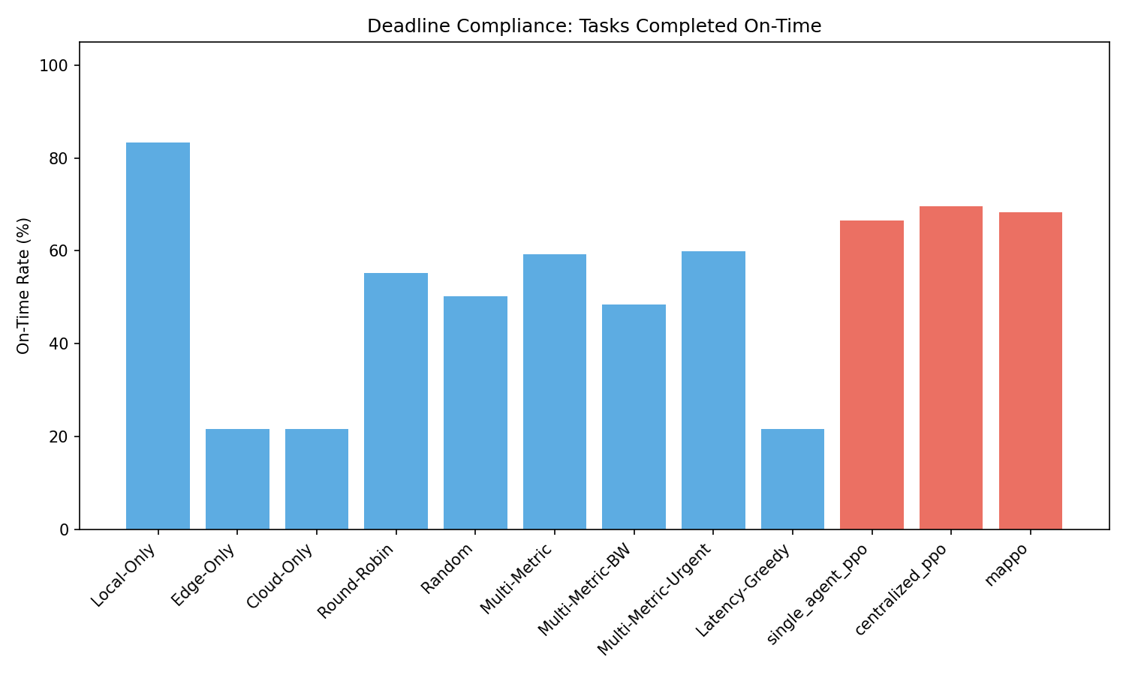
Fig F: Fraction of tasks completed before their deadlines.
This figure reports the fraction of tasks completed before their deadlines. FieldVision achieves higher on-time completion rates compared to heuristic and single-agent baselines, indicating improved reliability for time-sensitive agricultural workloads. Policies with skewed offloading behavior exhibit higher deadline violation rates under load.

Figure (G): Multi-Scenario Comparison
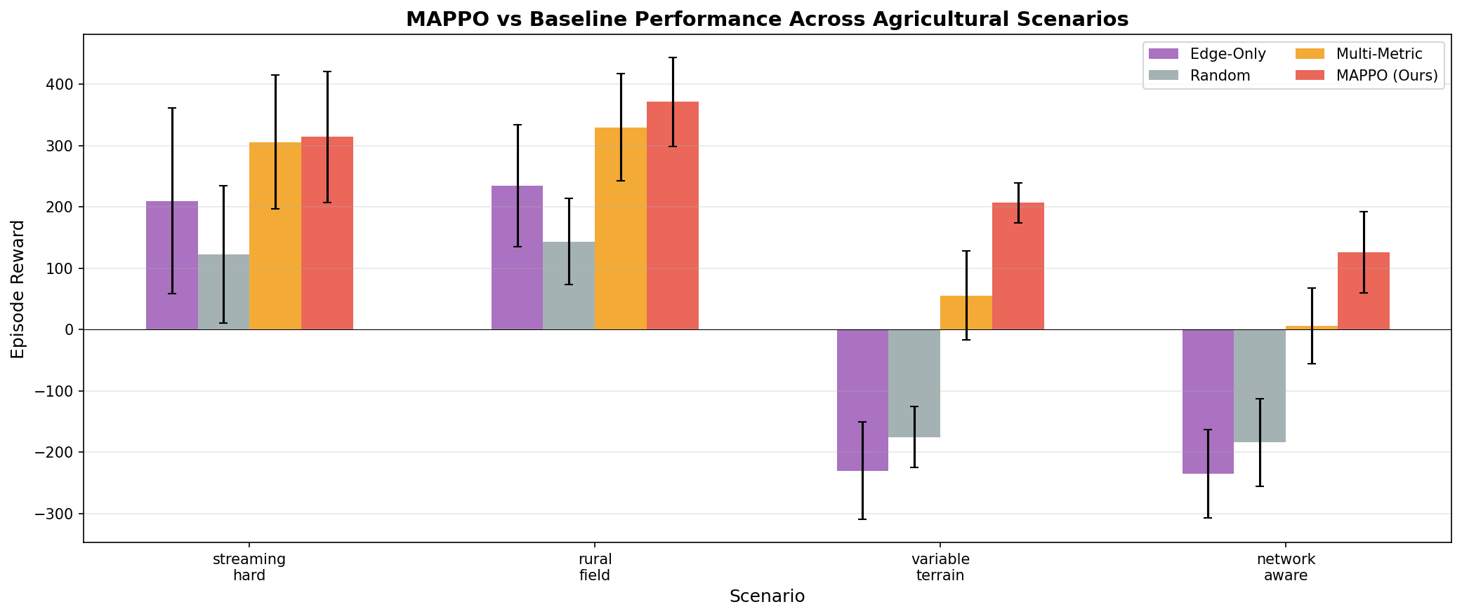
Fig F: Episode rewards for MAPPO and baseline models across 4 network scenarios.
This figure reports the mean episode reward for MAPPO and baseline models across 4 different network scenarios described in the paper. FieldVision achieves higher reward across all scenarios, and outperforms baseline models with higher certainty in more network-variable scenarios compared to more compute-constrained scenarios.

Appendix B: Performance comparison and Tradeoffs Analysis
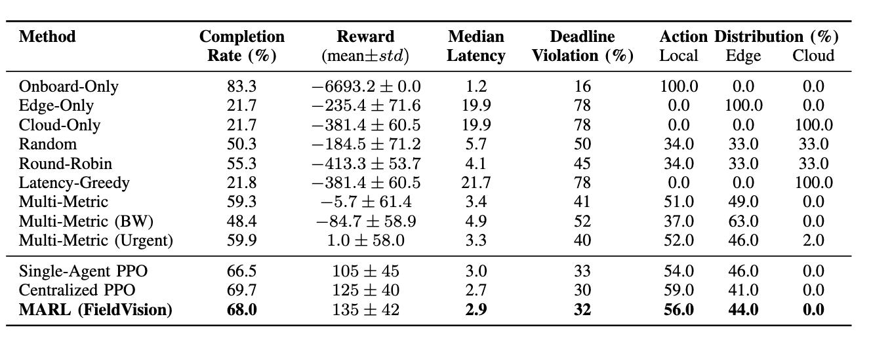
Table A: Quantative Performance Analysisacross Task Offloading Strategies

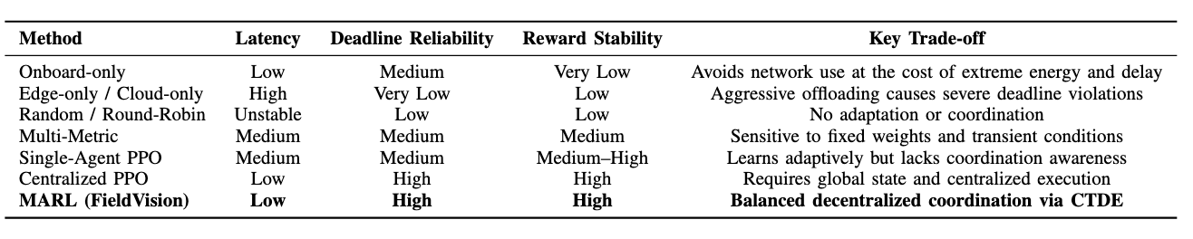
Table B: Qualitative Performance Trade-offs across Task Offloading Strategies
Heuristic and single-tier baselines exhibit extreme behaviors that optimize one objective at the expense of others.
For example, Onboard-only execution achieves a high task completion rate 83.3% but incurs prohibitively large negative rewards due to excessive processing delay and energy cost, making it unsuitable for time-sensitive missions. Conversely, Edge-only and Cloud-only strategies aggressively offload tasks, resulting in severe deadline violations 78% and poor completion rates under network contention.
Rule-based Multi-Metric policies provide moderate improvements by incorporating instantaneous system signals such as bandwidth and urgency. However, these approaches remain sensitive to transient network fluctuations and fixed weighting choices, leading to imbalanced offloading behavior and unstable rewards as workload intensity increases. Variants biased toward bandwidth or urgency further exacerbate this effect by overloading specific execution tiers, increasing deadline violations under contention.
Learning-based approaches demonstrate more favorable trade-offs. Single-Agent PPO improves reward and latency relative to heuristic methods but fails to consistently manage shared resource contention, resulting in higher deadline violations and skewed offloading patterns when multiple drones compete for edge resources. Centralized PPO achieves strong performance across most metrics but relies on centralized execution and global state access, which is impractical in real-world multi-drone deployments.
FieldVision achieves the most balanced operating point among decentralized methods. It combines a high task completion rate (68.0%), low median latency (2.9), and competitive deadline violation rate (32%) while maintaining stable offloading distributions across local and edge resources. This balance enables robust performance across varying network conditions without relying on explicit inter-drone communication or centralized control.
These results demonstrate that cooperative multi-agent learning enables favorable performance trade-offs that are unattainable with fixed heuristics or independent learning. By learning coordination implicitly during centralized training, FieldVision adapts effectively at runtime, achieving scalability and reliability in dynamic, partially observable multi-drone environments.

