

Mini Project Report

of

Database Systems Lab (CSE 2262)

Race Data Management System

SUBMITTED

BY

Tushar Pathak 230905396, CSE-B, 48

Riddhima Roy, 230905564, CSE-B, 65

Department of Computer Science and Engineering

**Manipal Institute of Technology, Manipal.**

**April 2024**

**TABLE OF CONTENTS**

* **Abstract**
* **Problem Statement**
* **ER Diagram and Relational Tables**
* **DDL Commands**
* **List of SQL Queries**
* **Procedures/ Triggers**
* **UI Design**
* **References**

**Abstract:**

The Formula 1 Database Management System is a comprehensive solution for organizing and managing all data related to Formula 1 racing. It covers everything from drivers, teams, circuits, and races to entire championship seasons. By maintaining clear connections between this information, the system makes it easy to analyze stats, track performance trends, and retrieve historical data.

**Problem Statement:**

What problem are we solving?

Formula 1 is packed with data—drivers, teams, circuits, races, championships, and so much more. Managing this data manually or in a disorganized system is not only time-consuming but also prone to errors.

We aim to solve this by building a well-structured database that keeps everything organized, connected, and easy to access. Here's what we’ll focus on:

1. Drivers: Storing details like their names, nationalities, debut years, retirement status, and team history.
2. Teams: Capturing team names, principals, active years, and base locations.
3. Seasons and Championships: Tracking each season’s race schedule, championship winners, and team performances.
4. Races and Circuits: Keeping detailed records of races (dates, circuits, winners, lap records) and circuit information (location, length, fastest laps).
5. Race Results: Logging how drivers and teams performed in each race—positions, points, and fastest laps.
6. Historical Analysis: Making it easy to pull stats like top-performing drivers, team rankings, and season trends.

**ER Diagram**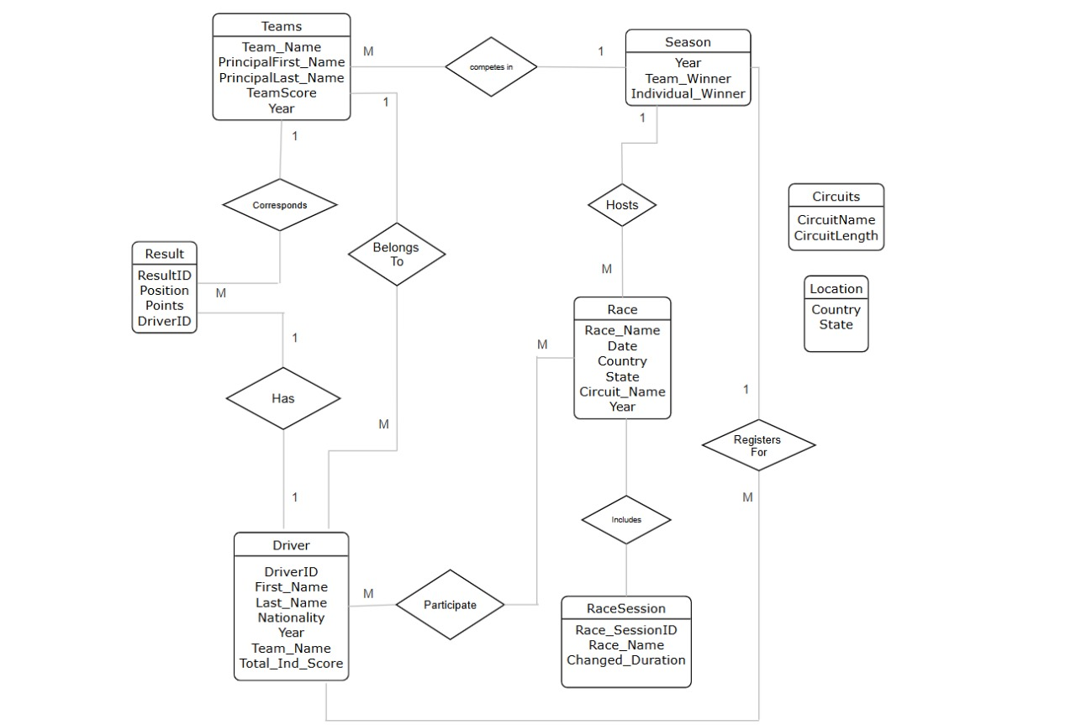

**Relational Tables**

* Driver (**Driver_ID**, First_Name, Last_Name, Nationality, Total_Ind_Score, **Year**, **Team_Name**)
* Race (**Race_Name**, Date, **Country**, **State**, **Circuit_Name**, **Year**)
* Result (**Result_ID**, Position, Points, **Driver_ID**, **Team_Name**, **Year**)
* Team (**Team_Name**, Principal_First_Name, Principal_Last_Name, Team_Score, **Year**)
* Circuit (**Circuit_Name**, Circuit_Length)
* Location (**Country**, **State**)
* RaceSession (**Race_SessionID**, Duration, Changed_Duration, **Race_Name**)
* Season (**Year**, Team_Winner, Individual_Winner)

**Schema Diagram  
  
  
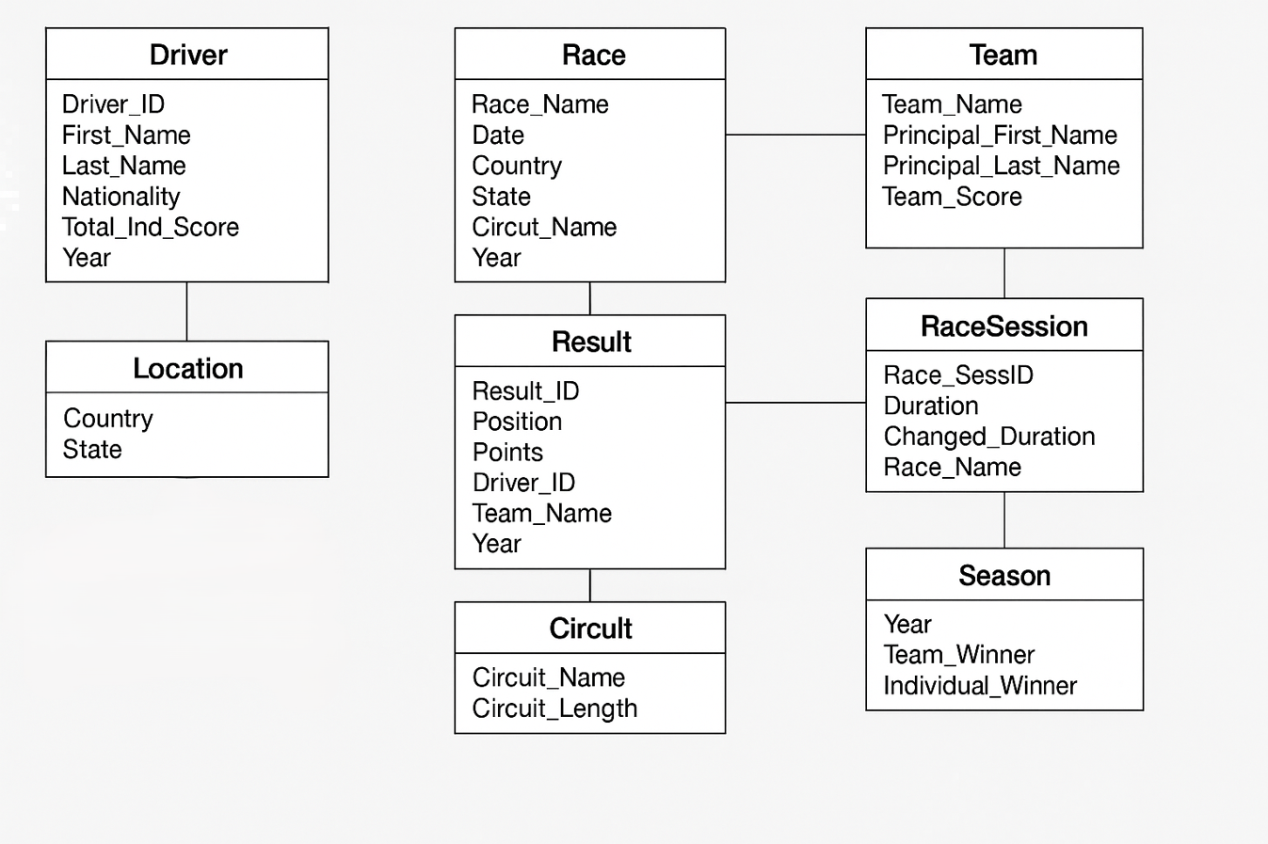  
  
DDL Commands:**CREATE TABLE Season (

Year INT PRIMARY KEY,

Team_Winner VARCHAR(255),

Individual_Winner VARCHAR(255)

);

CREATE TABLE Location (

Country VARCHAR(255),

State VARCHAR(255),

PRIMARY KEY (Country, State)

);

CREATE TABLE Circuit (

Circuit_Name VARCHAR(255) PRIMARY KEY,

Circuit_Length DECIMAL(10, 2)

);

CREATE TABLE Team (

Team_Name VARCHAR(255),

Principal_First_Name VARCHAR(255),

Principal_Last_Name VARCHAR(255),

Team_Score INT,

Year INT,

PRIMARY KEY (Team_Name, Year),

FOREIGN KEY (Year) REFERENCES Season (Year)

);

CREATE TABLE Driver (

Driver_ID INT NOT NULL,

Nationality VARCHAR(255),

Last_Name VARCHAR(255),

First_Name VARCHAR(255),

Total_Ind_Score INT,

Year INT NOT NULL,

Team_Name VARCHAR(255),

PRIMARY KEY (Driver_ID, Year),

FOREIGN KEY (Year) REFERENCES Season (Year),

FOREIGN KEY (Team_Name, Year) REFERENCES Team (Team_Name, Year)

);

CREATE TABLE Race (

Race_Name VARCHAR(255) PRIMARY KEY,

Race_Date DATE,

Country VARCHAR(255),

State VARCHAR(255),

Circuit_Name VARCHAR(255),

Year INT,

FOREIGN KEY (Circuit_Name) REFERENCES Circuit (Circuit_Name),

FOREIGN KEY (Year) REFERENCES Season (Year),

FOREIGN KEY (Country, State) REFERENCES Location (Country, State)

);

CREATE TABLE Result (

Result_ID VARCHAR(255) PRIMARY KEY,

Position INT NOT NULL,

Points INT,

Driver_ID INT NOT NULL,

Team_Name VARCHAR(255),

Year INT NOT NULL,

FOREIGN KEY (Year) REFERENCES Season (Year),

FOREIGN KEY (Driver_ID, Year) REFERENCES Driver (Driver_ID, Year),

FOREIGN KEY (Team_Name, Year) REFERENCES Team (Team_Name, Year)

);

CREATE TABLE RaceSession (

Race_SessionID VARCHAR(255) PRIMARY KEY,

Duration INT,

Changed_Duration INT,

Race_Name VARCHAR(255),

FOREIGN KEY (Race_Name) REFERENCES Race (Race_Name)

);

CREATE TABLE Audit_Log (

Audit_ID VARCHAR2(36),

Action_Type VARCHAR2(10),

Table_Name VARCHAR2(50),

Record_ID VARCHAR2(100),

Action_Details VARCHAR2(1000),

Action_By VARCHAR2(50),

Action_Date TIMESTAMP DEFAULT CURRENT_TIMESTAMP,

PRIMARY KEY (Audit_ID)

); **Queries:  
  
Get Team Standings**:SELECT t.Team_Name, t.Team_Score, t.Principal_First_Name || ' ' || t.Principal_Last_Name as Principal, COUNT(DISTINCT d.Driver_ID) AS Drivers_Count

    FROM Team t

    LEFT JOIN Driver d ON t.Team_Name = d.Team_Name AND t.Year = d.Year

    WHERE t.Year = :year

    GROUP BY t.Team_Name, t.Team_Score, t.Principal_First_Name, t.Principal_Last_Name

    ORDER BY t.Team_Score DESC

**Get Driver Standings**:SELECT d.Driver_ID, d.First_Name || ' ' || d.Last_Name AS Driver_Name,

           d.Total_Ind_Score, d.Team_Name, d.Nationality

    FROM Driver d

    WHERE d.Year = :year

    ORDER BY d.Total_Ind_Score DESC  
  
 **Race Schedule**:

 SELECT r.Race_Name, TO_CHAR(r.Race_Date, 'YYYY-MM-DD') as Race_Date,

           r.Country, r.State, r.Circuit_Name,

           c.Circuit_Length

    FROM Race r

    JOIN Circuit c ON r.Circuit_Name = c.Circuit_Name

    WHERE r.Year = :year

    ORDER BY r.Race_Date

**Championship History**:

 SELECT s.Year, s.Team_Winner, s.Individual_Winner,

           (SELECT MAX(Team_Score) FROM Team WHERE Year = s.Year) AS Winning_Team_Score,

           (SELECT MAX(Total_Ind_Score) FROM Driver WHERE Year = s.Year) AS Winning_Driver_Score

    FROM Season s

    ORDER BY s.Year DESC

**Top Teams**:

SELECT t.Team_Name, t.Team_Score

        FROM Team t

        WHERE t.Year = {year}

        ORDER BY t.Team_Score DESC

FETCH FIRST 5 ROWS ONLY

**Top Drivers**:

SELECT d.First_Name || ' ' || d.Last_Name as Driver_Name, d.Total_Ind_Score

        FROM Driver d

        WHERE d.Year = {year}

        ORDER BY d.Total_Ind_Score DESC

        FETCH FIRST 5 ROWS ONLY

**Show Multiple Championships**:

SELECT s.Individual_Winner, COUNT(*) as championships

        FROM Season s

        GROUP BY s.Individual_Winner

        HAVING COUNT(*) > 1

        ORDER BY championships DESC

**Popular Circuits**:

SELECT c.Circuit_Name, COUNT(r.Race_Name) as race_count

        FROM Circuit c

        JOIN Race r ON r.Circuit_Name = c.Circuit_Name

        WHERE r.Year = {year}

        GROUP BY c.Circuit_Name

        ORDER BY race_count DESC

        FETCH FIRST 5 ROWS ONLY

**Average Team Scores**:

SELECT t.Team_Name, AVG(t.Team_Score) as avg_score

        FROM Team t

        WHERE t.Year = {year}

        GROUP BY t.Team_Name

        ORDER BY avg_score DESC

**Driver Improvements**:

SELECT d.First_Name || ' ' || d.Last_Name as Driver_Name,

               (d.Total_Ind_Score - LAG(d.Total_Ind_Score) OVER (PARTITION BY d.First_Name, d.Last_Name ORDER BY d.Year)) as score_diff

        FROM Driver d

        WHERE d.Year IN (SELECT Year FROM Season)

        ORDER BY score_diff DESC NULLS LAST

        FETCH FIRST 5 ROWS ONLY

**Longest Race Sessions**:

SELECT r.Race_Name, MAX(rs.Duration) as max_duration

        FROM Race r

        JOIN RaceSession rs ON rs.Race_Name = r.Race_Name

        WHERE r.Year = {year}

        GROUP BY r.Race_Name

        ORDER BY max_duration DESC

        FETCH FIRST 5 ROWS ONLY

**Nationality Count**:

SELECT d.Nationality, COUNT(*) as driver_count

FROM Driver d

WHERE d.Year = {year}

GROUP BY d.Nationality

ORDER BY driver_count DESC

**PL/SQL Queries**

**Find Driver Positions:**

CREATE OR REPLACE FUNCTION get_driver_position(

            p_driver_id IN NUMBER,

            p_race_name IN VARCHAR2

        ) RETURN NUMBER IS

            v_position NUMBER;

        BEGIN

            SELECT Position INTO v_position

            FROM Result

            WHERE Driver_ID = p_driver_id

            AND SUBSTR(Result_ID, 1, INSTR(Result_ID, '-') - 1) = p_race_name;

            RETURN v_position;

        EXCEPTION

            WHEN NO_DATA_FOUND THEN

                RETURN NULL;

            WHEN OTHERS THEN

                RETURN -1;

        END;

**Update Team Score**:

CREATE OR REPLACE PROCEDURE update_team_score_proc (

p_team_name IN VARCHAR2,

p_year IN NUMBER,

p_additional_points IN NUMBER

)

AS

BEGIN

UPDATE Team

SET Team_Score = NVL(Team_Score, 0) + p_additional_points

WHERE Team_Name = p_team_name AND Year = p_year;

IF SQL%ROWCOUNT = 0 THEN

DBMS_OUTPUT.PUT_LINE('No team found with name "' || p_team_name || '" for year ' || p_year);

ELSE

DBMS_OUTPUT.PUT_LINE('Team score updated successfully.');

END IF;

COMMIT;

EXCEPTION

WHEN OTHERS THEN

DBMS_OUTPUT.PUT_LINE('Error: ' || SQLERRM);

ROLLBACK;

END;

**Race Session Count**:

CREATE OR REPLACE FUNCTION get_race_session_count(

                p_race_name IN VARCHAR2

            ) RETURN NUMBER IS

                v_count NUMBER;

            BEGIN

                SELECT COUNT(*) INTO v_count

                FROM RaceSession

                WHERE RacexEN NO_DATA_FOUND THEN

                    RETURN 0;

            END;

**Audit Log**:

CREATE OR REPLACE TRIGGER audit_trigger

    AFTER INSERT OR UPDATE OR DELETE ON Team

    FOR EACH ROW

    DECLARE

        v_action VARCHAR2(10);

        v_record_id VARCHAR2(100);

        v_details VARCHAR2(1000);

    BEGIN

        IF INSERTING THEN

            v_action := 'INSERT';

            v_record_id := :NEW.Team_Name || '-' || :NEW.Year;

            v_details := 'Team: ' || :NEW.Team_Name || ', Score: ' || :NEW.Team_Score ||

                        ', Principal: ' || :NEW.Principal_First_Name || ' ' || :NEW.Principal_Last_Name;

        ELSIF UPDATING THEN

            v_action := 'UPDATE';

            v_record_id := :NEW.Team_Name || '-' || :NEW.Year;

            v_details := 'Old Score: ' || :OLD.Team_Score || ', New Score: ' || :NEW.Team_Score ||

                        ', Old Principal: ' || :OLD.Principal_First_Name || ' ' || :OLD.Principal_Last_Name ||

                        ', New Principal: ' || :NEW.Principal_First_Name || ' ' || :NEW.Principal_Last_Name;

        ELSE

            v_action := 'DELETE';

            v_record_id := :OLD.Team_Name || '-' || :OLD.Year;

            v_details := 'Team: ' || :OLD.Team_Name || ', Score: ' || :OLD.Team_Score;

        END IF;

        INSERT INTO Audit_Log (

            Audit_ID,

            Action_Type,

            Table_Name,

            Record_ID,

            Action_Details,

            Action_By

        ) VALUES (

            SYS_GUID(),

            v_action,

            'Team',

            v_record_id,

            v_details,

            USER

        );

    END;

**UI Design**

Fig 1. Login Page

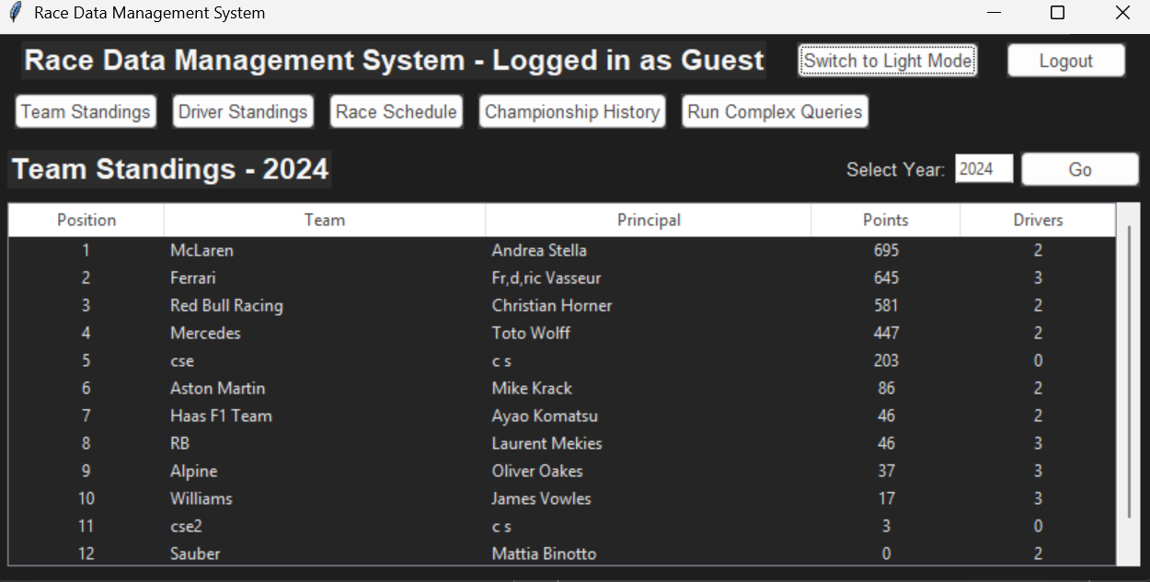

Fig 2. Guest Interface – Team Standings Tab

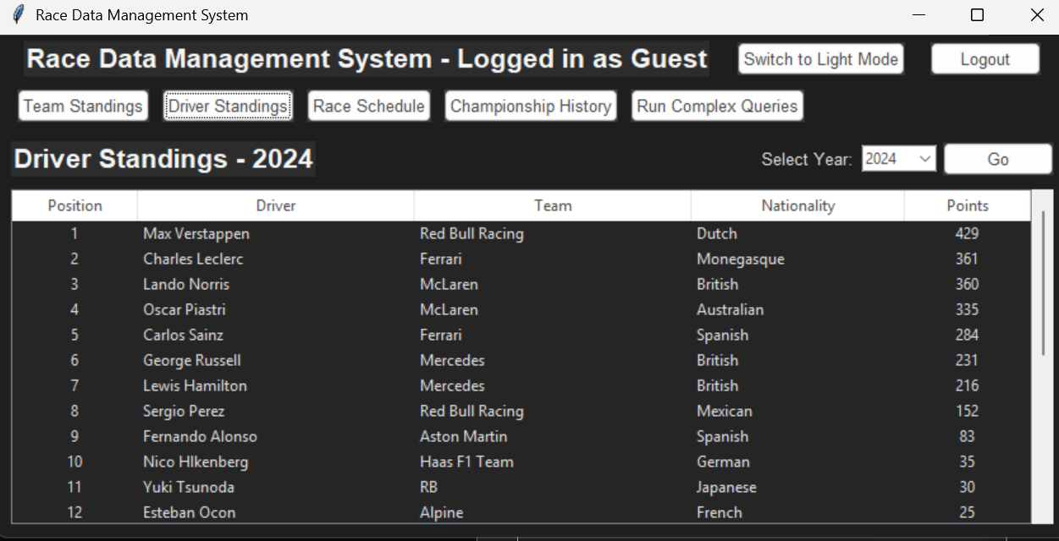

Fig 3. Driver Standings Tab

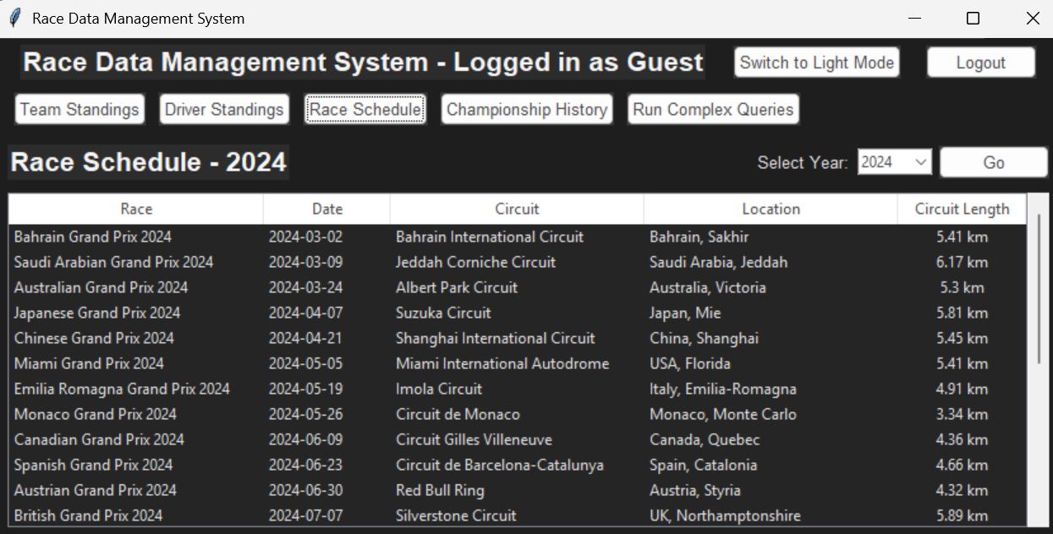

Fig 4. Race Schedule Tab

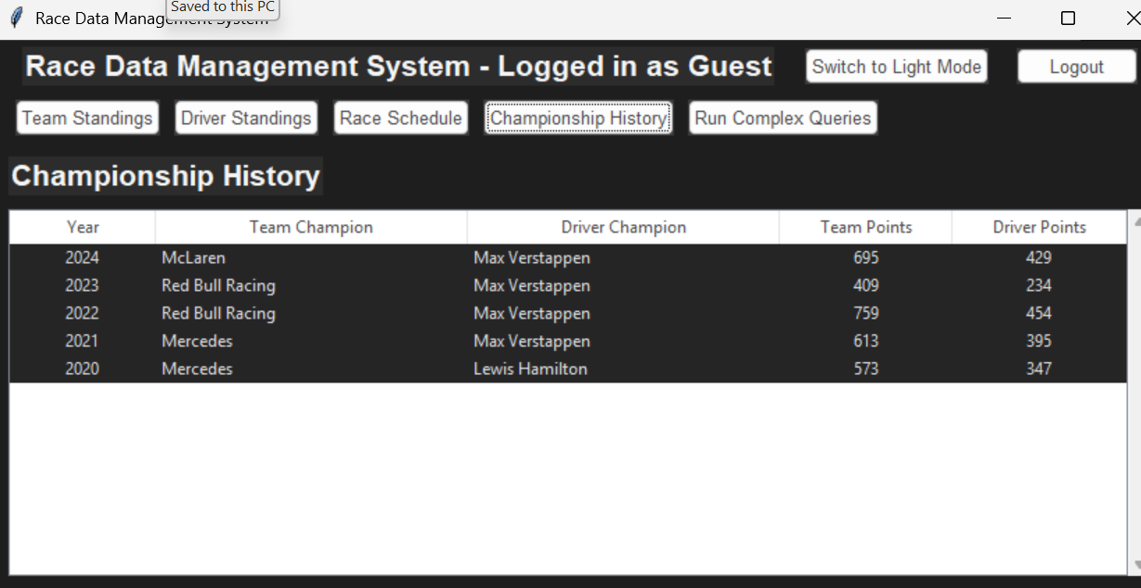

Fig 5. Championship History Tab

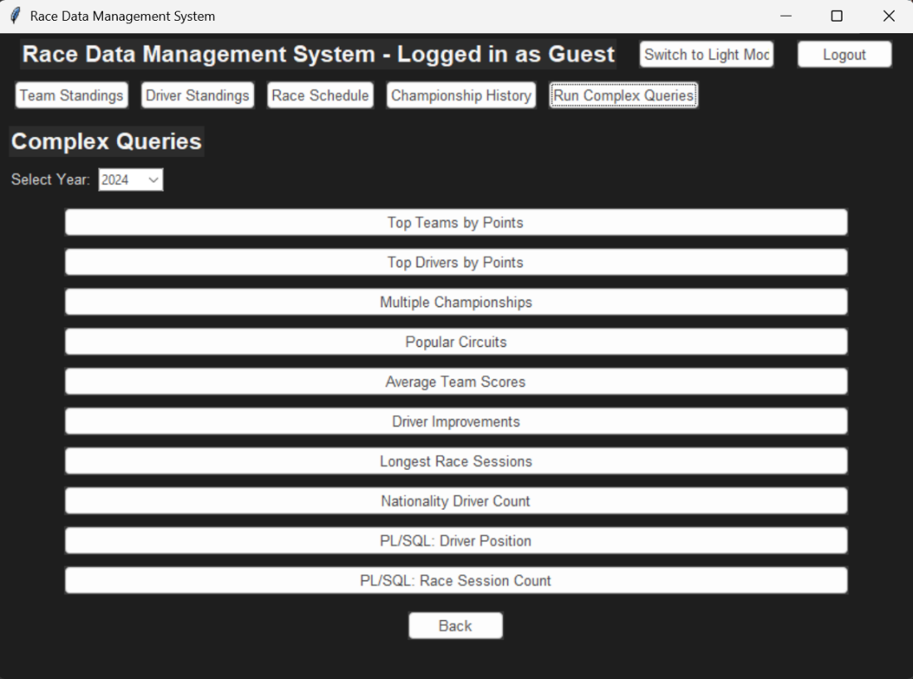

Fig 6. Complex Queries Tab

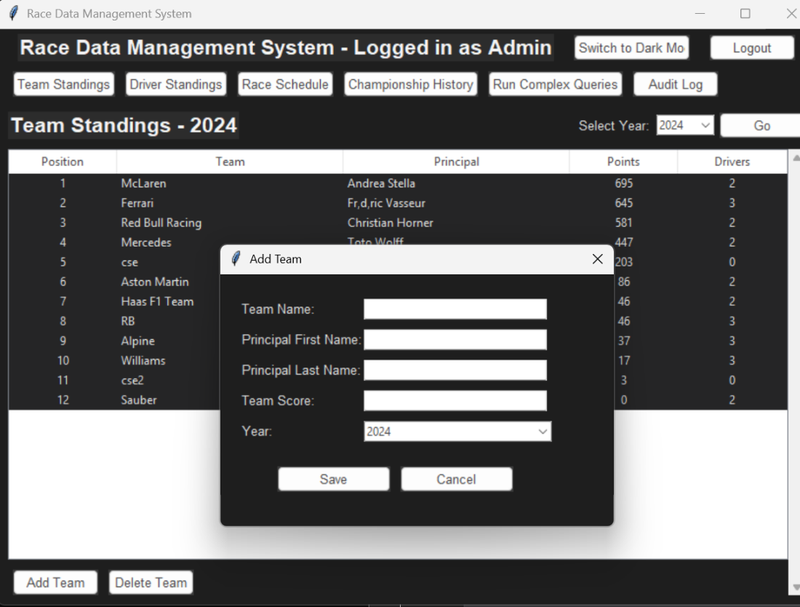

Fig 7. Add Team

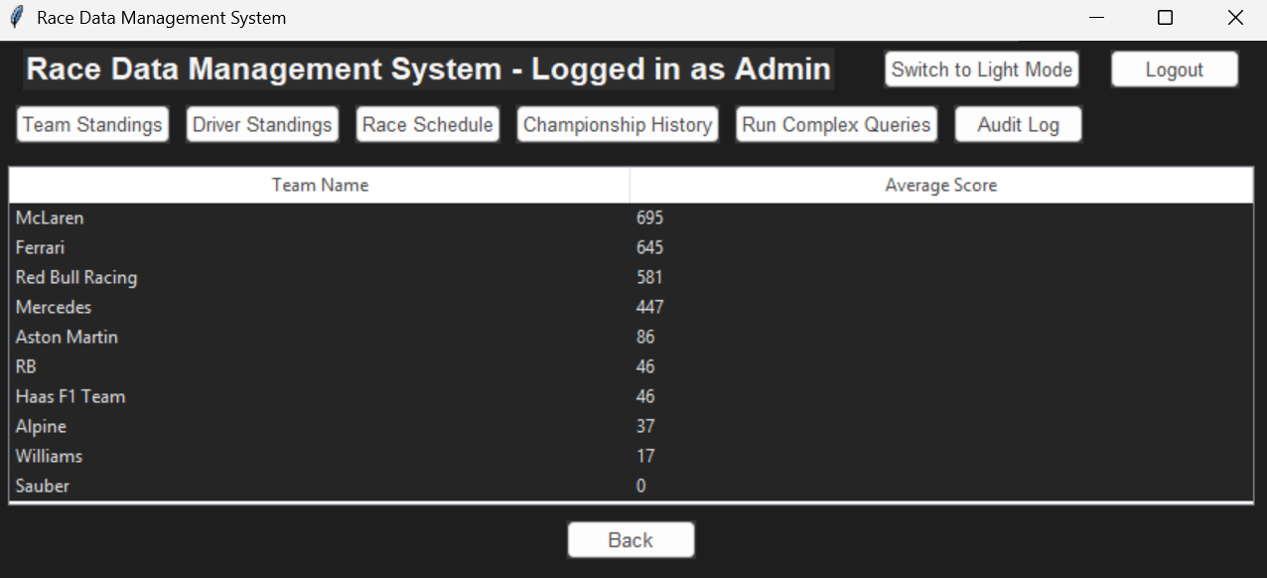

Fig 8. Average Team Scores Query Result

Fig 9. Nationality Count Query Result

Fig 10. Find Driver Position PL/SQL Query

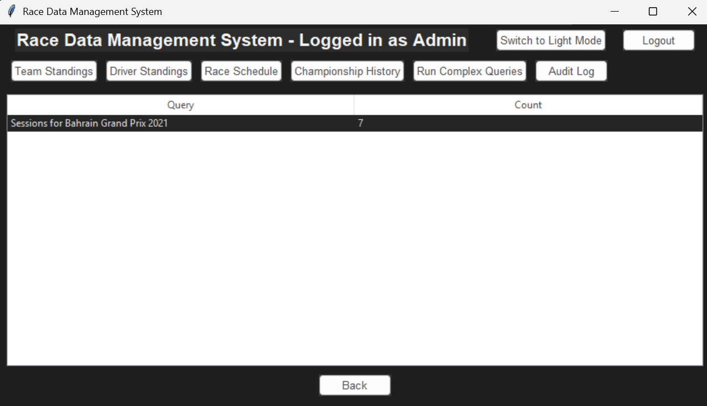

Fig 11. Find Race Session Count PL/SQL Query

**References**:

1. **Oracle Database 21c Documentation**  
   <https://docs.oracle.com/en/database/oracle/oracle-database/21/>
2. **Oracle PL/SQL Programming**  
   <https://www.oreilly.com/library/view/oracle-plsql-programming/9781449324445/>
3. **Expert Oracle Database Architecture**  
   <https://link.springer.com/book/10.1007/978-1-4302-6299-2>
4. **Python and Tkinter Programming**  
   <https://www.manning.com/books/python-and-tkinter-programming>
5. **Tkinter — Python Interface**   
   <https://docs.python.org/3/library/tkinter.html>
6. **Python CX_Oracle Documentation**  
   <https://cx-oracle.readthedocs.io/en/latest/>
7. **Python Programming on Win32**  
   <https://www.oreilly.com/library/view/python-programming-on/1565926218/>
8. **Flask Web Development**  
   <https://www.oreilly.com/library/view/flask-web-development/9781491991725/>
9. **Flask Documentation**  
   <https://flask.palletsprojects.com/en/2.3.x/>
10. **Formula 1 Regulations**  
    <https://www.fia.com/en/regulations>
11. **The Art of the Formula 1 Race Car**  
    <https://www.quartoknows.com/books/9780760368374/The-Art-of-the-Formula-1-Race-Car.html>